Spring JPA Mapping- 2025
One To One Unidirectional
@Entity @Table(name = "employee")
@Getter @Setter @ToString
public class Employee {

@Id @GeneratedValue
private Long id;

private String name;

public Employee(String name) {
this.name = name;
}
}
@Entity @Table(name = "department")
@Getter @Setter
public class Department {

@Id @GeneratedValue
private Long id;

private String name;

@OneToOne(cascade = CascadeType.ALL)
private Employee emp;

public Department(String name) {
this.name = name;
}
}

Database Tables – Spring JPA Creates the following tables.
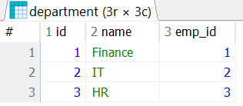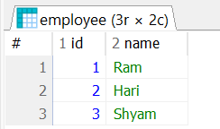

Note: @GeneratedValue(strategy = GenerationType.IDENTITY) – Always use like this in entity.

One To One – UniDirectional - @JoinTable
@Entity @Table(name = "department") @Getter @Setter
public class Department {

@Id @GeneratedValue
private Long id;

private String name;

@OneToOne(cascade = CascadeType.ALL)
@JoinTable(
name = "dept_emp_mapping",
joinColumns = @JoinColumn(name = "dept_id"), // owning side - Department
inverseJoinColumns = @JoinColumn(name = "emp_id") // target side - Employee
)
private Employee emp;

public Department(String name) {
this.name = name;
}
}

@Entity @Table(name = "employee") @Getter @Setter
@ToString
public class Employee {

@Id @GeneratedValue
private Long id;

private String name;

public Employee(String name) {
this.name = name;
}
}
In this case three tables will be created.
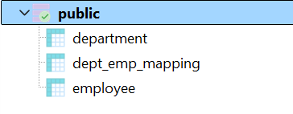
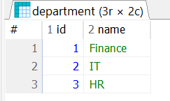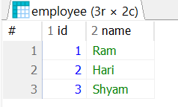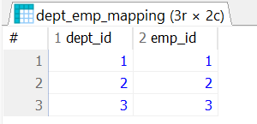
Note: However, if you don’t want to execute the script, Spring JPA will automatically create the tables, sequences and constraints. Table creation script is given below.
CREATE TABLE dept_emp_mapping (
dept_id BIGINT NOT NULL,
emp_id BIGINT NOT NULL,
PRIMARY KEY (dept_id, emp_id)
);
CREATE TABLE employee (
id SERIAL PRIMARY KEY,
name VARCHAR(100) NOT NULL
);
CREATE TABLE department (
id SERIAL PRIMARY KEY,
name VARCHAR(255) NOT NULL
);

One To One – BiDirectional
@Entity @Table(name = "employee")
@Getter @Setter @ToString
public class Employee {

@Id @GeneratedValue
private Long id;

private String name;

@OneToOne(mappedBy = "emp")
private Department dept;

public Employee(String name) {
this.name = name;
}
}

@Entity @Table(name = "department")
@Getter @Setter
public class Department {

@Id @GeneratedValue
private Long id;

private String name;

@OneToOne(cascade = CascadeType.ALL)
private Employee emp;

public Department(String name) {
this.name = name;
}
}

Following tables will be created.

One To One – BiDirectional - @JoinTable
@Entity @Table(name = "department")
@Getter @Setter
public class Department {

@Id @GeneratedValue
private Long id;

private String name;

@OneToOne(cascade = CascadeType.ALL)
@JoinTable(
name = "dept_emp",
joinColumns = @JoinColumn(name = "dept_id"), // owning side - Department
inverseJoinColumns = @JoinColumn(name = "emp_id") // target side - Employee
)
private Employee emp;

public Department(String name) {
this.name = name;
}
}

@Entity @Table(name = "employee")
@Getter @Setter @ToString
public class Employee {

@Id @GeneratedValue
private Long id;

private String name;

@OneToOne(mappedBy = "emp") Important
private Department dept;

public Employee(String name) {
this.name = name;
}
}

In this case three tables will be created.
Note: If you don’t want to mention mappedBy in employee table ie. @OneToOne, then you have to use @JoinTable in employee entity class. The example is given below. It means both Department and Employee entity will have @JoinTable. The above same tables will be created.

@Entity @Table(name = "employee")
@Getter @Setter @ToString
public class Employee {

@Id @GeneratedValue(strategy = GenerationType.IDENTITY)
private Long id;

private String name;

@OneToOne
@JoinTable(
name = "dept_emp",
joinColumns = @JoinColumn(name = "emp_id"), // owning side - Department
inverseJoinColumns = @JoinColumn(name = "dept_id") // target side - Employee
)
private Department dept;

public Employee(String name) {
this.name = name;
}
}
One To Many Unidirectional
@Entity @Table(name = "department")
@Getter @Setter
public class Department {

@Id @GeneratedValue
private Long id;

private String name;

@OneToMany(cascade = CascadeType.ALL)
private Set<Employee> employees;

public Department(String name) {
this.name = name;
}
}
@Entity @Table(name = "employee")
@Getter @Setter @ToString
public class Employee {

@Id @GeneratedValue
private Long id;

private String name;

public Employee(String name) {
this.name = name;
}

}

In this case, Spring JPA creates 3 tables as mentioned below.
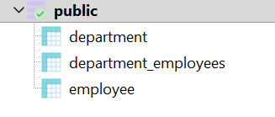
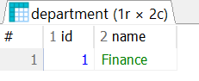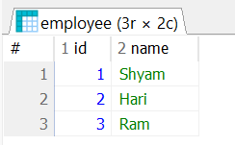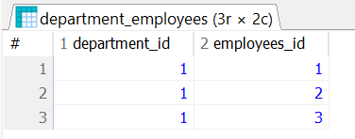

One To Many – UniDirectional Using @JoinTable
@Entity @Table(name = "department")
@Getter @Setter
public class Department {

@Id @GeneratedValue
private Long id;

private String name;

@OneToMany(cascade = CascadeType.ALL)
@JoinTable(
name = "dept_emp",
joinColumns = @JoinColumn(name = "dept_id"), // Foreign key column for Department
inverseJoinColumns = @JoinColumn(name = "emp_id") // Foreign key column for Employee
)
private Set<Employee> employees;

public Department(String name) {
this.name = name;
}

}

There is no change in Employee entity class.
The following database tables will be created by you or Spring JPA.
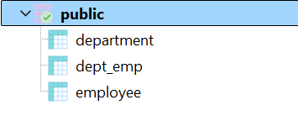
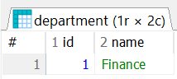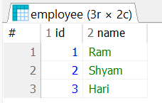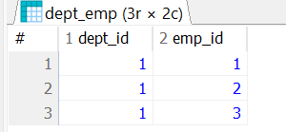

One To Many Bidirectional
@Entity @Table(name = "employee")
@Getter @Setter @ToString
public class Employee {

@Id @GeneratedValue
private Long id;

private String name;

@ManyToOne
private Department dept;

public Employee(String name) {
this.name = name;
}
}
@Entity @Table(name = "department")
@Getter @Setter
public class Department {

@Id @GeneratedValue
private Long id;

private String name;

@OneToMany(cascade = CascadeType.ALL)
private Set<Employee> employees;

public Department(String name) {
this.name = name;
}
}

In this case, Spring JPA creates 3 tables as mentioned below.
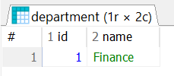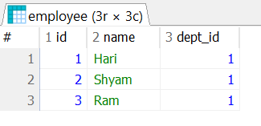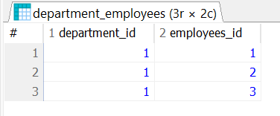

One To Many BiDirectional Using MappedBy
@Entity @Table(name = "employee")
@Getter @Setter @ToString
public class Employee {

@Id @GeneratedValue
private Long id;

private String name;

@ManyToOne
private Department dept;

public Employee(String name) {
this.name = name;
}
}
@Entity @Table(name = "department")
@Getter @Setter
public class Department {

@Id @GeneratedValue
private Long id;

private String name;

@OneToMany(cascade = CascadeType.ALL, mappedBy = "dept")
private Set<Employee> employees;

public Department(String name) {
this.name = name;
}
}

In this case Spring JPA creates two tables.
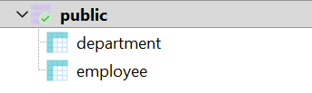
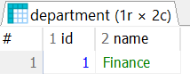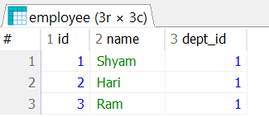

One To Many BiDirectional Using @JoinTable
@Entity @Table(name = "department")
@Getter @Setter
public class Department {

@Id @GeneratedValue
private Long id;

private String name;

@OneToMany(cascade = CascadeType.ALL)
@JoinTable(
name = "dept_emp",
joinColumns = @JoinColumn(name = "dept_id"), // owning side - Department
inverseJoinColumns = @JoinColumn(name = "emp_id") // target side - Employee
)
private Set<Employee> employees;

public Department(String name) {
this.name = name;
}
}

@Entity @Table(name = "employee")
@Getter @Setter @ToString
public class Employee {

@Id @GeneratedValue(strategy = GenerationType.IDENTITY)
private Long id;

private String name;

@ManyToOne
@JoinTable(
name = "dept_emp",
joinColumns = @JoinColumn(name = "emp_id"), // owning side - Department
inverseJoinColumns = @JoinColumn(name = "dept_id") // target side - Employee
)
private Department dept;

public Employee(String name) {
this.name = name;
}
}

In this case, Spring JPA creates the following tables.
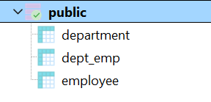
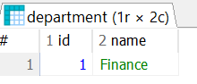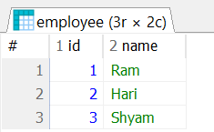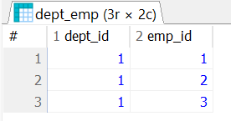
Note: You can not use mappedBy in @ManyToOne(), there is no such attribute.

Simplest Many-To-Many Unidirectional and Bidirectional Mapping
There is no need to use @JoinTable while creating Many-To-Many Unidirectional and Bidirectional mapping.
Many-To-Many Unidirectional
@Entity(name="Author") @Table(name="author")
@Getter @Setter @ToString(exclude="books") @NoArgsConstructor
public class Author {

@Id @GeneratedValue
private Long id;

private String name;

@ManyToMany(cascade = CascadeType.ALL)
private Set<Book> books = new HashSet<>();

public Author(String name) {
this.name = name;
}
}

@Entity(name = "Book") @Table(name = "book")
@Getter @Setter @NoArgsConstructor
public class Book {
@Id
@GeneratedValue
private Long id;

private String name;

public Book(String name) {
this.name = name;
}
}

@Repository
public interface AuthorRepository extends CrudRepository<Author, Long> {
List<Author> findAll();
}

Database Objects
NAME | TYPE
author_seq | SEQUENCE
book_seq | SEQUENCE
author | TABLE
author_books | TABLE
book | TABLE
Table: Author
id | name
1 | Author-0
2 | Author-1
Table: Book
id | name
1 | Book-0
2 | Book-0
Table: author_books
author_id | books_id
1 | 1
1 | 2
1 | 3
Many-To-Many Unidirectional Mapping Table Design

Testing Code
// For Unidirectional
public void saveAllAuthors() {
List<Author> authors = new ArrayList<>();
for( int i = 0; i < 5 ; i++ ) {
Author author = new Author("Author-"+i);

for(int j = 0; j < 5; j++) {
Book book = new Book("Book-"+i);
author.getBooks().add(book);
}
authors.add(author);
}
authorRepo.saveAll(authors);
}

public void showAuthorDetail() {
List<Author> authors = authorRepo.findAll();
authors.forEach( author -> {
System.out.println("Author Name: "+author.getName());
author.getBooks().forEach(book -> {
System.out.println("Book Name: "+book.getName());
});
});
}

Many-To-Many Bidirectional
@Entity(name="Author") @Table(name="author")
@Getter @Setter @ToString(exclude="books") @NoArgsConstructor
public class Author {
@Id @GeneratedValue
private Long id;

private String name;

@ManyToMany(cascade = CascadeType.ALL)
private Set<Book> books = new HashSet<>();

public Author(String name) {
this.name = name;
}
}

@Entity(name = "Book") @Table(name = "book")
@Getter @Setter @ToString(exclude = "authors") @NoArgsConstructor
public class Book {
@Id
@GeneratedValue
private Long id;

private String name;

@ManyToMany(cascade = CascadeType.ALL, mappedBy = "books")
private Set<Author> authors = new HashSet<>();

public Book(String name) {
this.name = name;
}
}

Database Objects
NAME | TYPE
author_seq | SEQUENCE
book_seq | SEQUENCE
author | TABLE
author_books | TABLE
book | TABLE
Many-To-Many Bidirectional Mapping Table Design
Table: author
id | name
1 | Author-1
2 | Author-2
Table: book
id | name
1 | Book-1
Table: author_books
authors_id | books_id
1 | 1

Here in the above book class, we have defined mappedBy = "books". Hence the relational table name is author_books because author is the owning side and book is the inverse side.

We can also define mappedBy = "authors" in author class. If we define mappedBy = "authors" in the author class, book will be the owning side and author will be inverse side. Let us check now.

@Entity(name="Author") @Table(name="author")
@Getter @Setter @ToString(exclude="books") @NoArgsConstructor
public class Author {

@Id @GeneratedValue
private Long id;

private String name;

@ManyToMany(cascade = CascadeType.ALL, mappedBy = "authors")
private Set<Book> books = new HashSet<>();

public Author(String name) {
this.name = name;
}
}

@Entity(name = "Book") @Table(name = "book")
@Getter @Setter @ToString(exclude = "authors")
@NoArgsConstructor
public class Book {

@Id
@GeneratedValue
private Long id;

private String name;

@ManyToMany(cascade = CascadeType.ALL)
private Set<Author> authors = new HashSet<>();

public Book(String name) {
this.name = name;
}
}

Table: book
id | name
1 | Book-1
Table: book_authors
books_id | authors_id
1 | 1
1 | 2
Database Table Design
Database objects
NAME | TYPE
author_seq | SEQUENCE
book_seq | SEQUENCE
author | TABLE
book | TABLE
book_authors | TABLE
Table: author
id | name
1 | Author-1
2 | Author-2

Testing Code
//For Bidirectional
public void saveAllAuthorBooks() {
Author author1 = new Author("Author-1");
Author author2 = new Author("Author-2");
Set<Author> authorSet = new HashSet<>();
authorSet.add(author1); authorSet.add(author2);

Set<Book> bookSet1 = new HashSet<>();
Book book1 = new Book("Book-1");
book1.setAuthors(authorSet);
author1.setBooks(bookSet1);
bookSet1.add(book1);

authorRepo.saveAll(authorSet);
}

Many-To-Many Unidirectional and Bidirectional Mapping Using @JoinTable
Many To Many Unidirectional (Using @JoinTable)
@Entity(name="Author") @Table(name = "author") @Getter @Setter @ToString(exclude = "books") @NoArgsConstructor
public class Author {
@Id
@GeneratedValue
private Long id;

private String name; Author Class

public Author(String name) {
this.name = name;
}

@ManyToMany(cascade = CascadeType.ALL)
@JoinTable(name = "author_book",
joinColumns = @JoinColumn(name = "author_id"),
inverseJoinColumns = @JoinColumn(name = "book_id"))
private Set<Book> books;

}

@Entity(name="Book") @Table(name = "book") @Getter @Setter @NoArgsConstructor @ToString
public class Book {
@Id
@GeneratedValue
private Long id; Book class

private String title;

public Book(String title) {
this.title = title;
}

}

@Repository
public interface AuthorRepository extends CrudRepository<Author, Long> {

}
Database Table Design

Table Name: author
id | name
52 | Author-1
53 | Author-2
Table Name: book
id | title
1 | Book-2
2 | Book-3
Table Name: author_book
author_id | book_id
52 | 1
52 | 2

Testing Method
public void saveAllAuthors() {
Author author1 = new Author("Author-1");
Set<Book> bookSet1 = Set.of(new Book("Book-1"), new Book("Book-2"), new Book("Book-3"));

author1.setBooks(bookSet1);

Author author2 = new Author("Author-2");
Set<Book> bookSet2 = Set.of(new Book("Book-4"), new Book("Book-5"), new Book("Book-6"));
author2.setBooks(bookSet2);

List<Author> authorList = List.of(author1,author2);

authorRepo.saveAll(authorList);
}

public void showAllAuthorAndBook() {
Author author1 = authorRepo.findById(52L).get();
System.out.println("Author Details: "+author1);
author1.getBooks().forEach(book -> System.out.println("Book: "+book));
}

To make a single query to avoid N+1 issue, you can modify like this.
@Repository
public interface AuthorRepository extends CrudRepository<Author, Long> {

@Query("select a from Author a join fetch a.books")
List<Author> getAuthorById(Long id);
}

Testing method
public void showAuthorAndBook() {
List<Author> authors = authorRepo.getAuthorById(52L);
System.out.println("Author Details: "+authors);
authors.forEach( author -> {
author.getBooks().forEach( book -> System.out.println("Book: "+book));
});
}
Similarly, you can also define @JoinTable, columns and inverse join columns in book class. The code is given below.
public class Author {
@ManyToMany(cascade = CascadeType.ALL)
private Set<Book> books;

public Author(String name) {
this.name = name;
}
}

public class Book {

@ManyToMany(cascade = CascadeType.ALL)
@JoinTable(name = "book_author", Book class we define @JoinTable
joinColumns = @JoinColumn(name = "book_id"),
inverseJoinColumns = @JoinColumn(name = "author_id"))
private Set<Author> authors;

public Book(String name) {
this.name = name;
}
}

Table Name: book_author
book_id | author_id
1 | 1
1 | 2
Database Tables
Table Name: author
id | name
1 | Author-2
2 | Author-1
Table Name: book
id | name
1 | Book-1

Many 2 Many Bidirectional (Using @JoinTable)
@Entity(name="Author") @Table(name = "author") @Getter @Setter @ToString(exclude = "books")
@NoArgsConstructor
public class Author {
@Id
@GeneratedValue
private Long id;

private String name;

public Author(String name) {
this.name = name;
}

@ManyToMany(cascade = CascadeType.ALL)
@JoinTable(name = "author_book", @JoinTable in Author class
joinColumns = @JoinColumn(name = "author_id"),
inverseJoinColumns = @JoinColumn(name = "book_id"))
private Set<Book> books;
}

@Entity(name="Book")@Table(name = "book") @Getter @Setter @NoArgsConstructor @ToString
public class Book {
@Id
@GeneratedValue
private Long id;

private String title;

public Book(String title) {
this.title = title;
}

@ManyToMany(fetch = FetchType.LAZY, cascade = CascadeType.ALL, mappedBy = "books")
private Set<Author> authors = new HashSet<>();

}
@Repository
public interface AuthorRepository extends CrudRepository<Author, Long> {
}

Testing Methods
public void saveAllAuthors() {
Author author1 = new Author("Author-1");
Author author2 = new Author("Author-2");
Set<Author> authorSet = new HashSet<>();
authorSet.add(author1); authorSet.add(author2);

Set<Book> bookSet1 = new HashSet<>();
Book book1 = new Book("Book-1");
book1.setAuthors(authorSet);
author1.setBooks(bookSet1);
bookSet1.add(book1);

authorRepo.saveAll(authorSet);
}

public void showAllAuthorAndBook() {
Author author1 = authorRepo.findById(2L).get();
System.out.println("Author Details: "+author1);
author1.getBooks().forEach(book -> System.out.println("Book: "+book));
}

Database Table Design
Table Name: author
id | name
1 | Author-2
2 | Author-1
Table Name: book
id | title
1 | Book-1
Table Name: author_book
author_id | book_id
2 | 1

Similarly, you can also define @JoinTable in the Book class, code is given below.
@Entity(name="Author") @Table(name="author") @Getter @Setter @ToString(exclude="books") @NoArgsConstructor
public class Author {

@Id @GeneratedValue
private Long id;

private String name;

@ManyToMany(cascade = CascadeType.ALL, mappedBy="authors")
private Set<Book> books;

public Author(String name) {
this.name = name;
}
}

@Entity(name = "Book") @Table(name = "book") @Getter @Setter @ToString(exclude = "authors")
@NoArgsConstructor
public class Book {

@Id
@GeneratedValue
private Long id;

private String name;

@ManyToMany(cascade = CascadeType.ALL/* ,mappedBy = "books" */)
@JoinTable(name = "book_author",
joinColumns = @JoinColumn(name = "book_id"), @JoinTable in Book class
inverseJoinColumns = @JoinColumn(name = "author_id"))
private Set<Author> authors;

public Book(String name) {
this.name = name;
}
}

Database Table Design
Table Name: author
id | name
1 | Author-2
2 | Author-1
Table Name: book
id | title
1 | Book-1
Table Name: book_author
book_id | author_id
2 | 1

Use of mappedBy in Bidirectional Mapping
In case of OneToOne – Bidirectional
public class Author { // Use same type annotations
@Id @GeneratedValue
private Long id;

private String name;

@OneToOne(cascade = CascadeType.ALL, mappedBy="author")
private Book book;

public Author(String name) {
this.name = name;
}
}

public class Book { // Use same type annotations
@Id @GeneratedValue
private Long id;

private String name;

@OneToOne(cascade = CascadeType.ALL)
private Author author;

public Book(String name) {
this.name = name;
}
}
In the above case, it is defined as mappedBy="author" in Author class.
Database Table
Table Name: Author
id | name
2 | Author-1
Table Name: Book
id | name | author_id
2 | Book-1 | 2

If we define mappedBy="book" in Book class, the database table structure will be like below.
@Entity(name="Author") @Table(name="author")
@Getter @Setter @ToString(exclude="book") @NoArgsConstructor
public class Author {

@Id @GeneratedValue
private Long id;

private String name;

@OneToOne(cascade = CascadeType.ALL)
private Book book;

public Author(String name) {
this.name = name;
}
}

@Entity(name="Book") @Table(name="book")
@Getter @Setter @ToString(exclude="author") @NoArgsConstructor
public class Book {

@Id @GeneratedValue
private Long id;

private String name;

@OneToOne(cascade = CascadeType.ALL, mappedBy="book")
private Author author;

public Book(String name) {
this.name = name;
}
}
Table Name: Book
id | name
1 | Book-1
Database Table
Table Name: Author
id | name | book_id
1 | Author-1 | 1

How to determine mappedBy value in the respective class ?
In Author class, it has been defined as
public class Author { // Use same type annotations

@Id @GeneratedValue
private Long id;

private String name;

@OneToOne(cascade = CascadeType.ALL)
private Book bookAA; Mark it

public Author(String name) {
this.name = name;
}
}
In Book Class, it is defined as
public class Book {

@Id @GeneratedValue
private Long id;

private String name;

@OneToOne(cascade = CascadeType.ALL, mappedBy="bookAA") Mark it
private Author author;

public Book(String name) {
this.name = name;
}
}
So in case mappedBy, the variable name used in the opposite class has to be used in the class where you are declaring mappedBy. It is visible from the above classes.
Meaning of mappedBy
- The mappedBy attribute is used on the inverse (non-owning) side of a bidirectional relationship.
- It points to the field name of the owning side in the other entity.
- The owning side is the one that has the foreign key or the @JoinColumn annotation.

