

Object Oriented Programming in Java Project

Topic :- Education Instituition Registration

Subject Code :- CS594D

Group No :- 2

Name:- Soumyak Paul

Roll No. :- 3

Name: Debjit Chattopadhyay

Roll No. :- 4

Section:CSE3D

Subject:- Java Laboratory

Enrollment No:12017009001087 &12017009001495

Batch :- 2017-2021

University of Engineering and

Components and Module Description.

The following components are used in the projects :-

1. **Activity :**- Activities are one of the fundamental building blocks of apps on the Android platform. They serve as the entry point for a user's interaction with an app, and are also central to how a user navigates within an app (as with the Back button) or between apps (as with the Recents button). Skillfully managing activities allows you to ensure that, for example:

* Orientation changes take place smoothly without disrupting the user experience.
* User data is not lost during activity transitions.
* The system kills processes when it's appropriate to do so.

1. **TextView** :- A user interface element that displays text to the user. It is a subclass of the View class which is itself a subclass of the Object class. Every class in Java is a subclass of the Object class of the java.lang package if it does not extend any other class. Class Heirarchy for the TextView Class is :-

|  |  |  |
| --- | --- | --- |
| [java.lang.Object](https://developer.android.com/reference/java/lang/Object.html) | | |
| ↳ | [android.view.View](https://developer.android.com/reference/android/view/View.html) | |
|  | ↳ | android.widget.TextView |

1. **Button ;**- A user interface element the user can tap or click to perform an action. Button is a subclass of the TextView Class. It is also the indirect subclass of the Object class.

|  |  |  |  |
| --- | --- | --- | --- |
| [java.lang.Object](https://developer.android.com/reference/java/lang/Object.html) | | | |
| ↳ | [android.view.View](https://developer.android.com/reference/android/view/View.html) | | |
|  | ↳ | [android.widget.TextView](https://developer.android.com/reference/android/widget/TextView.html) | |
|  |  | ↳ | android.widget.Button |

1. **EditText :**- A user interface element for entering and modifying text. Class hierarchy for EditText class :-

|  |  |  |  |
| --- | --- | --- | --- |
| [java.lang.Object](https://developer.android.com/reference/java/lang/Object.html) | | | |
| ↳ | [android.view.View](https://developer.android.com/reference/android/view/View.html) | | |
|  | ↳ | [android.widget.TextView](https://developer.android.com/reference/android/widget/TextView.html) | |
|  |  | ↳ | android.widget.EditText |

1. **Spinner:** A view that displays one child at a time and lets the user pick among them. The items in the Spinner come from the Adapter associated with this view. Class hierarchy for Spinner Class :-

|  |  |  |  |  |  |
| --- | --- | --- | --- | --- | --- |
| [java.lang.Object](https://developer.android.com/reference/java/lang/Object.html) | | | | | |
| ↳ | [android.view.View](https://developer.android.com/reference/android/view/View.html) | | | | |
|  | ↳ | [android.view.ViewGroup](https://developer.android.com/reference/android/view/ViewGroup.html) | | | |
|  |  | ↳ | [android.widget.AdapterView](https://developer.android.com/reference/android/widget/AdapterView.html)<[android.widget.SpinnerAdapter](https://developer.android.com/reference/android/widget/SpinnerAdapter.html)> | | |
|  |  |  | ↳ | [android.widget.AbsSpinner](https://developer.android.com/reference/android/widget/AbsSpinner.html) | |
|  |  |  |  | ↳ | android.widget.Spinner |

1. **ImageView :-** Displays image resources, for example Bitmap or Drawable resources. ImageView is also commonly used to [apply](https://developer.android.com/reference/android/widget/ImageView#setImageTintMode(android.graphics.PorterDuff.Mode)) ints to an image and handle image scaling .ImageView is a subclass of the View class. Class hierarchy of the ImageView Class :-

|  |  |  |
| --- | --- | --- |
| [java.lang.Object](https://developer.android.com/reference/java/lang/Object.html) | | |
| ↳ | [android.view.View](https://developer.android.com/reference/android/view/View.html) | |
|  | ↳ | android.widget.ImageView |

1. **Switch** :- A Switch is a two-state toggle switch widget that can select between two options. The user may drag the "thumb" back and forth to choose the selected option, or simply tap to toggle as if it were a checkbox. The [text](https://developer.android.com/reference/android/widget/TextView.html#setText(java.lang.CharSequence)) property controls the text displayed in the label for the switch, whereas the [off](https://developer.android.com/reference/android/widget/Switch.html#setTextOff(java.lang.CharSequence)) and [on](https://developer.android.com/reference/android/widget/Switch.html#setTextOn(java.lang.CharSequence)) text controls the text on the thumb. The class hierarchy for the Switch class is :-

|  |  |  |  |  |  |
| --- | --- | --- | --- | --- | --- |
| [java.lang.Object](https://developer.android.com/reference/java/lang/Object.html) | | | | | |
| ↳ | [android.view.View](https://developer.android.com/reference/android/view/View.html) | | | | |
|  | ↳ | [android.widget.TextView](https://developer.android.com/reference/android/widget/TextView.html) | | | |
|  |  | ↳ | [android.widget.Button](https://developer.android.com/reference/android/widget/Button.html) | | |
|  |  |  | ↳ | [android.widget.CompoundButton](https://developer.android.com/reference/android/widget/CompoundButton.html) | |
|  |  |  |  | ↳ | android.widget.Switch |

1. **CardView :-** A FrameLayout with a rounded corner background and shadow. CardView uses elevation property on Lollipop for shadows and falls back to a custom emulated shadow implementation on older platforms.Class Heirarchy for the cardview widget class :-

|  |  |  |  |  |
| --- | --- | --- | --- | --- |
| java.lang.Object | | | | |
| ↳ | [android.view.View](https://developer.android.com/reference/android/view/View.html) | | | |
|  | ↳ | [android.view.ViewGroup](https://developer.android.com/reference/android/view/ViewGroup.html) | | |
|  |  | ↳ | [android.widget.FrameLayout](https://developer.android.com/reference/android/widget/FrameLayout.html) | |
|  |  |  | ↳ | androidx.cardview.widget.CardView |

1. **ScrollView** :- A view group that allows the view hierarchy placed within it to be scrolled. Scroll view may have only one direct child placed within it. To add multiple views within the scroll view, make the direct child you add a view group, for example [LinearLayout](https://developer.android.com/reference/android/widget/LinearLayout.html), and place additional views within that LinearLayout.Scroll view supports vertical scrolling only. For horizontal scrolling, use HorizontalScrollView instead. Class Heirarchy for ScrollView is :-

|  |  |  |  |  |
| --- | --- | --- | --- | --- |
| [java.lang.Object](https://developer.android.com/reference/java/lang/Object.html) | | | | |
| ↳ | [android.view.View](https://developer.android.com/reference/android/view/View.html) | | | |
|  | ↳ | [android.view.ViewGroup](https://developer.android.com/reference/android/view/ViewGroup.html) | | |
|  |  | ↳ | [android.widget.FrameLayout](https://developer.android.com/reference/android/widget/FrameLayout.html) | |
|  |  |  | ↳ | android.widget.ScrollView |

**Module 1 :-**  SplashScreen.java and splash_screen.xml are the modules which serve as the introduction screen to the Application. A ImageView with a dummy image is placed to serve as the logo of the app. Android animations are used to implement a fading in effect to the ImageView. The activity itself is a timed activity which automatically changes to the next activity after 3500ms.

**Module 2 :-**  HomeScreen.java and home_screen.xml are the modules that have an imageView and two buttons. The two buttons serve as two different paths for the user. The register button are for the users who want to register themselves to the institute. The show status button is for users who have already registered. They can check whether their registration has been approved by providing their generated id through the show status button.

**Module 3 :-**The user has pressed the Register button and has come to the personal_info.xml page. In this activity a database connection is opened. Personal details about the students like name, address, gender, email-id, etc are collected and added to the Firebase Database through a HashMap. The timestamp of the device is fetched and used as the students registration number under which all these details are stored in the database.

**Module 4 :-** Academic Details of the student is collected through input fields and added to the same child through a objectMap. The registration id generated in the previous activity is carried along to the next activity during the Activity transition. The same child is updated every time.

**Module 5:** Whether the student will avail the institute bus service , is collected through bus_service.java and bus_service.xml . A switch is used which behave like a toggle button . if the switch is checked then the response is positive, else negative.

**Module 6:** The registration process is complete and the registration id is generated and displayed to the user. Each registration id is unique. The user can copy the registration id and go to the home screen to check his status.

**Module 7 :** The user is back to the home screen. The user has pressed the Show Status button and he/she is directed to the search page. In the search page the user can type in the id and press the Search button to see his registration details and check whether his registration is accepted or not.

**Module 8 :-** The results page is a combination of a ScrollView and 11 Cardviews. Since the details of each user in the database are pre-determined a Recyclerview is not favoured her. Each cardview displays each fields that the user has input during the registration process. A ScrollView is used to scroll through the details because all the details will not visible in the screen at the same time. A home button is also used to redirect the user to the home screen for further registrations.

**Database Schema.**

Firebase is used as the Database to develop this Android Application.

**How data is structured: it's a JSON tree**

All Firebase Realtime Database data is stored as JSON objects. You can think of the database as a cloud-hosted JSON tree. Unlike a SQL database, there are no tables or records. When you add data to the JSON tree, it becomes a node in the existing JSON structure with an associated key. You can provide your own keys, such as user IDs or semantic names.

For example, consider a chat application that allows users to store a basic profile and contact list. A typical user profile is located at a path, such as /users/$uid. The user alovelace might have a database entry that looks something like this:

{  
  "users": {  
    "alovelace": {  
      "name": "Ada Lovelace",  
      "contacts": { "ghopper": true },  
    },  
    "ghopper": { ... },  
    "eclarke": { ... }  
  }  
}

**Our Database design :-**

**Root Child Views : -**

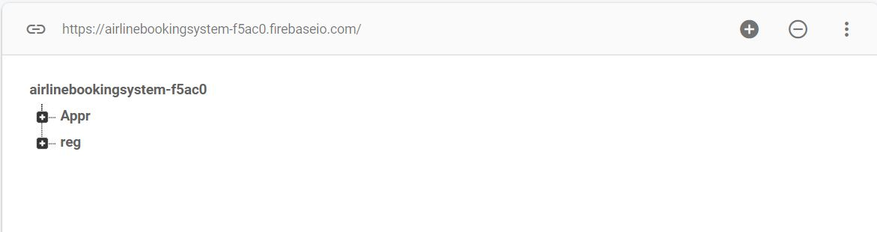

**Registrations Child Expanded View :-**

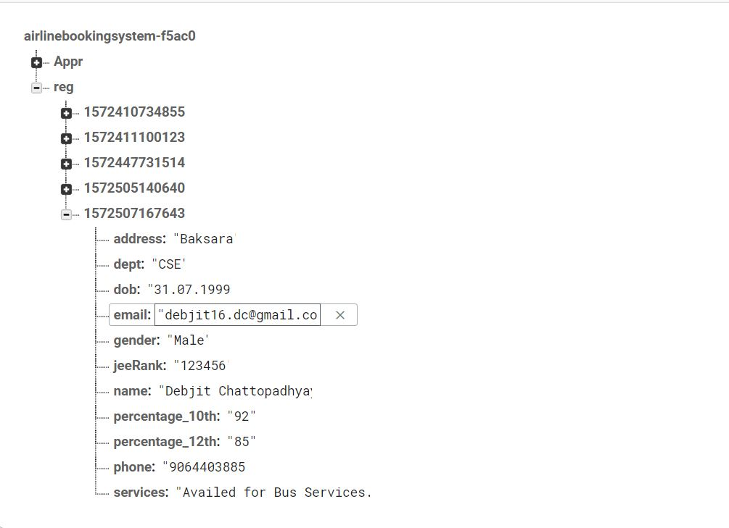

**Approved Child Expanded View :-**

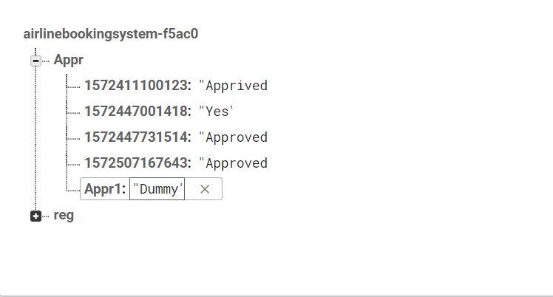

**Code.**

* 1. **Splash Screen(XML and Java)**

**XML:-**

*<?*xml version="1.0" encoding="utf-8"*?>*<RelativeLayout xmlns:android="http://schemas.android.com/apk/res/android"  
 xmlns:app="http://schemas.android.com/apk/res-auto"  
 xmlns:tools="http://schemas.android.com/tools"  
 android:layout_width="match_parent"  
 android:layout_height="match_parent"  
 tools:context=".SplashScreen"  
 android:background="#1C6679"  
 android:padding="16dp">  
  
 <ImageView  
 android:layout_height="match_parent"  
 android:layout_width="match_parent"  
 android:id="@+id/splash_img"  
 android:src="@drawable/splash"  
 android:padding="20dp"  
 android:alpha="0"  
 android:layout_centerInParent="true"  
 android:scaleType="centerInside"/>  
  
</RelativeLayout>

**Java:-**

**package** com.example.airlinebookingsystem;  
  
**import** androidx.appcompat.app.AppCompatActivity;  
  
**import** android.content.Intent;  
**import** android.os.Bundle;  
**import** android.os.Handler;  
**import** android.widget.ImageView;  
  
**public class** SplashScreen **extends** AppCompatActivity {  
  
 **private static int** *SPLASH_TIMEOUT* = 3500;  
 **private** ImageView **splimg**;  
  
 @Override  
 **protected void** onCreate(Bundle savedInstanceState) {  
 **super**.onCreate(savedInstanceState);  
 setContentView(R.layout.***activity_splash_screen***);  
  
 **splimg** = (ImageView) findViewById(R.id.***splash_img***);  
  
  
 **new** Handler().postDelayed(**new** Runnable() {  
 @Override  
 **public void** run() {  
  
 startActivity(**new** Intent(SplashScreen.**this**, HomeScreen.**class**));  
 finish();  
 }  
 }, *SPLASH_TIMEOUT*);  
 **splimg**.animate().alpha(1f).setDuration(3000);  
 }  
}

**HomeScreen :**-

**XML:**-

*<?*xml version="1.0" encoding="utf-8"*?>*<RelativeLayout xmlns:android="http://schemas.android.com/apk/res/android"  
 xmlns:app="http://schemas.android.com/apk/res-auto"  
 xmlns:tools="http://schemas.android.com/tools"  
 android:layout_width="match_parent"  
 android:layout_height="match_parent"  
 tools:context=".HomeScreen"  
 android:padding="20dp"  
 android:orientation="vertical"  
 android:background="#83C1D1">  
  
 <ImageView  
 android:id="@+id/home_logo"  
 android:src="@drawable/splash"  
 android:layout_height="200dp"  
 android:layout_width="200dp"  
 android:layout_margin="30dp"  
 android:layout_centerHorizontal="true"/>  
  
 <LinearLayout  
 android:layout_centerInParent="true"  
 android:layout_height="wrap_content"  
 android:layout_below="@+id/home_logo"  
 android:layout_width="wrap_content"  
 android:padding="10dp"  
 android:layout_marginTop="35dp"  
 android:id="@+id/buttonframe"  
 android:orientation="vertical">  
  
 <Button  
 android:id="@+id/registerBtn"  
 android:layout_height="wrap_content"  
 android:layout_width="250dp"  
 android:text="Register"  
 android:layout_margin="32dp"  
 android:textSize="30sp"  
 android:textStyle="italic"  
 android:background="@drawable/btn_back"/>  
  
 <Button  
 android:id="@+id/showRegStatus"  
 android:layout_height="wrap_content"  
 android:layout_width="250dp"  
 android:text="Show Status"  
 android:textSize="30sp"  
 android:layout_margin="32sp"  
 android:textStyle="italic"  
 android:background="@drawable/btn_back"/>  
  
 </LinearLayout>  
  
</RelativeLayout>

**Java :-**

**package** com.example.airlinebookingsystem;  
  
**import** android.content.Context;  
**import** android.content.Intent;  
**import** android.os.Bundle;  
**import** android.view.Menu;  
**import** android.view.View;  
**import** android.widget.Button;  
**import** android.widget.Toast;  
  
**import** androidx.appcompat.app.AppCompatActivity;  
  
**public class** HomeScreen **extends** AppCompatActivity {  
  
 **private** Button **register**;  
 **private** Button **showStatus**;  
  
  
 @Override  
 **protected void** onCreate(Bundle savedInstanceState) {  
 **super**.onCreate(savedInstanceState);  
 setContentView(R.layout.***activity_home_screen***);  
  
  
 **register** = (Button) findViewById(R.id.***registerBtn***);  
 **showStatus** = (Button) findViewById(R.id.***showRegStatus***);  
  
 **register**.setOnClickListener(**new** View.OnClickListener() {  
 @Override  
 **public void** onClick(View v) {  
 startActivity(**new** Intent(HomeScreen.**this**, personal_info.**class**));  
 }  
 });  
  
 **showStatus**.setOnClickListener(**new** View.OnClickListener() {  
 @Override  
 **public void** onClick(View v) {  
 *//Toast.makeText(HomeScreen.this, "Update Coming Soon!!", Toast.LENGTH_SHORT).show();* startActivity(**new** Intent(HomeScreen.**this**, search.**class**));  
 }  
 });  
 }  
  
 @Override  
 **public boolean** onCreateOptionsMenu(Menu menu) {  
  
 getMenuInflater().inflate(R.menu.***mymenu***,menu);  
  
  
 **return true**;  
 }  
}

**Personal Details :-**

**XML:-**

*<?*xml version="1.0" encoding="utf-8"*?>*<RelativeLayout xmlns:android="http://schemas.android.com/apk/res/android"  
 xmlns:app="http://schemas.android.com/apk/res-auto"  
 xmlns:tools="http://schemas.android.com/tools"  
 android:layout_width="match_parent"  
 android:layout_height="match_parent"  
 tools:context=".personal_info"  
 android:padding="16dp"  
 android:background="#ffffff"  
 android:orientation="vertical"  
 android:layout_gravity="left">  
  
  
 <TextView  
 android:id="@+id/activity_head"  
 android:layout_width="match_parent"  
 android:layout_height="wrap_content"  
 android:text="PERSONAl INFO"  
 android:background="@drawable/input_fields_back"  
 android:gravity="center_horizontal"  
 android:textSize="40sp"  
 android:textStyle="bold|italic"/>  
  
 <LinearLayout  
 android:layout_below="@+id/activity_head"  
 android:layout_height="wrap_content"  
 android:layout_width="wrap_content"  
 android:orientation="vertical"  
 android:gravity="center_horizontal"  
 android:weightSum="100">  
  
 *<!--name of the student-->* <LinearLayout  
 android:id="@+id/name_layout"  
 android:layout_margin="15dp"  
 android:layout_height="wrap_content"  
 android:layout_width="wrap_content"  
 android:orientation="horizontal">  
  
 <TextView  
 android:id="@+id/heading1"  
 android:layout_width="wrap_content"  
 android:layout_height="wrap_content"  
 android:text="Student's \n Name :- "  
 android:textAlignment="center"  
 android:layout_margin="5dp"  
 android:textSize="23sp"  
 android:textStyle="bold"  
 android:textColor="#000000" />  
  
  
 <EditText  
 android:id="@+id/nameEd"  
 android:layout_width="250dp"  
 android:layout_height="50dp"  
 android:layout_margin="5dp"  
 android:layout_toRightOf="@+id/heading1"  
 android:background="@drawable/input_fields_back"  
 android:gravity="center"  
 android:hint="Name" />  
 </LinearLayout>  
  
 *<!--Address-->* <LinearLayout  
 android:id="@+id/address_layout"  
 android:layout_below="@+id/name_layout"  
 android:layout_margin="15dp"  
 android:layout_height="wrap_content"  
 android:layout_width="wrap_content"  
 android:orientation="horizontal">  
  
 <TextView  
 android:id="@+id/heading2"  
 android:layout_width="wrap_content"  
 android:layout_height="wrap_content"  
 android:text="Address:- "  
 android:textAlignment="center"  
 android:layout_margin="5dp"  
 android:textSize="23sp"  
 android:textStyle="bold"  
 android:textColor="#000000" />  
  
  
 <EditText  
 android:id="@+id/addressEd"  
 android:inputType="textPostalAddress"  
 android:layout_height="50dp"  
 android:layout_width="250dp"  
 android:background="@drawable/input_fields_back"  
 android:layout_margin="5dp"  
 android:layout_toRightOf="@+id/heading2"  
 android:gravity="center"  
 android:hint="Address"/>  
 </LinearLayout>  
  
 *<!--Phone Number-->* <LinearLayout  
 android:id="@+id/phone_layout"  
 android:layout_below="@+id/address_layout"  
 android:layout_margin="15dp"  
 android:layout_height="wrap_content"  
 android:layout_width="wrap_content"  
 android:orientation="horizontal">  
  
 <TextView  
 android:id="@+id/heading3"  
 android:layout_width="wrap_content"  
 android:layout_height="wrap_content"  
 android:text="Phone \n Number:- "  
 android:textAlignment="center"  
 android:layout_margin="5dp"  
 android:textSize="23sp"  
 android:textStyle="bold"  
 android:textColor="#000000" />  
  
  
 <EditText  
 android:id="@+id/phoneEd"  
 android:inputType="number"  
 android:layout_height="50dp"  
 android:background="@drawable/input_fields_back"  
 android:layout_width="250dp"  
 android:layout_margin="5dp"  
 android:layout_toRightOf="@+id/heading3"  
 android:hint="Phone Number"  
 android:gravity="center"/>  
 </LinearLayout>  
  
 *<!--Gender-->* <LinearLayout  
 android:id="@+id/gender_layout"  
 android:layout_below="@+id/phone_layout"  
 android:layout_margin="15dp"  
 android:layout_height="wrap_content"  
 android:layout_width="match_parent"  
 android:orientation="horizontal">  
  
 <TextView  
 android:id="@+id/heading4"  
 android:layout_width="wrap_content"  
 android:layout_height="wrap_content"  
 android:text="Gender :- "  
 android:layout_margin="2dp"  
 android:textSize="23sp"  
 android:textStyle="bold"  
 android:textColor="#000000" />  
  
  
 <Spinner  
 android:id="@+id/genderEd"  
 android:layout_width="100dp"  
 android:layout_height="50dp"  
 android:layout_marginLeft="80dp"  
 android:layout_toRightOf="@+id/heading4"  
 android:gravity="center" />  
 </LinearLayout>  
  
 *<!--Email-->* <LinearLayout  
 android:id="@+id/email_layout"  
 android:layout_below="@+id/gender_layout"  
 android:layout_margin="15dp"  
 android:layout_height="wrap_content"  
 android:layout_width="wrap_content"  
 android:orientation="horizontal">  
  
 <TextView  
 android:id="@+id/heading5"  
 android:layout_width="wrap_content"  
 android:layout_height="wrap_content"  
 android:text="Email Id:- "  
 android:textAlignment="center"  
 android:layout_margin="5dp"  
 android:textSize="23sp"  
 android:textStyle="bold"  
 android:textColor="#000000" />  
  
  
 <EditText  
 android:id="@+id/emailEd"  
 android:inputType="textEmailAddress"  
 android:layout_height="50dp"  
 android:layout_width="250dp"  
 android:background="@drawable/input_fields_back"  
 android:layout_margin="5dp"  
 android:gravity="center"  
 android:layout_toRightOf="@+id/heading5"  
 android:hint="Email Id...."/>  
 </LinearLayout>  
  
 *<!--DOB-->* <LinearLayout  
 android:id="@+id/dob_layout"  
 android:layout_width="wrap_content"  
 android:layout_height="90dp"  
 android:layout_below="@+id/email_layout"  
 android:layout_margin="5dp"  
 android:layout_marginStart="15dp"  
 android:layout_marginTop="15dp"  
 android:layout_marginEnd="15dp"  
 android:layout_marginBottom="15dp"  
 android:orientation="horizontal">  
  
 <TextView  
 android:id="@+id/heading6"  
 android:layout_width="wrap_content"  
 android:layout_height="wrap_content"  
 android:layout_margin="3dp"  
 android:text="Date\n of \nbirth :- "  
 android:textAlignment="center"  
 android:textColor="#000000"  
 android:textSize="23sp"  
 android:textStyle="bold" />  
  
  
 <EditText  
 android:id="@+id/dobEd"  
 android:layout_width="250dp"  
 android:layout_height="50dp"  
 android:layout_margin="5dp"  
 android:layout_toRightOf="@+id/heading6"  
 android:background="@drawable/input_fields_back"  
 android:gravity="center"  
 android:hint="DOB"  
 android:inputType="date" />  
 </LinearLayout>  
  
 <Button  
 android:id="@+id/submitBtn"  
 android:layout_width="250dp"  
 android:layout_height="wrap_content"  
 android:layout_below="@+id/dob_layout"  
 android:layout_centerInParent="true"  
 android:layout_margin="20dp"  
 android:background="@drawable/btn_back"  
 android:text="NEXT"  
 android:textAlignment="center"  
 android:textSize="30sp"  
 android:textStyle="bold" />  
  
 </LinearLayout>  
  
</RelativeLayout>

**JAVA :-**

**package** com.example.airlinebookingsystem;  
  
**import** android.content.Intent;  
**import** android.os.Bundle;  
**import** android.text.TextUtils;  
**import** android.view.View;  
**import** android.widget.AdapterView;  
**import** android.widget.ArrayAdapter;  
**import** android.widget.Button;  
**import** android.widget.EditText;  
**import** android.widget.Spinner;  
**import** android.widget.Toast;  
  
**import** androidx.annotation.NonNull;  
**import** androidx.appcompat.app.AppCompatActivity;  
  
**import** com.google.android.gms.tasks.OnCompleteListener;  
**import** com.google.android.gms.tasks.Task;  
**import** com.google.firebase.database.DatabaseReference;  
**import** com.google.firebase.database.FirebaseDatabase;  
  
**import** java.util.HashMap;  
  
**public class** personal_info **extends** AppCompatActivity {  
  
 **private** DatabaseReference **mdatabase**;  
 **private** EditText **mName**;  
 **private** EditText **mAddress**;  
 **private** EditText **mPhone**;  
 **private** Spinner **mGender**;  
 **private** EditText **mEmail**;  
 **private** EditText **mDob**;  
 **private** Button **submit**;  
  
 **private** String **reg_id**;  
 **private** String **gender**;  
  
 @Override  
 **protected void** onCreate(Bundle savedInstanceState) {  
 **super**.onCreate(savedInstanceState);  
 setContentView(R.layout.***personal_info***);  
  
 **mdatabase** = FirebaseDatabase.*getInstance*().getReference().child(**"reg"**);  
  
 **mName** = (EditText) findViewById(R.id.***nameEd***);  
 **mAddress** = (EditText) findViewById(R.id.***addressEd***);  
 **mPhone** = (EditText) findViewById(R.id.***phoneEd***);  
 **mGender** = (Spinner) findViewById(R.id.***genderEd***);  
 **mEmail** = (EditText) findViewById(R.id.***emailEd***);  
 **mDob** = (EditText) findViewById(R.id.***dobEd***);  
 **submit** = (Button) findViewById(R.id.***submitBtn***);  
  
 ArrayAdapter<CharSequence> adapter = ArrayAdapter.*createFromResource*(**this**, R.array.***gender***, android.R.layout.***simple_spinner_item***);  
 adapter.setDropDownViewResource(android.R.layout.***simple_spinner_dropdown_item***);  
 **mGender**.setAdapter(adapter);  
  
 **mGender**.setOnItemSelectedListener(**new** AdapterView.OnItemSelectedListener() {  
 @Override  
 **public void** onItemSelected(AdapterView<?> parent, View view, **int** position, **long** id) {  
 **gender** = parent.getItemAtPosition(position).toString();  
 }  
  
 @Override  
 **public void** onNothingSelected(AdapterView<?> parent) {  
  
 }  
 });  
  
 **submit**.setOnClickListener(**new** View.OnClickListener() {  
 @Override  
 **public void** onClick(View v) {  
 add_pers_data();  
 }  
 });  
  
 }  
  
 **public void** add_pers_data() {  
  
  
 **try**{  
 String name = **mName**.getText().toString().trim();  
 String email = **mEmail**.getText().toString().trim();  
 String phone = **mPhone**.getText().toString().trim();  
 String address = **mAddress**.getText().toString().trim();  
 String dob = **mDob**.getText().toString().trim();  
  
 **if** (TextUtils.*isEmpty*(name) || TextUtils.*isEmpty*(email) || TextUtils.*isEmpty*(phone) || TextUtils.*isEmpty*(address) || TextUtils.*isEmpty*(dob)) {  
 Toast.*makeText*(**this**, **"Fields cannot be empty!!!"**, Toast.***LENGTH_SHORT***).show();  
 } **else** {  
 HashMap<String, String> newMap = **new** HashMap<String, String>();  
 newMap.put(**"name"**, name);  
 newMap.put(**"email"**, email);  
 newMap.put(**"phone"**, phone);  
 newMap.put(**"gender"**, **gender**);  
 newMap.put(**"address"**, address);  
 newMap.put(**"dob"**, dob);  
  
 **reg_id** = String.*valueOf*(System.*currentTimeMillis*());  
  
 **mdatabase**.child(**reg_id**).setValue(newMap).addOnCompleteListener(**new** OnCompleteListener<Void>() {  
 @Override  
 **public void** onComplete(@NonNull Task<Void> task) {  
 **if** (task.isSuccessful()) {  
 Intent intent = **new** Intent(personal_info.**this**, academic_details.**class**);  
 intent.putExtra(**"register"**, **reg_id**);  
 startActivity(intent);  
  
  
 }  
 }  
 });  
 }  
 }**catch** (Exception e){  
 Toast.*makeText*(**this**, **"Exception Occured"** + e, Toast.***LENGTH_SHORT***).show();  
 }  
 **finally** {  
 **mName**.setText(**""**);  
 **mEmail**.setText(**""**);  
 **mPhone**.setText(**""**);  
 **mAddress**.setText(**""**);  
 **mDob**.setText(**""**);  
 }  
 }  
}

**Academic Details :-**

**XML:-**

*<?*xml version="1.0" encoding="utf-8"*?>*<RelativeLayout xmlns:android="http://schemas.android.com/apk/res/android"  
 xmlns:app="http://schemas.android.com/apk/res-auto"  
 xmlns:tools="http://schemas.android.com/tools"  
 android:layout_width="match_parent"  
 android:layout_height="match_parent"  
 tools:context=".academic_details"  
 android:padding="16dp">  
  
  
 <TextView  
 android:id="@+id/heading_aca"  
 android:layout_height="wrap_content"  
 android:layout_width="match_parent"  
 android:text="Academic Details"  
 android:textStyle="bold"  
 android:layout_marginTop="30dp"  
 android:layout_marginBottom="50dp"  
 android:textAlignment="center"  
 android:textColor="#000000"  
 android:textSize="30sp"/>  
  
  
 *<!--Class 10 Percentage-->* <LinearLayout  
 android:id="@+id/class10"  
 android:layout_below="@+id/heading_aca"  
 android:layout_margin="15dp"  
 android:layout_height="wrap_content"  
 android:layout_width="wrap_content"  
 android:orientation="horizontal">  
  
 <TextView  
 android:id="@+id/class10_head"  
 android:layout_width="wrap_content"  
 android:layout_height="wrap_content"  
 android:text="\t\tClass X \n Percentage :- "  
 android:layout_margin="5dp"  
 android:textSize="23sp"  
 android:textStyle="bold"  
 android:textColor="#000000" />  
  
  
 <EditText  
 android:id="@+id/class10_ed"  
 android:inputType="number"  
 android:layout_height="50dp"  
 android:layout_width="250dp"  
 android:layout_margin="5dp"  
 android:layout_toRightOf="@+id/class10_head"  
 android:hint="Xth Percentage"/>  
 </LinearLayout>  
  
 *<!--Class 12 Percentage-->* <LinearLayout  
 android:id="@+id/class12"  
 android:layout_below="@+id/class10"  
 android:layout_margin="15dp"  
 android:layout_height="wrap_content"  
 android:layout_width="wrap_content"  
 android:orientation="horizontal">  
  
 <TextView  
 android:id="@+id/class12_head"  
 android:layout_width="wrap_content"  
 android:layout_height="wrap_content"  
 android:text="\t\tClass 12 \n Percentage- "  
 android:layout_margin="5dp"  
 android:textSize="23sp"  
 android:textStyle="bold"  
 android:textColor="#000000" />  
  
  
 <EditText  
 android:id="@+id/class12_ed"  
 android:inputType="number"  
 android:layout_height="50dp"  
 android:layout_width="250dp"  
 android:layout_margin="5dp"  
 android:layout_toRightOf="@+id/class12_head"  
 android:hint="XII th Percentage"/>  
 </LinearLayout>  
  
 *<!--JEE RAnk-->* <LinearLayout  
 android:id="@+id/jee"  
 android:layout_below="@+id/class12"  
 android:layout_margin="15dp"  
 android:layout_height="wrap_content"  
 android:layout_width="wrap_content"  
 android:orientation="horizontal">  
  
 <TextView  
 android:id="@+id/jee_head"  
 android:layout_width="wrap_content"  
 android:layout_height="wrap_content"  
 android:text="JEE Rank :- "  
 android:layout_margin="5dp"  
 android:textSize="23sp"  
 android:textStyle="bold"  
 android:textColor="#000000" />  
  
  
 <EditText  
 android:id="@+id/jee_ed"  
 android:inputType="number"  
 android:layout_height="50dp"  
 android:layout_width="250dp"  
 android:layout_margin="5dp"  
 android:layout_toRightOf="@+id/jee_head"  
 android:hint="Jee Rank"/>  
  
 </LinearLayout>  
  
  
 <LinearLayout  
 android:id="@+id/dept"  
 android:layout_below="@+id/jee"  
 android:layout_margin="15dp"  
 android:layout_height="wrap_content"  
 android:layout_width="wrap_content"  
 android:orientation="horizontal">  
  
 <TextView  
 android:id="@+id/dept_head"  
 android:layout_width="wrap_content"  
 android:layout_height="wrap_content"  
 android:text="Department of \n Choice :- "  
 android:layout_margin="5dp"  
 android:textSize="23sp"  
 android:gravity="center"  
 android:textStyle="bold"  
 android:textColor="#000000" />  
  
  
 <EditText  
 android:id="@+id/dept_ed"  
 android:inputType="text"  
 android:layout_height="50dp"  
 android:layout_width="200dp"  
 android:layout_margin="5dp"  
 android:layout_toRightOf="@+id/jee_head"  
 android:hint="Department"/>  
  
 </LinearLayout>  
  
 <Button  
 android:id="@+id/nextBtn"  
 android:layout_width="250dp"  
 android:layout_height="wrap_content"  
 android:layout_below="@+id/dept"  
 android:layout_marginTop="45dp"  
 android:layout_centerHorizontal="true"  
 android:background="@drawable/btn_back"  
 android:text="Next"  
 android:textAlignment="center"  
 android:textSize="30sp"  
 android:textStyle="bold" />  
  
</RelativeLayout>

**Java:-**

**package** com.example.airlinebookingsystem;  
  
**import** androidx.annotation.NonNull;  
**import** androidx.annotation.Nullable;  
**import** androidx.annotation.StringRes;  
**import** androidx.appcompat.app.AppCompatActivity;  
  
**import** android.content.Intent;  
**import** android.os.Bundle;  
**import** android.text.TextUtils;  
**import** android.view.View;  
**import** android.widget.Button;  
**import** android.widget.EditText;  
**import** android.widget.Toast;  
  
**import** com.google.android.gms.tasks.OnCompleteListener;  
**import** com.google.android.gms.tasks.Task;  
**import** com.google.firebase.database.ChildEventListener;  
**import** com.google.firebase.database.DataSnapshot;  
**import** com.google.firebase.database.DatabaseError;  
**import** com.google.firebase.database.DatabaseReference;  
**import** com.google.firebase.database.FirebaseDatabase;  
  
**import** java.util.HashMap;  
**import** java.util.Map;  
  
**public class** academic_details **extends** AppCompatActivity {  
  
  
 **private** EditText **class10**;  
 **private** EditText **class12**;  
 **private** EditText **dept**;  
 **private** EditText **jee**;  
 **private** Button **next**;  
  
 **private** String **reg_id**;  
  
 **private** DatabaseReference **mdatabase**;  
  
 @Override  
 **protected void** onCreate(Bundle savedInstanceState) {  
 **super**.onCreate(savedInstanceState);  
 setContentView(R.layout.***activity_academic_details***);  
  
 **class10** = (EditText) findViewById(R.id.***class10_ed***);  
 **class12** = (EditText) findViewById(R.id.***class12_ed***);  
 **dept** = (EditText) findViewById(R.id.***dept_ed***);  
 **jee** = (EditText) findViewById(R.id.***jee_ed***);  
  
 **next** = (Button) findViewById(R.id.***nextBtn***);  
  
 **reg_id** = getIntent().getStringExtra(**"register"**);  
 **mdatabase** = FirebaseDatabase.*getInstance*().getReference(**"reg"**).child(**reg_id**);  
  
 **next**.setOnClickListener(**new** View.OnClickListener() {  
 @Override  
 **public void** onClick(View v) {  
 add_academic_data();  
 }  
 });  
  
 }  
  
 **public void** add_academic_data(){  
  
 String mclass10 = **class10**.getText().toString().trim();  
 String mclass12 = **class12**.getText().toString().trim();  
 String mjee = **jee**.getText().toString().trim();  
 String mdept = **dept**.getText().toString().trim();  
  
 **if**(TextUtils.*isEmpty*(mclass10) || TextUtils.*isEmpty*(mclass12) || TextUtils.*isEmpty*(mjee) || TextUtils.*isEmpty*(mdept)){  
  
 Toast.*makeText*(**this**, **"Fields Cannot be Empty"**, Toast.***LENGTH_SHORT***).show();  
 }  
 **else**{  
 Map<String, Object> objectMap = **new** HashMap<>();  
 objectMap.put(**"percentage_10th"**, mclass10);  
 objectMap.put(**"percentage_12th"**, mclass12);  
 objectMap.put(**"jeeRank"**, mjee);  
 objectMap.put(**"dept"**, mdept);  
  
  
 **mdatabase**.updateChildren(objectMap).addOnCompleteListener(**new** OnCompleteListener<Void>() {  
 @Override  
 **public void** onComplete(@NonNull Task<Void> task) {  
 **if**(task.isSuccessful()){  
 Intent intent = **new** Intent(academic_details.**this**, bus_service.**class**);  
 intent.putExtra(**"register"**, **reg_id**);  
 startActivity(intent);  
 *//Toast.makeText(academic_details.this, "Success!!", Toast.LENGTH_SHORT).show();* **class10**.setText(**""**);  
 **class12**.setText(**""**);  
 **jee**.setText(**""**);  
 **dept**.setText(**""**);  
 }  
 }  
 });  
 }  
  
 }  
}

**Bus Details :-**

**XML:-**

*<?*xml version="1.0" encoding="utf-8"*?>*<RelativeLayout xmlns:android="http://schemas.android.com/apk/res/android"  
 xmlns:app="http://schemas.android.com/apk/res-auto"  
 xmlns:tools="http://schemas.android.com/tools"  
 android:layout_width="match_parent"  
 android:layout_height="match_parent"  
 tools:context=".bus_service"  
 android:orientation="vertical"  
 android:background="#ffffff"  
 android:padding="16dp">  
  
 <TextView  
 android:id="@+id/bus_head"  
 android:layout_width="match_parent"  
 android:layout_height="wrap_content"  
 android:text="Bus Service Info"  
 android:background="@drawable/input_fields_back"  
 android:gravity="center_horizontal"  
 android:textSize="40sp"  
 android:textStyle="bold|italic"/>  
  
 <Switch  
 android:switchPadding="20dp"  
 android:switchMinWidth="30dp"  
 android:id="@+id/switch1"  
 android:layout_below="@+id/bus_head"  
 android:layout_width="wrap_content"  
 android:layout_height="wrap_content"  
 android:layout_gravity="center"  
 android:layout_marginTop="75dp"  
 android:layout_marginBottom="45dp"  
 android:checked="false"  
 android:gravity="center"  
 android:text="Do you want bus service ?"  
 android:textColor="#000000"  
 android:textSize="30sp"  
 android:textStyle="bold" />  
  
  
 <Button  
 android:id="@+id/nextBtn2"  
 android:layout_width="250dp"  
 android:layout_height="wrap_content"  
 android:layout_below="@+id/switch1"  
 android:layout_marginTop="30dp"  
 android:layout_centerHorizontal="true"  
 android:background="@drawable/btn_back"  
 android:text="Next"  
 android:layout_gravity="center"  
 android:textAlignment="center"  
 android:textSize="30sp"  
 android:textStyle="bold" />  
  
  
  
</RelativeLayout>

**JAVA:-**

package com.example.airlinebookingsystem;  
  
import androidx.annotation.NonNull;  
import androidx.appcompat.app.AppCompatActivity;  
  
import android.content.Intent;  
import android.os.Bundle;  
import android.view.View;  
import android.widget.Button;  
import android.widget.CompoundButton;  
import android.widget.LinearLayout;  
import android.widget.Switch;  
  
import com.google.android.gms.tasks.OnCompleteListener;  
import com.google.android.gms.tasks.Task;  
import com.google.firebase.database.DatabaseReference;  
import com.google.firebase.database.FirebaseDatabase;  
  
import java.util.HashMap;  
import java.util.Map;  
  
public class bus_service extends AppCompatActivity {  
  
 private Switch bus;  
 private LinearLayout busLayout;  
 private Button next;  
  
 private DatabaseReference mdatabase;  
 private String reg_id;  
 String msg;  
  
 @Override  
 protected void onCreate(Bundle savedInstanceState) {  
 super.onCreate(savedInstanceState);  
 setContentView(R.layout.activity_bus_service);  
  
 reg_id = getIntent().getStringExtra("register");  
 mdatabase = FirebaseDatabase.getInstance().getReference().child("reg").child(reg_id);  
  
 bus = (Switch) findViewById(R.id.switch1);  
 next = (Button) findViewById(R.id.nextBtn2);  
  
 next.setOnClickListener(new View.OnClickListener() {  
 @Override  
 public void onClick(View v) {  
 // for not avaiaing bus service  
 add_bus_response("Not Availed for Bus Services");  
 }  
 });  
  
 bus.setOnCheckedChangeListener(new CompoundButton.OnCheckedChangeListener() {  
 @Override  
 public void onCheckedChanged(CompoundButton buttonView, boolean isChecked) {  
 if(isChecked){  
 next.setOnClickListener(new View.OnClickListener() {  
 @Override  
 public void onClick(View v) {  
 add_bus_response("Availed for Bus Services..");  
 }  
 });  
 }  
 else{  
 next.setOnClickListener(new View.OnClickListener() {  
 @Override  
 public void onClick(View v) {  
 add_bus_response("Not Availed for Bus Services");  
 }  
 });  
 }  
 }  
 });  
 }  
 public void add_bus_response(String msg){  
  
 Map<String, Object> newMap = new HashMap<>();  
 newMap.put("services",msg);  
  
 mdatabase.updateChildren(newMap).addOnCompleteListener(new OnCompleteListener<Void>() {  
 @Override  
 public void onComplete(@NonNull Task<Void> task) {  
 if(task.isSuccessful()){  
 Intent intent = new Intent(bus_service.this,TokenPage.class);  
 intent.putExtra("register", reg_id);  
 startActivity(intent);  
 //Toast.makeText(bus_service.this, "Response Added!!!", Toast.LENGTH_SHORT).show();  
 }  
 }  
 });  
  
  
 }  
}

**Token Page Details :-**

**XML:-**

*<?*xml version="1.0" encoding="utf-8"*?>*<RelativeLayout xmlns:android="http://schemas.android.com/apk/res/android"  
 xmlns:app="http://schemas.android.com/apk/res-auto"  
 xmlns:tools="http://schemas.android.com/tools"  
 android:layout_width="match_parent"  
 android:layout_height="match_parent"  
 tools:context=".TokenPage"  
 android:orientation="vertical"  
 android:background="#ffffff"  
 android:padding="16dp">  
  
  
 <TextView  
 android:id="@+id/confirm_header"  
 android:layout_width="300dp"  
 android:text="Confirmation Page"  
 android:textSize="34sp"  
 android:layout_margin="15dp"  
 android:textColor="#000000"  
 android:textStyle="italic|bold"  
 android:textAlignment="center"  
 android:layout_centerHorizontal="true"  
 android:layout_height="wrap_content"/>  
  
 <TextView  
 android:id="@+id/token_msg"  
 android:layout_below="@+id/confirm_header"  
 android:layout_height="wrap_content"  
 android:layout_width="300dp"  
 android:text="Your Registration is Recorded.\n We will reach to your if your application is approved.\n Use the temporary Registration ID to check your Status."  
 android:textAlignment="center"  
 android:textStyle="italic|bold"  
 android:textColor="#000000"  
 android:textSize="24sp"  
 android:layout_centerHorizontal="true"  
 android:layout_margin="15dp" />  
  
 <TextView  
 android:id="@+id/temp_regid_head"  
 android:layout_height="wrap_content"  
 android:layout_width="300dp"  
 android:text="Your Registration ID is "  
 android:layout_below="@+id/token_msg"  
 android:textAlignment="center"  
 android:layout_centerHorizontal="true"  
 android:textColor="#012FCD"  
 android:layout_margin="30dp"  
 android:textSize="40sp"  
 android:textStyle="italic|bold" />  
  
 <TextView  
 android:id="@+id/token"  
 android:layout_width="250dp"  
 android:layout_height="wrap_content"  
 android:layout_below="@id/temp_regid_head"  
 android:layout_centerHorizontal="true"  
 android:text="Token"  
 android:textIsSelectable="true"  
 android:textAlignment="center"  
 android:textStyle="bold"  
 android:textColor="#000000"  
 android:textSize="30sp"/>  
  
 <Button  
 android:id="@+id/gotoHome"  
 android:layout_below="@+id/token"  
 android:layout_width="300dp"  
 android:layout_height="wrap_content"  
 android:layout_margin="35dp"  
 android:layout_centerHorizontal="true"  
 android:background="@drawable/btn_back"  
 android:text="Home"  
 android:padding="5dp"  
 android:textSize="32sp"/>  
  
</RelativeLayout>

**JAVA:-**

package com.example.airlinebookingsystem;  
  
import androidx.appcompat.app.AppCompatActivity;  
  
import android.content.Intent;  
import android.os.Bundle;  
import android.view.View;  
import android.widget.Button;  
import android.widget.TextView;  
  
public class TokenPage extends AppCompatActivity {  
  
 private Button home;  
 private TextView tokenDisplay;  
 private String reg_id;  
  
 @Override  
 protected void onCreate(Bundle savedInstanceState) {  
 super.onCreate(savedInstanceState);  
 setContentView(R.layout.activity_token_page);  
  
 reg_id = getIntent().getStringExtra("register");  
  
 tokenDisplay = (TextView) findViewById(R.id.token);  
 home = (Button) findViewById(R.id.gotoHome);  
  
 tokenDisplay.setText(reg_id);  
 home.setOnClickListener(new View.OnClickListener() {  
 @Override  
 public void onClick(View v) {  
 startActivity(new Intent(TokenPage.this, HomeScreen.class));  
 }  
 });

**Search Page Details :-**

**XML:-**

*<?*xml version="1.0" encoding="utf-8"*?>*<RelativeLayout xmlns:android="http://schemas.android.com/apk/res/android"  
 xmlns:app="http://schemas.android.com/apk/res-auto"  
 xmlns:tools="http://schemas.android.com/tools"  
 android:layout_width="match_parent"  
 android:layout_height="match_parent"  
 tools:context=".search"  
 android:padding="16dp"  
 android:background="#ffffff">  
  
 <LinearLayout  
 android:layout_centerInParent="true"  
 android:id="@+id/ll1"  
 android:layout_height="wrap_content"  
 android:layout_width="match_parent"  
 android:orientation="vertical">  
  
 <TextView  
 android:id="@+id/head_label"  
 android:layout_width="300dp"  
 android:layout_height="wrap_content"  
 android:layout_marginTop="35dp"  
 android:textAlignment="center"  
 android:layout_gravity="center_horizontal"  
 android:text="Know your Status"  
 android:textSize="34sp"  
 android:textStyle="bold|italic" />  
  
 <EditText  
 android:id="@+id/search_id"  
 android:layout_width="match_parent"  
 android:layout_height="wrap_content"  
 android:layout_below="@+id/head_label"  
 android:hint="Enter your registration number.."  
 android:gravity="center"  
 android:layout_gravity="center"  
 android:textStyle="italic"  
 android:textSize="30sp"  
 android:layout_margin="20dp"  
 android:background="#ffffff"/>  
  
 <Button  
 android:id="@+id/searchBtn"  
 android:layout_height="wrap_content"  
 android:layout_width="300dp"  
 android:text="Search"  
 android:background="@drawable/btn_back"  
 android:textSize="20sp"  
 android:layout_below="@+id/search_id"  
 android:layout_gravity="center"  
 android:layout_margin="15dp" />  
  
 </LinearLayout>  
  
</RelativeLayout>

**JAVA:-**

**package** com.example.airlinebookingsystem;  
  
**import** androidx.appcompat.app.AppCompatActivity;  
  
**import** android.content.Intent;  
**import** android.os.Bundle;  
**import** android.text.TextUtils;  
**import** android.view.View;  
**import** android.widget.Button;  
**import** android.widget.EditText;  
**import** android.widget.Toast;  
  
**public class** search **extends** AppCompatActivity {  
  
 **private** EditText **searchId**;  
 **private** Button **searchBtn**;  
  
 @Override  
 **protected void** onCreate(Bundle savedInstanceState) {  
 **super**.onCreate(savedInstanceState);  
 setContentView(R.layout.***activity_search***);  
  
 **searchId** = (EditText) findViewById(R.id.***search_id***);  
 **searchBtn** = (Button) findViewById(R.id.***searchBtn***);  
  
 **searchBtn**.setOnClickListener(**new** View.OnClickListener() {  
 @Override  
 **public void** onClick(View v) {  
 String regid = **searchId**.getText().toString();  
 **if**(TextUtils.*isEmpty*(regid)){  
 Toast.*makeText*(search.**this**, **"Field Cannot be Empty"**, Toast.***LENGTH_SHORT***).show();  
 }**else**{  
 Intent intent = **new** Intent(search.**this**, results.**class**);  
 intent.putExtra(**"regid"**, regid);  
 startActivity(intent);  
 }  
 }  
 });  
 }

}

**Results Page Details :-**

**XML:-**

*<?*xml version="1.0" encoding="utf-8"*?>*<RelativeLayout xmlns:android="http://schemas.android.com/apk/res/android"  
 xmlns:app="http://schemas.android.com/apk/res-auto"  
 xmlns:tools="http://schemas.android.com/tools"  
 android:layout_width="match_parent"  
 android:layout_height="match_parent"  
 tools:context=".results"  
 android:orientation="vertical"  
 android:background="#D2ECF3"  
 android:padding="16dp">  
  
  
 <ScrollView  
 android:layout_marginTop="25dp"  
 android:id="@+id/scrollView"  
 android:layout_width="match_parent"  
 android:layout_height="550dp">  
  
 <LinearLayout  
 android:layout_width="match_parent"  
 android:layout_height="match_parent"  
 android:orientation="vertical"  
 android:padding="16dp">  
  
 *<!--Address Card-->* <androidx.cardview.widget.CardView  
 android:id="@+id/adrress_card"  
 android:layout_width="match_parent"  
 android:layout_height="wrap_content"  
 android:layout_margin="24dp"  
 android:elevation="15dp"  
 app:cardCornerRadius="15dp">  
  
  
 <LinearLayout  
 android:layout_width="match_parent"  
 android:layout_height="wrap_content"  
 android:orientation="vertical"  
 android:padding="16dp">  
  
 <TextView  
 android:id="@+id/AddressHead"  
 android:layout_width="match_parent"  
 android:layout_height="wrap_content"  
 android:text="Address"  
 android:textAlignment="center"  
 android:textSize="30sp"  
 android:textStyle="bold" />  
  
 <TextView  
 android:id="@+id/AddressDesc"  
 android:layout_width="match_parent"  
 android:layout_height="wrap_content"  
 android:layout_marginTop="15dp"  
 android:text="Description"  
 android:textAlignment="center"  
 android:textSize="30sp"  
 android:textStyle="bold" />  
  
 </LinearLayout>  
  
  
 </androidx.cardview.widget.CardView>  
  
 *<!--Department Card-->* <androidx.cardview.widget.CardView  
 android:id="@+id/dept_card"  
 android:layout_width="match_parent"  
 android:layout_height="wrap_content"  
 android:layout_margin="24dp"  
 android:elevation="15dp"  
 app:cardCornerRadius="15dp">  
  
  
 <LinearLayout  
 android:layout_width="match_parent"  
 android:layout_height="wrap_content"  
 android:orientation="vertical"  
 android:padding="16dp">  
  
 <TextView  
 android:id="@+id/deptHead"  
 android:layout_width="match_parent"  
 android:layout_height="wrap_content"  
 android:text="Department"  
 android:textAlignment="center"  
 android:textSize="30sp"  
 android:textStyle="bold" />  
  
 <TextView  
 android:id="@+id/deptDesc"  
 android:layout_width="match_parent"  
 android:layout_height="wrap_content"  
 android:layout_marginTop="15dp"  
 android:text="Description"  
 android:textAlignment="center"  
 android:textSize="30sp"  
 android:textStyle="bold" />  
  
 </LinearLayout>  
  
  
 </androidx.cardview.widget.CardView>  
  
 *<!--DOB-->* <androidx.cardview.widget.CardView  
 android:id="@+id/dob_card"  
 android:layout_width="match_parent"  
 android:layout_height="wrap_content"  
 android:layout_margin="24dp"  
 android:elevation="15dp"  
 app:cardCornerRadius="15dp">  
  
  
 <LinearLayout  
 android:layout_width="match_parent"  
 android:layout_height="wrap_content"  
 android:orientation="vertical"  
 android:padding="16dp">  
  
 <TextView  
 android:id="@+id/dobHead"  
 android:layout_width="match_parent"  
 android:layout_height="wrap_content"  
 android:text="Date of Birth"  
 android:textAlignment="center"  
 android:textSize="30sp"  
 android:textStyle="bold" />  
  
 <TextView  
 android:id="@+id/dobDesc"  
 android:layout_width="match_parent"  
 android:layout_height="wrap_content"  
 android:layout_marginTop="15dp"  
 android:text="Description"  
 android:textAlignment="center"  
 android:textSize="30sp"  
 android:textStyle="bold" />  
  
 </LinearLayout>  
  
  
 </androidx.cardview.widget.CardView>  
  
 *<!--Email Card-->* <androidx.cardview.widget.CardView  
 android:id="@+id/email_card"  
 android:layout_width="match_parent"  
 android:layout_height="wrap_content"  
 android:layout_margin="24dp"  
 android:elevation="15dp"  
 app:cardCornerRadius="15dp">  
  
  
 <LinearLayout  
 android:layout_width="match_parent"  
 android:layout_height="wrap_content"  
 android:orientation="vertical"  
 android:padding="16dp">  
  
 <TextView  
 android:id="@+id/emailHead"  
 android:layout_width="match_parent"  
 android:layout_height="wrap_content"  
 android:text="Email"  
 android:textAlignment="center"  
 android:textSize="30sp"  
 android:textStyle="bold" />  
  
 <TextView  
 android:id="@+id/emailDesc"  
 android:layout_width="match_parent"  
 android:layout_height="wrap_content"  
 android:layout_marginTop="15dp"  
 android:text="Description"  
 android:textAlignment="center"  
 android:textSize="30sp"  
 android:textStyle="bold" />  
  
 </LinearLayout>  
  
  
 </androidx.cardview.widget.CardView>  
  
 *<!--Gender-->* <androidx.cardview.widget.CardView  
 android:id="@+id/gender_card"  
 android:layout_width="match_parent"  
 android:layout_height="wrap_content"  
 android:layout_margin="24dp"  
 android:elevation="15dp"  
 app:cardCornerRadius="15dp">  
  
  
 <LinearLayout  
 android:layout_width="match_parent"  
 android:layout_height="wrap_content"  
 android:orientation="vertical"  
 android:padding="16dp">  
  
 <TextView  
 android:id="@+id/genderHead"  
 android:layout_width="match_parent"  
 android:layout_height="wrap_content"  
 android:text="Gender"  
 android:textAlignment="center"  
 android:textSize="30sp"  
 android:textStyle="bold" />  
  
 <TextView  
 android:id="@+id/genderDesc"  
 android:layout_width="match_parent"  
 android:layout_height="wrap_content"  
 android:layout_marginTop="15dp"  
 android:text="Description"  
 android:textAlignment="center"  
 android:textSize="30sp"  
 android:textStyle="bold" />  
  
 </LinearLayout>  
  
  
 </androidx.cardview.widget.CardView>  
  
 *<!--Jee Rank Card-->* <androidx.cardview.widget.CardView  
 android:id="@+id/rank_card"  
 android:layout_width="match_parent"  
 android:layout_height="wrap_content"  
 android:layout_margin="24dp"  
 android:elevation="15dp"  
 app:cardCornerRadius="15dp">  
  
  
 <LinearLayout  
 android:layout_width="match_parent"  
 android:layout_height="wrap_content"  
 android:orientation="vertical"  
 android:padding="16dp">  
  
 <TextView  
 android:id="@+id/rankHead"  
 android:layout_width="match_parent"  
 android:layout_height="wrap_content"  
 android:text="Jee Rank"  
 android:textAlignment="center"  
 android:textSize="30sp"  
 android:textStyle="bold" />  
  
 <TextView  
 android:id="@+id/rankDesc"  
 android:layout_width="match_parent"  
 android:layout_height="wrap_content"  
 android:layout_marginTop="15dp"  
 android:text="Description"  
 android:textAlignment="center"  
 android:textSize="30sp"  
 android:textStyle="bold" />  
  
 </LinearLayout>  
  
  
 </androidx.cardview.widget.CardView>  
  
 *<!--Name Card-->* <androidx.cardview.widget.CardView  
 android:id="@+id/name_card"  
 android:layout_width="match_parent"  
 android:layout_height="wrap_content"  
 android:layout_margin="24dp"  
 android:elevation="15dp"  
 app:cardCornerRadius="15dp">  
  
  
 <LinearLayout  
 android:layout_width="match_parent"  
 android:layout_height="wrap_content"  
 android:orientation="vertical"  
 android:padding="16dp">  
  
 <TextView  
 android:id="@+id/nameHead"  
 android:layout_width="match_parent"  
 android:layout_height="wrap_content"  
 android:text="Name"  
 android:textAlignment="center"  
 android:textSize="30sp"  
 android:textStyle="bold" />  
  
 <TextView  
 android:id="@+id/nameDesc"  
 android:layout_width="match_parent"  
 android:layout_height="wrap_content"  
 android:layout_marginTop="15dp"  
 android:text="Description"  
 android:textAlignment="center"  
 android:textSize="30sp"  
 android:textStyle="bold" />  
  
 </LinearLayout>  
  
  
 </androidx.cardview.widget.CardView>  
  
 *<!--Perc 10th-->* <androidx.cardview.widget.CardView  
 android:id="@+id/ten_card"  
 android:layout_width="match_parent"  
 android:layout_height="wrap_content"  
 android:layout_margin="24dp"  
 android:elevation="15dp"  
 app:cardCornerRadius="15dp">  
  
  
 <LinearLayout  
 android:layout_width="match_parent"  
 android:layout_height="wrap_content"  
 android:orientation="vertical"  
 android:padding="16dp">  
  
 <TextView  
 android:id="@+id/tenHead"  
 android:layout_width="match_parent"  
 android:layout_height="wrap_content"  
 android:text="10th Percentage"  
 android:textAlignment="center"  
 android:textSize="30sp"  
 android:textStyle="bold" />  
  
 <TextView  
 android:id="@+id/tenDesc"  
 android:layout_width="match_parent"  
 android:layout_height="wrap_content"  
 android:layout_marginTop="15dp"  
 android:text="Description"  
 android:textAlignment="center"  
 android:textSize="30sp"  
 android:textStyle="bold" />  
  
 </LinearLayout>  
  
  
 </androidx.cardview.widget.CardView>  
  
 *<!--Perc 12th-->* <androidx.cardview.widget.CardView  
 android:id="@+id/tw_card"  
 android:layout_width="match_parent"  
 android:layout_height="wrap_content"  
 android:layout_margin="24dp"  
 android:elevation="15dp"  
 app:cardCornerRadius="15dp">  
  
  
 <LinearLayout  
 android:layout_width="match_parent"  
 android:layout_height="wrap_content"  
 android:orientation="vertical"  
 android:padding="16dp">  
  
 <TextView  
 android:id="@+id/twHead"  
 android:layout_width="match_parent"  
 android:layout_height="wrap_content"  
 android:text="12th percentage"  
 android:textAlignment="center"  
 android:textSize="30sp"  
 android:textStyle="bold" />  
  
 <TextView  
 android:id="@+id/twDesc"  
 android:layout_width="match_parent"  
 android:layout_height="wrap_content"  
 android:layout_marginTop="15dp"  
 android:text="Description"  
 android:textAlignment="center"  
 android:textSize="30sp"  
 android:textStyle="bold" />  
  
 </LinearLayout>  
  
  
 </androidx.cardview.widget.CardView>  
  
 *<!--Phone Card-->* <androidx.cardview.widget.CardView  
 android:id="@+id/phone_card"  
 android:layout_width="match_parent"  
 android:layout_height="wrap_content"  
 android:layout_margin="24dp"  
 android:elevation="15dp"  
 app:cardCornerRadius="15dp">  
  
  
 <LinearLayout  
 android:layout_width="match_parent"  
 android:layout_height="wrap_content"  
 android:orientation="vertical"  
 android:padding="16dp">  
  
 <TextView  
 android:id="@+id/phoneHead"  
 android:layout_width="match_parent"  
 android:layout_height="wrap_content"  
 android:text="Phone"  
 android:textAlignment="center"  
 android:textSize="30sp"  
 android:textStyle="bold" />  
  
 <TextView  
 android:id="@+id/phoneDesc"  
 android:layout_width="match_parent"  
 android:layout_height="wrap_content"  
 android:layout_marginTop="15dp"  
 android:text="Description"  
 android:textAlignment="center"  
 android:textSize="30sp"  
 android:textStyle="bold" />  
  
 </LinearLayout>  
  
  
 </androidx.cardview.widget.CardView>  
  
 *<!--Bus Service-->* <androidx.cardview.widget.CardView  
 android:id="@+id/bus_card"  
 android:layout_width="match_parent"  
 android:layout_height="wrap_content"  
 android:layout_margin="24dp"  
 android:elevation="15dp"  
 app:cardCornerRadius="15dp">  
  
  
 <LinearLayout  
 android:layout_width="match_parent"  
 android:layout_height="wrap_content"  
 android:orientation="vertical"  
 android:padding="16dp">  
  
 <TextView  
 android:id="@+id/busHead"  
 android:layout_width="match_parent"  
 android:layout_height="wrap_content"  
 android:text="Bus Service"  
 android:textAlignment="center"  
 android:textSize="30sp"  
 android:textStyle="bold" />  
  
 <TextView  
 android:id="@+id/busDesc"  
 android:layout_width="match_parent"  
 android:layout_height="wrap_content"  
 android:layout_marginTop="15dp"  
 android:text="Description"  
 android:textAlignment="center"  
 android:textSize="30sp"  
 android:textStyle="bold" />  
  
 </LinearLayout>  
  
  
 </androidx.cardview.widget.CardView>  
  
 </LinearLayout>  
 </ScrollView>  
  
 <TextView  
 android:id="@+id/status"  
 android:layout_height="wrap_content"  
 android:layout_width="300dp"  
 android:layout_below="@+id/scrollView"  
 android:layout_centerHorizontal="true"  
 android:layout_marginTop="20dp"  
 android:textSize="34sp"  
 android:text="Status :- Pending"  
 android:textColor="@android:color/holo_red_dark"  
 android:textAlignment="center"  
 android:textStyle="bold|italic" />  
  
 <Button  
 android:id="@+id/backtohome"  
 android:layout_height="wrap_content"  
 android:layout_width="300dp"  
 android:layout_below="@+id/status"  
 android:layout_centerHorizontal="true"  
 android:background="@drawable/btn_back"  
 android:text="Home"  
 android:textSize="20dp"  
 android:layout_marginTop="15dp"/>  
  
</RelativeLayout>

**JAVA:-**

**package** com.example.airlinebookingsystem;  
  
**import** androidx.annotation.NonNull;  
**import** androidx.annotation.Nullable;  
**import** androidx.appcompat.app.AppCompatActivity;  
  
**import** android.content.Intent;  
**import** android.graphics.Color;  
**import** android.os.Bundle;  
**import** android.view.View;  
**import** android.widget.Button;  
**import** android.widget.EditText;  
**import** android.widget.TextView;  
**import** android.widget.Toast;  
  
**import** com.google.firebase.database.ChildEventListener;  
**import** com.google.firebase.database.DataSnapshot;  
**import** com.google.firebase.database.DatabaseError;  
**import** com.google.firebase.database.DatabaseReference;  
**import** com.google.firebase.database.FirebaseDatabase;  
**import** com.google.firebase.database.ValueEventListener;  
  
**public class** results **extends** AppCompatActivity {  
  
 **private** String **regid**;  
  
 **private** DatabaseReference **mdatabase**;  
 **private** DatabaseReference **mdb**;  
  
 **private** TextView **address**;  
 **private** TextView **dept**;  
 **private** TextView **dob**;  
 **private** TextView **email**;  
 **private** TextView **gender**;  
 **private** TextView **rank**;  
 **private** TextView **name**;  
 **private** TextView **perc10**;  
 **private** TextView **per12**;  
 **private** TextView **phone**;  
 **private** TextView **bus**;  
 **private** TextView **status**;  
 **private** Button **backtoHome**;  
  
 @Override  
 **protected void** onCreate(Bundle savedInstanceState) {  
 **super**.onCreate(savedInstanceState);  
 setContentView(R.layout.***activity_results***);  
  
 **regid** = getIntent().getStringExtra(**"regid"**);  
 **mdatabase** = FirebaseDatabase.*getInstance*().getReference().child(**"reg"**).child(**regid**);  
 **mdb** = FirebaseDatabase.*getInstance*().getReference().child(**"Appr"**);  
  
 *//Toast.makeText(this, regid, Toast.LENGTH_SHORT).show();* **address** = (TextView) findViewById(R.id.***AddressDesc***);  
 **dept** = (TextView) findViewById(R.id.***deptDesc***);  
 **dob** = (TextView) findViewById(R.id.***dobDesc***);  
 **email** = (TextView) findViewById(R.id.***emailDesc***);  
 **gender** = (TextView) findViewById(R.id.***genderDesc***);  
 **rank** = (TextView) findViewById(R.id.***rankDesc***);  
 **name** = (TextView) findViewById(R.id.***nameDesc***);  
 **perc10** = (TextView) findViewById(R.id.***tenDesc***);  
 **per12** = (TextView) findViewById(R.id.***twDesc***);  
 **phone** = (TextView) findViewById(R.id.***phoneDesc***);  
 **bus** = (TextView) findViewById(R.id.***busDesc***);  
 **status** = (TextView) findViewById(R.id.***status***);  
 **backtoHome** = (Button) findViewById(R.id.***backtohome***);  
  
 **backtoHome**.setOnClickListener(**new** View.OnClickListener() {  
 @Override  
 **public void** onClick(View v) {  
 startActivity(**new** Intent(results.**this**, HomeScreen.**class**));  
 }  
 });  
  
 **mdatabase**.addListenerForSingleValueEvent(**new** ValueEventListener() {  
 @Override  
 **public void** onDataChange(@NonNull DataSnapshot dataSnapshot) {  
 **address**.setText(dataSnapshot.child(**"address"**).getValue().toString());  
 **dept**.setText(dataSnapshot.child(**"dept"**).getValue().toString());  
 **dob**.setText(dataSnapshot.child(**"dob"**).getValue().toString());  
 **email**.setText(dataSnapshot.child(**"email"**).getValue().toString());  
 **gender**.setText(dataSnapshot.child(**"gender"**).getValue().toString());  
 **rank**.setText(dataSnapshot.child(**"jeeRank"**).getValue().toString());  
 **name**.setText(dataSnapshot.child(**"name"**).getValue().toString());  
 **perc10**.setText(dataSnapshot.child(**"percentage_10th"**).getValue().toString());  
 **per12**.setText(dataSnapshot.child(**"percentage_12th"**).getValue().toString());  
 **phone**.setText(dataSnapshot.child(**"phone"**).getValue().toString());  
 **bus**.setText(dataSnapshot.child(**"services"**).getValue().toString());  
  
 onStart();  
 }  
  
 @Override  
 **public void** onCancelled(@NonNull DatabaseError databaseError) {  
  
 }  
 });  
 **mdb**.addChildEventListener(**new** ChildEventListener() {  
 @Override  
 **public void** onChildAdded(@NonNull DataSnapshot dataSnapshot, @Nullable String s) {  
 onStart();  
 }  
  
 @Override  
 **public void** onChildChanged(@NonNull DataSnapshot dataSnapshot, @Nullable String s) {  
  
 }  
  
 @Override  
 **public void** onChildRemoved(@NonNull DataSnapshot dataSnapshot) {  
 onStart();  
 }  
  
 @Override  
 **public void** onChildMoved(@NonNull DataSnapshot dataSnapshot, @Nullable String s) {  
  
 }  
  
 @Override  
 **public void** onCancelled(@NonNull DatabaseError databaseError) {  
  
 }  
 });  
 }  
  
 **public void** onStart(){  
 **super**.onStart();  
  
  
 **mdb**.addListenerForSingleValueEvent(**new** ValueEventListener() {  
 @Override  
 **public void** onDataChange(@NonNull DataSnapshot dataSnapshot) {  
 **if**(dataSnapshot.hasChild(**regid**)){  
 **status**.setText(**"Status :- Approved"**);  
 **status**.setTextColor(Color.***GREEN***);  
 }  
 **else**{  
 **status**.setText(**"Status :- Pending"**);  
 **status**.setTextColor(Color.***RED***);  
 }  
 }  
  
 @Override  
 **public void** onCancelled(@NonNull DatabaseError databaseError) {  
  
 }  
 });  
 }  
}

**SCREENSHOTS**

**SplashScreen**



**Home Screen**

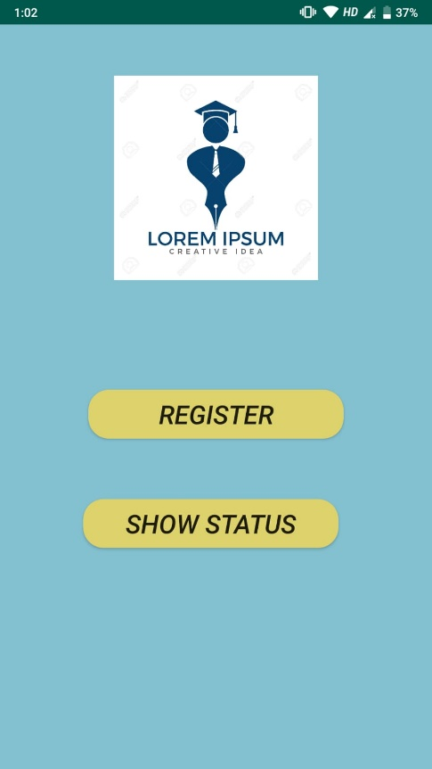

**Personal details.**

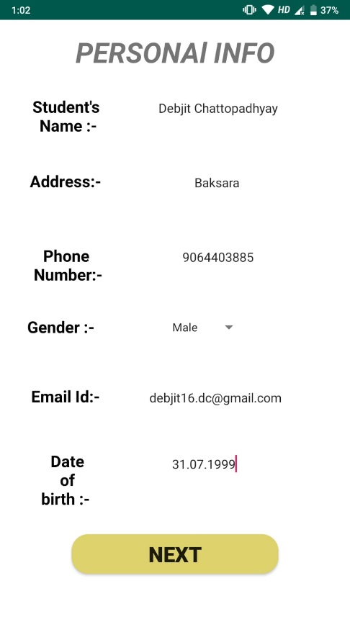

**Academic Details**

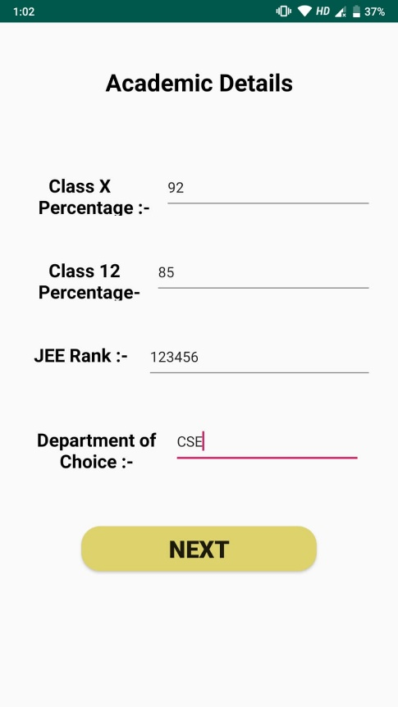

**Bus Details**

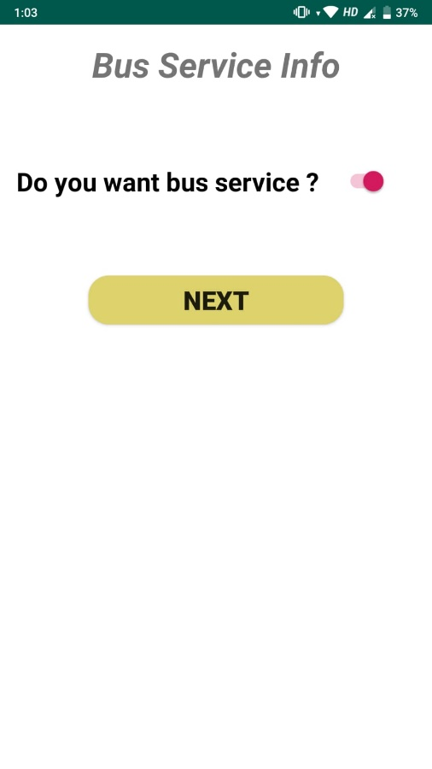

**Confirmation Page**

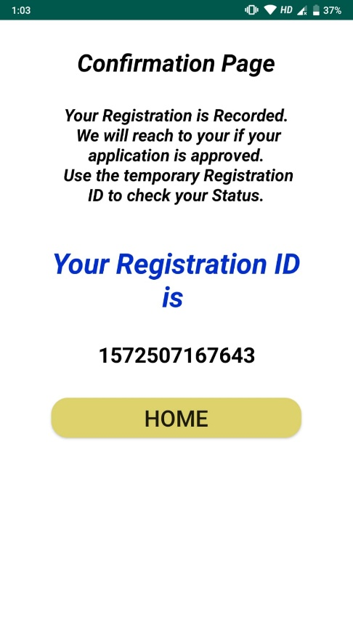

**Search Page**

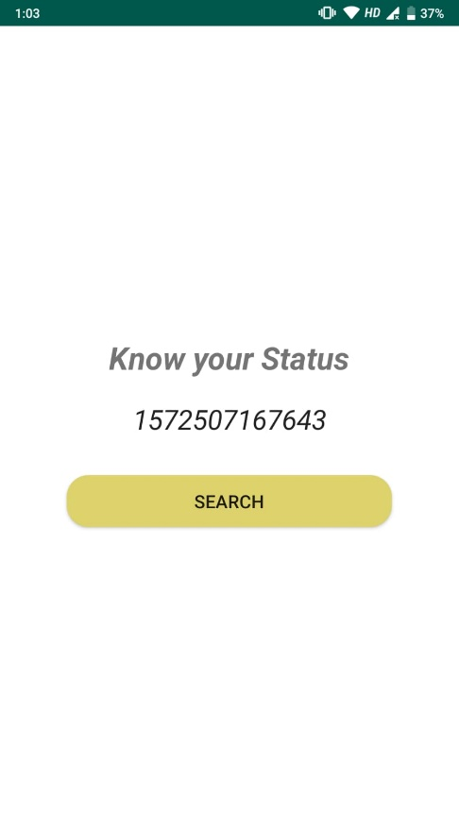

**Results Display**



      
      
    
     
      
      
      
      
      
      
      
      
      
      
      
      
      
      
      
      