PROJECT REPORT
Vehicle Health Monitoring and Failure Prediction Using Machine Learning
Predicting failure within the next 100 operating hours from vehicle telemetry
Submitted by: Debjit
Program: B.Tech, Electronics and Communication Engineering (Semester VI)
Tools: Python, Pandas, NumPy, Scikit-learn, Matplotlib, Seaborn, Google Colab

1. Abstract
Unplanned vehicle breakdowns are costly and unsafe. Predictive maintenance addresses this by using sensor data to warn of a failure before it happens. This project builds a supervised machine learning model that reads vehicle telemetry (engine temperature, RPM, oil pressure, vibration, battery voltage, coolant temperature, fuel consumption and speed) and predicts whether the vehicle will fail within the next 100 operating hours.
A dataset of 62,279 records from 250 vehicles was cleaned, encoded and standardised, then split 70:30 in a stratified manner. A Random Forest classifier trained on 43,595 records reached an accuracy of 99.42%, a ROC AUC of 0.99, a precision of 0.93 and a recall of 0.80 on the failure class, evaluated on 18,684 unseen records.

2. Introduction and Objectives
Modern vehicles continuously log sensor data. Failures in subsystems such as the cooling system, oil pump, bearings and electrical system usually show up as drifts in these signals (rising temperature, falling oil pressure, growing vibration, sagging battery voltage) well before the breakdown. A model that learns these patterns can trigger maintenance at the right time instead of too late or too early.
Objectives:
- Clean and explore the vehicle telemetry dataset.
- Train a classifier to predict failure_within_100h (binary: 0 = no failure, 1 = failure).
- Evaluate it with accuracy, precision, recall, F1, a confusion matrix and a ROC curve.
- Identify which sensor signals contribute most to the prediction.

3. Dataset Description
The file vehicle_telemetry_dataset.csv contains 62,279 rows and 14 columns from 250 vehicles (122 to 359 records per vehicle, one record every 10 operating hours). There are no duplicate rows.
Column | Type | Description
vehicle_id, record_no | ID | Vehicle identifier and record counter
operating_hours | int | Cumulative operating hours (10 to 3,590)
engine_temp_C | float | Engine temperature (mean 94.2 C)
rpm | float | Engine speed (mean 2,305)
oil_pressure_psi | float | Oil pressure (mean 45.2 psi)
vibration_mm_s | float | Vibration level (mean 3.67 mm/s)
battery_voltage_V | float | Battery voltage (mean 13.81 V)
coolant_temp_C | float | Coolant temperature (mean 89.3 C)
fuel_consumption_L100km | float | Fuel use (mean 7.86 L/100 km)
vehicle_speed_kmh | float | Vehicle speed (mean 68.4 km/h)
fault_type | category | none, electrical, oil_pump, cooling_system, bearing_wear
remaining_useful_life_h | float | Hours to failure (45.0% missing)
failure_within_100h | int | Target: 1 if failure occurs within 100 h

3.1 Class imbalance
Only 1,370 of 62,279 records (2.2%) are failures, so the problem is heavily imbalanced. A model that always predicts "no failure" would already score 97.8% accuracy, which is why precision, recall and the ROC curve matter more than accuracy here.
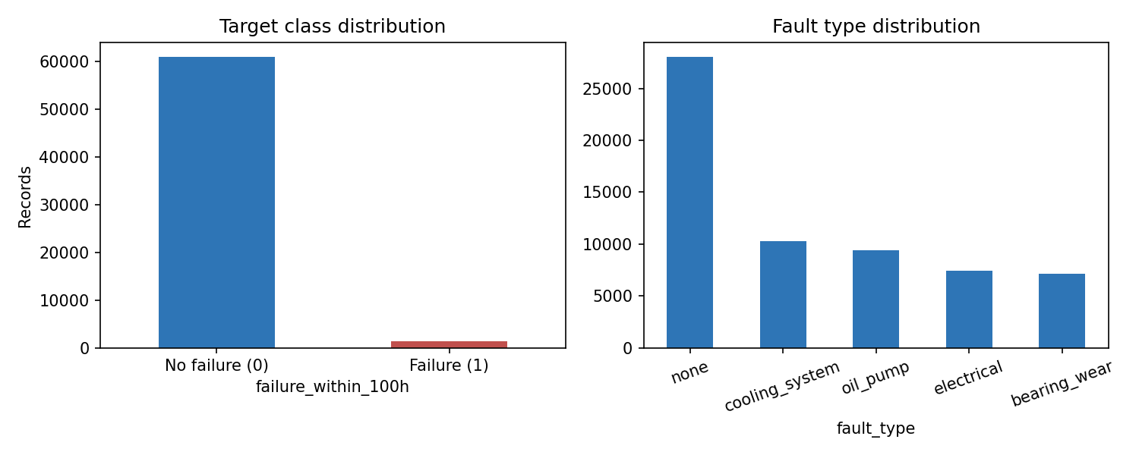
Figure 1: Target class distribution and fault type distribution.

3.2 Sensor behaviour before failure
Records labelled as failures show clearly different sensor levels from healthy records: higher engine temperature (100.5 vs 94.0 C), lower oil pressure (40.6 vs 45.3 psi), higher vibration (5.17 vs 3.63 mm/s), lower battery voltage (13.46 vs 13.81 V) and higher coolant temperature (94.1 vs 89.2 C). This separation is what the classifier exploits.
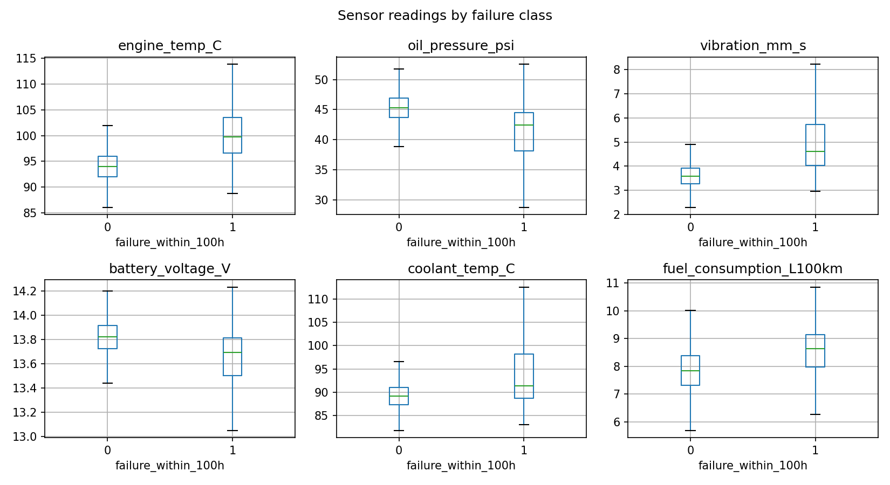
Figure 2: Sensor readings for failure (1) and non-failure (0) records.

4. Methodology

4.1 Data preprocessing
- Missing values: only remaining_useful_life_h had missing values (45.0%).
- Dropped columns: vehicle_id and record_no (identifiers) and remaining_useful_life_h (too many missing values and a regression target rather than an input for this classification task).
- Encoding: fault_type was one-hot encoded with drop_first=True, giving 4 binary columns and a final feature matrix of 13 columns.
- Split: 70% training (43,595 rows) and 30% testing (18,684 rows), stratified on the target with random_state=42.
- Scaling: StandardScaler fitted on the training set only and applied to both sets, which avoids test-set leakage.

4.2 Model
A RandomForestClassifier (scikit-learn defaults, random_state=42) was used. Random Forests handle non-linear relationships between sensors, are robust to outliers and need little tuning, and they report feature importance, which helps interpret which signals drive a prediction.

4.3 Evaluation metrics
Accuracy, precision, recall and F1-score for each class, the confusion matrix, and the ROC curve with its area under the curve (AUC).

5. Results

5.1 Output 1: Confusion matrix
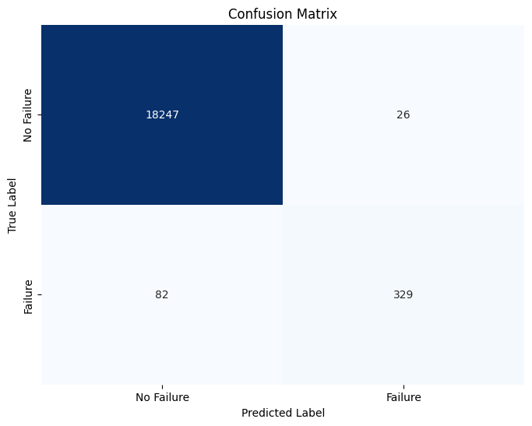
Figure 3: Confusion matrix of the Random Forest classifier on the test set.
Outcome | Count | Meaning
True Negative (TN) | 18,247 | Healthy correctly predicted as healthy
False Positive (FP) | 26 | False alarm on a healthy vehicle
False Negative (FN) | 82 | Missed failure
True Positive (TP) | 329 | Failure correctly predicted

Of 411 real failures, the model caught 329 and missed 82. Of 18,273 healthy records, only 26 were falsely flagged.

5.2 Output 2: ROC curve
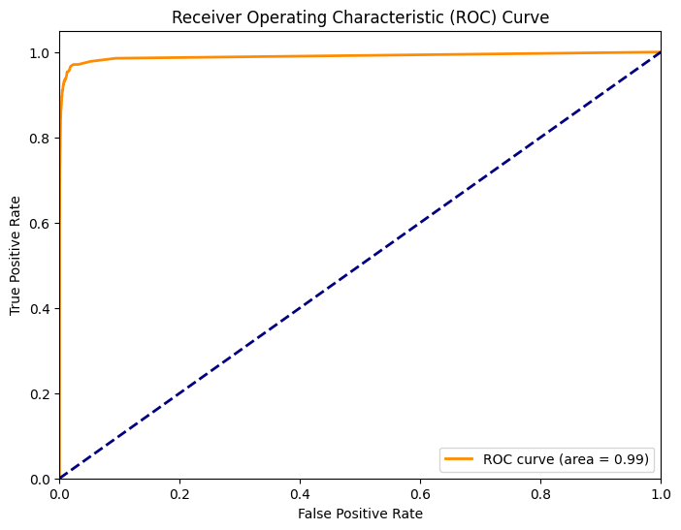
Figure 4: ROC curve of the classifier (AUC = 0.99).
The ROC curve rises almost vertically along the y-axis and stays close to the top-left corner, far above the diagonal that represents random guessing. An AUC of 0.99 means that, for a randomly chosen failing record and a randomly chosen healthy record, the model assigns a higher failure probability to the failing one about 99% of the time.

5.3 Performance summary
Class | Precision | Recall | F1-score | Support
0 (No failure) | 0.9955 | 0.9986 | 0.9970 | 18,273
1 (Failure) | 0.9268 | 0.8005 | 0.8590 | 411
Accuracy |  |  | 0.9942 | 18,684
Macro average | 0.9611 | 0.8995 | 0.9280 | 18,684

Derived metric | Value
Accuracy = (TP+TN)/Total | 99.42%
Precision = TP/(TP+FP) = 329/355 | 92.68%
Recall (sensitivity) = TP/(TP+FN) = 329/411 | 80.05%
Specificity = TN/(TN+FP) = 18247/18273 | 99.86%
False positive rate | 0.14%
False negative rate | 19.95%
ROC AUC | 0.99

5.4 Feature importance
The five most influential features are vibration (0.187), battery voltage (0.181), coolant temperature (0.178), oil pressure (0.162) and engine temperature (0.104). Together they account for about 81% of the total importance. Fuel consumption, RPM and speed contribute little, which agrees with the sensor comparison in Section 3.2.
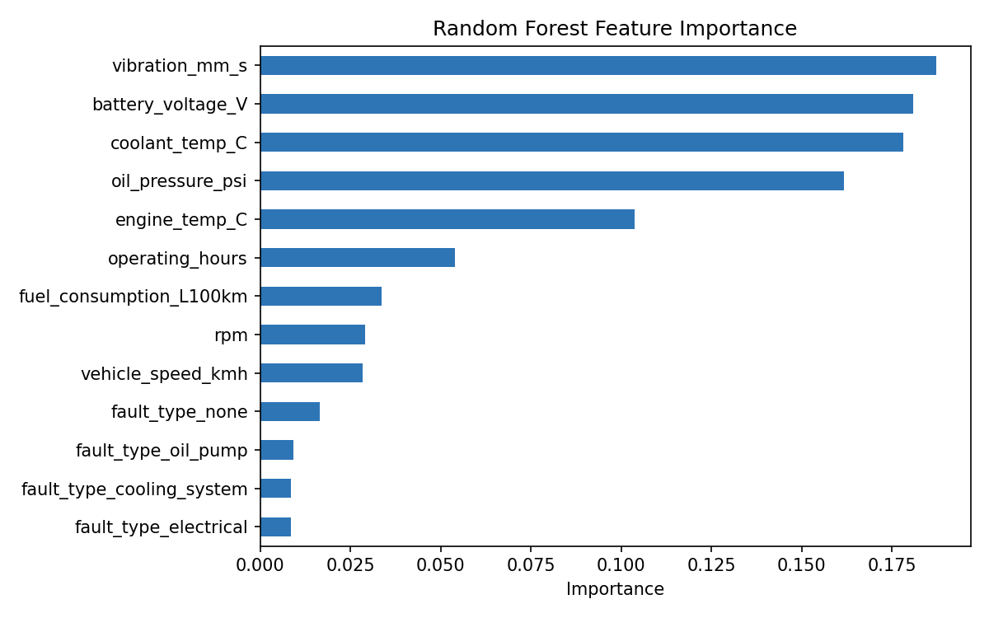
Figure 5: Feature importance from the Random Forest.

6. Discussion
The model separates healthy and failing records very well (AUC 0.99) and raises very few false alarms (26 out of 18,273). Its weaker point is recall: about 1 in 5 real failures (82 of 411) is missed. Because the failure class is only 2.2% of the data, the overall accuracy of 99.42% looks better than it is; the F1-score of 0.86 for the failure class is the more honest measure. In predictive maintenance a missed failure is usually more expensive than a false alarm, so recall should be prioritised.

7. Limitations
- Possible label leakage from fault_type. In this dataset every record with fault_type = none has failure_within_100h = 0 (28,031 records), while the four fault categories contain all 1,370 failures. If fault_type is not known in advance in a real deployment, it should be removed from the features and the model re-evaluated, since the scores may drop.
- Random row-wise split. Records from the same vehicle appear in both training and test sets, and consecutive records are highly correlated. A split by vehicle_id (for example GroupKFold) would give a more realistic estimate of performance on new vehicles.
- Imbalance. Only 2.2% of records are failures, and no imbalance handling was applied.
- Untuned model. Default Random Forest hyperparameters were used and no cross-validation was performed.

8. Future Work
- Use class_weight="balanced", SMOTE, or a lower decision threshold to raise recall on failures.
- Tune hyperparameters with cross-validation and compare with Gradient Boosting, XGBoost and Logistic Regression.
- Add rolling-window features (moving averages and trends per vehicle) to capture gradual drift.
- Predict remaining_useful_life_h with regression models and classify the fault type with a multi-class model.
- Deploy as a real-time monitoring dashboard with maintenance alerts.

9. Conclusion
This project built a Random Forest model that predicts vehicle failure within 100 operating hours from telemetry data. On the test set it achieved 99.42% accuracy, 0.93 precision, 0.80 recall and an AUC of 0.99, and it identified vibration, battery voltage, coolant temperature and oil pressure as the strongest failure indicators. With imbalance handling, leakage-free features and vehicle-wise validation, the approach can be developed into a dependable predictive maintenance tool.

