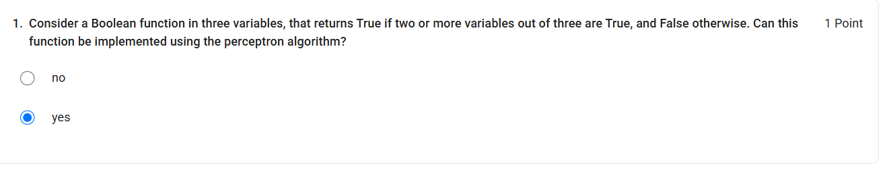
This function is a majority function: it outputs 1 when at least two of the three inputs are 1.
It is linearly separable, so a single perceptron can implement it.
For example, choose:
Then:
- 0 or 1 true inputs → sum → False
- 2 or 3 true inputs → sum → True

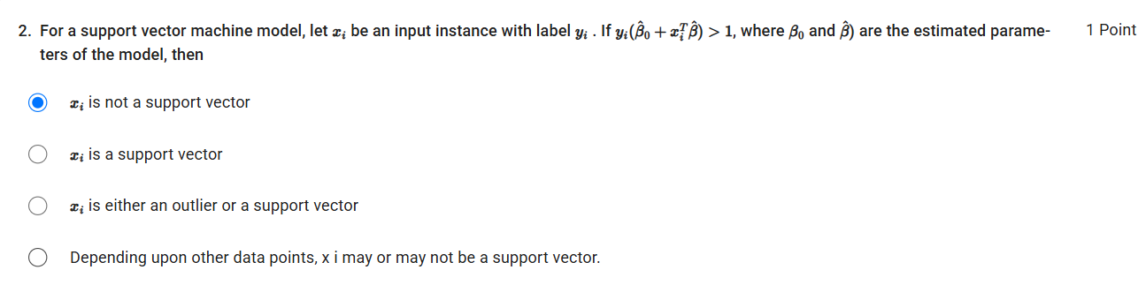
For an SVM, the margin condition is:
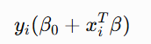
- If , the point is outside the margin and is not a support vector.
- If , it lies on the margin → support vector.
- If , it lies inside the margin or is misclassified → generally a support vector in soft-margin SVM.
Given:
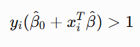
Therfore the answer is A.
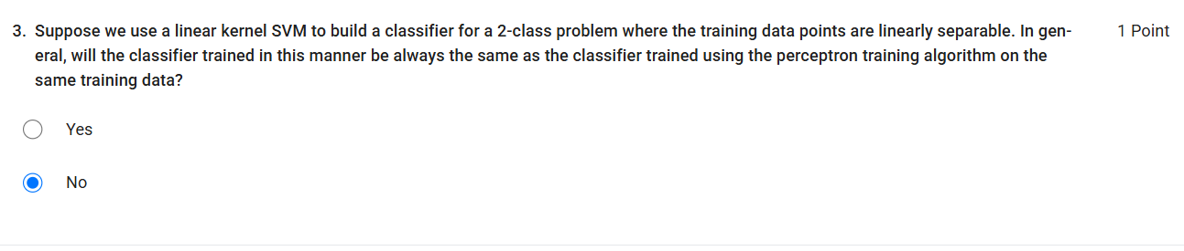
Although both linear SVM and the Perceptron can produce a linear decision boundary for linearly separable data, they optimize different objectives:
- Perceptron: Finds any separating hyperplane that correctly classifies the training data.
- SVM: Finds the separating hyperplane that maximizes the margin between the two classes.
Therefore, even with the same linearly separable training data, they do not necessarily produce the same classifier.
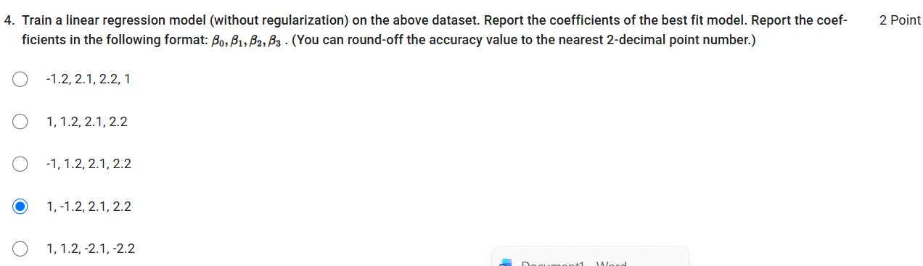
The linear regression model is:
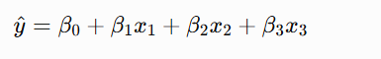
The fitted coefficients are:
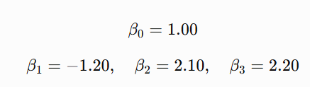
So the required format is,
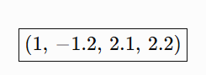

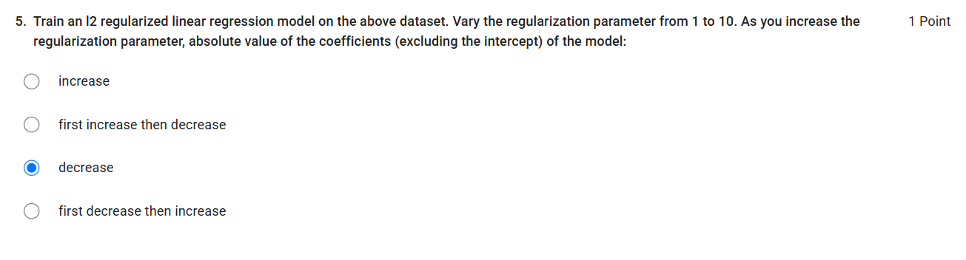

In L2-regularized linear regression (Ridge regression), increasing the regularization parameter increases the penalty on large coefficients:
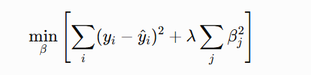
As increases, the model is increasingly penalized for having large coefficient values. Therefore, the absolute values of the coefficients (excluding the intercept) generally decrease toward zero.
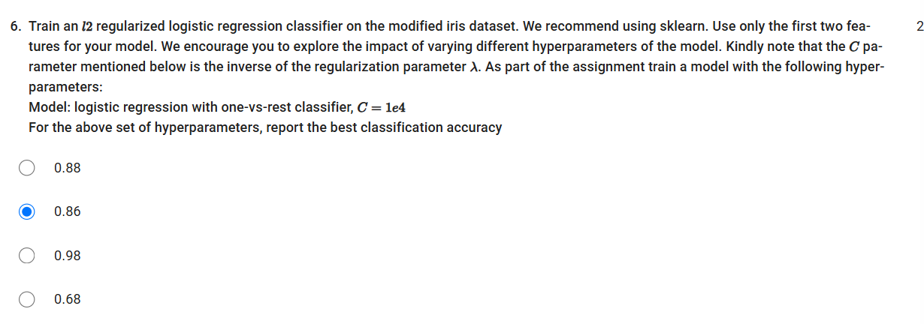
- Total samples = 150
- Training set = first 100 samples
- Test set = remaining 50 samples
- Features used = first 2 features
- Classifier = L2-regularized Logistic Regression
- One-vs-Rest strategy
The test accuracy is:
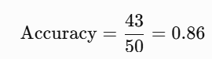
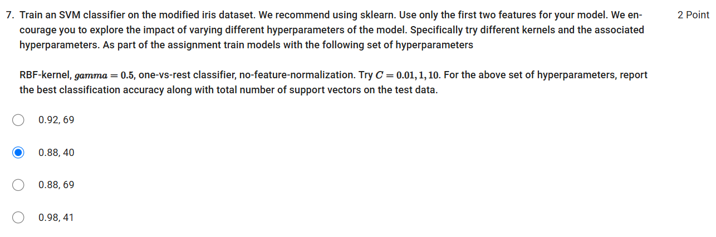
• First 100 samples → training
• Last 50 samples → testing
• First 2 features only
• RBF kernel
• 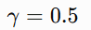
• One-vs-Rest
• No feature normalization
• 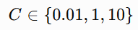
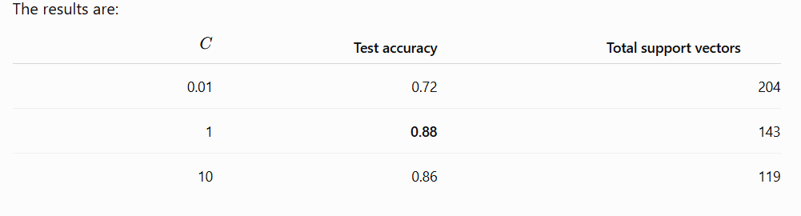
Thus, the best test accuracy is 0.88 at 1.

