Curriculum Vitae
v0.01-digit
Personal information |  |  |  |  |  |  |  |  |  |  |  |  | 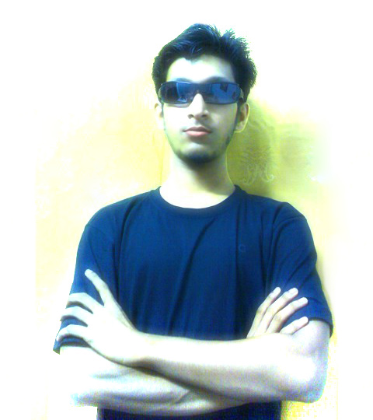
Name : |  | Soumya Kanti Deb
Address : |  | P.O : Teor, Balurghat, D. Dinajpur, West Bengal, 733145
Mobile : |  | +91-9475473209
E-mail : |  | deblopper@gmail.com
Nationality : |  | Indian
Date of birth : |  | 16th May, 1987
Gender : |  | Male
Education and training
 |  |  | Board/University |  |  |  |  | Year/Duration |  |  | Marks/Percentage |  |  |  | Division/Grade
Post-Graduation [MCA] (10+2+3+3) |  |  | W.B.U.T |  |  |  |  | 2007 – Present |  |  | GPA 8.3 |  |  |  | E
Graduation [B.Sc. in Phys] (10+2+3) |  |  | University of North Bengal |  |  |  |  | 2004 – 2007 |  |  | 50% |  |  |  | 2nd
Higher Secondary [HS] (10+2) |  |  | W.B.C.H.S.E. |  |  |  |  | 2002 – 2004 |  |  | 78% |  |  |  | 1st
Secondary [Madhyamik] (10) |  |  | W.B.B.S.E. |  |  |  |  | Passed on 2002 |  |  | 85% |  |  |  | 1st
Personal Skills and Competences
Communication Skills
Mother Tongue : |  | Bengali (bn-IN)
Other language(s) |  | Language Levels – According to Europass :
 |  |  |  | Understanding |  |  |  |  | Speaking |  |  |  |  |  | Writing
 |  |  |  | Listening |  | Reading |  |  | Spoken interaction |  |  | Spoken production
Bengali (bn-IN) |  |  |  | C2 | Proficient | C2 | Proficient |  | C2 | Proficient |  | C2 |  | Proficient | C2 | Proficient
English (en-GB) |  |  |  | C1 | Proficient | C1 | Proficient |  | B2 | Independent |  | B2 |  | Independent | C2 | Proficient
Hindi (hi-IN) |  |  |  | C1 | Proficient | B1 | Independent |  | C1 | Proficient |  | B2 |  | Independent | B1 | Independent
Social Skills |  | Eager to help people out of distress and save their day, with knowledge & experience, that is not necessarily always being technical.
Organisational Skills |  | Profound expertise in publicity and contemporary expressing technique that Attracts the Target-audience to Listen OR Leads the Teammates for cumulative co-operation.
Technical Skills |  | Ability to work with Linux/Unix, Windows & Mac Systems, Virtualisation, P2P, Audio/Video/Image Processing, Multimedia & Codecs, Mobile Technologies & Platforms, Website Development,
Computer Skills |  | Operating Systems, Networking, Shell Scripting, C/C++, PHP
Artistic Skills |  | Sound Knowledge of Traditional & Digital Arts, CGI, 2D/3D Animation & VFX
Passions |  | FOSS, PC Gaming, Photography, Music & Movies
Additional information |  | Acting Leader of Wikiproject Software, Mozilla-Labs Member & Nightly-Builds Tester, Google Wave Developer Sandbox User, Fedora FAS Account Member

