[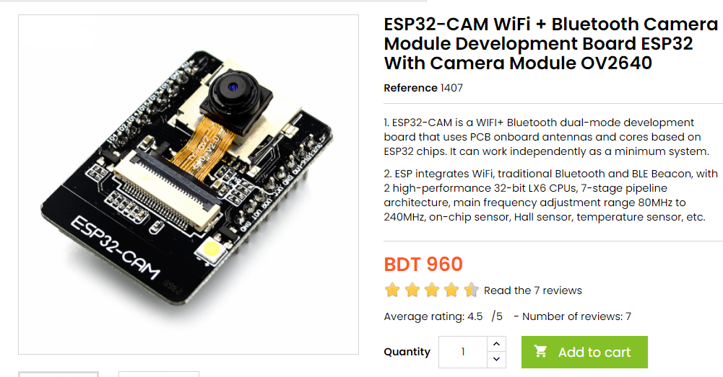](https://store.roboticsbd.com/arduino-bangladesh/1407-esp32-cam-wifi-bluetooth-camera-module-development-board-esp32-with-camera-module-ov2640-robotics-bangladesh.html)

[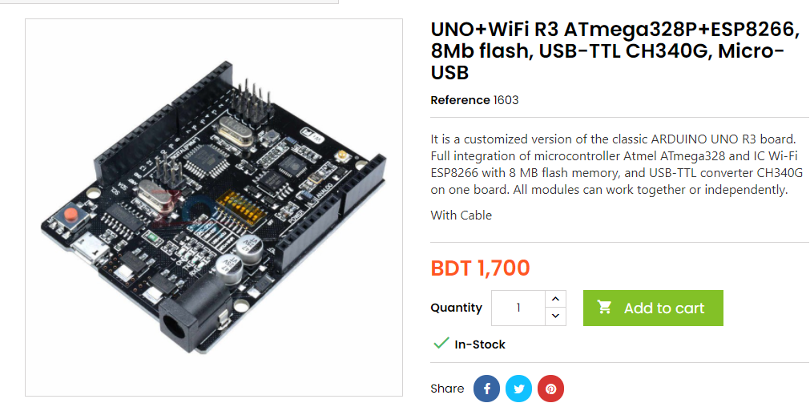](https://store.roboticsbd.com/arduino-bangladesh/1603-unowifi-r3-atmega328pesp8266-8mb-flash-usb-ttl-ch340g-micro-usb-robotics-bangladesh.html)

[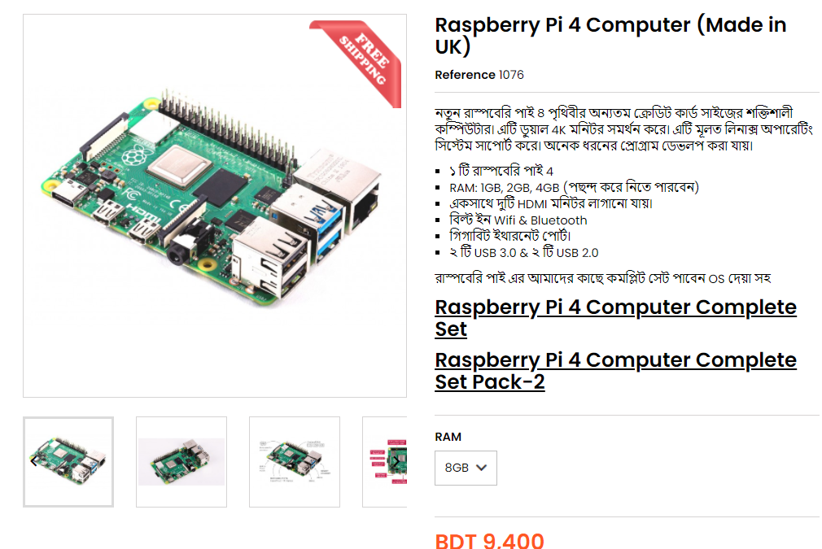](https://store.roboticsbd.com/home/1076-75-raspberry-pi-4-robotics-bangladesh.html#/50-ram-2gb)

[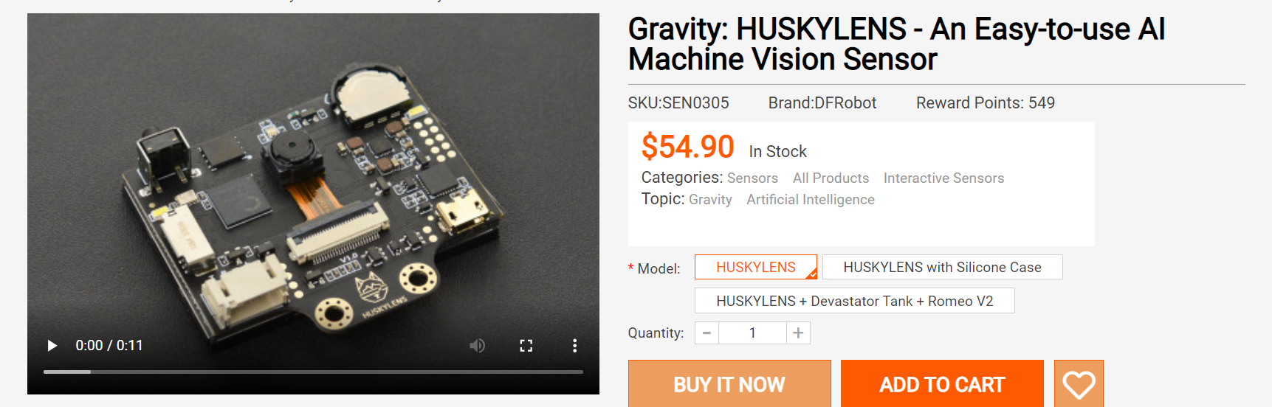](https://www.dfrobot.com/product-1922.html?tracking=60af103e54d81)

[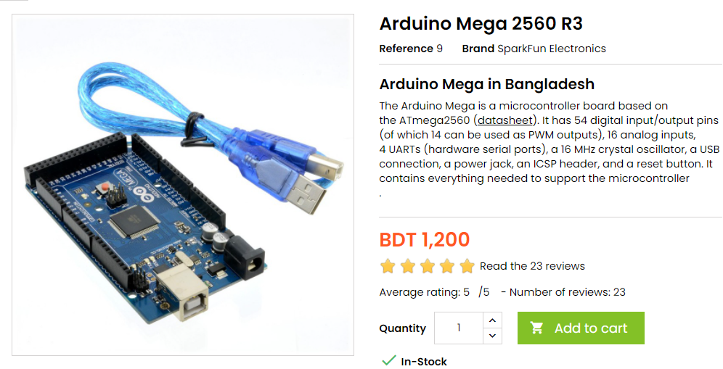](https://store.roboticsbd.com/arduino-bangladesh/9-arduino-mega-2560-r3-robotics-bangladesh.html)

Pending:

[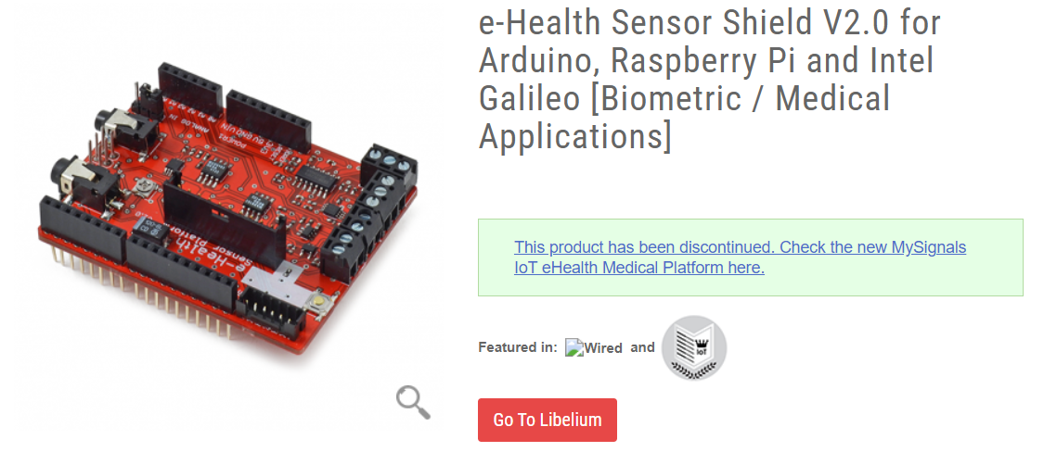](https://www.cooking-hacks.com/ehealth-sensor-shield-biometric-medical-arduino-raspberry-pi.html)

More links on EHealth

<https://sites.google.com/site/ncadarduino/home/2-afternoon-day-1/e-health-sensors>

[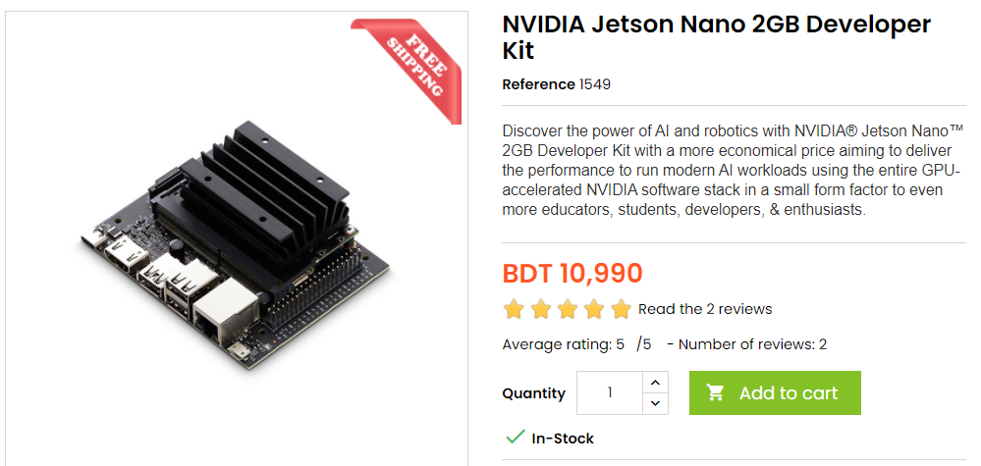](https://store.roboticsbd.com/raspberry-pi/1549-nvidia-jetson-nano-2gb-developer-kit-robotics-bangladesh.html)[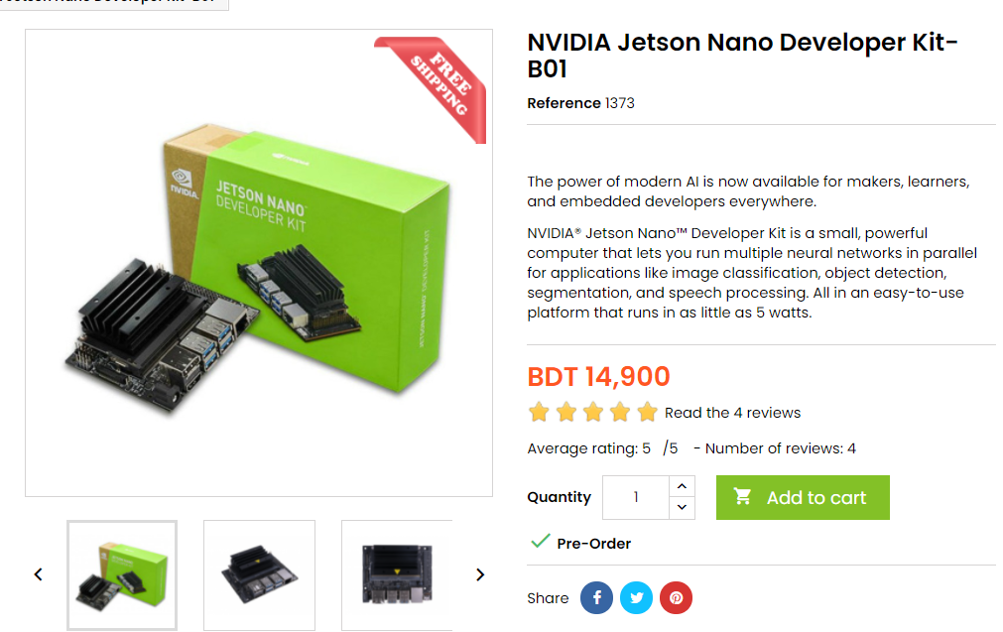](https://store.roboticsbd.com/mini-computer-pc/1373-nvidia-jetson-nano-developer-kit-b01-robotics-bangladesh.html)[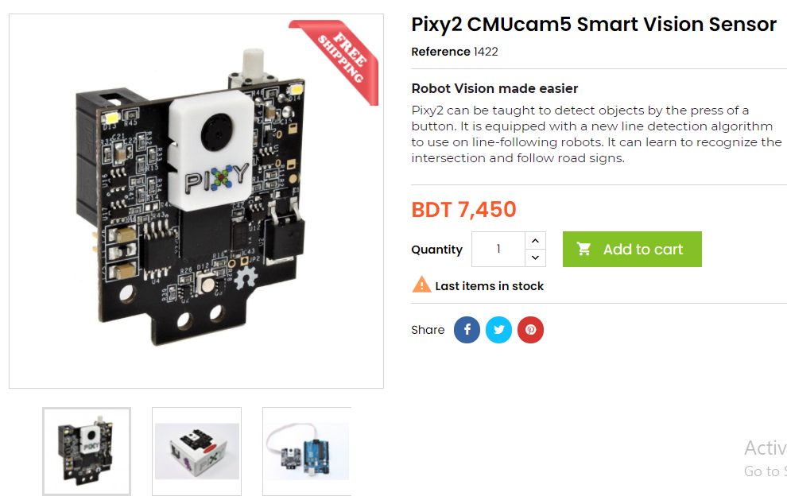](https://store.roboticsbd.com/sensors/1422-pixy2-cmucam5-smart-vision-sensor-robotics-bangladesh.html)