**Methodology**

The primary aim of this investigation was to conduct individualized network analyses for each dental implant sample to identify nodes with high degrees of connectivity. Subsequent functional enrichment analyses were then performed, focusing on pathways pertinent to osteology, including bone generation and wound healing mechanisms. Additionally, the study aimed to explore biomarker genes and their adjacent genes within the identified networks, thereby elucidating potential molecular markers associated with osteological processes.

There are five classes of implants – OM, mSLA, PT, TCPS, and Titan, with another class, BMP2, as control. Differential gene expression analysis was performed for each class as pairs for ~23,000 genes, keeping only the genes with expression padj < 0.01. In addition, transcriptional factor genes for Rattus norvegicus are also added to the gene list, irrespective of their expression value. Based on this final gene list, corresponding raw count data instances were selected for all the implants. Finally, gene expression raw count data were segregated for each of the five classes, then passed to miRsig network analysis pipeline.

Networks created for each class were then further preprocessed, to keep only the instances where the edge weights are > 0.9. Finally, pathway enrichment analysis was performed for each implant type. Among the five implants, pathway enrichment analysis for OM didn’t generate significant pathway list, maybe due to the absence of significant associations with the GO terms.

The overall methodology is illustrated in the following diagram:

Implants – OM, mSLA, PT, TCPS, Titan and BMP2 (control)

Differential gene expression analysis

# genes ~23,000

Filtered raw count data

Regulatory network generation

Pathway enrichment analysis

Significant genes + TFs

miRsig

Filter low-degree nodes

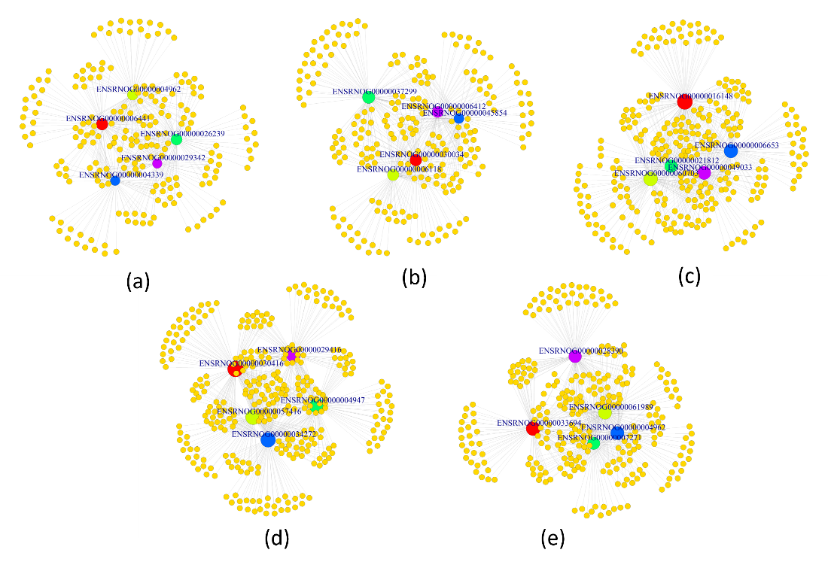Regulatory networks for each of the implant types are illustrated as below:

**Figure 1:** Regulatory network for (a) mSLA, (b) OM, (c) PT, (d) TCPS, and (e) Titan are illustrated above. Top 5 highest degree nodes are selected for constructing the network.

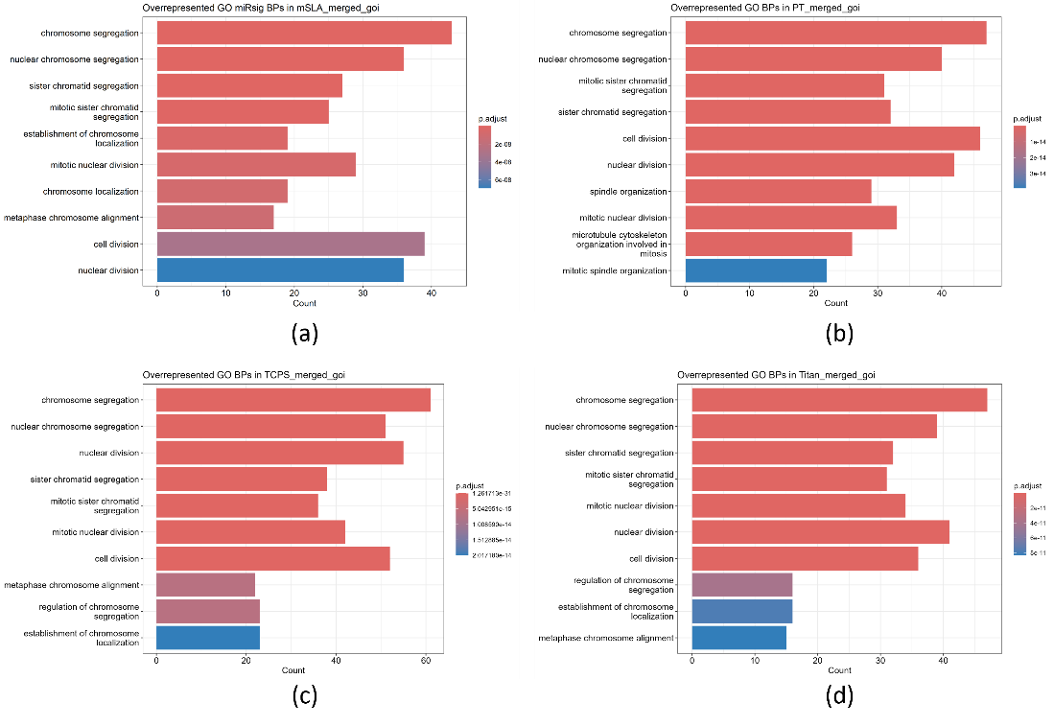Finally, pathway enrichment analysis outcomes for each implant are illustrated below:

**Figure 2:** Regulatory network for (a) mSLA, (b)PT, (c) TCPS, and (d) Titan are illustrated above. Top 5 highest degree nodes are selected for constructing the network. Relevant pathways related to osteology, including bone generation and wound healing mechanisms were not significantly observed.