**Question 3. Exploiting instantaneous temperature**

* Find one example over the lands surface, one in a water body (lake/sea) and one in the atmosphere where an image of instantaneous observations of temperature can be used to detect or map an event or study some phenomenon.
* Discuss the range of temperature variation observed, and the reason for the temperature variation (in more detail than provided in the caption).
* Who are the users of this information? And what they do with it?

**1. Example in a surface (Death Valley)**

Image source: <https://ecostress.jpl.nasa.gov/downloads/gallery/00095_death_valley.jpg>

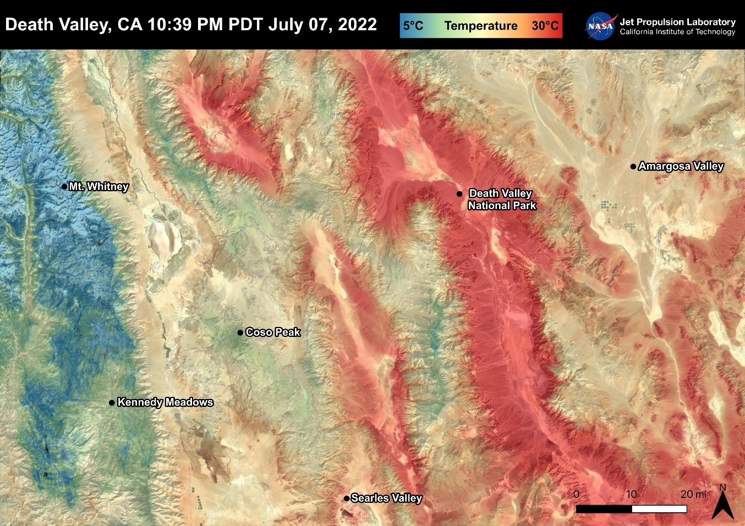

This image of Land Surface Temperature (LST) was captured by ECOSTRESS and shows a temperature distribution exceeding 30°C in Death Valley and dropping below 5°C in the Sierra Nevada mountains. The variation in temperature is partly due to differences in elevation and also the distribution of vegetation and moist soil. Low temperatures (5°C) are observed in the area around Mt. Whitney, while high temperatures (30°C) are found in Death Valley. Low temperatures at higher altitudes are associated with reduced atmospheric pressure, which decreases heat retention. In contrast, lower altitudes are more susceptible to warming due to denser air, which is more effective at trapping heat. We can also see that areas covered with vegetation and moist soil, such as around Kennedy Meadows, cool down faster, whereas desert areas retain heat for longer period. Another contributing factor could also be the time of observation. From the image, we know that the measurement was taken at 10:39 PM, meaning nighttime cooling significantly influenced the temperatures. This information is essential for researchers from various sectors in climate, ecosystems, and environmental fields. In the climate sector, it is used to analyze the impacts of extreme temperatures on ecosystems, vegetation, and the atmosphere over specific periods. In the environmental sector, surface temperature data is needed to study erosion rates and assess groundwater availability in desert regions of high-elevation areas.

**2. Example in a water body (Nile River at night)**

Image source: <https://ecostress.jpl.nasa.gov/downloads/gallery/00001_first_light2.jpg>

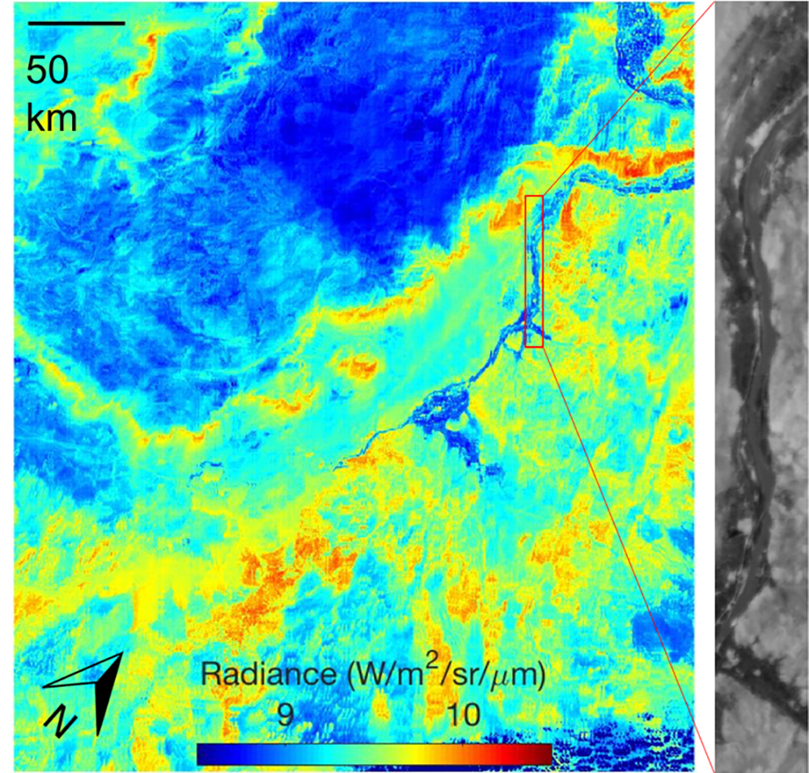

This image shows radiance values between 9 W/m2/sr/μm for cooler areas (blue) and 9 W/m2/sr/μm for warmer areas (orange-red). Using the Planck’s Law, we can convert the radiance value to temperature and based on the radiance values, the estimated temperature range is around ~15°C. These radiance values correspond to surface temperature differences, with cooler areas near water bodies of Nile River (thin blue line). The nighttime measurement also plays a role to the observed data as radiative cooling during the night reduces surface temperature. This information provided by ECOSTRESS is essential for researchers to determine how much water plants use and to study how droughts affect plant health.

**3. Example in the atmosphere (Hurricane Florence)**

Image source: <https://ecostress.jpl.nasa.gov/downloads/gallery/00010_FlorenceT_v2.png>

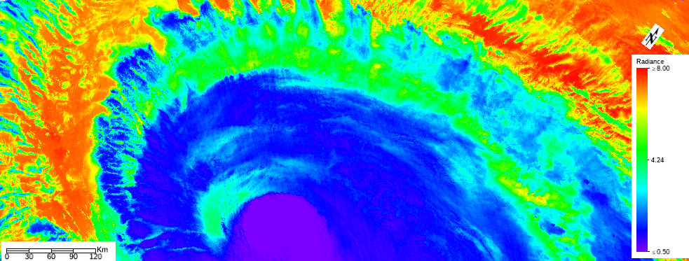

From the image above, we can see the radiance value range from 0.5 W/m2/sr/μm (blue/purple) to >8.0 W/m2/sr/μm (red/orange). These radiance values may correspond to surface temperature variations. To convert the radiance values to temperature, we can use Planck’s Law, which relates radiance to surface temperature. Purple and blue indicate coldest regions, corresponding to radiance values around ~0.50-2.0 W/m2/sr/μm, with temperatures likely in the range of -70°C to -50°C. These regions represent the cold tops at high altitudes in the hurricane. Green indicates moderate regions, corresponding to radiance values around ~4.0-5.0 W/m2/sr/μm, with temperatures likely around in the range -20°C to 0°C. These regions represent the middle-altitude clouds in the hurricane. Yellow and red indicate warmest regions, corresponding to radiance values of 6.0-8.0 W/m2/sr/μm, with temperature likely range from 20°C to 30°C or more. These regions are associated to warm land surfaces or sea surfaces surrounding the hurricane system. The variation of temperatures could be caused by cold cloud tops (where the coldest temperatures are observed at the high-altitude cloud tops of the hurricane as intense convection lifts moist air rapidly). As the air rises, it expands and cools due to lower atmospheric pressure. These cloud tops emit low radiance and thus appearing purple-blue in the image. This information is essential for researchers from various sectors in meteorology, climate and weather, and oceanography. In the meteorology sector, it is used to study and predict hurricane dynamics and behaviour by analysing temperature gradients of warm sea surfaces and cold cloud tops to assess hurricane strength and potential intensification. Researchers in oceanography use this information to learn ocean-atmosphere interactions during hurricanes by analysing sea surface temperature (SST) data to study how hurricanes draw energy from warn ocean waters.