Advanced AI

Assignment 1 Report

Debonil Ghosh

Roll No: M21AIE225

Executive MTech

Artificial Intelligence

Indian Institute of Technology, Jodhpur

# Problem Statement:

# **Task 1: Let’s Play Soccer**

# AIM: To make students understand the utility theory and bring it to practice by working on Utility functions, policies, single agent game, agent interaction with environment etc.

# The task is to model an agent to perform assisted goal shootout in the game of soccer. This is a simple implementation of policies; no learning is expected by the agent.

# • There are 2 teams, Chennai FC and Bengaluru FC

# • Chennai FC has 3 players and Bengaluru FC has 4 players (1 Kicker and 3 in team Chennai FC play area).

# • The players cannot move from their respective places once the game starts.

# • Bengaluru FC is performing an assisted goal shootout but from the Center Circle position. (Condition 1)

# • So, one player from the Bengaluru FC team must remain at the center circle to take an assisted goal shoot.

# • One player from each team will be staying in the Chennai FC goal box and will not leave it. (Condition 2)

# • Apart from the center kicker from team BLUE players, the rest of the players will remain in the upper part as shown (Chennai FC Team area). (Condition 3)

# • Shootouts must be done from the center by the team BLUE player as shown in the below image.

# • How to Play:

# – The assisted goal shoot will be taken by a Bengaluru FC player from the center.

# – The kicker is our agent

# – The agent needs to decide the shortest goal path, this will be your heuristic cost. (has to be assisted goal) (Condition 4)

# – With every run, the position of players will be changed, which has to be randomized and should satisfy the previous condition. (Condition 5)

# 

# Figure 1: Start of the game

# • Evaluation Componenets:

# – System Design and architecture explanation [20 Marks]

# ∗ You can include block diagrams, algorithms, flowchart, whichever you feel

# is necessary to understand the approach.

# ∗ A detailed explanation of each component that is used.

# – Implementation of Environment and Agents. [20 Marks]

# – Conditions followed.[ 6*5 = 30 Marks ]

# – Printing the cost of the steps (Top 2) for every iteration. (The ways the agent can perform assisted goal. [10 Marks]

# – Working demo of the game [20 Marks]

# Solution:

As a solution, a Python Game has been developed with Turtle library. It starts with some default player arrangement. Then on mouse click rearranges player positions according to the given constraints, and shows smallest path and distance from Kicker at centre position to the Goal. And prints distances.

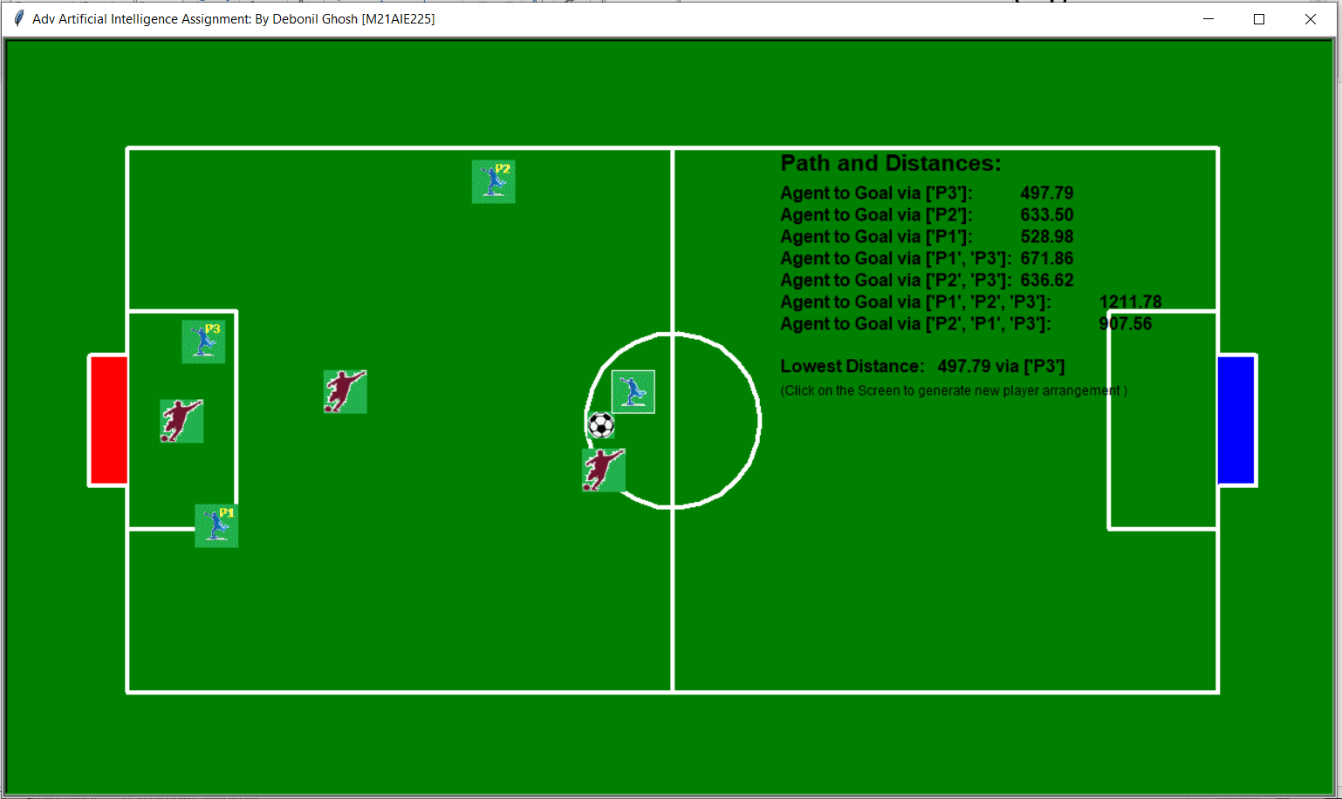

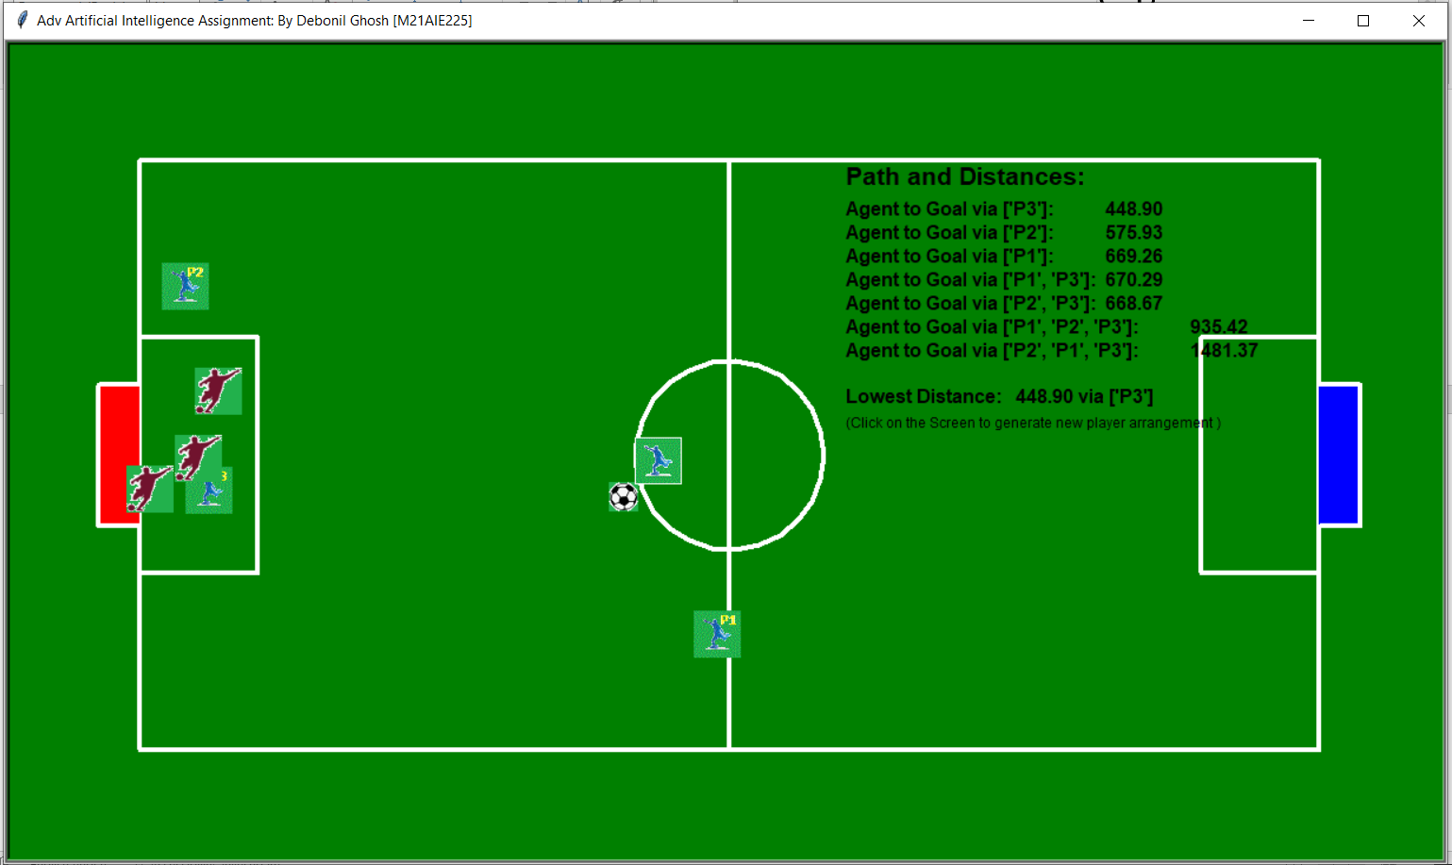

# **Task2: Trying our hand at Game theory**

# Alice, Bob, and Charlie play the following simultaneous game. They are sitting in different rooms facing a keyboard with only one key and each has to decide whether or not to press the key. Alice wins if the number of people who press the key is odd (that is, all three of them or only Alice or only Bob or only Charlie), Bob wins if exactly two people (he may be one of them) press the key and Charlie wins if nobody presses the key.

# A. Represent this situation as a game-frame. Note that we can represent a three-player game with a set of tables: Player 1 chooses the row, Player 2 chooses the column and Player 3 chooses the table (that is, we label the rows with Player 1’s strategies, the columns with Player 2’s strategies and the tables with Player 3’s strategies). (25 marks)

## Solution:

**Alice**

|  |  |  |
| --- | --- | --- |
|  | Presses | Not Presses |
| Presses | Alice wins  (As total press=3; odd number) | Bob wins  (As total press=2) |
| Not Presses | Bob wins  (As total press=2) | Alice wins  (As total press=1; odd number) |

Bob

Charlie Presses

**Alice**

|  |  |  |
| --- | --- | --- |
|  | Presses | Not Presses |
| Presses | Bob wins  (As total press=2) | Alice wins  (As total press=1; odd number) |
| Not Presses | Alice wins  (As total press=1; odd number) | Charlie wins  (As total press=0) |

Bob

Charlie Not Presses

Fig: Game Frame representation of given problem

# B. Using the game-frame of part (a) obtain a reduced-form game by adding the information that each player prefers winning to not winning and is indifferent between any two outcomes where he/she does not win. For each player use a utility function with values from the set 0,1. (25 marks)

## Solution:

|  |  |  |  |
| --- | --- | --- | --- |
| **Player →**  **Outcome↓** | **Alice** | **Bob** | **Charlie** |
| **O1** | Presses | Presses | Presses |
| **O2** | Not Presses | Presses | Presses |
| **O3** | Presses | Not Presses | Presses |
| **O4** | Not Presses | Not Presses | Presses |
| **O5** | Presses | Presses | Not Presses |
| **O6** | Not Presses | Presses | Not Presses |
| **O7** | Presses | Not Presses | Not Presses |
| **O8** | Not Presses | Not Presses | Not Presses |

|  |  |  |  |  |  |  |  |  |
| --- | --- | --- | --- | --- | --- | --- | --- | --- |
| **Outcome →**  **Utility function ↓** | O1  (Press count =3) | O2  (Press count =2) | O3  (Press count =2) | O4  (Press count =1) | O5  (Press count =2) | O6  (Press count =1) | O7  (Press count =1) | O8  (Press count =0) |
| **U1 (Alice)** | 1 | 0 | 0 | 1 | 0 | 1 | 1 | 0 |
| **U2**  **(Bob)** | 0 | 1 | 1 | 0 | 1 | 0 | 0 | 0 |
| **U3 (Charlie)** | 0 | 0 | 0 | 0 | 0 | 0 | 0 | 1 |

**Alice**

|  |  |  |
| --- | --- | --- |
|  | Presses | Not Presses |
| Presses | 1 0 0 | 0 1 0 |
| Not Presses | 0 1 0 | 1 0 0 |

Bob

Charlie Presses

**Alice**

|  |  |  |
| --- | --- | --- |
|  | Presses | Not Presses |
| Presses | 0 1 0 | 1 0 0 |
| Not Presses | 1 0 0 | 0 0 1 |

Bob

Charlie Not Presses

Fig: Reduced form Game

# C. Using the game-frame of part (a) obtain a reduced-form game by adding the information that (1) each player prefers winning to not winning, (2) Alice is indifferent between any two outcomes where she does not win, (3) conditional on not winning, Bob prefers if Charlie wins rather than Alice, (4) conditional on not winning, Charlie prefers if Bob wins rather than Alice. For each player use a utility function with values from the set 0,1,2. (25 marks)

## Solution:

|  |  |  |  |  |  |  |  |  |
| --- | --- | --- | --- | --- | --- | --- | --- | --- |
| **Outcome →**  **Utility function ↓** | O1  (Press count =3) | O2  (Press count =2) | O3  (Press count =2) | O4  (Press count =1) | O5  (Press count =2) | O6  (Press count =1) | O7  (Press count =1) | O8  (Press count =0) |
| **U1 (Alice)** | 2 | 0 | 0 | 2 | 0 | 2 | 2 | 0 |
| **U2**  **(Bob)** | 0 | 2 | 2 | 0 | 2 | 0 | 0 | 1 |
| **U3 (Charlie)** | 0 | 1 | 1 | 0 | 1 | 0 | 0 | 2 |

**Alice**

|  |  |  |
| --- | --- | --- |
|  | Presses | Not Presses |
| Presses | 2 0 0 | 0 2 1 |
| Not Presses | 0 2 1 | 2 0 0 |

Bob

Charlie Presses

**Alice**

|  |  |  |
| --- | --- | --- |
|  | Presses | Not Presses |
| Presses | 0 2 1 | 2 0 0 |
| Not Presses | 2 0 0 | 0 1 2 |

Bob

Charlie Not Presses

Fig: Reduced form Game

# D. Find the Nash equilibria of the games of (b) and (c). (25 marks)

## Solution:

1. **Nash Equilibria for the games of (b):**

**Alice**

|  |  |  |
| --- | --- | --- |
|  | Presses | Not Presses |
| Presses | 1 0 0 | 0 1 0 |
| Not Presses | 0 1 0 | 1 0 0 |

Bob

Charlie Presses

**Alice**

|  |  |  |
| --- | --- | --- |
|  | Presses | Not Presses |
| Presses | 0 1 0 | 1 0 0 |
| Not Presses | 1 0 0 | 0 0 1 |

Bob

Charlie Not Presses

Fig: strategic-form game with ordinal payoffs

*Hence: O6(Alice Presses, Bob and Charlie not Presses) is the Nash equilibria

1. **Nash Equilibria for the games of (c):**

**Alice**

|  |  |  |
| --- | --- | --- |
|  | Presses | Not Presses |
| Presses | 2 0 0 | 0 2 1 |
| Not Presses | 0 2 1 | 2 0 0 |

Bob

Charlie Presses

**Alice**

|  |  |  |
| --- | --- | --- |
|  | Presses | Not Presses |
| Presses | 0 2 1 | 2 0 0 |
| Not Presses | 2 0 0 | 0 1 2 |

Bob

Charlie Not Presses

Fig: strategic-form game with ordinal payoffs

*There is **NO Nash Equilibria** for the games of problem C