Machine Learning – Assignment 1

Submitted by

Debonil Ghosh (M21AIE225)

**Question 1.**

There are two models, M1 and M2, used to predict the scores for some input data. Suppose M1

predicts the score for input data as score1.npy and M2 predicts the score for the same data as

score2.npy. Actual labels for a given score is label.npy

(use np.load to load .npy files)

1. Plot ROC curve (from scratch) for both the models in a single plot. (10 marks)

2. Explain which model performs better on this data and why? (5 marks)

3. Compute AUC for both the ROC curves. (5 marks)

4. Calculate true positive rate for both models when false acceptance rate is 10% (5 marks)

5. Draw your analysis on (3) and (4) (5 marks)

Note: Scores here represent the distance between two samples using two different models. 0 in

the label represents similar samples and 1 represents different samples.

**Solution:**

1. 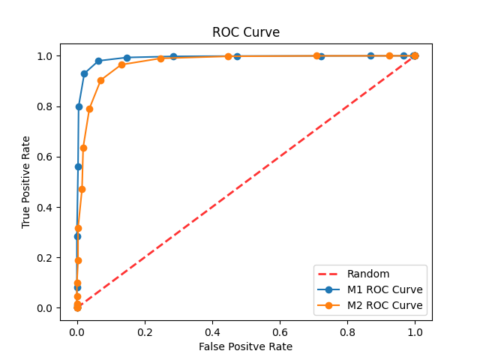
2. **Model M1** performs better on this data.

The curve that reaches closer to the top left corner of the graph denotes the better performing model. By visually comparing ROC graphs of given two models, it is found that ROC graph of M1 is slightly in top-left position with ROC curve of M2. It confirms that M1 will always give better (lesser False Positive points compare to True positive points) or same results than M2.

It is found that AUC of M1 is greater than AUC of M2 and that also supports the above statement.

**3.**

Area Under the curve (AUC) for M1: **0.9894237454500838**

Area Under the curve (AUC) for M2: **0.9681889933184838**

1. When false acceptance rate is 10%,

True positive rate for M1: **0.9858447507259417**

True positive rate for M2: **0.9334093356781591**

1. Model M1 and M2 can achieve