Machine Learning

Assignment - Fractal 3

Submitted by

Debonil Ghosh (M21AIE225)

**Problem 1: Perceptron [40 points]**

Following training samples are given:

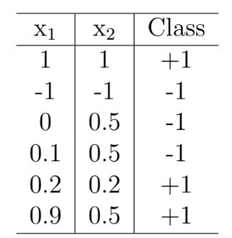

Table 1: Sample data

Assuming weight vector of initial decision boundary wT x = 0 as w=[1, 1], solve the following:

1. In how many steps perception learning algorithm will converge. (15 points)

2. What will be the final decision boundary? Show step-wise-step update of weight vector

using computation as well as hand-drawn plot. (15 points)

3. Prove that Perceptron Learning Algorithm converges in a finite number of steps. (10

points)

# Solution:

#### Program Output Part:

(Hand Written part Added later)

#### Initial Decision Boundary: w=[1,1,1]

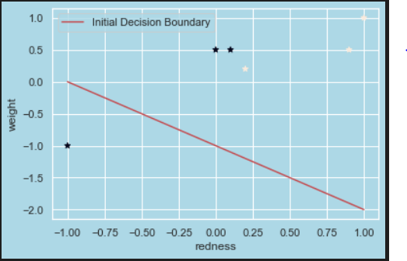

#### Iteration is : 1

Sample is : [1. 1. 1.]

Class is : 1

Dot Product of W & X is : 3.0

Positive Sample is correctly classified

Sample is : [-1. -1. 1.]

Class is : -1

Dot Product of W & X is : -1.0

Negative Sample is Correctly classified

Sample is : [0. 0.5 1. ]

Class is : -1

Dot Product of W & X is : 1.5

Negative Sample is classified positive

Updated W is : [1. 0.5 0. ]

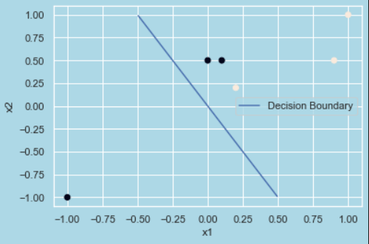

Sample is : [0.1 0.5 1. ]

Class is : -1

Dot Product of W & X is : 0.35

Negative Sample is classified positive

Updated W is : [ 0.9 0. -1. ]

Sample is : [0.2 0.2 1. ]

Class is : 1

Dot Product of W & X is : -0.82

Positive Sample is classified negative

Updated W is : [1.1 0.2 0. ]

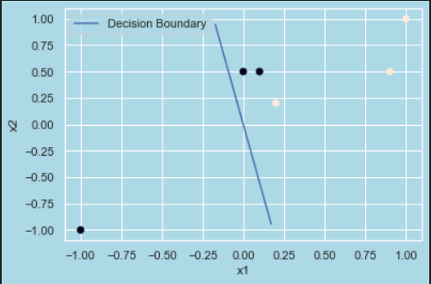

Sample is : [0.9 0.5 1. ]

Class is : 1

Dot Product of W & X is : 1.09

Positive Sample is correctly classified

#### Iteration is : 2

Sample is : [1. 1. 1.]

Class is : 1

Dot Product of W & X is : 1.3

Positive Sample is correctly classified

Sample is : [-1. -1. 1.]

Class is : -1

Dot Product of W & X is : -1.3

Negative Sample is Correctly classified

Sample is : [0. 0.5 1. ]

Class is : -1

Dot Product of W & X is : 0.1

Negative Sample is classified positive

Updated W is : [ 1.1 -0.3 -1. ]

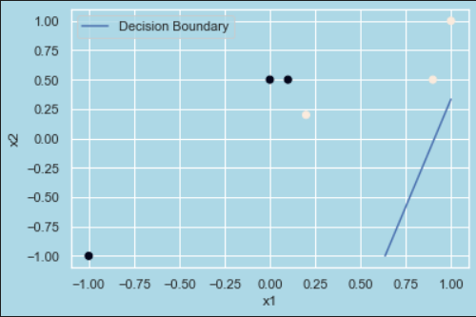

Sample is : [0.1 0.5 1. ]

Class is : -1

Dot Product of W & X is : -1.04

Negative Sample is Correctly classified

Sample is : [0.2 0.2 1. ]

Class is : 1

Dot Product of W & X is : -0.84

Positive Sample is classified negative

Updated W is : [ 1.3 -0.1 0. ]

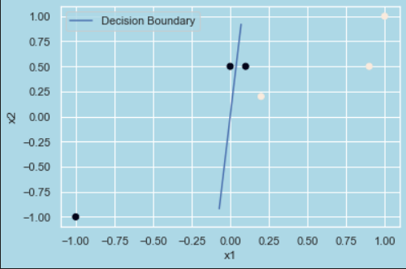

Sample is : [0.9 0.5 1. ]

Class is : 1

Dot Product of W & X is : 1.12

Positive Sample is correctly clasified

#### Iteration is : 3

Sample is : [1. 1. 1.]

Class is : 1

Dot Product of W & X is : 1.2000000000000002

Positive Sample is correctly clasified

Sample is : [-1. -1. 1.]

Class is : -1

Dot Product of W & X is : -1.2000000000000002

Negative Sample is Correctly classified

Sample is : [0. 0.5 1. ]

Class is : -1

Dot Product of W & X is : -0.04999999999999999

Negative Sample is Correctly classified

Sample is : [0.1 0.5 1. ]

Class is : -1

Dot Product of W & X is : 0.08000000000000002

Negative Sample is classified positive

Updated W is : [ 1.2 -0.6 -1. ]

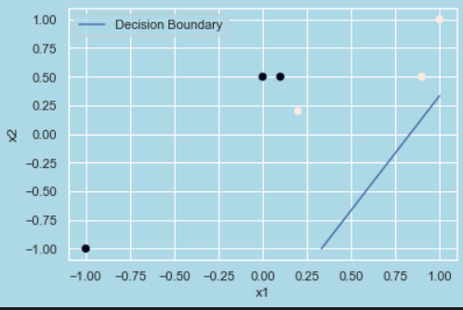

Sample is : [0.2 0.2 1. ]

Class is : 1

Dot Product of W & X is : -0.88

Positive Sample is classified negative

Updated W is : [ 1.4 -0.4 0. ]

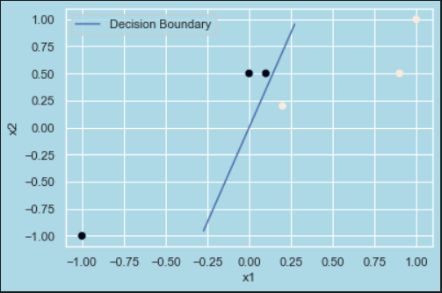

Sample is : [0.9 0.5 1. ]

Class is : 1

Dot Product of W & X is : 1.06

Positive Sample is correctly classified

#### Iteration is : 4

Sample is : [1. 1. 1.]

Class is : 1

Dot Product of W & X is : 1.0

Positive Sample is correctly classified

Sample is : [-1. -1. 1.]

Class is : -1

Dot Product of W & X is : -1.0

Negative Sample is Correctly classified

Sample is : [0. 0.5 1. ]

Class is : -1

Dot Product of W & X is : -0.19999999999999998

Negative Sample is Correctly classified

Sample is : [0.1 0.5 1. ]

Class is : -1

Dot Product of W & X is : -0.06

Negative Sample is Correctly classified

Sample is : [0.2 0.2 1. ]

Class is : 1

Dot Product of W & X is : 0.19999999999999998

Positive Sample is correctly classified

Sample is : [0.9 0.5 1. ]

Class is : 1

Dot Product of W & X is : 1.06

Positive Sample is correctly classified

[ 1.4 -0.4 0. ]

#### Final Decision Boundary is:

#### 