

**ITS30305107816 Web Programming**

**Assignment 1**

**Cover Sheet**

**Hand out Date: 24th October 2017 (Tuesday)**

**Hand in Date : 8th November 2017 (Wednesday)**

**Presentation time: 7th/8th November 2017 (During class time)**

**WEIGHTAGE: 15%**

**Instructions to students:**

* The assignment should be attempted individualy
* Complete this cover sheet and attach it to your assignment – this should be your first page!

|  |  |
| --- | --- |
| **Student declaration:** | |
| ***I declare that:***   1. ***I understand what is meant by plagiarism*** 2. ***The implication of plagiarism have been explained to us by our lecturer***   ***This project is all our work and I have acknowledged any use of the published or unpublished works of other people.*** | |
| **Name** | **Student ID** |
| **Thaqif Syarafuddin bin Roslan** | 0331337 |

*Avoid copy and paste job in your report and it is considered as plagiarism. Plagiarism in all forms is forbidden. Students who submit plagiarised assignment will deserved a 0 marks.*

Table of Contents

**Introduction3**

**Website Design4**

Site map4

Storyboard5-7

**Appendix8-35**

**List of references36**

Introduction

The purpose and goal of the website is to share things about me and my hobbies. The target audience of my website is my friends and other teenagers. This website allows people to get to know me more and get to interact with me through email and other social medias that I have linked in the website. The website is called Me-ow, this is a play on words which is “Me” means it’s about myself and I love cats, so I added the “ow” which makes it “Meow”. With this website I hope I can make more new friends and even strengthen bonds with friends that I already have.

Website Design

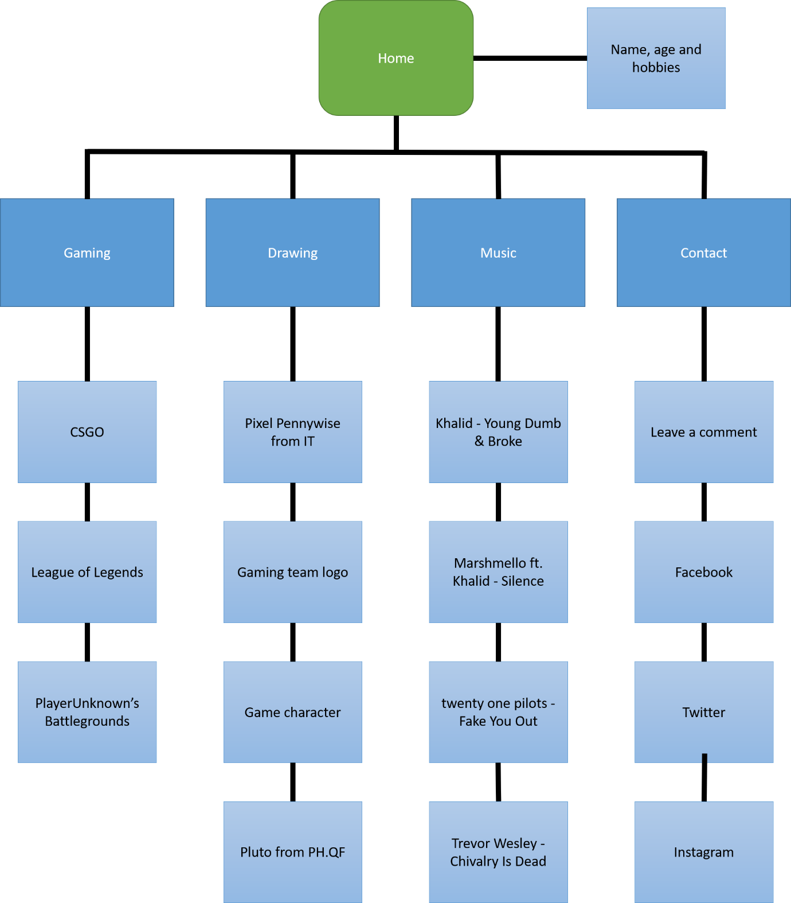Site Map

Storyboard

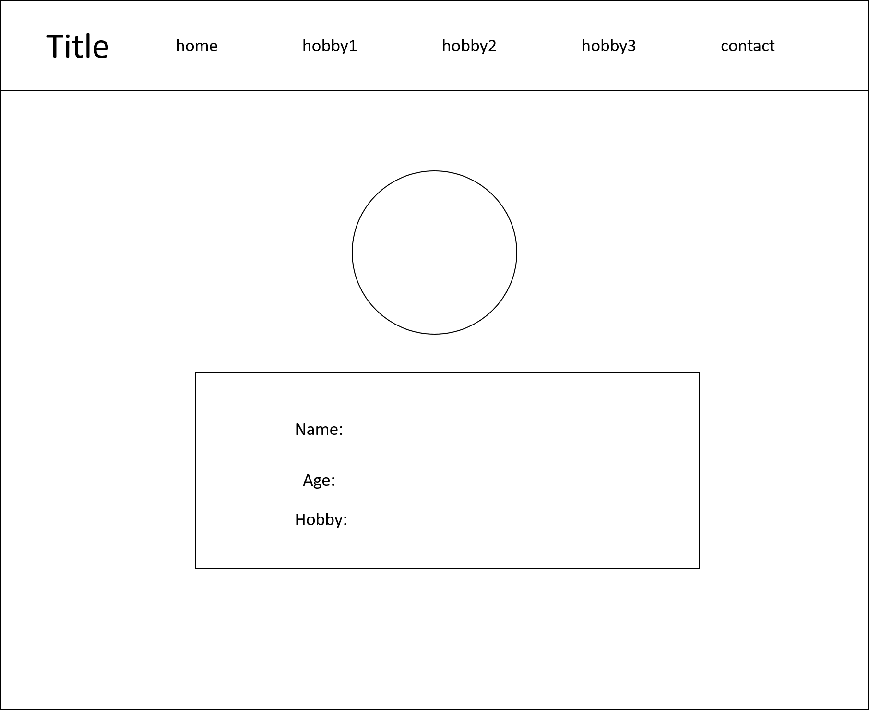

Home page

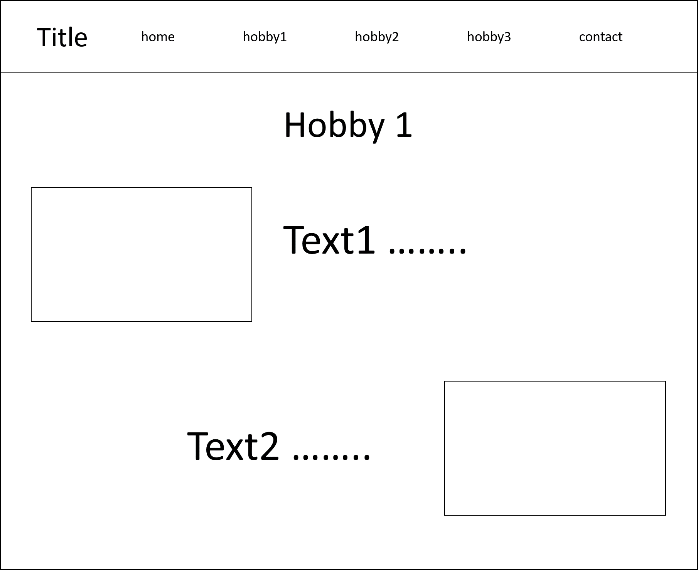

Hobby1 page

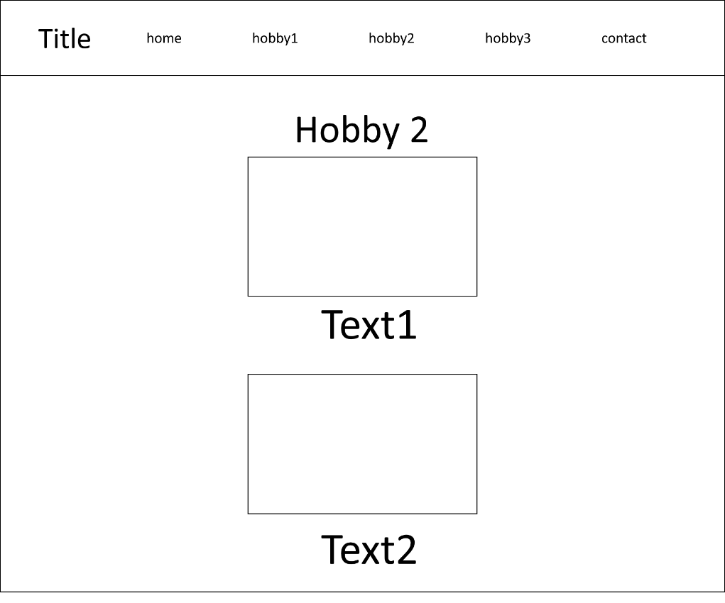

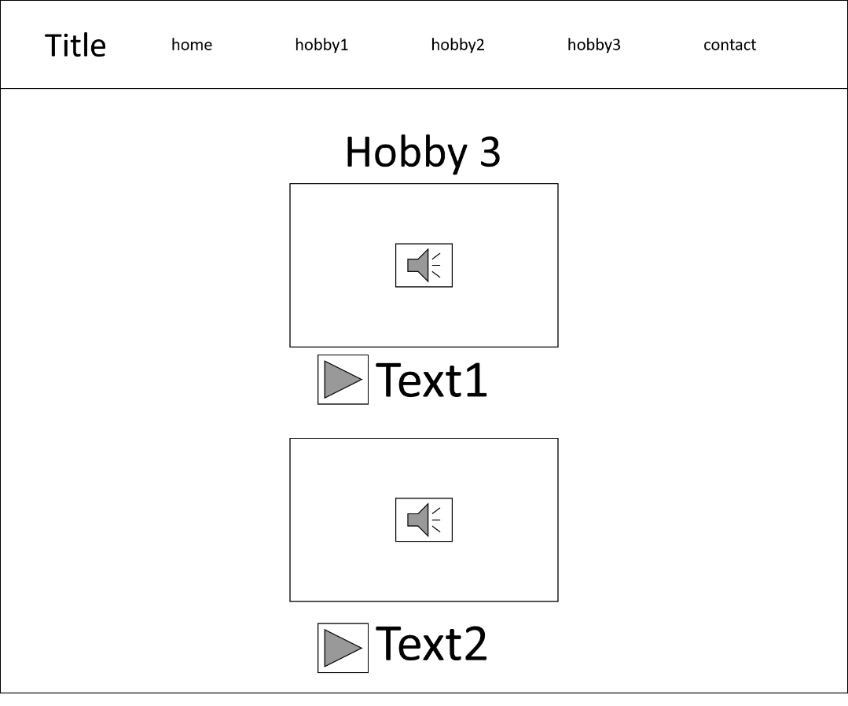 Hobby2 page

Hobby3 page

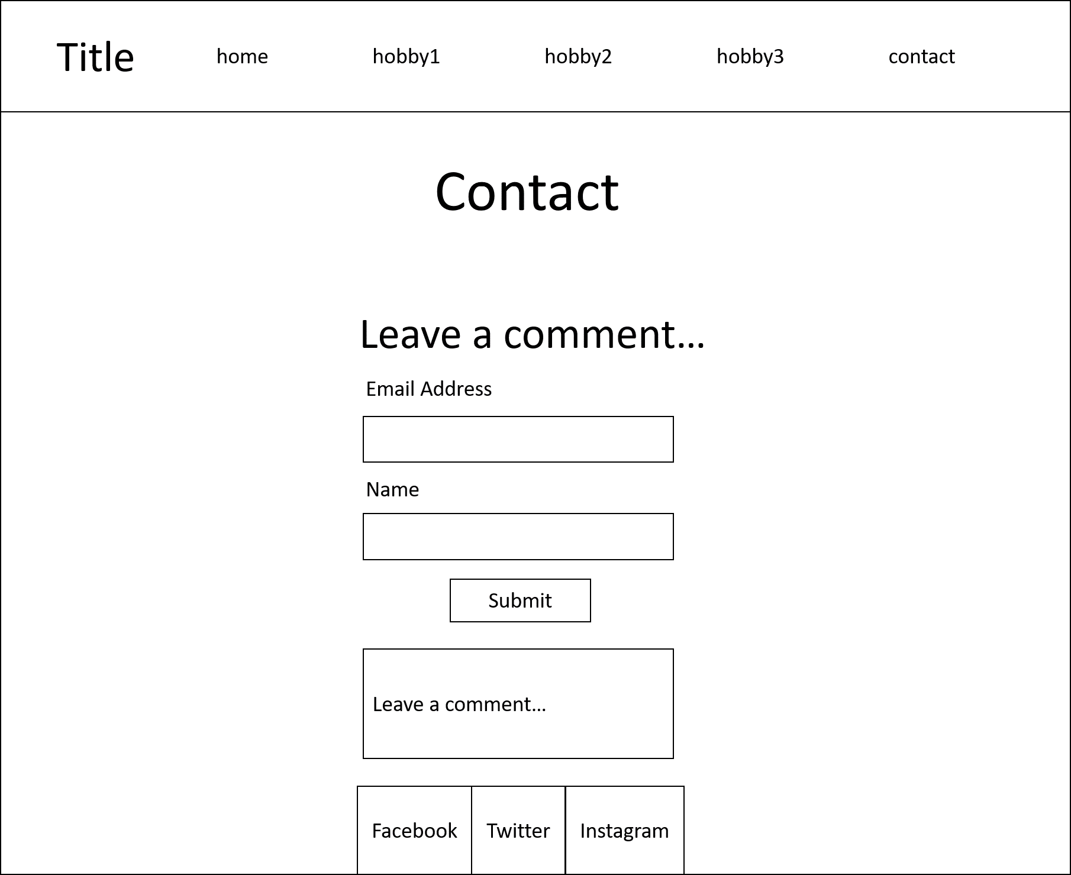

Contact page

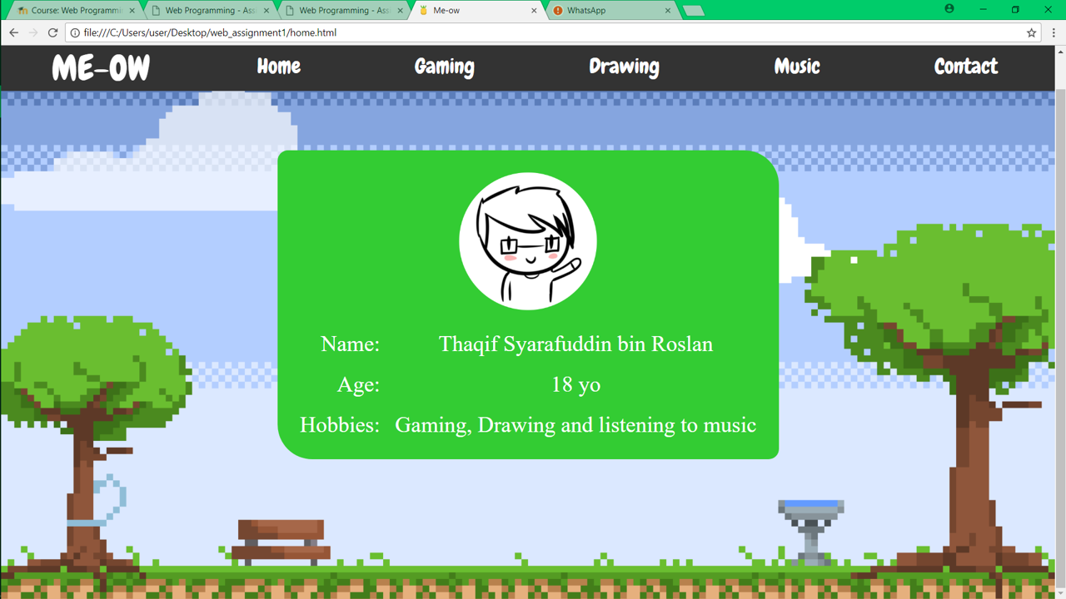Appendix

Home page

<!DOCTYPE html>

<html>

<link type ="text/css" rel="stylesheet" href="style_sheet.css"/>

<link rel="shortcut icon" href="new logo.png" type="image/x-icon">

<head>

<link href="https://fonts.googleapis.com/css?family=Chewy" rel="stylesheet">

<title> Me-ow </title>

</head>

<body>

<ul>

<li ID="meow">ME-OW</li>

<li><a href="home.html">Home</a></li>

<li><a href="gaming.html">Gaming</a></li>

<li><a href="drawing.html">Drawing</a></li>

<li><a href="music.html">Music</a></li>

<li><a href="contact.html">Contact</a></li>

</ul>

<br>

<br>

<br>

<br>

<br>

<br>

<br>

<br>

<br>

<br>

<br>

<table ID="rcorners6">

<tr ID="fontchewy">

<td align="center" colspan="2"> <img src="new pic.png" height="200" width="200"></td>

</tr>

<tr>

<td align="right"> Name: </td>

<td align="center"> Thaqif Syarafuddin bin Roslan </td>

</tr>

<tr>

<td align="right"> Age: </td>

<td align="center"> 18 yo </td>

</tr>

<tr>

<td align="right"> Hobbies: </td>

<td align="center"> Gaming, Drawing and listening to music</td>

</tr>

</table>

<br>

<br>

<br>

<br>

<br>

<br>

<br>

<br>

<br>

<br>

<br>

</body>

</html>

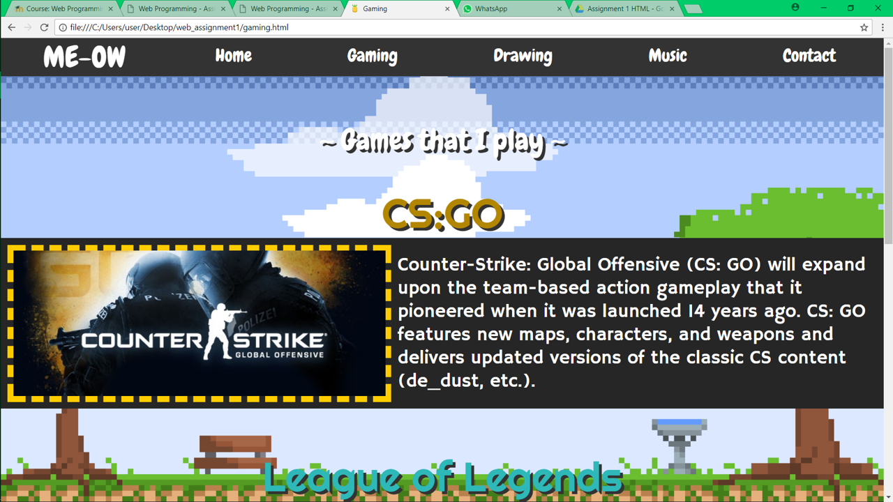Gaming page

<!DOCTYPE html>

<html>

<link type ="text/css" rel="stylesheet" href="style_sheet.css"/>

<link rel="shortcut icon" href="new logo.png" type="image/x-icon">

<link href="https://fonts.googleapis.com/css?family=Righteous" rel="stylesheet">

<link href="https://fonts.googleapis.com/css?family=Hammersmith+One" rel="stylesheet">

<head>

<link href="https://fonts.googleapis.com/css?family=Chewy" rel="stylesheet">

<title> Gaming </title>

</head>

<body>

<ul>

<li ID="meow">ME-OW</li>

<li><a href="home.html">Home</a></li>

<li><a href="gaming.html">Gaming</a></li>

<li><a href="drawing.html">Drawing</a></li>

<li><a href="music.html">Music</a></li>

<li><a href="contact.html">Contact</a></li>

</ul>

<br>

<br>

<br>

<br>

<br>

<p ID="default" align="center"> ~ Games that I play ~ </p>

<table ID="color">

<caption ID="caption"> CS:GO </caption>

<tr>

<td ID="border1"><img src="csgo.png" align="center" ></td>

<td>Counter-Strike: Global Offensive (CS: GO) will expand upon the team-based action gameplay that it pioneered when it was launched 14 years ago. CS: GO features new maps, characters, and weapons and delivers updated versions of the classic CS content (de_dust, etc.).</td>

</tr>

</table>

<br>

<br>

<br>

<br>

<table ID="color">

<caption ID="caption1"> League of Legends </caption>

<tr>

<td ID="caption3">League of Legends (abbreviated LoL) is a multiplayer online battle arena video game developed and published by Riot Games for Microsoft Windows and macOS. The game follows a freemium model and is supported by microtransactions, and was inspired by the Warcraft III: The Frozen Throne mod, Defense of the Ancients.</td>

<td ID="border2"><img src="league.png" align="center" width="640px" height="360px"></td>

</tr>

</table>

<br>

<br>

<br>

<br>

<table ID="color">

<caption ID="caption"> PlayerUnknown's Battlegrounds </caption>

<tr>

<td ID="border1"><img src="pubg.png" align="center" width:"640px" height="359.68"></td>

<td ID="caption2">PlayerUnknown's Battlegrounds (PUBG) is a multiplayer online battle royale video game developed and published by PUBG Corp., a subsidiary of Korean publisher Bluehole. The game is based on previous mods that were developed by Brendan "PlayerUnknown" Greene for other games using the 2000 film Battle Royale for inspiration, and expanded into a standalone game under Greene's creative direction. In the game, up to one hundred players parachute onto an island and scavenge for weapons and equipment to kill others while avoiding getting killed themselves. The available safe area of the game's map decreases in size over time, directing surviving players into tighter areas to force encounters. The last player or team standing wins the round.</td>

</tr>

</table>

</body>

</html>

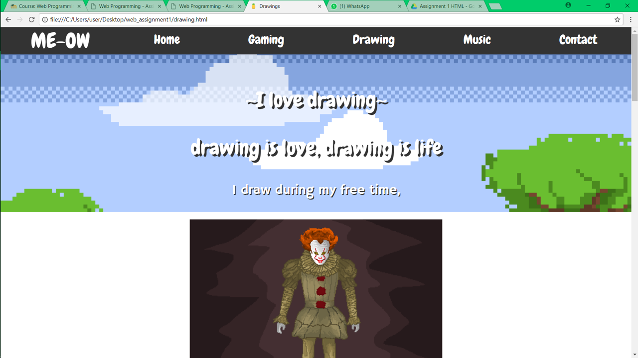

Drawing page

<!DOCTYPE html>

<html>

<link type ="text/css" rel="stylesheet" href="style_sheet.css"/>

<link rel="shortcut icon" href="new logo.png" type="image/x-icon">

<link href="https://fonts.googleapis.com/css?family=Righteous" rel="stylesheet">

<link href="https://fonts.googleapis.com/css?family=Hammersmith+One" rel="stylesheet">

<head>

<link href="https://fonts.googleapis.com/css?family=Chewy" rel="stylesheet">

<title> Drawings </title>

</head>

<body>

<ul>

<li ID="meow">ME-OW</li>

<li><a href="home.html">Home</a></li>

<li><a href="gaming.html">Gaming</a></li>

<li><a href="drawing.html">Drawing</a></li>

<li><a href="music.html">Music</a></li>

<li><a href="contact.html">Contact</a></li>

</ul>

<br>

<br>

<br>

<br>

<br>

<center>

<p ID="default" align="center"> ~I love drawing~ </p>

<p ID="default" align="center"> drawing is love, drawing is life </p>

<p ID="caption4" align="center"> I draw during my free time,</p>

<div class="container">

<br>

<img ID="center" src="it pixelart.png">

<p ID="caption5"> Pixel Pennywise from IT</p>

</div>

</center>

<br>

<br>

<br>

<br>

<br>

<br>

<br>

<br>

<br>

<br>

<br>

<br>

<br>

<br>

<br>

<center>

<div class="container2">

<br>

<img ID="center" src="lizard hazard vector2.png">

<p ID="caption6"> Gaming team logo</p>

</div>

</center>

<br>

<br>

<br>

<br>

<br>

<br>

<br>

<br>

<br>

<br>

<br>

<br>

<br>

<br>

<br>

<center>

<div class="container3">

<br>

<img ID="center" src="nargacuga.png">

<p ID="caption6"> game character</p>

</div>

</center>

<br>

<br>

<br>

<br>

<br>

<br>

<br>

<br>

<br>

<br>

<br>

<br>

<br>

<br>

<br>

<center>

<div class="container4">

<br>

<img ID="center" src="Pluto_v1a.png">

<p ID="caption6"> Pluto <br>from PH.QF</p>

</div>

</center>

</body>

</html>

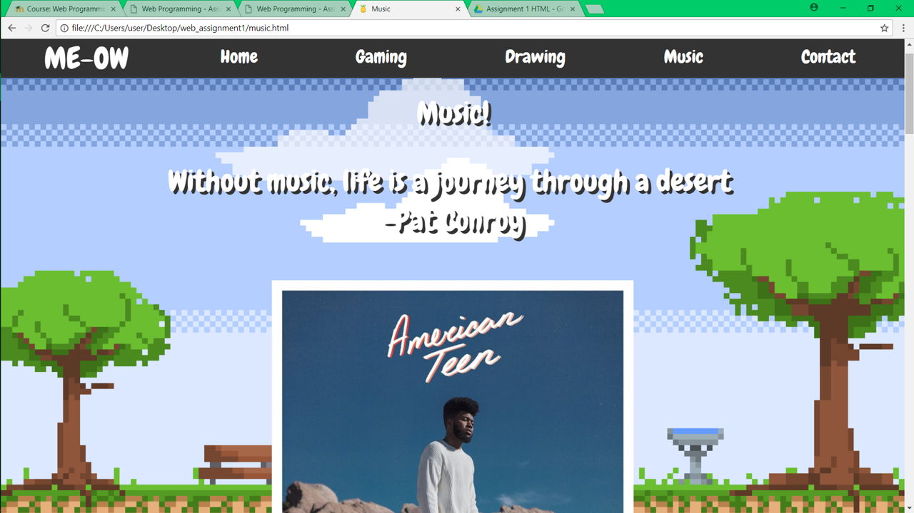Music page

<!DOCTYPE html>

<html>

<link type ="text/css" rel="stylesheet" href="style_sheet.css"/>

<link rel="shortcut icon" href="new logo.png" type="image/x-icon">

<link href="https://fonts.googleapis.com/css?family=Righteous" rel="stylesheet">

<link href="https://fonts.googleapis.com/css?family=Hammersmith+One" rel="stylesheet">

<head>

<link href="https://fonts.googleapis.com/css?family=Chewy" rel="stylesheet">

<title> Music </title>

</head>

<body>

<ul>

<li ID="meow">ME-OW</li>

<li><a href="home.html">Home</a></li>

<li><a href="gaming.html">Gaming</a></li>

<li><a href="drawing.html">Drawing</a></li>

<li><a href="music.html">Music</a></li>

<li><a href="contact.html">Contact</a></li>

</ul>

<br>

<br>

<br>

<br>

<br>

<center>

<p ID="default" align="center"> Music! </p>

<p ID="default" align="center"> Without music, life is a journey through a desert <br>-Pat Conroy </p>

<!-- <p ID="caption4" align="center"> I draw during my free time,</p>--!>

<div>

<br>

<img ID="center" src="youngdumb.png">

<p ID="music" >Khalid - Young Dumb & Broke</p>

<audio controls>

<source src="young_dumb_and_broke.mp3" type="audio/mp3">

</audio>

</div>

</center>

<br>

<br>

<br>

<br>

<br>

<br>

<br>

<br>

<br>

<br>

<br>

<br>

<br>

<br>

<br>

<center>

<div>

<br>

<img ID="center" src="silence.png">

<p ID="music">Marshmello ft. Khalid - Silence</p>

<audio controls>

<source src="silence_marshmellow.mp3" type="audio/mp3">

</audio>

</div>

</center>

<br>

<br>

<br>

<br>

<br>

<br>

<br>

<br>

<br>

<br>

<br>

<br>

<br>

<br>

<br>

<center>

<div>

<br>

<img ID="center" src="vessel.png">

<p ID="music2"> twenty one pilots - Fake You Out</p>

<audio controls>

<source src="fake_u_out.mp3" type="audio/mp3">

</audio>

</div>

</center>

<br>

<br>

<br>

<br>

<br>

<br>

<br>

<br>

<br>

<br>

<br>

<br>

<br>

<br>

<br>

<center>

<div>

<br>

<img ID="center" src="chivalry.png">

<p ID="music">Trevor Wesley - Chivalry Is Dead</p>

<audio controls>

<source src="chivalry_is_dead.mp3" type="audio/mp3">

</audio>

</div>

</center>

<br>

<br>

<br>

<br>

</body>

</html>

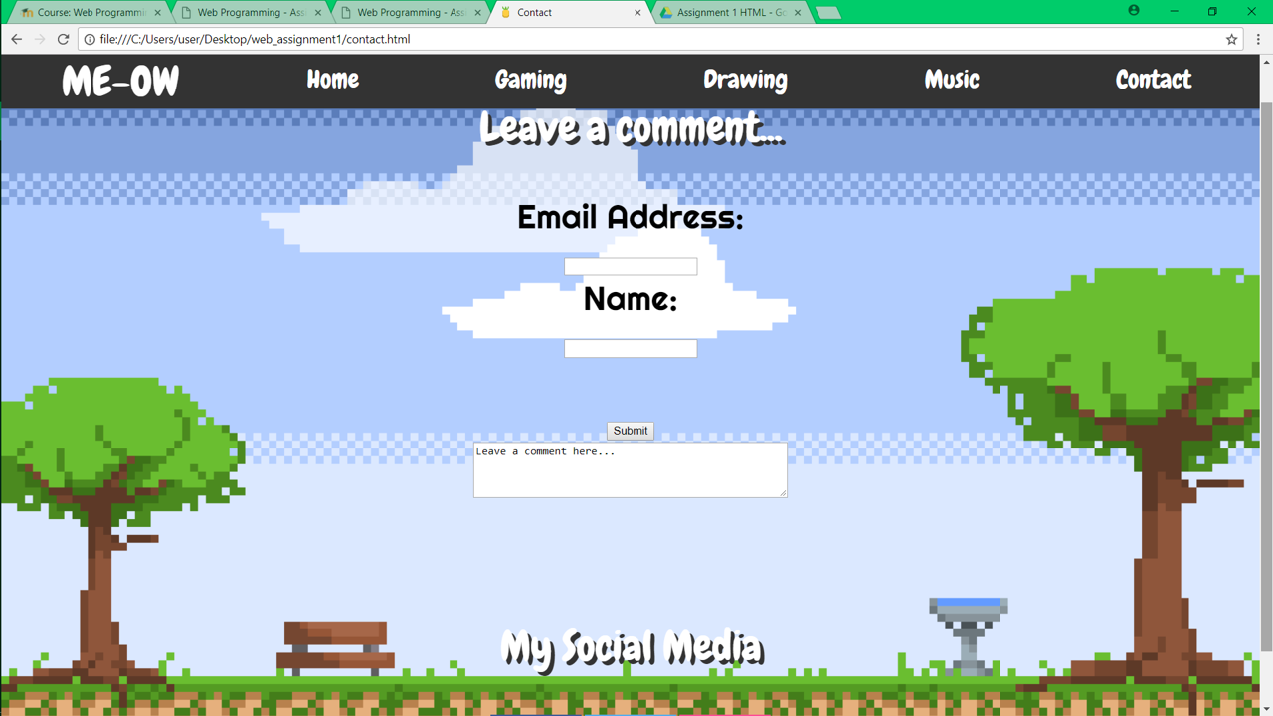

Contact page

<!DOCTYPE html>

<html>

<link type ="text/css" rel="stylesheet" href="style_sheet.css"/>

<link rel="shortcut icon" href="new logo.png" type="image/x-icon">

<link href="https://fonts.googleapis.com/css?family=Righteous" rel="stylesheet">

<link href="https://fonts.googleapis.com/css?family=Hammersmith+One" rel="stylesheet">

<head>

<link href="https://fonts.googleapis.com/css?family=Chewy" rel="stylesheet">

<title> Contact </title>

</head>

<body>

<ul>

<li ID="meow">ME-OW</li>

<li><a href="home.html">Home</a></li>

<li><a href="gaming.html">Gaming</a></li>

<li><a href="drawing.html">Drawing</a></li>

<li><a href="music.html">Music</a></li>

<li><a href="contact.html">Contact</a></li>

</ul>

<br>

<br>

<br>

<center>

<!-- <p ID="default" align="center"> Contact </p>--!>

<p ID="default" align="center"> Leave a comment...</p>

<!-- <p ID="caption4" align="center"> I draw during my free time,</p>--!>

<div>

<form ID="caption7">

Email Address:<br>

<input type="text" name="email" value=""><br>

Name:<br>

<input type="text" name="name" value=""><br><br>

<input type="submit" value="Submit" onclick="myFunction()">

<script>

function myFunction() {

alert("Your comment has been submitted, Thanks!");

}

</script>

</form>

<textarea rows="4" cols="50" name="comment" form="usrform">

Leave a comment here...</textarea>

</center>

<br>

<br>

<br>

<br>

<br>

<p ID="default" align="center"> My Social Media</p>

<!-- Add icon library -->

<link rel="stylesheet" href="https://cdnjs.cloudflare.com/ajax/libs/font-awesome/4.7.0/css/font-awesome.min.css">

<!-- Add font awesome icons -->

<center>

<a href="https://www.facebook.com/thaqif.syarafuddin.7" class="fa fa-facebook"></a>

<a href="https://twitter.com/justqif" class="fa fa-twitter"></a>

<a href="https://www.instagram.com/justqif/" class="fa fa-instagram"></a>

<center>

</body>

</html>

CSS

body {

background-image: url('background_ani.gif');

margin: 0;

padding: 0;

background-attachment: fixed;

background-position: center;

background-repeat: no-repeat;

background-size: cover;

}

ul {

overflow: hidden;

list-style-type: none;

margin: 0;

padding: 0;

background-color: #333;

width: 100%;

position: fixed;

top: 0;

text-align: center;

display: flex;

justify-content: space-around;

}

li {

display: inline-block;

padding: 10px 10px;

}

li a:hover

{

color: #46CB2D;

}

li a {

display: block;

padding: 0px;

color: white;

text-align : center;

text-decoration: none;

font-size: 30px;

font-family: 'Chewy';

}

.active {

background-color: #FF0000

}

table, tr, td

{

font-family: 'Chewy';

padding: 10px;

align: center;

margin-right: auto;

margin-left: auto;

}

td {

color: white;

font-size: 32px;

font-family: 'Hammersmith One'

}

#rcorners6

{

border-radius: 15px 50px;

background: #33cc33;

padding: 20px;

}

ul {

position: fixed;

top: 0;

width: 100%;

}

#meow {

display: block;

padding: 0px;

color: white;

text-align : center;

text-decoration: none;

font-size: 50px;

font-family: 'Chewy';

}

#default

{

font-family: 'Chewy';

color: white;

font-size: 50px;

text-shadow: 5px 5px #333333;

}

#border1

{

border-width:10px;

border-style:dashed;

border-color: #ffcc00;

padding: 0px;

}

#color

{

background-color: #262626;

}

#caption

{

font-family: 'Righteous';

color: #b38600;

font-size: 70px;

text-shadow: 5px 5px #333333;

}

#caption1

{

font-family: 'Righteous';

color: #2eb8b8;

font-size: 70px;

text-shadow: 5px 5px #333333;

}

#border2

{

border-width:10px;

border-style:dashed;

border-color: #47d1d1;

padding: 0px;

}

#caption2

{

font-family: 'Righteous';

font-color: white;

font-size: 25px;

}

#caption3

{

font-family: 'Righteous';

font-color: white;

font-size: 40px;

}

#caption4

{

color: white;

font-size: 32px;

font-family: 'Hammersmith One';

text-shadow: 2px 2px #333333;

}

#center

{

display: block;

margin: auto;

width: 40%;

}

#caption5

{

color: white;

font-size: 32px;

font-family: 'Hammersmith One';

text-shadow: 2px 2px #333333;

border-radius: 25px;

background: #b30000;

padding: 20px;

width: 500px;

height: 30px;

}

.container

{

width: 100%;

height: 510px;

background-color: white;

float: center;

}

.container2

{

width: 100%;

height: 550px;

background-color: white;

float: center;

}

#caption6

{

color: white;

font-size: 32px;

font-family: 'Hammersmith One';

text-shadow: 2px 2px #333333;

border-radius: 25px;

background: #66cc00;

padding: 20px;

width: 200px;

height: 80px;

}

.container3

{

width: 100%;

height: 680px;

background-color: white;

float: center;

}

#fontchewy

{

font-family: 'Chewy';

}

.container4

{

width: 100%;

height: 640px;

background-color: white;

float: center;

}

#music

{

color: white;

font-size: 32px;

font-family: 'Hammersmith One';

text-shadow: 2px 2px #333333;

border-radius: 25px;

background: black;

padding: 20px;

width: 500px;

height: 30px;

}

#music2

{

color: white;

font-size: 32px;

font-family: 'Hammersmith One';

text-shadow: 2px 2px #333333;

border-radius: 25px;

background: black;

padding: 20px;

width: 600px;

height: 30px;

}

#caption7

{

font-family: 'Righteous';

font-color: white;

font-size: 40px;

}

.fa {

padding: 30px;

font-size: 50px;

width: 50px;

text-align: center;

text-decoration: none;

}

.fa:hover

{

opacity: 0.7;

}

/* Facebook */

.fa-facebook

{

background: #3B5998;

color: white;

}

/* Twitter */

.fa-twitter

{

background: #55ACEE;

color: white;

}

/* Instagram*/

.fa-instagram

{

background: #ff4d94;

color: white;

}

Reference

-https://www.w3schools.com/colors/colors_picker.asp

-https://www.w3schools.com/css/css_navbar.asp

-https://www.w3schools.com/howto/howto_css_social_media_buttons.asp

-https://www.youtube.com/watch?v=IPfJnp1guPc

-https://www.youtube.com/watch?v=tk36ovCMsU8

-https://www.youtube.com/watch?v=KnthhE071-I

-https://www.youtube.com/watch?v=aZfR7qc0WVs