**library management system**

**Project Abstract**

**Version 1.0**

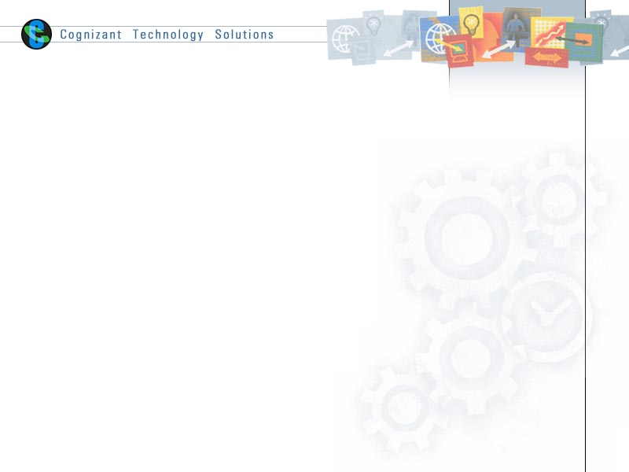

|  |  |  |  |
| --- | --- | --- | --- |
|  | Prepared By / Last Updated By | Reviewed by | Approved By |
| Name | Debopriya Dey | Tanmay Ghosal | Tanmay Ghosal |
| Role | Intern | Cohort Mentor | Cohort Mentor |
| Signature | Debopriya Dey | Tanmay Ghosal | Tanmay Ghosal |
| Date |  |  |  |

Table of Contents

1.0 Purpose of this document 4

2.0 Business Case 4

3.0 Appendices 4

3.1 Glossary 4

3.2 Other 4

4.0 Terms & Conditions 5

5.0 Change Log 5

# Purpose of this document

This document provides an overview about the business need and the solution that can be provided to fulfil the objective.

# Business Case

An online ticket booking platform facilitates selection, reservation and purchase of tickets for the movies. The platform contains:

1. Information such as current Movie that is being aired also the list of upcoming movies. The user provides the necessary details such as or phone number and creates a password for the platform. Once done he has to enter the created credential to log in.  movie schedule, trailers and price of the tickets.
2. A ticket booking system that allows the user to select and book seats and even purchase the tickets.  Logged in users can view booking history on the website.
3. The admin can view the details of the booked seats and generate income report from the website. They have the authority to Add/Update Movies.

# Appendices

## Glossary

|  |  |
| --- | --- |
| **Acronyms** | **Definitions** |
|  |  |

## Other

# Terms & Conditions

***Disclaimer: Please do not circulate or distribute this document outside of Cognizant Network, We have a Zero Tolerance Policy. Kindly adhere to 100% Compliance at all times.***

# Change Log

*Please note that this table needs to be maintained even if a Configuration Management tool is used.*

|  |  |  |  |  |
| --- | --- | --- | --- | --- |
| Version Number | Changes made | | | |
| V<1.0> | *<If the change details are not explicitly documented in the table below, reference should be provided here>* | | | |
| Page no | Changed by | Effective date | Changes effected |
|  |  |  |  |
|  |  |  |  |
|  |  |  |  |
|  |  |  |  |