**Greedy Based Channel Allocation Strategy**

Prepared By

**B.Tech. Sem – VI**

**Saradindu Rana -- T91-CSE-186011**

**Debopriyo Ghosh – T91-CSE-186003**

***Under the guidance of Dr. Rajib Kumar Das***

**Contents**

|  |  |  |
| --- | --- | --- |
| Index | Pg. No | |
| 1. Abstract | |  |
| 1. Introduction | |  |
| 1. Mathematical model | |  |
| 1. Proposed algorithm | |  |
| 1. System Simulation | |  |
| 1. Conclusion | |  |
| 1. References | |  |

**Greedy Based Channel Allocation Strategy**

1. **Abstract**

Channel allocation schemes are required in mobile networks to allocate bandwidth and channels to mobile stations. The main objective of channel allocation is to achieve maximum efficiency by means of channel reuse by avoiding adjacent and co-channel interferences among nearby cells or networks that share the bandwidth.

1. **Introduction**

Channel allocation is a process in which a single channel is divided and allotted to multiple users in order to carry user specific tasks. There is user’s quantity may vary every time the process takes place. If there are N number of users and channel is divided into N equal-sized sub channels, each user is assigned one portion. If the number of users are small and don’t vary at times, then Frequency Division Multiplexing can be used as it is a simple and efficient channel bandwidth allocating technique.

Channel allocation problem can be solved by two schemes: Static Channel Allocation in LANs and MANs, and Dynamic Channel Allocation. Channel allocation schemes can be divided into a number of different categories depending on the comparison basis. For example, when channel algorithms are compared based on the manner in which co-channels are separated, they can be divided into three main categories:

A. Fixed channel allocation (FCA),

B. Dynamic channel allocation (DCA),

C. Hybrid channel allocation (HCA).

**A. Static Channel Allocation:**

It is the classical or traditional approach of allocating a single channel among multiple competing users using Frequency Division Multiplexing (FDM). if there are N users, the bandwidth is divided into N equal sized portions each user being assigned one portion. since each user has a private frequency band, there is no interface between users. It is not efficient to divide into fixed number of chunks.

* Working Principle

Suppose that there are N competing users. Here, the total bandwidth is divided into N discrete channels using frequency division multiplexing (FDM). In most cases, the size of the channels is equal. Each of these channels is assigned to one user.

* Advantages
* Static channel allocation scheme is particularly suitable for situations where there are a small number of fixed users having a steady flow of uniform network traffic. The allocation technique is simple and so the additional overhead of a complex algorithm need not be incurred. Besides, there is no interference between the users since each user is assigned a fixed channel which is not shared with others.
* Disadvantages
* Most real-life network situations have a variable number of users, usually large in number with bursty traffic. If the value of N is very large, the bandwidth available for each user will be very less. This will reduce the throughput if the user needs to send a large volume of data once in a while.
* It is very unlikely that all the users will be communicating all the time. However, since all of them are allocated fixed bandwidths, the bandwidth allocated to non-communicating users lies wasted.
* If the number of users is more than N, then some of them will be denied service, even if there are unused frequencies.

**B. Dynamic Channel Allocation**

In dynamic channel allocation scheme, frequency bands are not permanently assigned to the users. Instead channels are allotted to users dynamically as needed, from a central pool. The allocation is done considering a number of parameters so that transmission interference is minimized. This allocation scheme optimises bandwidth usage and results is faster transmissions.

* Working Principle

In dynamic channel allocation schemes, frequency channels are not permanently allotted to any user. Channels are assigned to the user as needed depending upon the network environment. The available channels are kept in a queue or a spool. The allocation of the channels is temporary. Distribution of the channels to the contending users is based upon distribution of the users in the network and offered traffic load. The allocation is done so that transmission interference is minimized.

* Advantages
* Dynamic channel allocation schemes allot channels as needed. This results in optimum utilization of network resources. There are less chances of denial of services and call blocking in case of voice transmission. These schemes adjust bandwidth allotment according to traffic volume, and so are particularly suitable for bursty traffic.
* Disadvantages
* Dynamic channel allocation schemes increase the computational as well as storage load on the system.

## **Mathematical model of Channel Allocation Problem**

Let,

There are **n** no of devices **d1, d2, … dn** placed randomly,

One base station **BS** placed randomly,

Distance of device **di** from **BS** = **fi**

Bandwidth of every Channel = **B,**

The Signal to Noise Ratio(**SNR)** will be**,**

**SNR = 1 / (sum of interference of the devices which are allocated to same channel)**

**= 1 / ∑ I**

**Sum of Interference ∑ I = 1/SNR**

**Interference**  **I i, j** **= (fi / fj)4  , if i ≠ j**

**I i, j** = **0 , if i = j**

From **Shannon’s Theorem,**

Data Rate **(D)** = **B * Log2 (SNR+1)**

So to achieve this Data Rate,

**SNR ≥ 2 D/B  -1**

**or, 1/ SNR ≤ 1/ 2 D/B  -1**

**or, ∑ I ≤ 1/ 2 D/B  -1 [ Tolerance Ƭi = 1/ 2 D/B  -1 ]**

This Equation must have satisfied,  **∑ I ≤ Ƭi**

## **Proposed algorithm**

**Greedy Algorithm to allocate channels to devices**

Let,

There are **k** channels.

First **p** devices **d1, d2, ... dp** asking for data rate more than **B**, **[p < k]**

The next (**n – p)** devices **dp+1, dp+2, … dn** asking for data rate below **B**,

Sort the devices **dp+1** to **dn** in ascending order of data rate **ri**

[ **ri** = data rate in Mbps for device **di** in sorted order i, i = 1, 2 …. n]

Initialize,

**allocatedi** = i for i = 1 to p

**allocatedi** = 0 for i = p + 1 to n

1. **Begin**
2. **For I = p+1 . . . n do**
3. **For c = 1 . . . k do**
4. **Allocatedi = c**
5. **D = { j : allocatedj = c}**
6. **For each d ϵ D do**
7. **sumd = ∑x ϵ D  I d , x ;**
8. If **sumd > Ƭ’d** then
9. **allocatedi  = 0; break;**

[end if]

[end for]

1. If **allocatedi = c** then
2. Break

[end if]

[end for]

[end for]

1. **Stop**

## **System Simulation**

A Web application

Static Part

Assuming each device submits its information (location, data rate) to server as a client. In the server the above channel allocation algorithm runs and then the if the device is allocated to any channel then the data of the device is transmitted.

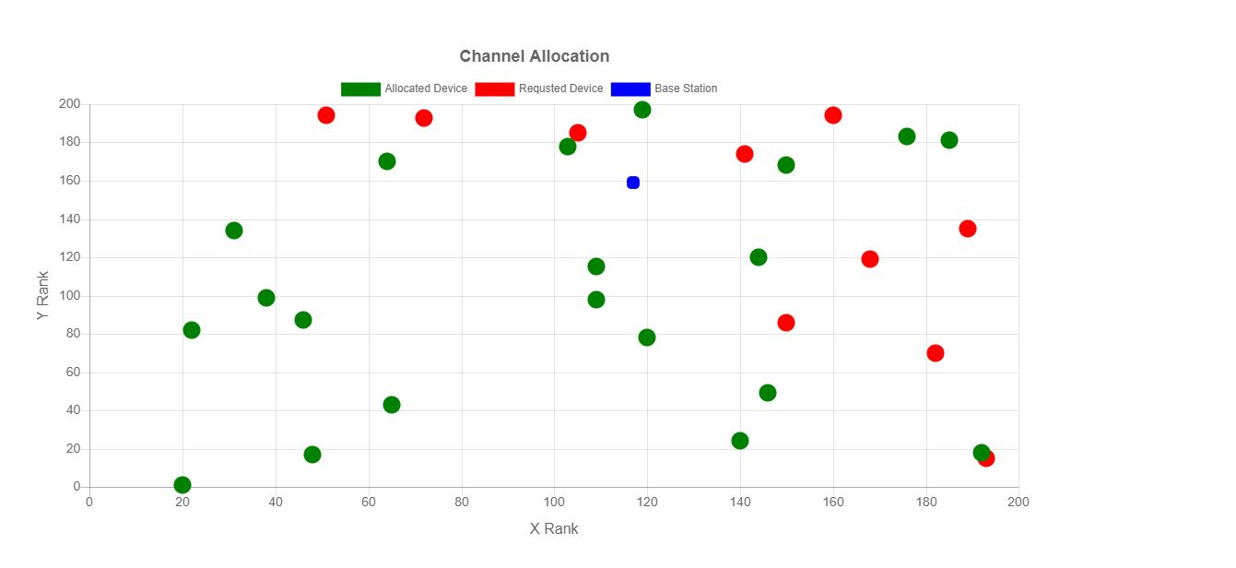

Fig 1: static channel allocation graph

The simulation model is shown in fig 1, here the base station placed randomly in (117, 159) coordinate (blue dot), and the number of channel is 10. Out of 30 devices 20 devices are allocated using above algorithm. Green dots indicate allocated device and Red dot indicates requesting devices for allocation.

Dynamic Part

A device after completing its communication will release the channel. Thus in a dynamic situation some devices leave and new devices may join. The channel allocation is done for the new set of devices without affecting existing communications. Some priority is given to devices denied earlier.

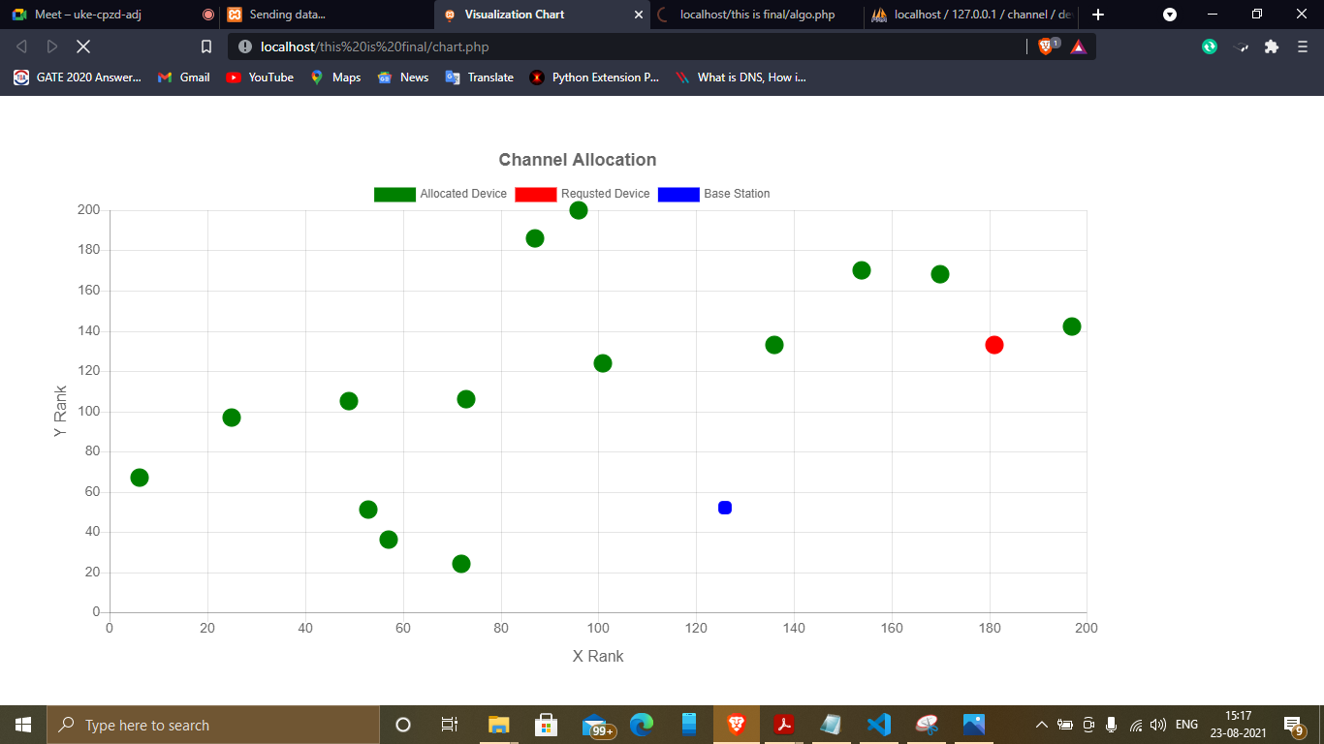

Fig 2: Dynamic channel allocation graph with requesting device

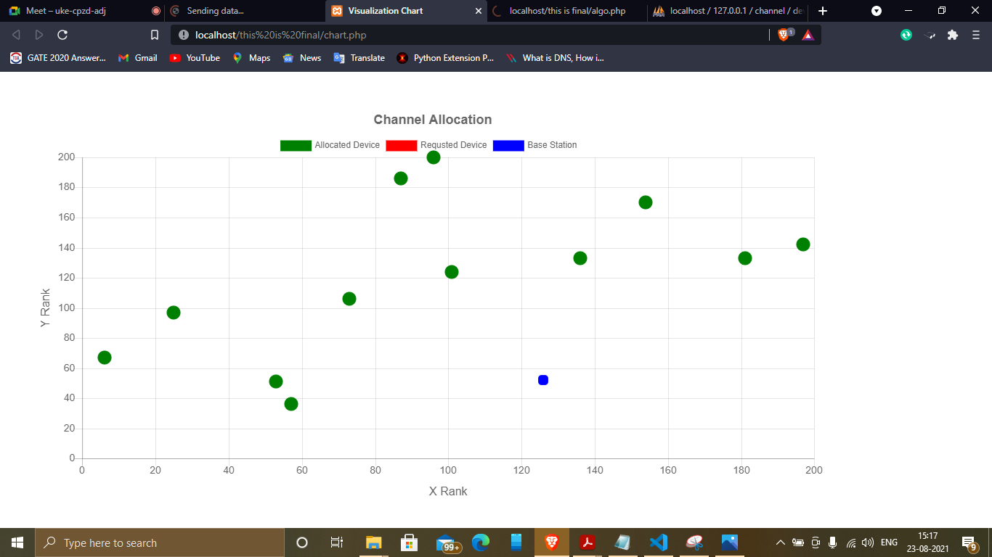

Fig 3: Dynamic channel allocation graph with allocated device

In this above simulation of dynamic situation number of channel is 7 and at first with 20 devices the algorithm starts, after sometime some device complete data transfer and leave the channel. All the requesting devices are sorted according to their priority. Meanwhile at the same time the sum of interference between the first requesting device in the sorted list and those allocated devices transferring data on that channel is calculated. If the sum of interference is less than the tolerance value of the device, that device gets allocated in that channel. A new requesting device joined (Red dot at right fig 2) then in fig 3 it gets allocated and turns green.

## **Conclusion**

Channel allocation problem, an NP hard problem, which means an exact solution cannot be found in polynomial time. Evolutionary and heuristic algorithms can be applied to find near optimal solutions to channel allocation.

This algorithm tries to allocate as many devices as possible to the channels in dynamic situation by greedy approach.

## **References**

* + - 1. [www.google.com](http://www.google.com)
      2. <https://ieeexplore.ieee.org/document/8729351>
      3. [Ruifang Li](https://ieeexplore.ieee.org/author/37086265775); [PuSheng Zhu](https://ieeexplore.ieee.org/author/37086853328); [Lisha Jin](https://ieeexplore.ieee.org/author/37086574663) Channel Allocation Scheme Based on Greedy Algorithm in Cognitive Vehicular Networks by Published in: 2019 IEEE 3rd Information Technology, Networking, Electronic and Automation Control Conference (ITNEC).
      4. M. Zhang and T. P.Yum, “Comparisons of channel assignment strategies in cellular mobile telephone systems,” IEEE Trans. Veh. Technol., vol. 38, pp. 211–215, Nov. 1989.
      5. <https://www.geeksforgeeks.org/maximum-data-rate-channel-capacity-for-noiseless-and-noisy-channels/>