**Index**

1. **Abstract**
2. **Introduction**
3. **Current Scenario**
4. **Purpose Of Dynamic Pricing**
5. **Various Pricing Strategies**
6. **Data and Dynamic pricing algorithms**
7. **Business Model & Implementation Planning**
8. **Use Case Diagram**
9. **E-R Diagram**
10. **Data Flow Diagram**
11. **Conclusion**
12. **Reference**
13. **Abstract**

Recently, as Electric Vehicles (EVs) take centre stage for the eco-friendly and cost-effective transportation, commercial EV charging stations would be widely prevalent in the future. However, previous studies in the fields of the management of EV charging stations did not synthetically take practical charging systems into account.

Dynamic pricing means, that the charging provider—which can be a distribution system operator or an operator/aggregator of charging stations—dynamically adapts the price, which has to be paid by the end users (the EV drivers) for charging their EVs. In this way, it is possible to react to changes in the operating conditions, for example, to increase the charging prices during periods of high electricity prices or high energy production costs, respectively. A second and even more important advantage of dynamic pricing for EV charging is that it allows to increase the flexibility provided by the users or to make use of the users’ flexibility in order to control their behaviour to a certain degree.

1. **Introduction**

The electric vehicle (EV) market in India is expected to hit over 63 lakh unit mark per annum by 2027, according to a report by India Energy Storage Alliance (IESA). "In the base case scenario, the EV market is expected to grow at CAGR of 44 per cent between 2020-2027 and is expected to hit 6.34-million-unit annual sales by 2027," the IESA report said. One of the challenges people have with electric vehicles is figuring out how much they cost to operate. The price of fully charging an electric vehicle’s battery can vary wildly depending on when and where you charge it. For the bigger picture, you should also include the amortized cost of buying and installing a home charging station and the rates your utility company charges.

The transport sector accounts for 18% of total energy consumption in India. This translates to an estimated 94 million tonnes of oil equivalent (MTOE) energy. If India were to follow the current trends of energy consumption, it would require an estimated 200 MTOE of energy supply annually, by the year 2030 to meet the demand of this sector. Moreover, the sector also contributes an estimated 142 Million Tonnes of CO2 emissions annually, out of which 123 million tonnes is contributed by the road transport segment alone.

An important requirement for the electrification of transport, besides the successful integration of the EVs into the power grid, is the availability of an adequate public EV charging infrastructure. The AFI (Alternative Fuels Infrastructure) directive of the European Union recommends a ratio of one publicly accessible charger per ten EVs .

If it is possible to operate public charging stations in a profitable way, then such an infrastructure or part of it could be deployed and operated by private sector stakeholders, like car manufacturers, oil companies or utility companies. The profitable operation of charging stations can be supported by so called EV aggregators. An EV aggregator is an agent, which aggregates a large number of charging points and acts as a middleman between charging station operators or EV owners and the energy market. According to Reference the viable trading of EV power on the wholesale market requires the aggregation of at least around 500 charging points or EVs.

Dynamic pricing is a promising approach to overcome the challenges related to an increasing penetration of EVs.

The International Renewable Energy Agency considers smart charging and user incentives, like dynamic pricing, to be two key factors for unlocking the flexibility potential from EVs, which is required for a successful grid integration of EVs and renewable energy in the future.

Thus, dynamic pricing for EV charging attracted a lot of researchers and a lot of different approaches to dynamic pricing in the context of EV charging were proposed and published in recent years. Different approaches to dynamic pricing for public and residential EV charging are reviewed and categorized according to their properties in this paper.

1. **Current Scenario**

The Electric Vehicle industry in India is far behind, with less than 1% of the total vehicle sales. Currently, Indian roads are dominated by conventional vehicles and have approximately 0.4 million electric two-wheelers and a few thousand electric cars only. The Indian EV industry has been on the back seat due to various challenges. In India there is less charging station compared to other nation due to which people cannot charge their vehicle for more time and use it daily. Government in India is implementing different policies to make people aware about using electric mobilities.

With electricity distribution and supply being a state subject as per the Indian Constitution, regulations at the state level determine the rules around connection and supply of electricity. This regulatory framework differs from one state to another, and appropriate state regulations should be considered when planning or installing charging facilities. Among the provisions of the state supply code, the following issues especially impact electricity connections for EV charging.

In recent years, the penetration of electric vehicles (EVs) significantly increased. In the year 2017, the sales of new EVs surpassed 1 million units and the global stock of electric passenger cars reached 3.1 million (an increase of 57% compared to 2016). In 2018, nearly 2 million new EVs were sold and the global stock increased to 5.1 million units (63 % more than in 2017) . The share of EVs is still small. Only five countries had an EV share higher than 1 % in 2018 . However, it can be expected that the considerable growth of the EV penetration will continue in the next years.

As of March 2021, 21 states and Union Territories have introduced specific tariffs for EV charging with reduced energy charges and/or demand charge exemptions. Details of state EV tariffs are provided in below table.

**EV tariffs in different states in India**

|  |  |  |  |
| --- | --- | --- | --- |
| State | EV TARIFF | | |
| ENERGY CHARGE | DEMAND CHARGE | |
| Low tension | High tension |
| Andhra Pradesh | Rs 6.7/kWh | - | - |
| Assam | Rs 5.25 to 6.75/kWh | Rs 130/kW per month | Rs 160/kVA per month |
| Bihar | Rs 6.3 to 7.4/kWh | - | - |
| Chhattisgarh | Rs 5/kWh | - | - |
| Delhi | Rs 4.5/kWh | - | - |
| Gujarat | Rs 4 to 4.1/kWh | - | Rs 25 to 50 per kVA per month |
| Haryana | Rs 6.2/kWh | Rs 100/kW per month | - |
| Himachal Pradesh | Rs 4.70 to Rs 5/kWh | - | Rs 130/connection per month and Rs 140/kVA per month |
| Jharkhand | Rs 6.00 to 6.25/kWh | Rs 40 to 150/connection per month |  |
| Karnataka | Rs 5/kWh | Rs 60/kW per month | Rs 190/kVA per month |
| Kerala | Rs 5/kWh | Rs 75/kW | 250/kVA per month |
| Madhya Pradesh | Rs 5.9 to Rs 6/kWh | - | Rs 100 to 120/kVA of billing demand |
| Maharashtra | Rs 4.05 to 4.24/kWh | - | Rs 70/kVA per month |
| Meghalaya | Rs 10.09/kWh | Rs 100 to 230/ connection per month | |
| Odisha | Rs 4.20 to 5.70/ kWh | Rs 200 to 250/kW per month | Rs 200 to 250/kVA per month |
| Punjab | Rs 5.4/kWh | - | - |
| Rajasthan | Rs 6/kWh | Rs 40/HP per month | Rs 135/kVA per month |
| Tamil Nadu | Rs 5 to 8.05/kWh | Rs 70/kW per month | - |
| Telangana | Rs 6/kWh | - | - |
| Uttar Pradesh | Rs 5.9 to Rs 7.7/kWh | - | - |
| Uttarakhand | Rs 5.5/kWh | - | - |

Fixed pricing is a strategy in which a price point is established and maintained for an extended period of time.

**Problem with Fixed Pricing**

* Fixed pricing doesn't allow for adjustments if a consumer realizes that cost basis is higher than expected.
* The customer pays the established price regardless of changes in electricity cost per unit also other factors.
* Fixed pricing also doesn't allow for adjustments over time to sell off extra inventory.

**4. Purpose of Dynamic Pricing:**

**Dynamic pricing**

Businesses implement dynamic pricing as a type of price discrimination. This allows businesses to change the price of a product based on a number of variables such as the market conditions or varying components within the business. With dynamic pricing, you can change the price your business charges for a product or service to reflect differences in market conditions and seasonality. For instance, charging price may be increased in case of peak hours in the charging stations, which will indirectly decrease load on the grid.

**Dynamic Pricing Advantages**

Dynamic pricing means the price on a product or service can change over time. Selecting the appropriate strategy for your business has major implications in your ongoing effort to attract customers and achieve optimal profit margins. Dynamic pricing often is referred to as discriminatory pricing because it allows you to maximize profits with each customer. This approach is common in event promotions: If initial demand is low, facility or event managers work to sell off open seats to generate whatever revenue is possible. Another strength of dynamic pricing is the ability to adjust prices for service projects or products based on the time and costs involved or fluctuating demand. Seafood distributors and restaurants, for instance, often vary prices depending on season and inventory supply.

Dynamic pricing means, that the charging provider—which can be a distribution system operator or an operator/aggregator of charging stations—dynamically adapts the price, which has to be paid by the end users (the EV drivers) for charging their EVs.

In this way, it is possible to react to changes in the operating conditions, for example, to increase the charging prices during periods of high electricity prices or high energy production costs, respectively.

A second and even more important advantage of dynamic pricing for EV charging is that it allows to increase the flexibility provided by the users or to make use of the users’ flexibility in order to control their behaviour to a certain degree.

Hereby, it is possible to achieve different benefits like

1. reducing energy production costs,
2. increasing the stability of the power grid,
3. increasing user satisfaction,
4. reducing the operating costs of public charging stations.

Dynamic pricing for EV charging can be seen as a special form of demand response, which refers to a procedure that motivates end users to change their electricity consumption, in response to financial incentives.

**Utility Function**

The modelling of user preferences is often done with the help of utility functions. dynamic pricing for EV charging, the preferences of users are modelled with the help of utilities. The right choice of a utility function is especially important for simulation experiments. The more realistic the used utility function is, the more meaningful are the experimental results.

It is assumed that a **user (n)** gets a **certain satisfaction** from **consuming a good (x)**,

which is expressed as utility **Un (x) ∈ R**.

In the context of EV charging, the “good” x can be, for example, the amount of charged energy or the duration of the charging session.

In works on dynamic pricing for EV charging, it is frequently assumed that users make decisions that maximize their profit, which is their utility minus their costs.

That means,

a **user n** **chooses x** so that **Un(x)−Pn(x)** is **maximized**, where **Pn(x) is the price**, the user has to pay for x.

Often, it is also assumed that users do not charge, if charging results in a negative profit for all possible values of x. In that sense, the utility Un(x) can be seen as the price, the user n is willing to pay for the good x.

It is common to assume that users act in a way that the following optimization problem is solved:

**Max *x f*(x, p) = g(x) − h(x, p) ………………………………(1)**

where **x is the good**, which can be consumed (e.g., the amount of charged energy), **p is the charging price** (or a price vector) set by the charging provider, **g(x) is the satisfaction the user** gains by consuming x and **h(x ,p) is the amount of money** the user has to pay for consuming x (e.g. h(x, p) = x ⋅ p).

That means, it is assumed that a user chooses a ‘good’ x so that the satisfaction gained g(x) from the ‘good’ minus the price that has to be paid for the ‘good’ is maximized. The setting of charging prices is commonly done by solving an optimization problem of the following form:

**Max p Ø(x ’, p) …………………………………(2)**

**s. t. x ‘ = arg x max *f*(x, p) ………………………………..(3)**

where the function **Ø models the objective of the pricing approach**, like for example, the charging provider’s profit or the peak load reduction. Constraint (3) models the user response to prices according to Equation (1). The complete problem is a bi-level optimization. In the outer optimization the prices are optimized. In the inner optimization the user’s decision based on the utility function and the prices is optimized.

1. **Various Pricing Strategies:**

Steffen Limmer [4] has shown that the pricing strategies can be categorized according to the following figure. 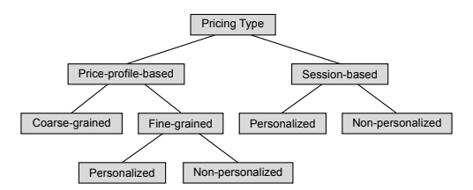  
Price-profile-based pricing sets different prices (usually per energy unit) for different time intervals. Mostly used Price-profile-based are fine-grained price profiles, which set an individual price for each small scheduling interval which may be for 5 minutes or one hour. However, some authors like Guo et al. [7] propose coarse-grained price profiles, which set a constant charging price for a longer time.

The fine-grained price profiles can be either personalized or non-personalized. This means that the charging price in a certain interval is the same for all users, while with a personalized price profile, different users can get different charging prices for the same interval.

In session-based pricing, a user is presented with a total price for a complete charging session. Like for fine-grained price profiles, personalized and non-personalized variants of session-based pricing can also be defined.

**6. Data and dynamic pricing and algorithms**

By analysing massive quantities of available data, in combination with current market events and other external data sources, system can optimize their prices for the customers with the help of algorithms. We can differentiate between two types of algorithms that are being used in pricing,

**A. Traditional**, **rule-based algorithms:**

The logic of these algorithms has been explicitly programmed. They often consist of a range of “if/then” rules that determine prices based on a range of influencing factors.

**B. Machine learning based algorithms:**

These algorithms learn on a set of training data to make predictions on the price effect on sales, revenue and profit. Based on that forecast, one can run optimizations to reach business targets. This algorithm and its logic of prediction is not explicitly programmed. The algorithm continuously learns from new data.

A limitation of traditional algorithms is that they can only consider a limited amount of influencing factors, often less than three. Managing and monitoring this rule-based approach also takes a fair amount of time and effort.

In contrast, by utilizing big data in conjunction with a machine learning based approach, system can be equipped to define the most appropriate pricing strategy for the business.

A machine learning based approach can calculate considering a range of influencing factors, both internal (e.g. electricity consumption charges, charging station maintenance price etc.) as well as external (e.g. competitor data, time-based and weather factors).

By using machine learning based dynamic price optimization, these systems can identify narrow segments, determine what drives value for each one, and match that with historical transactional data. This allows charging stations to set optimal prices for clusters of customers and segments based on data.

Automation also makes it much easier to replicate and tweak analyses so it’s not necessary to start from scratch every time, as the pricing algorithm learns and adapts with data over time.

**The types of data used for dynamic pricing optimization**

Machine-learning based dynamic pricing requires massive amount of data and external factors that need to be considered for price determination: sales data, inventory levels, competitor data, promo data, transaction data, seasonal trends, weather data – and more. At first our data can be categorised in two parts,

**A. Structured data:**

This type of data includes names, addresses, transactions history, loyalty programs, and mostly any other data that involves an “amount” type of measurement.

**B. Unstructured data:**

This type of data includes product reviews, images, social likes and mentions, and any other social media data.

In addition to ‘structured’ and ‘unstructured’ types of data mentioned above, it’s important to utilize both micro and macro level data when developing machine learning-based price optimization. This includes,

**1. Micro level data:**

Internal data including current price per unit, charging stations maintenance cost, load on that charging stations (number of EVs currently charging) etc.

**a. Inventory level:** This is essential data regarding details among current availability if the ports (existing supplies combine with existing demand), which is a key determinant in how a dynamic pricing will be calculated.

**b. Electricity cost:** Electricity cost per unit is a deciding factor.

**c. Maintenance charges:** This includes all the cost which must be spent as human resources, rent for the lands of charging stations, and also maintenance charges for the software or cloud service charges.

**2. Macro level data:**

This is external market data and influential factors that include competitor data, time-oriented data (e.g. day of the week; the season), and location specific data (e.g. regional data; weather data), review of the charging stations, etc.

**a. Competitor Data:** Competitor data can be far reaching. This data can be gathered by crawling (also called ‘scraping’) software which gathers the information from publicly available sources. Businesses are becoming increasingly sophisticated with regards to trying to limit the ability of their competitors to gather this data.

**b. Days of the Week:**

Days of the week have an influence on consumer demand, such as on office days, the demand for charging may increase in evening (it is expected that consumer will charge their EVs at the evening as charging takes up to 30 to 40 mins.), Or at the first half of office hours (as they may charge in parking lots.)The dynamic pricing strategy will take this data and set prices to increase or decrease based on demand for specific hours.

**c. Holidays:**

The demand of charging may vary. On certain charging stations demand may increase (charging stations that nearer to attractions, movies halls, shopping malls, etc.). And decrease on some charging stations (charging stations in parking slot of offices.)

**d. Weather and Seasonal Data:**

Weather can affect the demand, both as a broader pattern. For example, good weather is good for demand, while if the weather outside is bad people will stay home. Weather forecast data can therefore help in predicting demand and optimizing prices accordingly.

**7. Business Model & Implementation Planning**

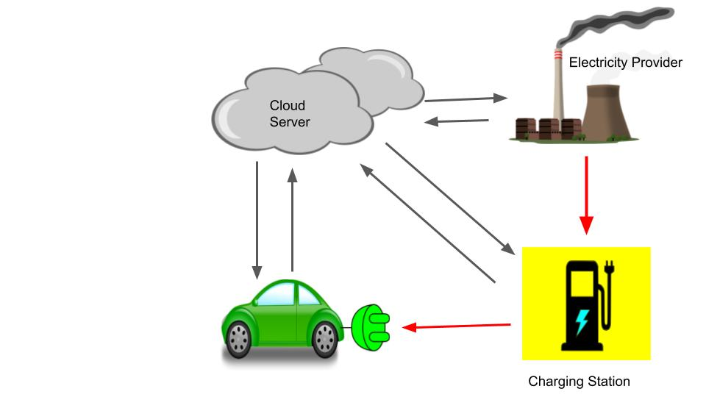

**A. Data** **collection**

When it comes to building a tailored, machine learning based dynamic pricing solution, the targeted internal data will be gathered from traffic modelling simulation on a time slice basis. The simulation will prepare the data on their end, that will be extracted and making sure all of the proper variables are contained. There will be an automated programs that help to manage this data.

When it comes to external data, this is gathered on the basis of business strategy and needs. open APIs are utilized to gather this information as per our requirement.

Competitor data will gather in different ways, usually by a web crawling service or software that gathers the requested data points from open sources. This is increasingly difficult to do as companies are becoming more protective of their data.

**B. Data processing**

Managing large and complex datasets can be challenging. After data is collected, it must be cleaned of errors and prepared for further processing. This step is challenging because data of different formats from different sources must be merged. The task is to ensure that the data is correctly and completely transformed into an algorithm. Once the data has been gathered and gone through an initial cleaning process, further prepare the data to feed into the algorithm.

**C. Data inputting**

From the prepared data, we will then create features and deciding factors – input variables for the machine learning models – that are tailored to specific charging stations and take account of their unique strategic needs. Depending on the particular needs of a charging station different features may be more or less suitable for explaining an outcome. The type of machine learning model and which parameters are used can also differ very much from case to case.

**8. Use Case Diagram:**

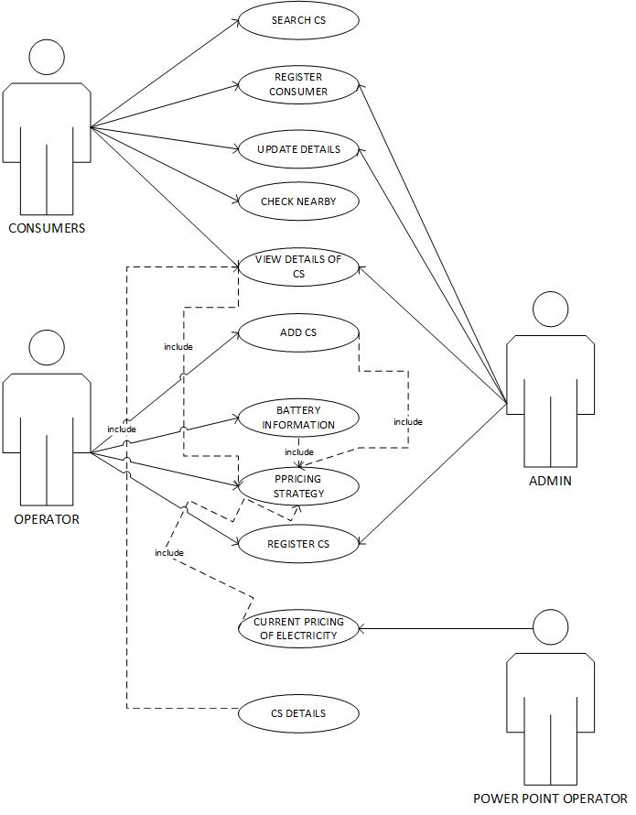

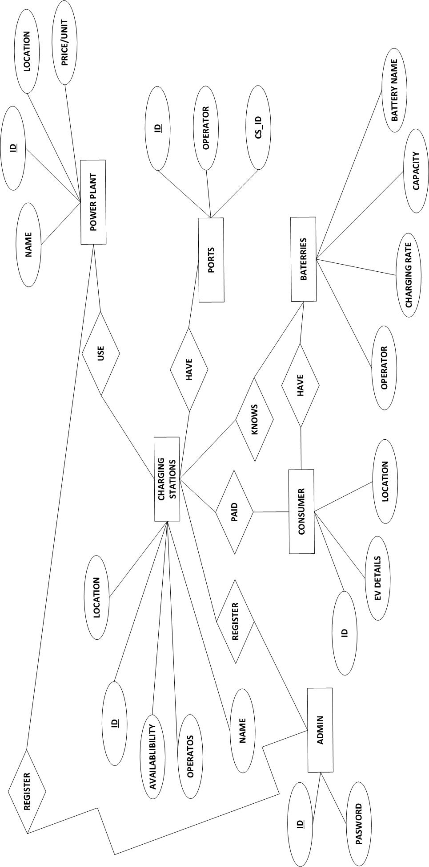**9. ER Diagram:**

**Admin:** The role of “Admin” will perform by any centralized unit/Power System Operator (PSO) to control the available as well as new constructed charging. Station and power plants. This unit would be organized by government or any private firm. Power plants and Charging stations have to forward all the necessary information along with documents and then the admin will verify and will upload all the related meaningful information on server.

**Power Plant:** The power plant operator (PPO) or independent system operator (ISO) registered by admin with a unique PP_ID and a self-assigned password which can later be changed by Power Plant operator.

**Charging Stations Operator:** The Charging Station Operator (CSO) also registered by Admin with a unique CS_ID and a self-given Password which can later change by Charging Station Operator.

**Consumers:** The EV user can register themselves using an online form filling process. EV users have further properties like ID, location, EV details (EV vehicle identification number (VIN), and type of EV battery etc).

**10. Data Flow Diagram:**

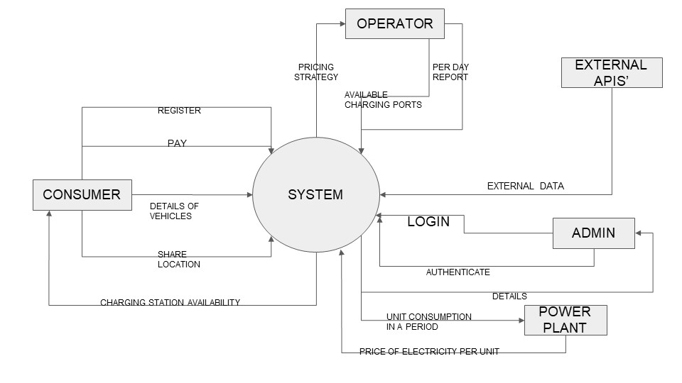

**11. Conclusion:**

Dynamic pricing for EV charging is of increasing interest, since it can help to solve issues related to grid integration of EVs and to the profitable operation of public EV charging stations. There are a growing number of publications, proposing different approaches to dynamic pricing for EV charging, which address different flexibilities of users.

But dynamic pricing arises questions like how do EV drivers respond to dynamic prices in reality? Furthermore, it is not clear if a dynamic pricing scheme would be accepted by the users at all.

Although it is highly expected that Dynamic Pricing will resist the increase of Monopoly of one particular company in the market as there will be a competition factor on deciding the dynamic pricing.

**12. References :**

1. <https://economictimes.indiatimes.com/industry/auto/auto-news/electric-vehicle-market-in-india-expected-to-hit-63-lakh-units-per-annum-mark-by-2027-iesa>.
2. A Comprehensive Analysis of Electric Vehicle Charging Station Infrastructure in an Urban AreaSuresh Chavhan, P. Sanjeevikumar, Baseem Khan.<https://aeee.in/wp-content/uploads/2020/07/2020-Dissecting-India%E2%80%99s-Electricity-Tariff-Landscape-For-EV-1.pdf>
3. Dynamic Pricing for Electric Vehicle Charging—A Literature Review Steffen Limmer <https://www.researchgate.net/publication/335919327_Dynamic_Pricing_for_Electric_Vehicle_Charging-A_Literature_Review>
4. Arie Shpanya (2014)"Why Dynamic Pricing is a Must for eCommerce Retailers“ https[://en.wikipedia.org/wiki/Dynamic_pricing](https://en.wikipedia.org/wiki/Dynamic_pricing)
5. Guo, Y.; Liu, X.; Yan, Y.; Zhang, N.; Su, W. Economic Analysis of Plug-in Electric Vehicle Parking Deck with Dynamic Pricing. In Proceedings of the 2014 IEEE PES General Meeting | Conference Exposition, National Harbor, MD, USA, 27–31 July 2014, pp. 1–5, [CrossRef] <https://www.researchgate.net/publication/286738372_Economic_analysis_of_plug-in_electric_vehicle_parking_deck_with_dynamic_pricing>
6. <https://7learnings.com/blog/how-dynamic-pricing-works-data-driven-price-optimization/>