**Index**

1. **Abstract**
2. **Introduction**
3. **Current Scenario**
4. **Purpose Of Dynamic Pricing**
5. **Various Pricing Strategies**
6. **Business Model & Implementation Planning**
7. **Use Case Diagram**
8. **E-R Diagram**
9. **Data Flow Diagram**
10. **Conclusion**
11. **Reference**
12. **Abstract**

Recently, as Electric Vehicles (EVs) take center stage for the eco-friendly and cost-effective transportation, commercial EV charging stations would be widely prevalent in the future. However, previous studies in the fields of the management of EV charging stations did not synthetically take practical charging systems into account.

Dynamic pricing means, that the charging provider—which can be a distribution system operator or an operator/aggregator of charging stations—dynamically adapts the price, which has to be payed by the end users (the EV drivers) for charging their EVs. In this way, it is possible to react to changes in the operating conditions, for example, to increase the charging prices during periods of high electricity prices or high energy production costs, respectively. A second and even more important advantage of dynamic pricing for EV charging is that it allows to increase the flexibility provided by the users or to make use of the users’ flexibility in order to control their behaviour to a certain degree.

1. **Introduction**

The electric vehicle (EV) market in India is expected to hit over 63 lakh unit mark per annum by 2027, according to a report by India Energy Storage Alliance (IESA). "In the base case scenario, the EV market is expected to grow at CAGR of 44 per cent between 2020-2027 and is expected to hit 6.34-million-unit annual sales by 2027," the IESA report said. One of the challenges people have with electric vehicles is figuring out how much they cost to operate. The price of fully charging an electric vehicle’s battery can vary wildly depending on when and where you charge it. For the bigger picture, you should also include the amortized cost of buying and installing a home charging station and the rates your utility company charges.

The transport sector accounts for 18% of total energy consumption in India. This translates to an estimated 94 million tonnes of oil equivalent (MTOE) energy. If India were to follow the current trends of energy consumption, it would require an estimated 200 MTOE of energy supply annually, by the year 2030 to meet the demand of this sector. Moreover, the sector also contributes an estimated 142 Million Tonnes of CO2 emissions annually, out of which 123 million tonnes is contributed by the road transport segment alone.

An important requirement for the electrification of transport, besides the successful integration of the EVs into the power grid, is the availability of an adequate public EV charging infrastructure. The AFI (Alternative Fuels Infrastructure) directive of the European Union recommends a ratio of one publicly accessible charger per ten EVs .

If it is possible to operate public charging stations in a profitable way, then such an infrastructure or part of it could be deployed and operated by private sector stakeholders, like car manufacturers, oil companies or utility companies. The profitable operation of charging stations can be supported by so called EV aggregators. An EV aggregator is an agent, which aggregates a large number of charging points and acts as a middleman between charging station operators or EV owners and the energy market. According to Reference the viable trading of EV power on the wholesale market requires the aggregation of at least around 500 charging points or EVs.

Dynamic pricing is a promising approach to overcome the challenges related to an increasing penetration of EVs.

The International Renewable Energy Agency considers smart charging and user incentives, like dynamic pricing, to be two key factors for unlocking the flexibility potential from EVs, which is required for a successful grid integration of EVs and renewable energy in the future.

Thus, dynamic pricing for EV charging attracted a lot of researchers and a lot of different approaches to dynamic pricing in the context of EV charging were proposed and published in recent years. Different approaches to dynamic pricing for public and residential EV charging are reviewed and categorized according to their properties in this paper.

1. **Current Scenario**

The Electric Vehicle industry in India is far behind, with less than 1% of the total vehicle sales. Currently, Indian roads are dominated by conventional vehicles and have approximately 0.4 million electric two-wheelers and a few thousand electric cars only. The Indian EV industry has been on the back seat due to various challenges. In India there is less charging station compared to other nation due to which people cannot charge their vehicle for more time and use it daily. Government in India is implementing different policies to make people aware about using electric mobilities.

With electricity distribution and supply being a state subject as per the Indian Constitution, regulations at the state level determine the rules around connection and supply of electricity. This regulatory framework differs from one state to another, and appropriate state regulations should be considered when planning or installing charging facilities. Among the provisions of the state supply code, the following issues especially impact electricity connections for EV charging.

In recent years, the penetration of electric vehicles (EVs) significantly increased. In the year 2017, the sales of new EVs surpassed 1 million units and the global stock of electric passenger cars reached 3.1 million (an increase of 57% compared to 2016). In 2018, nearly 2 million new EVs were sold and the global stock increased to 5.1 million units (63 % more than in 2017) . The share of EVs is still small. Only five countries had an EV share higher than 1 % in 2018 . However, it can be expected that the considerable growth of the EV penetration will continue in the next years.

As of March 2021, 21 states and Union Territories have introduced specific tariffs for EV charging with reduced energy charges and/or demand charge exemptions. Details of state EV tariffs are provided in below table.

EV TARIFFS IN DIFFERENT STATES

|  |  |  |  |
| --- | --- | --- | --- |
| State | EV TARIFF | | |
| ENERGY CHARGE | DEMAND CHARGE | |
| Low tension | High tension |
| Andhra Pradesh | Rs 6.7/kWh | - | - |
| Assam | Rs 5.25 to 6.75/kWh | Rs 130/kW per month | Rs 160/kVA per month |
| Bihar | Rs 6.3 to 7.4/kWh | - | - |
| Chhattisgarh | Rs 5/kWh | - | - |
| Delhi | Rs 4.5/kWh | - | - |
| Gujarat | Rs 4 to 4.1/kWh | - | Rs 25 to 50 per kVA per month |
| Haryana | Rs 6.2/kWh | Rs 100/kW per month | - |
| Himachal Pradesh | Rs 4.70 to Rs 5/kWh | - | Rs 130/connection per month and Rs 140/kVA per month |
| Jharkhand | Rs 6.00 to 6.25/kWh | Rs 40 to 150/connection per month |  |
| Karnataka | Rs 5/kWh | Rs 60/kW per month | Rs 190/kVA per month |
| Kerala | Rs 5/kWh | Rs 75/kW | 250/kVA per month |
| Madhya Pradesh | Rs 5.9 to Rs 6/kWh | - | Rs 100 to 120/kVA of billing demand |
| Maharashtra | Rs 4.05 to 4.24/kWh | - | Rs 70/kVA per month |
| Meghalaya | Rs 10.09/kWh | Rs 100 to 230/ connection per month | |
| Odisha | Rs 4.20 to 5.70/ kWh | Rs 200 to 250/kW per month | Rs 200 to 250/kVA per month |
| Punjab | Rs 5.4/kWh | - | - |
| Rajasthan | Rs 6/kWh | Rs 40/HP per month | Rs 135/kVA per month |
| Tamil Nadu | Rs 5 to 8.05/kWh | Rs 70/kW per month | - |
| Telangana | Rs 6/kWh | - | - |
| Uttar Pradesh | Rs 5.9 to Rs 7.7/kWh | - | - |
| Uttarakhand | Rs 5.5/kWh | - | - |

Fixed pricing is a strategy in which a price point is established and maintained for an extended period of time.

**Problem with Fixed Pricing**

The risk with fixed pricing is that it doesn't allow for adjustments if you get into product or service delivery and realize your cost basis is higher than expected. The customer pays the established price regardless of changes in your time or costs. This may mean you undercharge a customer due to a lot of additional work hours beyond those estimated in the price quote. Fixed pricing also doesn't allow for adjustments over time to sell off extra inventory or available seats for entertainment and other types of events.

**What is dynamic pricing?**

Businesses implement dynamic pricing as a type of price discrimination. This allows businesses to change the price of a product based on a number of variables such as the market conditions or varying components within the business. With dynamic pricing, you can change the price your business charges for a product or service to reflect differences in market conditions and seasonality. For instance, flights to different places are always more expensive around Christmas. This dynamic pricing model allows airlines to charge a higher price at a time of greater demand.

**Dynamic Pricing Advantages**

Dynamic pricing means the price on a product or service can change over time. Selecting the appropriate strategy for your business has major implications in your ongoing effort to attract customers and achieve optimal profit margins. Dynamic pricing often is referred to as discriminatory pricing because it allows you to maximize profits with each customer. This approach is common in event promotions: If initial demand is low, facility or event managers work to sell off open seats to generate whatever revenue is possible. Another strength of dynamic pricing is the ability to adjust prices for service projects or products based on the time and costs involved or fluctuating demand. Seafood distributors and restaurants, for instance, often vary prices depending on season and inventory supply.

**4. Purpose of Dynamic Pricing:**

Dynamic pricing means, that the charging provider—which can be a distribution system operator or an operator/aggregator of charging stations—dynamically adapts the price, which has to be paid by the end users (the EV drivers) for charging their EVs.

In this way, it is possible to react to changes in the operating conditions, for example, to increase the charging prices during periods of high electricity prices or high energy production costs, respectively.

A second and even more important advantage of dynamic pricing for EV charging is that it allows to increase the flexibility provided by the users or to make use of the users’ flexibility in order to control their behaviour to a certain degree.

Hereby, it is possible to achieve different benefits like

1. reducing energy production costs,
2. increasing the stability of the power grid,
3. increasing user satisfaction,
4. reducing the operating costs of public charging stations.

Dynamic pricing for EV charging can be seen as a special form of demand response, which refers to a procedure that motivates end users to change their electricity consumption, in response to financial incentives.

The modelling of user preferences is often done with the help of utility functions. dynamic pricing for EV charging, the preferences of users are modelled with the help of utilities. The right choice of a utility function is especially important for simulation experiments. The more realistic the used utility function is, the more meaningful are the experimental results.

It is assumed that a **user (n)** gets a **certain satisfaction** from **consuming a good (x)**,

which is expressed as utility **Un (x) ∈ R**.

In the context of EV charging, the “good” x can be, for example, the amount of charged energy or the duration of the charging session.

In works on dynamic pricing for EV charging, it is frequently assumed that users make decisions that maximize their profit, which is their utility minus their costs.

That means,

a **user n** **chooses x** so that **Un(x)−Pn(x)** is **maximized**, where **Pn(x) is the price**, the user has to pay for x.

Often, it is also assumed that users do not charge, if charging results in a negative profit for all possible values of x. In that sense, the utility Un(x) can be seen as the price, the user n is willing to pay for the good x.

It is common to assume that users act in a way that the following optimization problem is solved:

**Max *x f*(x, p) = g(x) − h(x, p) ………………………………(1)**

where **x is the good**, which can be consumed (e.g., the amount of charged energy), **p is the charging price** (or a price vector) set by the charging provider, **g(x) is the satisfaction the user** gains by consuming x and **h(x ,p) is the amount of money** the user has to pay for consuming x (e.g. h(x, p) = x ⋅ p).

That means, it is assumed that a user chooses a ‘good’ x so that the satisfaction gained g(x) from the ‘good’ minus the price that has to be paid for the ‘good’ is maximized.

The setting of charging prices is commonly done by solving an optimization problem of the following form:

**Max p Ø(x ’, p) …………………………………(2)**

**s. t. x ‘ = arg x max *f*(x, p) ………………………………..(3)**

where the function **Ø models the objective of the pricing approach**, like for example, the charging provider’s profit or the peak load reduction.

Constraint (3) models the user response to prices according to Equation (1). The complete problem is a bi-level optimization. In the outer optimization the prices are optimized. In the inner optimization the user’s decision based on the utility function and the prices is optimized.

1. **Various Pricing Strategies:**

Steffen Limmer[reference no.] has shown that the pricing strategies can be categorized according to the following figure.

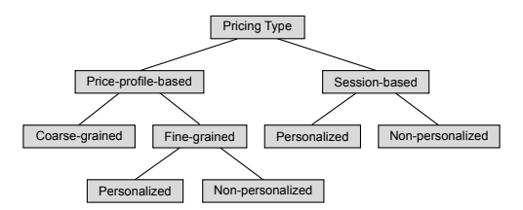

Price-profile-based pricing sets different prices (usually per energy unit) for different time intervals. Mostly used Price-profile-based are fine-grained price profiles, which set an individual price for each small scheduling interval which may be for 5 minutes or one hour. However, some authors like Guo et al. [] propose coarse-grained price profiles, which set a constant charging price for a longer time.

The fine-grained price profiles can be either personalized or non-personalized. This means that the charging price in a certain interval is the same for all users, while with a personalized price profile, different users can get different charging prices for the same interval.

In session-based pricing, a user is presented with a total price for a complete charging session. Like for fine-grained price profiles, personalized and non-personalized variants of session-based pricing can also be defined.

1. **Business Model & Implementation Planning**

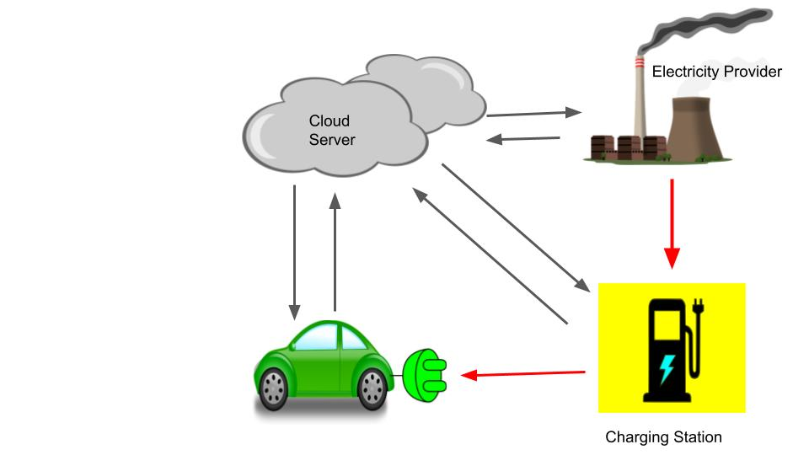

1. **References :**
2. <https://www.niti.gov.in/sites/default/files/2021-08/HandbookforEVChargingInfrastructureImplementation081221.pdf>
3. <https://www.youtube.com/watch?v=pOmyp1ScXXI>
4. https://evreporter.com/ocpp-and-ev-charging/
5. https://ieeexplore.ieee.org/document/9057557
6. Y. Zhou, M. Wang, H. Hao, L. Johnson, H. Wang and H. Hao, "Plug-in electric vehicle market penetration and incentives: A global review", Mitigation Adaptation Strategies Global Change, vol. 20, no. 5, pp. 777-795, Jun. 2015. https://link.springer.com/article/10.1007/s11027-014-9611-2
7. J. Neubauer and E. Wood, "The impact of range anxiety and home workplace and public charging infrastructure on simulated battery electric vehicle lifetime utility", J. Power Sources, vol. 257, pp. 12-20, Jul. 2014.
8. https://www.researchgate.net/publication/260215083_The_impact_of_range_anxiety_and_home_workplace_and_public_charging_infrastructure_on_simulated_battery_electric_vehicle_lifetime_utility
9. https://www.hindawi.com/journals/jat/2020/8890233/