The Effects of Math Anxiety on Identification of Financial Terminology

Deborah Gorelik

CUNY Hunter College

Abstract

Those who suffer from math anxiety may have trouble answering math questions or managing their personal finances. One hundred fifty-two undergraduate students (58.6% females) participated in our study. The participants completed a series of lab-based tasks that included defining financial terminology, solving math equations, and a math anxiety inventory. We examined the relationship between overall math anxiety, the subscales of math anxiety (anxiety towards math tests, math courses, and numeracy), math ability, and the ability to identify financial terms. While we did not find a correlation between math anxiety and the ability to identify financial terms in the overall population, we found a non-robust negative correlation in looking at just the female population. We also found negative correlations within the subscales of math anxiety and the ability to define financial terms. In addition, we also found a moderate positive correlation between math ability and financial literacy.

*Keywords*: Math anxiety, financial literacy, and math ability

**The Effects of Math Anxiety on Financial Literacy**

Math anxiety is characterized by negative or anxious feelings associated with the anticipation or performance of mathematics (Ashcraft, 2002.) Anxiety towards mathematics may result in an avoidance of classes and careers that rely on mathematical skills (Pizzie, 2017.) Several factors that are known to be associated with the presence of math anxiety are situational factors, environmental factors, and dispositional factors. Situational factors include instructional approach, assessment approach, as well as curriculum and classroom factors. Environmental factors include negative experiences with math in the classroom or in a family context, and a teacher or parent exhibiting anxiety towards math. Dispositional factors are personality-related factors that an individual has that make them more susceptible to experiencing math anxiety (Espinosa, 2014.)

It is generally known that people tend to show much more anxiety towards math than to a subject in the liberal arts realm. One study compared anxiety in Australian 9-year olds taking math and literacy courses (Punaro & Reeve, 2012) and found that the children showed greater anxiety when presented with math stimuli than they did when presented with literacy stimuli. People who suffer from math anxiety may be less inclined to choose careers related to math or have difficulty managing their personal finances.

It is important to note that females are reported to have a higher level of math anxiety in comparison to their male counterparts (Dowker, Sarkar & Looi, 2016.) This could be due to stereotype threat that speaks to gender differences in math performance. Stereotype threat occurs when females are aware of the stereotypes that exist about them and doing poorly in math and are subsequently perform poorly on a math-related task (O’Brien & Crandall, 2003.) Negative stereotypes include the stereotype that females are not good at math, and that math is not an inherently feminine activity (Richardson & Woolfolk, 1980.)

The high levels of math anxiety in females could be due to an environmental factor discussed earlier, such as the influence on students from female teachers, who themselves are anxious in math. Research has shown that highly math-anxious female primary school teachers were more likely to have students with lower achievement and gender stereotypes in regards to math. A study conducted on elementary students revealed that there was no relationship between a teacher’s math anxiety and her students at the start of the school year. However, after spending an entire school year learning from a highly math-anxious teacher, the more likely the young female students were to hold the stereotype that “boys are good at math, and girls are good at reading.” At the school years end, the female students who endorsed this stereotype had significantly worse math achievement than girls who did not endorse this stereotype and boys overall (Beilock, 2010.) This result could be due to elementary school student’s modeling what they perceive to be gender-specific behavior. Young female students are more likely to be influenced by their teacher’s anxieties than their male counterparts because most elementary school teachers are female. The high levels of math anxiety in this female teacher population could confirm an existing stereotype about females and math ability, which does not exist between males and math ability.

Gender stereotypes do not just pervade in the realm of math anxiety but in financial literacy as well. A field study conducted on 13-15-year-old teenagers from German schools showed that female teenagers have lower financial knowledge than their male counterparts (Driva, Luhrmann & Winter, 2016.) The researchers found that stereotypical beliefs about females having lesser financial literacy than their male counterparts propagate a gender gap in financial literacy. For females, financial knowledge decreases with stereotype intensity whereas it increases for males.

Financial illiteracy is more widespread among women than men, particularly with familiarity with basic economic and financial concepts (Lusardi and Mitchell, 2008.) A study conducted by RAND utilized existing data on financial literacy from the RAND American Life Panel. The study found that the main predictors of the financial literacy gap between men and women, were education, income and current and past marital status (Fonseca et. al, 2010.)

Financial literacy is defined as the ability to process economic information and make informed decisions about financial planning, wealth accumulation, debt, and pensions (Lusardi, 2015.) The financial decisions that people make are colored by their financial literacy. However, studies have shown that many individuals do not have a good enough understanding of financial literacy to make sound financial decisions. In order to do so, one must have a degree of familiarity with financial terms and a strong vocabulary, a high level of reading comprehension, and strong mathematical and analytical skills (Sole, 2014.)

Low financial literacy could be due to how finance is taught in schools. Research shows that many schools across the United States do not devote much time to financial education - only nineteen states mandate that financial education be taught in grades K-12 (Council for Economic Education [CEE], 2014.) A study by the Organization for Economic Co-operation and Development (2014) found that 45% of students receive no financial education as a separate school subject, and 54.9% received no financial education as part of a cross-curricular subject. The lack of financial education in school could make it harder for people to learn how to plan their own personal finances.

There has not been much research conducted on the intersection of financial literacy and math anxiety. While our literature reviews did not reveal a study that directly examined the correlation between math anxiety and financial literacy, math and finances are both related to numbers. Hence, anxiety towards math and financial literacy are both related to numeracy. Numeracy can be defined as the ability to process basic numerical concepts, quantitative estimations, probability, and ratios (Peters, 2006.)

A lack of numeracy can lead people to make poor and misinformed financial decisions. In a study analyzing financial literacy in planning for retirement, the researchers created questions to test the financial literacy of participants who were soon to retire. One of the questions was: Suppose you had $100 in a savings account and the interest rate was 2% per year. After 5 years, how much do you think you would have in the account if you left the money to grow: more than $102, exactly $102, less than $102? (Lusardi & Mitchell, 2011.) The results showed that only 67% participants over the age of 50 were able to answer the first question correctly. The problem demonstrates how numeracy and financial literacy can be linked through a real-world example. The findings of this study are a cause for concern, as most people over 50 should have already had to deal with financial decisions of this sort in their lifetime. Lusardi and Mitchel posited financial questions similar to this one to participants in countries all over the world and found that a low understanding of numeracy was not exclusive to the United States. They found that Germany, the Netherlands, and New Zealand performed highest on the numeracy task, whereas Sweden, Italy, Russia, Japan, and The United States got less than 70% of the numeracy questions correct.

Lack of financial literacy and numeracy are not simply widespread amongst countries but are further prevalent upon microanalysis of specific demographics. The data from the 2011 study found that women were less likely than men to answer financial literacy and numeracy questions correctly, and more likely to say that they are unsure of the answer. This finding was not exclusive to the United States but was in fact mimicked in Sweden, the Netherlands, Germany, Italy, Russia, and New Zealand.

A recent study found that a central component of financial literacy could be traced to numeracy and math anxiety (Skagerlund et. al, 2018.) They conducted on a representative sample of the general population in Sweden testing math anxiety, financial anxiety, numeracy, financial literacy, and cognitive reflection ability. The results of their study showed that math anxiety and financial anxiety were significantly related to one another. The researchers explained that if an individual were unable to complete simple mathematical calculations, understand ratios and percentages, they would not be able to conceptually understand any financial matters. They argue that financial literacy is contingent upon numeracy and an emotional attitude towards math (math anxiety) that does not infringe upon their ability to engage in activities involving math and financial decisions. Skagerlund et al.’s study is similar to ours in terms of the measures that they use, however, their study was conducted via a survey, whereas our study was conducted in a lab setting. In their discussion, they suggest that financial literacy should be more thoroughly investigated through a lab setting where researchers could supervise the participants completing the tasks.

This study hypothesizes that there will be a negative correlation between math anxiety and the ability to identify financial terms. In addition, we hypothesize that there will be negative correlations between the math anxiety subscales (anxiety towards math tests, math classes, and numeracy) and the ability to identify financial terms. Lastly, we hypothesize that there will be a positive correlation between math ability and the ability to identify financial terms.

**Methods**

One hundred fifty-two undergraduate students (58.6% female) participated in our study about thoughts and feelings about math and money. There were two rounds of data collection: the first occurring in 2014 and the second in the spring and fall of 2018. Our study utilized participants from the Introduction to Psychology pool, as well as paid participants. Students chose to sign up to participate in the study for Introduction to Psychology course credit. For those who were not in an Introduction to Psychology course, and wished to participate in our study, we offered them compensation of ten dollars. Flyers for the ‘Examination of Thoughts and Feelings about Math and Money’ were posted around Hunter College’s 68th Street Campus. All of our participants were matriculated students of Hunter College.

**Procedure**

Data collection began in 2014 and ran for the entire year and continued into early 2015. Data collection was put on pause and started up again in the spring semester of 2018 and continued into the middle of the fall 2018 semester. Participants were first welcomed into the research suite and then led into the testing room and asked to read over the consent form on Qualtrics and call for a research assistant when they finished. The research assistant waited outside the testing room until the participant called for them. The research assistant initiated DirectRT in order for the participant to complete the Stroop task component. Once the participant finished the Stroop Task, the research assistant was called in once more to switch the screen back to Qualtrics so that they could complete the remainder of the tasks. There was scrap paper and a pen available for the participant when they entered the testing room. The research assistants explained to the participants that they were free to use the scrap paper to make calculations when needed. When the participant completed the tasks, they were debriefed and compensated with either intro to psychology research credit or ten dollars in cash.

Once the participant left, the research assistant noted any behavior that the participant exhibited. The research assistants took note of any outside factors that may have had an effect on their data such as any intrusive noise. We also noted any behaviors of the participant that may have had an effect on the data such as the participant leaving the testing room to ask the Research assistant a question, or exhibiting anxious behavior prior to the start of the study.

**Materials**

Appendix A contains ‘Math Feelings’ scale, which asks participants to indicate their current reaction to 25 situations involving math on a 5-point Likert Scale. A response of 1 – indicates the least anxiety to 5 – indicates the most anxiety. Responding to any of the situations with a ‘4’ or ‘5’ to any of the statements would indicate that the participant is anxious around math and numbers. The participant is asked to indicate their current reaction to the situations presented. The scale was adapted from revised Math Anxiety Scale (rMARS) (Alexander and Martray, 1989.)

Appendix B contains the factor analysis of rMARS, which contains subscales of math anxiety. Kazelskis (1989) conducted a factor analysis on the rMARS and divided the scale into three subscales of math anxiety: math test anxiety, math class anxiety, and numerical anxiety. The subscales utilize the same questions from the rMARS (Alexander and Martray, 1989), as well as the same 5-point Likert scale where a response of 1 – indicates the least anxiety to 5 – indicates the most anxiety. The math test anxiety subscale included 15 questions and tested the participant’s anxiety toward math tests. The math course anxiety subscale included 5 questions and tested one's anxiety toward math courses. Lastly, numerical anxiety contains 5 questions and deals with day-to-day use of mathematical and computational concepts.

Appendix C contains a matching activity with financial terminologies. The participants have to match the words with their correct definitions. The number of correct matches the participant is able to successfully make will determine their level of financial literacy. This scale was developed specifically for this study.

Appendix D contains eight questions that measure math ability. The eight questions were taken from the COMPASS exam. The COMPASS exam is the exam the incoming freshman to the CUNY system takes to determine their math placement within their college. The questions on the exam draw from four sections: numerical skills/pre-algebra, algebra, college algebra, and trigonometry.

Appendix E contains a demographic task. The task requires the participant to write in their age. It also asks the participant about their age by having them check off whether they identify as male, female, transgender or other. The participant is asked about their race/ethnicity by checking off whether they identify as Caucasian, Latino, Black/African, American, Asian, or other. The participant is asked to check off whether they have a credit card, as well answer how long they have had it for. The participant is asked to check off how long they have had their debit card, as well as how long they have had it. They are asked to check off whether they know the difference between a debit and credit card. The participant is asked to check off whether they have a checking account, how long they have had it for, and if it is a shared account. The participant is then asked to write in number responses about three questions regarding their checking out. They are asked how many cash withdrawals they make from their checking account, how many deposits are made in their checking account from sources such as cash deposits, paychecks or other sources, and how many times they review the activity in their checking account, during the time span of a month.

**Results**

We found no significance between math anxiety and the ability to identify financial terminology with an *r* (152) = -.15, *p* =. 06. When analyzing only female data, the relationship was *r* (89)= -.21, *p* =. 047, which is significant at the 0.05 level. For males, the relationship was *r* (62) = -.04, *p* = .79, which is non-significant (Table 1.)

For the overall sample, we found no significant correlation between math anxiety and the ability to identify financial terminology. This result contradicts my hypothesis that there will be a negative correlation between math anxiety and the ability to define financial terms. However, we did find a significant but not robust negative correlation between math anxiety and the ability to identify terms in looking at just females. A significant correlation was not found for males.

In looking at the subscales within rMARS, the correlation between math test anxiety and the ability to identify financial terms was *r* (152) = -.09, *p* =.275, which has no significance. The relationship between math course anxiety and the ability to identify financial terms had a correlation of *r* (152) = -.21, *p* =. 011. The relationship between anxiety towards numeracy and ability to identify financial terms had a correlation of *r* (152) = -.21, *p* = .011. Both of these relationships proved to be significant at a 0.05 level (Table 2.)

For females, the relationship between math test anxiety and the ability to identify financial terms were *r* (89)= -.12, *p* =. 255, these results proved to be non-significant. The relationship between numeracy anxiety and the ability to identify financial terms showed *r* (89) = -. 24, *p* = .023, these results were significant at the 0.05 level. The relationship between math course anxiety and the ability to identify financial terms was *r* (89) = -.29, *p* = .007, these results showed significance at the 0.01 level (Table 2.)

For males, the relationship between math test anxiety and the ability to identify financial terminology was *r* (62) = -.02, *p* =. 898. The relationship between numeracy anxiety and the ability to identify financial terminology showed *r (*62) = -.15, *p* = .237. The relationship math course anxiety and the ability to identify financial terminology was *r* (62) = -.07, *p* = .576. None of these results showed significance (Table 2.)

We found a significant but not robust negative correlation between the ability to identify financial terms and math course anxiety. This pattern was also found between the ability to identify financial terms and numeracy anxiety. These results remained consistent within the female population. However, there were no significant results within just males. These results support my hypothesis that there would be a negative correlation between the math anxiety subscales and ability to identify financial terminology. However, this only proved true for two of the subscales, anxiety towards numeracy and math courses. There was no significant correlation found between math test anxiety and the ability to identify terminology in the overall population, as well as within just males, and females.

With regard to the correlation between numeracy and the ability to identify financial terminology, the relationship for the overall sample was *r* (152) = 0. 45, *p* < 0.01. For females, the correlation between numeracy and the ability to identify financial terminology was *r* (89) = 0.40, *p* < 0.01, and for males the correlation coefficient was *r* (62) = 0.50, *p* < 0.01 (Table 3.)

We found a moderate positive correlation between math ability and the ability to identify financial terms. The correlation was slightly higher in males than in females. This result supports my hypothesis that there is a positive correlation between math ability and the ability to identify financial terminology.

**Discussion**

The first hypothesis was that there would be a negative correlation between math anxiety and the ability to identify financial terms. For the overall sample, we found no significant correlation between math anxiety and the ability to identify financial terminology. However, we did find a significant but not robust negative correlation between math anxiety and the ability to identify terms in looking at just females. A significant correlation was not found for males. This may mean that females who are anxious toward math may have trouble identifying financial terminology.

The second hypothesis is that there will be negative correlations between the math anxiety subscales (anxiety towards math tests, math classes, and numeracy) and the ability to identify financial terms. We found a significant but not robust negative correlation between the ability to identify financial terms and math course anxiety. This means that those are anxious toward math courses may have trouble identifying financial terminology. This pattern was also found between the ability to identify financial terms and numeracy anxiety. This means that individuals who are anxious around numbers may have trouble identifying financial terminology. These results remained consistent within the female population. There were no significant results within just males.

The third hypothesis was that there would be a positive correlation between math ability and the ability to identify financial terms. We found a moderate positive correlation between math ability and the ability to identify financial terms. This means that those who performed well on our math questions had an easier time identifying financial terminology. On the converse, this also means that those who have trouble answering our math questions also had trouble identifying financial terminology. The correlation was slightly higher in males than in females.

The median age of our participants was 20, as our participants came from a pool of college students. A future study may want to explore the option of using a broader age group and seeing how that affects their findings. Our experiment was conducted in a lab setting, which allowed for thorough investigation through a supervised setting. The time needed to complete the study averaged around one to one and one-half hours. This may have lead to burnout in some participants. Future researchers may consider a complementary approach – utilizing both online surveys and lab tasks.

Future studies may also consider how the current findings extend to other measures of financial literacy. Our study utilized a financial terminology-matching task, which asked the participant to define terms like ‘compound interest.’ This task was created specifically for our study; there is no measure of its reliability or validity in testing financial literacy. Future studies may want to implement questions that test one's knowledge of compound interest through a numeracy question such as “Suppose you had US$100 in a savings account and the interest rate was 2% per year. After 5 years, how much do you think you would have in the account if you left the money to grow: more than US$102, exactly US$102, less than US$102? Do not know (DK). Refuse to answer (Lusardi, 2015.)” This type of question is able to test an individual’s capability to apply a concept such as compound interest.

Research also shows that math anxiety typically starts early in childhood and continues into ones adult life. Early interventions targeting math anxiety in elementary school children may strengthen their math ability and decrease their numeracy anxiety. Early interventions may make it easier for people with anxiety towards numeracy to acquire financial knowledge, as they get older. Given that most individuals in the United States and other countries cannot perform simple calculations and do not understand basic financial concepts (Lusardi, 2015) future research should focus on the efficacy of financial literacy interventions on adults.

According to Sole (2014), personal finance is a topic that is not explored well in a classroom setting and is often not part of the curriculum in traditional math courses. In order to ensure that students will be financially literate, teachers ought to develop students math computation skills. Development of analytical and mathematical skills, provide the background for one to be familiar with and make sense of financial documents.

For a future study, I propose integrating financial concepts into remedial math courses. The experiment could utilize two sections of a remedial math course taught within a college - one would serve as the control and one as the manipulated variable.

The control would simply teach the course consistent with how it was typically taught, and the manipulated variable would integrate financial concepts into the curriculum. Towards the end of the course, both sections should be asked to complete the Revised Math Anxiety Rating Scale (rMARS), identify financial terminology, and answer financially-oriented math questions such as those Lusardi utilized in her 2015 study. The results of this study may indicate if financial literacy has a place in a remedial mathematics curriculum.

References

Alexander, L., & Martray, C. R. (1989). The development of an abbreviated version of the Mathematics Anxiety Rating Scale. *Measurement and Evaluation in Counseling and Development,* 22(3), 143-150.

Ashcraft, M. H. (2002). Math anxiety: Personal, educational, and cognitive consequences. *Current Directions in Psychological Science, 11*(5), 181-185.

Baloglu, M & Kocak, R (2006): A multivariate investigation of the differences in mathematics anxiety. *Personality Individual Differences* 40(7): 1325-1335.

Beilock, S. L. & Ramirez, G. & Gunderson, E.A. & Levine, S. C. & Levine (2013): Math Anxiety, Working Memory, and Math Achievement in Early Elementary School, *Journal of Cognition and Development*, 14:2, 187-202.

Buckley, S. & Reid, K. & Goos, M. & Lipp, O. V. & Thomson, Sue Understanding and addressing math anxiety using perspectives from education, psychology, and neuroscience. *Australian Journal of Education*; London Vol. 60, Iss. 2,  (Aug 2016): 157-170.

COMPASS Test. Retrieved from http://cunymath.cuny.edu/COMPASS.php

Council for Economic Education. (2014, February). Survey of the states: Economic and personal finance education in our nation’s schools. New York, NY.

Driva, A. & Lührmann, M. & Winter, J (2016), [Gender differences and stereotypes in financial literacy: Off to an early start](https://econpapers.repec.org/article/eeeecolet/v_3a146_3ay_3a2016_3ai_3ac_3ap_3a143-146.htm),*Economics Letters*, 143-146

Dowker, A. & Sarkar, A. & Looi, C.Y. (2016). Mathematics Anxiety: What Have We Learned in 60 Years? *Frontiers in Psychology*.

Espinosa, J. (2014). Reducing Math Anxiety by Addressing Mindsets at a Public Elementary School in Los Angeles.

Fonseca, R., Mullen, K. J., Zamarro, G., & Zissimopoulos, J. (2012). What Explains the Gender Gap in Financial Literacy? The Role of Household Decision Making. *The Journal of consumer affairs*, 46(1), 90-106.

Hunter College. (2015). Facts and Statistics.

http://www.hunter.cuny.edu/communications/media-relations/facts

Kazelskis, R. (1998). Some Dimensions of Mathematics Anxiety: A Factor Analysis Across Instruments. *Educational and Psychological Measurement*, 58(4), 623–633.

King, F, Heinrich, D., Stephenson, R., Spielberger, C., & Williams, Joanna. (1976). An investigation of the causal influence of trait and state anxiety on academic achievement. *Journal of Educational Psychology,* *68*(3), 330-334.

Kazelskis, R. (1998). Some Dimensions of Mathematics Anxiety: A Factor Analysis Across Instruments. *Educational and Psychological Measurement*, 58(4), 623–633.

Lusardi, A. (2015). Financial literacy: Do people know the ABCs of finance? *Public*

*Understanding of Science*, Vol. 24(3) 260–271.

Lusardi, A. & Mitchell, S., (2011.) "[Financial literacy and retirement planning in the United States,](http://ideas.repec.org/a/cup/jpenef/v10y2011i04p509-525_00.html)" *Journal of Pension Economics and Finance*, Cambridge University Press, vol. 10(04), pages 509-525.

Lusardi A., & Tufano, P. (2009) Debt literacy, financial experiences and overindebtedness, Cambridge, MA: *National Bureau of Economic Research*.

O’Brien, L. T., & Crandall, C. S. (2003). Stereotype threat and arousal: Effects on

Women’s math performance. *Personality and Social Psychology Bulletin*, 29, 782–789.

[O’Leary, Krystle](http://research.library.mun.ca/view/creator_az/O==2019Leary=3AKrystle=3A=3A.html) (2014) The role of math experiences and personality traits in math anxiety*.* Doctoral (Ph.D.) thesis, Memorial University of Newfoundland.

Organization for Economic Cooperation and Development. (2014). PISA 2012 Results: Students and money (Volume VI): Financial literacy skills for the 21st century, PISA, OECD Publishing

Peters, E., Västfjäll, D., Slovic, P., Mertz, C.K., Mazzocco, K. & Dickert, S. (2006) [Numeracy and decision making](https://doi.org/10.1111/j.1467-9280.2006.01720.x). *Psychol. Sci.*, pp. 407-413

Pizzie & Kraemer (2017). Avoiding math on a rapid timescale: Emotional responsivity and anxious attention in math anxiety. *Brain and Cognition,* 118, 100-107.

Punaro, L. & Reeve, R. (2012). Relationships between 9-Year-Olds' Math and Literacy Worries and Academic Abilities. *Child Development Research*. 2012.

Richardson, F. C., & Woolfolk, R. L. (1980). Mathematics anxiety. In I. G. Sarason (Ed.), *Test anxiety: Theory, research and applications* (pp. 271–288). New Jersey: Lawrence Erlbaum Associates.

Shapiro, G. K., & Burchell, B. J. (2012). Measuring financial anxiety. *Journal Of Neuroscience, Psychology, And Economics*, 5(2), 92-103.

Skagerlund, Lind, Strömbäck, Tinghog & Västfjäll. (2018). Financial literacy and the role of numeracy–How individuals’ attitude and affinity with numbers influence financial literacy. *Journal of Behavioral and Experimental Economics,* *74*, 18-25.

Sole, M. A. (2014). Financial literacy: An essential component of mathematics literacy and numeracy. *Journal of Mathematics Education at Teachers College*, 55- 62

Table 1

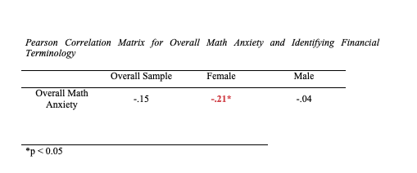

Table 2

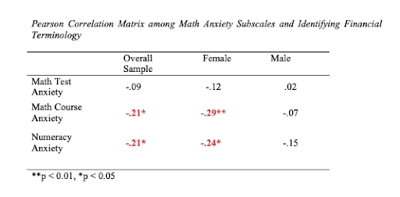

Table 3

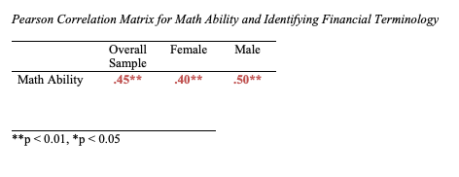

Appendix A

**MATH FEELINGS SCALE:**

**Please indicate your current reaction to the below situations involving mathematics by clicking the number from one to five that best describes the level of anxiety caused by the event described. 1 indicates the least anxiety, 5 indicates the most:**

1. Studying for a math test

1 2 3 4 5

not at all anxious very much anxious

2. Taking the math section of a college entrance exam

1 2 3 4 5

not at all anxious very much anxious

3. Taking an exam (quiz) in a math course

1 2 3 4 5

not at all anxious very much anxious

4. Taking an exam (final) in a math course

1 2 3 4 5

not at all anxious very much anxious

5. Picking up a math textbook to begin working on a homework assignment

1 2 3 4 5

not at all anxious very much anxious

6. Being given homework assignments of many difficult questions that are due the next class meeting

1 2 3 4 5

not at all anxious very much anxious

7. Thinking about an upcoming math test 1 week before the exam

1 2 3 4 5

not at all anxious very much anxious

8. Thinking about an upcoming math test 1 day before the exam

1 2 3 4 5

not at all anxious very much anxious

9. Thinking about an upcoming math test 1 hour before the exam

1 2 3 4 5

not at all anxious very much anxious

10. Realizing you have to take a certain number of math classes to fulfill your major

1 2 3 4 5

not at all anxious very much anxious

11. Picking up a math textbook to begin a difficult reading assignment

1 2 3 4 5

not at all anxious very much anxious

12. Receiving your final math grade in the mail

1 2 3 4 5

not at all anxious very much anxious

13. Opening a math or statistics book and seeing a page full of math problems

1 2 3 4 5

not at all anxious very much anxious

14. Getting ready to study for a math test

1 2 3 4 5

not at all anxious very much anxious

15. Being given a “pop” quiz in a math class

1 2 3 4 5

not at all anxious very much anxious

16. Being given a set of numerical problems involving addition to solve on paper

1 2 3 4 5

not at all anxious very much anxious

17. Being given a set of subtraction problems to solve

1 2 3 4 5

not at all anxious very much anxious

18.Being given a set of multiplication problems to solve

1 2 3 4 5

not at all anxious very much anxious

19. Being given a set of division problems to solve

1 2 3 4 5

not at all anxious very much anxious

20. Buying a math textbook

1 2 3 4 5

not at all anxious very much anxious

21. Watching a teacher work on an algebraic equation on the blackboard

1 2 3 4 5

not at all anxious very much anxious

22. Signing up for a math course

1 2 3 4 5

not at all anxious very much anxious

23. Listening to another student explain a math formula

1 2 3 4 5

not at all anxious very much anxious

24. Walking into a math course

1 2 3 4 5

not at all anxious very much anxious

25.Reading a cash register receipt after your purchase

1 2 3 4 5

not at all anxious very much anxious

Appendix B

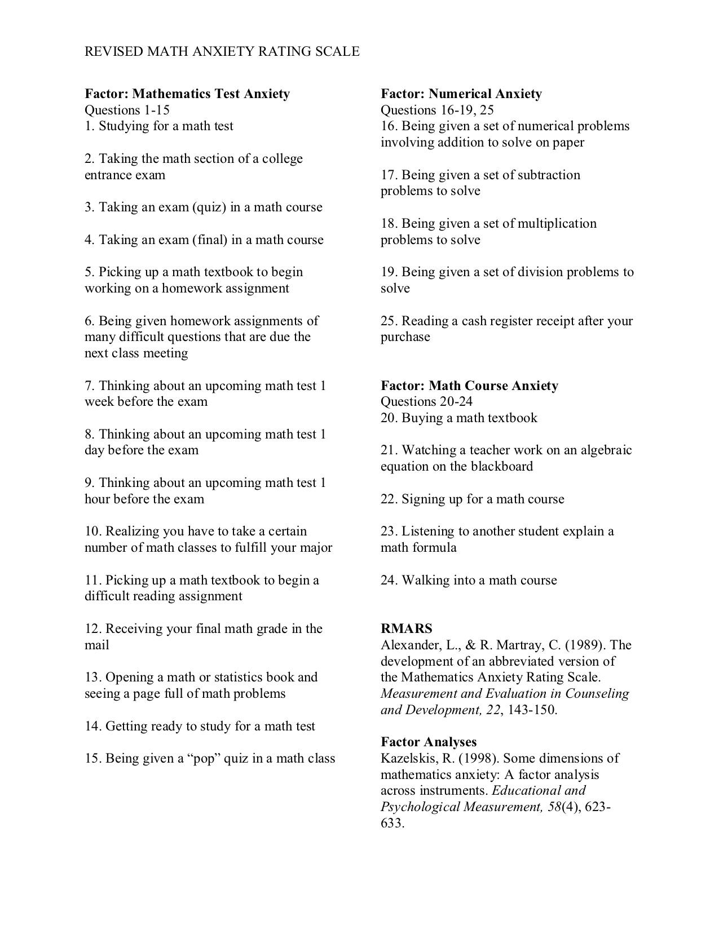

Appendix C

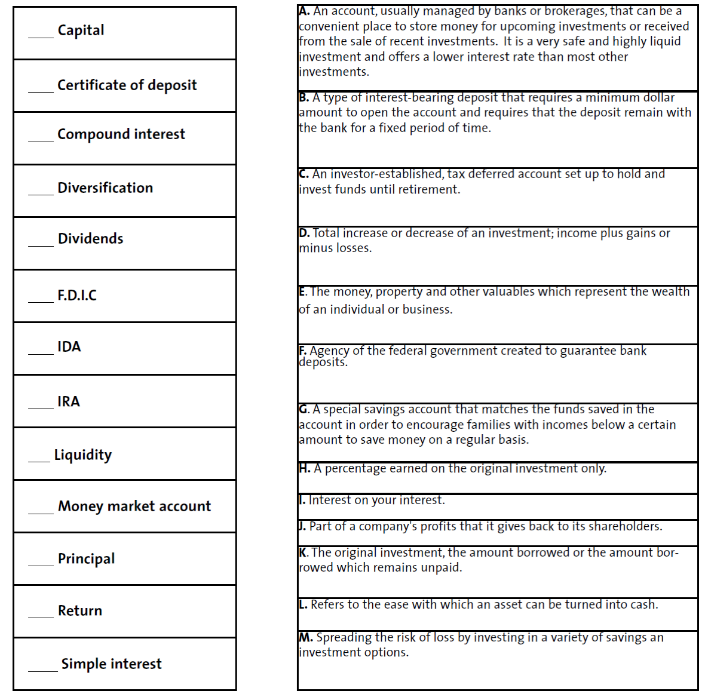

Appendix D

**Please solve the following math problems to the best of your ability. Some are very challenging, but try to solve as many as you can. Feel free to use a blank piece of paper to help solve these problems. Click the letter you choose. You may indicate,** “**don**’**t know**” **for any problems that you feel you cannot solve.**

1. What is the average (arithmetic mean) of 8, 7, 7, 5, 3, 2 and 2?

A) 3 4/7

B) 4 5/6

C) 4 6/7

D) 5

E) 6 4/5

F) don’t know

2. Ben is making wooden toys for the next arts and crafts sale. Each toy costs Ben $1.80 to make. If he sells the toys for $3.00 each, how many will he have to sell to make a profit of exactly $36.00?

A) 12

B) 20

C) 30

D) 60

E) 108

F) don’t know

210.How many yards of rope from a 24-yard length of rope remain after 3 pieces, each measuring 3 ½ yards long, and 5 pieces, each measuring 2 ¼ yards long, are removed?

A) 2 ¼

B) 4 ¼

C) 4 5/6

D) 10 ¼

E) 10 5/6

F) don’t know

211. Phillip charged $400 worth of goods on his credit cards. On his first bill he was not charged any interest and he made a payment of $20. He then charged another $18 worth of goods. On his second bill a month later, he was charged 2% interest on his entire unpaid balance. How much interest was Phillip charged on his second bill?

A) $8.76

B) $7.96

C) $7.60

D) $7.24

E) $6.63

F) don’t know

212. A student has earned scores of 87, 81, and 88 on the first 3 of 4 tests. If the student wants an average of exactly 87, what score must she earn on the fourth test?

A) 85

B) 86

C) 87

D) 92

E) 93

F) don’t know

213. Which of the following expressions represents the product of 3 less than twice *x* and 2 more than the quantity 3 times *x*?

A) -6*x*2+25*x*+6

B) 6*x*2+5*x*+6

C) 6*x*2-5*x*+6

D) 6*x*2-5*x*-6

E) 6*x*2-13*x*-6

F) don’t know

214. If *x* = -1 and *y* = 2, what is the value of the expression 2*x*3-3*xy*?

A) 8

B) 4

C) -1

D) -4

E) -8

F) don’t know

215. If *f*(4) = 0 and *f*(6) = 6, which of the following could represent *f(x*)?

A) 2/3*x* – 4

B) *x*+2

C) *x*-4

D) 3/2*x*+6

E) 3*x*-12

F) don’t know

Appendix E

**ABOUT YOURSELF**

**Please answer the following questions honestly, to the best of your ability.**

1.  What is your age? ________

2.  What is your gender?         Male          Female                 Transgender    Other

3.  What is your race/ethnicity?      Caucasian         Latino        Black/African American        Asian        Other

Do you have a credit card, check Yes or No

If yes, for how long have you had your credit card? ____________

Do you have a debit card, check Yes or No

If yes, for how long have you had your debit card? ___________________

Do you know the difference between a debit and a credit card? Check Yes or No

Do you have a checking account? Check Yes or No 

If yes, for how long have you had your checking account? ____________

Is it a shared account? Check Yes or No 

In a typical month, how many cash withdrawals do you make from your checking account?

(Write in a number)

In a typical month, how many deposits are made into your checking account from any source (cash deposits, paychecks, other sources)? (Write in a number)

In a typical month, how many times do you balance or review activity in your checking account, whether online or in a mailed statement? (Write in number)