**Extremely Awesome Real Estate**

By

Christian Wojteczko, Joseph Briggs, Ira Muan, Danielle Segassie, Deborah Nsele

**Project Description –**

Our database will reflect the systems of a real estate company. It will have the entities of Agent, Office, Client, Property, Rental_Property, Property_ForSale, and Maintenance.

**Agent:**

* Every agent is identified by their unique SSN.
* Every agent has a full name, consisting of a first, middle, and last name.
* Every agent has an email address and a phone number.
* Every agent is overseen by one supervisor. A supervisor can oversee one or more agents. Every supervisor is an agent, but not all agents are supervisors.

**Office:**

* Every office can be identified by a unique office ID.
* Every office has an address.
* Every office has one or more agents working at it. An agent will only work at one office.
* Every office is managed by an agent. We would like to keep track of the date the agent started managing their office.

**Client**:

* Every client can be identified by their unique SSN.
* Every client has a full name, consisting of their first, middle, and last names.
* Every client will have a specified budget they are operating under while in the real estate system.
* Every client has a home address, an email address, and a phone number.
* Every client must be handled by an agent. An agent may manage multiple clients, but a client will only have one agent.
* One or more clients may meet with an agent for an appointment. An appointment will take place at a scheduled date and time.

**Property:**

* Every property can be identified by its unique property ID.
* Every property has an address.
* Every property has a short description of its notable features, such as bed/bath count.
* Every property has a given method of contacting its owners

**Rental_Property:**

* Some properties are rental properties, and as a result carry some certain unique attributes.
* Every rental property can be identified with a unique rental ID.
* Every rental property will have a rent price.
* Every rental property will have a lease length.

**Property_ForSale**:

* Some properties are marked for sale and have some certain unique attributes as a result.
* Every property for sale can be identified with a unique sale ID.
* Every property for sale will have a purchasing cost. This cost is made up of the property’s listed value and the taxes imposed on the sale.
* We would like to keep track of a property’s status as it goes though the process of being sold.

**Maintenance:**

* Both rental and sellable properties may need multiple different services of maintenance.
* Every maintenance service is identified by a unique ID number.
* Every maintenance service will have a specific type of maintenance that it covers.
* A maintenance service must be needed by at least one property to be represented in the system.

**ER Diagram –**

**RM Diagram –**

**Database Implementation Screenshots –**

**Office –**

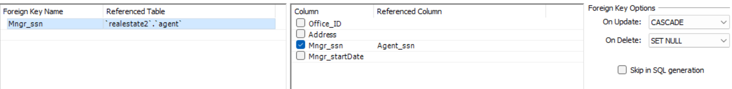

**Agent –**

**Client –**

**Property –**

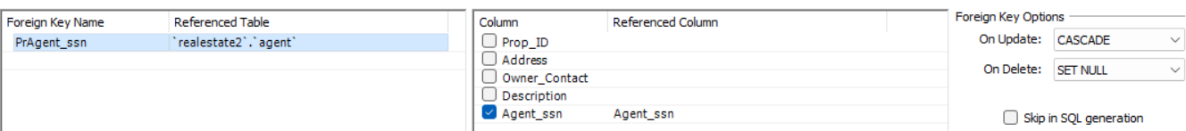

**Property_Rental –**



**For_Sale_Prop –**

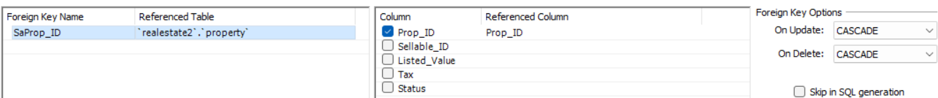

**Maintenance –**



**Appointments –**



**Database Sample Data Screenshots –**

**Office –**

**Agent –**

**Client –**

**Property –**

**Property_Rental –**

**For_Sale_Prop –**

**Maintenance –**

**Appointments –**

**Sample Queries and Descriptions –**

Query 1 –

This query gives us a list of each agent and the number of clients that they have.

SELECT a.Agent_fname, a.Minit, a.Lname, Count(*)

FROM agent AS a JOIN client AS c ON a.Agent_ssn = c.Agent_ssn

GROUP BY a.Agent_ssn;

Query 2 –

This query gives us a list of which agents are supervised by the same specified agent.

Query 3 –

This query gives us a list of the properties that a specific agent is assigned to.

Query 4 –

This query gives us a list of clients whose budgets fall within the $300,000-$400,000 range.

SELECT Fname, Lname

FROM client

WHERE Budget >= 300000 AND Budget <= 400000;

Query 5 –

This query allows us to insert a new client into our records for tracking.

INSERT INTO client

VALUES (602354678, 'Iwana', 'N', 'House', 'notascam@definitelynotfake.com', '111 Real Street Vicksburg, MS 39180', 8156174523, 845000.00, 692016880);



Query 6 –

This query finds us a list of property addresses and owner contact information for properties that need Corrective or Preventive maintenance.

SELECT Address, Owner_Contact

FROM property NATURAL JOIN maintenance

WHERE Maint_Type = 'Corrective' OR Maint_Type = 'Preventive';

**Screenshots of GUI –**

**Conclusion –**

Overall, it was interesting to have implemented python to output live data that was being stored and manipulate it. Our group meetings to also work jointly on the project were also interesting, productive, and fun. Improvements our database could have in the future are that we could add a table to store multiple pictures of the property so those could be easily shown to the clients. We could also create a more complex GUI adding in things such as logins for both agents and clients to receive information. We could introduce a messaging system to allow easy communication between the agent and client. We could also introduce a table of records to allow storage of past properties that have been sold with their selling price and past issues so the company would be able to track metrics over time and increase their company development.

**Work Form –**

|  |  |  |
| --- | --- | --- |
| Team Member Name | Sections you implemented, wrote, or designed | Approximate hours you spent |
| Christian Wojteczko | ER, Final report, Queries, Scheduled and Led group work time | 14 Hours |
| Ira Muan | RM, Note Taking, Queries | 12 Hours |
| Joseph Briggs | Project Description, Team Lead, GUI | 15 Hours |
| Danielle Segassie | Created Database, Determined proper attributes, Queries | 12 Hours |
| Deborah Nsele | Populated Database, Queries | 18 Hours |