Personal, social, and transgenerational determinants of childhood and adolescent obesity
Yiqing Wang, Ph.D.^{1,2*}, Bethsaida Cardona, M.S.^{1,2*}, Jiaxian Shen, Ph.D.^{1,2}, Daniel Sikavi, M.D., M.P.H.^{1,2}, Prooksa Ananchuensook, M.D.^{1,2}, Etienne Nzabarushimana, Ph.D.^{1,2}, Francine Laden, Sc.D.³,^{4,5}, Jorge Chavarro, M.D., Sc.D.^{3,5,6}, Jaime E. Hart, Sc.D.^{4,5}, Peter James, Sc.D.⁴, Tracey G. Simon, M.D., M.P.H.^{1,2}, Mingyang Song, MBBS, Sc.D.^{1,2,3,6}, Jonas F. Ludvigsson, M.D., Ph.D.^{7,8,9}, David Ouyang, M.D.¹⁰, Hanseul Kim, Ph.D.^{1,2}, Amrisha Bhosle, Ph.D.^{1,2}, Andrew T. Chan, M.D., M.P.H^{1,2,5,11#}, Long H. Nguyen, M.D., M.S.^{1,2,11#}
¹Clinical and Translational Epidemiology Unit, Massachusetts General Hospital and Harvard Medical School, Boston, MA, 02114, USA.
²Division of Gastroenterology, Massachusetts General Hospital and Harvard Medical School, Boston, MA, 02114, USA.
³Department of Epidemiology, Harvard TH Chan School of Public Health, Boston, MA, USA.
⁴Department of Environmental Health, Harvard TH Chan School of Public Health, Boston, MA, USA.
⁵Channing Division of Network Medicine, Department of Medicine, Brigham and Women’s Hospital and Harvard Medical School, Boston, MA, USA
⁶Department of Nutrition, Harvard TH Chan School of Public Health, Boston, MA, USA.
⁷Department of Medical Epidemiology and Biostatistics, Karolinska Institutet, Stockholm, Sweden
⁸Department of Paediatrics, Örebro University Hospital, Örebro, Sweden
⁹Department of Medicine, Columbia University College of Physicians and Surgeons, New York, USA
¹⁰Division of Research, Kaiser Permanente Northern California, Oakland, CA
¹¹Broad Institute of MIT and Harvard, Cambridge, MA, 02142, USA.

*Contributed equally as first authors
#Contributed equally as senior authors

Correspondence:

Long H. Nguyen, M.D., M.S.
Assistant Professor of Medicine
Clinical and Translational Epidemiology Unit
Massachusetts General Hospital and Harvard Medical School
Email: lnguyen24@mgh.harvard.edu
Phone: 617-726-2426

ABSTRACT
Background: Childhood and adolescent obesity is a critical public health issue influenced by diverse, interrelated risk factors. While prior studies have evaluated select personal, social, and transgenerational determinants, few have assessed their relative contributions, which are crucial for identifying those at greatest risk.
Methods: We followed the Growing Up Today Study participants from baseline (age 7-17 years) until the onset of obesity (International Obesity Task Force’s BMI cut-offs) or adulthood. We used multivariable generalized estimating equations to estimate the relative risk of obesity associated with individual risk factors and calculated population attributable fractions (PAF).
Results: We identified 1,431 incident obesity cases among 25,648 children and adolescents over a median follow-up of 5 years (IQR: 4-7). We found that maternal risk factors, including Western diet pattern, low physical activity, obesity, smoking, and night-shift work, collectively accounted for 45.7% (95% CI: 35.1-56.3%) of obesity risk. Social (low neighborhood socioeconomic status, paternal education level, and household income), personal (Western diet pattern, sedentary activity, and low physical activity), and intrauterine risk factors (large birth weight, late-term birth, C-section birth, gestational diabetes, gestational hypertension, preeclampsia, and excess gestational weight gain) accounted for 41.0% (30.8-51.2%), 38.3%, (25.6-50.9%), and 16.8% (13.1-20.5%) of obesity risk, respectively. These risk factors together had a PAF of 65.5% (54.7-76.4%).
Conclusions: Our findings underscore the important and complicated role of leading risk factors in childhood and adolescent obesity. Multifaceted preventative strategies targeting personal and maternal health behaviors, broader social determinants, and early-life exposures may reduce obesity and its downstream consequences.
Keywords: childhood obesity, adolescent obesity, multi-generation, epidemiology, diet, lifestyle, social determinants, intrauterine, population attributable fraction.

Introduction
The global prevalence of obesity among children and adolescents has tripled between 1990 and 2021 and is projected to reach 15.6% in children (5-14 years) and 14.2% in adolescents (15-24 years) by 2050.{40049185} In the U.S., this rate will exceed one in five children and one in three adolescents.{39551059}. Overweight and obesity in pre-adulthood are demonstrably linked to subsequent risk of chronic health conditions, including adulthood obesity, heart disease, premature mortality, and various psychological and social comorbidities.{23200634; 25451390; 27519139; 35883220} With an excess $116 per person in annual healthcare expenditures associated with obesity compared to children and adolescents maintaining weight in the recommended range{33760880}, the cost to the U.S. medical system exceeded $1.3 billion annually in 2019{33760880}. To develop cost-effective, evidence-based policies to resolve this major public health crisis, we must fully understand the multifaceted determinants of childhood and adolescent obesity.
A Western-style dietary pattern — characterized by high consumption of processed foods, red meats, refined grains, and sugary drinks — has been consistently linked to increased obesity risk during childhood and adolescence.{ 31742427} Nearly half of U.S. teens do not eat fruits or vegetables daily, and 15% consume sugar-sweetened beverages daily.{37104531} Relatedly, >70 % of U.S. teens do not achieve the recommended levels of physical activity.{37104531} Sedentary behaviors and lack of physical activity independently contribute to childhood and adolescent obesity.{35018425; 21836171} Collectively, these personal lifestyle behaviors represent the first and most modifiable layer of risk.
Personal lifestyle choices can be greatly influenced by wider social factors. Numerous studies have demonstrated a greater risk of obesity among children and adolescents whose parents have limited education, come from households with lower income, and face other neighborhood-level socioeconomic factors{38956737; 30524739; 29986976}, which could each contribute to the accessibility and availability of more healthful foods and venues for physical activity. Taken together, these non-personal factors could compound or exacerbate one’s own behavioral risks.{31603208; 37915814}
Transgenerational determinants can also impact offspring’s health.{16445312; 17341215} Studies have shown that maternal smoking, alcohol consumption, poor diet quality, and lower physical activity are each associated with offspring risk of obesity.{ 29973352; 36198411} While maternal lifestyles during child‑rearing shape the current home environment, earlier pre‑conception and gestational windows impact childhood metabolic trajectories. Meta-analyses have identified a 264% and 57% increase in the odds of childhood obesity among children of mothers suffering from pre-pregnancy obesity{31185012} and gestational diabetes mellitus,{40116186},respectively. Similar relationships also emerge for birth by Caesarian section (C-section),{40521792} maternal gestational hypertension and pre-eclampsia,{36082079} and excess maternal gestational weight gain.{25267200}
Despite this rich literature, most prior studies examine these interrelated determinants in relative isolation, often using cross-sectional designs. Thus, we conducted a well-integrated longitudinal study of the personal, social, and transgenerational factors linked to childhood and adolescent obesity using multi-generational U.S. cohorts to characterize the relative contributions of seventeen risk factors, their potential for effect modification, and whether these associations differ according to exposure window. This multilevel, life‑course approach offers a comprehensive and integrated picture of childhood and adolescent obesity to date, helping identify those at greatest risk and paving the way for more effective and targeted intervention strategies.

Methods

Study population
We included longitudinal data from children and adolescents in the Growing Up Today Study (waves I & II) and their mothers in the Nurses’ Health Study II (NHSII). The GUTS cohort enrolled children and adolescents aged 8-15 years in 1996 and 7-17 years in 2004. The NHSII included mothers of GUTS participants with biennial questionnaires administered to assess health behaviors and medical history.{9315766} These studies were approved by the Committee on the Use of Human Subjects in Research at the Harvard T.H. Chan School of Public Health and the Institutional Review Board of Brigham and Women’s Hospital. Voluntarily returning self-administered questionnaires was considered informed consent in both cohorts.
In total, 27,772 children and adolescents were matched to 20,518 mothers. At baseline, we excluded children with missing body mass index (BMI) or obesity. The final pooled cohorts included 25,648 children born to 17,883 mothers (Fig. 1).
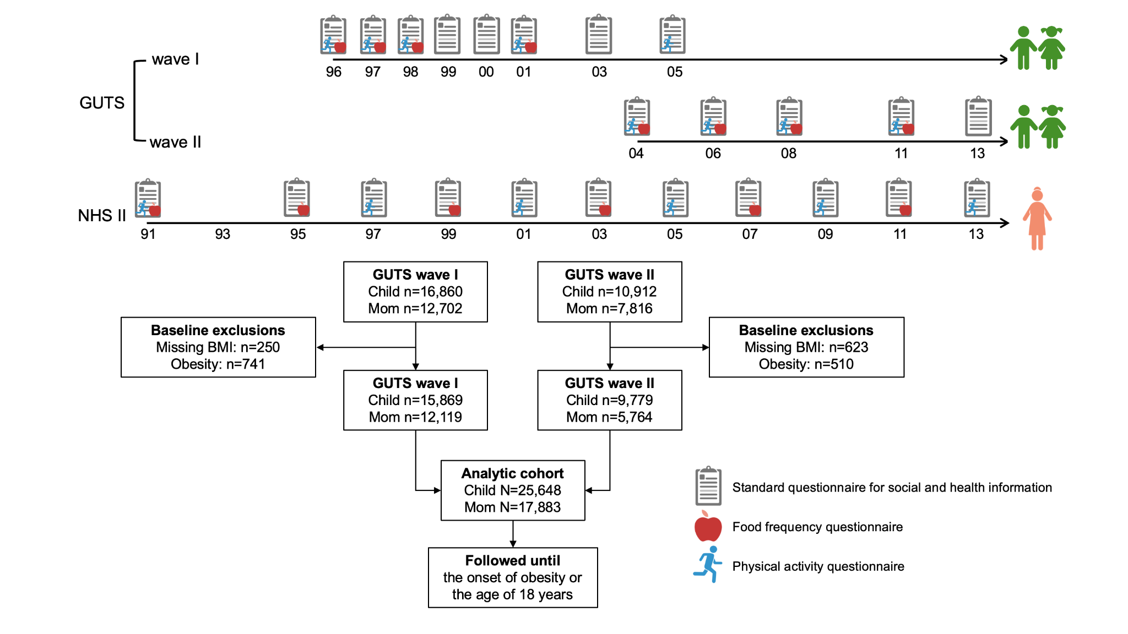
Figure 1. Study design and cohort assembly. A prospective multi-generational study to comprehensively assess the personal, social, and transgenerational determinants of childhood and adolescent obesity. All GUTS participants were aged ≥ 18 years by 2005 and 2013, respectively. Abbreviations: BMI, body mass index; GUTS, Growing Up Today Study; NHS, Nurses’ Health Study; Q, questionnaire.

Body adiposity & case ascertainment
The BMI for each participant was calculated from self-reported weight and height in each questionnaire cycle. Participants were instructed to measure weight in pounds without shoes or heavy clothing and height from the feet to the top of the head while standing up straight against a wall with flat feet on the floor. We performed multiple imputation using SAS PROC MI and the Markov Chain Monte Carlo method to estimate missing BMI values, consistent with prior work.{29973352; 36198411} We included baseline and follow-up BMI, along with all exposures of interest and covariates, as predictors in our primary model to generate five imputed datasets. Our missing completely at random (MCAR) assumption was supported by prior studies demonstrating no discernible patterns in BMI missingness.{28352203; 18652544} The validity of this method has been evaluated previously in GUTS,{29973352} finding that 97.4% of individuals were correctly classified by obesity status using imputed BMI. We identified overweight and obesity cases according to age- and sex-specific BMI cut-offs defined by the International Obesity Task Force.{10797032}

Personal risk factor assessment
Diet: GUTS used a semi-quantitative food frequency questionnaire (FFQ) with approximately 150 food items modified from the validated full-form NHS (“Willett”) FFQ,{7860946} including additional snack foods and foods consumed away from home. We converted the frequencies of food intake in standard serving sizes to average daily servings. Nutrient intake was estimated using the U.S. Department of Agriculture and Harvard University Food Composition Database. We used principal component analysis based on 37 food groups defined a priori to identify the Western dietary pattern, characterized by higher intake of processed meat, red meat, refined grains, sweets, and desserts.{11010931} The reliability of factor score-based dietary patterns has been previously described,{11010931} showing that the correlations between two FFQs one year apart and between the FFQ and the 7-day diet records were 0.67 and 0.74 for the Western dietary pattern, respectively.
Physical activity and sedentary time: GUTS participants reported the weekly hours they engaged in each type of physical activity, (e.g. basketball, soccer, tennis, biking, dancing, running/jogging, swimming) and each type of sedentary behavior (e.g., reading or doing homework, using the computer, watching TV, surfing the internet) in each season (i.e., winter, spring, summer, and autumn). We estimated total physical activity and sedentary time in hours per week. This seasonal format questionnaire has been found to reduce overreporting of activities in which GUTS participants engaged in fewer seasons compared to the annual format.{11331117}

Social risk factor assessment
Paternal education: Given the relatively uniform educational attainment of mothers in the NHSII (i.e., professional nurses), we inferred paternal educational attainment from the 1999 NHSII supplemental questionnaire that asked nurses for the highest level of education achieved by their spouse/partner. We categorized education into high school or less, college degree (2-year or 4-year), and graduate degree.
Household income: NHSII participants provided information on annual household income in 2001. We categorized it to <$50,000, $50,000 to $99,999, $100,000 to $149,000, and $150,000+.

Neighborhood socioeconomic status (nSES) score: Derivation of the nSES index has been described in detail previously.{36777531} In brief, a principal component analysis was performed on 17 selected Census variables that approximate neighborhood environments in six aspects: education, employment, housing, poverty/wealth, racial composition, and population age. The nSES index was the sum of nine z-standardized variables with a loading (i.e., contribution to a principal component) of 0.60 or greater: percent with a college degree, percent unemployed, median home value, percent of occupied housing units, median household income, percent of families receiving interest or dividends, percent non-Hispanic White, percent non-Hispanic Black, and percent of foreign-born residents.

Maternal risk factor assessment
Maternal weight status: Maternal overweight and obesity were defined as BMI≥25 kg/m² and BMI≥30 kg/m², respectively, according to the World Health Organization. BMI throughout the child-rearing period was calculated from biennially self-reported weight divided by the square of baseline height.
Maternal diet: Beginning in 1991, a “Willett” FFQ with approximately 131 food items was administered every four years in NHSII. The FFQ has been validated using 7-day diet records in NHSII.{28338828} We used the same methods described above to estimate daily food intakes and identify a Western dietary pattern,{11010931} characterized by high intake of red meats, processed meats, refined grains, high-fat dairy products, sweets, and butter.
Maternal physical activity: Weekly physical activity over the past year was estimated every four years using a validated activity questionnaire{7860180}, including eight moderate and vigorous activities, usual walking pace, and number of flights of stairs.{7860180} We multiplied the intensity of each activity in metabolic equivalents by duration.
Maternal smoking: Mothers reported smoking history at each biennial questionnaire cycle. We categorized smoking status into never, past, and current.
Maternal night shift work: Duration of night shift work was initially assessed in 1989 through this question: “What is the total number of years during which you worked rotating night shifts (at least 3 nights/month in addition to days/evenings in that month)?” We calculated cumulative shift-work hours by summing baseline history and subsequent shift-work information (total number of months in the prior years) updated in 1991, 1993, 1997, 2001, 2005, 2011, and 2013.

Intrauterine risk factor assessment
Gestational age: Mothers reported the length of pregnancies in 12-19 weeks, 20-23 weeks, 24-27 weeks, 28-31 weeks, 32-36 weeks, 37-42 weeks, and 43+ weeks. We categorized pregnancies into preterm (<37 weeks), full-term (37-42 weeks), and post-term (≥43 weeks). The long-term maternal recall of gestational age and other pregnancy-related events (e.g., gestational diabetes, preeclampsia, pre-term delivery, birth weight) has been shown to be highly correlated with data collected during pregnancies and medical records.{8720526; 23215903; 10535796}
Birth weight: Mothers reported birth weights for their children in six categories: <5 pounds, 5–5.4 pounds, 5.5–6.9 pounds, 7.0–8.4 pounds, 8.5–9.9 pounds, and ≥10 pounds. We defined low birth weight as <5.5 pounds (2.5 kg) and high birth weight as ≥10 pounds (4.5 kg) based on previously established criteria.{33972065}
Cesarean delivery: Mothers reported the mode of delivery, Cesarean (C-section) or vaginal.
Other pregnancy complications: Mothers indicated whether they had been diagnosed with gestational diabetes, pregnancy-induced hypertension, or pre-eclampsia during the pregnancies in which the study participants were born.
Pre-pregnancy weight and gestational weight gain: Pre-pregnancy BMI and gestational weight gain were self-reported among GUTS wave I mothers. We estimated pre-pregnancy BMI for wave II mothers using the most recent BMI before childbirth. According to Institute of Medicine guidelines,{23262962} we defined excess gestational weight gain as gaining >40 pounds (18.1 kg), >35 pounds (15.9 kg), >25 pounds (11.3 kg), and >20 pounds (9.1 kg) among women with pre-pregnancy BMI <18.5 kg/m², 18.5-24.9 kg/m², 25–29.9 kg/m², and ≥30 kg/m², respectively.

Statistical analysis
We followed children and adolescents from baseline until the onset of obesity or age 18, whichever occurred first, and excluded observations when female participants reported being pregnant (n=373). We censored at age 18 due to our presumption that parental lifestyle and parental social factors are likely to have less influence on offspring's health during adulthood. We carried forward prior questionnaire cycles in case of missing exposure data and cumulatively averaged continuous exposures updated at each follow-up cycle. The exposures were imputed by the same multiple imputation approach described in case ascertainment. If not otherwise specified, we categorized continuous exposures into cohort- and imputation-specific quartiles to facilitate comparisons.
We estimated the relative risk (RR) and 95% confidence interval (CI) of incident obesity associated with individual exposures using a multivariable log-binomial model with generalized estimating equations (GEE), a Poisson distribution, and an unstructured correlation structure, accounting for correlations across time for the same child and between siblings born to the same mother. Linear trend for categorical exposures was assessed using median values of quartiles as continuous variables. We adjusted for age, sex, race (non-Hispanic White/others), and cohort (GUTSI & GUTSII) in all models. Additionally, we adjusted for maternal age (year) and maternal energy intake (kcal/day) in models of maternal modifiable factors; maternal age (year) at delivery and parity (1, 2, 3, ≥4) in models of intrauterine factors; baseline BMI (kg/m²) and energy intake (kcal/day) in models of personal factors; and geographic region (Northeast, South, Midwest, West) in models of social factors. Most exposures in each exposure/modelling category (e.g., maternal modifiable factors) were mutually adjusted, except for maternal obesity, pregnancy outcomes (e.g., gestational week), and nSES, which are on the causal pathways for other maternal behavioral factors: pre-pregnancy obesity, and education and income, respectively.
We calculated the population attributable fraction (PAF) for incident obesity explained by our models based on the RRs and the prevalence of each risk factor in our study population using Spiegelman et al.’s method.{17387622; 11446148; 4050778} The PAF for all risk factors combined was estimated using a separate GEE model that included all risk factors and covariates. The PAF estimates the percent of incident obesity that would be prevented if the corresponding risk factors were set to the lowest-risk level (i.e., the reference group). Then, we used PROC MIANALYZE to calculate the composite RR, PAF, and 95% CI for incident obesity.
As a secondary analysis, we repeated all analyses above for incident overweight or obesity (OWOB). For this analysis, 5,612 GUTS participants with OWOB were excluded at baseline, giving a final analytic sample of 19,731 children and adolescents (Fig. S1). To examine whether the observed associations differed by age (<13 versus 13+ years), sex, and maternal obesity status, we also conducted stratified subgroup analyses by these potential modifiers. We computed the Q statistic to assess heterogeneity in subgroup RRs and PAFs. Additionally, to evaluate whether the timing of exposures impacted their relationships with obesity risk, we examined individual risk factors across four windows: peri-pregnancy (year of and year before birth), early childhood (1-4 years), elementary school (5-11 years), and adolescence (12-18 years). The exposure window analyses were restricted to participants with data beginning in the earliest relevant window (peri-pregnancy for maternal and social factors, and elementary school for personal factors) and with follow-up through adolescence to enhance inter-window comparability. Obesity was defined as onset during adolescence, and we excluded 0 and 12 cases that developed before adolescence for maternal/social and personal factor analyses, respectively. The year of questionnaire return was used to align exposures with the corresponding exposure windows. In sensitivity analyses, we excluded participants with missing BMI at follow-up or missing exposures at baseline (i.e., complete case analysis).
All analyses were conducted in SAS version 9.4 (SAS Institute). All statistical tests were two-sided at a pre-specified significance level of 0.05.

Results

Baseline characteristics
The average age of eligible GUTS participants in wave I (n=15,869) and II (n=9,779) was 11.6 (SD: 1.6) and 13.1 (1.9) years, respectively (Table 1). While maternal age (45.6±3.7 vs. 40.7±3.6), the prevalence of maternal never smokers (71.1% vs. 68.6%), and maternal parity (2 births: 23.5% vs. 18.6%; 3 or more births: 20.6% vs. 12.3%) were slightly higher for wave II, maternal shift-work months (5.2±6.5 vs. 9.0±11.7) were lower for wave II than wave I participants. Other exposures, including the Western diet score, physical activity, nSES, birth weight, and maternal obesity, were similar between these two cohorts.
These baseline personal, social, and transgenerational exposures had low to moderate intercorrelation (Figure 2), with stronger correlations within each risk factor category. Maternal obesity had the strongest positive correlation with maternal pre-pregnancy obesity (Spearman correlation=0.84), followed by maternal excess gestational weight gain (0.28) and participant BMI (0.26).
Table 1. Participants' characteristics at study enrollment (1996 for GUTS wave I and 2004 for wave II) by domain.*
 | GUTS wave I  (n=15,869) | GUTS wave II  (n=9,779)
Personal (i.e., participants)
Age, year | 11.6 (1.6) | 13.1 (1.9)
Female, %(n) | 53.9 (8,554) | 55.1 (5,386)
White race, %(n) | 93.2 (14,789) | 95.7 (9,358)
BMI, kg/m² | 18.7 (2.9) | 19.8 (3)
Western diet score | -0.01 (1.0) | -0.01 (0.99)
Total calorie intake, kcal/day | 2173 (704) | 2130 (735)
Sedentary time (h/week) | 51.1 (23.0) | 39.7 (21.7)
Physical activity (h/week) | 17.7 (11.2) | 13.8 (9.7)
Social
Paternal educational attainment, %(n)
High school and below | 17.7 (2,145) | 15.3 (883)
College | 50.6 (6,135) | 51.2 (2,952)
Graduate school | 31.7 (3,839) | 33.5 (1,929)
Household pre-tax annual income, 2001, %(n)
< $50k | 13.4 (1,630) | 12.3 (707)
$50-99k | 46.2 (5,600) | 48.6 (2,803)
$100-149k | 26.0 (3,152) | 22.6 (1,301)
$≥$$150k | 14.4 (1,737) | 16.5 (953)
Neighborhood socioeconomic status index | 0.2 (3.5) | 0.6 (3.5)
Residential region, %(n)
Northeast | 35.6 (4,309) | 32.5 (1,877)
Midwest | 34.9 (4,232) | 35.7 (2,056)
South | 15.4 (1,864) | 15.8 (908)
West | 14.1 (1,714) | 16.0 (923)
Maternal
Age, years | 40.7 (3.6) | 45.6 (3.7)
Obesity (BMI $≥$ 30 kg/m²), %(n) | 10.0 (1,211) | 10.7 (615)
Western diet score | 0.1 (0.9) | 0.1 (0.8)
Total calorie intake, kcal/day | 1859 (498) | 1895 (470)
Physical activity, (METs-h/wk) | 20 (22.6) | 22 (21.0)
Smoking status, %(n)
Never | 68.6 (8,311) | 71.1 (4,099)
Past smokers | 23.6 (2,860) | 24.2 (1,393)
Current smokers | 7.8 (948) | 4.7 (272)
Cumulative shift-work, months | 9.0 (11.7) | 5.2 (6.5)
Intrauterine
Birth weight, %(n)
$≤$ 2.5 kg | 3.8 (607) | 4.4 (431)
2.6-4.4 kg | 93.5 (14,839) | 93.0 (9,091)
$≥$ 4.5 kg | 2.7 (423) | 2.6 (257)
Gestational age at birth, %(n)
< 37 weeks | 6.4 (1,009) | 7.8 (767)
37-42 weeks | 86.8 (13,787) | 87.8 (8,586)
$≥$ 43 weeks | 6.8 (1,073) | 4.4 (426)
Born by Cesarean section, %(n) | 19.8 (3,135) | 20.8 (2,034)
Pregnancy complication†, %(n) | 8.9 (1,414) | 9.9 (964)
Prior maternal parity, %(n)
0 | 34.8 (5,513) | 23.7 (2,317)
1 | 34.3 (5,447) | 32.2 (3,149)
2 | 18.6 (2,958) | 23.5 (2,294)
$≥$ 3 | 12.3 (1,951) | 20.6 (2,019)
Maternal age at birth, years | 28.4 (3.5) | 31.6 (3.7)
Maternal pre-pregnancy obesity (BMI $≥$ 30 kg/m²), %(n) | 3.2 (515) | 5.1 (494)
Maternal excess weight gain‡, %(n) | 31.5 (5,002) | Not assessed
Values are means (SD) for continuous variables; percentages (participant number) for categorical variables.
* The baseline of the first multiple-imputed dataset. Personal and intrauterine factors vary at the individual participant level, while social and maternal modifiable factors vary at the maternal level.
† Gestational diabetes, hypertension, or eclampsia.
‡ Women with excess gestational weight gain gained > 40 pounds if they had BMI < 18.5 before pregnancy, >35 pounds if they had BMI $≥$ 18.5 and < 25, >25 pounds if they had BMI $≥$ 25 and < 30, and >20 pounds if they had BMI $≥$ 30.
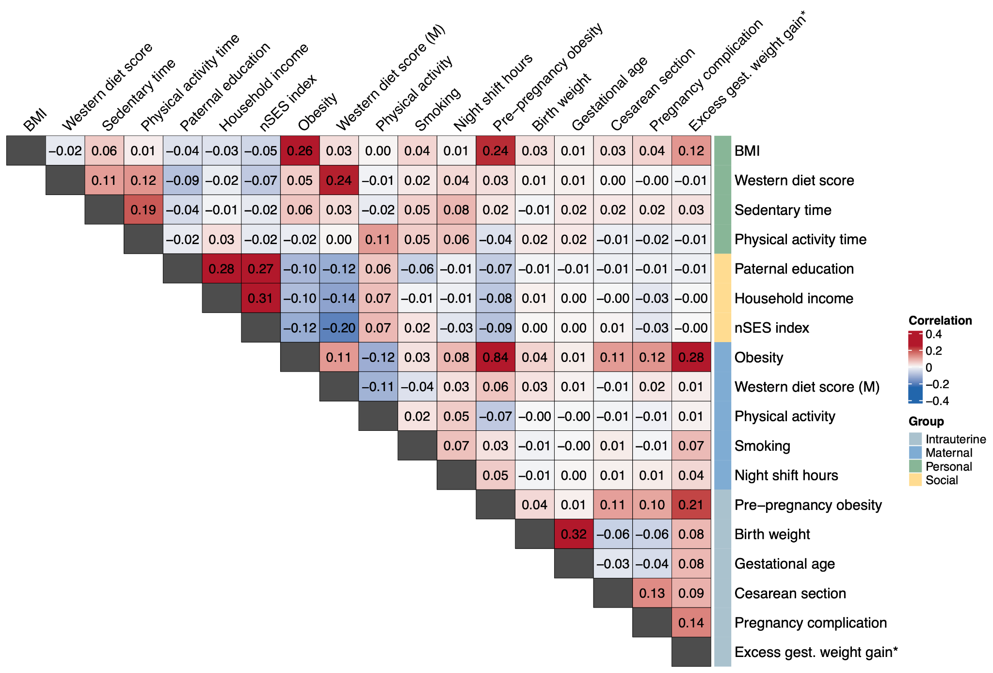
Figure 2. Spearman correlations between personal, social, maternal, and intrauterine exposures and BMI at the baseline. BMI, body mass index; gest., gestational; nSES, neighborhood socioeconomic status. * Only available in GUTS I.

Individual and combined risk factors for childhood and adolescent obesity
We documented 1,431 incident obesity cases over a median follow-up of 5 years (interquartile range: 4-7 years) (Table S1). We found that maternal pre-pregnancy obesity (RR: 3.45; 95% CI: 2.92-4.09) and maternal obesity during follow-up (RR: 3.13, 95% CI: 2.76-3.55) had the strongest associations with obesity (Figure 3A, Table S1), followed by maternal excess gestational weight gain, a lower nSES index, higher adherence to a Western diet, higher birth weight, higher maternal Western diet score, lower paternal education, maternal smoking, lower maternal physical activity, lower physical activity, maternal pregnancy complications, lower household income, higher gestational week, born by C-section, longer maternal night shift hours, and sedentary time.
The PAF for nSES index (23.3%, 95% CI: 13.7-32.8%) was the highest (Table S2, Figure 3B), followed by maternal physical activity, maternal obesity, maternal excess gestational weight gain, adherence to a Western diet, sedentary time, maternal Western diet score, paternal education, household income, maternal night shift hours, physical activity, maternal pre-pregnancy obesity, maternal smoking, born by C-section, maternal pregnancy complication, birth weight, and gestational week. Overall, 45.7% (35.1-56.3%), 41.0% (30.8-51.2%), 38.3% (25.6-50.9%), and 16.8% (13.1-20.5%) of incident obesity would be prevented if the assessed maternal modifiable risk factors, socioeconomic risk factors, personal modifiable risk factors, and intrauterine risk factors were all set to the lowest risk levels, respectively. In total, the PAF for all risk factors from all domains combined was 65.5% (54.7-76.4%).
The associations between individual risk factors and incident childhood and adolescent overweight or obesity (OWOB, n=4,341), our secondary outcome, were similar but slightly attenuated (Table S3). Maternal pre-pregnancy OWOB and maternal OWOB during child-rearing remain the leading risk factors. Personal, social, maternal, and intrauterine risk factors contributed to a total PAF of 45.1% (36.3-54.0%).

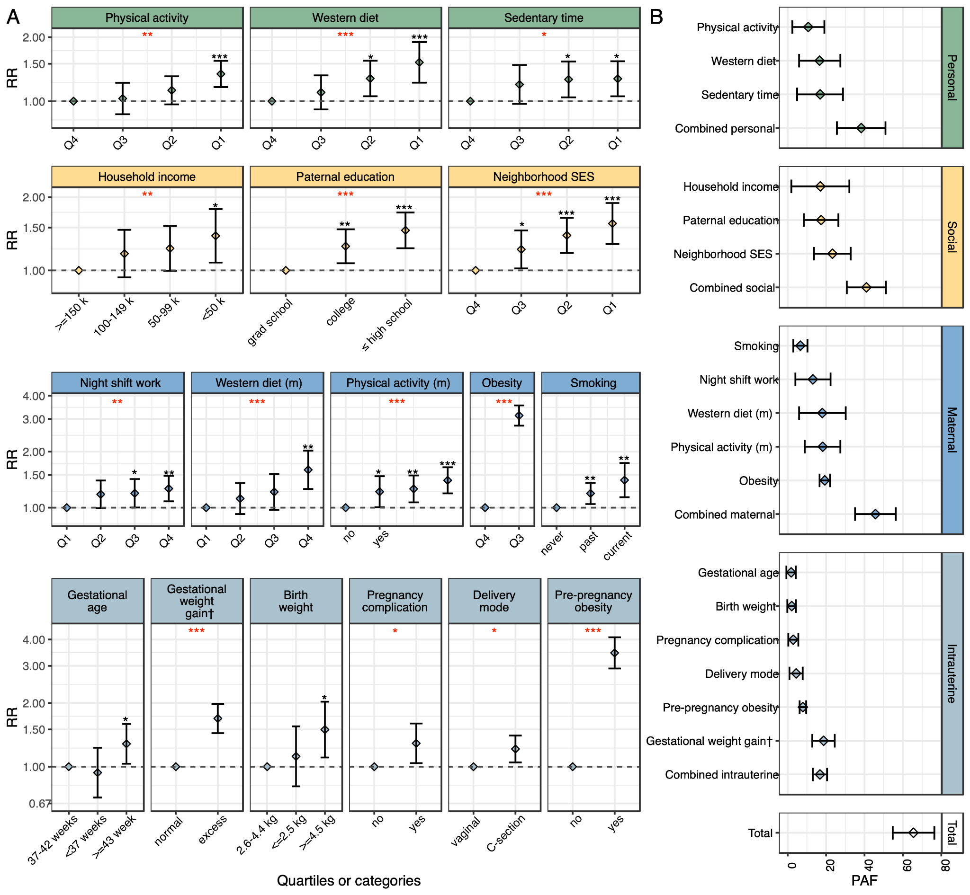
Figure 3. Personal, social, maternal, and intrauterine risk factors for incident obesity during childhood and adolescence. A. Composite relative risks (RRs) and 95% confidence interval (CI) for incident obesity associated with individual risk factors, adjusting for cohort, age, sex, and race. Additionally, maternal age and maternal energy intake were adjusted in models of maternal modifiable factors; maternal age at delivery and parity for intrauterine factors; baseline BMI and energy intake for personal factors; and geographic regions for socioeconomic factors. Exposures in each category were mutually adjusted, except for maternal obesity, pregnancy outcomes, and neighborhood socioeconomic status (SES) index. B. Composite population attributable fractions (PAFs) and 95% confidence intervals (CIs) of obesity that can be attributed to individual and combined risk factors relative to their reference groups. The sum of individual PAFs may exceed the combined PAFs or 100% due to overlapping pathways. Q, quartile. *, **, *** P-values < 0.05, < 0.01, or < 0.0001. Red * represents p-values for linear trend tests or tests between binary categories. † Only available in GUTS I.

Potential effect modification by age, offspring sex, and maternal obesity
In stratified analyses, we found that the risk of incident childhood and adolescent obesity was largely similar between strata, with some exceptions (Table S5-7). Among teens ($≥$13 years), compared to children ($<$13 years), there was a statistically significantly higher obesity risk associated with sedentary time and maternal current smoking status (Figure 4). The obesity risk associated with maternal obesity and maternal Western diet score was higher among females than males (Figure 4). The PAFs explained by maternal obesity (24.17% vs. 15.86%) and maternal pre-pregnancy obesity (10.34% vs. 6.07%) were also greater in females than in males (Figure 5).
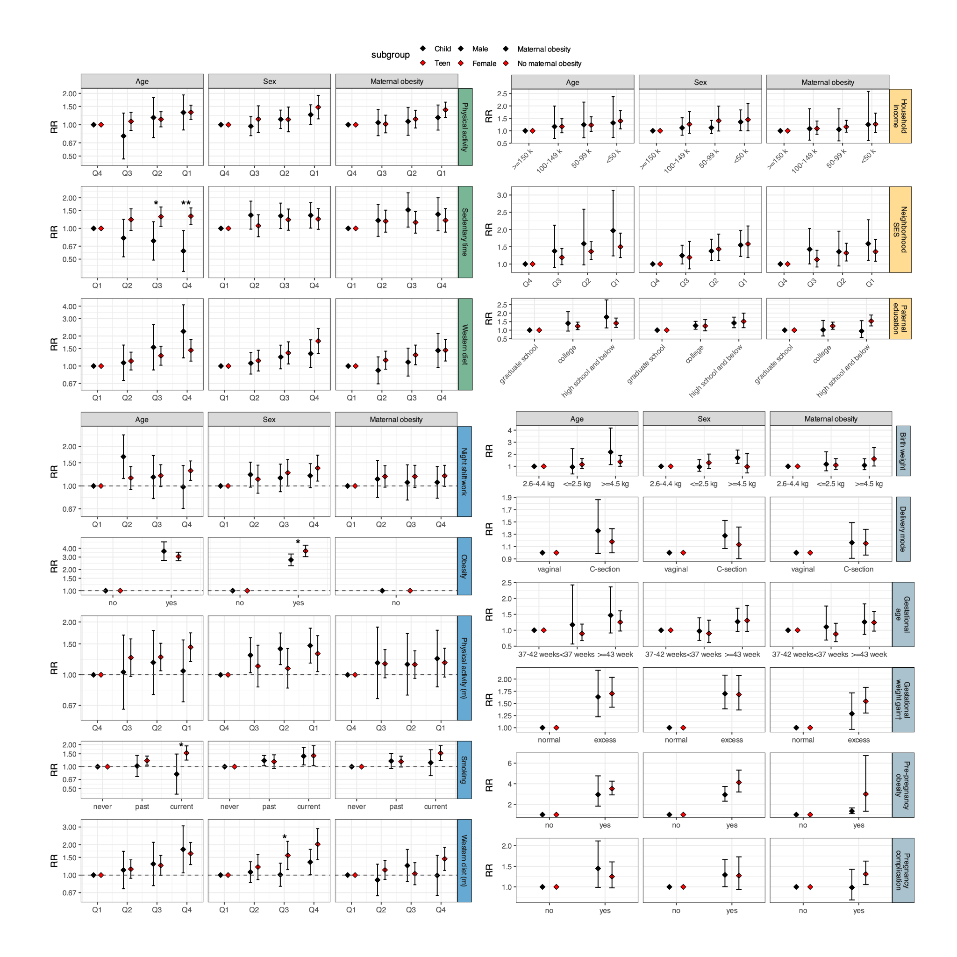Figure 4. Associations of personal, social, maternal, and intrauterine risk factors with incident childhood and adolescent obesity according to age, sex, and maternal obesity status. Composite relative risks (RRs) and 95% confidence intervals (CIs) for incident obesity associated with individual risk factors, adjusting for cohort, age, sex, and race. Additionally, maternal age and maternal energy intake were adjusted for in models of maternal modifiable factors; maternal age at delivery and parity for intrauterine factors; baseline BMI and energy intake for personal factors; and geographic regions for socioeconomic factors. Exposures in each category were mutually adjusted, except for maternal obesity, pregnancy outcomes, and neighborhood socioeconomic status (SES) index. Q, quartile. *, P-heterogeneity < 0.05; **, P-heterogeneity < 0.01 for a Cochran’s Q test of RRs between strata. † Only available in GUTS I.
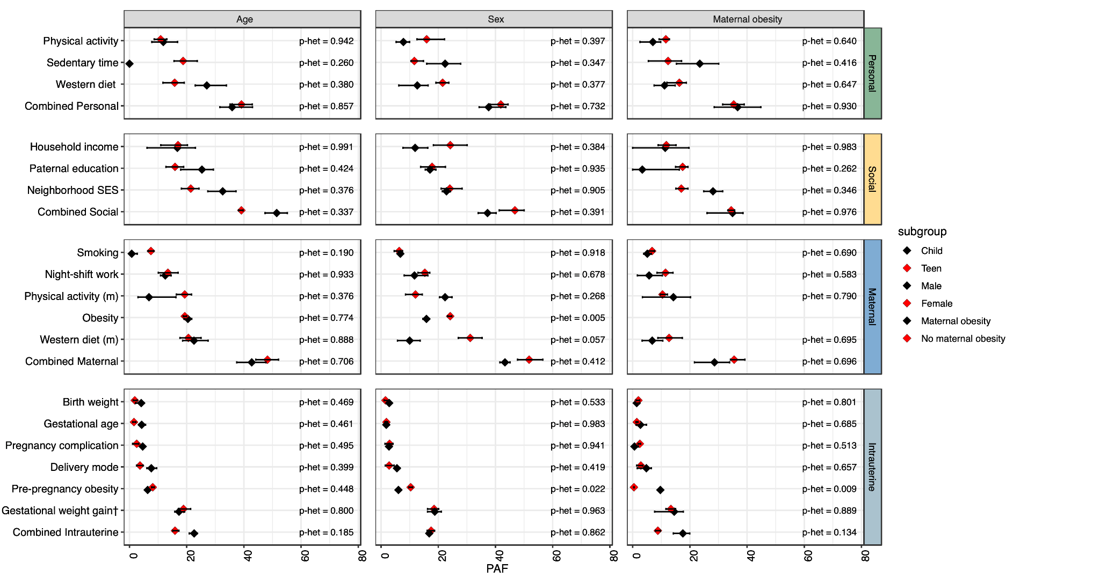
Figure 5. Population attributable fraction (PAFs) of childhood and adolescent obesity attributable to personal, social, maternal, and intrauterine risk factors according to age, offspring sex, and maternal obesity status. Composite PAFs and 95% confidence intervals (CIs) of obesity attributable to individual and combined risk factors relative to their reference groups. The sum of individual PAFs may exceed the combined PAFs or 100% due to overlapping pathways. For risk status with negative coefficient estimates, PAFs were set to zero. P-het, p-heterogeneity; Q, quartile. *, P-heterogeneity < 0.05 for a Cochran’s Q test of PAFs between strata. † Only available in GUTS I.

Adolescent obesity according to the exposure window
In a subset of participants (n=3,895–7,107), we examined the associations between risk factors and adolescent obesity risk (onset at $≥$13 years) according to exposure window (peri-pregnancy, early childhood, elementary school, adolescent). Maternal obesity during any of the exposure windows was associated with more than 150% increased risk for adolescent obesity (Table S8). While sedentary time, nSES index, and maternal obesity tended to be more strongly associated with adolescent obesity risk in later than in earlier exposure windows, personal and maternal Western diet and physical activity tended to have weaker associations over time.

Complete-case analysis
In a sensitivity analysis excluding participants with missing exposure data, we identified 508 obesity cases among 15,258 children and adolescents (Figure S2). The associations between individual risk factors and obesity risk were not materially changed from the primary analysis (Table S9), although the statistical significance was slightly attenuated due to the reduced sample size. Maternal modifiable risk factors remained the leading risk factors, explaining 46.5% (PAF 95% CI: 29.6-60.5%) of obesity risk, followed by socioeconomic risk factors, personal modifiable risk factors, and intrauterine risk factors.

Discussion
In large multigenerational cohorts of US parents, children, and adolescents, we found that 65.5% of incident obesity could be attributed to leading personal, social, and transgenerational risk factors. Specifically, approximately one-fourth of childhood and adolescent obesity was attributed to neighborhood-level factors, and approximately one-fifth of childhood and adolescent obesity was principally attributed to maternal obesity, maternal physical activity, excess gestational weight gain, and personal diet. Collectively, maternal risk factors had the largest population attributable fraction (PAF), followed by social, personal, and intrauterine risk factors. These findings provide evidence for the multifactorial and complex nature of childhood and adolescent obesity, paving the way for more effective, integrated interventions that identify individuals most at risk for obesity and address multi-level risk factors simultaneously.
Our finding that maternal risk factors–especially pre-pregnancy obesity–had the strongest independent association with childhood and adolescent obesity is highly concordant with other studies {28507009; 33781054}. In a meta-analysis of 37 cohorts, Voerman et al. estimated that 10.2%-21.6% of childhood overweight/obesity prevalence could be attributed to maternal pre-pregnancy obesity and excessive gestational weight gain, with the strongest associations occurred in late childhood (10-18 years), compared to early (2-5 years) and mid childhood (5-10 years),{30742624} closely mirroring our estimates. Additionally, similar to our analyses, they observed that regardless of maternal pre-pregnancy weight status (except for underweight), offspring of mothers with excess gestational weight gain tended to have a higher risk of overweight/obesity.{30742624} However, these studies overlooked other major risk factors of childhood obesity and did not account for confounding from maternal diet, physical activity, and intrauterine factors, as we do. Furthermore, our results showed stronger associations of maternal obesity and maternal diet with childhood/adolescent obesity among offspring girls, consistent with prior studies reporting a tighter mother-daughter coupling than mother-son or father-child pairs.{36943299; 28750045} In response to maternal obesity, placentas supporting female children may exhibit reduced fatty acid oxidation, increased esterification, and heightened inflammation, favoring lipid accrual.{37298720} Social pathways likely amplify these biological predispositions, as maternal feeding practices and weight-related concerns tend to relate more strongly to girls’ eating and weight-control behaviors than boys’.{12885700; 20498008}
Notably, the PAF for concurrent maternal obesity, diet, and physical activity exceeded that for pre-pregnancy obesity. This pattern aligns with evidence from Mendelian randomization and family-based studies, which show limited direct intrauterine effects of maternal pre-pregnancy weight status and imply a substantial contribution from shared genetic and environmental factors.{28118352; 35101027; 22771730} For instance, mothers may directly influence the dietary patterns and physical activity levels of their children, including snack patterns, food rewards, and television viewing.{39342321; 33819915} Microbiome–immune–endocrine pathways may also explain how maternal exposures can leave durable biological imprints relevant to metabolic regulation. Recent studies have shown that a Western dietary pattern during pregnancy is associated with altered maternal and fetal blood metabolites,{40033007} and maternal consumption of common emulsifiers may perturb offspring's early-life gut ecology,{40730751} including elevated pro-inflammatory flagellin and premature closure of goblet cell-associated antigen passages.
The associations we observed for social determinants are also consistent with prior smaller-scale studies in the U.S.{29986976; 36873636} and other high-income countries.{38956737; 30524739; 38297032} For example, an analysis of seven prospective cohorts in six high-income countries has reported clear social gradients by maternal education and household income.{35821522} Similar associations were presented in a recent analysis of the National Health and Nutrition Examination Survey, which estimated a 4- and 9-percentage-point increase in the prevalence of adolescent obesity among lower-income households and lower head-of-household education, respectively.{35727570} Much of these social factors may impact early childhood obesity by altering prenatal and early postnatal factors and child energy balance-related behaviors.{35383270}
In our study, child health behaviors–personal diet, sedentary time, and physical activity–collectively accounted for a population-attributable burden (38.3%), comparable to that of social risk factors (41.0%) and prior literature.{33595354; 30412690} In the Growing Up in New Zealand study, shorter sleep, higher consumption of takeaway food or soft drinks, higher screen time, and food insecurity yielded a cumulative PAF of 42.9% for early childhood obesity.{33595354} At older ages, the US Youth Risk Behavior Survey estimated that 34.8% of adolescent obesity could be attributed to unhealthy diet, physical activity, and other modifiable risk factors.{30412690} In particular, we found that a less healthful dietary pattern explained a greater risk for obesity than decreased physical activity, which aligns with findings from one recent study, suggesting that dietary intake may play a greater role than reduced energy expenditure.{40658837}
Finally, our findings for the associations of birth weight {15908441; 28645970}, C-section {27599167; 37085536}, and maternal pregnancy complications {34442053; 36111112; 40116186} with childhood and adolescent obesity are concordant with existing evidence. Both preeclampsia and gestational diabetes have been repeatedly linked to elevated risk of obesity, cardiovascular diseases, diabetes, and neurodevelopmental disorders in children.{34442053; 36111112; 40116186} While a few studies have shown that Cesarean delivery was associated with a modestly increased risk of offspring obesity,{27599167; 37085536} others have indicated that such an association may be explained mainly by maternal pregnancy BMI{34585502} and might not persist into older childhood.{30878984} In our analyses, we found no significant difference in obesity risk by Cesarean delivery or other intrauterine risk factors when comparing participants aged ≧13 years versus <13 years.
The large-scale, comprehensive, and prospective design of our study, spanning peri-pregnancy, childhood, and adolescent periods, enabled a thorough investigation of 17 key risk factors of pediatric obesity across four broad domains. To our knowledge, no prior investigation has examined this breadth of determinants, quantified their relative contributions, explored differences across key demographics, and assessed critical windows of susceptibility. However, as with all observational work, residual confounding (e.g., paternal exposures) may remain. Weight and several behaviors, like diet and physical activity, were self-reported and may be subject to misreporting. Nevertheless, the numerous high-quality validation studies of NHSII ensured the reliability of maternal exposures.{28338828; 7860180; 2090285} In addition, self-reported weight and height have been shown to be highly correlated with measured weight and height among US adolescents.{17890505; 10878149; 11460871} The relatively high post-term birth rate observed in our study may reflect the use of menstrual-based estimates, which have been shown to inflate post-term rates compared with clinical methods in the U.S.{17400841} Mothers in our study were all nurses and predominantly white, which may restrict generalizability. The higher health awareness among our maternal population than in the general population may result in underestimated PAFs for obesity risk factors. Nevertheless, we collected information on overall household income and paternal education, which better captured household SES variation. Moreover, because our cohorts enrolled children from age 7 years onwards, we were unable to assess obesity risk and personal lifestyle in early childhood, which could be critical risk periods for persistent obesity.{8172099} A smaller sample size and potential exposure misclassification may have contributed to the mostly null associations in the exposure window analysis.
Taken together, our study provides comprehensive evidence on the roles and preventable burdens of leading obesity determinants, including broader social factors, maternal adiposity, unhealthy diet, and lower physical activity. Our study highlights the potential benefits of pairing behavioral-focused clinical recommendations and interventions with policies that address financial and social structural barriers (e.g., healthy food environment and safe spaces for activity). Effective interventions might need to target not only children, but also their families, communities, and women of reproductive age. Future research should refine the understanding of causal relationships and the biological and social pathways involved.

Author Contributions
- Substantial contributions to conception and design: YW, BC, ATC, LHN
- Acquisition, analysis, or interpretation of data: YW, BC, LHN, JEH, JC, FL
- Drafting of the article: YW, BC, AB, LHN
- Critical revision for important intellectual content: All authors
- Final approval of the version to be published: All authors
- Agreement to be accountable for all aspects of the work in ensuring that questions related to the accuracy or integrity of any part of the article are appropriately investigated and resolved: All authors

Acknowledgments
This work was supported by the National Institutes of Health (U01 CA176726 to the Nurses’ Health Study II, U01 HL145386 to the Growing Up Today Study, and K23 DK125838 to LHN), Massachusetts General Hospital (ECOR FMD Fellowship Award to YW), and the American Cancer Society (Postdoctoral Fellowship to YW), American Gastroenterological Association (Research Scholars Award to LHN), the Crohn’s and Colitis Foundation (Career Development Award to LHN), and the American Heart Association (2025A007041 to DO and LHN).

Abbreviations
BMI, body mass index; CDC, Centers for Disease Control and Prevention; CI, confidence interval; C-section, Cesarean section; FFQ, food frequency questionnaire; GUTS, Centers for Disease Control and Prevention; Growing Up Today Study; IQR, interquartile range; MET, metabolic equivalent of task; LCI, lower 95% confidence interval; NHSII, Nurses’ Health Study II; nSES, neighborhood socioeconomic status; OWOB, overweight or obesity; PAR, population attributable risk; Q, questionnaire or quartile; RR, relative risk; UCI, upper 95% CI; WHO, World Health Organization.

Conflict of Interest: Dr Ludvigsson has received financial support from Merck/MSD for a study on inflammatory bowel disease and fibrosis; and for developing a paper reviewing national healthcare registers in China. Dr Ludvigsson also has an ongoing research collaboration on celiac disease with Takeda. Earlier support includes a grant from Janssen for an unrelated study on behalf of the Swedish IBD quality register (SWIBREG).

References

