Title: Rebecca and the Tale of the Knowledge-Seeking Toys

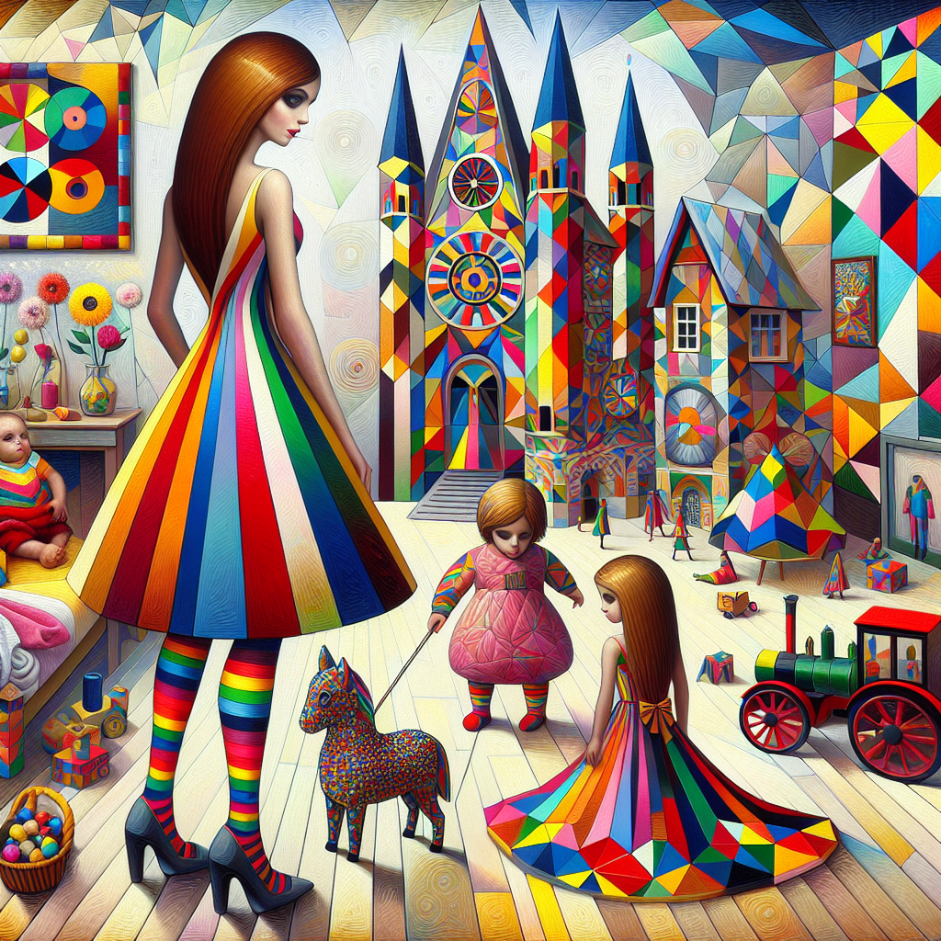

Once upon a time, in the admirable city of London, lived a jovial 7-year-old named Rebecca. Rebecca was loved by everyone for her bright brown eyes that outshined when she dressed up in her favorite clothes: multi-colored dresses paired with vibrant leggings. What made her remarkable, though, was her ever-present smile and insatiable curiosity.

