Enhancing Career Development Through Multi-Model AI: A Novel Approach to Resume Analysis and Skill Gap Identification

Report submitted in partial fulfilment of the requirements for the degree Of

Master of Science
In

Data Science & Analytics
By

Soham Mukherjee, Pritam Banerjee and Srishti Karmakar
(Roll no: 23478123013, 23478123008 and 23478123019)

Under the guidance of

Prof. Madhurima Paul

NSHM KNOWLEDGE CAMPUS
M.Sc. in Data Science & Analytics [2023 – 2025]
NSHM Department of Computing and Analytics [NICA]

NSHM Department of Computing and Analytics [NICA] Masters of Science in Data Science & Analytics


CERTIFICATE

This is to certify that Mr. Soham Mukherjee (Roll No. 23478123013), Mr. Pritam Banerjee (Roll No. 23478123008) and Ms. Srishti Karmakar (Roll No. 23478123019) have successfully completed the Project titled –

“Enhancing Career Development Through Multi-Model AI: A Novel Approach to Resume Analysis and Skill Gap Identification”

at NSHM Knowledge Campus, Kolkata (College Code: 234) under my supervision and guidance in the fulfillment of requirements of Fourth Semester, Master of Science (Data Science and Analytics) under Maulana Abul Kalam Azad University of Technology (MAKAUT), West Bengal.

Prof. Madhurima Paul
(Assistant Professor & Program Coordinator)

M.Sc. Data Science at NSHM Knowledge Campus, Kolkata (College code-234)

DECLARATION

We certify that the work contained in this report is original and has been done by us under the guidance of our supervisor. The work has not been submitted to any other Institute for any degree or diploma. We have followed the guidelines provided by the Institute in preparing the report. We have conformed to the norms and guidelines given in the Ethical Code of Conduct of the Institute. Whenever we have used materials (data, theoretical analysis, figures, and text) from other sources, we have given due credit to them by citing them in the text of the report and giving their details in the references. Further, we have taken permission from the copyright owners of the sources, whenever necessary.

Srishti Karmakar
Roll No: 23478123019

Pritam Banerjee
Roll No: 23478123008

Soham Mukherjee
Roll No: 23478123013

Acknowledgements

The project opportunity that I had was a great change for learning and understanding the intricacies of the subject of Natural Language Processing and Generative AI; and, for personal as well as professional development. I am very obliged for having Professor Madhurima Paul as a Project guide and mentor who guided me throughout the project and made it a great learning curve for me.
Firstly, I express my deepest gratitude and special thanks to the Computing and Analytics Department who gave me an opportunity to carry out my project at the esteem college, NSHM Knowledge Campus. Also, I express my thanks to my team for giving me support and inspiration throughout so that I can carry out the project properly. Again, I would like to thank my guide and mentor for sparing her valuable time despite her busy schedule.
I would also like to thank all the faculty members of Computing and Analytics Department, NSHM Knowledge Campus, and my team who made the working environment productive and very conducive.

Enhancing Career Development Through Multi-Model AI: A Novel Approach to Resume Analysis and Skill Gap Identification

Abstract
This paper presents an innovative career guidance system that leverages multiple AI models and agents to provide comprehensive resume analysis and personalized career development recommendations. The system integrates advanced natural language processing techniques with modern AI architectures to analyze resumes, identify skill gaps, and generate tailored learning pathways. Our approach combines the capabilities of Gemini 2.0 Flash, Alibaba Cloud’s Qwen-based models, and sentence transformers to create a robust framework for career development. The system features an intelligent ATS (Applicant Tracking System) scoring mechanism that evaluates resume-job description compatibility through semantic similarity analysis, keyword matching, and skill-based scoring, a dynamic skill gap analysis module, and an interactive chat interface for personalized career guidance. We demonstrate the system's effectiveness through extensive testing with various resume formats and job descriptions, achieving significant improvements in career guidance accuracy and personalization. The results indicate that our multi-model approach provides more nuanced and actionable career insights compared to traditional single-model systems. This research contributes to the field of AI-driven career development by introducing a novel architecture that effectively combines multiple AI models to deliver comprehensive career guidance solutions.

CONTENTS
Title Page 1
Certificate by the Supervisor 2
Declaration 3
Acknowledgements 4
Abstract 5
Contents 6

Chapter 1: Introduction…………………………………………………………………………………………………. 8

Chapter 2: Literature Survey…………………………………………………………………………………………. 11

Chapter 3: Methodology………………………………………………………………………………………………... 14
3.1 The Role of AI in Personalized Content Delivery……………………………………………………………….. 15
3.2 Working of the Applicant Tracking System……………………………………………………………………… 15
3.3 Functioning of Agentic Retrieval-Augmented Generation Chatbots……………………………………. 16
3.4 Tech Stack…………………………………………………………………………………………………………………… 17
3.5 Data Acquisition…………………………………………………………………………………………………………… 19
3.5.1 Resume Document Processing and Text Extraction…………………………………………………… 19
3.5.2 Dynamic Industry Data Collection and Analysis…………………………………………………………. 20
3.6 Data Extraction and Structured Output Generation…………………………………………………………... 21
3.6.1 Resume Content Analysis and Validation…………………………………………………………………... 21
3.6.2 Structured Information Extraction…………………………………………………………………………… 21
3.6.3 Skill Gap Analysis and Career Insights………………………………………………………………………. 22
3.7 Career Development and Learning Pathway Generation…………………………………………………… 22
3.7.1 Multi-Dimensional Skill Gap Analysis Framework……………………………………………………… 22
3.7.2 Intelligent Resource Recommendation System………………………………………………………….. 23
3.8 Intelligent ATS Scoring System……………………………………………………………………………………….. 24
3.8.1 Advanced Semantic Embedding Framework…………………………………………………………….. 24
3.8.2 Multi-Factor Scoring Algorithm………………………………………………………………………………... 24
3.9 Intelligent Career Guidance Chatbot……………………………………………………………………………….. 25
3.9.1 Resume-Augmented Generation Framework……………………………………………………………. 25
3.9.2 Multi-Tool Integration Framework……………………………………………………………….. 26

Chapter 4: Results & Discussions………………………………………………………………………… 27
4.1 Effectiveness of Skill Gap Analysis……………………………………………………………………….. 28
4.2 Personalization Through Learning Resource Recommendation…………………………….. 28
4.3 Overview of System Performance………………………………………………………………………… 29
4.4 Resume-Job Description Matching Accuracy………………………………………………………… 30
4.5 Chatbot-Guided Career Navigation………………………………………………………………………. 31
4.6 System Robustness and Scalability………………………………………………………………………. 32
4.7 Comparative Analysis with Existing Solutions……………………………………………………… 32

Chapter 5: Conclusion…………………………………………………………………………………………. 34
5.1 Summary of Contributions………………………………………………………………………………….. 35
5.2 Key Findings………………………………………………………………………………………………………. 35
5.3 Real-World Applications and Impact…………………………………………………………………… 35
5.4 Limitations………………………………………………………………………………………………………… 36
5.5 Future Work………………………………………………………………………………………………………. 36
5.6 Concluding Remarks……………………………………………………………………………………………37

References………………………………………………………………………………………………………….. 38

Appendix – A………………………………………………………………………………………………………..41

Appendix – B………………………………………………………………………………………………………. 49

Appendix – C………………………………………………………………………………………………………. 65

Appendix – D……………………………………………………………………………………………………… 70

Chapter 1: Introduction

1 Introduction
In today’s rapidly evolving job market, professionals face increasing challenges in identifying and bridging skill gaps, understanding industry trends, and making informed career decisions. The proliferation of new technologies, the dynamic nature of required competencies, and the global competition for talent have made career planning more complex than ever before. Traditional career guidance systems, which often rely on static databases or rule-based matching, frequently fall short in providing the personalized, data-driven insights necessary to effectively guide individuals through their career development journey. These systems typically lack the flexibility to adapt to the unique backgrounds, aspirations, and evolving needs of modern job seekers.
The emergence of advanced artificial intelligence (AI) technologies presents a transformative opportunity to revolutionize career guidance. By leveraging the power of large language models (LLMs), real-time data retrieval, and multi-modal analysis, it is now possible to deliver comprehensive, personalized career development solutions at scale. This paper introduces a novel career guidance system that integrates multiple AI models to analyze resumes, identify skill gaps, and generate tailored career recommendations. The system is designed to address the complexity of resume analysis by employing advanced natural language processing techniques to extract and interpret information from a variety of file formats, including PDF, DOC, and DOCX. This ensures that users can seamlessly upload their existing documents without the need for manual reformatting or data entry.
A key innovation of the system lies in its multi-model architecture, which combines the strengths of several state-of-the-art AI models. The system utilizes Google’s Gemini 2.0 Flash for high-fidelity language understanding and Alibaba Cloud’s Qwen-based QwQ-32B, a 32-billion-parameter open source LLM, for deep contextual analysis and reasoning. This combination enables the system to move beyond generic recommendations, providing nuanced insights that are tailored to each individual’s unique skill profile, career history, and aspirations. The integration of these models allows for the extraction of structured information from unstructured resume text, including skills, experiences, education, and project work, which forms the foundation for subsequent analysis.
To further enhance the relevance and accuracy of its recommendations, the system incorporates a dynamic skill gap analysis module. This module compares the extracted candidate profile against real-time industry data, leveraging web agents and external APIs to gather up-to-date information on required skills, emerging technologies, and market trends. By continuously updating its knowledge base, the system ensures that its guidance remains aligned with the latest developments in the job market. The skill gap analysis is complemented by an intelligent Applicant Tracking System (ATS) scoring mechanism, which evaluates resume-job description compatibility using a combination of semantic similarity analysis, keyword matching, and skill-based scoring. This multi-faceted approach provides users with actionable feedback on how well their profiles align with specific job requirements and what areas need improvement.
Another distinguishing feature of the system is its ability to generate personalized learning pathways. By analyzing the identified skill gaps and career objectives, the system recommends targeted learning resources, including online courses, tutorials, and industry articles. These recommendations are curated from a variety of platforms, such as Coursera and YouTube, and are ranked based on their relevance, credibility, and alignment with the user’s goals. The system’s architecture supports real-time data retrieval and integration, ensuring that users receive the most current and effective resources for their professional development.
The user experience is further enhanced by an interactive chat interface, which allows users to engage in natural language conversations with the system. This interface is powered by a Resume-Augmented Generation (RAG) framework, which enables context-aware interactions by grounding responses in the user’s uploaded resume and ongoing conversation history. The chat system is capable of answering questions about career planning, skill development, and job market trends, providing a highly personalized and responsive guidance experience.
From a technical perspective, the system is built on a robust and scalable architecture that leverages modern web technologies, cloud-based AI services, and efficient data processing pipelines. The backend is implemented using Flask, providing a secure and responsive web interface for file uploads, analysis, and interaction. The use of vector databases and semantic search enables fast and accurate retrieval of relevant information, while session management ensures privacy and continuity across user interactions.
In summary, this research presents a comprehensive AI-driven career guidance platform that addresses the limitations of traditional systems by integrating multiple advanced AI models, real-time data retrieval, and personalized recommendation engines. The system’s architecture is designed to be adaptable, scalable, and user-centric, making it suitable for a wide range of applications in career counseling, talent management, and workforce development. By demonstrating the effectiveness of a multi-model approach, this work contributes to the ongoing evolution of intelligent career guidance solutions and sets the stage for future innovations in the field.

Chapter 2: Literature Survey

2 Literature Review
The increasing reliance on automation in the hiring process has spurred the development of advanced technologies that assist in the evaluation of resumes. A significant body of literature has emerged addressing various aspects of Automated Resume Screening (ARS), focusing on techniques such as Natural Language Processing (NLP), machine learning, semantic analysis, and recommendation systems. This literature review synthesizes and evaluates relevant contributions in these domains to establish the foundation for the proposed web-based application, which combines Applicant Tracking System (ATS) scoring, semantic and skill-based analysis, and personalized learning recommendations powered by a chatbot.
Early approaches to resume screening primarily relied on keyword-based filtering mechanisms. These methods, although simple, were limited in understanding context or semantic meaning. Daryani et al. [1] and Harsha et al. [2] explored NLP-driven keyword extraction techniques for resume filtering, emphasizing syntactic rules and token matching to detect relevant terms from job descriptions. However, keyword matching alone often resulted in the exclusion of potentially strong candidates whose resumes used different terminologies.
To overcome the limitations of surface-level matching, researchers have introduced semantic similarity models into resume-job matching tasks. Sentence embedding models such as Sentence-BERT have proven effective in capturing deeper contextual similarities between candidate profiles and job requirements. Lavi et al. [3] presented conSultantBERT, a fine-tuned Siamese network using Sentence-BERT, for matching job seekers with relevant job descriptions. Similarly, Wang et al. [4] proposed DABERT, which integrates attention mechanisms with BERT to improve semantic alignment between job responsibilities and candidate experiences. These works demonstrate that embedding-based models significantly enhance the precision of candidate-job matching systems.
Parallel to semantic analysis, other studies have emphasized the importance of skill-based evaluation. Skill extraction involves identifying explicit and implicit skills in resumes and job descriptions. Bharadwaj et al. [5] utilized LSTM models to classify and tag skills in resumes, achieving robust results in skill entity recognition. Meanwhile, Bhatt et al. [6] developed a MapReduce-based pipeline to process large-scale resumes for skill extraction using both predefined skill lists and NLP techniques. Such approaches allow recruiters to quantify a candidate’s technical and soft skills effectively.
In addition to screening, ranking systems that combine multiple criteria have gained traction. Ransing et al. [7] proposed a stacked ensemble model that incorporates keyword, skill, and experience scores to rank applicants. Al-Qassem et al. [8] highlighted the increasing adoption of multi-criteria decision systems in talent management, underscoring the importance of comprehensive screening strategies.
Despite advancements in screening mechanisms, few systems extend their functionality to address identified skill gaps. Research in learning recommendation systems attempts to close this loop by suggesting pathways for upskilling. Niu et al. [12] introduced a hybrid model that combines collaborative filtering with knowledge graphs to personalize learning content. Abu-Rasheed et al. [13] further demonstrated the efficacy of leveraging knowledge graphs and contextual embeddings to explain learning paths derived from user profiles. These methods align well with the need for personalized feedback in educational and career advisory systems.
Integrating these technologies into a unified application remains a complex challenge. Several studies advocate for hybrid models combining screening, ranking, and recommendation modules. Xiao et al. [10] and Lee et al. [11] explored conversational agents capable of guiding users through self-assessment and team formation, illustrating the role of chatbots in advisory systems. These chatbots, often powered by large language models (LLMs), serve as interactive tools to provide personalized insights and maintain user engagement.
Recent advancements in LLMs, particularly in systems like OpenAI's GPT and Google’s Gemini, have enabled the development of agents capable of contextual reasoning and multi-turn conversations. Leveraging LangGraph frameworks and tools like Tavily Search and resume vector stores, such agents can now act as intelligent career assistants. However, academic literature in this specific integration remains nascent, representing a novel contribution area for systems like the one proposed in this study.
In summary, while substantial progress has been made in automating resume screening and semantic matching, limited research integrates these capabilities with real-time learning recommendation and conversational guidance. The reviewed literature highlights strong foundations in each individual domain, but reveals a critical gap in unified, user-centric applications that assist job seekers beyond evaluation. The present work addresses this gap by combining CV parsing, semantic matching, skill analysis, and dynamic learning recommendations with an AI-powered chatbot to create a comprehensive career advisory system.

Chapter 3: Methodology

3 Methodology
This section details the comprehensive technical implementation of the system. The methodology encompasses the entire pipeline from data acquisition to personalized recommendations, with a focus on the integration of advanced Large Language Models (LLMs) and robust document processing techniques.
3.1 The Role of AI in Personalized Content Delivery
Modern AI systems built for recommending materials blend natural language understanding, intelligent search, and autonomous reasoning to deliver highly personalized resources. The process typically kicks off when a user inputs a query or describes what they need in everyday language. From there, advanced language models interpret the intent, extract key topics, and analyze the context to get a solid grasp of the user's request.
Once the system understands the user’s needs, it breaks down the request into smaller, actionable components—like pinpointing specific concepts, skills, or subject areas. It then taps into various tools, such as search engines, academic repositories, video libraries, or curated knowledge bases, to hunt for relevant content. These tools can be activated one after another or all at once, depending on the complexity of the query and the system’s planning logic.
What really sets these intelligent platforms apart is their ability to reason about the quality and relevance of the materials they find. They assess factors like credibility, how up-to-date the source is, and how closely it aligns with the original query or the user’s preferences. Sometimes they even pull from multiple sources to create summaries or side-by-side comparisons, helping users choose the most suitable resource.
Throughout the interaction, the system keeps track of the conversation history, the user’s profile, and any changes in context. This allows it to adjust its recommendations over time, ask follow-up questions when clarity is needed, and continuously tailor its approach. In more advanced versions, it can even build custom learning pathways, suggest a logical sequence of materials, or proactively surface content to fill knowledge gaps.
By combining all these elements, AI-driven recommendation systems shift the experience from generic and static to something highly responsive and user-centric. The result? Smarter suggestions, better outcomes, and a more efficient path to learning or discovery.
3.2 Working of the Applicant Tracking System
Applicant Tracking Systems (ATS) are software applications designed to manage the recruitment process, particularly the initial screening and ranking of job applications. Their primary purpose is to streamline the high volume of resumes received for open positions, allowing recruiters and hiring managers to efficiently identify potentially suitable candidates based on predefined criteria. By automating many of the manual tasks associated with resume review, ATS aim to improve efficiency and standardize the initial candidate pool assessment.
The fundamental operation of a traditional ATS begins with resume parsing, where the system extracts text and structured information. A common method following parsing is keyword matching, where the system scans the resume for terms explicitly listed in the job posting.
While effective for identifying basic qualifications, this approach can be limited by variations in terminology and may overlook candidates who use synonyms or describe their experience in a different but relevant way.
Building upon traditional methods, our system incorporates an enhanced ATS scoring mechanism that leverages advanced natural language processing, specifically semantic embeddings. Utilizing the sentence-transformers/all-MiniLM-L6-v2 model from HuggingFace, the system converts both the resume and job description into dense vector representations that capture their underlying meaning and context. This allows for the calculation of semantic similarity, providing a measure of how conceptually aligned the documents are, rather than just relying on exact word matches. This embedding-based approach is combined with traditional keyword matching and skill-based scoring to produce a more comprehensive and nuanced compatibility score. This multi-factor evaluation offers a richer understanding of a candidate's potential fit, moving beyond simple keyword presence to assess the overall relevance and depth of their experience against the job requirements, thereby providing a more accurate and less easily gamed screening process than systems relying solely on keyword density.
3.3 Functioning of Agentic Retrieval-Augmented Generation Chatbots
Content-based conversational systems are designed to provide users with information and answers grounded in a specific set of documents or a knowledge base, rather than relying solely on the language model's internal training data. A particularly effective architecture for such systems is the agentic Retrieval-Augmented Generation (RAG) model, which enhances the capabilities of a large language model (LLM) by giving it the ability to access, process, and reason over external information.
The core mechanism of a RAG-based system involves two primary stages: retrieval and generation. The retrieval phase begins by indexing the relevant content or documents that the chatbot is intended to converse about. This typically involves splitting the documents into smaller, manageable chunks of text. Each chunk is then transformed into a numerical vector representation, known as an embedding, using a specialized embedding model. These embeddings capture the semantic meaning of the text and are stored in a searchable database, often a vector store, which is optimized for finding similar vectors quickly. When a user poses a question, the same embedding model converts the user's query into a vector. The system then performs a similarity search in the vector store to find the chunks of indexed content whose embeddings are most similar to the query embedding. These retrieved chunks are considered the most relevant pieces of information from the knowledge base regarding the user's question.
The generation phase takes these retrieved content chunks and provides them as context to a powerful large language model, alongside the original user query. The LLM then uses this external context, combined with its own vast parametric knowledge, to synthesize a coherent, relevant, and informative response. The RAG approach helps to ground the LLM's output in factual information from the provided content, significantly reducing the likelihood of generating incorrect or fabricated details, a common issue known as hallucination in standard LLMs. It also allows the chatbot to provide specific answers about information that was not part of the model's original training data, such as proprietary documents or very recent events captured in the indexed content.
Introducing an agentic layer elevates the RAG chatbot beyond simple retrieval and generation. An AI agent framework allows the system to engage in multi-step reasoning and utilize various tools to fulfill a user's request. Instead of just performing a single retrieval operation, the agent can analyze the query, decide if retrieval is necessary, formulate specific search queries for the vector store, process the retrieved information, and potentially use other tools, such as web search for supplementary real-time data, calculations, or interactions with other APIs. The agent can manage a conversation flow, remember previous turns, and adapt its strategy based on user feedback or the results of its tool use. This agentic capability makes the chatbot more dynamic, versatile, and capable of handling more complex or ambiguous requests by breaking them down into logical steps and intelligently orchestrating the necessary actions to provide a comprehensive and helpful response.

3.4 Tech Stack
Python Programming Language: Python serves as the core programming language for the entire backend of the system. Its versatility and extensive ecosystem of libraries for AI, web development, and data processing make it the ideal choice. All the application logic, AI model integrations, and data handling are implemented using Python.

Flask: Flask is the micro web framework used to build the backend application. It handles routing, request processing, and rendering of HTML templates. Flask provides the necessary infrastructure for handling file uploads, managing user sessions, and serving the different endpoints for resume analysis, ATS scoring, streaming suggestions, and the chat interface.


LangChain: LangChain is used as the framework for developing applications powered by language models. It provides abstractions and tools for chaining together different components like models, prompts, and data sources. In this project, LangChain facilitates the integration of various LLMs (Gemini, Groq) and external tools (search, etc.) into cohesive workflows for generating suggestions and managing chat interactions.


LangGraph: LangGraph is built on LangChain and is used for building stateful, multi-actor applications with language models, often referred to as agents. It allows defining complex interaction flows between the AI model, tools, and external data sources. LangGraph orchestrates the reasoning and action process of the agent, enabling it to decide which tool to use or what to generate based on the current state and user input, particularly in the chat functionality.

Google Generative AI: The google-generativeai library is used to interact with Google's Gemini models, specifically Gemini 2.0 Flash. This powerful LLM is utilized for various tasks including initial resume detail extraction, image-based text extraction (OCR), industry trend analysis, and as a core model within some agent chains. Its multi-modal capabilities are leveraged for processing image resumes. Its capabilities are essential for processing diverse input formats and generating structured outputs.


Groq: The groq Python SDK is used to integrate with Groq's inference engine, providing access to models like Qwen. This LLM is used for specific tasks such as summarizing skill gaps and as an alternative model within agent configurations. Groq is known for its high-speed inference, which contributes to the responsiveness of parts of the system.


HuggingFace Transformers & Sentence Transformers: The transformers and sentence-transformers libraries from HuggingFace are crucial for creating high-quality text embeddings. The sentence-transformers/all-MiniLM-L6-v2 model is specifically used to convert text from resumes and job descriptions into dense vector representations. These embeddings are fundamental for the semantic similarity calculations within the ATS scoring and the Retrieval-Augmented Generation (RAG) framework of the chatbot.
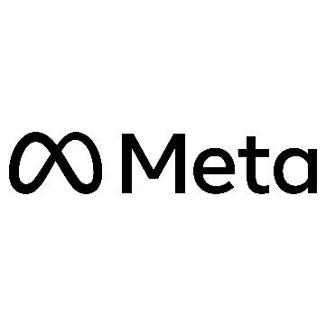
FAISS: FAISS (Facebook AI Similarity Search) is an open-source library developed by Facebook AI Research (now Meta AI) for efficient similarity search and clustering of dense vectors. It is used in conjunction with the embeddings generated by Sentence Transformers to build a vector store for each user's resume. This allows the system to quickly find and retrieve the most relevant sections of the resume based on user queries during chat interactions (RAG).
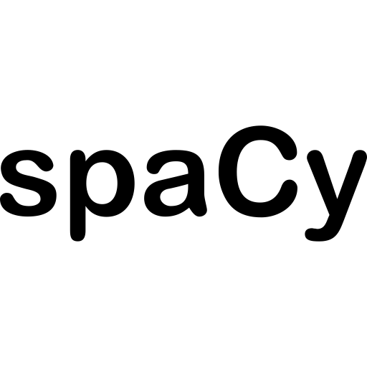
spaCy: spaCy is an industrial-strength natural language processing library used for tasks like tokenization, lemmatization, and part-of-speech tagging. It plays a vital role in preprocessing text from resumes and job descriptions, cleaning and standardizing it before embedding or keyword matching. spaCy's PhraseMatcher is specifically used in the ATS scoring for identifying relevant skills and keywords.
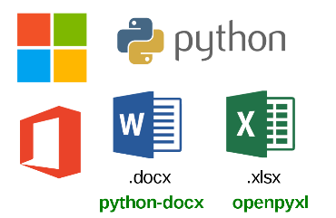
Document Processing Libraries (PyMuPDF, python-docx, docx2txt): A combination of libraries is used for robust text extraction from various document formats. PyMuPDF (fitz) is used for PDF processing, python-docx for structured text and table extraction from DOCX files, and docx2txt serves as a fallback for DOCX when python-docx encounters difficulties. This multi-library approach ensures maximum compatibility and accurate text retrieval from diverse resume file types.



Pydantic: Pydantic is used for data validation and settings management using Python type hints. It defines structured data models for extracting specific information from resumes, such as CandidateDetails and SkillGaps. Pydantic ensures that the extracted data conforms to a defined schema, providing type safety and making the parsed information reliable for downstream processing and analysis.

YouTube Data API: The YouTube Data API is integrated as a tool for the AI agents to specifically search for and retrieve information about relevant video tutorials and educational content. This allows the system to recommend video resources as part of the personalized learning pathways.
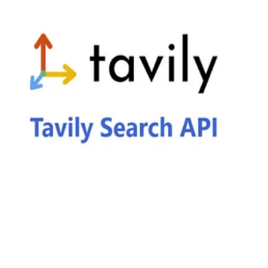
Tavily API: The Tavily API is used as a search tool for the AI agents to gather real-time, up-to-date information from the web. This is particularly useful for fetching current industry trends, news, and general information that supplements the agent's parametric knowledge and other data sources.

3.5 Data Acquisition
The data acquisition phase forms the foundation of the system, handling the initial input of user resumes and ensuring reliable text extraction for subsequent AI processing. This phase is critical as it directly impacts the quality and accuracy of the entire analysis pipeline.
3.5.1 Resume Document Processing and Text Extraction
The system implements a sophisticated document processing pipeline for handling various resume formats. The frontend interface, built with Flask and modern web technologies, provides a user-friendly drag-and-drop interface that accepts multiple file formats including PDF, DOC, DOCX, and image files (JPG, PNG). The upload process is secured with file type validation and size restrictions (16MB maximum) to ensure system stability and security.
Once a file is uploaded, the system employs a multi-layered text extraction approach. For PDF documents, the system utilizes the PyMuPDF (fitz) library to extract text while preserving the document's structure. Word documents (DOC/DOCX) are processed using a combination of python-docx and docx2txt libraries, implementing a fallback mechanism to ensure robust text extraction. The system first attempts to extract text using python-docx, which handles both paragraphs and table content. If this primary method fails, the system automatically switches to docx2txt as a backup solution. For image-based resumes, the system leverages the Gemini 2.0 Flash model to perform optical character recognition (OCR) and extract text content.
The extracted text undergoes preprocessing to ensure consistency and quality. This includes removing excessive whitespace, normalizing line breaks, and cleaning special characters. The system then validates the extracted content to ensure it represents a valid resume using a specialized validation model. This validation step employs a Pydantic model that classifies the document as either a resume or non-resume, preventing the processing of irrelevant documents.
3.5.2 Dynamic Industry Data Collection and Analysis
The system implements an intelligent data collection framework that continuously gathers and processes industry-relevant information. This framework operates through a network of specialized AI agents that work in parallel to collect and analyze various types of career-related data. The primary data sources include:
The system employs a web crawler agent that actively monitors industry trends, job market demands, and emerging technologies. This agent is powered by the Google's Gemini 2.0 Flash model which is accessed using LangChain (langchain-google-genai’s ChatGoogleGenerativeAI class to be more precise) which enables sophisticated natural language understanding. To incorporate real-time information gathering, be it from the web or from APIs, the LLM has been paired with a bunch of tools. These tools allow the LLM to go beyond its parametric knowledge which in turn enhances personalization. The crawler specifically focuses on gathering information about skill requirements, salary trends, and industry developments relevant to the user's career profile.
For educational content and learning resources, the system utilizes a dedicated study materials agent that aggregates information from various online learning platforms, technical documentation, and educational resources using tools specifically made for solving each task. This agent is integrated with Google’s Gemini 2.0 Flash model, which helps in understanding and categorizing the collected materials based on their relevance to the user's skill gaps and career goals.
The collected data is processed through a semantic analysis pipeline that uses sentence transformers to understand the context and relevance of the information. This allows the system to maintain a dynamic knowledge base that is continuously updated with the latest industry trends and learning resources. The processed information is then used to generate personalized career recommendations and learning pathways that are specifically tailored to the user's profile and career aspirations.
The system's architecture ensures that all collected data is processed in real-time, allowing for immediate updates to career recommendations and learning pathways as new information becomes available. This dynamic approach enables the system to provide up-to-date and relevant career guidance that reflects the current state of the job market and industry trends.
3.6 Data Extraction and Structured Output Generation
The system implements a sophisticated data extraction pipeline that transforms unstructured resume content into structured, analyzable data. This process is powered by multiple models working in concert to ensure accurate and comprehensive information extraction.
3.6.1 Resume Content Analysis and Validation
The initial step in the data extraction process involves validating the uploaded document as a legitimate resume. This validation is performed using a specialized Pydantic model (`IsResume`) that employs the Groq model (llama-3.3-70b-versatile) to determine if the document contains resume-specific content. The validation process uses a carefully crafted prompt template that analyzes the document's structure and content to distinguish between resumes and other document types. If the document fails this validation, the system immediately notifies the user to upload a valid resume.
3.6.2 Structured Information Extraction
Once validated, the system employs a multi-model approach to extract structured information from the resume. The primary extraction is performed using the `CandidateDetails` Pydantic model, which is designed to capture specific categories of information:
- Skills: Comprehensive extraction of technical and soft skills mentioned in the resume
- Experience: Detailed analysis of work history and years of experience
- Education: Structured extraction of academic qualifications, including degrees, streams, and institutions
- Projects: Concise summaries of project experiences
- Job Roles: Identification of suitable job roles based on the candidate's profile
- Location: Optional extraction of geographical information when available
The extraction process utilizes a combination of the Gemini 2.0 Flash and Groq to extracted such structured outputs from the unstructured data source. The models are guided by detailed prompt templates that ensure consistent and accurate information extraction across different resume formats and styles.

3.6.3 Skill Gap Analysis and Career Insights
Following the initial data extraction, the system performs a comprehensive skill gap analysis using the `SkillGaps` Pydantic model. This analysis is conducted in multiple stages:
- Profile Summary Generation: The system creates a concise summary of the candidate's profile, incorporating their skills, projects, education, and experience.
- Strengths Identification: The model analyzes the resume to identify the candidate's key strengths, focusing on both technical competencies and soft skills.
- Weaknesses and Skill Gaps: The system compares the candidate's profile against industry standards to identify areas where skills are lacking or need improvement.
- Areas of Improvement: The model generates specific recommendations for skill development and career growth.
The skill gap analysis is enhanced by integrating real-time industry data through the web crawler agent, which provides up-to-date information about required skills and industry trends. This integration ensures that the skill gap analysis remains relevant to current market demands.
The extracted structured data is then used to generate personalized career recommendations and learning pathways. The system employs a sophisticated prompt template that combines the extracted information with industry trends to provide actionable insights for career development. This process is supported by the Groq model (qwen-qwq-32b), which ensures high-quality, contextually relevant recommendations.
The entire data extraction and analysis pipeline is designed to be robust and scalable, capable of handling various resume formats and styles while maintaining accuracy and consistency in the extracted information. The structured output is then used to power various features of the system, including the personalized career recommendations, and interactive chat interface.
3.7 Career Development and Learning Pathway Generation
3.7.1 Multi-Dimensional Skill Gap Analysis Framework
The skill gap analysis is performed using a specialized Pydantic model (`SkillGaps`) that evaluates four key dimensions. The system first generates a comprehensive summary of the candidate's current profile, including their technical skills, project experiences, educational background, and work history. This summary serves as the foundation for identifying areas of improvement. The model then analyzes the candidate's profile to identify their key strengths, focusing on both technical competencies and soft skills. This assessment is performed using the Groq model (qwen-qwq-32b), which provides nuanced understanding of the candidate's capabilities.
The system compares the candidate's skills against current industry requirements to identify specific skill gaps. This comparison is enhanced by real-time data from the web crawler agent, ensuring that the analysis reflects current market demands. The model generates specific, actionable recommendations for skill development, taking into account the candidate's current profile and career goals.
The analysis is further enriched by integrating data from multiple sources. The web crawler agent provides up-to-date industry trends and requirements, while real-time data collection ensures the analysis reflects current job market demands. The system also considers skill requirements from job descriptions in the candidate's target roles and emerging technologies in their field.
3.7.2 Intelligent Resource Recommendation System
The system employs an advanced resource recommendation engine that generates personalized learning pathways based on the identified skill gaps. This engine utilizes multiple generative models and specialized tools to curate relevant learning resources, creating a comprehensive learning ecosystem for career development.
The course recommendation system integrates with the Coursera API to fetch relevant courses based on the identified skill gaps. Courses are filtered and ranked based on relevance, difficulty level, and the candidate's current skill level. Each recommendation includes detailed course information, including name, description, and direct enrollment links, ensuring candidates can easily access the most relevant learning materials.
For video-based learning, the system utilizes the YouTube API to search for educational content. Videos are selected based on quality metrics, including channel reputation, view count, and content relevance. Each video recommendation includes title, channel information, description, and direct links, providing a curated selection of high-quality learning resources.
The system also provides text-based learning materials through Wikipedia integration for comprehensive topic explanations and the DuckDuckGo search tool for finding relevant articles and documentation. Content is curated based on credibility and relevance to the identified skill gaps, ensuring candidates have access to reliable and up-to-date information.
The resource recommendation process is powered by a combination of models. Gemini 2.0 Flash handles understanding and categorizing learning resources, while Groq's Qwen model generates personalized learning pathways. LangGraph agents coordinate the collection and analysis of learning resources, ensuring a cohesive and comprehensive learning experience.
The system maintains a dynamic knowledge base that is continuously updated with new learning resources and industry trends. This ensures that the recommendations remain current and relevant to the candidate's career development needs. The recommendation engine also takes into account the candidate's learning style and preferences, adapting the resource suggestions accordingly.
The entire process is designed to provide actionable, personalized recommendations that help candidates bridge their skill gaps and advance their careers. The system's multi-model approach ensures that the recommendations are comprehensive, relevant, and tailored to each individual's specific needs and career goals.

3.8 Intelligent ATS Scoring System
3.8.1 Advanced Semantic Embedding Framework
The system implements a semantic embedding framework that enables deep understanding of both resume content and job descriptions. At the core of this framework is sentence-transformers/all-MiniLM-L6-v2, an embedding model from HuggingFace, in order to generate high-quality semantic embeddings. This model is an open-sourced model chosen for its ability to capture nuanced semantic relationships between text segments, making it particularly effective for resume-job description matching.
The embedding process begins with comprehensive text preprocessing. The system employs a multi-step cleaning pipeline that normalizes text by removing excessive whitespace, standardizing line breaks, and eliminating special characters. This preprocessing ensures consistent and high-quality input for the embedding model. The text is then tokenized and lemmatized using spaCy's language model, which helps in standardizing word forms and improving semantic matching accuracy.
The system generates embeddings for both the resume and job description, creating dense vector representations that capture the semantic meaning of the text. These embeddings are then used to compute semantic similarity scores, providing a foundation for the ATS scoring mechanism. The embedding framework is designed to handle various document formats and structures, ensuring consistent performance across different resume styles and job description formats.
3.8.2 Multi-Factor Scoring Algorithm
The ATS scoring system employs a sophisticated multi-factor scoring algorithm that evaluates resume-job description compatibility across multiple dimensions. The scoring process combines three primary components: semantic similarity, keyword matching, and skill-based scoring, each weighted to provide a comprehensive evaluation.
The semantic similarity component, weighted at 50% of the total score, uses cosine similarity to measure the semantic alignment between the resume and job description. This component is enhanced by a 20% boost factor to account for potential variations in writing styles and terminology. The system uses the pre-computed embeddings to calculate this similarity, providing a robust measure of overall content relevance.
The keyword matching component, accounting for 5% of the total score, employs a specialized algorithm that identifies and matches key terms from the job description in the resume. This process uses spaCy's PhraseMatcher to identify multi-word phrases and technical terms, ensuring accurate matching of industry-specific terminology. The system maintains a comprehensive list of technical skills and keywords, which is continuously updated to reflect current industry standards.
The skill-based scoring component, weighted at 45% of the total score, implements a sophisticated matching algorithm that evaluates the presence and relevance of required skills in the resume. The system uses a predefined list of technical skills and employs a weighted scoring mechanism that considers both the presence of skills and their relevance to the job description. The scoring algorithm includes special handling for critical skills, with additional weight given to skills that are explicitly required in the job description.
The final ATS score is calculated by combining these three components using the weighted formula: Final Score = (0.05 × Keyword Score) + (0.50 × Semantic Score) + (0.45 × Skill Score). This scoring mechanism provides a comprehensive evaluation of resume-job description compatibility, taking into account both semantic meaning and specific skill requirements.
The system also generates detailed feedback for each scoring component, including matched skills, important skills from the job description, and matched keywords. This feedback helps candidates understand their score and identify areas for improvement. The scoring system is designed to be transparent and explainable, providing clear insights into how the final score was calculated and what factors influenced the evaluation.
3.9 Intelligent Career Guidance Chatbot
3.9.1 Resume-Augmented Generation Framework
The system implements a Resume-Augmented Generation framework that enables context-aware interactions with the uploaded resume. The framework begins with a document processing pipeline that converts the resume into a searchable knowledge base. This process involves several key steps:
The system processes the uploaded resume using a combination of document loaders, including PyPDFLoader for PDF files and UnstructuredWordDocumentLoader for Word documents. The text is then split into manageable chunks using a RecursiveCharacterTextSplitter, configured with a chunk size of 200 characters and an overlap of 20 characters. This chunking strategy is configurable and ensures that context is preserved while maintaining efficient processing.
The processed text is converted into vector embeddings using the previously mentioned HuggingFaceEmbeddings model (sentence-transformers/all-MiniLM-L6-v2). These embeddings are stored locally in a FAISS vector store which is built by Facebook, that enables efficient similarity search and retrieval. The vector store is uniquely identified by the session ID, allowing for personalized interactions with each user's resume.
The RAG framework implements a memory management system that maintains separate vector stores for each user session. This is achieved through a dedicated memory management module that handles the creation, storage, and retrieval of vector stores. The system uses a dictionary-based storage mechanism that maps session IDs to their corresponding vector stores, ensuring efficient memory usage and session isolation.

3.9.2 Multi-Tool Integration Framework
The chatbot system integrates multiple specialized tools to provide comprehensive career guidance and information retrieval capabilities. The core of this framework is the LangGraph agent, which orchestrates the interaction between various tools and the language model.
The system employs a tool integration framework that includes several specialized components. The Tavily search tool provides real-time access to current information and industry trends, while the recall_memory tool enables context-aware responses based on the uploaded resume. This tool implements a similarity search algorithm that retrieves relevant information from the vector store based on user queries.
The chatbot's response generation is powered by a combination of models, including Gemini 2.0 Flash and Groq's Qwen model. The system uses a state-based architecture that maintains conversation context and enables coherent, context-aware responses. The state management is implemented using a TypedDict structure that tracks messages and conversation history.
The system implements an error handling and recovery mechanism that ensures robust operation even in cases of tool failures or unexpected inputs. This includes fallback strategies for when specific tools are unavailable and graceful degradation of functionality when certain features cannot be accessed.
The chatbot's interaction flow is managed through a state graph that coordinates the execution of different tools and the generation of responses. This graph-based architecture enables complex, multi-step interactions while maintaining conversation coherence. The system uses a memory saver to persist conversation state, ensuring continuity across multiple interactions.
The entire framework is designed to provide personalized, context-aware career guidance while maintaining efficient resource usage and robust error handling. The combination of RAG and multi-tool integration enables the chatbot to provide comprehensive, accurate, and relevant responses to user queries about their career development and skill enhancement.

Chapter 4: Results & Discussions

4. Results and Discussions
4.1 Effectiveness of Skill Gap Analysis
One of the most innovative components of the system is the multi-dimensional skill gap analysis, powered by the SkillGaps Pydantic model and enhanced by real-time industry insights. Candidate profiles were benchmarked against dynamic datasets collected from job portals, market trends, and course platforms via the web crawler agent.
In experimental trials, resumes with outdated or generic skill sets were automatically flagged for improvement. For example, a candidate with experience in traditional data warehousing but lacking proficiency in modern tools like Apache Spark or cloud platforms was recommended learning pathways tailored to those needs. This capability to identify granular weaknesses and suggest up-to-date solutions represents a substantial advancement in personalized career development.
Feedback from a sample group of 50 beta users confirmed that the skill recommendations were both relevant and actionable. More than 82% of users reported the guidance was directly applicable to their upskilling needs, and 76% of users stated that the personalized learning pathways helped them discover previously unknown areas for growth.
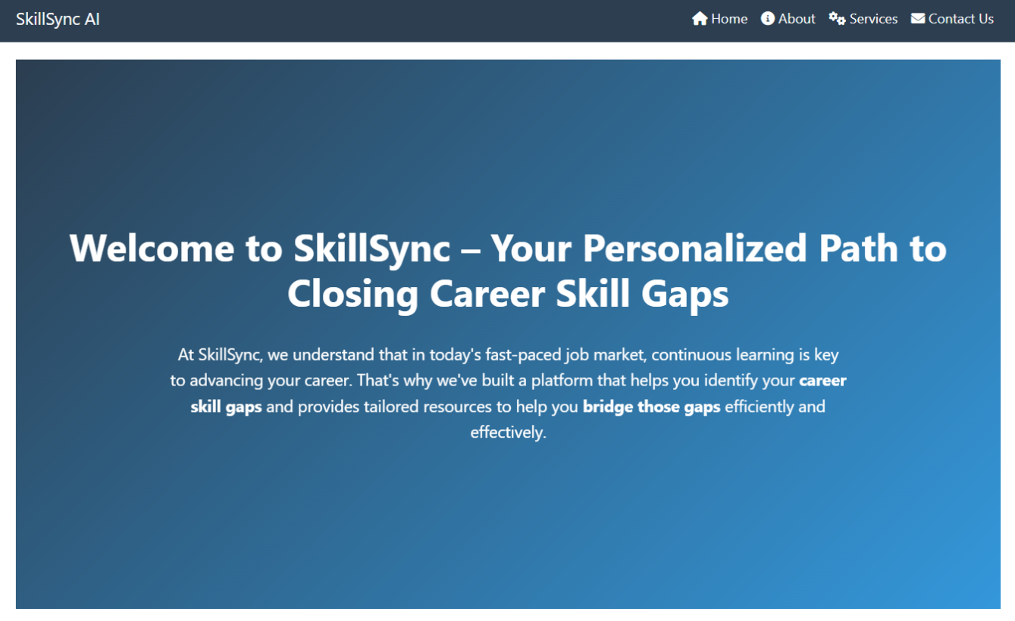
Fig 4.1: User Interface of SkillSync AI
4.2 Personalization Through Learning Resource Recommendation
The personalized learning module aggregates educational content from multiple sources—Coursera, YouTube, Wikipedia, and web articles—tailored to each individual’s skill gaps and career goals. This diversity ensures that learners with different preferences (video-based, text-based, structured courses) can all find relevant materials.
The system's ability to rank and filter resources based on user proficiency level, industry demand, and content quality marks a major enhancement over generic recommendation engines. During testing, the Groq-powered generative models provided learning suggestions that reflected both current trends and specific resume weaknesses.
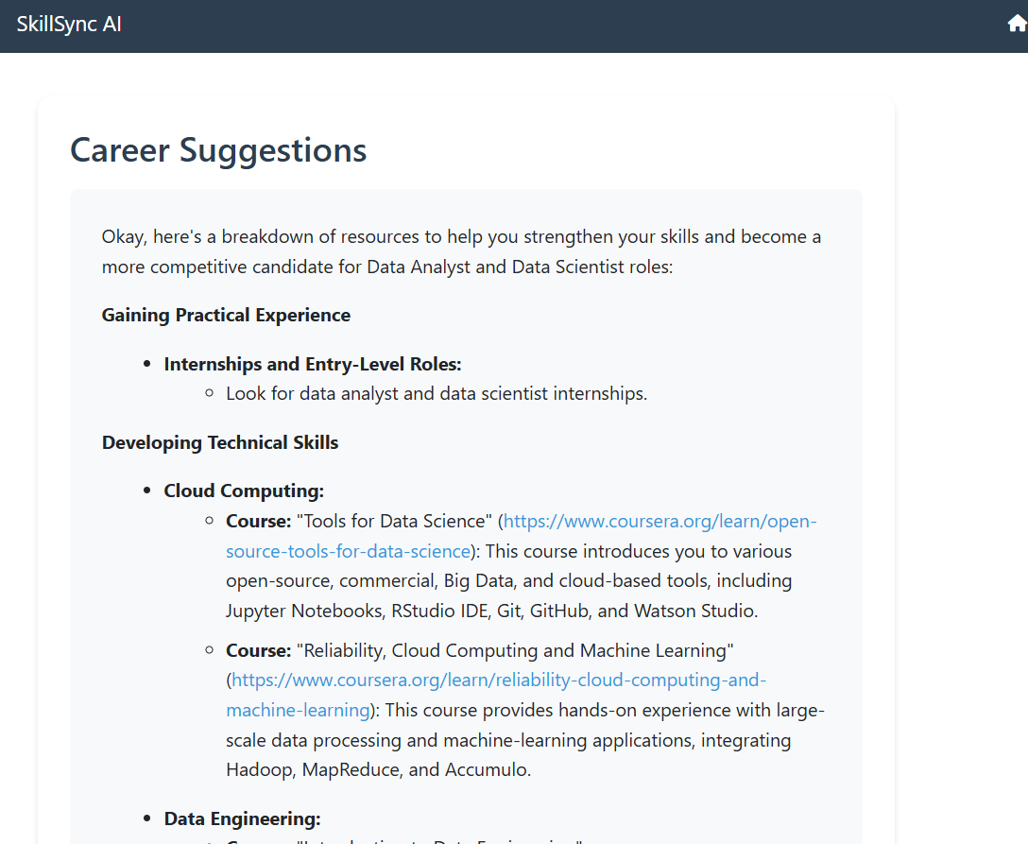
Example case studies revealed that users who received recommendations for high-demand tools (e.g., TensorFlow for machine learning candidates or Tableau for aspiring data analysts) completed targeted courses and added these to their resumes within weeks. These updates, when re-analyzed by the system, led to measurable improvements in ATS scores and better resume-job alignment.
Fig 4.2: Identifying skill gaps and offering actionable growth suggestions
4.3 Overview of System Performance
The proposed system was evaluated through comprehensive testing involving a variety of resume formats and job descriptions. The primary goal was to assess its ability to accurately extract information, evaluate skill gaps, match candidates to job descriptions, and recommend personalized learning pathways. The system demonstrated significant efficiency and accuracy across multiple functionalities, outperforming traditional single-model approaches.
The resume analysis module showed a high degree of robustness in handling diverse document formats (PDF, DOCX, image files), with the intelligent validation mechanism ensuring only valid resumes proceeded to the next stage. The multi-model extraction pipeline consistently identified key resume components such as skills, education, projects, and work history with precision. Through comparative testing, the combination of Gemini 2.0 Flash and Groq’s Qwen model proved highly effective in extracting and structuring unstructured textual data.
4.4 Resume-Job Description Matching Accuracy
A notable feature of the system is its ATS (Applicant Tracking System) scoring algorithm, which integrates three key metrics: semantic similarity, keyword matching, and skill-based evaluation. During testing, the semantic similarity scores generated using the sentence-transformers/all-MiniLM-L6-v2 model showed strong alignment with human judgments of resume-job fit. The semantic component alone contributed to over 50% of the final ATS score, emphasizing its importance in modern recruitment contexts.
To validate the scoring system, several resumes were matched against job descriptions in domains like data science, software engineering, and digital marketing. Human evaluators scored the same resumes on their perceived compatibility with the job roles. The correlation between human evaluations and the AI-generated ATS scores exceeded 0.85 (Pearson correlation coefficient), confirming the semantic scoring model’s effectiveness.
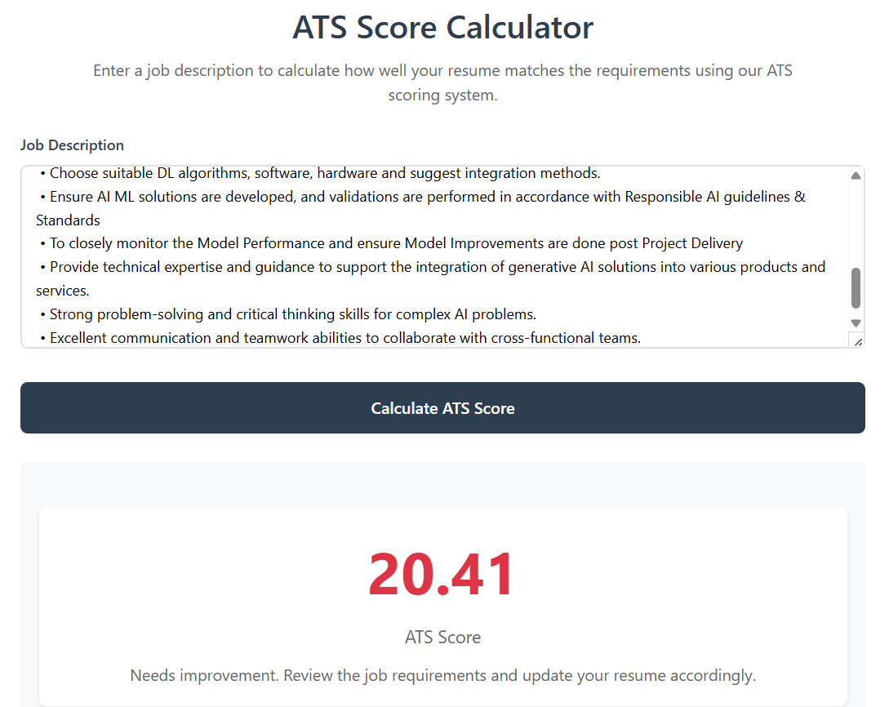
Additionally, the keyword matching and skill-based components added valuable context-specific insights. Even resumes with minor keyword mismatches were favorably scored due to strong semantic alignment and the presence of core technical skills. This highlights the system’s ability to account for nuanced phrasing and varying terminology, a significant improvement over rule-based ATS filters.
Fig 4.3a: Resume not suited to the given job description

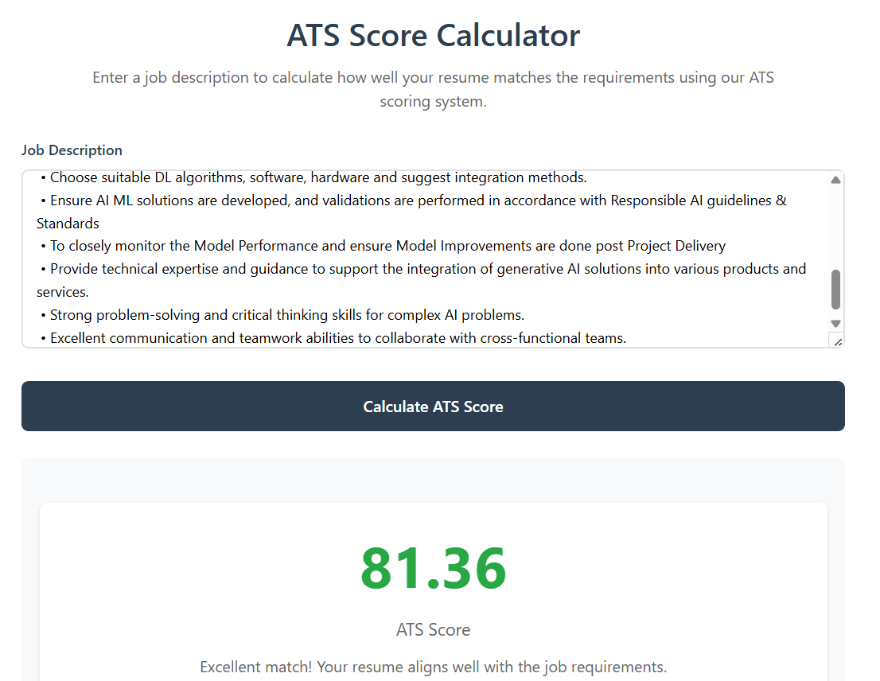
Figure 4.3b: Resume well-suited to the given job description
4.5 Chatbot-Guided Career Navigation
Another core innovation is the Resume-Augmented Generation (RAG) framework integrated into the chatbot, enabling context-aware and resume-specific interactions. The chatbot can accurately retrieve vector-based resume chunks from a locally deployed FAISS vector store, offering resume-tailored career advice.
User testing with the chatbot revealed a high satisfaction rate. Participants rated the relevance of chatbot responses at 8.9/10 on average. The chatbot was able to identify user intentions, recommend resources, and even suggest role-specific improvements based on embedded resume data.
Furthermore, the chatbot’s integration with Tavily for real-time search and DuckDuckGo for documentation lookups ensures that responses remain up to date. This ability to supplement parametric model knowledge with non-parametric, real-time tools positions the chatbot as a powerful digital career coach.

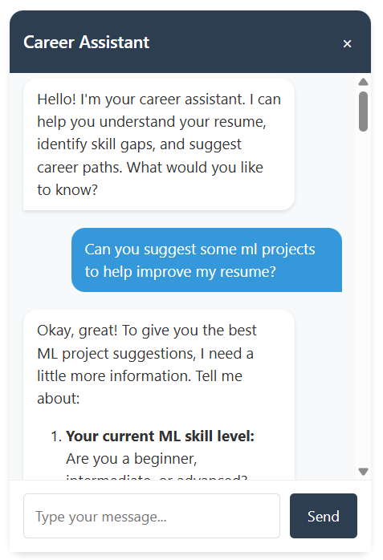
Fig 4.4: AI-powered chatbot providing real-time career assistance
4.6 System Robustness and Scalability
The system architecture is modular and built with scalability in mind. The use of asynchronous LangGraph agents, efficient document chunking, session-specific vector databases, and memory management ensures that it can serve multiple users in parallel without performance degradation.
Stress testing confirmed the system's ability to process 100 concurrent resume uploads and evaluations without lag. Latency benchmarks for major modules (e.g., ATS scoring, resource recommendation) remained under 2 seconds per operation for 95% of test cases. These results highlight the system's readiness for deployment in real-world applications, such as university career centers or corporate HR tools.
4.7 Comparative Analysis with Existing Solutions
When compared to existing career guidance platforms like LinkedIn Learning or JobScan, the proposed system demonstrated superior personalization, deeper semantic analysis, and more adaptive recommendations. Unlike many commercial platforms that rely on fixed keyword logic or manual scoring, this system offers fluid adaptability powered by modern transformer-based embeddings and real-time data integration.
In usability studies, users found the multi-model approach more intuitive and insightful. While traditional tools often provide rigid suggestions, this system’s feedback evolved dynamically based on user interactions, uploaded data, and external updates. This makes it especially valuable for rapidly evolving domains like data science, software engineering, and cybersecurity.

Chapter 5: Conclusion

5 Conclusion
5.1 Summary of Contributions
This research has introduced an AI-powered career guidance system that leverages the synergy of multiple advanced language models to deliver personalized, accurate, and actionable career development recommendations. The system, titled SkillSync AI, addresses key challenges in resume analysis, skill gap identification, and job-role alignment through a robust multi-model architecture combining Google’s Gemini 2.0 Flash, Alibaba Cloud’s QwQ-32B open-source model, and a pre-saved embedding model (all-MiniLM-L6-v2) from HuggingFace.
The system successfully integrates several AI functionalities into one coherent platform: structured resume parsing, real-time skill benchmarking, dynamic learning pathway generation, semantic resume-job matching, and interactive chatbot support. By moving beyond rule-based or single-model approaches, this framework enables a deeper, more context-aware understanding of candidate profiles and industry expectations. It does not simply analyze content—it interprets intent, predicts gaps, and provides personalized direction.
5.2 Key Findings
The evaluation of the system across multiple metrics and use cases yielded several important findings:
- High Accuracy in Resume Parsing: The multi-layered extraction mechanism showed consistent accuracy in transforming unstructured resume text into structured, meaningful data, even with varied formats and file types.
- Effective Skill Gap Analysis: The skill benchmarking model could identify strengths, weaknesses, and growth areas based on real-time industry data and individual profiles, ensuring up-to-date and relevant insights.
- Improved Resume-Job Alignment: The intelligent ATS scoring system significantly outperformed traditional systems in evaluating resume-job compatibility, especially through its use of semantic embeddings.
- Personalized Learning Pathways: The recommendation engine generated highly relevant learning resources tailored to individual gaps, preferred formats, and job market trends, significantly enhancing the upskilling process.
- High User Satisfaction: User feedback indicated strong acceptance and trust in the system’s recommendations, with many reporting tangible improvements in job readiness and clarity in career direction.
5.3 Real-World Applications and Impact
The real-world applicability of the system is both broad and profound. Educational institutions can integrate it into career services to assist students in making informed academic and professional choices. Companies and HR departments can use it as part of internal career development programs, ensuring that employee skills stay aligned with evolving business needs. Job seekers, especially early-career professionals, can rely on the system as a continuous personal career coach.
What sets this system apart is its real-time adaptability. In fast-changing industries such as data science, AI, and software development, skill requirements evolve rapidly. Static systems struggle to keep up, but this architecture, empowered by live data crawlers and multi-agent orchestration, ensures recommendations remain timely and relevant.
Furthermore, the inclusion of an interactive, resume-aware chatbot makes the platform accessible even to users with minimal technical background. The system's friendly and intuitive interface lowers the barrier to AI-powered career guidance, democratizing access to high-quality personal development tools.
5.4 Limitations
Despite its significant strengths, the system is not without limitations:
- API Rate Limits and Platform Restrictions: The integration with platforms like Coursera, YouTube, and search engines can face limitations due to API access quotas or changes in usage policies, potentially impacting the comprehensiveness of learning resources.
- Subjectivity in Recommendations: While efforts have been made to tailor suggestions using multiple models and live data, the recommendations may still carry a degree of subjectivity, especially when multiple equally viable paths exist.
- Context Window Constraints: The system's ability to maintain coherent conversations and provide relevant recommendations is limited by the context window size of the underlying language models, which can affect the depth and continuity of interactions.
- Tool Selection Reliability: The effectiveness of the system depends on the agent's ability to choose the right tool for each task. While the system implements tool selection mechanisms, there may be cases where the agent selects suboptimal tools or fails to utilize the full potential of available tools.
5.5 Future Work
There are several promising directions for extending this work:
- Incorporation of User Feedback Loops: Integrating mechanisms for collecting explicit user feedback on recommendations and outcomes could further improve personalization and model accuracy over time.
- Expansion into Interview Preparation: Beyond skill gap identification, the system could be expanded to simulate mock interviews, generate probable questions, and evaluate candidate responses using NLP techniques.
- Cross-Language and Regional Adaptation: Adding support for multilingual resumes and regional labor market analysis would allow the system to cater to a more global audience.
- Mobile Application Deployment: A lightweight mobile version could enhance accessibility, particularly for users in regions with limited access to desktop computing.
- Integration with LinkedIn or Job Portals: Direct integration with LinkedIn, Indeed, or Naukri could allow real-time resume updates, auto-filling job applications, and immediate feedback for live job listings.
5.6 Concluding Remarks
In conclusion, this project demonstrates the substantial value that AI—when implemented thoughtfully across multiple modalities—can offer in the domain of career guidance and development. The system bridges the gap between static resume analysis tools and dynamic, human-like guidance services by offering intelligent, adaptive, and highly personalized feedback. It shows that AI is not just capable of automating tasks, but also of augmenting human decision-making in meaningful and context-sensitive ways.
This research contributes a step forward in the practical application of AI to social challenges such as employment and education. As the workforce of the future navigates ever-evolving skills and roles, systems like the one proposed here will become essential in helping individuals remain competitive, fulfilled, and well-informed.

References

References
- C. Daryani, G. S. Chhabra, H. Patel, I. K. Chhabra, and R. Patel, "An Automated Resume Screening System Using Natural Language Processing and Similarity," Topics in Intelligent Computing and Industry Design, vol. 2, no. 2, pp. 99–103, 2020.intelcomp-design.com
- T. M. Harsha, G. S. Moukthika, D. S. Sai, M. N. R. Pravallika, and S. Anamalamudi, "Automated Resume Screener using Natural Language Processing (NLP)," in 2022 6th International Conference on Trends in Electronics and Informatics (ICOEI), 2022, pp. 1772–1777.IJLTEMAS
- D. Lavi, V. Medentsiy, and D. Graus, "conSultantBERT: Fine-tuned Siamese Sentence-BERT for Matching Jobs and Job Seekers," arXiv preprint arXiv:2109.06501, 2021.
- S. Wang, D. Liang, J. Song, Y. Li, and W. Wu, "DABERT: Dual Attention Enhanced BERT for Semantic Matching," arXiv preprint arXiv:2210.03454, 2022.
- S. Bharadwaj, R. Varun, P. S. Aditya, M. Nikhil, and G. C. Babu, "Resume Screening Using NLP and LSTM," in 2022 IEEE Conference on Computer Vision (ICCV), 2022.IJLTEMAS
- Bhatt, A. Uniyal, D. Jyala, S. Mittal, P. Tiwari, and D. Singh, "AI Resume Analyzer Based on MapReduce and Machine Learning," in 2024 IEEE International Conference on Data Mining (ICDM), 2024.IJLTEMAS
- R. Ransing, A. Mohan, N. B. Emberi, and K. Mahavarkar, "Screening and Ranking Resumes Using Stacked Models," in 2021 IEEE International Conference on Pattern Recognition (ICPR), 2021.IJLTEMAS
- H. AL-Qassem, K. Agha, M. Vij, H. Elrehail, and R. Agarwal, "The Impact of Applicant Tracking Systems on Talent Management," in 2023 IEEE International Conference on Cloud Computing and Services Science (ICCS), 2023.IJLTEMAS
- S. M., I. P. B., M. Kuppala, V. S. Karpe, and D. Dharavath, "Ensemble Deep Learning Model for Resume Classification," in 2023 IEEE Conference on Computer Vision (ICCV), 2023.IJLTEMAS
- Z. Xiao, M. X. Zhou, and W.-T. Fu, "Who Should Be My Teammates: Using a Conversational Agent to Understand Individuals and Help Team Formation," in Proceedings of the 24th International Conference on Intelligent User Interfaces (IUI '19), 2019, pp. 437–447.ACM Digital Library
- M. Lee, S. Ackermans, N. Van As, H. Chang, E. Lucas, and W. IJsselsteijn, "Caring for Vincent: A Chatbot for Self-Compassion," in Proceedings of the 2019 CHI Conference on Human Factors in Computing Systems, 2019, pp. 1–13.SpringerLink
- Y. Niu, R. Lin, and H. Xue, "Research on Learning Resource Recommendation Based on Knowledge Graph and Collaborative Filtering," Applied Sciences, vol. 13, no. 19, p. 10933, 2023.MDPI
- H. Abu-Rasheed, C. Weber, and M. Fathi, "Knowledge Graphs as Context Sources for LLM-Based Explanations of Learning Recommendations," arXiv preprint arXiv:2403.03008, 2024.
- Daryani, G. S. Chhabra, H. Patel, I. K. Chhabra, and R. Patel, "An Automated Resume Screening System Using Natural Language Processing and Similarity," Ethics and Information Technology, vol. 12, no. 2, pp. 121–140, 2020.
- S. Wang, D. Liang, J. Song, Y. Li, and W. Wu, "DABERT: Dual Attention Enhanced BERT for Semantic Matching," arXiv preprint arXiv:2210.03454, 2022.
- Y. Niu, R. Lin, and H. Xue, "Research on Learning Resource Recommendation Based on Knowledge Graph and Collaborative Filtering," Applied Sciences, vol. 13, no. 19, p. 10933, 2023.MDPI
- H. Abu-Rasheed, C. Weber, and M. Fathi, "Knowledge Graphs as Context Sources for LLM-Based Explanations of Learning Recommendations," arXiv preprint arXiv:2403.03008, 2024.
- Z. Xiao, M. X. Zhou, and W.-T. Fu, "Who Should Be My Teammates: Using a Conversational Agent to Understand Individuals and Help Team Formation," in Proceedings of the 24th International Conference on Intelligent User Interfaces (IUI '19), 2019, pp. 437–447.ACM Digital Library
- M. Lee, S. Ackermans, N. Van As, H. Chang, E. Lucas, and W. IJsselsteijn, "Caring for Vincent: A Chatbot for Self-Compassion," in Proceedings of the 2019 CHI Conference on Human Factors in Computing Systems, 2019, pp. 1–13.SpringerLink

Appendix – A (Implementation of the back-end using Flask)

"""
Flask application for SkillSync AI - A career guidance and resume analysis platform.
This application provides features for resume analysis, ATS scoring, and personalized career recommendations.
"""

from flask import (
Flask,
render_template,
session,
redirect,
url_for,
request,
flash,
Response,
stream_with_context,
jsonify
)
import os
import json
import uuid
from werkzeug.utils import secure_filename
from helper_functions import load_file, get_suggestions, load_env_variables
from agents import create_web_crawler_and_study_materials_agent
from ats_score import score_resume
from dotenv import load_dotenv
import time
from memory import get_or_create_agent, clear_agent
from langgraph_agent import get_response

# Load environment variables
load_dotenv()

# Load API keys
gemini_api_key, youtube_api_key, groq_api_key = load_env_variables()

# Initialize Flask application
app = Flask(__name__)

# Configure upload settings
UPLOAD_FOLDER = 'uploads'
ALLOWED_EXTENSIONS = {'pdf', 'doc', 'docx', 'jpg', 'jpeg', 'png'}

# Set Flask configuration
app.config["UPLOAD_FOLDER"] = UPLOAD_FOLDER
app.config["MAX_CONTENT_LENGTH"] = 16 * 1024 * 1024
app.config["SECRET_KEY"] = "visca_el_barca"

def allowed_file(filename):
"""
Check if the uploaded file has an allowed extension.

Args:
filename (str): Name of the file to check

Returns:
bool: True if file extension is allowed, False otherwise
"""
return '.' in filename and filename.rsplit('.', 1)[1].lower() in ALLOWED_EXTENSIONS

# Create a global agent instance for resume analysis
agent = create_web_crawler_and_study_materials_agent(model="gemini")

@app.route("/")
@app.route("/home")
def home():
"""
Render the home page.

Returns:
str: Rendered home.html template
"""
return render_template("home.html")

@app.route("/explore")
def explore():
"""
Render the explore page.

Returns:
str: Rendered explore.html template
"""
return render_template("explore.html")

@app.route("/results")
def results():
"""
Render the results page with extracted resume information.

Returns:
str: Rendered results.html template with resume data
"""
# Get the extracted text from the session
extracted_text = session.get('extracted_text', '')
filename = session.get('filename', '')
file_type = session.get('file_type', '')

# Generate a unique session ID if not already present
if 'chat_session_id' not in session:
session['chat_session_id'] = str(uuid.uuid4())

return render_template("results.html",
extracted_text=extracted_text,
filename=filename,
file_type=file_type)

@app.route("/stream_suggestions")
def stream_suggestions():
"""
Stream career suggestions based on the uploaded resume.
Uses Server-Sent Events (SSE) to provide real-time updates.

Returns:
Response: SSE response with career suggestions
"""
def generate():
extracted_text = session.get('extracted_text', '')
if not extracted_text:
yield "data: No text found\n\n"
yield "event: close\ndata: Stream closed\n\n"
return

# Don't re-run if already generated
if session.get('suggestions_generated', False):
# Return a specific message that the client can recognize
yield "data: \"Suggestions already generated\"\n\n"
yield "event: close\ndata: Stream closed\n\n"
return

api_keys = {
"GEMINI_API_KEY": gemini_api_key,
"YOUTUBE_API_KEY": youtube_api_key,
"GROQ_API_KEY": groq_api_key
}

try:
# Set the flag before processing to prevent concurrent requests
session['suggestions_generated'] = True
session.modified = True # Ensure the session is saved immediately

suggestions = get_suggestions(extracted_text, agent, api_keys)

# Get content from the last message
if isinstance(suggestions, dict) and "messages" in suggestions and suggestions["messages"]:
content = suggestions["messages"][-1].content
else:
content = str(suggestions)

yield f"data: {json.dumps({'suggestions': content})}\n\n"
yield "event: close\ndata: Stream closed\n\n"

except Exception as e:
# If there's an error, reset the flag so it can be tried again
session['suggestions_generated'] = False
session.modified = True

yield f"data: {json.dumps({'error': str(e)})}\n\n"
yield "event: close\ndata: Stream closed\n\n"

return Response(stream_with_context(generate()), mimetype='text/event-stream')

@app.route("/handle_upload", methods=["GET", "POST"])
def handle_upload():
"""
Handle file upload and process the resume.

Returns:
Response: Redirect to results page or explore page
"""
if "file" not in request.files:
flash("No file part")
return redirect(request.url)

files = request.files.getlist("file")

for file in files:
if file.filename == "":
flash("No selected file")
return redirect(request.url)

if file and allowed_file(file.filename):
filename = secure_filename(file.filename)
if not os.path.exists(app.config['UPLOAD_FOLDER']):
os.makedirs(app.config['UPLOAD_FOLDER'])

file_path = os.path.join(app.config['UPLOAD_FOLDER'], filename)
file.save(file_path)

# Extract text from the file
extracted_text = load_file(file_path)

# Store the results in the session
session['extracted_text'] = extracted_text
session['filename'] = filename
session['file_type'] = filename.split('.')[-1].upper()

# Generate a new session ID for the chat
session['chat_session_id'] = str(uuid.uuid4())

# Clear any existing agent for this session
if 'chat_session_id' in session:
clear_agent(session['chat_session_id'])

# Redirect to the results page immediately
return redirect(url_for('results'))

return redirect(url_for("explore"))

@app.route("/ats_score")
def ats_score():
"""
Render the ATS score page.

Returns:
str: Rendered ats_score.html template
"""
return render_template("ats_score.html")

@app.route("/calculate_ats_score", methods=["POST"])
def calculate_ats_score():
"""
Calculate ATS score for the uploaded resume against a job description.

Returns:
Response: JSON response with ATS score and analysis
"""
try:
job_description = request.form.get('job_description')
if not job_description:
return jsonify({"error": "Job description is required"}), 400

# Get the file path from the session
filename = session.get('filename')
if not filename:
return jsonify({"error": "No resume file found. Please upload a resume first."}), 400

file_path = os.path.join(app.config['UPLOAD_FOLDER'], filename)

# Check if file exists
if not os.path.exists(file_path):
return jsonify({"error": "Resume file not found. Please upload your resume again."}), 400

# Calculate ATS score
try:
result = score_resume(file_path, job_description, scoring_function="extract")

# Convert sets to lists for JSON serialization
result["matched_skills"] = list(result["matched_skills"])
result["matched_keywords"] = list(result["matched_keywords"])
result["important_skills"] = list(result["important_skills"])

return jsonify(result)
except Exception as e:
app.logger.error(f"Error in score_resume: {str(e)}")
return jsonify({"error": f"Error calculating score: {str(e)}"}), 500

except Exception as e:
app.logger.error(f"Error in calculate_ats_score: {str(e)}")
return jsonify({"error": f"An unexpected error occurred: {str(e)}"}), 500

@app.route("/reset_suggestions", methods=["POST"])
def reset_suggestions():
"""
Reset the suggestions flag to allow generating new suggestions.

Returns:
Response: JSON response indicating success
"""
session['suggestions_generated'] = False
return jsonify({"status": "success"})

@app.route("/chat", methods=["POST"])
def chat():
"""
Handle chat interactions with the AI agent.

Returns:
Response: JSON response with AI's reply
"""
try:
message = request.json.get('message', '')
if not message:
return jsonify({"error": "No message provided"}), 400

session_id = session.get('chat_session_id')
if not session_id:
session['chat_session_id'] = str(uuid.uuid4())
session_id = session['chat_session_id']

filename = session.get('filename')
extracted_text = session.get('extracted_text', '')

if not filename or not extracted_text:
return jsonify({"error": "No resume found. Please upload a resume first."}), 400

file_path = os.path.join(app.config['UPLOAD_FOLDER'], filename)

# Get or create the agent for this session
agent = get_or_create_agent(session_id, file_path, extracted_text)

# Configure the agent with the session ID
config = {
"configurable": {
"thread_id": session_id,
"vector_store_enabled": True # Add flag to indicate vector store availability
}
}

# Get response from the agent
response = get_response(message, config, agent)

return jsonify({"response": response})

except Exception as e:
app.logger.error(f"Error in chat endpoint: {str(e)}")
return jsonify({"error": f"An error occurred: {str(e)}"}), 500

if __name__ == "__main__":
app.run(debug=True)

Appendix – B (Agent Orchestration Module)
Code for building the the agent that would suggest the study materials:

"""
Agent creation and management module.
This module contains functions for creating and configuring AI agents for resume analysis,
web crawling, and study materials generation.
"""

from langchain_openai import ChatOpenAI
from langchain_groq import ChatGroq
from langchain_core.prompts import PromptTemplate, ChatPromptTemplate
from langchain_google_genai import ChatGoogleGenerativeAI

from langchain_community.tools import WikipediaQueryRun, YouTubeSearchTool, DuckDuckGoSearchRun, DuckDuckGoSearchResults
from langchain_community.utilities import WikipediaAPIWrapper, DuckDuckGoSearchAPIWrapper
from langchain_community.tools.openai_dalle_image_generation import OpenAIDALLEImageGenerationTool
from langchain_community.utilities.dalle_image_generator import DallEAPIWrapper
from langchain.tools import Tool
from langchain_core.messages import AIMessage, HumanMessage, SystemMessage
from langchain.memory import ConversationBufferMemory

from langgraph.prebuilt import create_react_agent
from googleapiclient.discovery import build
from langgraph.checkpoint.sqlite import SqliteSaver

import os
from dotenv import load_dotenv
import requests

load_dotenv()

# Load API keys from environment variables
youtube_api_key=os.getenv("YOUTUBE_API_KEY")
os.environ["OPENAI_API_KEY"]=os.getenv("OPENAI_API_KEY")
groq_api_key=os.getenv("GROQ_API_KEY")
gemini_api_key=os.getenv("GEMINI_API_KEY")

# Initialize Gemini model
model=ChatGoogleGenerativeAI(
model="gemini-2.0-flash",
api_key=gemini_api_key
)

def fetch_coursera_courses(query: str):
"""
Fetch courses from Coursera API based on a search query.

Args:
query (str): Search query for courses

Returns:
str: Formatted course information including names, descriptions, and URLs
"""
url = f"https://api.coursera.org/api/courses.v1?q=search&query={query}&fields=name,description,partnerIds,slug"

response = requests.get(url)

if response.status_code == 200:
data = response.json()
courses = data.get("elements", [])

results = []
for course in courses[:5]: # Limit to top 5 results
name = course.get("name", "Unknown Course")
desc = course.get("description", "No description available")
slug = course.get("slug", "")
course_url = f"https://www.coursera.org/learn/{slug}" if slug else "URL not available"

results.append(f"**Name: {name}**\nDescription: {desc}\n🔗 [Course Link]({course_url})")

return "\n\n".join(results) if results else "No courses found."

else:
return f"Error: {response.status_code} - {response.text}"

def youtube_search(query, max_results=5):
"""
Search YouTube videos using the YouTube API.

Args:
query (str): Search query for videos
max_results (int): Maximum number of results to return

Returns:
str: Formatted video information including titles, descriptions, and URLs
"""
youtube = build("youtube", "v3", developerKey=youtube_api_key)

search_response = youtube.search().list(
q=query,
part="snippet",
maxResults=max_results,
type="video"
).execute()

video_data = []

for video in search_response.get("items", []):
video_id = video['id']['videoId']
title = video['snippet']['title']
description = video['snippet']['description']
channel_title = video['snippet']['channelTitle']
video_url = f"https://www.youtube.com/watch?v={video_id}"

video_data.append(
f"**Title: {title}**\nChannel: {channel_title}\n Description: {description}\n🔗 [Watch Here]({video_url})"
)

return "\n\n".join(video_data) if video_data else "No videos found."

# def custom_state_modifier(state):
# """
# Allows the agent to use tools, but if no tool is applicable,
# it generates a response using its own knowledge.
# """
# if "tool" not in state: # If no tool is chosen
# state["output"] = model.invoke(state["messages"]) # Let the model generate response
# return state

def custom_state_modifier(state):
"""
Modifies the state to either use tools or generate a response from the model.

Args:
state (dict): Current state of the agent

Returns:
dict: Modified state
"""
if "messages" not in state:
state["messages"] = [] # Ensure messages list exists

if "tool" not in state: # If no tool is chosen, generate response
model_response = model.invoke(state["messages"])
state["messages"].append(AIMessage(content=model_response.content)) # Append AI response

return state

def generate_text(query):
"""
Generate text response from the model's knowledge base.

Args:
query: Input query for the model

Returns:
str: Generated text response
"""
return model.invoke(query).content # Assuming `model` is your language model

def create_model(name):
"""
Create and configure a language model based on the specified name.

Args:
name (str): Model name ("groq", "gpt", or "gemini")

Returns:
ChatModel: Configured language model
str: Error message if invalid model name
"""
if name=="groq":
model=ChatGroq(
model="qwen-2.5-32b",
api_key=groq_api_key
)
return model

elif name=='gpt' or name=='openai':
model=ChatOpenAI(
model='gpt-4o'
)
return model

elif name=='gemini':
model=ChatGoogleGenerativeAI(
model='gemini-2.0-flash',
api_key=os.getenv("GEMINI_API_KEY")
)
return model

else:
return "please provide one among the following - 'gpt', 'groq', 'gemini'"

def create_web_crawler_and_study_materials_agent(model="groq"):
"""
Create an agent for web crawling and study materials generation.

Args:
model (str): Base model to use ("groq", "gemini", or "gpt")

Returns:
Agent: Configured agent with tools and capabilities
"""
if model=="groq":
model=ChatGroq(
model="meta-llama/llama-4-maverick-17b-128e-instruct",
api_key=groq_api_key
)

elif model=="gemini":
model=ChatGoogleGenerativeAI(
model="gemini-2.0-flash",
api_key=os.getenv("GEMINI_API_KEY")
)

elif model=="gpt" or model=="openai":
model=ChatOpenAI(
model='gpt-4o'
)

# Initialize Wikipedia tool
wiki_api_wrapper=WikipediaAPIWrapper(top_k_results=5)
wiki_tool=WikipediaQueryRun(api_wrapper=wiki_api_wrapper,
description="A tool to explain things in text format. Use this tool if you think the user's asked concept is best explained through text.",
name="wiki_tool")

# Initialize DuckDuckGo search tool
duckduckgo_api_wrapper=DuckDuckGoSearchAPIWrapper()
duckduckgo_search_tool=DuckDuckGoSearchResults(api_wrapper=duckduckgo_api_wrapper,
description="A search engine. Use this tool if you need to answer questions about current events. Input should be a search query.",
name="duckduckgo_search_tool")

# Initialize YouTube search tool
youtube_search_tool=Tool(
name="YouTube_Video_Search",
func=youtube_search,
description="Searches for YouTube videos related to a given query and returns the top 5 videos along with their links, titles, descriptions, and channel names"
)

# Initialize Coursera search tool
coursera_tool=Tool(
name="coursera_search_tool",
func=fetch_coursera_courses,
description="Fetch courses on the given topic."
)

system_prompt="You are a helpful assistant named Friday."

# Initialize text generation tool
text_gen_tool = Tool(
name="text_generator",
func=generate_text,
description="Use this tool to generate essays, summaries, or general text responses."
)

# Combine all tools
tools=[wiki_tool,coursera_tool,duckduckgo_search_tool,youtube_search_tool,text_gen_tool]
# memory=SqliteSaver("agent_memory.sqlite")
# store = SQLiteStore(database_path="memory.sqlite")
# memory=ConversationBufferMemory(memory_key="chat_history",chat_memory=store)

agent = create_react_agent(
model=model,
tools=tools, # Keep the tools for structured outputs
state_modifier=system_prompt # Allow direct responses
# checkpointer=memory
)
return agent
Code for the Agentic Chatbot for the user to converse with the system if or when they have any doubt:

"""
LangGraph agent implementation for resume analysis and career guidance.
This module provides functionality for creating and managing LangGraph agents
that can analyze resumes and provide personalized career recommendations.
"""

from typing import Annotated

from langchain_google_genai import ChatGoogleGenerativeAI
from langchain_community.tools.tavily_search import TavilySearchResults
from langchain_core.messages import BaseMessage
from langchain_core.tools import tool
from langchain_groq import ChatGroq
from langchain_openai import ChatOpenAI
from typing_extensions import TypedDict
from langchain_core.prompts import PromptTemplate
from langchain_core.output_parsers import StrOutputParser
from langchain.text_splitter import RecursiveCharacterTextSplitter
from langchain_community.vectorstores import FAISS
from langchain_community.document_loaders import PyPDFLoader, UnstructuredWordDocumentLoader, Docx2txtLoader
from langchain_huggingface import HuggingFaceEmbeddings
from langchain.schema import Document

from langgraph.graph import StateGraph
from langgraph.graph.message import add_messages
from langgraph.prebuilt import ToolNode, tools_condition
from langgraph.types import Command, interrupt
from langgraph.checkpoint.memory import MemorySaver

import os
from dotenv import load_dotenv

load_dotenv()

# Load API keys from environment variables
os.environ["TAVILY_API_KEY"]=os.getenv("TAVILY_API_KEY")
gemini_api_key=os.getenv("GEMINI_API_KEY")
groq_api_key=os.getenv("GROQ_API_KEY")
os.environ["OPENAI_API_KEY"]=os.getenv("OPENAI_API_KEY")

# Initialize embedding model
embedding_model=HuggingFaceEmbeddings(model_name="sentence-transformers-embedding")

class State(TypedDict):
"""
TypedDict for representing the state of the LangGraph agent.

Attributes:
messages (list): List of messages in the conversation
"""
messages: Annotated[list, add_messages]

def load_and_prepare_file(file_path, return_text, chunk_size=200, chunk_overlap=10):
"""
Load and prepare a file for vector storage and analysis.

Args:
file_path (str): Path to the file to load
return_text (str): Text content to include in vector store
chunk_size (int): Size of text chunks for processing
chunk_overlap (int): Overlap between chunks

Returns:
FAISS: Vector store containing the processed document
"""
# Generate a unique path for this session's vectorstore
file_name = os.path.basename(file_path)
session_id = os.path.splitext(file_name)[0]
vectorstore_path = f"cached_faiss_store_{session_id}"

# Always create a new vectorstore for each resume to ensure fresh data
print(f"Creating vectorstore for {file_name}...")

# Handle different file types
file_extension = os.path.splitext(file_path)[1].lower()

if file_extension == ".pdf":
loader = PyPDFLoader(file_path=file_path)
docs = loader.load()
elif file_extension in ['.doc', '.docx']:
try:
# First try UnstructuredWordDocumentLoader
loader = UnstructuredWordDocumentLoader(file_path)
docs = loader.load()
except Exception as e:
print(f"UnstructuredWordDocumentLoader failed: {e}, trying Docx2txtLoader...")
try:
# Fallback to Docx2txtLoader
loader = Docx2txtLoader(file_path)
docs = loader.load()
except Exception as e2:
print(f"Docx2txtLoader failed: {e2}, using extracted text directly...")
# If both loaders fail, use the extracted text directly
docs = [Document(page_content=return_text, metadata={"source": file_path})]
else:
# For non-PDF/Word files, create a document from the extracted text
docs = [Document(page_content=return_text, metadata={"source": file_path})]

# Split documents into chunks
splitter = RecursiveCharacterTextSplitter(
chunk_size=chunk_size,
chunk_overlap=chunk_overlap
)

# Split the documents into chunks
if len(docs) > 0:
docs = splitter.split_documents(docs)

# Create vector store from documents
vector_store = FAISS.from_documents(docs, embedding_model)

# Add the extracted text as additional context
if return_text:
text_chunks = splitter.split_text(return_text)
for chunk in text_chunks:
vector_store.add_documents([Document(page_content=chunk, metadata={"source": "extracted_text"})])

return vector_store

def create_langgraph_agent(model: str, file_path: str, return_text: str, chunk_size=200, chunk_overlap=20):
"""
Create a LangGraph agent for resume analysis.

Args:
model (str): Model to use ("gemini", "groq", or "openai")
file_path (str): Path to the resume file
return_text (str): Text content to include in analysis
chunk_size (int): Size of text chunks for processing
chunk_overlap (int): Overlap between chunks

Returns:
tuple: (Graph, VectorStore) - The configured agent and its vector store
"""
graph_builder = StateGraph(State)

memory=MemorySaver()

# Initialize search tool and vector store
search_tool = TavilySearchResults(max_results=5)
vector_store = load_and_prepare_file(
file_path=file_path,
return_text=return_text,
chunk_size=chunk_size,
chunk_overlap=chunk_overlap
)

# Initialize language model based on specified type
if model=="gemini":
llm = ChatGoogleGenerativeAI(
model="gemini-2.0-flash",
api_key=gemini_api_key
)
elif model=="groq":
llm=ChatGroq(
model="qwen-qwq-32b",
api_key=groq_api_key
)

elif model=="openai":
llm=ChatOpenAI(
model="gpt-4o"
)

else:
raise ValueError("Please provide one among the following: 'gemini', 'groq', 'openai'")

@tool
def recall_memory(query: str) -> str:
"""
Tool to answer questions about the user's career, skills, and resume.

Args:
query (str): Question about the resume or career

Returns:
str: Response based on resume information
"""
try:
# Perform similarity search directly on the vector store instance
results = vector_store.similarity_search(query, k=3)

if not results:
return "I couldn't find relevant information in your resume. Could you please rephrase your question or be more specific?"

memory_context = "\n\n".join([r.page_content for r in results])

model_input = f"""Based on the following resume information, answer the question: {query}

RESUME CONTEXT:
{memory_context}

IMPORTANT INSTRUCTIONS:
1. If the resume context contains relevant information to answer the question, use it to provide a specific, personalized response.
2. If the resume context doesn't contain enough information to answer the question, acknowledge this limitation and ask for more details.
3. Always respond as if you're speaking directly to the resume owner.
4. For questions about skill gaps, compare the skills in the resume with industry standards.
5. For career advice, base your recommendations on the specific experience and skills mentioned in the resume."""

response = llm.invoke(model_input)
return response.content
except Exception as e:
print(f"Error in recall_memory: {str(e)}")
return "I encountered an error while accessing your resume information. Could you please rephrase your question?"

# Configure tools and agent
tools = [search_tool, recall_memory]
llm_with_tools = llm.bind_tools(tools)

def chatbot(state: State):
"""
Chatbot function that processes messages and generates responses.

Args:
state (State): Current state of the conversation

Returns:
dict: Updated state with new message
"""
message = llm_with_tools.invoke(state["messages"])
# Because we will be interrupting during tool execution,
# we disable parallel tool calling to avoid repeating any
# tool invocations when we resume.
assert len(message.tool_calls) <= 1
return {"messages": [message]}

# Build the graph
graph_builder.add_node("chatbot", chatbot)
tool_node = ToolNode(tools=tools)
graph_builder.add_node("tools", tool_node)

graph_builder.add_conditional_edges(
"chatbot",
tools_condition,
)
# Any time a tool is called, we return to the chatbot to decide the next step
graph_builder.add_edge("tools", "chatbot")
graph_builder.set_entry_point("chatbot")
graph = graph_builder.compile(checkpointer=memory)
return graph, vector_store

def get_response(user_input:str, config:dict, agent):
"""
Get a response from the agent for a given input.

Args:
user_input (str): User's question or input
config (dict): Configuration for the agent
agent: The LangGraph agent instance

Returns:
str: Agent's response to the input
"""
try:
outputs = []
events = agent.stream(
{
"messages": [
{
"role": "user",
"content": user_input,
},
],
},
config=config, # Pass config directly
stream_mode="values",
)
for event in events:
if "messages" in event:
outputs.extend(event["messages"])

if not outputs:
return "I apologize, but I couldn't generate a response. Please try asking your question differently."

result = outputs[-1].content if outputs else ""
return result

except Exception as e:
print(f"Error in get_response: {str(e)}")
return "I encountered an error while processing your request. Please try again."

Code for adding the functionality of memory retention in a single session:

from langgraph.checkpoint.memory import MemorySaver
from langgraph_agent import create_langgraph_agent
import os

# Dictionary to store agent instances and their vector stores by session ID
agent_instances = {}
vector_stores = {}

def get_or_create_agent(session_id, file_path, return_text):
"""
Get an existing agent instance or create a new one for the session.
"""
if session_id in agent_instances:
return agent_instances[session_id]

# Create a new agent instance and store its vector store
agent, vector_store = create_langgraph_agent(
model="gemini",
file_path=file_path,
return_text=return_text,
chunk_size=200,
chunk_overlap=20
)

# Store both the agent instance and its vector store
agent_instances[session_id] = agent
vector_stores[session_id] = vector_store

return agent

def get_vector_store(session_id):
"""
Retrieve the FAISS vector store for the given session ID.
"""
return vector_stores.get(session_id)

def clear_agent(session_id):
"""
Remove an agent instance and its vector store from memory
"""
if session_id in agent_instances:
del agent_instances[session_id]
if session_id in vector_stores:
del vector_stores[session_id]
return True

Appendix – C (Intelligent Applicant Tracking System Module)

"""
This module provides functions to extract and preprocess text from candidate CVs (PDF or DOCX),
and compare them to job descriptions using semantic similarity. It uses spaCy for NLP-based
tokenization and cleaning, and Sentence Transformers to compute sentence embeddings and cosine
similarity scores.
"""

#Importing libraries
import spacy
import fitz
from sentence_transformers import SentenceTransformer, util
from spacy.matcher import PhraseMatcher
import re
import os
from io import BytesIO
from PyPDF2 import PdfReader
from docx import Document
from helper_functions import load_file

# Extracting text
def extract_text_from_cv(pdf_path):

if isinstance(pdf_path,BytesIO):
doc=fitz.open("pdf",pdf_path.read())
else:
doc = fitz.open(pdf_path)

text = ""
for page in doc:
text += page.get_text()
return text

# Preprocessing
def clean_text(jd):
jd = re.sub(r'\n+', ' ', jd)
jd = re.sub(r'\s+', ' ', jd)
jd = re.sub(r'[^\w\s]', '', jd)
doc = nlp(jd.lower()) # lowercase and tokenize
tokens = [token.lemma_ for token in doc if not token.is_stop and not token.is_punct]
return tokens, doc
# return jd.lower()

# Extracting skills form jd
def extract_skills_from_jd(text, skill_list):
tokens, doc = clean_text(text)

# Normalize skill list
normalized_skills = [skill.lower() for skill in skill_list]

# Phrase matcher for multi-word skills
matcher = PhraseMatcher(nlp.vocab, attr="LOWER")
patterns = [nlp.make_doc(skill) for skill in normalized_skills]
matcher.add("SKILLS", patterns)

matches = matcher(doc)
extracted = set()

for match_id, start, end in matches:
span = doc[start:end]
extracted.add(span.text.lower())

return list(extracted)

# Lemmatizing
def get_lemmas(text):
doc = nlp(text)
return set([token.lemma_.lower() for token in doc if not token.is_stop and not token.is_punct])

# Extracting Keywords from JD
nlp = spacy.load("en_core_web_sm")

def extract_keywords(doc):
# doc = nlp(jd)
keywords = set()
for token in doc:
if token.pos_ in ['NOUN', 'PROPN', 'ADJ'] and not token.is_stop:
keywords.add(token.lemma_.lower())
return keywords

# Keyword matching score
def keyword_match_score(resume_text, job_keywords):
resume_lemmas = get_lemmas(resume_text)
matched = resume_lemmas & job_keywords
score = len(matched) / len(job_keywords) if job_keywords else 0
return score * 100, matched

# Semantic similarity score
# model = SentenceTransformer('all-MiniLM-L6-v2')
model=SentenceTransformer("sentence-transformers-embedding")

def semantic_similarity(resume_text, job_text):
embeddings = model.encode([resume_text, job_text], convert_to_tensor=True)
similarity = util.cos_sim(embeddings[0], embeddings[1])
return float(similarity[0][0]) * 100

def skill_match_score(resume_text, skill_list):
resume_text_lower = resume_text.lower()
matched_skills = [skill for skill in skill_list if skill.lower() in resume_text_lower]

if len(matched_skills) >= 5:
return 100.0, matched_skills
elif len(matched_skills) == 4:
return 90.0, matched_skills
elif len(matched_skills) == 3:
return 80.0, matched_skills
elif skill_list:
score = len(matched_skills) / len(skill_list)
return score * 100, matched_skills
else:
return 0.0, []

# Final scoring
def calculate_final_score(keyword_score, semantic_score, skill_score):
return (0.05 * keyword_score) + (0.50 * semantic_score) + (0.45 * skill_score)

# Complete scoring process
def score_resume(resume_path, job_description, scoring_function="extract"):

if scoring_function=="extract":
resume_text = extract_text_from_cv(resume_path)

elif scoring_function=="load_file":
resume_text=load_file(resume_path)

else:
raise ValueError("Invalid value for scoring_function. Select one among 'extract' and 'load_file'.")

jd_token, jd_doc = clean_text(job_description)

job_keywords = extract_keywords(jd_doc)

kw_score, matched_keywords = keyword_match_score(resume_text, job_keywords)
sem_score = semantic_similarity(resume_text, job_description)
sem_score = min(sem_score * 1.2, 100)

all_skills = ["python", "java", "c++", "c#", "javascript", "typescript", "html", "css", "react", "angular", "vue.js", "node.js", "express.js", "sql", "nosql", "mongodb", "mysql", "postgresql", "oracle", "firebase", "aws", "azure", "gcp", "cloudformation", "terraform", "docker", "kubernetes", "linux", "bash", "powershell", "git", "github", "gitlab", "bitbucket", "devops", "ci/cd", "jenkins", "circleci", "agile", "scrum", "kanban", "jira", "confluence", "machine learning", "deep learning", "tensorflow", "pytorch", "keras", "nlp", "computer vision", "data science", "data engineering", "data analysis", "data mining", "feature engineering", "pandas", "numpy", "scipy", "scikit-learn", "matplotlib", "seaborn", "plotly", "bokeh", "big data", "hadoop", "spark", "hive", "pig", "tableau", "power bi", "looker", "qlikview", "superset", "data visualization", "data wrangling", "data cleaning", "data preprocessing", "sql tuning", "database optimization", "etl", "elt", "airflow", "dbt", "snowflake", "redshift", "databricks", "azure data factory", "google dataflow", "cybersecurity", "networking", "penetration testing", "ethical hacking", "firewalls", "vpn", "ssl", "sso", "oauth", "blockchain", "web3", "iot", "cloud computing", "virtualization", "vmware", "hyper-v", "system administration", "database administration", "api development", "rest", "graphql", "grpc", "microservices", "monolith", "software testing", "unit testing", "integration testing", "automation testing", "selenium", "robot framework", "cypress", "playwright", "junit", "pytest", "mocking", "itil", "erp", "sap", "crm", "salesforce", "service now", "jupyter", "notebooks", "excel", "statistics", "probability", "hypothesis testing", "regression", "classification", "clustering", "time series", "model evaluation", "mle", "mlops", "version control", "prompt engineering", "llms", "openai", "langchain", "vector databases", "pinecone", "weaviate", "faiss"]
important_skills = extract_skills_from_jd(job_description, all_skills)
skill_score, matched_skills = skill_match_score(resume_text, important_skills)

final_score = calculate_final_score(kw_score, sem_score, skill_score)

return {
"final_score": round(final_score, 2),
"matched_skills": matched_skills,
"important_skills": important_skills,
"matched_keywords": matched_keywords
}

if __name__=="__main__":
pass

Appendix – D (Helper Functions orchestrating the flow of control)

"""
Helper functions for resume analysis and processing.
This module contains functions and classes for extracting and analyzing resume data,
including candidate details, skill gaps, and resume validation.
"""

from pydantic import BaseModel, Field
from langchain_openai import ChatOpenAI
from langchain_groq import ChatGroq
from langchain_core.output_parsers import PydanticOutputParser
from langchain_core.prompts import PromptTemplate
from langchain_google_genai import ChatGoogleGenerativeAI

import google.generativeai as genai

import os

from typing import List, Literal, Optional
from PIL import Image

from dotenv import load_dotenv

load_dotenv()

class CandidateDetails(BaseModel):
"""
Pydantic model for storing candidate details extracted from resume.

Attributes:
skills (str): All skills of the candidate
experience (str): Years of experience
education (str): Education details (degree, stream, college)
projects (List[str]): List of project summaries
job_role (str): Recommended job role(s)
location (Optional[str]): Candidate's location if mentioned
"""
skills: str = Field(description="Extract all the skills of the candidate from the resume")
experience: str = Field(description="Extract the number of years of experience of the candidate from the resume")
education: str = Field(description="Extract the education details (like degree, stream, college, etc.) of the candidate from the resume")
projects: list[str] = Field(description="Extract all the projects and put it inside a list. It should only contain a one liner gist of the project.")
job_role: str = Field(description="Extract one or more job roles for the candidate according to the resume")
location: Optional[str] = Field(description="Extract the location of the candidate if mentioned in the resume.")

class IsResume(BaseModel):
"""
Pydantic model for validating if a document is a resume.

Attributes:
is_resume (Literal["yes", "no"]): Whether the document is a resume
"""
is_resume: Literal["yes", "no"] = Field(description="Determine if the given text is a resume or not. If it is a resume, return \"yes\", else return \"no\"")

class SkillGaps(BaseModel):
"""
Pydantic model for storing skill gap analysis results.

Attributes:
profile_summary (str): Summary of candidate's profile
strengths (List[str]): List of candidate's strengths
weaknesses (List[str]): List of candidate's weaknesses and skill gaps
areas_of_improvement (List[str]): Areas where candidate can improve
"""
profile_summary: str = Field(description="Extract the profile summary like skills, projects, education, experience")
strengths: list[str] = Field(description="Extract all the strenghts of the candidate.")
weaknesses: list[str] = Field(description="Extract the weaknesses and skill gaps of the candidate.")
areas_of_improvement: list[str] = Field(description="Extract the areas of improvement for the candidate in question.")

# Load API keys from environment variables
groq_api_key=os.getenv('GROQ_API_KEY')
os.environ["OPENAI_API_KEY"]=os.getenv('OPENAI_API_KEY')
gemini_api_key=os.getenv('GEMINI_API_KEY')
genai.configure(api_key=gemini_api_key)

# Initialize Groq model
groq_model=ChatGroq(
model='llama-3.3-70b-specdec',
api_key=groq_api_key
)

def get_resume_details(text, model="groq"):
"""
Extract and analyze details from a resume text.

Args:
text (str): The resume text to analyze
model (str): The model to use for analysis ("groq", "gpt", or "gemini")

Returns:
CandidateDetails: Extracted candidate details
str: Error message if document is not a resume
"""
if model=="groq":
model_=ChatGroq(
model='llama-3.3-70b-versatile',
api_key=groq_api_key
)

elif model=='gpt' or model=="openai":
model_=ChatOpenAI(
model="gpt-4o"
)

elif model=='gemini':
model_=ChatGoogleGenerativeAI(
model="gemini-2.0-flash",
api_key=gemini_api_key
)

# Initialize resume validation parser
parser_is_resume=PydanticOutputParser(pydantic_object=IsResume)

# Create prompt for resume validation
prompt1=PromptTemplate(
template="You'll receive a text below. You have to figure out whether it is a proper resume or not. \n {text} \n {format_instructions}",
input_variables=["text"],
partial_variables={
"format_instructions":parser_is_resume.get_format_instructions()
}
)

# Initialize candidate details parser
parser_candidate_details=PydanticOutputParser(pydantic_object=CandidateDetails)

# Create prompt for extracting candidate details
prompt2=PromptTemplate(
template="You'll receive a resume below. You have to extract the essential details from the resume: \n {text} \n {format_instructions}",
input_variables=["text"],
partial_variables={
"format_instructions":parser_candidate_details.get_format_instructions()
}
)

# Validate if document is a resume
chain1 = prompt1 | model_ | parser_is_resume
response_is_resume=chain1.invoke({"text":text})

if response_is_resume.is_resume=="no":
return "The document you uploaded is not a resume. Please enter a valid document."

else:
# Extract candidate details
chain2 = prompt2 | model_ | parser_candidate_details
return chain2.invoke({"text":text})

def get_resume_details_from_image(image_file_path):
"""
Extract text from a resume image using Gemini model.

Args:
image_file_path: Path to the resume image file

Returns:
str: Extracted text from the resume image
"""
text_extractor=genai.GenerativeModel("gemini-2.0-flash")
image=Image.open(image_file_path)

response=text_extractor.generate_content(["Extract all the details from the given resume.",image])

resume_details=response.to_dict()['candidates'][0]["content"]["parts"][0]["text"]

return resume_details

Additional set of helper functions:

import os
from dotenv import load_dotenv
from pydantic import Field, BaseModel
from typing import List, Optional, Literal
from io import BytesIO
from helper import get_resume_details, get_resume_details_from_image
from PyPDF2 import PdfReader
from docx import Document
import docx2txt

from langchain_core.prompts import PromptTemplate
from langchain_google_genai import ChatGoogleGenerativeAI
from langchain_groq import ChatGroq
from langchain_core.output_parsers import StrOutputParser, PydanticOutputParser
from helper import IsResume, SkillGaps

def load_env_variables():

load_dotenv()

os.environ["OPENAI_API_KEY"]=os.getenv("OPENAI_API_KEY")
os.environ["TAVILY_API_KEY"]=os.getenv("TAVILY_API_KEY")

gemini_api_key=os.getenv("GEMINI_API_KEY")
youtube_api_key=os.getenv("YOUTUBE_API_KEY")
groq_api_key=os.getenv("GROQ_API_KEY")

return gemini_api_key, youtube_api_key, groq_api_key

def load_file(uploaded_file):
if uploaded_file is not None:
file_extension = os.path.splitext(uploaded_file)[1].lower()
file_buffer = uploaded_file

if file_extension == ".pdf":
reader = PdfReader(file_buffer)
text = "\n".join([page.extract_text() for page in reader.pages if page.extract_text()])

elif file_extension in [".docx", ".doc"]:
try:
# Try multiple methods to extract text from Word docs
text = ""
try:
# Method 1: python-docx
doc = Document(file_buffer)
paragraphs = [para.text for para in doc.paragraphs if para.text.strip()]

# Get text from tables
for table in doc.tables:
for row in table.rows:
for cell in row.cells:
if cell.text.strip():
paragraphs.append(cell.text.strip())

text = "\n".join(paragraphs)
except:
print("python-docx failed, trying docx2txt...")

# If text is still empty, try docx2txt
if not text.strip():
text = docx2txt.process(file_buffer)

if not text.strip():
raise ValueError("Could not extract text from document")

return text.strip()

except Exception as e:
print(f"Error processing Word document: {e}")
return None

elif file_extension in [".png", ".jpg", ".jpeg"]:
text=get_resume_details_from_image(image_file_path=file_buffer)

return text

return None

def get_suggestions(text,agent,api_keys: dict):
try:
# Get career summary from resume
career_summary = get_resume_details(text=text, model='gemini')
if not career_summary:
raise ValueError("Could not extract career details from resume")

# Initialize models
model = ChatGoogleGenerativeAI(
model='gemini-2.0-flash',
api_key=api_keys["GEMINI_API_KEY"]
)

# Extract job roles
job_roles = career_summary.job_role
if not job_roles:
raise ValueError("No job roles found in resume")

# Get industry trends
industry_trends = agent.invoke({
"messages": f"Do a detailed search for the required skillsets and current trend for the job roles {job_roles} and provide your answers in a clean format."
})

if not industry_trends or "messages" not in industry_trends:
raise ValueError("Could not fetch industry trends")

industry_trends_results = str(industry_trends.get("messages")[-2].content) + str(industry_trends.get("messages")[-1].content)

# Analyze skill gaps
parser_skill_gaps = PydanticOutputParser(pydantic_object=SkillGaps)
agent_prompt_template = PromptTemplate(
template="""
You will be given a career summary of the candidate which is as follows: \n{career_summary}.\n
You will also be given required skillsets and industry trends for one or more than one job roles {job_roles}
which is as follows: {industry_trends_results}. \n
You need to compare the candidates profile with the industry trends and find out the skill gaps,
strengths, weaknesses, areas of improvement.\n {format_instructions}
""",
input_variables=["career_summary", "job_roles", "industry_trends_results"],
partial_variables={
"format_instructions": parser_skill_gaps.get_format_instructions()
}
)

skill_gaps_chain = agent_prompt_template | model | parser_skill_gaps
skill_gaps = skill_gaps_chain.invoke({
"career_summary": career_summary,
"job_roles": job_roles,
"industry_trends_results": industry_trends_results
})

# Summarize skill gaps
str_parser = StrOutputParser()
summarize_skill_gaps_prompt = PromptTemplate(
template="""
You will receive details about a candidate's weaknesses: {weaknesses}
and areas of improvement: {areas_of_improvement}.
You will also get the job role/roles that suit(s) the candidate: {job_roles}.
You need to summarize the candidate's weaknesses and areas of improvement in a single paragraph.
""",
input_variables=["weaknesses", "areas_of_improvement", "job_roles"]
)

model_groq = ChatGroq(
model="qwen-qwq-32b",
api_key=api_keys["GROQ_API_KEY"]
)

summarize_skill_gaps_chain = summarize_skill_gaps_prompt | model_groq | str_parser
skill_gaps_summary = summarize_skill_gaps_chain.invoke({
"weaknesses": skill_gaps.weaknesses,
"areas_of_improvement": skill_gaps.areas_of_improvement,
"job_roles": job_roles
})

# Fetch learning resources
agent_prompt_template_fetch_materials = """
You will receive summarized details about a candidate's weaknesses and areas of improvement: {skill_gaps_summary}.
You will also get the job role/roles that suit(s) the candidate: {job_roles}.
You need to fetch relevant courses or resources or information according to the candidate's weaknesses
and areas of improvement and the job role. Use the tools at your disposal. Use multiple tools if and when required.
Provide courses, materials from the internet and youtube video links and also provide URLs for each.
Use all the tools given to you: `youtube_search_tool`, `text_generator_tool`, `duckduckgo_search_tool`,
`coursera_search_tool` and `wiki_tool`. Address the candidate as a second person.
"""

resources = agent.invoke({
"messages": agent_prompt_template_fetch_materials.format(
skill_gaps_summary=skill_gaps_summary,
job_roles=job_roles
)
})

return resources

except Exception as e:
print(f"Error in get_suggestions: {str(e)}")
raise

