Daily Project Report – Day 4
Project: Velora Parlour POS System
Technology: PHP & MySQL
Module: Appointments & Schedule
Work Completed Today
Today, we worked on the Appointments & Schedule module of the Velora Parlour POS System. The purpose of this module is to help parlour staff manage customer appointments, assign staff members, monitor schedules, and update appointment statuses.
Appointment Features Developed
- Appointment Management
  - Created a dedicated Appointments & Schedule page.
  - Displays all appointment records in an organized table.
  - Provides a Book New Appointment option.
- Customer Information
  - Displays the customer's name and contact number.
  - Each appointment is associated with a specific customer.
- Staff Assignment
  - Shows the staff member assigned to each appointment.
  - This helps manage which beautician or staff member will handle the service.
- Appointment Schedule
  - Displays the appointment date.
  - Shows the start and end time of each appointment.
  - Makes it easier for staff to manage their daily schedule.
- Appointment Status
  - Added status indicators for different appointment stages, including:
    - Pending
    - Confirmed
    - Checked In
    - In Progress
    - Completed
    - Cancelled
- Update Status
  - Added an update-status dropdown for each appointment.
  - Staff can change the status as the appointment progresses.
- Appointment Notes
  - Added a notes section to store additional information related to an appointment.
PHP & MySQL Implementation
The appointment module is designed to use PHP and MySQL for storing and managing appointment information.
The MySQL database can store details such as customer, assigned staff, appointment date, start time, end time, status and notes. PHP handles retrieving the appointment records and displaying them in the appointment table.
When the appointment status is changed, the updated status can be sent to the PHP backend and stored in MySQL so that the latest appointment information is available throughout the system.
User Interface Improvements
The appointment page was designed to provide a clear overview of the parlour's schedule. Important information such as customer, staff, timing and status is displayed in separate columns, allowing staff to quickly identify the current state of each appointment.
The different status indicators also make it easier to distinguish between completed, confirmed, pending and active appointments.
Current Status
The basic Appointments & Schedule interface has been developed successfully. The page provides the required structure for viewing appointments, customer information, assigned staff, schedules and appointment statuses.
Next Steps
- Connect appointments with the MySQL database.
- Implement the Book New Appointment functionality.
- Connect customers with appointments.
- Implement staff assignment.
- Add appointment conflict/time-slot validation.
- Implement status updates through PHP.
- Add appointment editing and cancellation functionality.
- Test appointment scheduling and database operations.
Summary
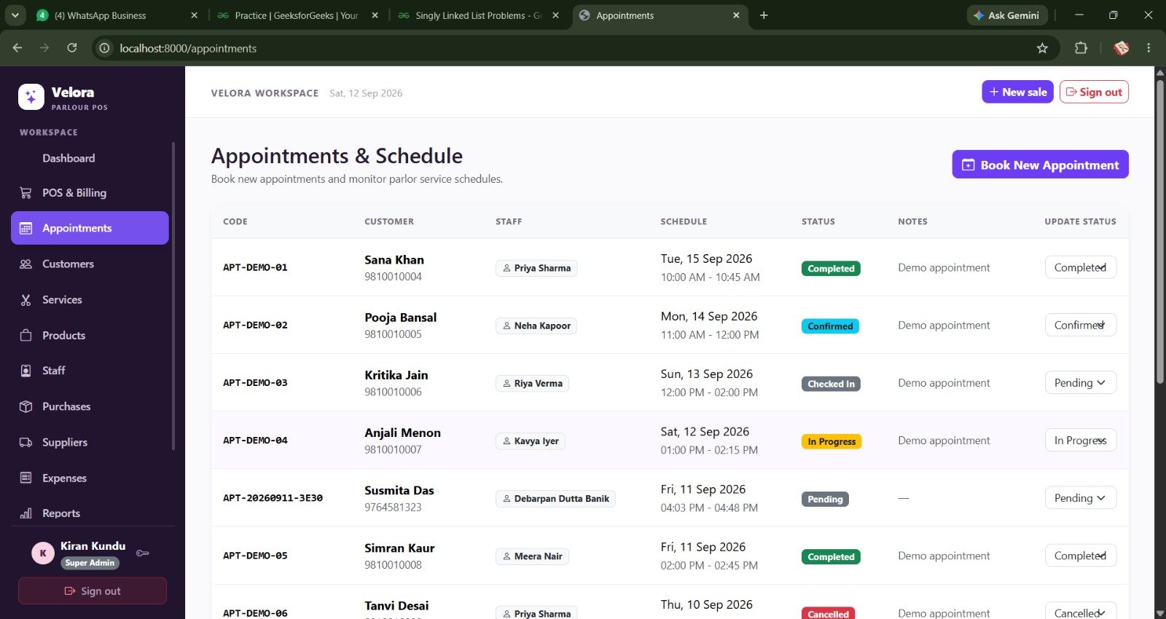
Today's work focused on developing the Appointments & Schedule module of the Velora Parlour POS System. The module provides a centralized place for managing customer appointments and staff schedules. With PHP and MySQL integration, the system will be able to store, retrieve and update appointment information dynamically.

