Daily Project Report – Day 5
Project: Velora Parlour POS System
Technology: PHP & MySQL
Module: Customer Management
Work Completed Today
Today, we worked on the Customer Management module of the Velora Parlour POS System. The main objective was to create a centralized section where the parlour can store, view and manage customer information.
Customer Management Features Developed
- Customer List
  - Created a dedicated Customers page.
  - Displays all registered customers in a structured table.
- Customer Information
The customer table contains important details such as:
  - Customer Name
  - Mobile Number
  - Email Address
  - Gender
  - Notes
  - Created Date
- Add Customer
  - Added an Add Customer button for registering new customers.
  - This allows staff to add customer information directly into the system.
- Customer Contact Details
  - Added mobile number and email fields to maintain customer contact information.
  - These details can also be used during billing and appointment booking.
- Customer Notes
  - Added a notes field for storing additional customer-related information.
- Customer Registration Date
  - The system records the date and time when a customer is added.
PHP & MySQL Implementation
The Customer Management module is designed using PHP and MySQL. Customer information is stored in the MySQL database, while PHP is responsible for processing customer data and displaying the records on the Customers page.
When a new customer is added, the submitted information can be validated by PHP and inserted into the appropriate MySQL table. The customer list can then retrieve the stored records dynamically from the database.
Integration With Other Modules
The customer module will serve as a central source of customer information for other parts of the POS system.
Customer records can be connected with:
- POS & Billing – Select a customer while creating an invoice.
- Appointments – Associate appointments with customers.
- Dashboard – Calculate and display customer statistics.
- Reports – Generate customer-related reports and transaction history.
Current Status
The basic Customer Management interface has been developed successfully. The page provides a clear view of registered customers along with their contact and profile information.
Next Steps
- Implement the complete Add Customer functionality.
- Connect customer forms with MySQL.
- Add customer validation.
- Implement customer editing and updating.
- Implement customer deletion where required.
- Add customer search and filtering.
- Connect customers with appointments and invoices.
- Test customer data storage and retrieval.
Summary
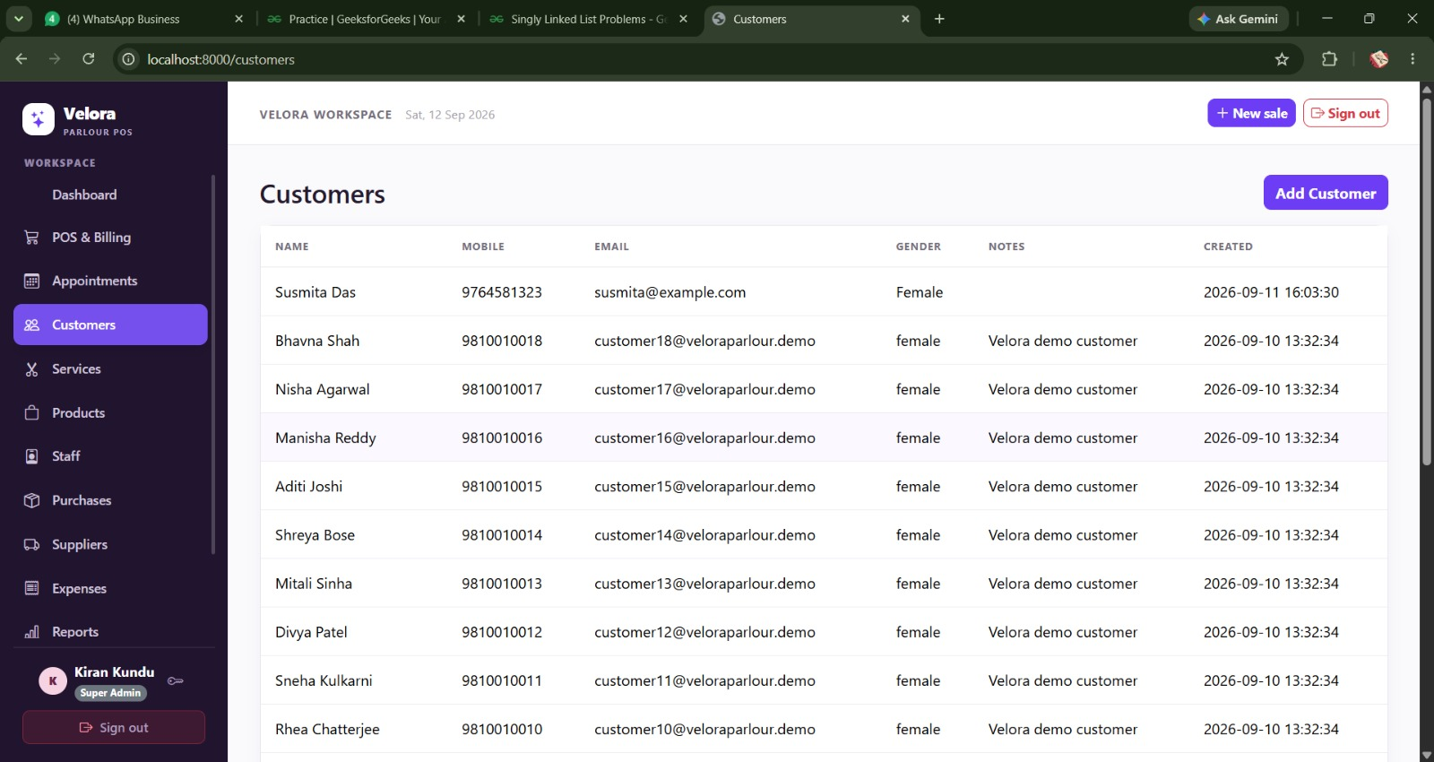
Today's work focused on developing the Customer Management module of the Velora Parlour POS System. The module provides a centralized system for maintaining customer records, including personal details, contact information, notes and registration dates. PHP and MySQL will be used to make the customer data dynamic and connect it with the billing, appointment and reporting modules.

