Daily Project Report – Day 6
Project: Velora Parlour POS System
Technology: PHP & MySQL
Module: Services Management
Work Completed Today
Today, we worked on the Services Management module of the Velora Parlour POS System. The purpose of this module is to maintain all the services offered by the parlour along with their pricing, duration, tax and commission information.
Services Features Developed
- Service List
  - Created a dedicated Services page.
  - Displays all available parlour services in a structured table.
- Service Information
The service table contains:
  - Service Name
  - Duration in Minutes
  - Price
  - Tax Rate
  - Commission Value
  - Created Date
- Add Service
  - Added an Add Service button for creating new services.
  - This allows the admin to add new parlour services to the system.
- Service Duration
  - Added duration information for each service.
  - This can be used for appointment scheduling and managing staff availability.
- Service Pricing
  - Added individual pricing for each service.
  - The price can later be used automatically during POS billing.
- Tax Rate
  - Added a tax-rate field for each service.
  - This allows the system to calculate applicable taxes during billing.
- Commission Management
  - Added a commission value for services.
  - This can be used to calculate staff commissions based on completed services.
PHP & MySQL Implementation
The Services Management module is designed using PHP and MySQL. Service information can be stored in the MySQL database and retrieved dynamically using PHP.
Each service can contain its name, duration, price, tax rate and commission value. When a service is selected from the POS & Billing module, the stored service information can be retrieved and used to automatically calculate the bill.
The service duration can also be connected with the Appointments module to help determine the expected duration of a customer's appointment.
Integration With Other Modules
The Services module will be connected with:
- POS & Billing – Services can be selected while creating an invoice.
- Appointments – Service duration can help determine appointment schedules.
- Staff – Commission values can be used for staff commission calculations.
- Reports – Service-wise sales and revenue can be analyzed.
- Dashboard – Service-related sales information can contribute to overall business statistics.
Current Status
The basic Services Management interface has been developed successfully. The system currently provides a structured view of available services with their duration, price, tax and commission information.
Next Steps
- Implement the complete Add Service functionality.
- Connect services with the MySQL database.
- Add service validation.
- Implement service editing and updating.
- Implement service deletion where required.
- Connect services with the POS billing system.
- Use service duration during appointment booking.
- Implement tax and commission calculations.
- Test service data storage and retrieval.
Summary
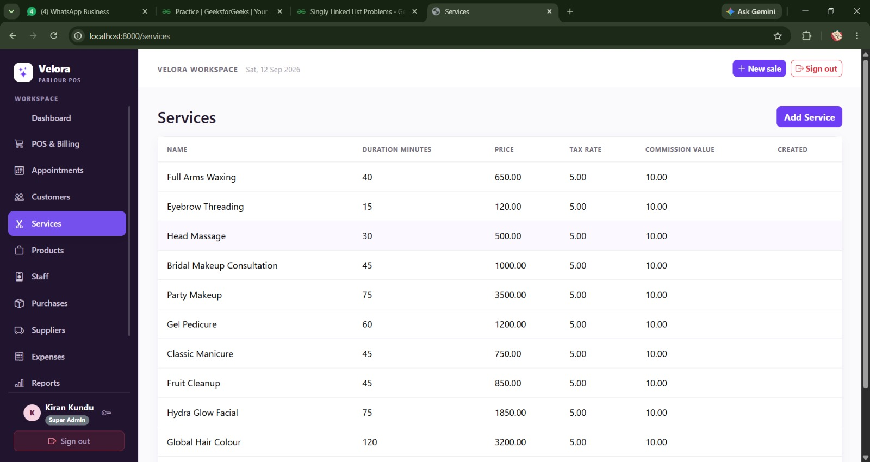
Today's work focused on developing the Services Management module of the Velora Parlour POS System. The module provides a centralized system for managing parlour services, including their duration, pricing, tax rates and commission values. PHP and MySQL will be used to connect the service data with billing, appointments, staff management and reporting modules.

