Daily Project Report – Day 11
Project: Velora Parlour POS System
Technology: PHP & MySQL
Module: User Management
Work Completed Today
Today, we worked on the User Management module of the Velora Parlour POS System. The main objective was to create a centralized system for managing system login accounts, user roles, staff associations and account status.
User Management Features Developed
- User Management Dashboard
  - Created a dedicated User Management page.
  - Displays all registered system users in an organized table.
- User Information
  - Displays important details such as:
    - User Name
    - Email Address
    - Assigned Role
    - Linked Staff Profile
    - Account Status
    - Last Login
    - Account Creation Date
- Role Management
  - Added role information for system users.
  - Different roles can be assigned based on the user's responsibilities, such as:
    - Staff
    - Receptionist / Cashier
    - Administrator
- Staff Profile Linking
  - Added the ability to associate a login account with a staff profile.
  - This allows the system to connect user accounts with employee information.
- User Search
  - Added a search field to find users by:
    - Name
    - Email
    - Staff information
- Role & Status Filtering
  - Added filters for user roles and account status.
  - This makes it easier for administrators to find specific accounts.
- User Status Management
  - Added Active status indicators for user accounts.
  - Added a Deactivate option to disable user access when required.
- Edit User
  - Added an Edit option for modifying user account information and role assignments.
- Add New User
  - Added an Add New User button for creating new system login accounts.
- Audit Logs
  - Added a View Audit Logs option.
  - This provides a foundation for tracking important user and system activities.
PHP & MySQL Implementation
The User Management module is designed using PHP and MySQL. User account information, roles, staff associations and account statuses can be stored in the MySQL database.
PHP handles user management operations such as creating accounts, updating user information, assigning roles and changing account status.
The authentication system developed earlier can use these user records to verify login credentials and determine the permissions available to each user.
Role-Based Access Control
The User Management module provides the foundation for role-based access control. Based on the assigned role, different users can be provided with appropriate access to system modules.
For example, an administrator may have access to user management and reports, while a receptionist or staff member may have access only to the modules required for their daily responsibilities.
Integration With Other Modules
The User Management module will be connected with:
- Authentication – Manage login accounts and sessions.
- Staff – Link system users with staff profiles.
- POS & Billing – Control access to billing operations.
- Appointments – Provide appropriate access to appointment management.
- Reports – Restrict sensitive business reports based on roles.
- Audit Logs – Track important user activities.
Current Status
The basic User Management interface has been developed successfully. The page provides user listing, search and filtering, role information, staff profile linking, account status management, editing and audit-log access.
Next Steps
- Implement the complete Add New User functionality.
- Connect users with the MySQL database.
- Implement role-based permissions.
- Connect users with staff profiles.
- Implement account activation/deactivation.
- Complete audit-log functionality.
- Improve authentication and session security.
- Test different user roles and access permissions.
Summary
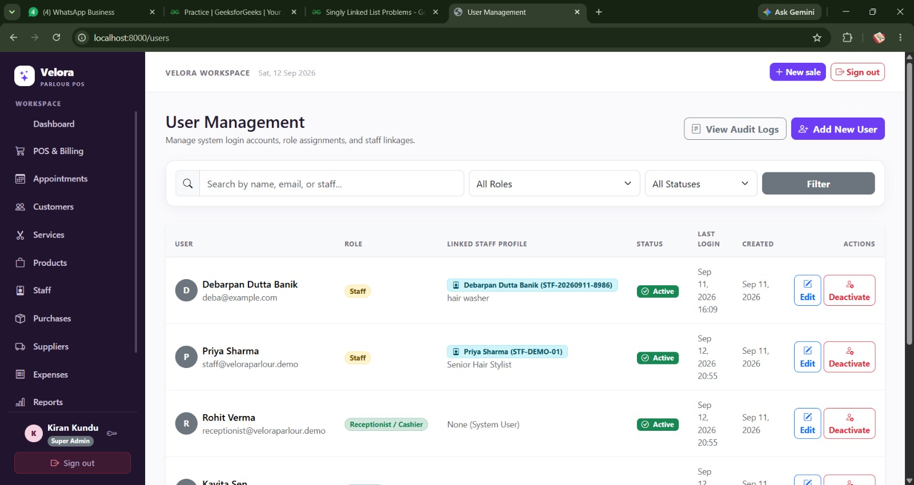
Today's work focused on developing the User Management module of the Velora Parlour POS System. The module provides administrators with centralized control over system login accounts, roles, staff associations and account status. PHP and MySQL will be used to manage user records and support secure authentication and role-based access throughout the POS system.

