Daily Project Report – Day 12
Project: Velora Parlour POS System
Technology: PHP & MySQL
Module: Audit Trail & Security Logs
Work Completed Today
Today, we worked on the Audit Trail & Security Logs module of the Velora Parlour POS System. The main objective was to create a system for recording and monitoring important user activities, authentication events, data changes and administrative actions.
Audit Log Features Developed
- Audit Trail Dashboard
  - Created a dedicated Audit Trail & Security Logs page.
  - Provides a centralized view of important system activities.
- Timestamp Tracking
  - Each activity is recorded with its date and time.
  - This helps administrators identify when a particular action occurred.
- User / Actor Information
  - Displays the user who performed an action.
  - The user's assigned role is also displayed.
- Action Tracking
  - Records different types of system actions, such as:
    - Login/Logout
    - Created
    - Updated
    - Deleted
    - Uploaded
    - Finalized
- Module Tracking
  - Identifies the system module where the action occurred.
  - Examples include:
    - Authentication
    - Invoice
    - Invoices
    - Staff
    - Staff Documents
- Record ID Tracking
  - Stores the ID of the affected database record.
  - This helps administrators identify exactly which record was modified.
- IP Address Logging
  - Records the IP address associated with the activity.
  - This provides an additional layer of security monitoring.
- Details / Changes
  - Added a section for recording additional information or changes associated with an action.
- Module Filtering
  - Added a filter that allows administrators to view events from specific modules.
  - An All Modules option is also available.
- Refresh Functionality
  - Added a Refresh button to retrieve the latest audit events.
- User Management Integration
  - Added a Back to User Management option for easy navigation between user accounts and their security logs.
PHP & MySQL Implementation
The Audit Trail module is designed using PHP and MySQL. Audit events can be stored in a dedicated MySQL audit-log table containing information such as user, action, module, record ID, timestamp, IP address and details.
PHP can automatically create an audit entry whenever an important system operation is performed. For example, when an invoice is created, a staff document is uploaded or deleted, or a user logs out, the corresponding activity can be recorded in the audit trail.
Security Benefits
The audit system provides an additional layer of accountability by maintaining a history of important activities. Administrators can use the logs to investigate unexpected changes, identify which user performed an operation and review authentication or administrative events.
Integration With Other Modules
The Audit Trail module can be integrated with:
- User Management – Track user account activities.
- Authentication – Record login and logout events.
- POS & Billing – Track invoice creation and finalization.
- Staff Management – Track staff profile changes.
- Staff Documents – Track document uploads and deletions.
- Products & Inventory – Track important inventory changes.
- Appointments – Track appointment updates.
- Purchases – Track purchase-related modifications.
Current Status
The basic Audit Trail & Security Logs interface has been developed successfully. The page provides timestamp tracking, user information, action types, module identification, record IDs, IP addresses, filtering and refresh functionality.
Next Steps
- Connect audit logs with MySQL.
- Automatically record important system actions.
- Implement login and logout event tracking.
- Record create, update and delete operations.
- Store detailed change information.
- Implement advanced audit-log filtering.
- Add pagination for large numbers of records.
- Restrict audit-log access to authorized administrators.
- Test audit logging across all major modules.
Summary
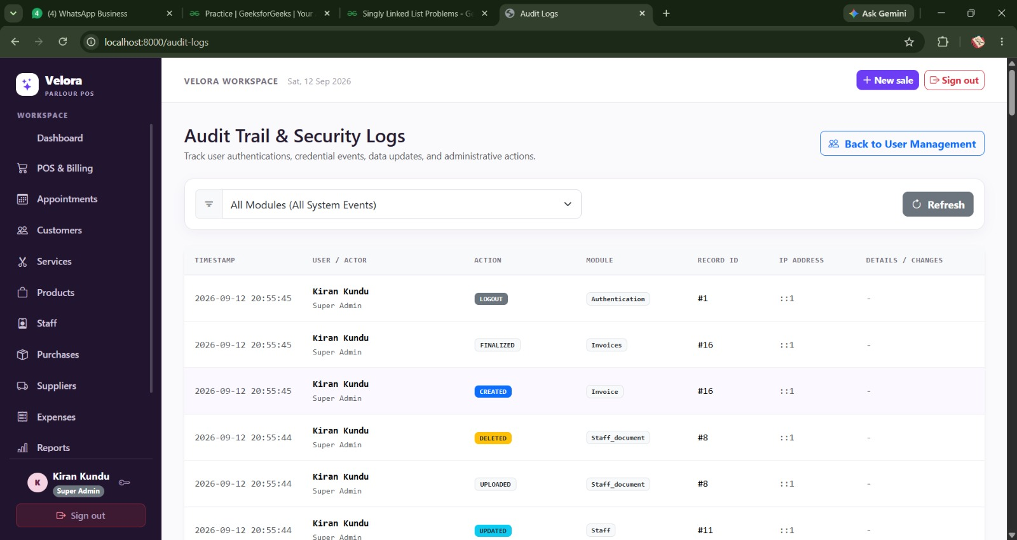
Today's work focused on developing the Audit Trail & Security Logs module of the Velora Parlour POS System. The module provides a centralized mechanism for tracking user activities, authentication events, data modifications and administrative actions. PHP and MySQL will be used to maintain these records and provide administrators with a reliable history of important system activities.

