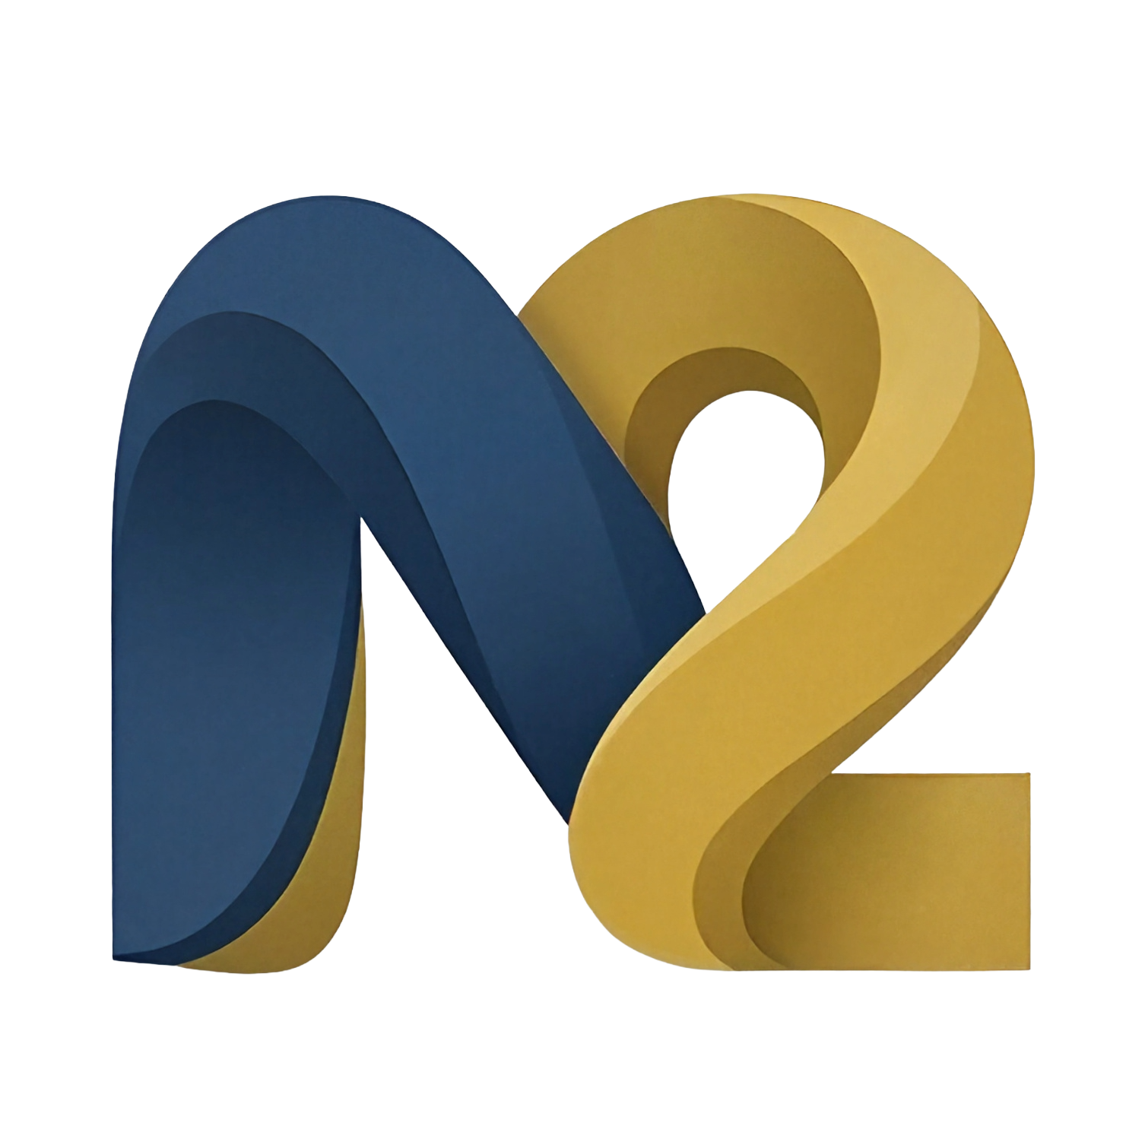
Me2Leads
Scannez. Connectez. Convertissez.
Scan. Connect. Convert.
Product Overview & Competitive Positioning

1. EXECUTIVE SUMMARY

Me2Leads is a mobile-first professional contact management and lead-conversion platform built for field sales representatives, networkers, recruiters, and business development professionals. It replaces the painful manual process of transcribing paper business cards by letting users capture contact details in seconds via OCR (camera), or QR code, then scoring, following up on, and converting those leads directly from their smartphone.
Available on Android and iOS, Me2Leads combines the power of a fully-featured CRM with the simplicity of a contact book. Its bilingual (FR/EN) interface, offline-first SQLite storage with optional cloud sync, and a competitive pricing model starting at just €2.99/month make it accessible to individuals and teams alike.
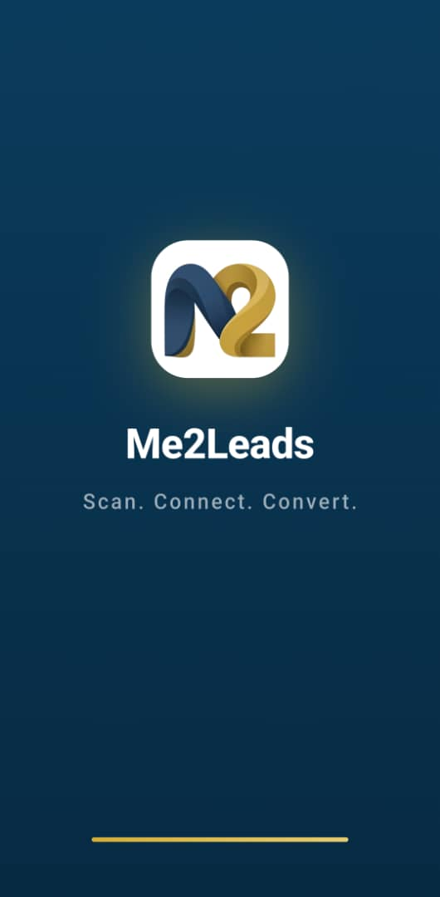  Splash / branding screen | 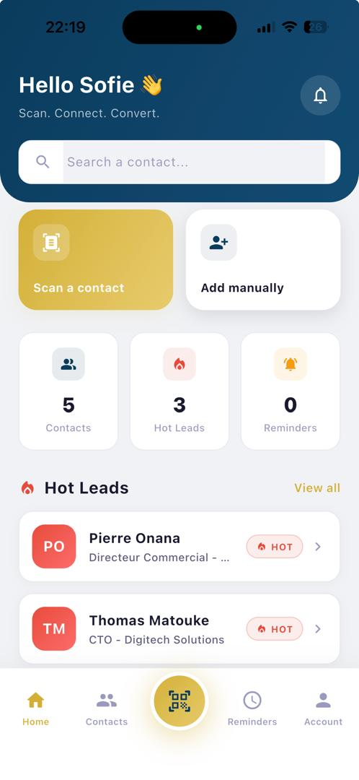  Home dashboard

2. WHAT IS ME2LEADS?

Me2Leads is a smart lead-capture and relationship-management application designed for professionals who collect contacts in the physical world — at trade shows, conferences, networking events, or during field visits. Instead of juggling stacks of business cards or forgetting to follow up, Me2Leads creates a structured, searchable, and syncable contact database on the user's device.
Core Value Proposition
- ⚡ Speed: Capture a complete contact profile in under 10 seconds using the device camera.
- 🎯 Prioritisation: Every contact gets a Hot / Warm / Cold status so you always know who to call next.
- 📲 Instant Action: Built-in call, SMS, WhatsApp, and email actions — no app-switching.
- ☁ Offline-first: Works without internet; syncs silently to the cloud when connectivity is restored.
- 👥 Team-ready: Team features let organisations share contacts, assign roles, and track activity.
3. KEY FEATURES & FUNCTIONALITIES

3.1 Multi-Modal Contact Capture
Me2Leads offers three distinct capture methods, all accessible from the prominent gold scan button in the centre of the navigation bar:
- Camera OCR: Point the camera at any business card; ML Kit OCR extracts name, title, company, phone, and email automatically. A confidence indicator (high / fair / low) shows parse quality before saving.
- QR Code: Scan a contact's QR code to import their digital business card in one tap.
- Manual Entry: Full form with phone-prefix selector, project fields, notes, and tags.
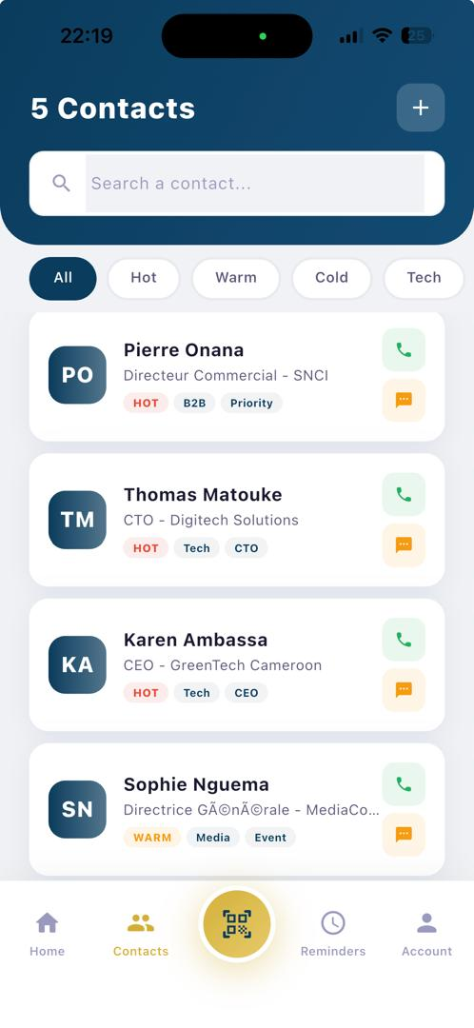  Contact list with status filters | 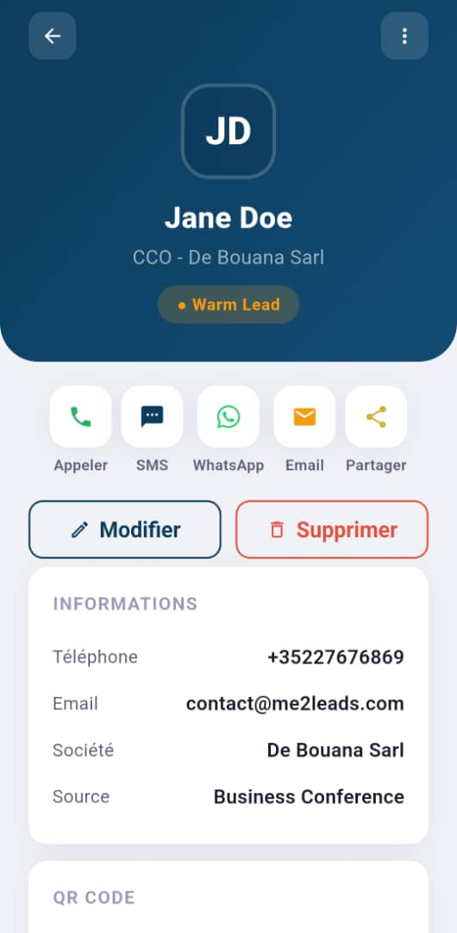  Contact detail view

3.2 Lead Scoring & Status Management
Every contact carries a status badge — HOT, WARM, or COLD — displayed prominently on contact cards. Users can filter the entire contact list by status, making it effortless to focus on the most urgent leads first.
- HOT: Urgent leads requiring immediate follow-up.
- WARM: Active prospects in progress.
- COLD: Leads to nurture or archive.
3.3 Smart Reminders & Follow-Up
Reminders in Me2Leads are tied directly to contacts and carry an action type (call, SMS, WhatsApp, or email) as well as a priority level (Very Important, Important, Normal). The reminders screen organises tasks into Today, This Week, Later, and Overdue buckets for at-a-glance triage.
- Repeating reminders for recurring follow-ups (daily, weekly, monthly).
- Automatic calendar integration — saved reminders are added to the device calendar.
- Push notifications via WorkManager, even when the app is closed.
3.4 Quick Actions
From any contact detail screen, a single tap initiates the desired communication channel. Me2Leads launches the native phone dialler, SMS app, WhatsApp, or email client pre-filled with the contact's details — eliminating copy-paste friction.
3.5 Interaction History
Every call, message, edit, and note is automatically logged to the contact's timeline. Field teams can review a complete interaction history and see which colleagues last touched a contact, ensuring consistent follow-through without duplication.
3.6 Encrypted Cloud Sync
All sensitive fields (phone numbers, email addresses) are encrypted on-device with AES-256-CBC before being stored or synced. Cloud synchronisation to a PostgreSQL backend runs silently in the background, with a manual sync screen for users who want explicit control.
- Free plan: user profile only.
- Premium & Business plans: full contact, reminder, interaction, and org data.
- Business plan: automatic 15-minute background sync via WorkManager.
3.7 Organisation & Team Management
Me2Leads supports multi-user organisations for sales teams. An admin creates an organisation, shares an 8-character invite code, and manages member permissions through a granular privilege matrix.
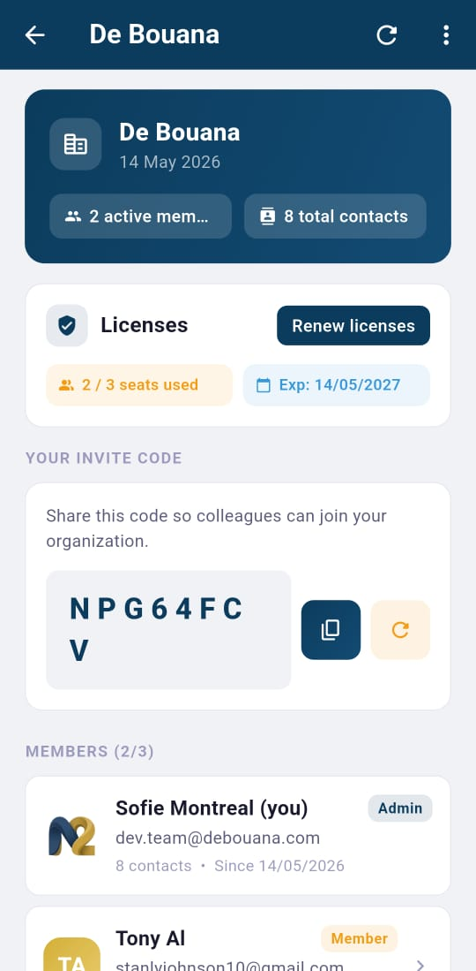
Organisation admin panel — member management & privilege matrix
Privilege flags include: Create Contacts, Edit Contacts, View Reminders, View History, and Export Contacts. Admins can suspend members without losing contact data — orphaned contacts are transferred automatically.
3.8 Import / Export
Contacts can be exported to CSV or JSON for use in other tools, or bulk-imported to seed the database from an existing source. Export access is gated by the organisation permission flag.
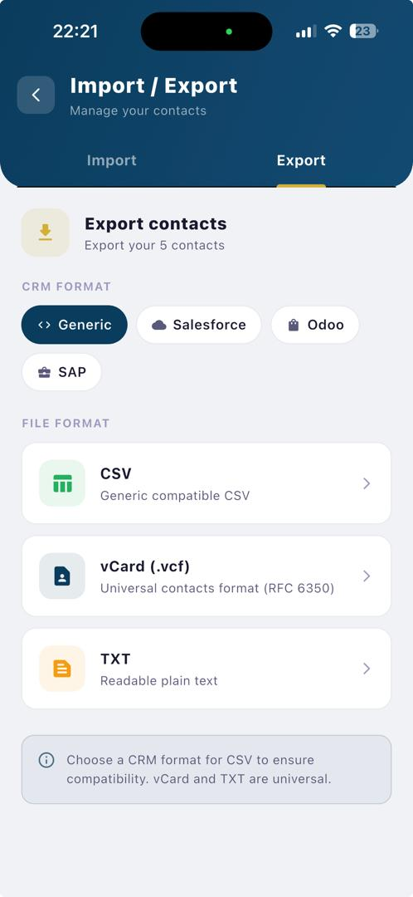
Import / Export screen
3.9 Flexible Subscription Model
Me2Leads uses a freemium model with transparent pricing:
Plan | Price | Contacts | Key Features
Free | €0 | Up to 10 | Local storage, manual entry, basic actions
Premium | €2.99/mo | Unlimited | Full sync, all capture modes, reminders, history
Business | €5.99/user/mo | Unlimited (shared) | All Premium + org management, bg sync, export

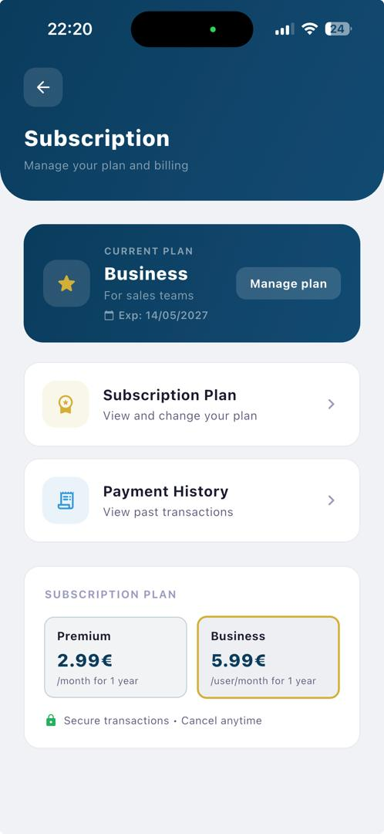
Subscription plan selection screen
4. USE CASES

4.1 Field Sales Representative
A sales rep attends a trade show and collects 30 business cards over two days. Using Me2Leads, they photograph each card during the event — the OCR extracts all fields automatically. By the time they leave the venue, every contact is scored, tagged with the event name, and has a follow-up reminder set for the next morning. The team back at the office can see the new leads in real time via cloud sync.
4.2 Recruiter
A recruiter uses Me2Leads to manage candidates encountered at university career fairs. Candidate cards are scanned on the spot, tagged with the role and graduation year, and set to HOT or WARM based on initial conversation quality. Weekly reminders prompt follow-up calls. The interaction history gives a clear timeline of every touchpoint.
4.3 Freelancer / Consultant
A freelance consultant captures leads from LinkedIn QR codes and Business cards at networking meetups. With Me2Leads' offline-first model, data is captured even without mobile data on the subway. Contacts sync to the cloud when Wi-Fi is available, ensuring nothing is lost.
4.4 SME Sales Team
A small business creates an Me2Leads organisation, adds four sales team members, and enables full sync on the Business plan. Shared contacts eliminate duplicate outreach, the privilege matrix ensures junior members can capture and edit but not export, and the admin has a real-time view of the pipeline on the home dashboard.
4.5 Real Estate Agent
A real estate agent uses Me2Leads to track prospective buyers and sellers. Contacts are linked to specific projects (property addresses) with associated budgets. Reminders for follow-up viewings appear under today's tasks, and the WhatsApp quick action keeps communication instant and personal.
5. BENEFITS VS. EXISTING CRM SOLUTIONS

Traditional CRM platforms (Salesforce, HubSpot, Zoho, Monday.com) are powerful but designed primarily for desk-bound teams managing large sales pipelines. Me2Leads fills a different niche: the mobile professional who needs to capture, score, and act on contacts in the physical world — quickly, simply, and without a steep learning curve.
Feature / Criterion | Me2Leads | Salesforce | HubSpot Free | CamCard
Mobile-first UX | ✅ Native | ⚠ App limited | ⚠ App limited | ✅ Mobile
Business card OCR | ✅ Built-in | ❌ Add-on only | ❌ Not available | ✅ Built-in
QR + OCR capture | ✅ Both | ❌ | ❌ | ⚠ QR only
Lead scoring (Hot/Warm/Cold) | ✅ Simple tags | ✅ Complex rules | ⚠ Limited | ❌
Offline-first storage | ✅ SQLite | ❌ Cloud-required | ❌ Cloud-required | ⚠ Partial
End-to-end encryption | ✅ AES-256 | ⚠ Vendor-managed | ⚠ Vendor-managed | ⚠ Partial
Team / Org management | ✅ Included | ✅ (expensive) | ⚠ Limited | ❌
Entry-level price | ✅ Free / €2.99 | 💰 ~€25/user/mo | Free (limited) | ~€5/mo
Setup complexity | ✅ < 2 minutes | ❌ Weeks/months | ⚠ Hours/days | ✅ Fast

Key Differentiators
- Beyond card scanning: CamCard and similar apps digitise cards but stop there. Me2Leads adds scoring, reminders, interaction history, team sharing, and cloud sync — a complete post-capture workflow.
- No enterprise overhead: Salesforce and HubSpot require weeks of onboarding, dedicated admin staff, and hundreds of euros per user per month. Me2Leads is production-ready in minutes at a fraction of the cost.
- Privacy by design: Contacts and sensitive fields are AES-256 encrypted on the device before any network transmission — a level of privacy rarely offered by cloud-first CRMs.
- True offline capability: Me2Leads works fully offline. Contacts captured underground or in areas with poor connectivity are stored locally and synced automatically when the connection returns.
- Frictionless first contact: Quick-action buttons for Call, SMS, WhatsApp, and Email — no copy-paste, no app-switching — compress the gap between capture and first contact to seconds.
6. ACCOUNT MANAGEMENT & SETTINGS

Me2Leads provides a full self-service account experience. Users can update their profile, change their email or password, manage their subscription, and view their full payment history — all from within the app.
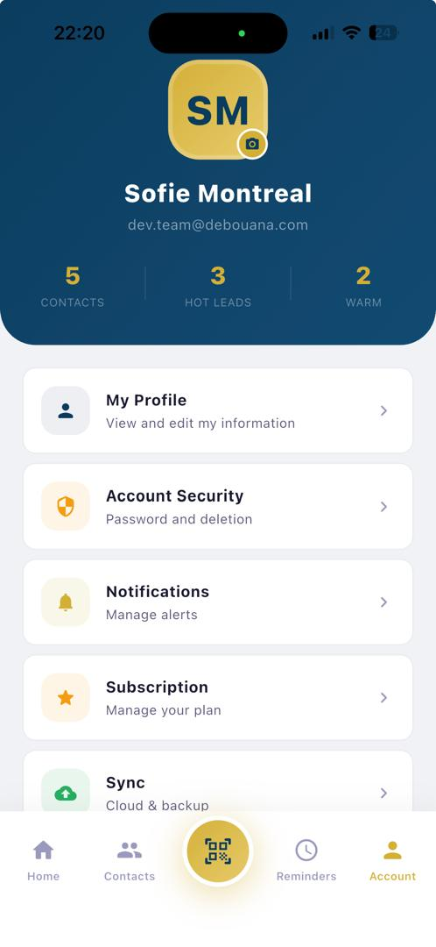  Account / profile screen | 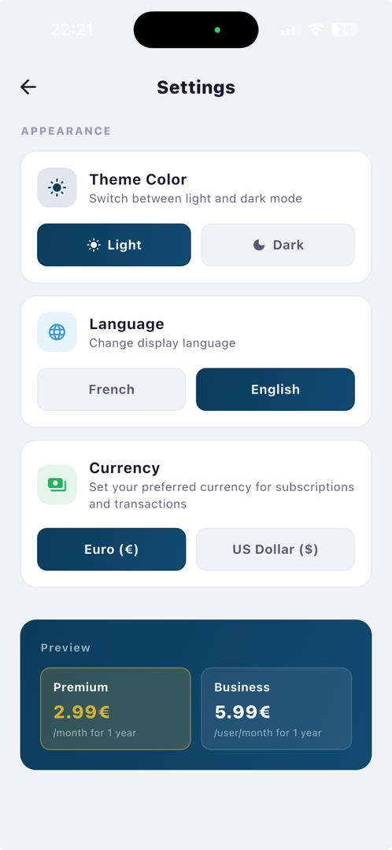  App settings

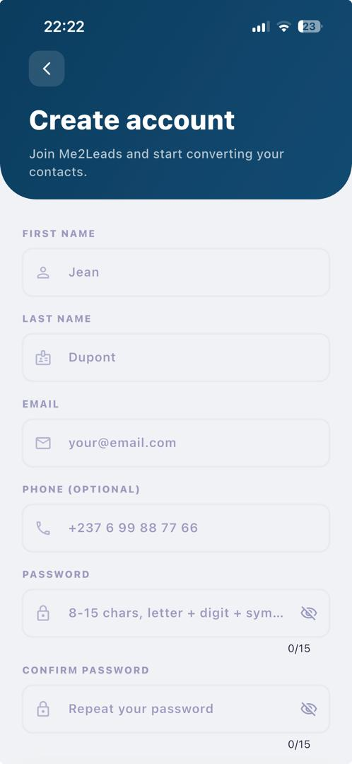  Account registration | 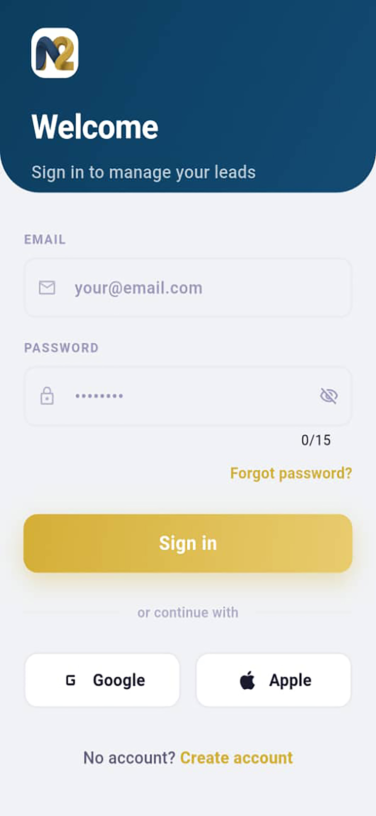  Secure login

7. SECURITY & PRIVACY

- On-device encryption: AES-256-CBC encryption for all PII fields (phone, email) stored on-device and in the cloud.
- Secure key storage: Master encryption key stored in Android Keystore / iOS Secure Enclave — never written to disk.
- Privacy-preserving dedup: SHA-256 lookup hashes allow de-duplication without exposing plaintext values.
- Session hygiene: Session tokens are rotated on logout and every password change.
- No hardcoded secrets: Background sync credentials are XOR-obfuscated; Firebase/Stripe keys loaded from .env at runtime — nothing hardcoded.
- Apple Sign-In: Apple Sign-In supported, including email-relay hidden-address flows.
8. GETTING STARTED IN UNDER 2 MINUTES

1. Download | Install Me2Leads from Google Play or the App Store. No account required to explore.
2. Create account | Sign up with your email. A verification code is sent instantly.
3. Capture your first contact | Tap the gold Scan button → point at a business card → confirm the extracted data.
4. Set a follow-up reminder | Tap the bell icon on the contact → choose action, priority, and date.
5. Upgrade when ready | Unlock unlimited contacts and cloud sync from the Pricing screen.

Me2Leads · com.debouana.myleads · © 2026 Debouana

