HTB Labs

Starting Point

Learn the basics of Penetration Testing

Learning Outcomes
In the first tier, you will gain essential skills in the world of cybersecurity pen-testing. You'll start by learning how to connect to various services, such as FTP, SMB, Telnet, Rsync, and RDP anonymously. Next, you'll discover the power of Nmap, a valuable tool for identifying open ports on target systems, allowing you to assess their vulnerabilities. Lastly, you'll explore connecting to a MongoDB server, adding a valuable layer to your penetration testing knowledge. This tier will lay a strong foundation for your journey into the realm of cybersecurity.
- Learn how to connect FTP, SMB, Telnet, Rsync and RDP anonymously.
- Learn how to use Nmap to identify open ports.
- Learn how to connect to a MongoDB server.
ENUMERATION
1. Meow
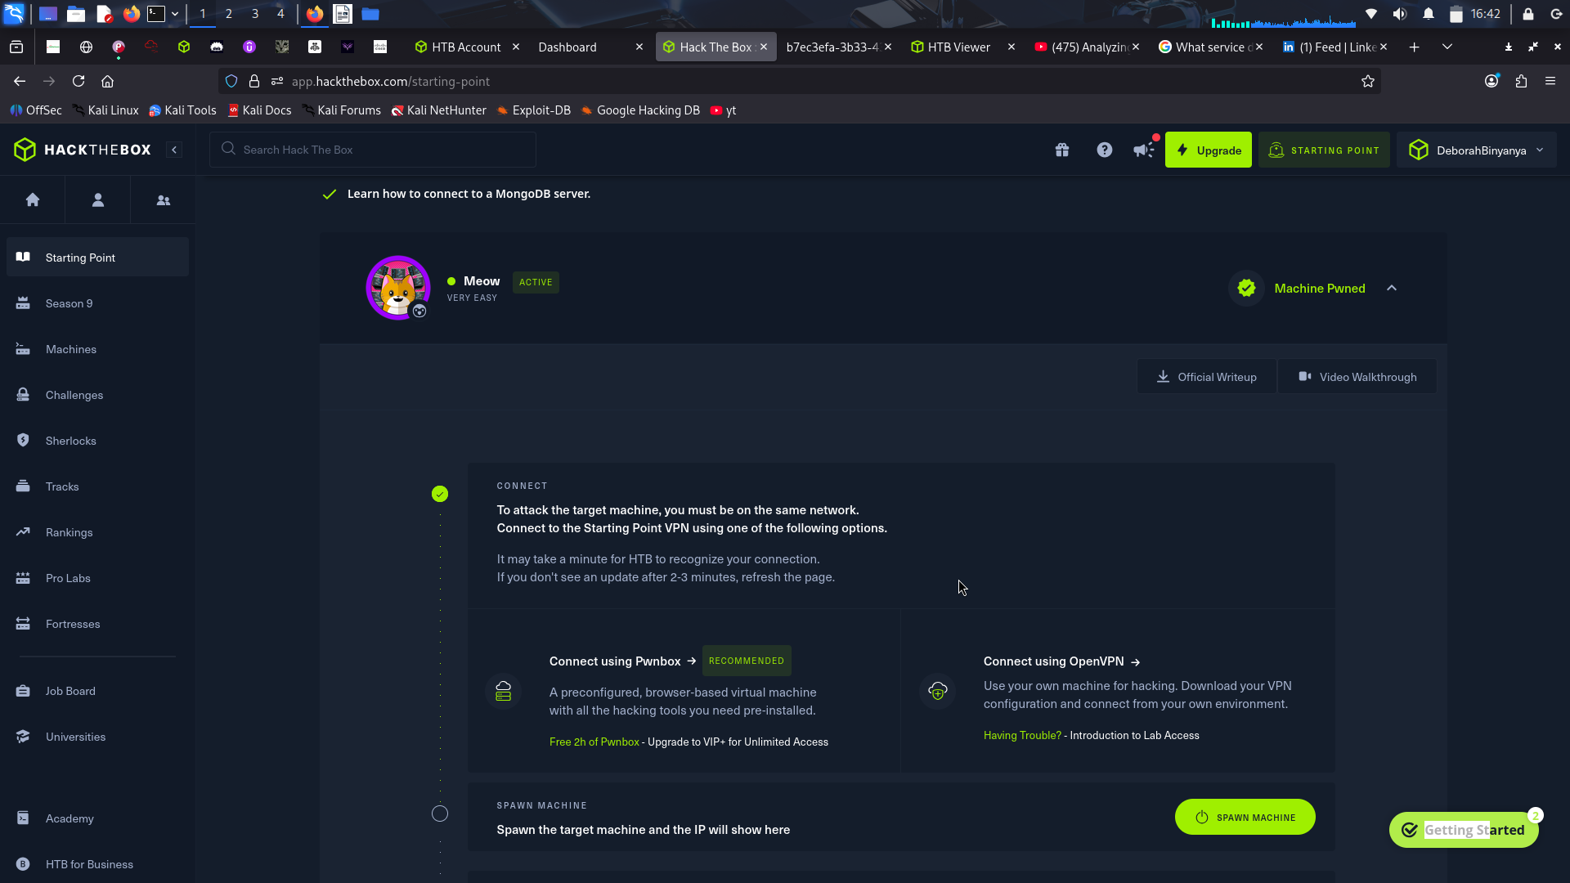
Task 1-3
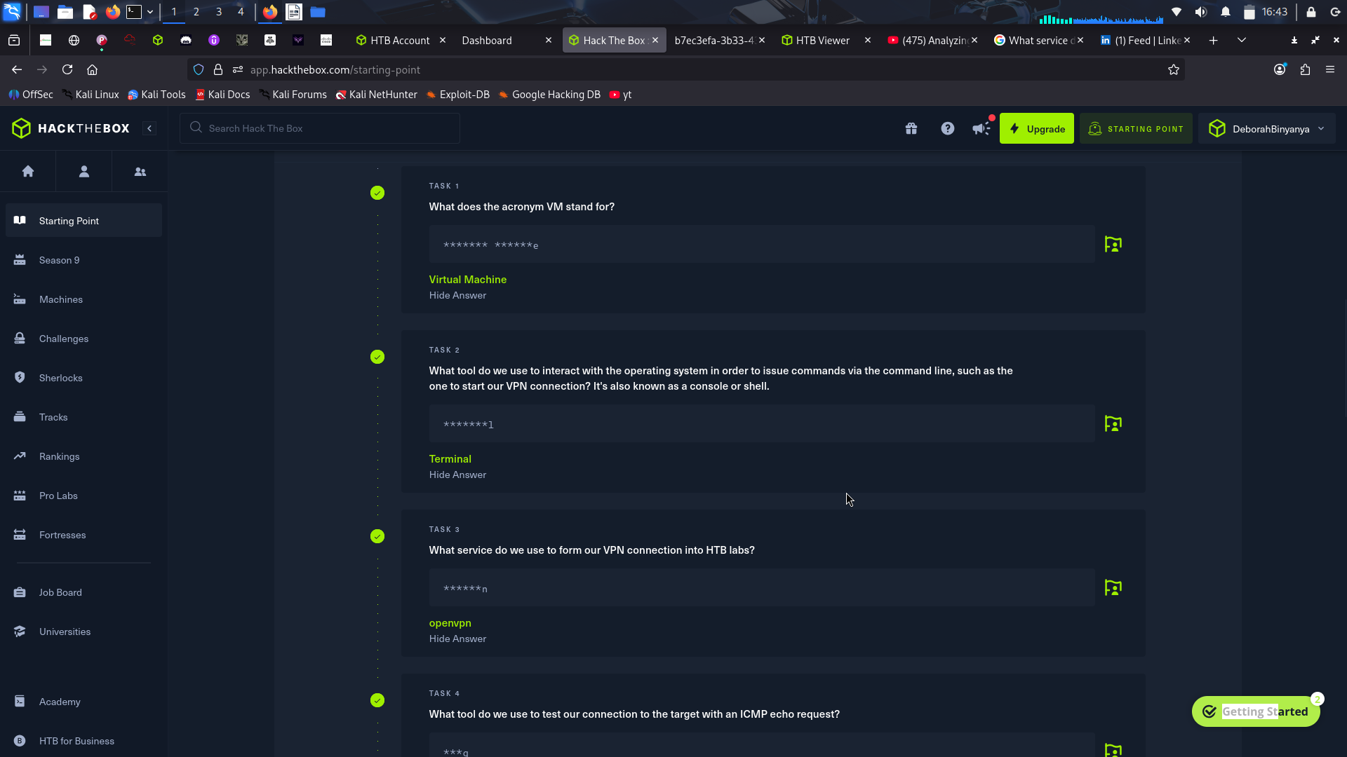
Task 4-6
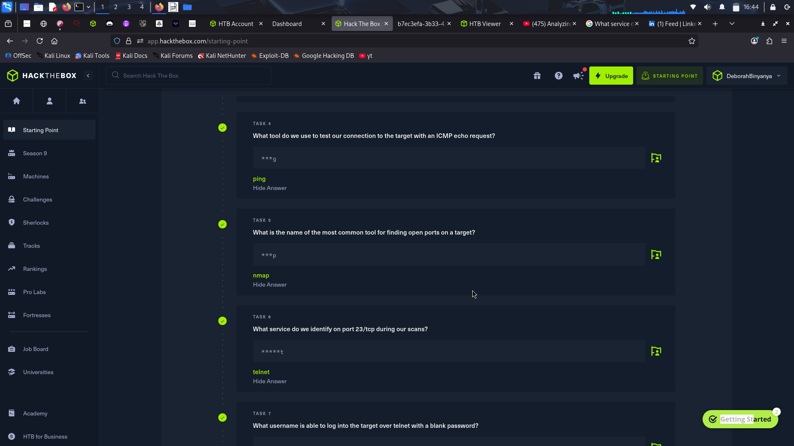
Task 7-8
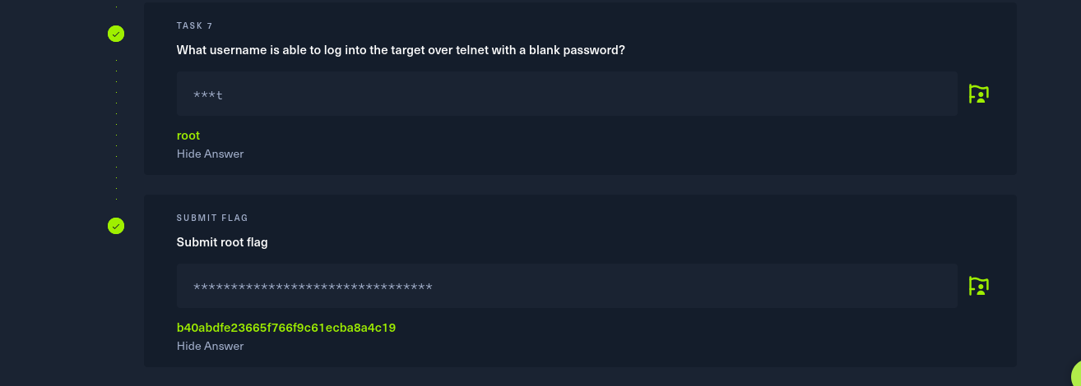
Guide to the flag
ping target IP
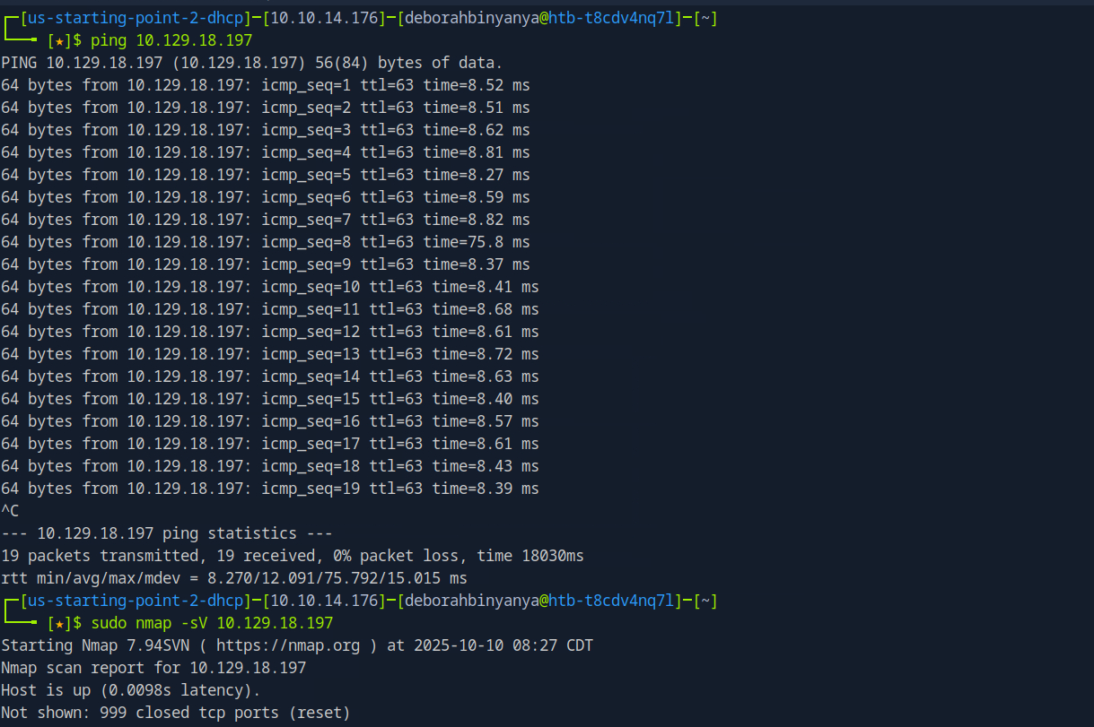
Nmap to see open ports
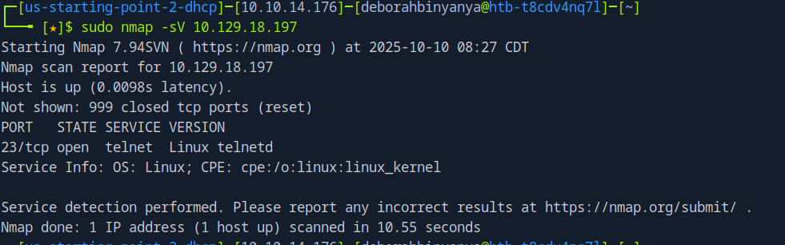
telnet to get connection
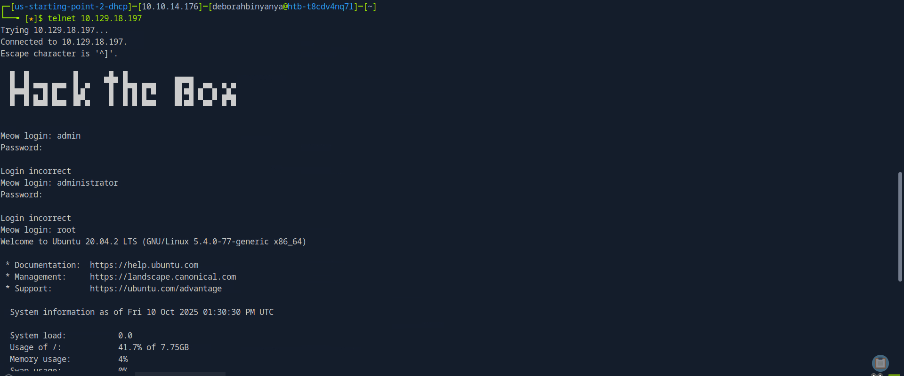
ls to see available files and opne the flag.txt to find flag
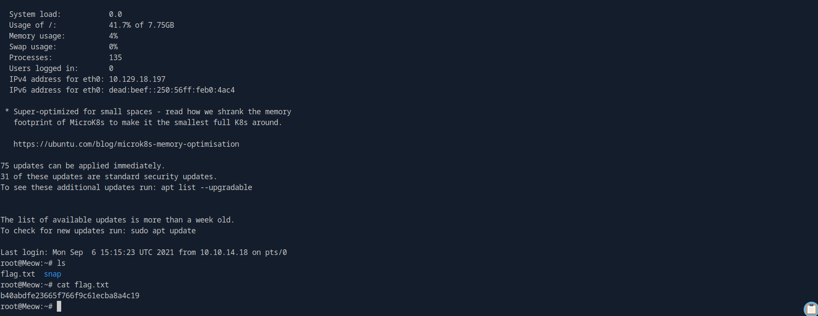
2.Fawn
The purpose of this exercise is to familiarize yourself with the File Transfer Protocol (FTP), a native protocol to all host operating systems and used for a long time for simple file transfer tasks, be they automated or manual.

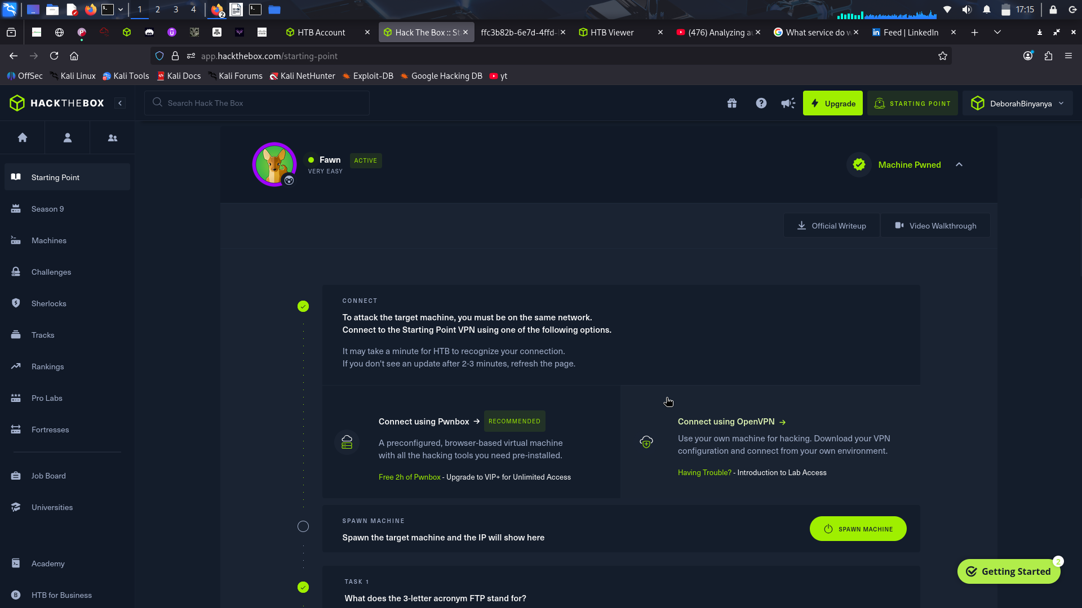
Task 1- 3
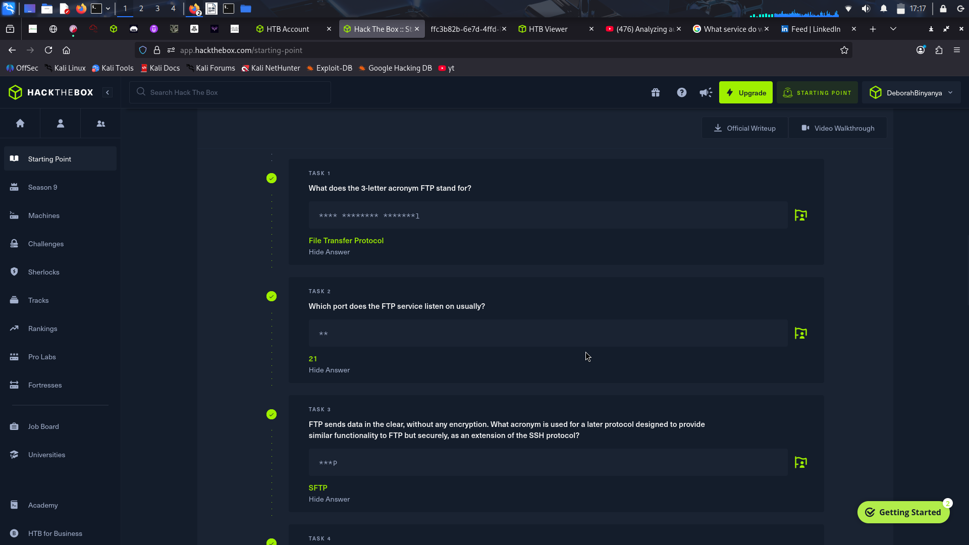
Task 4-6

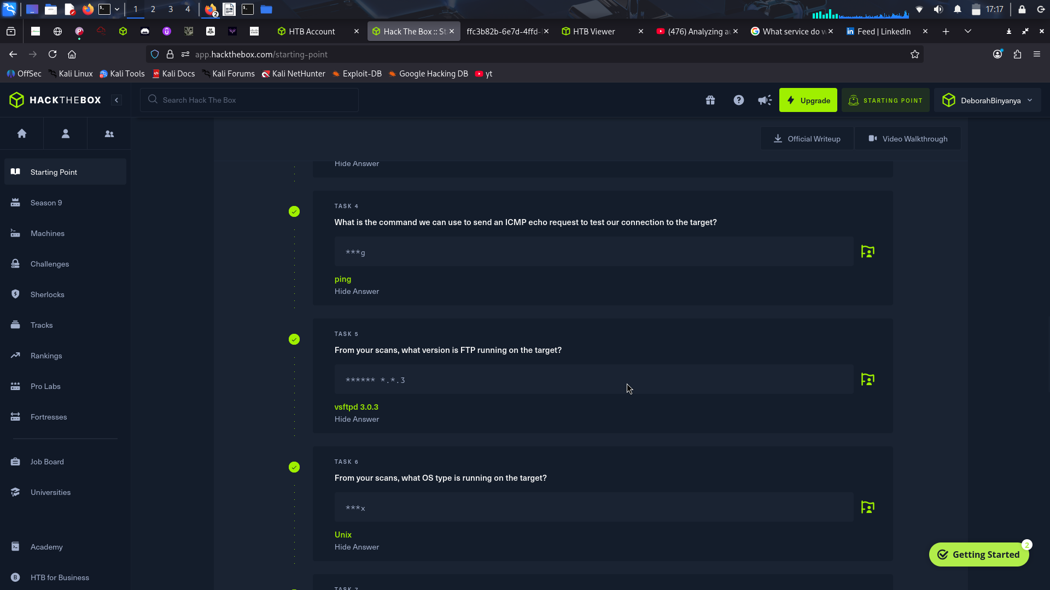
Task 7 -9
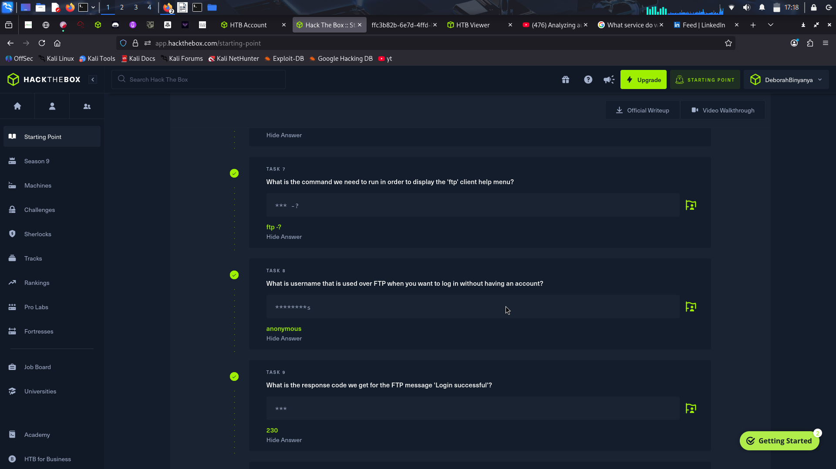
Task 10 – 11
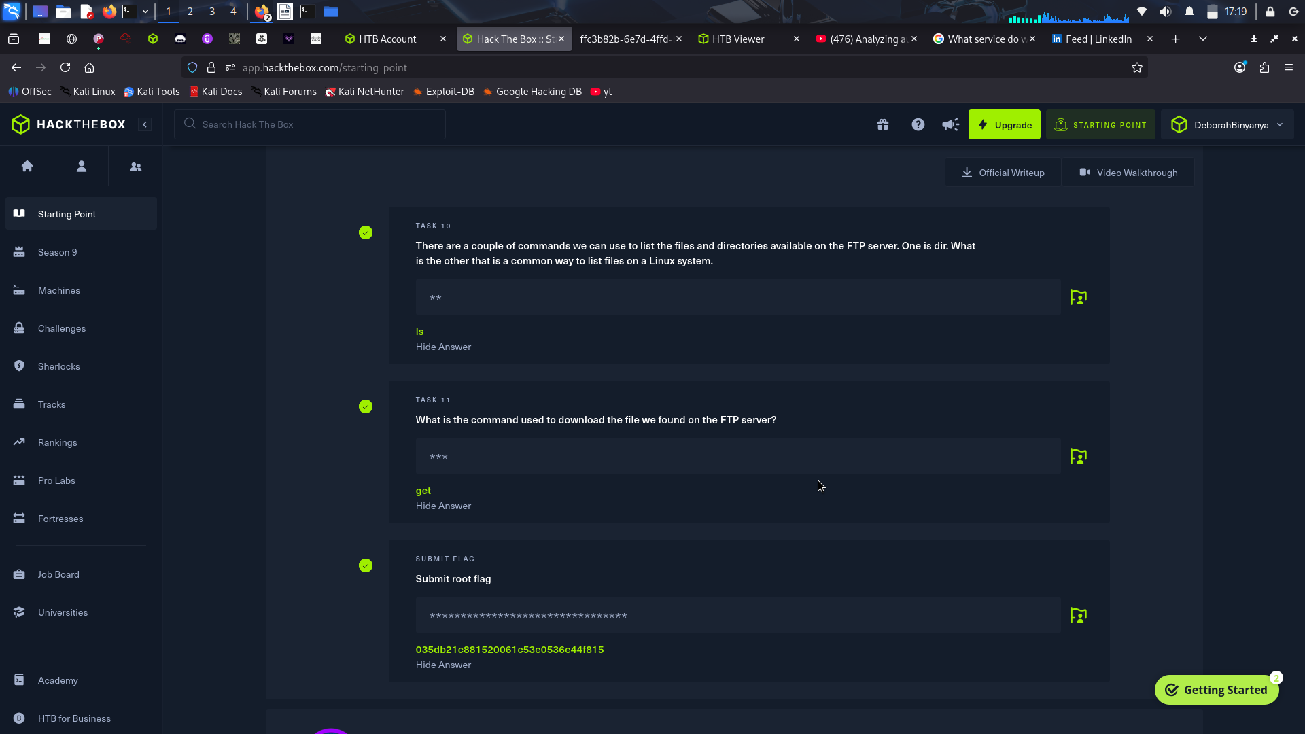
Guide to get the flag
ping to confirm connection
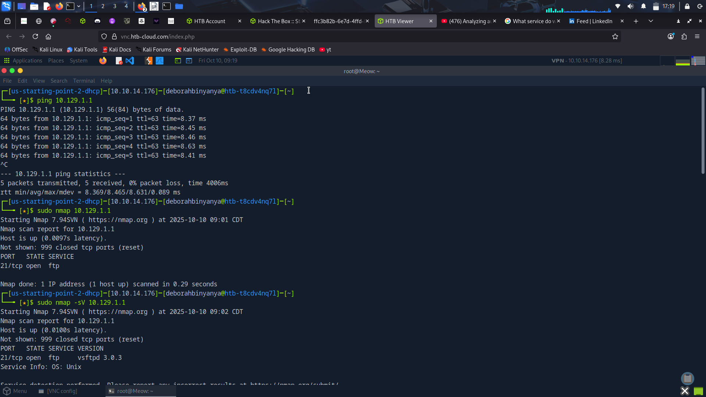
scan with nmap to see the open port and install ftp
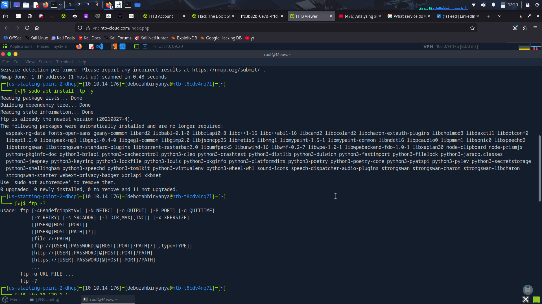
ftp into the target IP
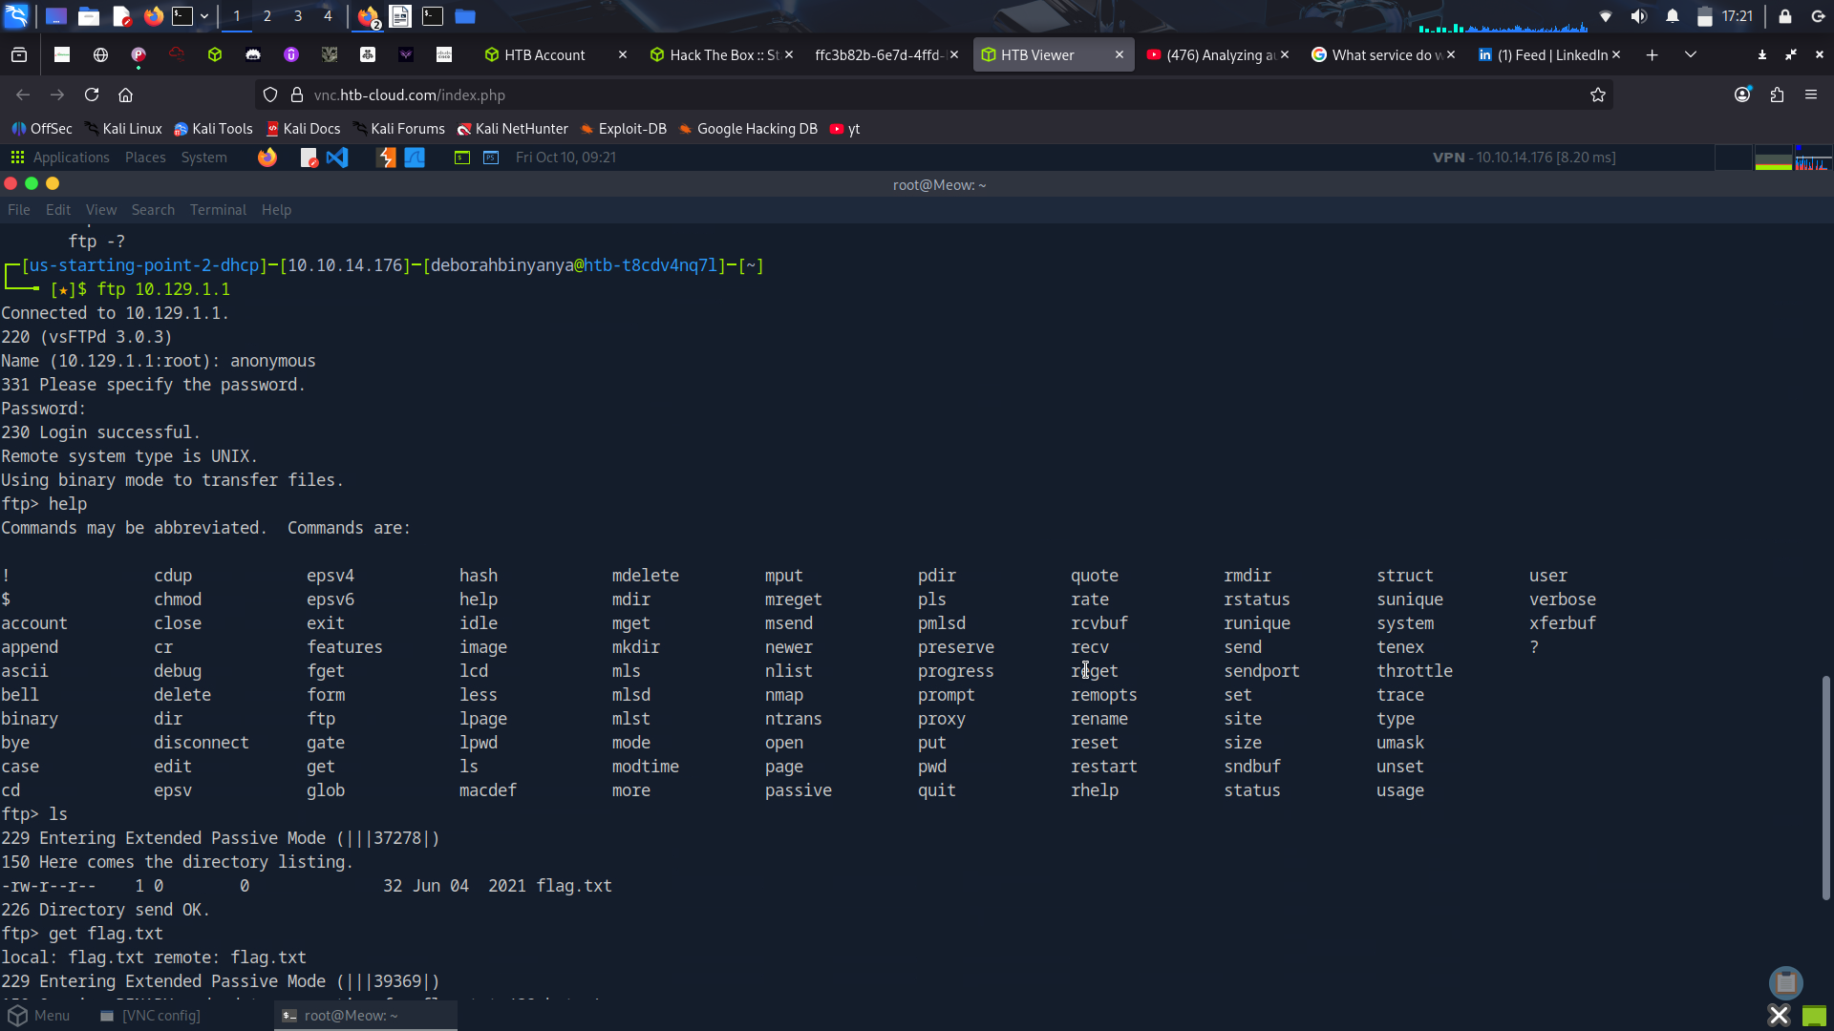
get the flag file and exit then open it using “cat” command
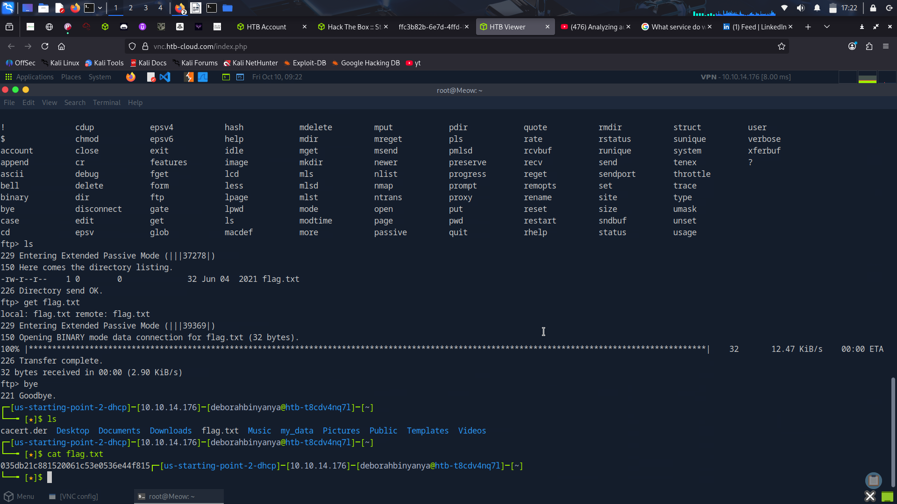
Dancing
SMB (Server Message Block). This communication protocol provides shared access to files, printers, and serial ports between endpoints on a network. We mostly see SMB services running on Windows machines. During scanning, we will typically see port 445 TCP open on the target, reserved for the SMB protocol.
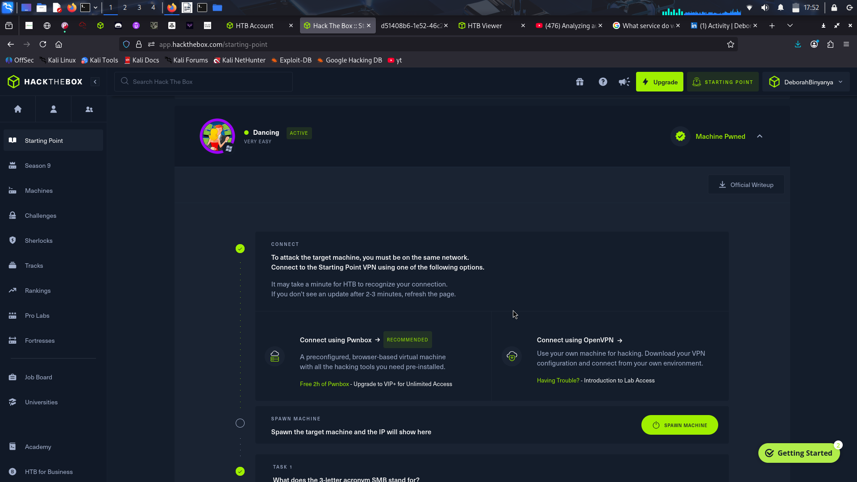
Task 1-3
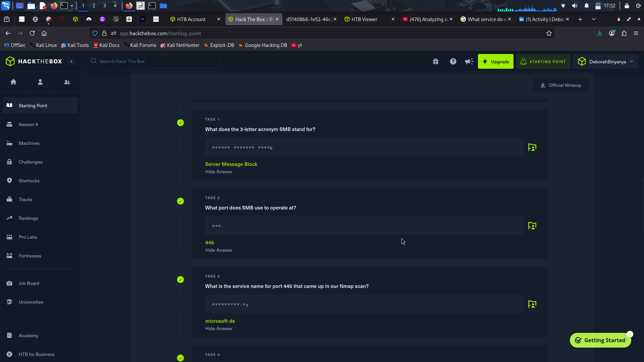
Task 4-6
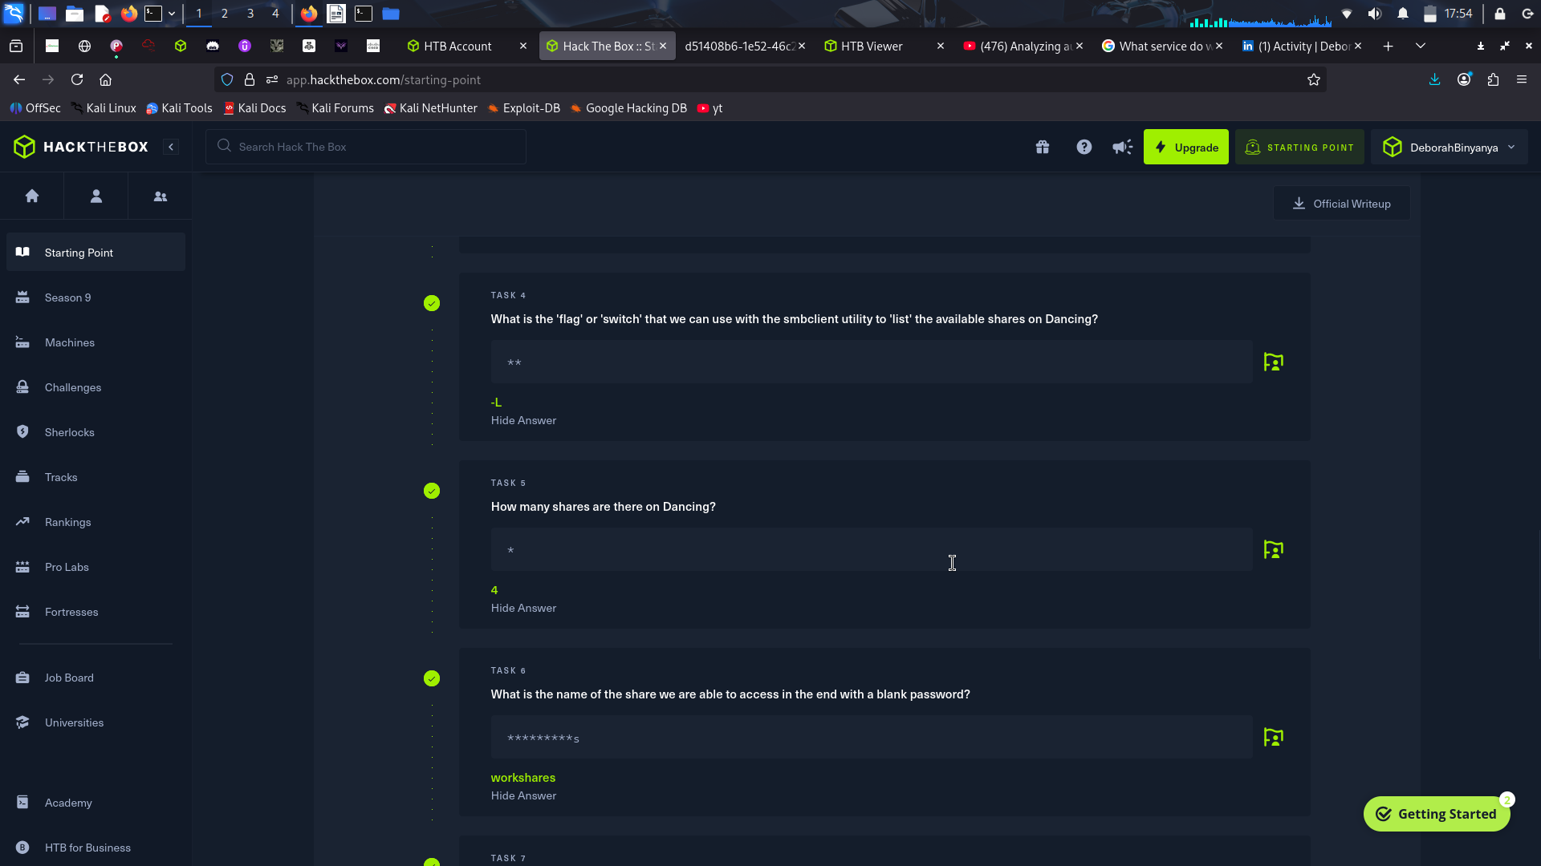
Task 7
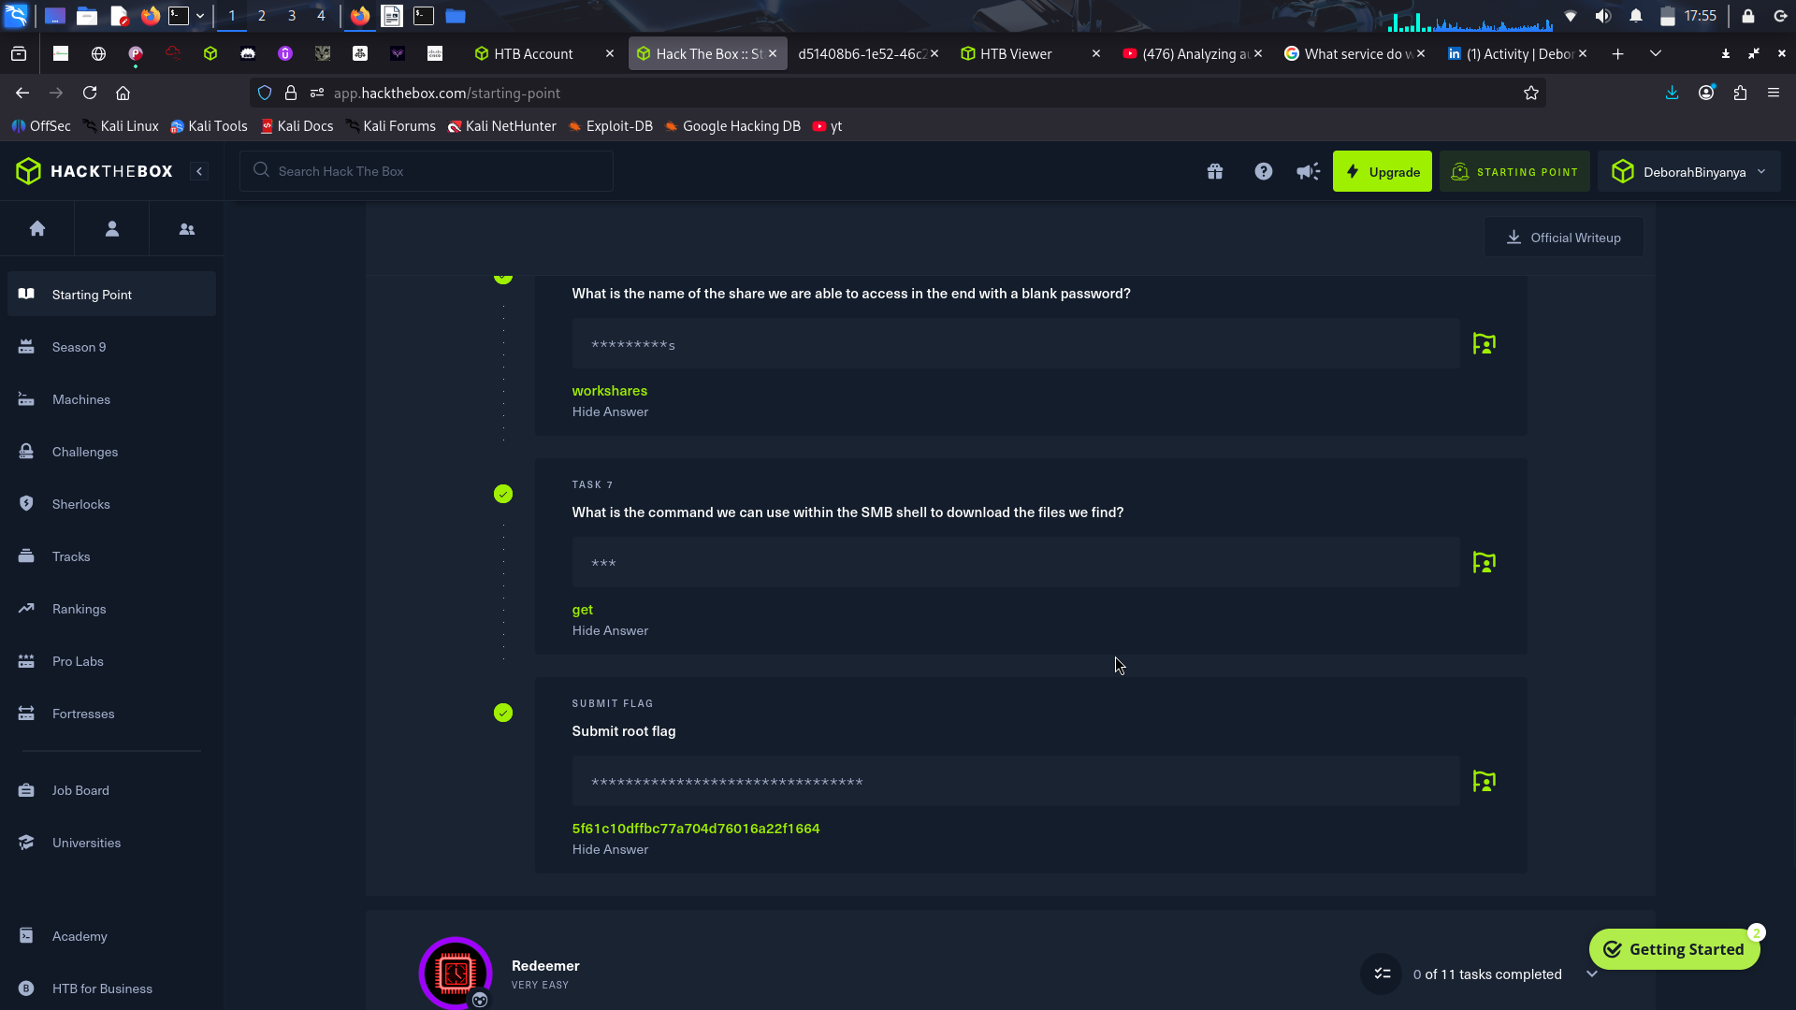
Steps to get the flag
scan using nmap to see open ports and install smbclient
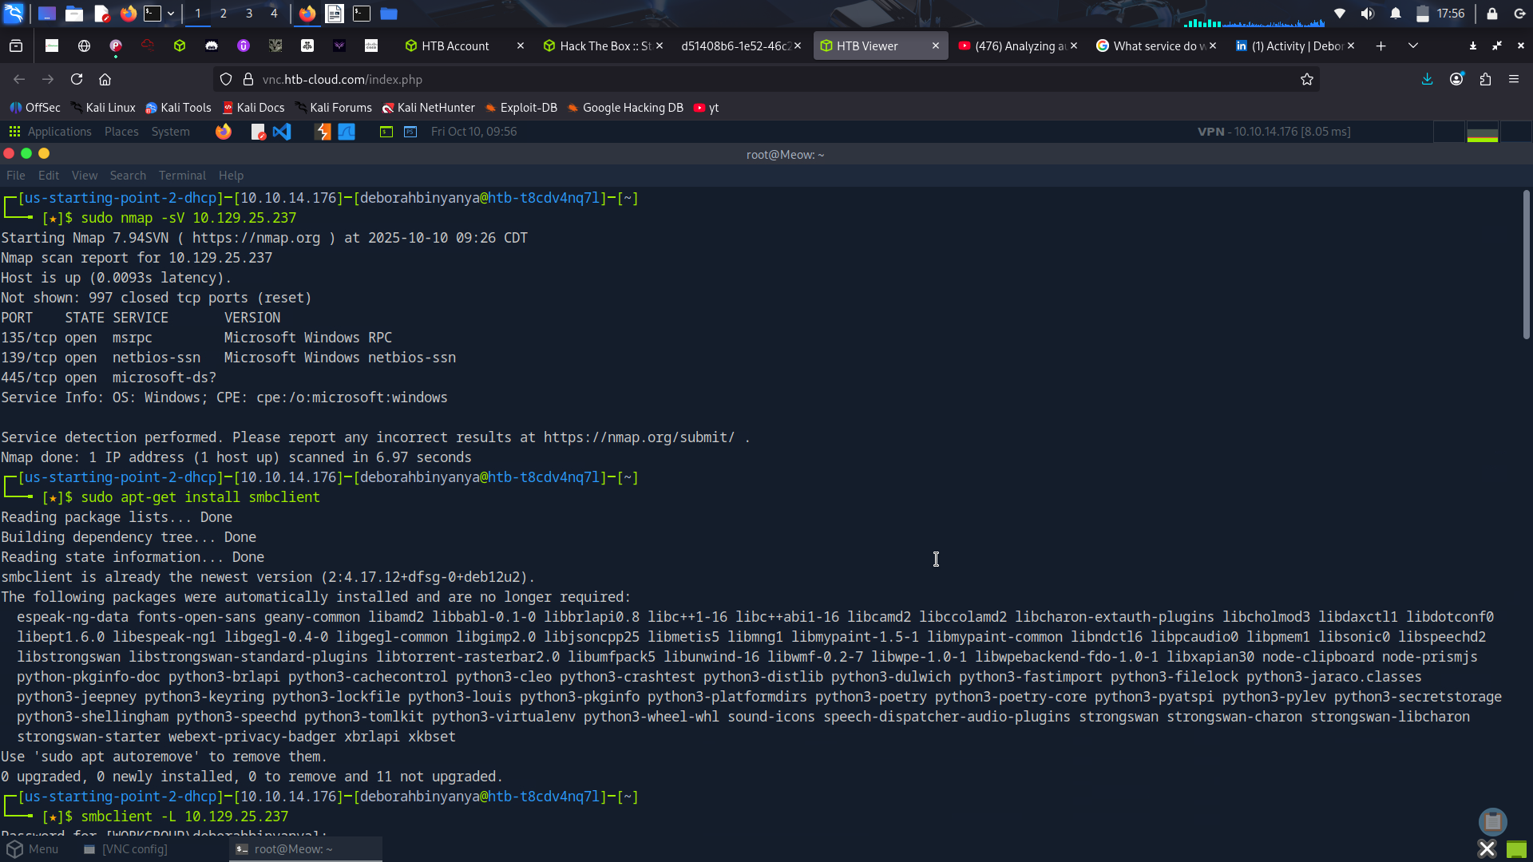
list files listed in shares and try to log into each
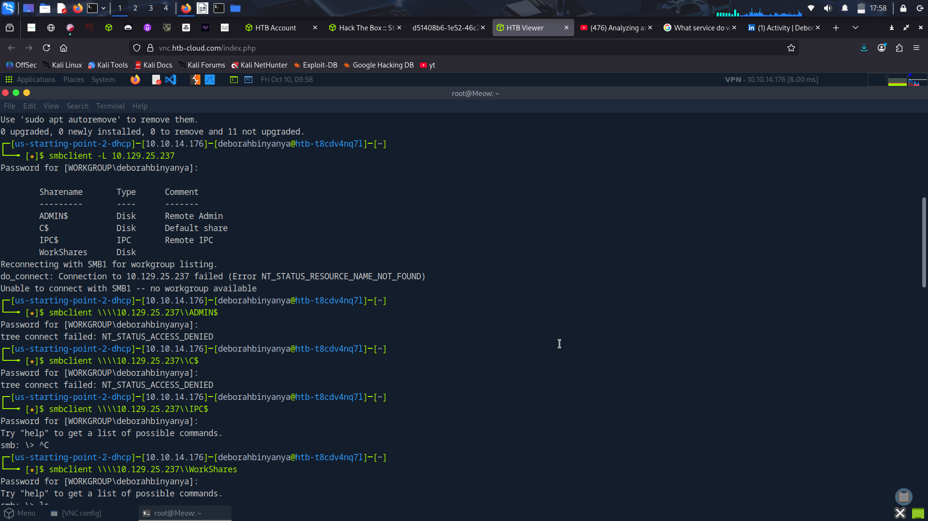
Workshares grants access and you can see available files
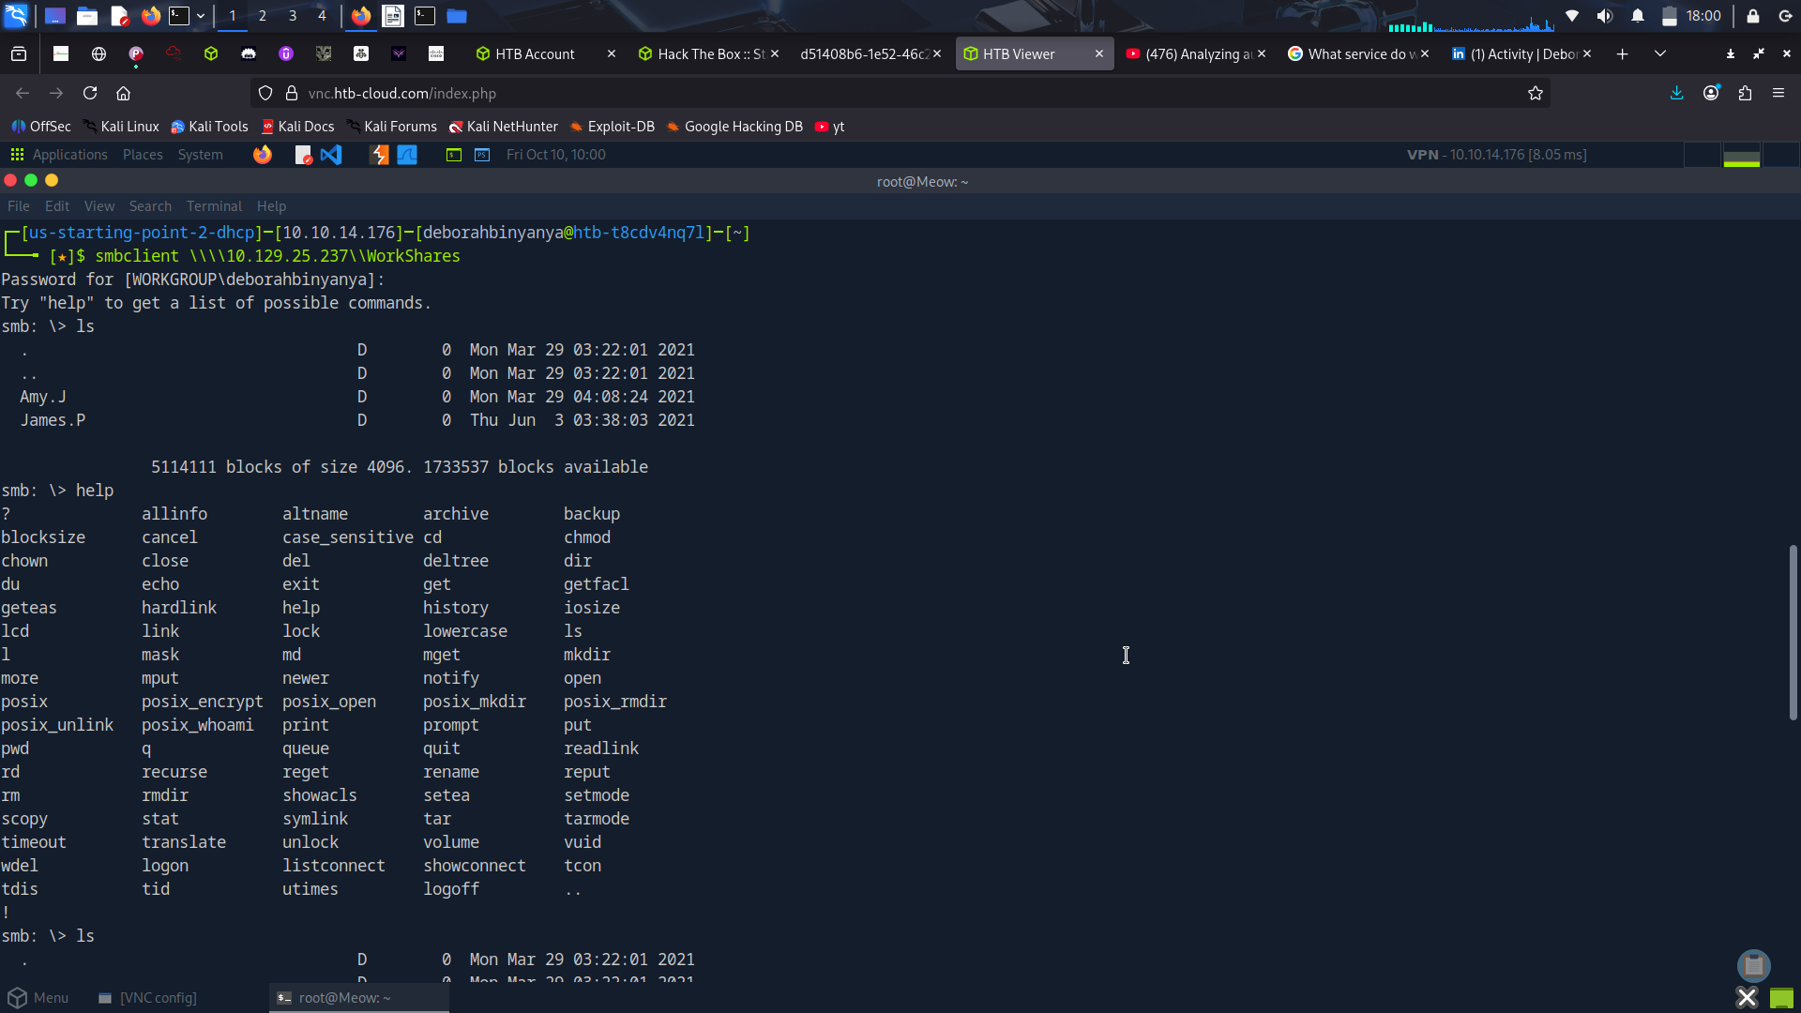
Change into each directory of the users to get the flag an open it
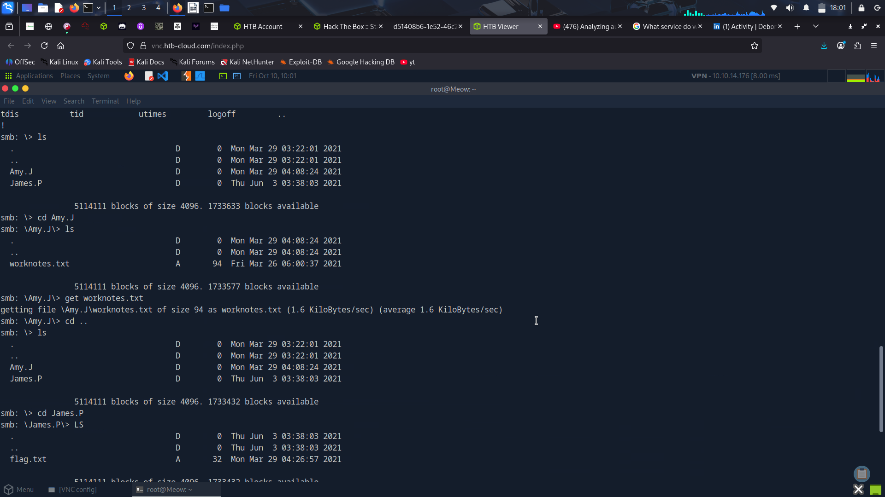
Get the flag and cat into the files Copy the flag
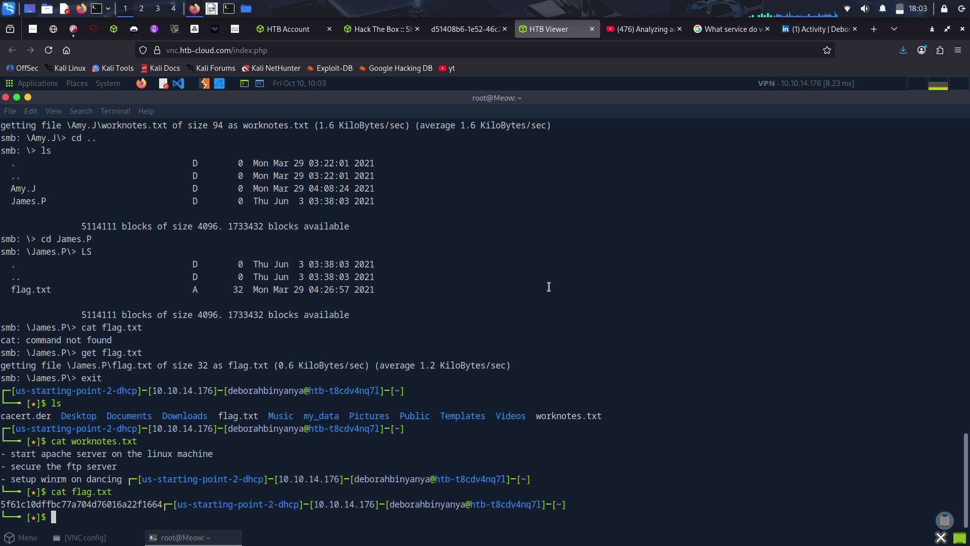
Redeemer
Databases are a collection of organized information that can be easily accessed, managed and updated. Inmost environments, database systems are very important because they communicate information related to your sales transactions, product inventory, customer profiles and marketing activities.
Redis is an 'in-memory' database. In-memory databases are the ones that rely essentially on the primary memory for data storage (meaning that the database is managed in the RAM of the system); in contrast to databases that store data on the disk or SSDs.
As the primary memory is significantly faster than the secondary memory, the data retrieval time in the case of 'in-memory' databases is very small, thus offering very efficient & minimal response times.
In-memory databases like Redis are typically used to cache data that is frequently requested for quick
retrieval. For example, if there is a website that returns some prices on the front page of the site. The
website may be written to first check if the needed prices are in Redis, and if not, then check the traditional
database (like MySQL or MongoDB). When the value is loaded from the database, it is then stored in Redis
for some shorter period of time (seconds or minutes or hours), to handle any similar requests that arrive
during that timeframe. For a site with lots of traffic, this configuration allows for much faster retrieval for the
majority of requests, while still having stable long term storage in the main database.

What is Redis?
Redis (REmote DIctionary Server) is an open-source advanced NoSQL key-value data store used as a
database, cache, and message broker. The data is stored in a dictionary format having key-value pairs. It is typically used for short term storage of data that needs fast retrieval. Redis does backup data to hard drives to provide consistency
How to get the flag
Ping to confirm connectivity
Scan with nmap to check open ports and versions
Install Redis
View the help page and connect to the redis server of the target IP
Get the info of the server
Select the redis logical database with the index given
We can list all the keys present in the database using the command: keys *
We can view the values stored for a corresponding key using the get command followed by the
keynote: get <key>

