**NAME: BINYANYA DEBORAH NYATICHI**

**CS NO: ADC-CSS02-25051**.

**DESCRIPTION: Week 1 Cyber Security Essentials**

**ASSIGNMENT:** [**Assignment 1: SC-900 Learning Path**](https://learning.cybershujaa.co.ke/mod/assign/view.php?id=1968)

**DATE: 05/04/2025**

# Introduction

In today’s rapidly evolving digital landscape, securing organizational assets and ensuring regulatory compliance has become top priorities for businesses and institutions worldwide. As cyber threats grow, it is essential to understand the foundational concepts of security, compliance and identity management. We will explore key security and compliance concepts, delve into identity management principles and examine the capabilities of Microsoft Entra ID formerly known as Azure Active Directory. We will cover core identity types, authentication methods, access management strategies, as well as identity protection and governance features provided by Microsoft Entra ID. By understanding these elements, organizations can better safeguard their digital environments, manage user access effectively, and align with modern security best practices.

# [Describe security and compliance concepts](https://learn.microsoft.com/en-us/training/modules/describe-security-concepts-methodologies/)

<https://learn.microsoft.com/api/achievements/share/en-us/DeborahBinyanya-1253/XQ7TZPZY?sharingId=BBBCB3F098199A41>

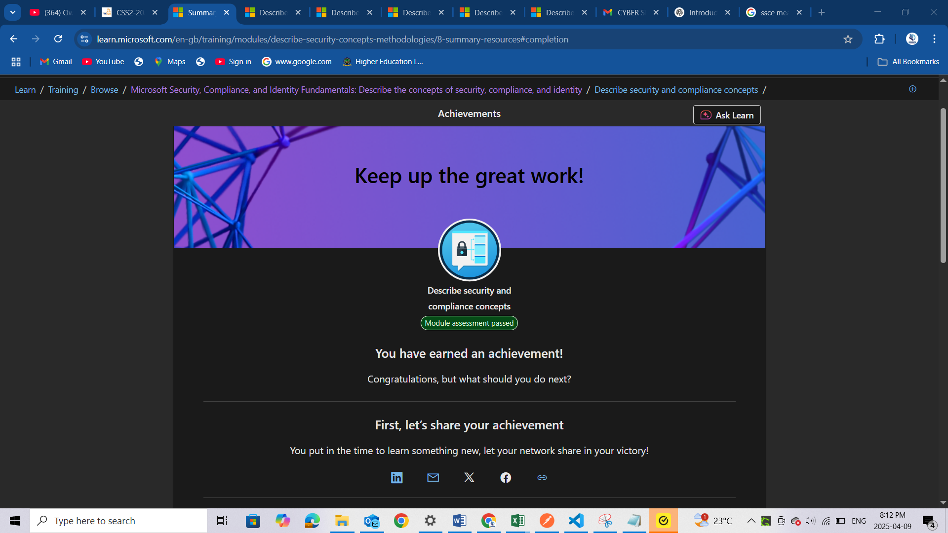

# [Describe identity concepts](https://learn.microsoft.com/en-us/training/modules/describe-identity-principles-concepts/)

<https://learn.microsoft.com/api/achievements/share/en-us/DeborahBinyanya-1253/CXHMMHK9?sharingId=BBBCB3F098199A41>

<https://learn.microsoft.com/api/achievements/share/en-us/DeborahBinyanya-1253/3ANPPNTH?sharingId=BBBCB3F098199A41>

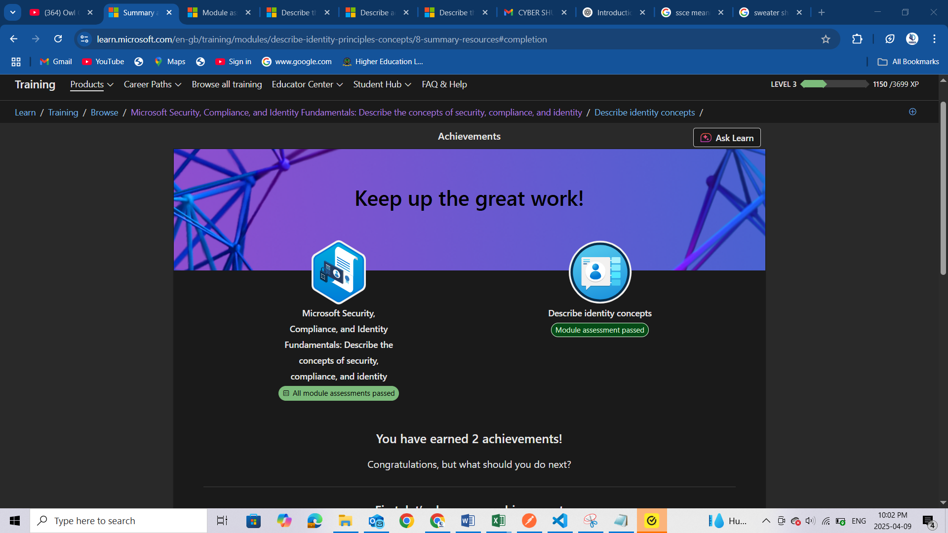

# Conclusion

Understanding the foundational elements of security, compliance, and identity management is essential in protecting organizational resources in today’s digital age. Through this assignment, I have gained valuable insights into the core security and compliance principles that guide modern cybersecurity strategies. I explored how Microsoft Entra ID supports identity management through its various identity types, robust authentication capabilities, and effective access control mechanisms. Additionally, I examined how identity protection and governance features contribute to enhancing an organization's overall security posture. With this knowledge, I am better equipped to support identity and access management in cloud environments and contribute to building secure, compliant, and resilient IT infrastructures.