**NAME: BINYANYA DEBORAH NYATICHI**

**CS NO: ADC-CSS02-25051**.

**DESCRIPTION: Week 2 Identity Management**

**ASSIGNMENT: Assignment 2: SC-900 Learning Path**

**DATE: 04/05/2025**

# Introduction

This overview will guide you through the core capabilities of Microsoft Entra, starting with its fundamental function and the various types of identities it manages. We'll then explore its robust authentication features, including multi-factor and passwordless options, followed by a look at its access management tools like Conditional Access and RBAC. Finally, we'll touch upon Entra's identity protection mechanisms and governance features that ensure secure and compliant identity lifecycles.

# [Describe the function and identity types of Microsoft Entra ID](https://learn.microsoft.com/en-us/training/modules/explore-basic-services-identity-types/)

[**https://learn.microsoft.com/api/achievements/share/en-us/DeborahBinyanya-1253/H7F4B678?sharingId=BBBCB3F098199A41**](https://learn.microsoft.com/api/achievements/share/en-us/DeborahBinyanya-1253/H7F4B678?sharingId=BBBCB3F098199A41)

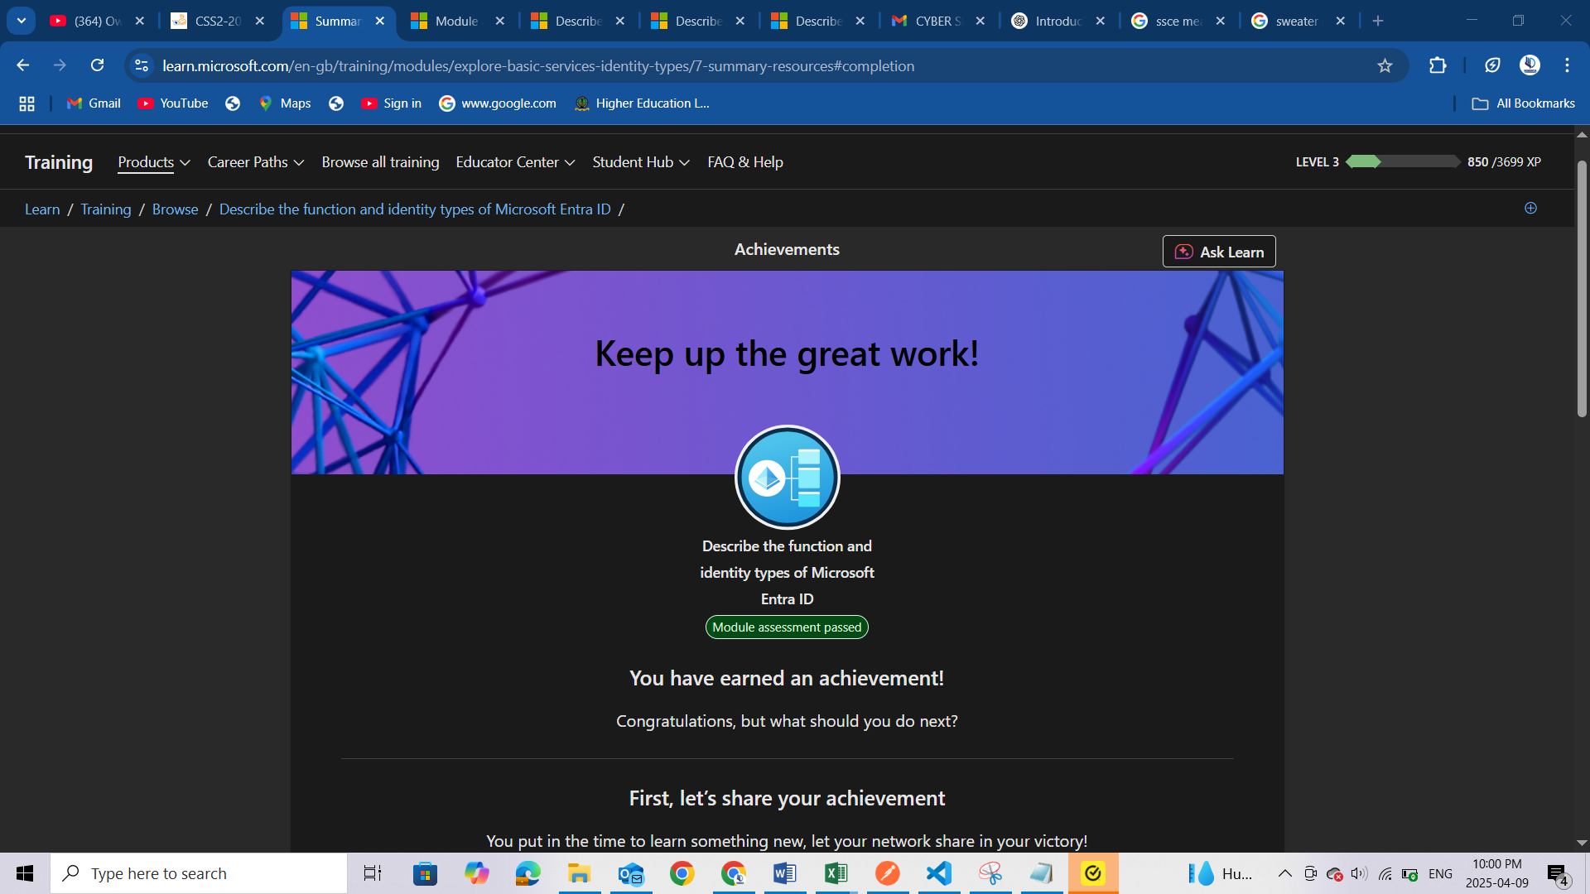

# [Describe the authentication capabilities of Microsoft Entra ID](https://learn.microsoft.com/en-us/training/modules/explore-authentication-capabilities/)

<https://learn.microsoft.com/api/achievements/share/en-us/DeborahBinyanya-1253/3ANPD3QH?sharingId=BBBCB3F098199A41>

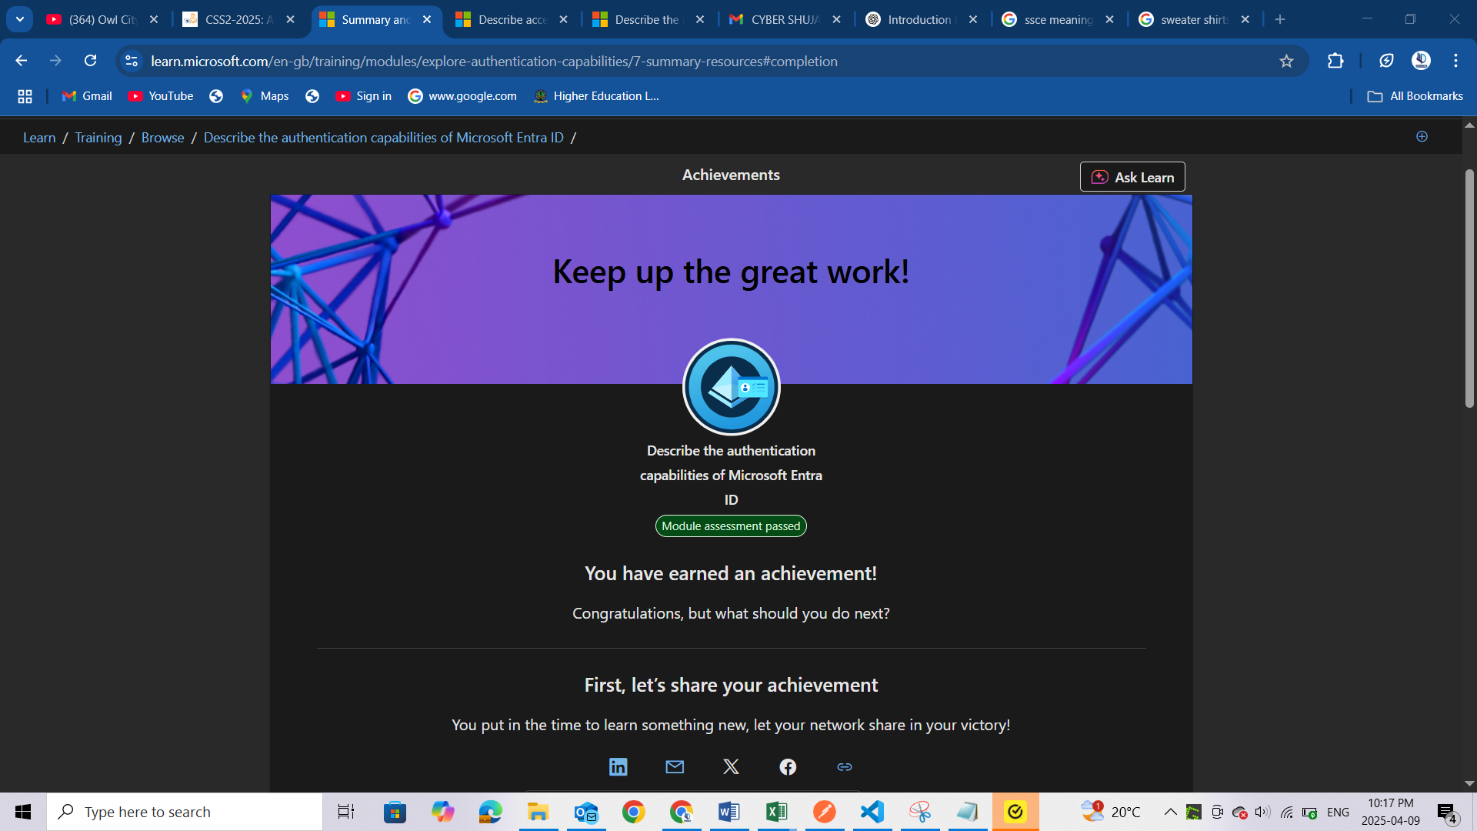

# [Describe access management capabilities of Microsoft Entra ID](https://learn.microsoft.com/en-us/training/modules/explore-access-management-capabilities/)

<https://learn.microsoft.com/api/achievements/share/en-us/DeborahBinyanya-1253/H7F4STH8?sharingId=BBBCB3F098199A41>

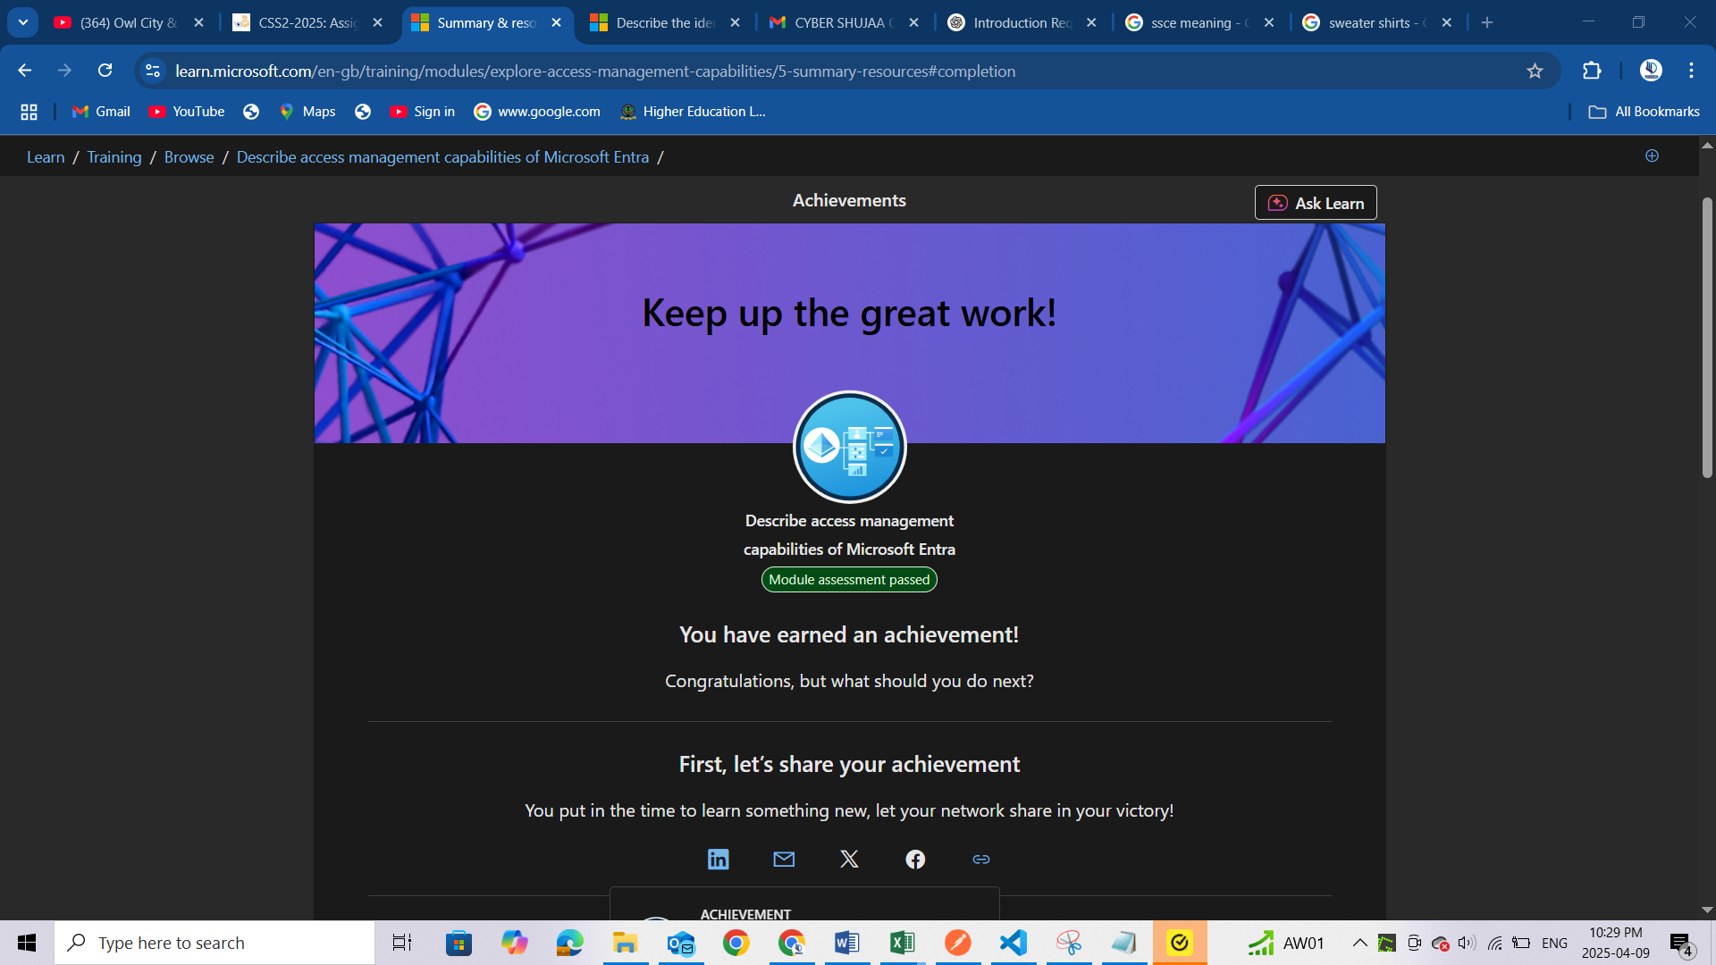

# [Describe the identity protection and governance capabilities of Microsoft Entra](https://learn.microsoft.com/en-us/training/modules/describe-identity-protection-governance-capabilities/)

<https://learn.microsoft.com/api/achievements/share/en-us/DeborahBinyanya-1253/3ANPSKUH?sharingId=BBBCB3F098199A41>

<https://learn.microsoft.com/api/achievements/share/en-us/DeborahBinyanya-1253/CXHMDEG9?sharingId=BBBCB3F098199A41>

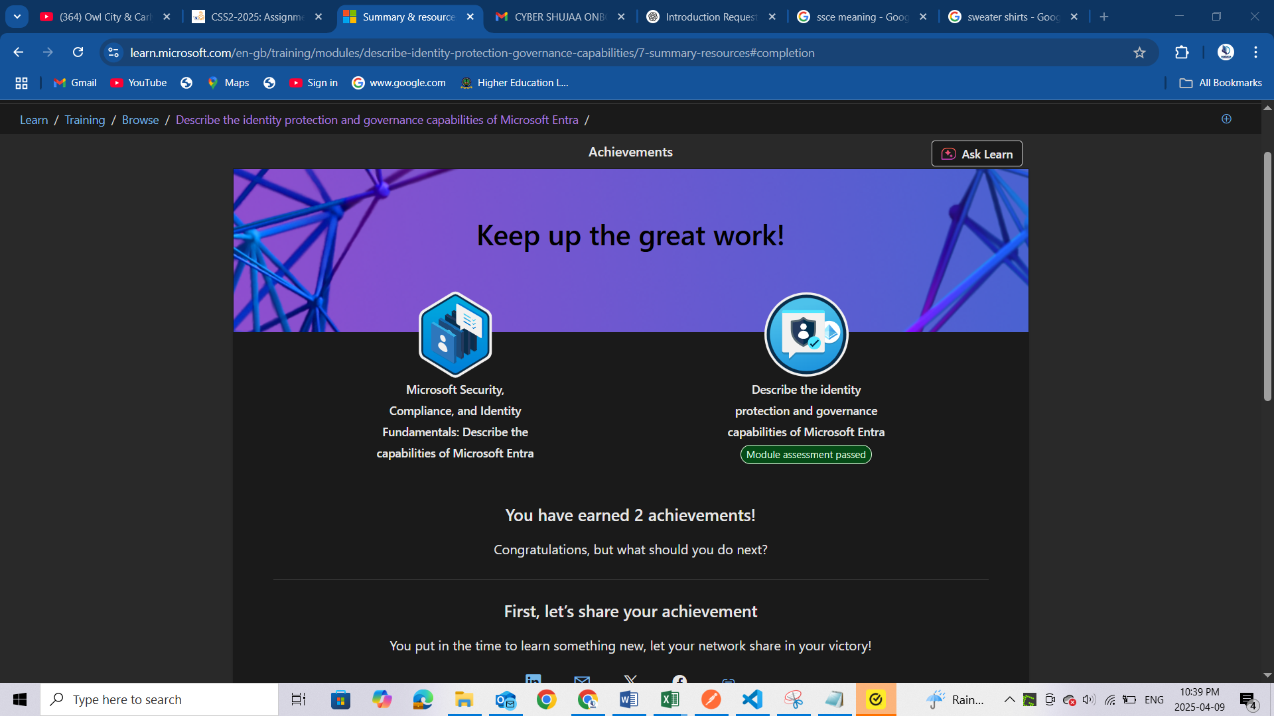

# Conclusion

I've gained a clearer understanding of Microsoft Entra as a comprehensive identity and access management solution. I learnt about the different identity types it handles, its diverse authentication methods that enhance security, the granular access control capabilities it offers, and the crucial identity protection and governance features that contribute to a robust security framework in modern cloud environments.