**NAME: BINYANYA DEBORAH NYATICHI**

**CS NO: ADC-CSS02-25051**.

**DESCRIPTION: Week 3: Microsoft Security Solutions**

**ASSIGNMENT: Assignment 4: SC-900 Learning Path**

**DATE: 04/05/2025**

# INTRODUCTION

This week's focus shifts to exploring the powerful capabilities embedded within Microsoft's security solutions. You'll gain insights into the cutting-edge AI-powered assistance of Microsoft Security Copilot, understand the fundamental security services safeguarding your Azure infrastructure, discover how Azure streamlines security management, and finally, unravel the robust security intelligence offered by Microsoft Sentinel. Get ready to explore a comprehensive suite designed to protect and defend in today's complex digital landscape.

We will explore these 4 parts:

Describe Microsoft Security Copilot

Describe core infrastructure security services in Azure

Describe the security management capabilities in Azure

Describe security capabilities of Microsoft Sentinel

# Describe Microsoft Security Copilot

<https://learn.microsoft.com/api/achievements/share/en-us/DeborahBinyanya-1253/CXFJWEP9?sharingId=BBBCB3F098199A41>

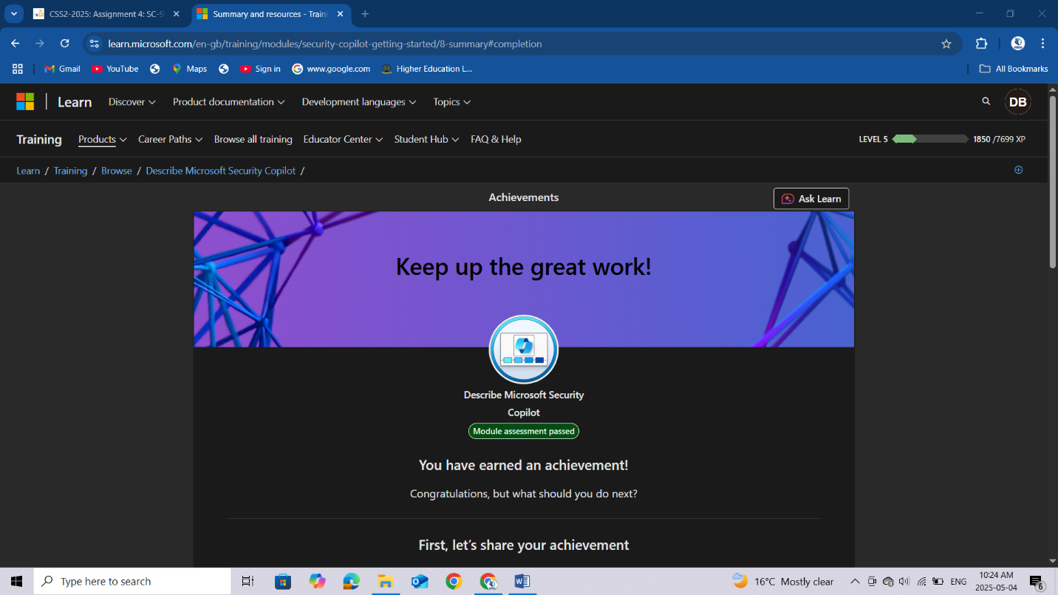

## Describe core infrastructure security services in Azure

<https://learn.microsoft.com/api/achievements/share/en-us/DeborahBinyanya-1253/VJDXD4XM?sharingId=BBBCB3F098199A41>

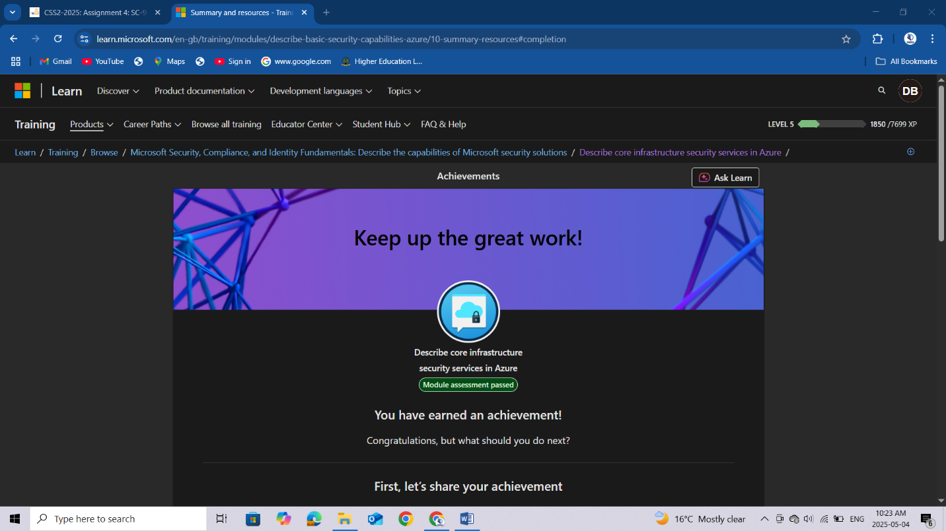

## Describe the security management capabilities in Azure

<https://learn.microsoft.com/api/achievements/share/en-us/DeborahBinyanya-1253/9YXTXJ8U?sharingId=BBBCB3F098199A41>

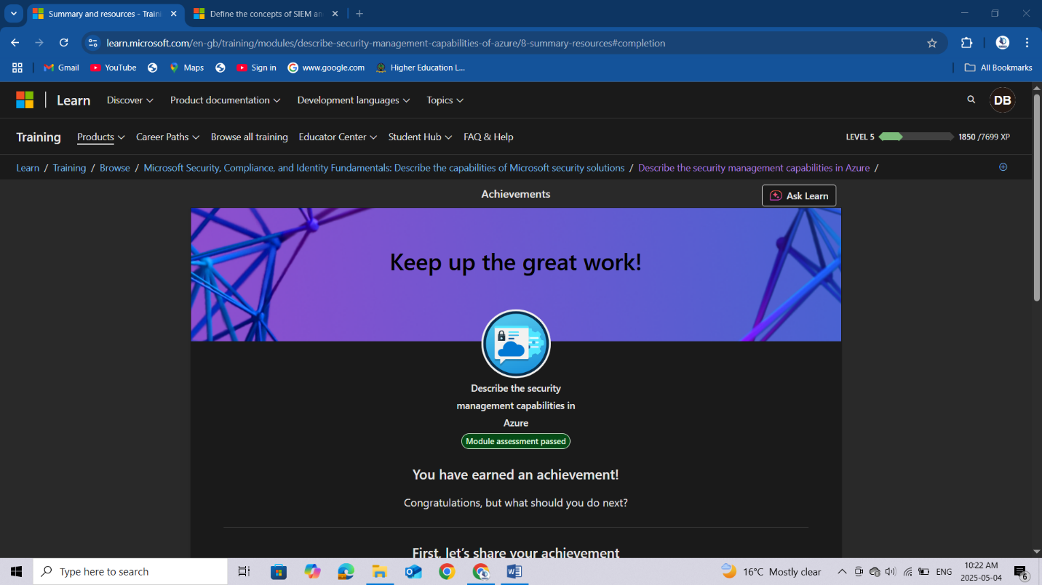

## Describe security capabilities of Microsoft Sentinel

<https://learn.microsoft.com/api/achievements/share/en-us/DeborahBinyanya-1253/2DBFDDZV?sharingId=BBBCB3F098199A41>

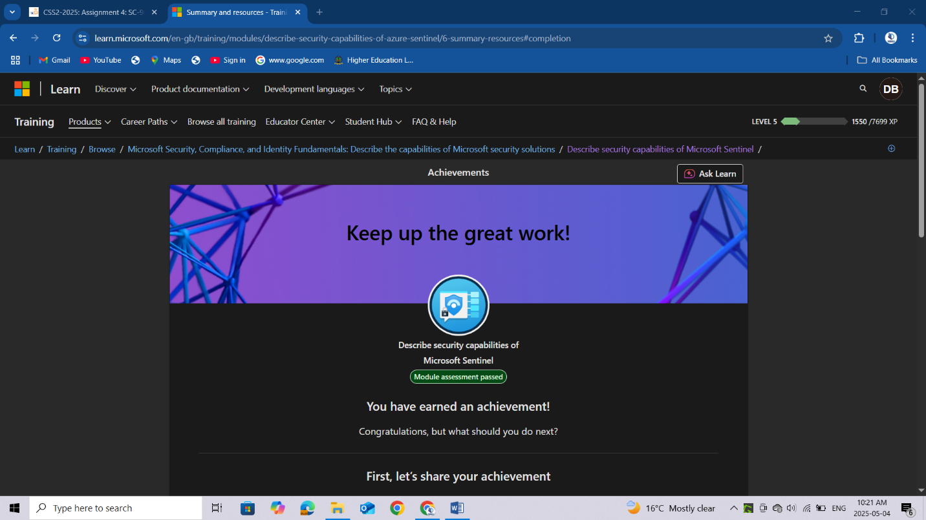

## Conclusion

In summary, I've now gained a solid understanding of Microsoft's security solutions through this part of the SC-900 Learning Path. I've explored how Microsoft Security Copilot leverages AI to enhance security operations, examined the core security services that protect Azure infrastructure, and investigated the tools and features Azure provides for comprehensive security management. I've also delved into Microsoft Sentinel, gaining insights into its capabilities for security information and event management (SIEM) and security orchestration, automation, and response (SOAR). This knowledge forms a crucial part of my understanding of Microsoft's security offerings, preparing me to tackle real-world security challenges and paving the way for more advanced learning in my cybersecurity journey.