**NAME: BINYANYA DEBORAH NYATICHI**

**CS NO: ADC-CSS02-25051**.

**DESCRIPTION: Week 4: Microsoft Compliance Solutions**

**ASSIGNMENT: Assignment 6: SC-900 Learning Path**

**DATE: 04/05/2025**

## INTRODUCTION

This week, I'll be diving into how Microsoft helps organizations meet their crucial compliance obligations. Specifically, I'll be focusing on: understanding the resources available through Microsoft's Service Trust Portal and its privacy features, exploring the data security, compliance, and governance solutions offered within the Microsoft Purview suite. This will provide a comprehensive overview of how Microsoft empowers organizations to manage risk, protect sensitive information, and adhere to regulatory requirements.

# Describe Microsoft’s Service Trust portal and privacy capabilities

<https://learn.microsoft.com/api/achievements/share/en-us/DeborahBinyanya-1253/VJDXYYAM?sharingId=BBBCB3F098199A41>

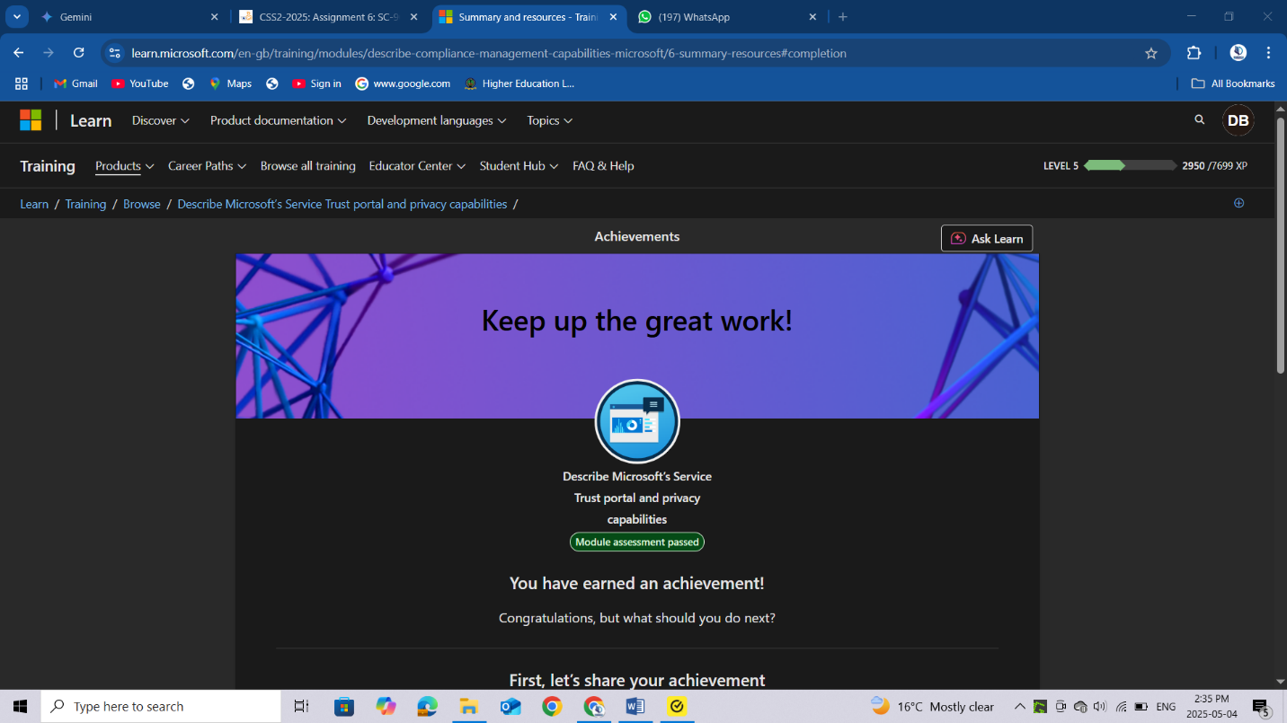

# Describe the data security solutions of Microsoft Purview

<https://learn.microsoft.com/api/achievements/share/en-us/DeborahBinyanya-1253/4GLZVG8K?sharingId=BBBCB3F098199A41>

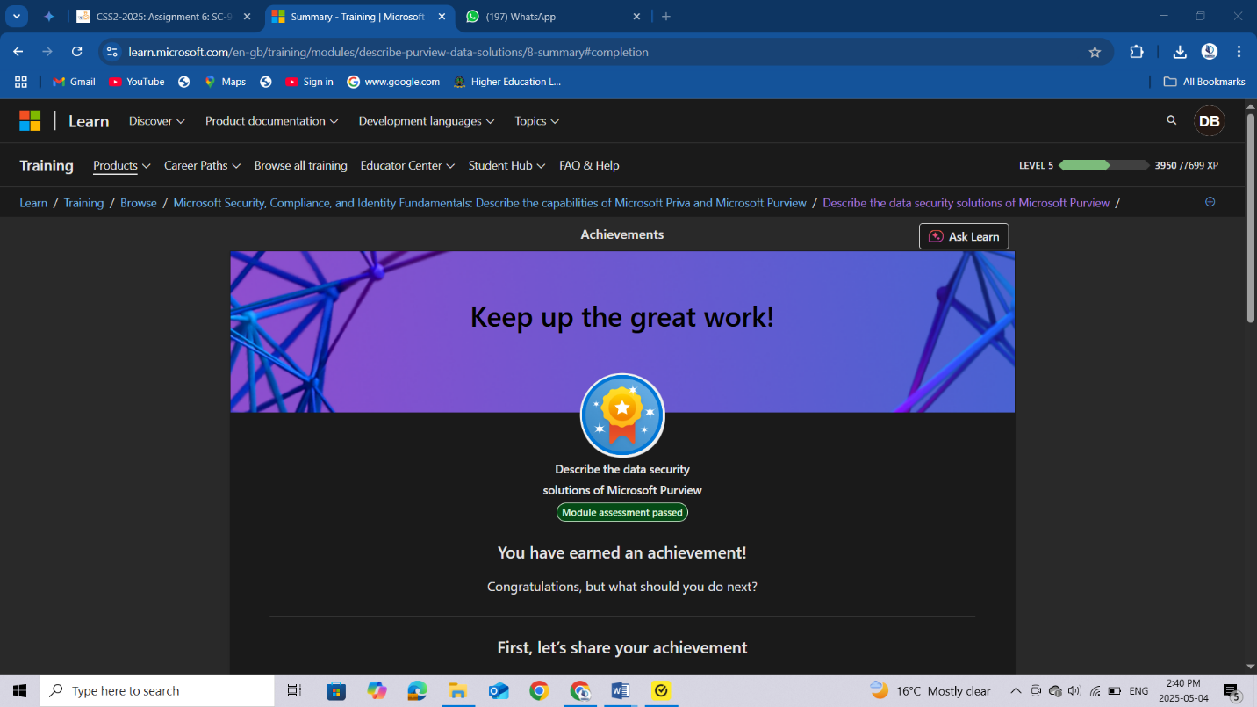

# Describe the data compliance solutions of Microsoft Purview

<https://learn.microsoft.com/api/achievements/share/en-us/DeborahBinyanya-1253/FMV936YX?sharingId=BBBCB3F098199A41>

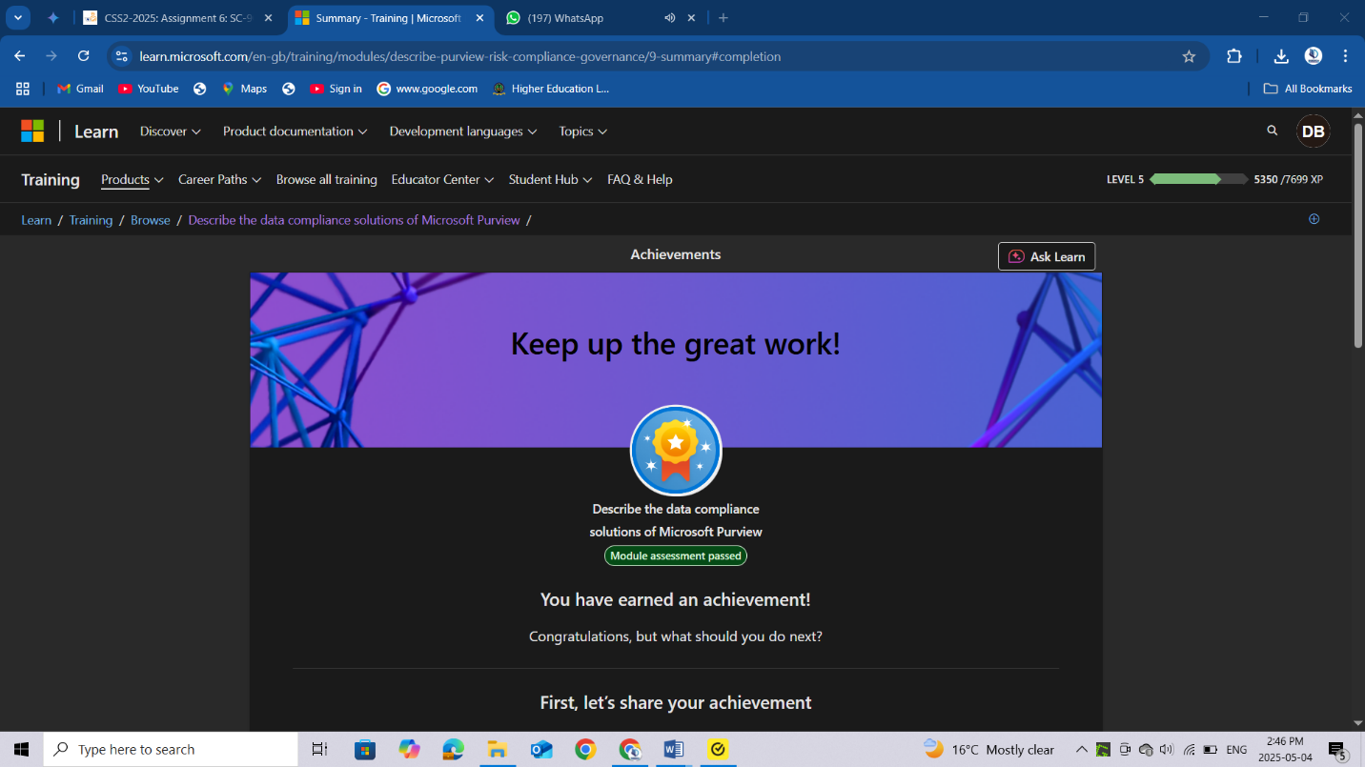

# Describe the data governance solutions of Microsoft Purview

<https://learn.microsoft.com/api/achievements/share/en-us/DeborahBinyanya-1253/9YXT59TU?sharingId=BBBCB3F098199A41>

<https://learn.microsoft.com/api/achievements/share/en-us/DeborahBinyanya-1253/BC6VQBMD?sharingId=BBBCB3F098199A41>

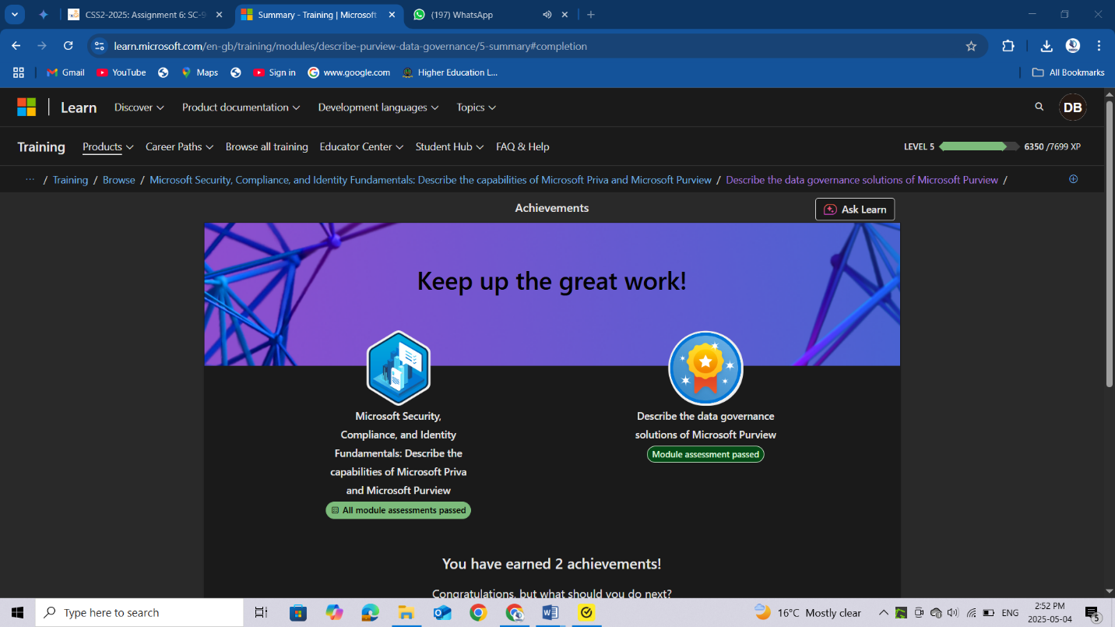

# CONCLUSION

In conclusion, this assignment has provided a foundational understanding of Microsoft's comprehensive suite of compliance solutions. By exploring the Service Trust Portal and its privacy capabilities, I gained insight into Microsoft's commitment to transparency and data protection. Delving into Microsoft Purview, I examined its critical role in data security through features designed to identify and protect sensitive information. Furthermore, I investigated Purview's data compliance solutions, understanding how they facilitate adherence to regulatory requirements. Finally, I explored the data governance capabilities within Purview, recognizing their importance in managing, understanding, and governing an organization's data estate. This exploration underscores the critical role of Microsoft's compliance offerings in empowering organizations to navigate complex regulatory landscapes, safeguard sensitive data, and establish effective data governance practices.