# Microsoft ADC Cybersecurity Skilling Program

# Week 5 Assignment 8

**Student Name:** DEBORAH BINYANYA

**Student ID:** ADC-CSS02-25051

## Introduction

This week I worked through the SC-900 Learning Path: Microsoft Security, Compliance, and Identity Fundamentals: Describe the concepts of security, compliance, and identity. It consisted of 2 modules:

1. Describe security and compliance concepts
2. Describe identity concepts

## Tasks Completed

### Describe security and compliance concepts

This module delved into common security and compliance concepts that are foundational to Microsoft solutions. Topics I explored include: the shared responsibility model and Zero Trust models, encryption and hashing, governance, risk and compliance, data residency and data sovereignty.

I completed the module assessment and passed as shown below. I shared my achievement on Linked In and started building my visibility.

**Verification link:** <https://learn.microsoft.com/en-us/users/paulamusuva/achievements/hrvugrw8>

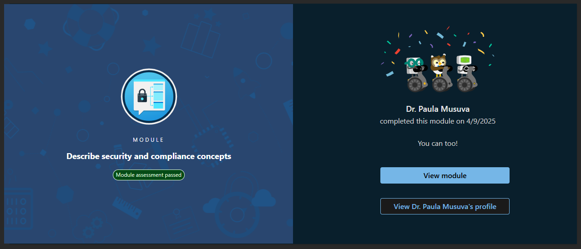

### Describe identity concepts

This module covered key concepts of authentication and authorization and why identity is important in securing corporate resources. I learnt about Identity Providers, and I was able to understand the difference between Entra and Active Directory. I also learned about the concept of Federation and Single Sign On (SSO).

I completed the module assessment and passed as shown below. I shared my achievement on Linked In and started building my visibility.

**Verification link:** <https://learn.microsoft.com/en-us/users/paulamusuva/achievements/fmapb3mx>

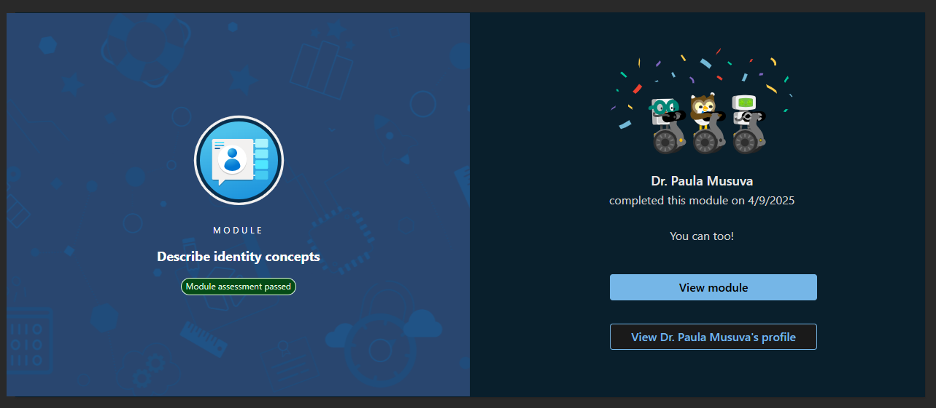

## Conclusion

This week I gained a good grounding on the introductory concepts relating security, compliance, and identity and I am getting a better understanding that I can build on as we work on more advanced concepts in later weeks. I had not done a Microsoft learning path before so I am excited with my achievements and I am keen to share my progress and build on it on Social Media.