**NAME: BINYANYA DEBORAH NYATICHI**

**CS NO: ADC-CSS02-25051**.

**DESCRIPTION: Week 5: Secure Identity and Access**

**ASSIGNMENT: Assignment 9: Lab - Role-Based Access Control**

**DATE: 14/05/2025**

# INTRODUCTION

In this lab, I will be working on implementing Role-Based Access Control (RBAC) in a cloud environment to enhance security and streamline user permissions. Specifically, I will create three separate security groups—Senior Admins, Junior Admins, and Service Desk—each containing a designated user: Joseph Price, Isabel Garcia, and Dylan Williams, respectively. After establishing the groups and assigning the correct users, I will apply the Virtual Machine Contributor role to the Service Desk group. This exercise aims to demonstrate how to manage access control effectively by granting the right level of permissions to users based on their roles within an organization.

# ROLE-BASED ACCESS CONTROL

## Lab Setup

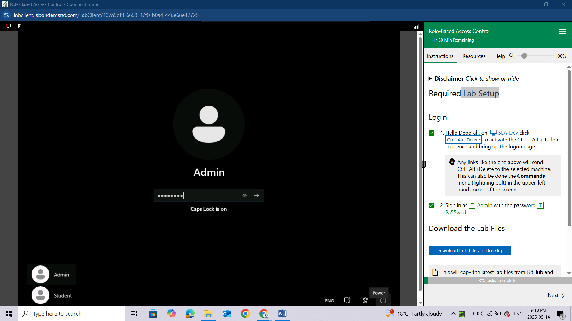

## Download the Lab Files

Download the files from the link provided in the lab setup

After successful download you will see a green bar of “***SUCCESS! The Lab Files have been downloaded to the Desktop.***”

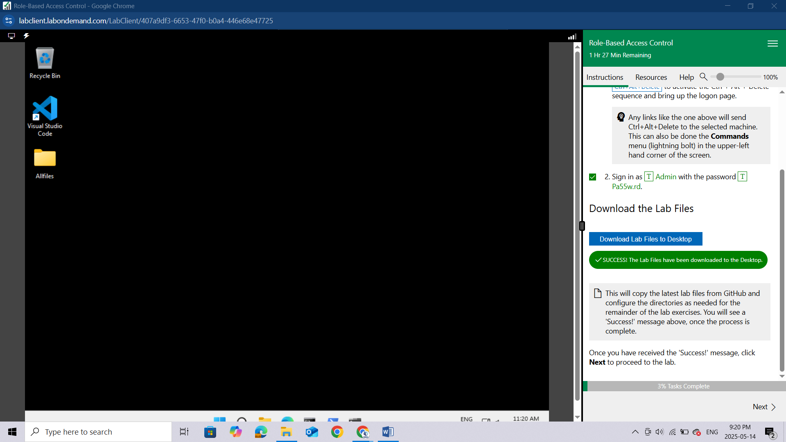

## Lab 01: Role-Based Access Control

### Lab scenario

You have been asked to create a proof of concept showing how Azure users and groups are created. Also, how role-based access control is used to assign roles to groups. Specifically, you need to:

Create a Senior Admins group containing the user account of Joseph Price as its member.

Create a Junior Admins group containing the user account of Isabel Garcia as its member.

Create a Service Desk group containing the user account of Dylan Williams as its member.

Assign the Virtual Machine Contributor role to the Service Desk group.

### Lab objectives

In this lab, you will complete the following exercises:

Exercise 1: Create the Senior Admins group with the user account Joseph Price as its member (the Azure portal).

Exercise 2: Create the Junior Admins group with the user account Isabel Garcia as its member (PowerShell).

Exercise 3: Create the Service Desk group with the user Dylan Williams as its member (Azure CLI).

Exercise 4: Assign the Virtual Machine Contributor role to the Service Desk group.

### Role-Based Access Control architecture diagram

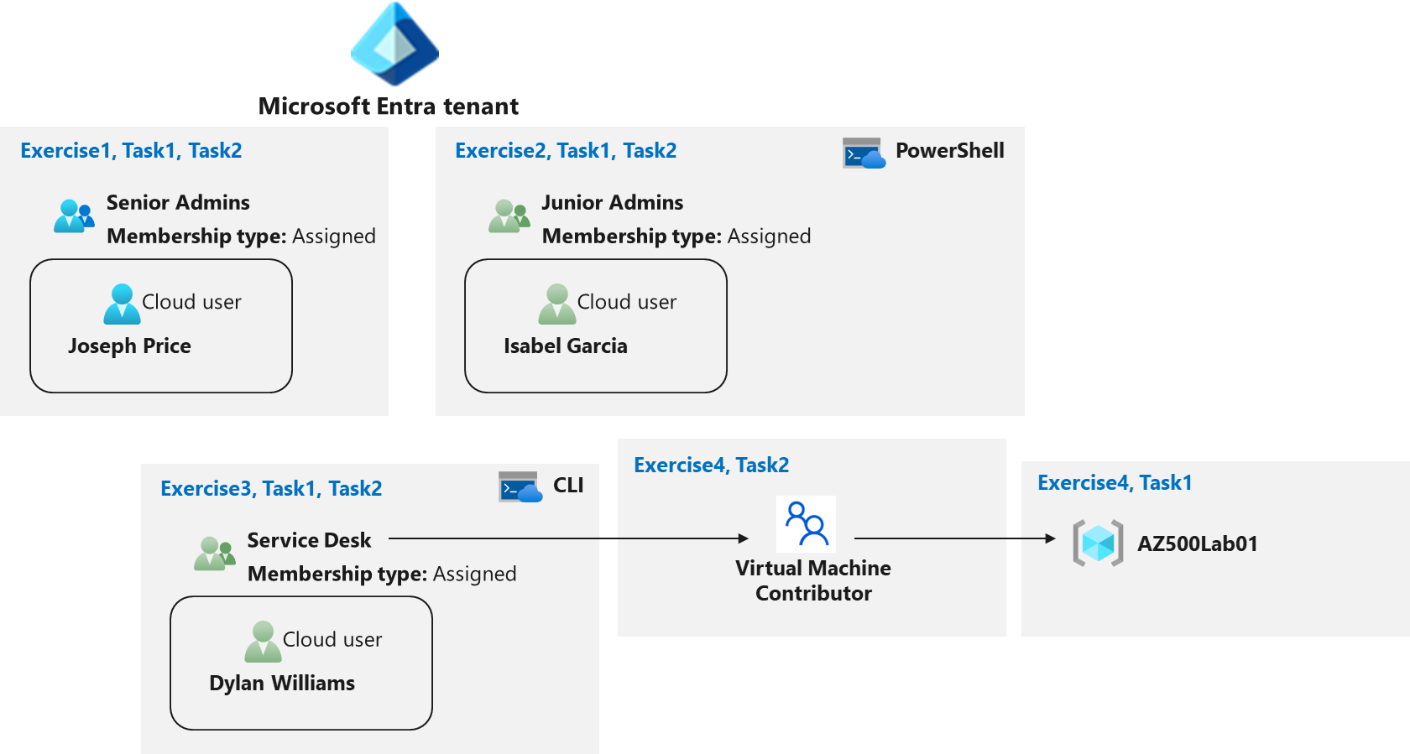

# Instructions

## Exercise 1: Create the Senior Admins group with the user account Joseph Price as its member

In this exercise, you will complete the following tasks:

Task 1: Use the Azure portal to create a user account for Joseph Price.

Task 2: Use the Azure portal to create a Senior Admins group and add the user account of Joseph Price to the group.

### Task 1: Use the Azure portal to create a user account for Joseph Price

In this task, you will create a user account for Joseph Price.

Start a browser session and **sign-in** to the Azure portal https://portal.azure.com/.

Sign in to the Azure portal using an account that has the Owner or Contributor role in the Azure subscription you are using for this lab and the Global Administrator role in the Microsoft Entra tenant associated with that subscription.

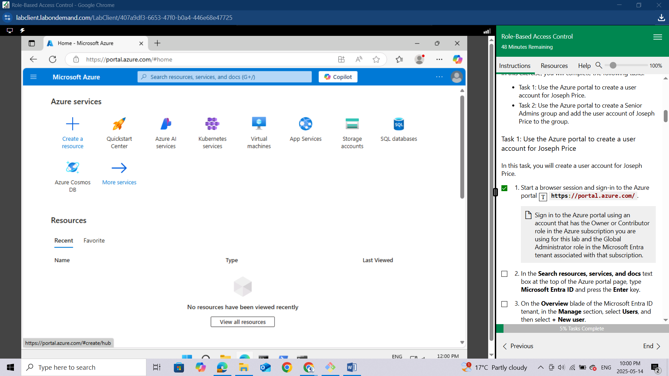

In the Search resources, services, and docs text box at the top of the Azure portal page, type **Microsoft Entra ID** and press the **Enter key.**

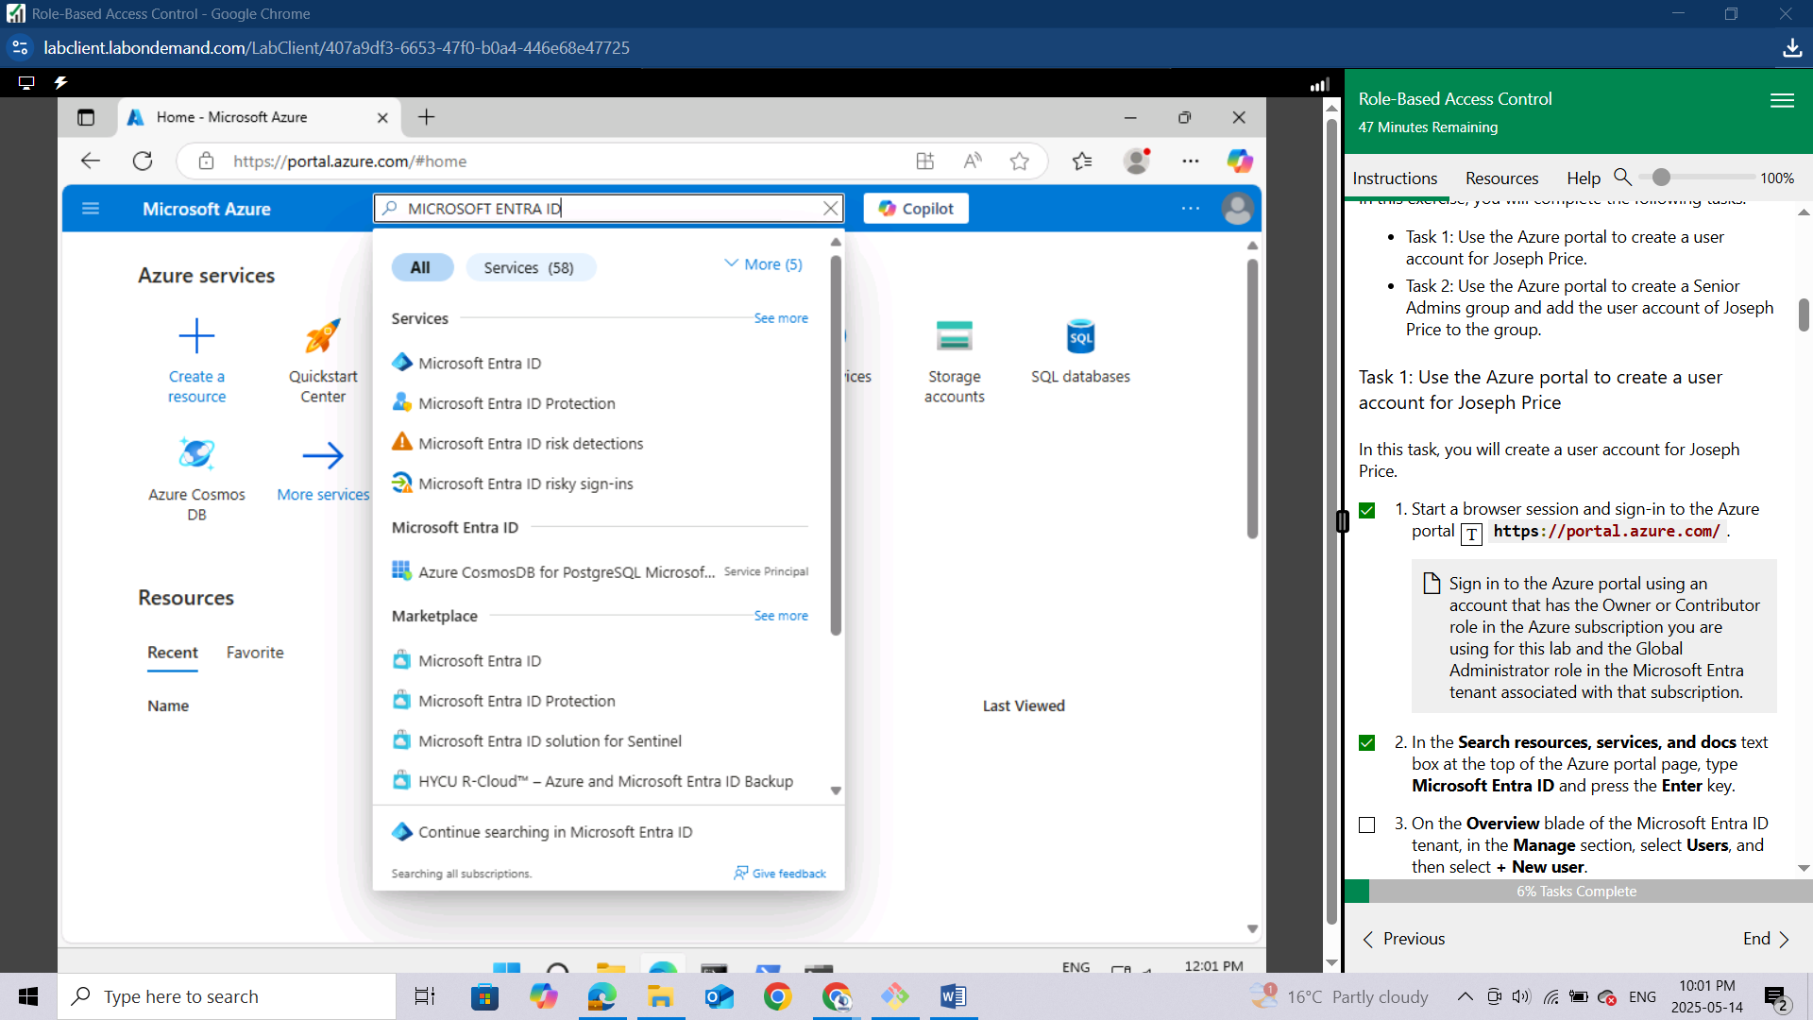

On the Overview blade of the Microsoft Entra ID tenant, in the **Manage** section, **select Users**, and then select **+ New user**.

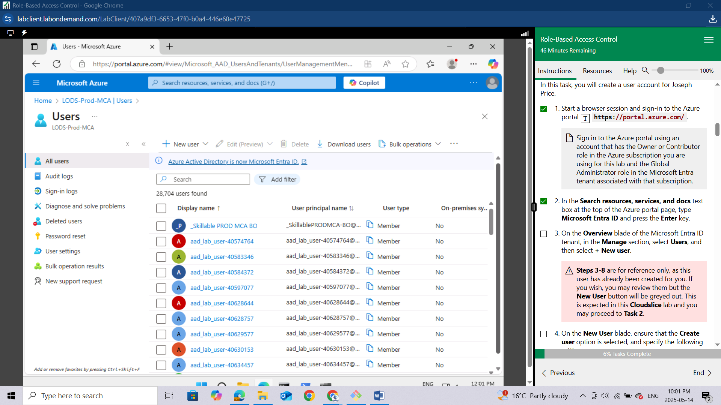

*Steps 3-8 are for reference only, as this user has already been created for you. If you wish, you may review them but the New User button will be greyed out. This is expected in this Cloudslice lab and you may proceed to Task 2.*

On the New User blade, ensure that the Create user option is selected, and specify the following settings:

**Setting** **Value**

**User name** Joseph

**Name** Joseph Price

Click on the copy icon next to the User name to copy the full user.

Ensure that the Auto-generate password is selected, select the Show password checkbox to identify the automatically generated password. You would need to provide this password, along with the user name to Joseph.

Click **Create**.

Refresh the **Users | All users** blade to verify the new user was created in your Microsoft Entra tenant.