Microsoft ADC Cybersecurity Skilling Program

Week 6 Assignment 10
Student Name: DEBORAH BINYANYA
Student ID: ADC-CSS02-25051

AZ-500 LEARNING PATH – SECURE NETWORKING

Introduction
In this module, I focused on learning how to plan and implement security for virtual networks in Microsoft Azure. The content introduced key strategies for protecting network resources by using built-in Azure security features. I explored how to design secure network architectures using network security groups (NSGs), application security groups (ASGs), Azure Firewall, and route tables. Additionally, I gained insight into best practices for segmenting networks, controlling traffic flow, and reducing the attack surface through proper configuration and monitoring. This foundational knowledge is essential for anyone responsible for securing cloud-based infrastructure in Azure.

Tasks Completed

Plan and implement security for virtual networks
https://learn.microsoft.com/api/achievements/share/en-us/DeborahBinyanya-1253/H7JFA5F8?sharingId=BBBCB3F098199A41
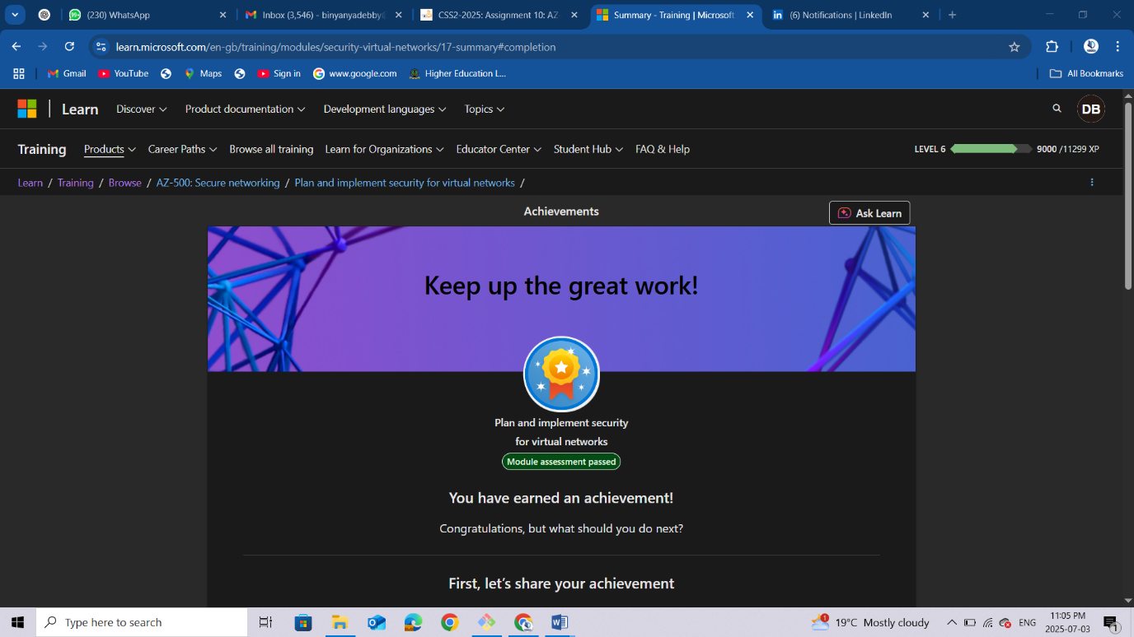

Conclusion
Completing this module has strengthened my understanding of how to secure virtual networks in Microsoft Azure. I learnt how to design and implement security controls that protect network resources from both internal and external threats. I now understand how to use tools like NSGs, ASGs, and Azure Firewall to enforce traffic filtering and access policies, as well as how to structure virtual networks for isolation and security. These skills are vital for any security engineer working in the cloud, as they ensure that Azure environments remain protected, resilient, and compliant with security standards.

