Microsoft ADC Cybersecurity Skilling Program

Week 10 Assignment 19
Student Name: DEBORAH BINYANYA
Student ID: ADC-CSS02-25051

CLOUD GOVERNANCE

Introduction
I will be focusing on the module "Implement and manage the enforcement of cloud governance policies", which explores how to define, apply, and monitor governance policies in Microsoft Azure to ensure secure and compliant resource management. In this module, I will learn how to use tools such as Azure Policy, Azure Blueprints, and role-based access control (RBAC) to enforce organizational standards and regulatory requirements across Azure environments. I will explore how policies can be used to control resource configurations, enforce naming conventions, limit deployment types, and ensure that resources stay within defined compliance boundaries. By the end of this module, I aim to understand how governance policies support security, consistency, and accountability in cloud operations, and how to implement them effectively to prevent misconfigurations and unauthorized changes across Azure subscriptions and resources.

Tasks Completed

Implement and manage enforcement of cloud governance policies
https://learn.microsoft.com/api/achievements/share/en-us/DeborahBinyanya-1253/D97UWXLJ?sharingId=BBBCB3F098199A41
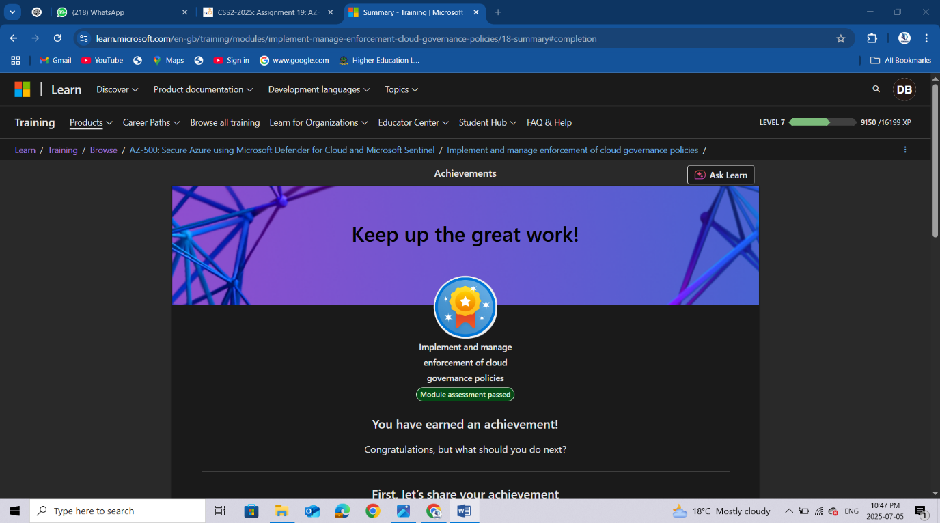

Conclusion
After completing the module on implementing and managing the enforcement of cloud governance policies, I have gained a solid understanding of how to maintain control and consistency across Azure environments using built-in governance tools. I learned how to use Azure Policy to define and enforce rules that ensure resources are deployed and configured in alignment with organizational and compliance standards. I also explored how to group related policies using initiatives, how to monitor compliance, and how to remediate non-compliant resources automatically. Additionally, I gained insights into using Azure Blueprints for defining repeatable environments that include policies, role assignments, resource groups, and templates. By applying these governance tools, I can now help ensure that Azure resources remain secure, compliant, and manageable at scale—reducing the risk of misconfiguration and supporting strong cloud security practices.

