Microsoft ADC Cybersecurity Skilling Program

Week 11 Assignment 21
Student Name: DEBORAH BINYANYA
Student ID: ADC-CSS02-25051

SECURE POSTURE MANAGEMENT

Introduction
In this module, I focus on learning how to manage and strengthen the security posture of Azure resources using Microsoft Defender for Cloud. This tool provides a centralized view of security across cloud environments and offers actionable recommendations to reduce vulnerabilities and maintain compliance. Throughout the module, I explore how to assess resource configurations, identify potential security risks, and implement hardening recommendations through secure score, regulatory compliance standards, and security alerts. I also learn how to enable and configure Microsoft Defender plans for specific services like virtual machines, storage accounts, and databases to provide advanced threat protection. By the end of this module, I aim to understand how to continuously monitor, improve, and manage the overall security posture of my cloud infrastructure using Microsoft Defender for Cloud.

Tasks Completed

Manage security posture by using Microsoft Defender for Cloud
https://learn.microsoft.com/api/achievements/share/en-us/DeborahBinyanya-1253/FMLQBDBX?sharingId=BBBCB3F098199A41
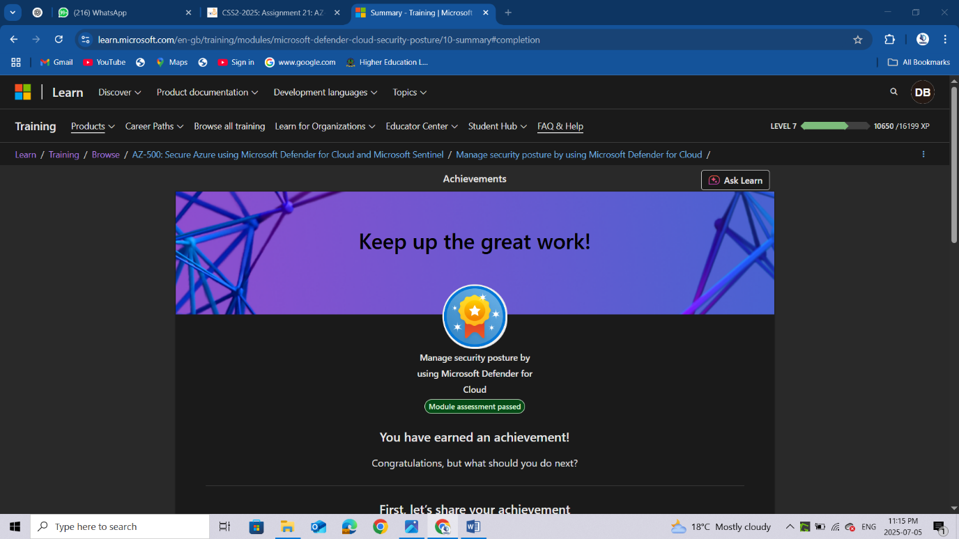

Conclusion
Completing this module has given me valuable insights into how Microsoft Defender for Cloud can be used to proactively manage and enhance security posture across Azure environments. I now understand how to interpret the secure score, prioritize security recommendations, and align configurations with industry-standard compliance frameworks. I also gained hands-on knowledge of enabling Defender plans for various resource types and using security alerts and automated responses to detect and mitigate threats in real-time. This experience has improved my ability to implement a proactive cloud security strategy and maintain continuous visibility into the health and compliance of Azure resources. Microsoft Defender for Cloud proves to be an essential tool for any security engineer aiming to enforce strong, ongoing cloud security and risk management practices.

