Microsoft ADC Cybersecurity Skilling Program

Week 12 Assignment 23
Student Name: DEBORAH BINYANYA
Student ID: ADC-CSS02-25051

CONFIGURE AND MANAGE THREAT PROTECTION BY USING MICROSOFT DEFENDER FOR CLOUD

Introduction
In this module, I focus on learning how to configure and manage security monitoring and automation solutions in Microsoft Azure. Monitoring and automation are critical components of a robust cloud security strategy, enabling timely detection of threats and reducing the time to respond. I explore key Azure services such as Microsoft Sentinel, Log Analytics, and Microsoft Defender for Cloud, which provide centralized visibility, alerting, and automation capabilities. I learn how to configure data connectors, create custom analytics rules, and implement workbooks for dashboards and reporting. Additionally, I explore how to set up automated responses using Playbooks in Azure Sentinel, powered by Azure Logic Apps, to streamline incident response and reduce manual overhead. By working through this module, I aim to build the skills needed to establish proactive, automated security operations that improve visibility, reduce response time, and enhance overall cloud security posture.

Tasks Completed

Configure and manage security monitoring and automation solutions
https://learn.microsoft.com/api/achievements/share/en-us/DeborahBinyanya-1253/FMLQB8CX?sharingId=BBBCB3F098199A41
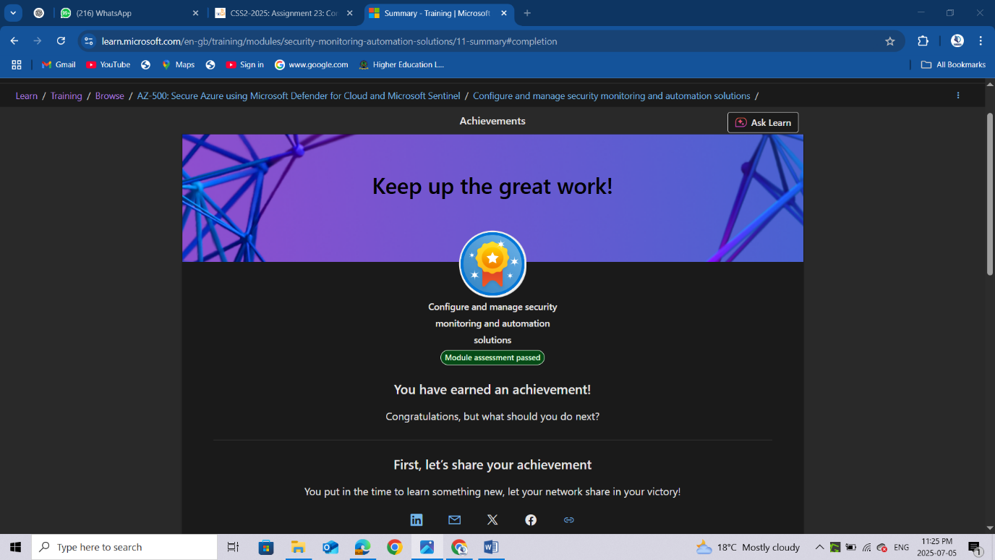

Conclusion
After completing the module on configuring and managing security monitoring and automation solutions, I have developed a strong understanding of how to implement a modern, scalable, and proactive security monitoring framework in Microsoft Azure. I learned how to use Microsoft Sentinel to collect and correlate security data across multiple sources, create analytics rules to detect suspicious activity, and build workbooks to visualize trends and metrics. I also explored how to automate incident response through Logic App-based playbooks, which can respond to alerts by triggering actions such as sending notifications, isolating resources, or launching investigations. This module has enhanced my ability to design and implement a comprehensive Security Information and Event Management (SIEM) and Security Orchestration, Automation, and Response (SOAR) solution within Azure. These skills are essential for maintaining continuous visibility, enabling faster threat detection, and automating incident handling in a cloud-first security operations environment.

