Microsoft ADC Cybersecurity Skilling Program

Week 7 Assignment 12
Student Name: DEBORAH BINYANYA
Student ID: ADC-CSS02-25051

AZ-500 LEARNING PATH - SECURE NETWORKING

Introduction
In this task, I will be completing the final two modules of the AZ-500: Secure Networking: Plan and implement security for private access to Azure resources, and Plan and implement security for public access to Azure resources. These topics are essential for any Azure Security Engineer, as they address the dual challenges of securely connecting internal users and services to Azure resources (private access), while also enabling safe, controlled access for external users and services (public access). In the private access module, I will focus on how to keep network traffic private within Azure’s backbone network by using features such as Azure Private Link, private endpoints, and service endpoints. These tools ensure that sensitive resources like storage accounts, SQL databases, and web apps are accessible only from trusted virtual networks, thereby reducing exposure to the public internet and minimizing security risks. In the public access module, I will explore secure methods of exposing resources to the internet when required, while still maintaining a strong security posture. This includes learning how to configure Azure Application Gateway, Web Application Firewall (WAF), Azure Front Door, and Azure DDoS Protection. These services help mitigate threats such as distributed denial-of-service (DDoS) attacks, SQL injection, and cross-site scripting (XSS), ensuring that publicly accessible applications are resilient and secure. Together, these modules provide a comprehensive understanding of how to design and implement secure connectivity in Microsoft Azure, whether traffic is internal or exposed to the internet.

Tasks Completed

Plan and implement security for private access to Azure resources
https://learn.microsoft.com/api/achievements/share/en-us/DeborahBinyanya-1253/NV5M2SMF?sharingId=BBBCB3F098199A41
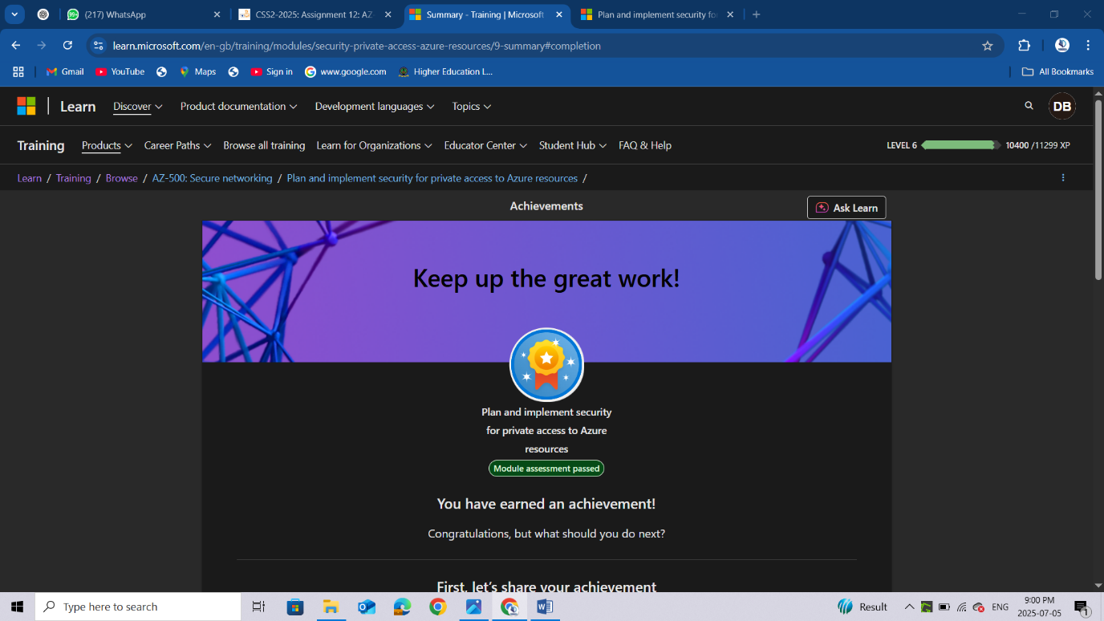

Plan and implement security for public access to Azure resources
https://learn.microsoft.com/api/achievements/share/en-us/DeborahBinyanya-1253/3AD7RL9H?sharingId=BBBCB3F098199A41
https://learn.microsoft.com/api/achievements/share/en-us/DeborahBinyanya-1253/JUZ39EDT?sharingId=BBBCB3F098199A41
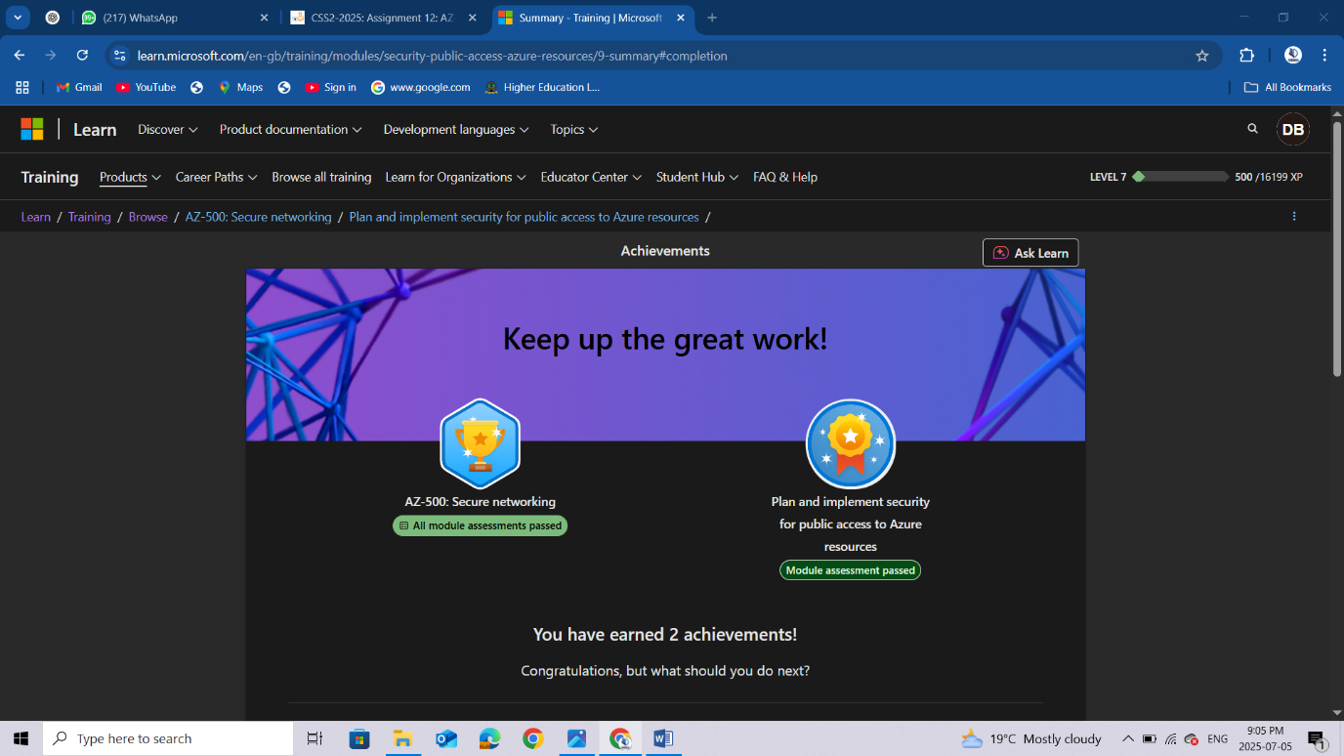

Conclusion
After completing the modules on securing both private and public access to Azure resources, I have gained an in-depth understanding of how to design secure, scalable, and compliant network architectures in Microsoft Azure. For private access, I learnt how to implement Azure Private Link and private endpoints to provide secure, private connectivity to services such as Azure Storage, Azure SQL, and other PaaS offerings. These technologies ensure that sensitive data traffic stays within Azure’s private network, effectively removing the need to traverse the public internet. I also explored service endpoints and how they allow services to be securely accessible within a virtual network, helping enforce fine-grained access controls at the subnet level. For public access, I studied how to use Azure Application Gateway with WAF to inspect and filter HTTP/S traffic, protecting applications from common vulnerabilities. I also looked into Azure Front Door for global load balancing and performance optimization, and Azure DDoS Protection for mitigating large-scale denial-of-service attacks. These services together offer a robust defense-in-depth strategy that ensures public-facing applications remain accessible, performant, and secure. By applying these concepts, I am now better equipped to secure cloud-based resources from both internal and external threats, making sure that Azure environments are protected while still meeting business and user access needs. These skills are vital in any enterprise setting where cloud adoption is growing, and security is a top priority.

