Microsoft ADC Cybersecurity Skilling Program

Week 8 Assignment 14
Student Name: DEBORAH BINYANYA
Student ID: ADC-CSS02-25051

SECURE COMPUTE

Introduction
In this module, I will focus on planning and implementing advanced security for compute resources in Microsoft Azure. Compute resources—such as virtual machines (VMs), containers, and app services—play a central role in cloud workloads, and securing them remains critical to maintaining a strong and resilient security posture. Throughout the module, I will explore key strategies and tools that help harden Azure-based compute environments. I will utilize Microsoft Defender for Cloud to assess, monitor, and respond to threats targeting compute workloads. I will also apply just-in-time (JIT) VM access, configure endpoint protection, and enable adaptive application controls to help reduce the attack surface and prevent unauthorized access. Additionally, I will work with Azure Policy to enforce consistent security configurations, implement disk encryption using Azure-managed keys, and leverage secure boot and virtual Trusted Platform Module (vTPM) to provide hardware-level protection. These practices lay the foundation for implementing a defense-in-depth strategy that will help me secure Azure compute workloads both now and in the future.

Tasks Completed

Plan and implement advanced security for compute
https://learn.microsoft.com/api/achievements/share/en-us/DeborahBinyanya-1253/H7JZZZ78?sharingId=BBBCB3F098199A41
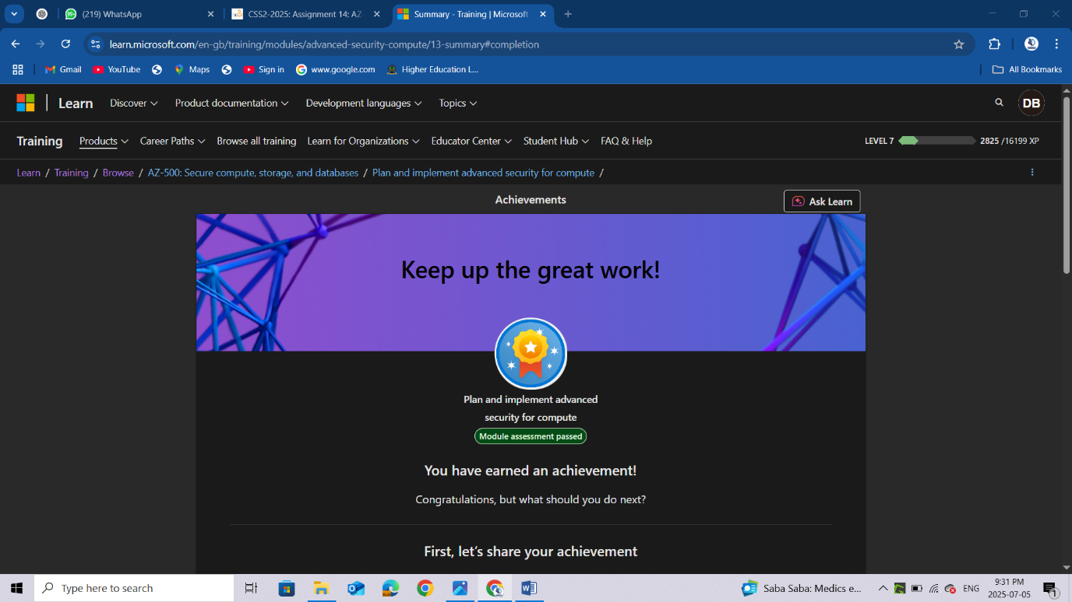

Conclusion
After completing this module, I have developed a comprehensive understanding of how to secure Azure compute resources using advanced, layered security techniques. I learnt how to monitor the security state of VMs and other compute workloads using Microsoft Defender for Cloud, and how to proactively reduce exposure through just-in-time access, network hardening, and application control policies. Additionally, I now understand how to implement disk encryption, configure antimalware solutions, and enforce security baselines using Azure Policy to ensure all compute resources comply with organizational standards. Features such as secure boot and vTPM offer further assurance by validating the integrity of the VM operating system at startup. This module has equipped me with the skills needed to design and maintain a secure compute environment in Azure—one that is resilient to modern threats, aligned with best practices, and tailored to meet enterprise security and compliance requirements.

