Microsoft ADC Cybersecurity Skilling Program

Week 9 Assignment 16
Student Name: DEBORAH BINYANYA
Student ID: ADC-CSS02-25051

SECURE STORAGE, AND DATABASES

Introduction
In this module i will be focusing on two important modules that cover how to plan and implement security for storage and Azure databases. These modules are critical in understanding how to protect sensitive data stored in the cloud and ensure that only authorized users and services can access it. In the storage security module, I will learn how to secure Azure Storage accounts using features such as shared access signatures (SAS), service endpoints, private links, firewalls, and encryption mechanisms. I will also explore how to manage identity-based access using Azure Active Directory (Azure AD), role-based access control (RBAC), and storage account keys. In the module covering Azure SQL Database and Azure SQL Managed Instance, I will focus on securing databases through Transparent Data Encryption (TDE), network security, auditing, Advanced Data Security, and threat detection. These features help protect data both at rest and in transit, while also enabling proactive monitoring and response to potential security threats. By working through these modules, I aim to strengthen my ability to secure data resources in Azure environments, ensuring confidentiality, integrity, and compliance.

Tasks Completed

Plan and implement security for storage
https://learn.microsoft.com/api/achievements/share/en-us/DeborahBinyanya-1253/9YKR7SGU?sharingId=BBBCB3F098199A41
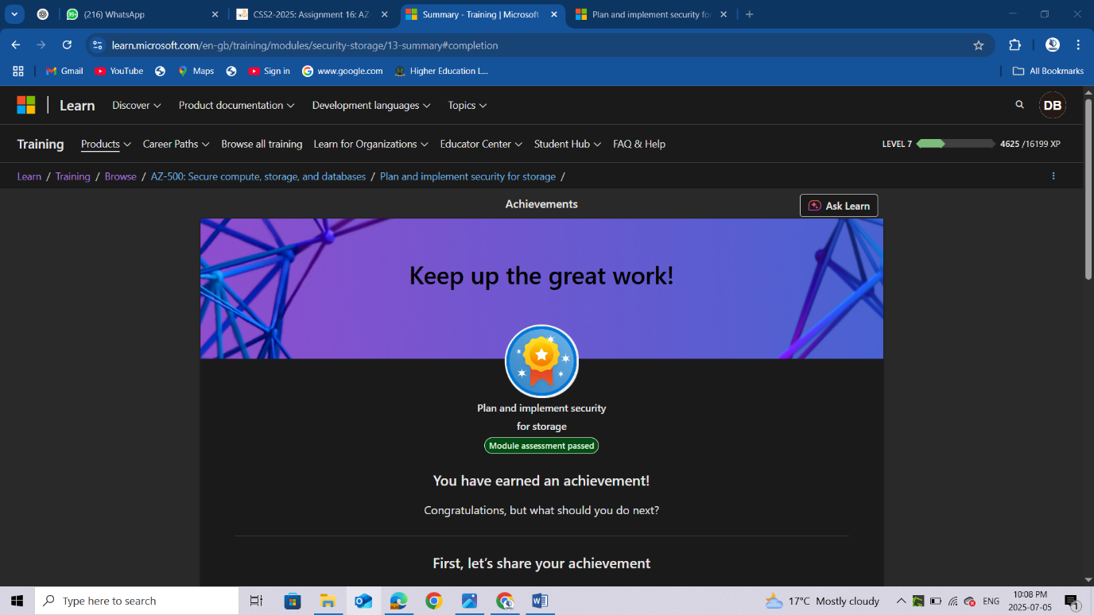

Plan and implement security for Azure SQL Database and Azure SQL Managed Instance
https://learn.microsoft.com/api/achievements/share/en-us/DeborahBinyanya-1253/D97U8SVJ?sharingId=BBBCB3F098199A41
https://learn.microsoft.com/api/achievements/share/en-us/DeborahBinyanya-1253/2DHJ5QFV?sharingId=BBBCB3F098199A41
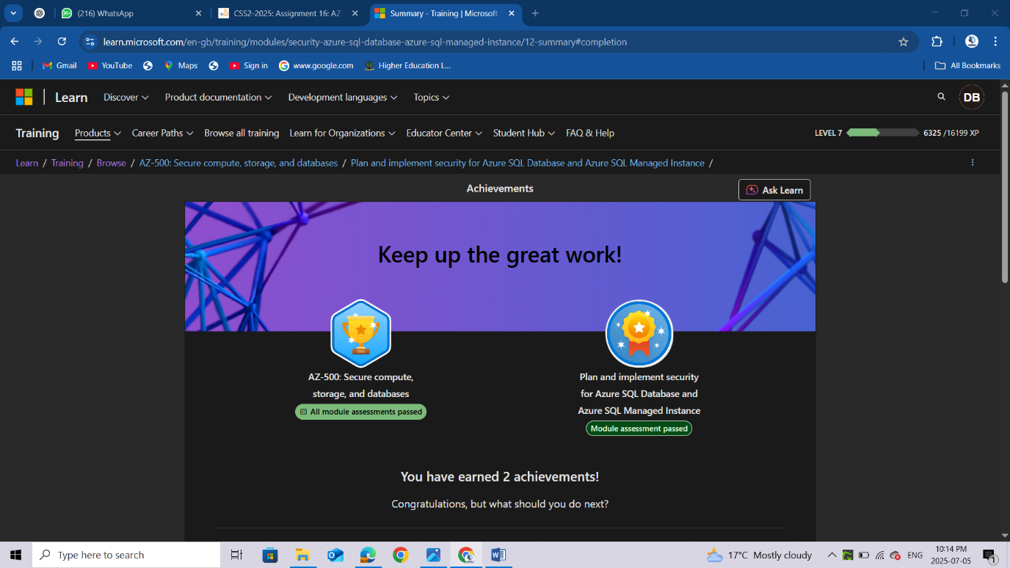

Conclusion
After completing the modules on securing Azure Storage and Azure SQL databases, I have developed a deeper understanding of how to effectively protect cloud-based data resources using Microsoft Azure's built-in security tools and best practices. In the storage security module, I learned how to control access through shared access signatures, storage account keys, and Azure RBAC, while also using network restrictions, such as firewall rules and private endpoints, to isolate storage resources from unauthorized networks. Additionally, I explored how to apply encryption at rest and in transit, ensuring data remains protected throughout its lifecycle. In the SQL security module, I discovered how to implement key database protections such as Transparent Data Encryption (TDE), Always Encrypted, and network security controls to restrict access to only trusted sources. I also worked with auditing, Advanced Data Security, and threat detection to enhance visibility and automate alerts on suspicious or risky activities within the database environment. Overall, these modules have equipped me with essential skills to design and implement a secure, compliant, and well-governed data infrastructure in Azure. I now feel more confident in my ability to secure both structured and unstructured data across different services in the cloud.

