Microsoft ADC Cybersecurity Skilling Program

Week 9 Assignment 17
Student Name: DEBORAH BINYANYA
Student ID: ADC-CSS02-25051

Securing Azure SQL Database

Introduction
In this lab, we will explore essential security configurations for protecting data stored in Azure SQL Databases as part of the AZ500: Microsoft Azure Security Technologies course. The primary objective is to understand and implement security best practices that ensure database integrity, confidentiality, and compliance. The lab focuses on deploying an Azure SQL Database and applying several layers of security controls. These include configuring Advanced Data Protection to guard against threats like SQL injection and data exfiltration, implementing Data Classification to discover and label sensitive information, and setting up Auditing to monitor and log database activities. By completing this lab, we will gain hands-on experience with securing SQL databases in the cloud, an essential skill for any Azure security professional.

Tasks Completed

Required Lab Setup

Login:
Hello Deborah, on SEA-Dev click Ctrl+Alt+Delete to activate the Ctrl + Alt + Delete sequence and bring up the logon page.
Sign in as Admin with the password Pa55w.rd.
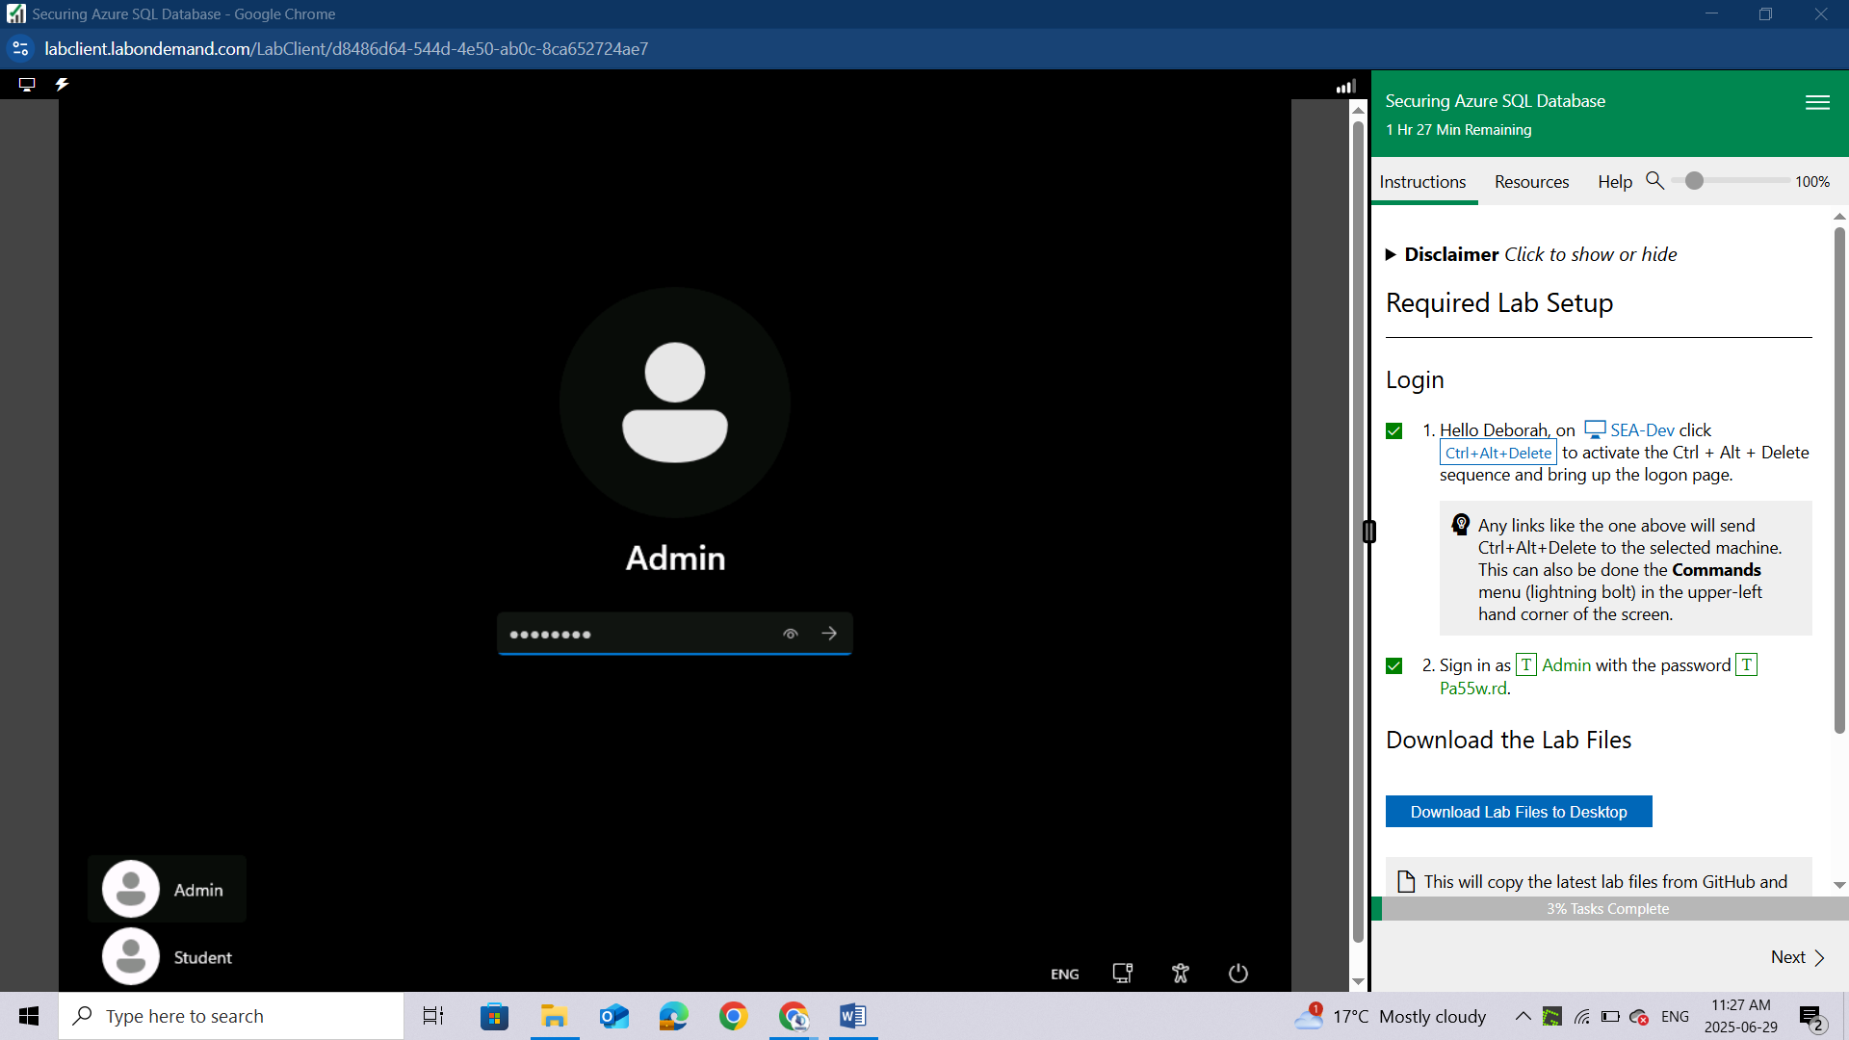

Download the Lab Files
This will copy the latest lab files from GitHub and configure the directories as needed for the remainder of the lab exercises. You will see a 'Success!' message above, once the process is complete.
Once you have received the 'Success!' message, click Next to proceed to the lab.
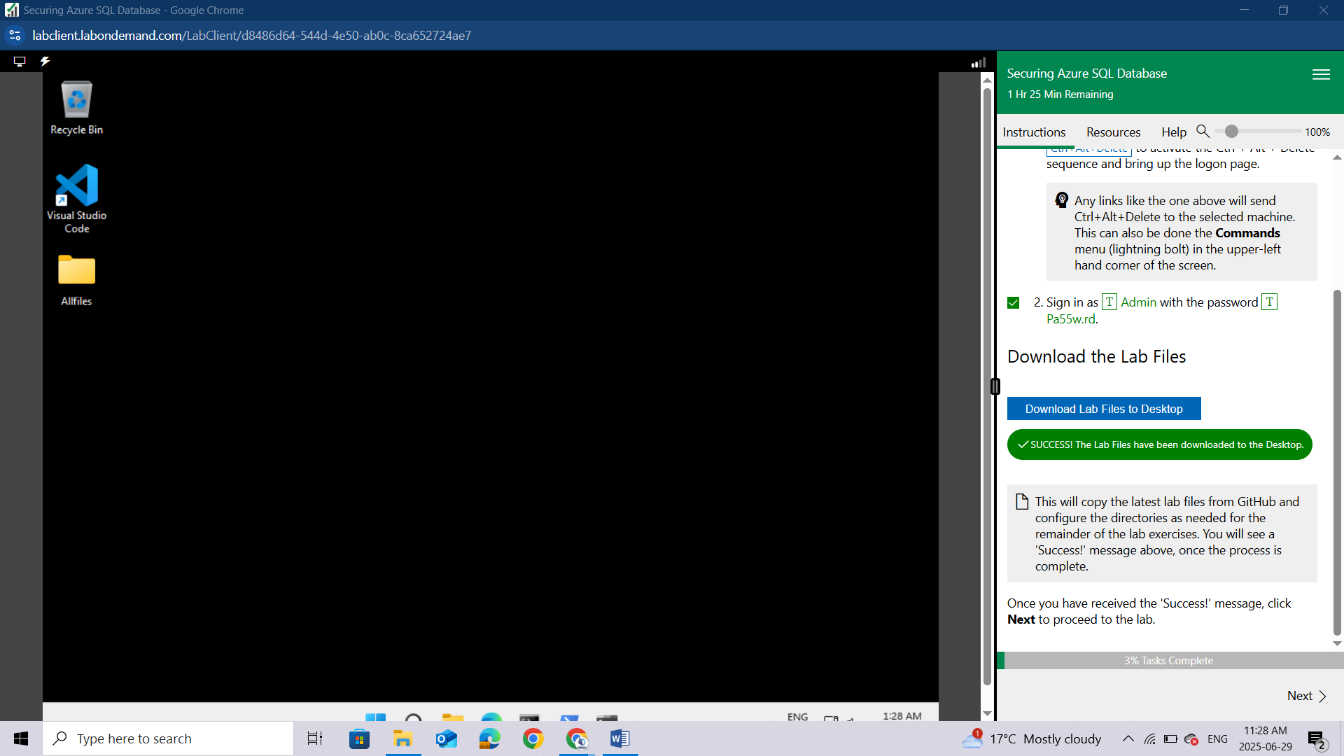

Prepare cloud shell for later use
Login to the Azure Portal (https://portal.azure.com) using the below credentials:
Username | LabUser-52595914@cloudslice.onmicrosoft.com
Password | hBdB1e!0D#m0
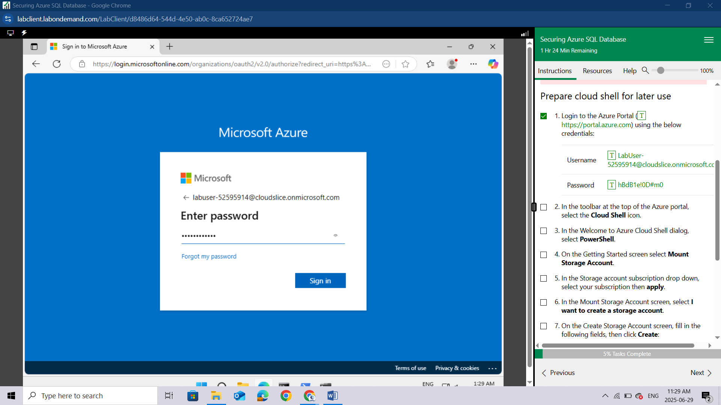
In the toolbar at the top of the Azure portal, select the Cloud Shell icon.
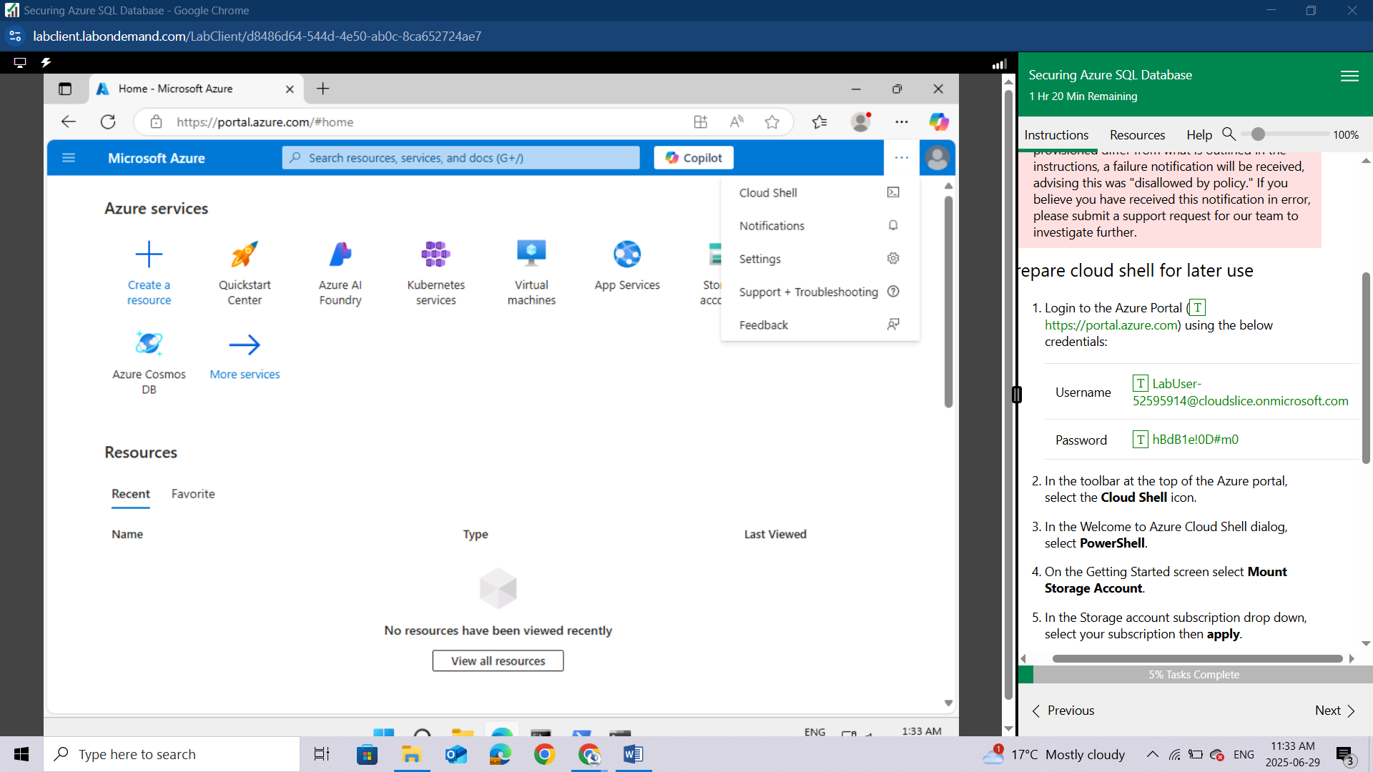
In the Welcome to Azure Cloud Shell dialog, select PowerShell.
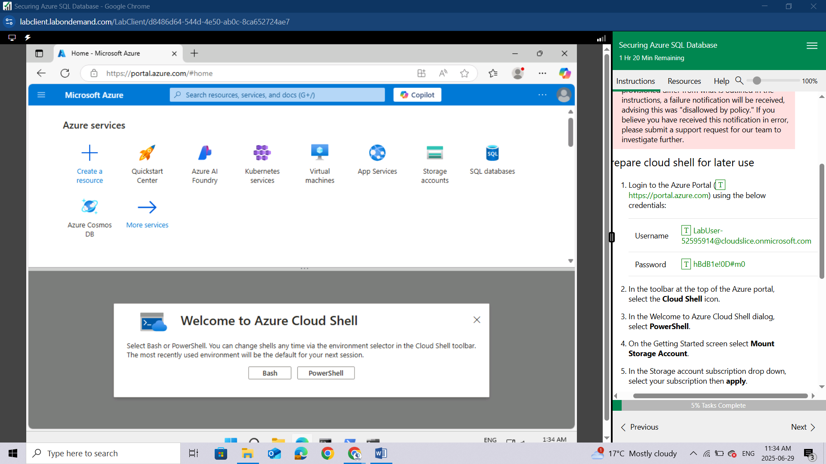
On the Getting Started screen select Mount Storage Account.
In the Storage account subscription drop down, select your subscription then apply.
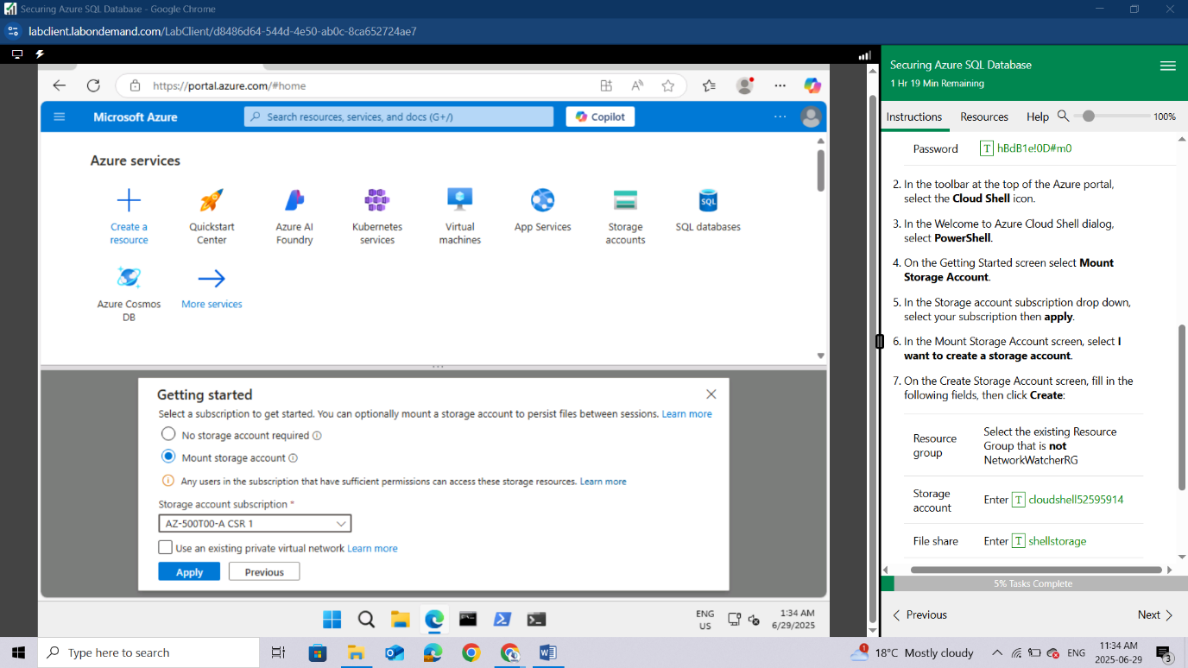
In the Mount Storage Account screen, select I want to create a storage account.
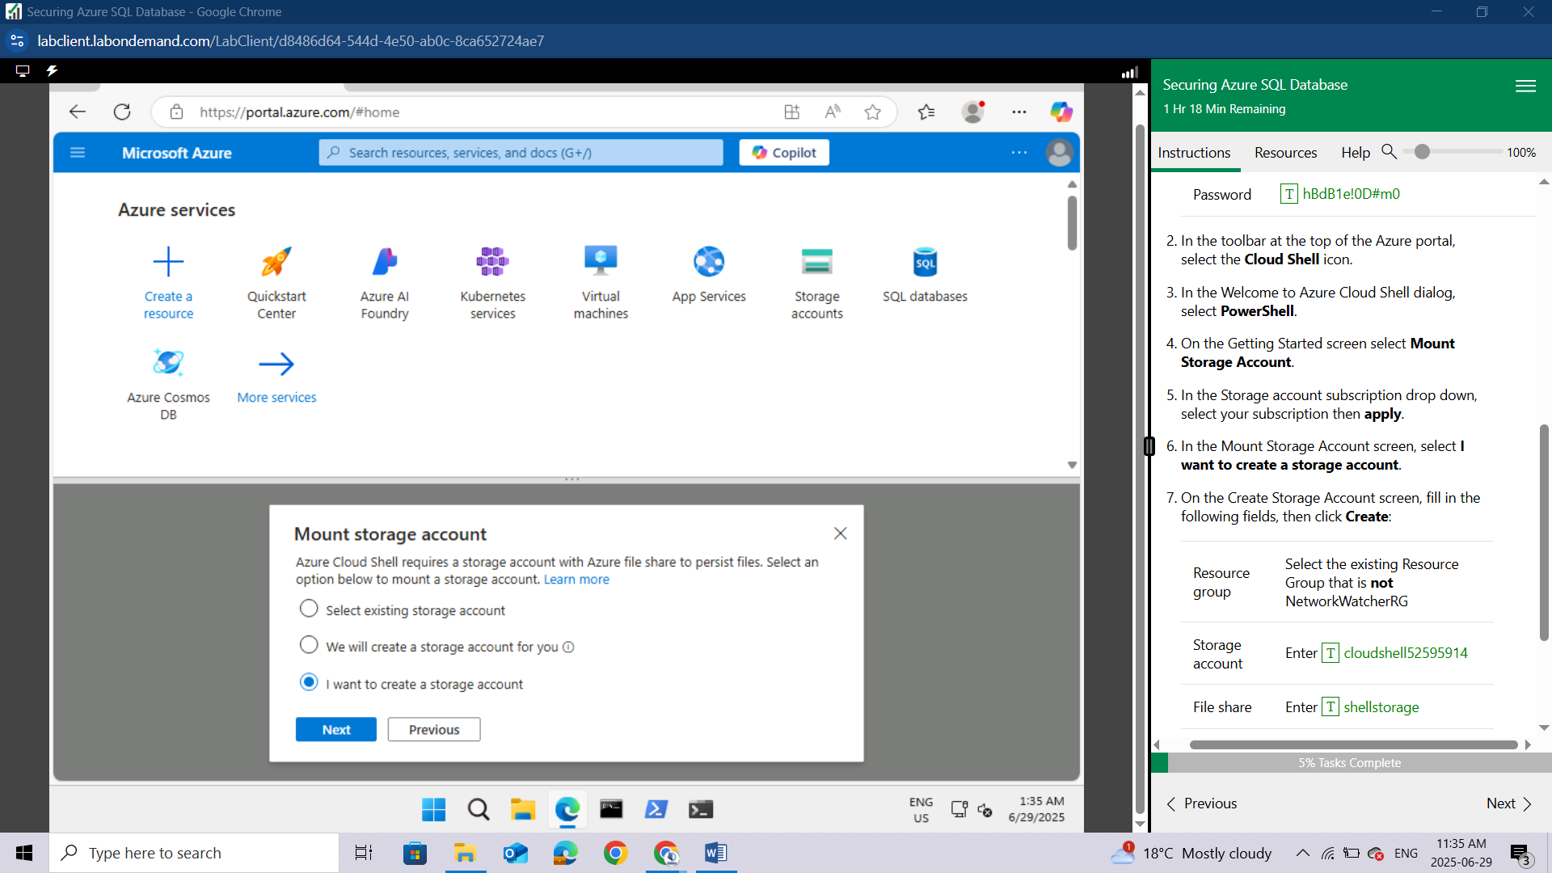
On the Create Storage Account screen, fill in the following fields, then click Create:
Resource group | Select the existing Resource Group that is not NetworkWatcherRG
Storage account | Enter cloudshell52595914
File share | Enter shellstorage
Region | Select a Region nearest to you
If you receive a "Tenant User Over Quota" error, change your Cloud Shell Region to an alternative region.
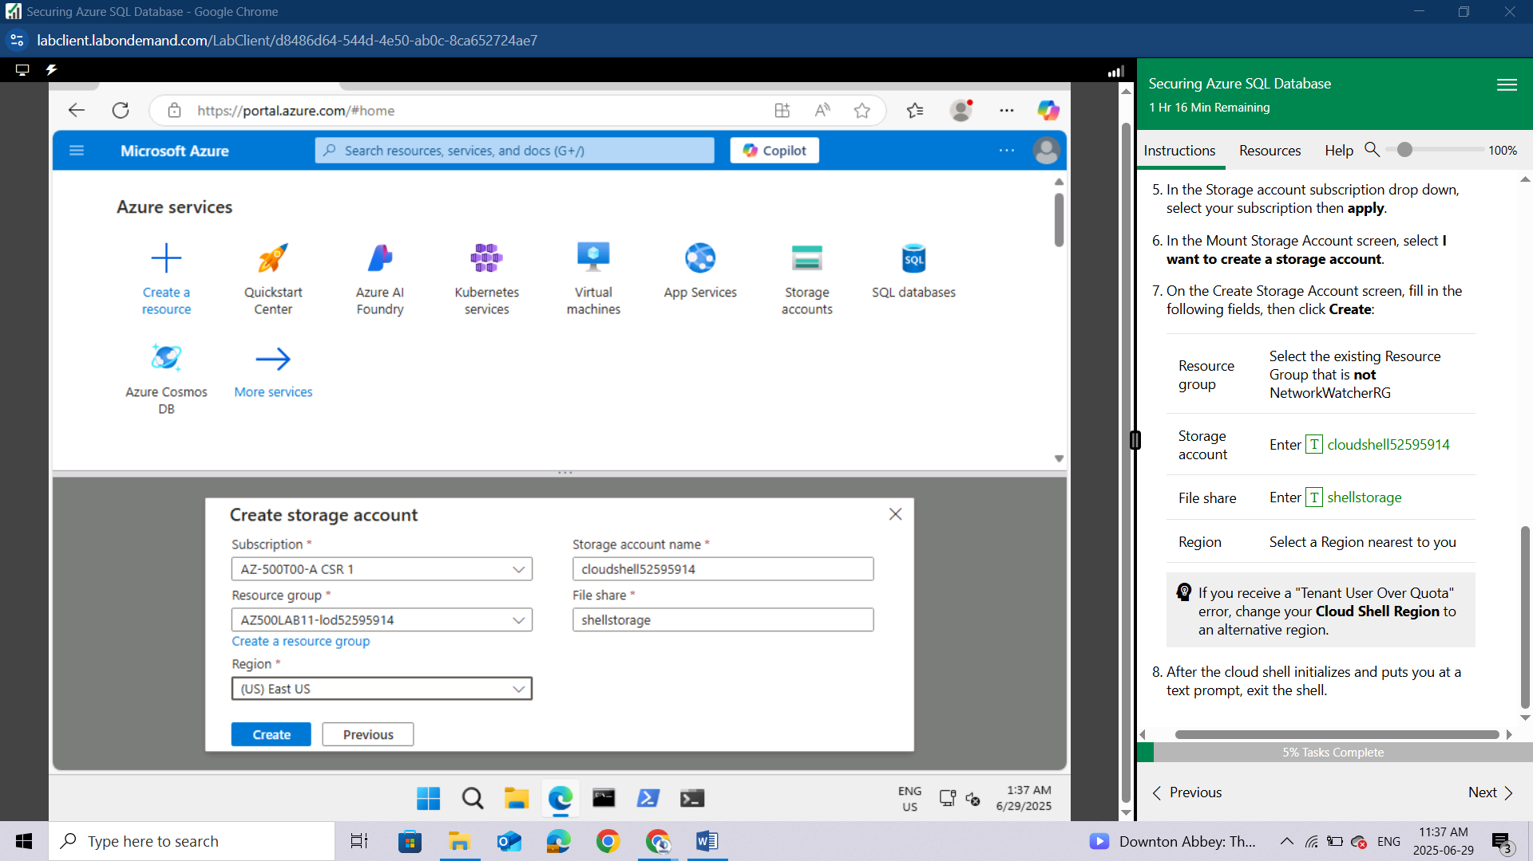
After the cloud shell initializes and puts you at a text prompt, exit the shell.
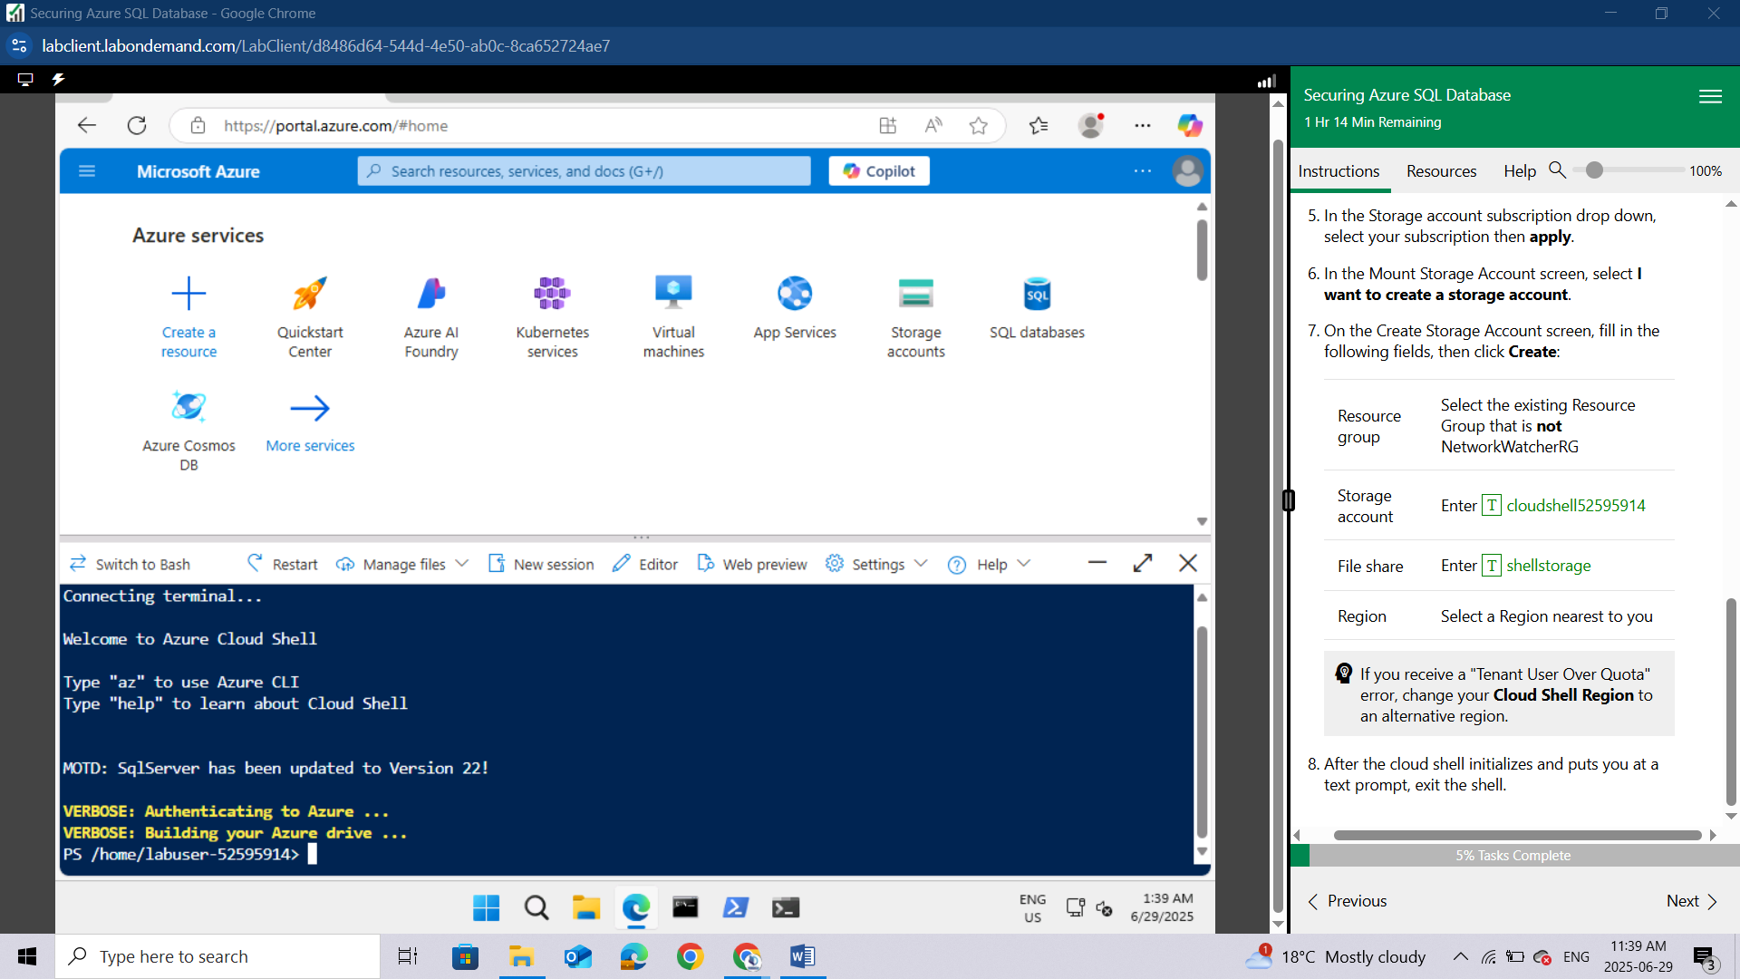

Lab 05: Securing Azure SQL Database

Student lab manual

Lab scenario
You have been asked to review security features for Azure SQL database. Specifically, you are interested in:
- Protection against attacks such as SQL injection and data exfiltration.
- Ability to discover and classify database information into categories such as Confidential.
- Ability to audit database server and database queries and log events.
For all the resources in this lab, we are using the East US region. Verify with your instructor this is the region to use for class.

Lab objectives
In this lab, you will complete the following exercise:
- Exercise 1: Implement SQL Database security features

Securing Azure SQL Database diagram
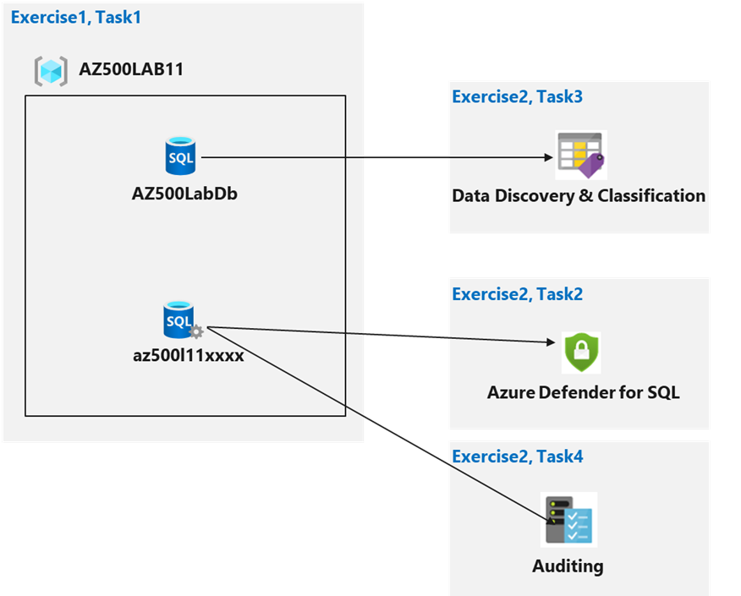

Instructions

Lab files:
- \Allfiles\Labs\11\azuredeploy.json

Exercise 1: Implement SQL Database security features
Estimated timing: 30 minutes
In this exercise, you will complete the following tasks:
- Task 1: Deploy an Azure SQL Database
- Task 2: Configure Advanced Data Protection
- Task 3: Configure Data Classification
- Task 4: Configure Auditing

Task 1: Deploy an Azure SQL Database
In this task, you will use a template to deploy the lab infrastructure.
Sign-in to the Azure portal https://portal.azure.com/.
Note: Sign in to the Azure portal using an account that has the Owner or Contributor role in the Azure subscription you are using for this lab.
In the Azure portal, in the Search resources, services, and docs text box at the top of the Azure portal page, type Deploy a custom template and press the Enter key.
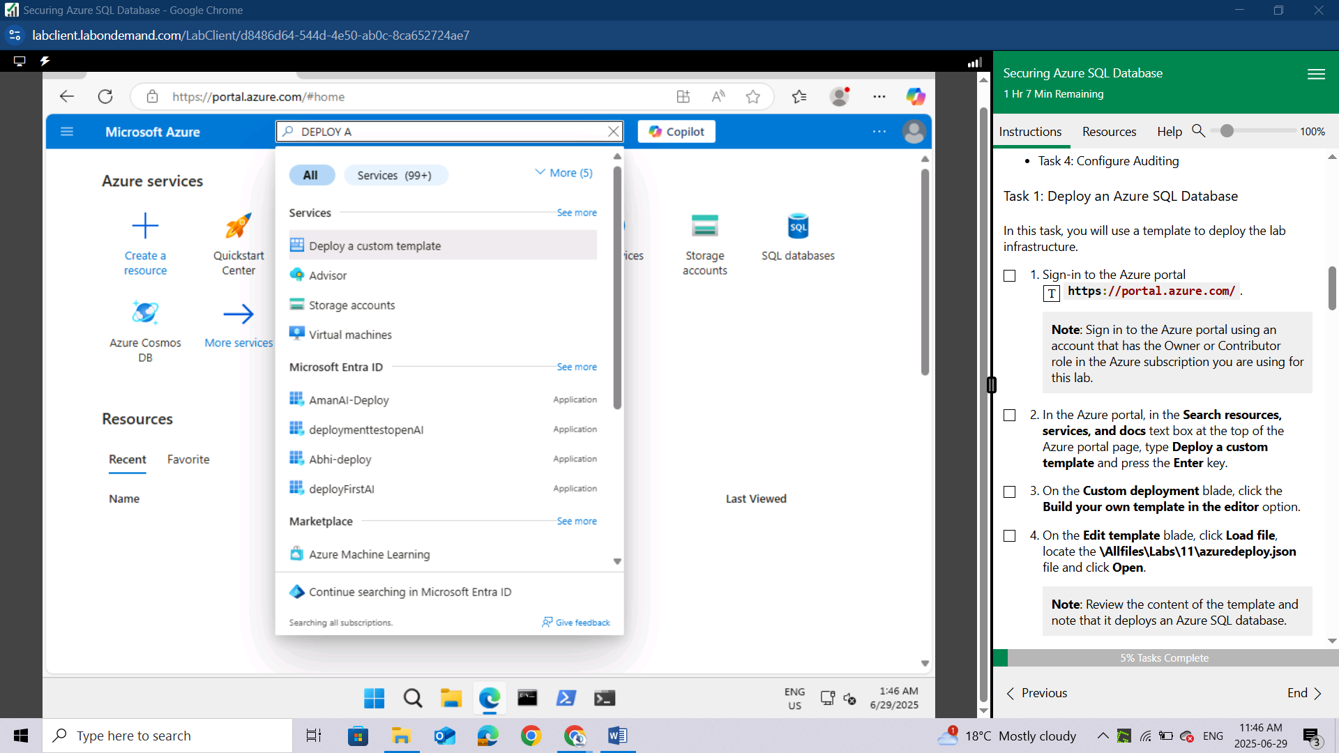
On the Custom deployment blade, click the Build your own template in the editor option.
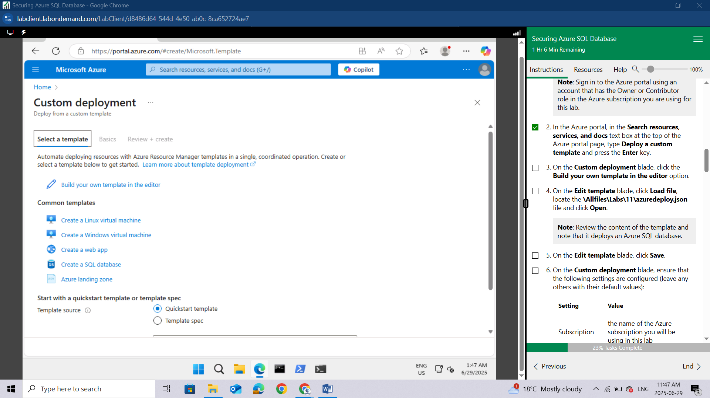
On the Edit template blade, click Load file, locate the \Allfiles\Labs\11\azuredeploy.json file and click Open.
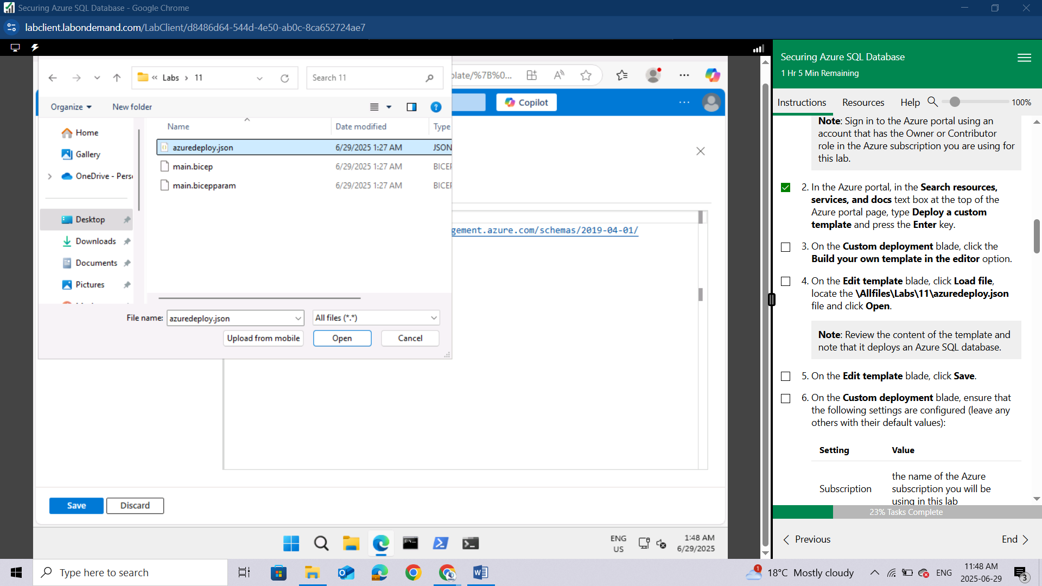
Note: Review the content of the template and note that it deploys an Azure SQL database.
On the Edit template blade, click Save.
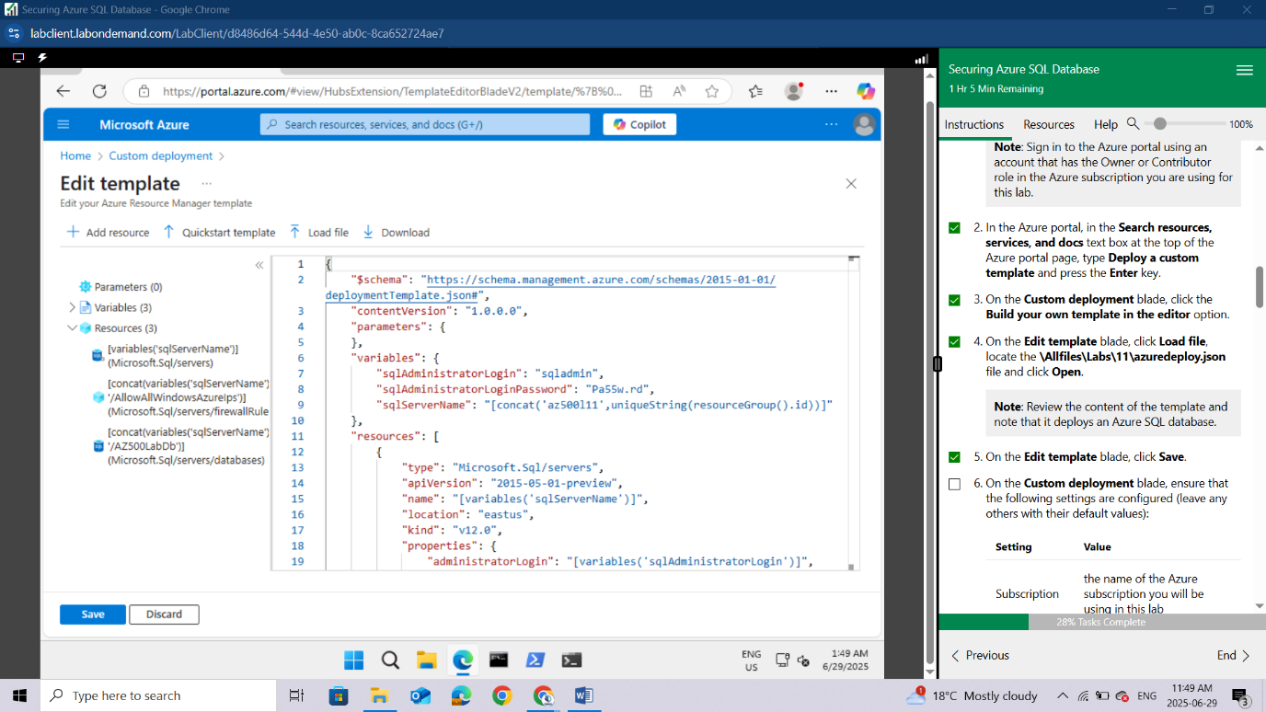
On the Custom deployment blade, ensure that the following settings are configured (leave any others with their default values):
Setting | Value
Subscription | the name of the Azure subscription you will be using in this lab
Resource group | Use the existing Resource Group AZ500LAB11-lod52595914
Location | (US) East US
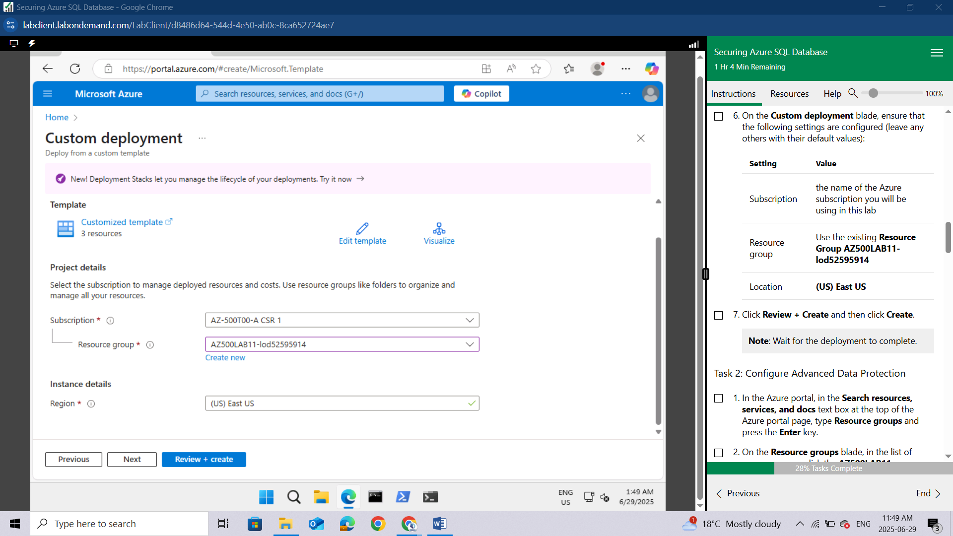
Click Review + Create and then click Create.
Note: Wait for the deployment to complete. It might take a while so you need to be patient
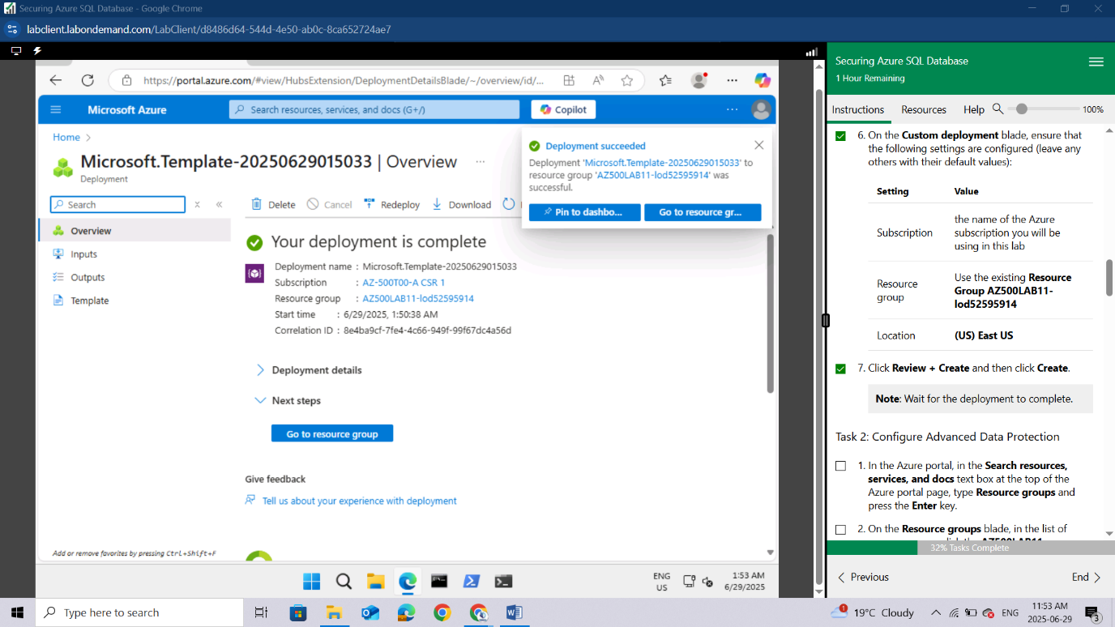

Task 2: Configure Advanced Data Protection
In the Azure portal, in the Search resources, services, and docs text box at the top of the Azure portal page, type Resource groups and press the Enter key.
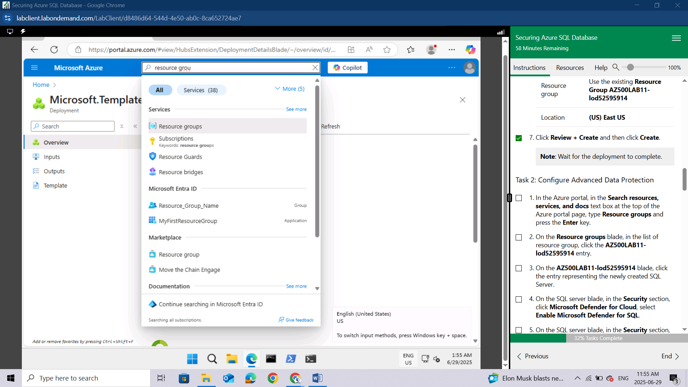
On the Resource groups blade, in the list of resource group, click the AZ500LAB11-lod52595914 entry.
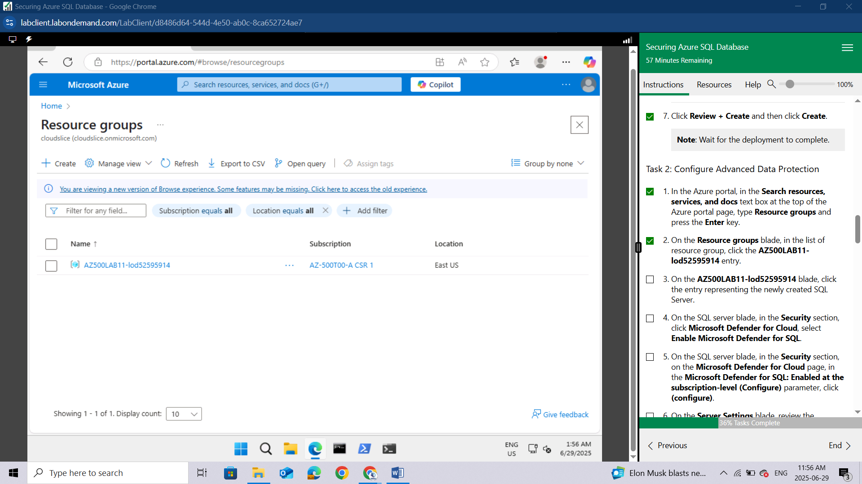
On the AZ500LAB11-lod52595914 blade, click the entry representing the newly created SQL Server.
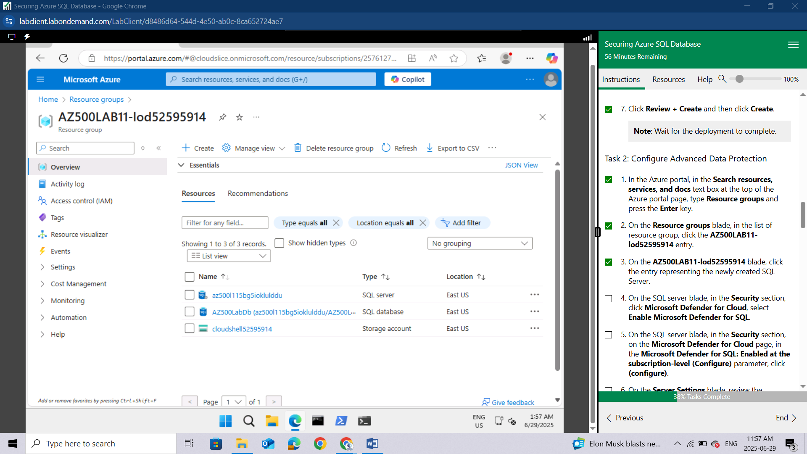
On the SQL server blade, in the Security section, click Microsoft Defender for Cloud, select Enable Microsoft Defender for SQL.
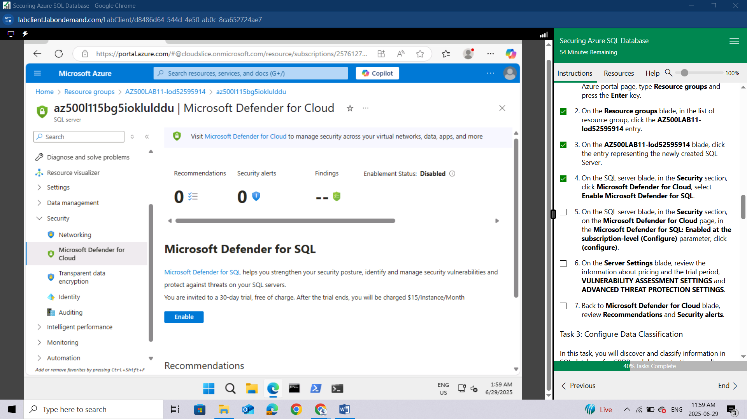
On the SQL server blade, in the Security section, on the Microsoft Defender for Cloud page, in the Microsoft Defender for SQL: Enabled at the subscription-level (Configure) parameter, click (configure).
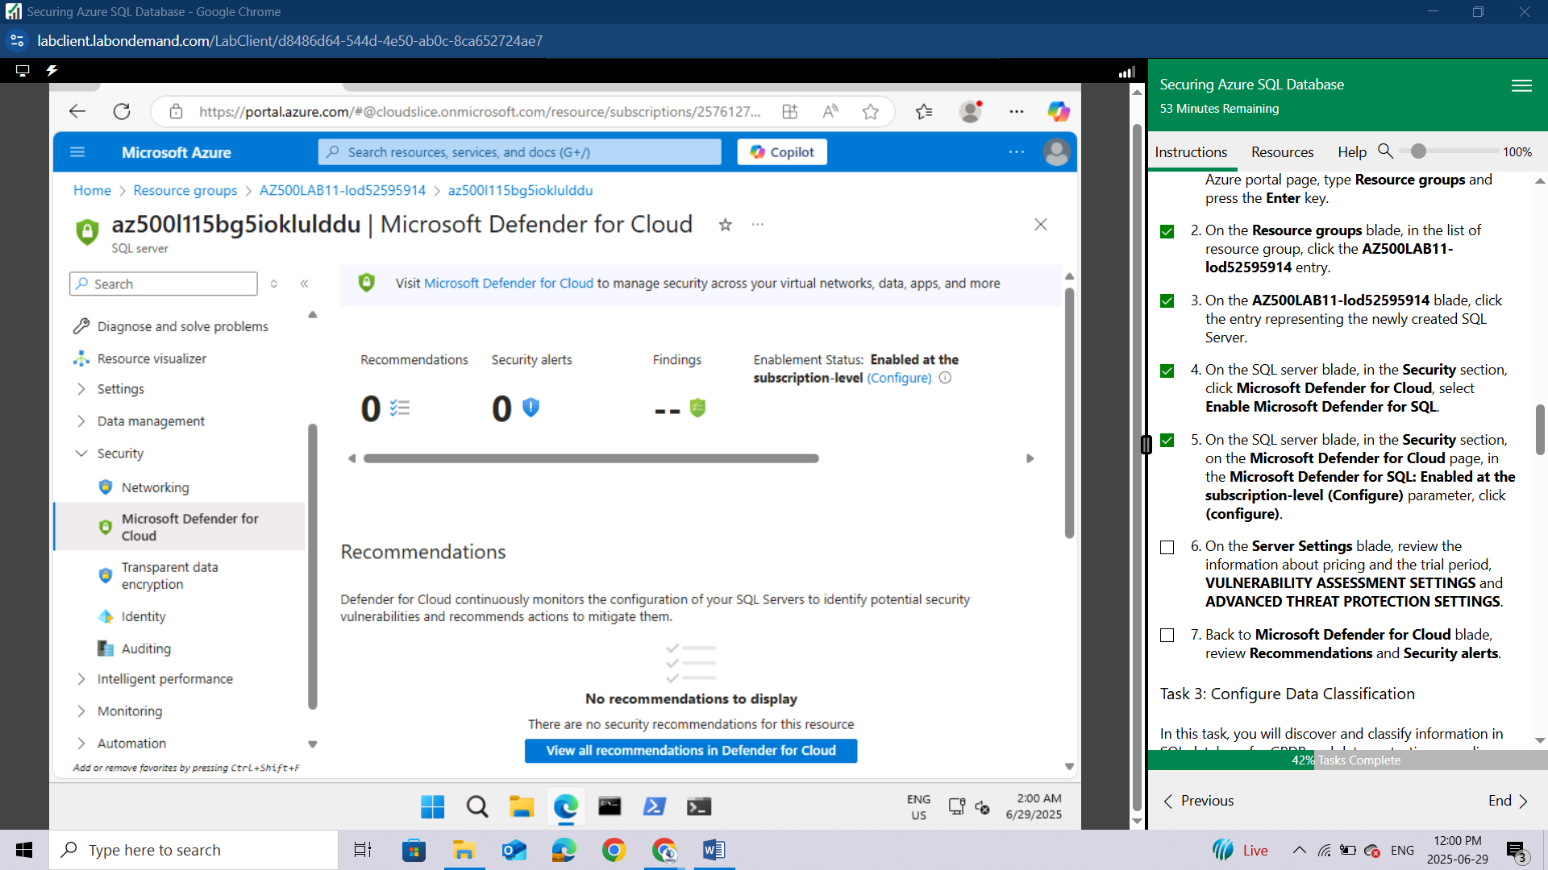
On the Server Settings blade, review the information about pricing and the trial period, VULNERABILITY ASSESSMENT SETTINGS and ADVANCED THREAT PROTECTION SETTINGS.
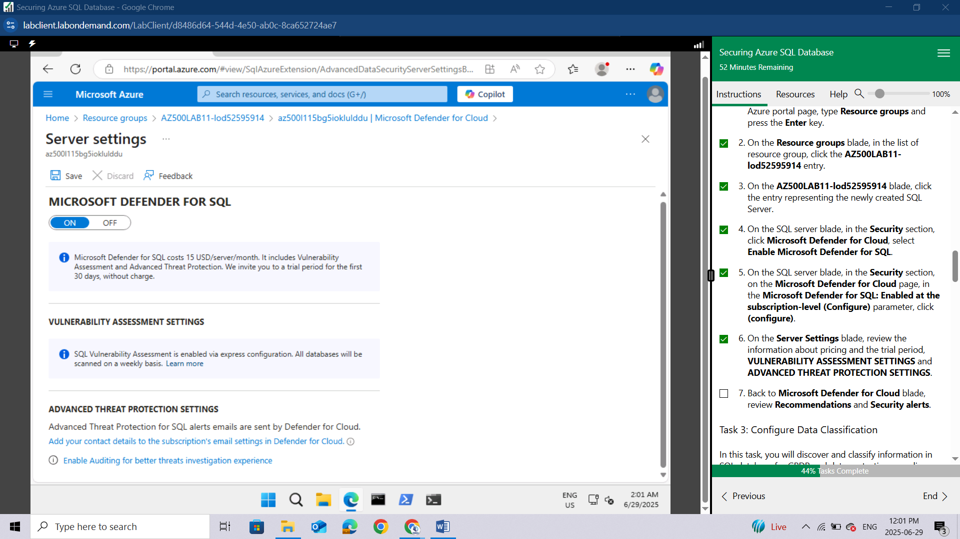
Back to Microsoft Defender for Cloud blade, review Recommendations and Security alerts.
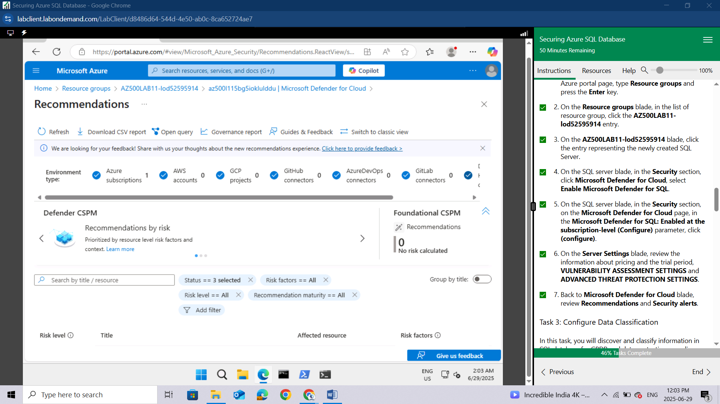

Task 3: Configure Data Classification
In this task, you will discover and classify information in SQL database for GPDR and data protection compliance.
On the SQL server blade, in the Settings section, click SQL Databases.
In the list of databases, select the AZ500LabDb entry.
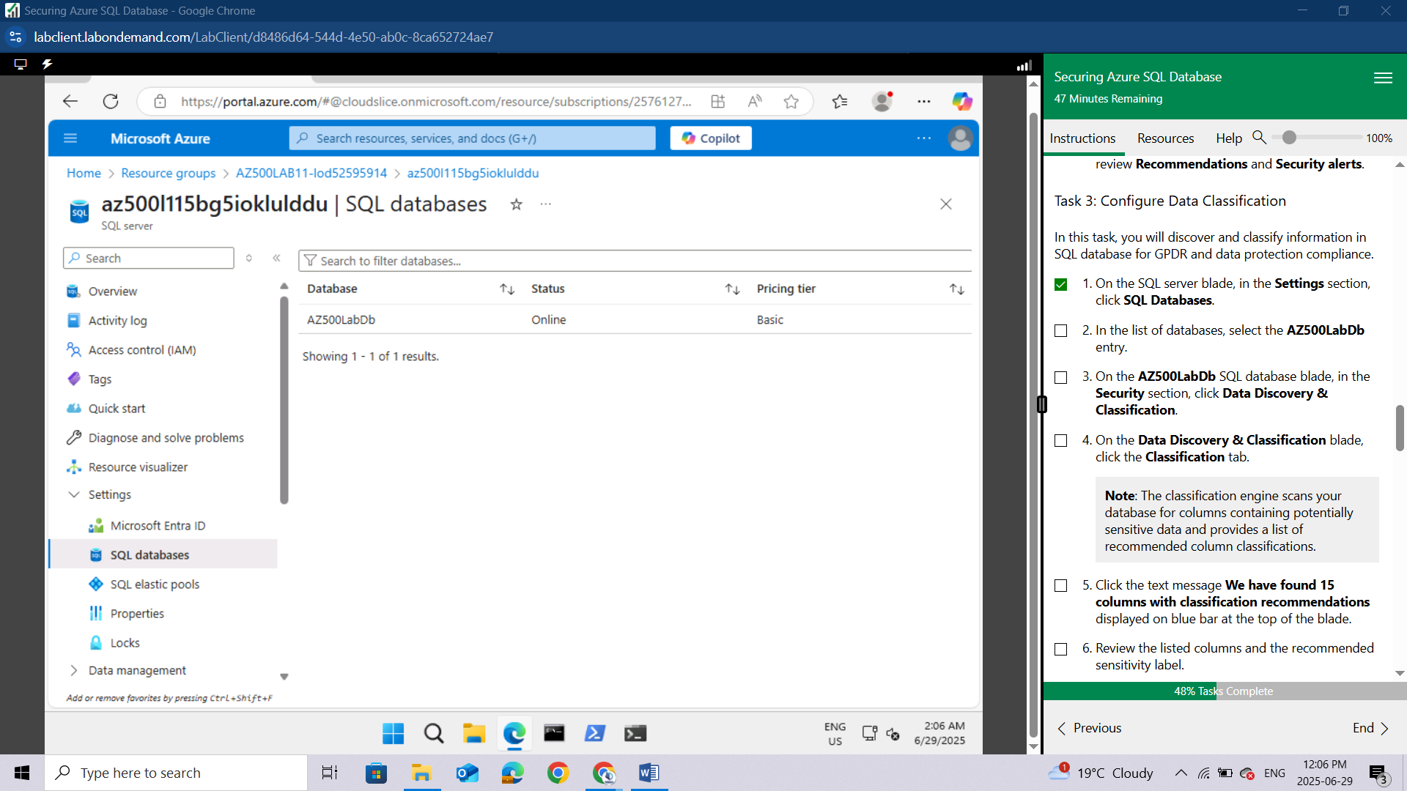
On the AZ500LabDb SQL database blade, in the Security section, click Data Discovery & Classification.
On the Data Discovery & Classification blade, click the Classification tab.
Note: The classification engine scans your database for columns containing potentially sensitive data and provides a list of recommended column classifications.
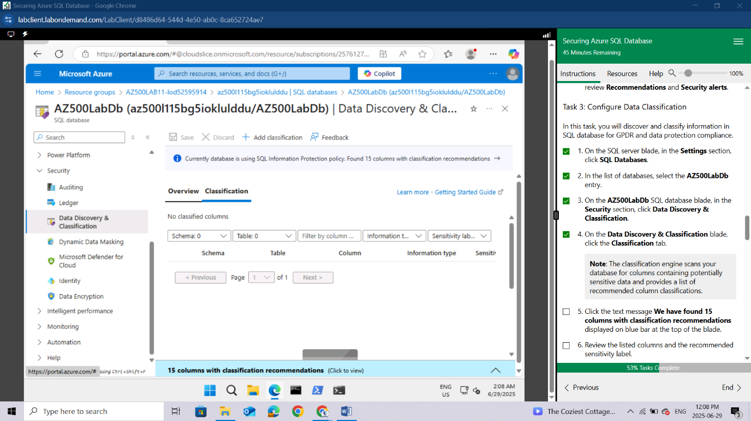
Click the text message We have found 15 columns with classification recommendations displayed on blue bar at the top of the blade.
Review the listed columns and the recommended sensitivity label.
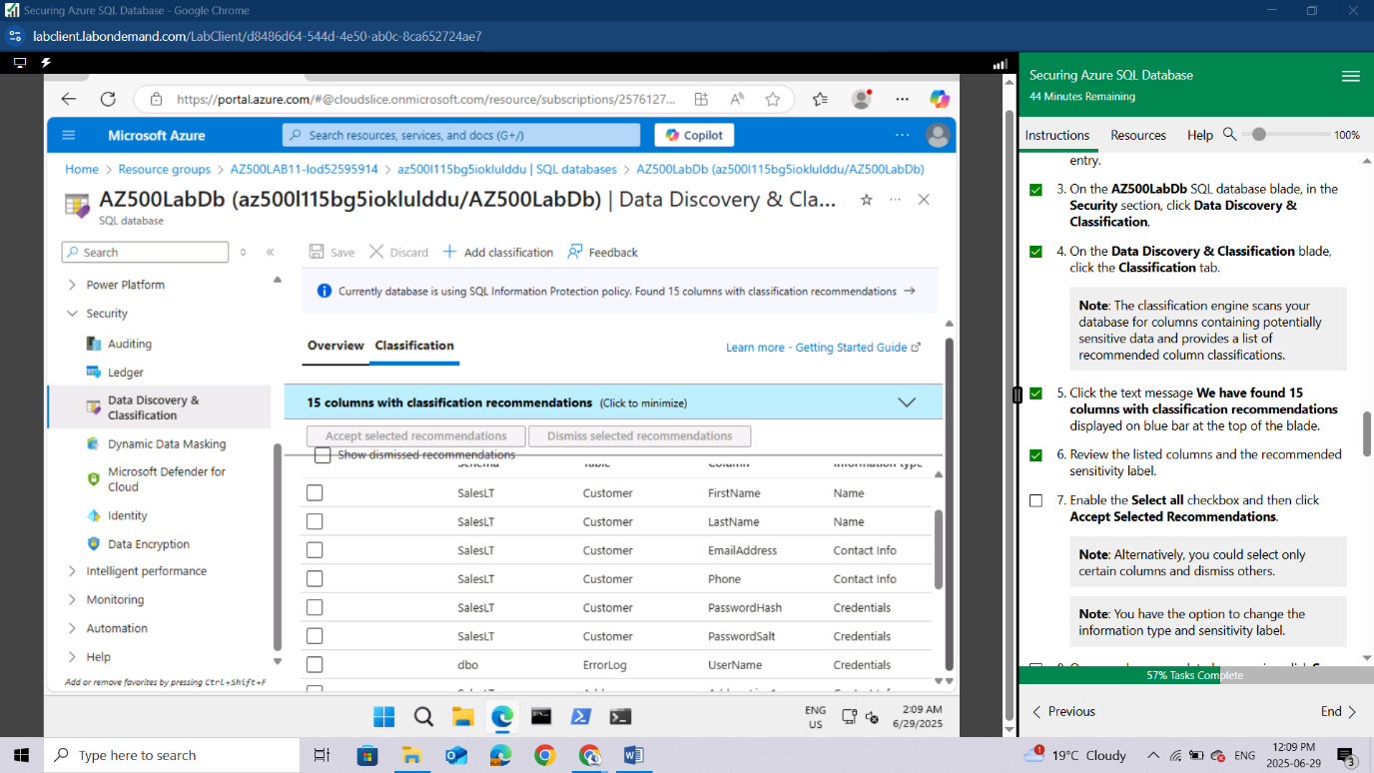
Enable the Select all checkbox and then click Accept Selected Recommendations.
Note: Alternatively, you could select only certain columns and dismiss others.
Note: You have the option to change the information type and sensitivity label.
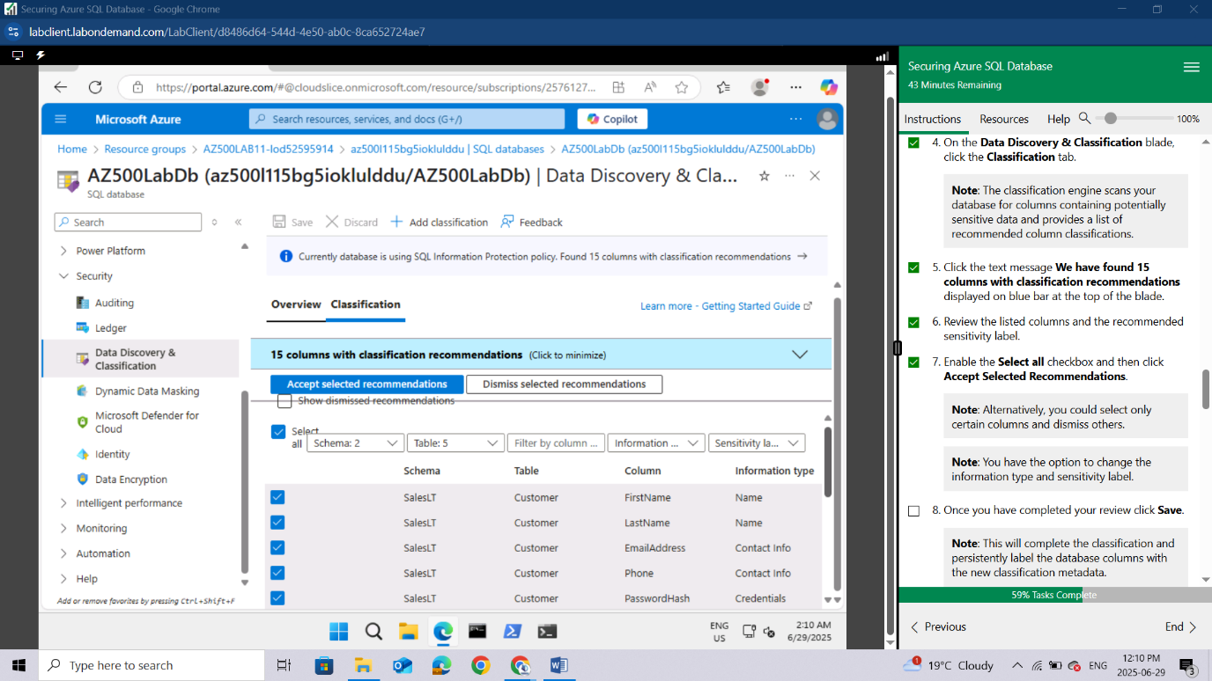
Once you have completed your review click Save.
Note: This will complete the classification and persistently label the database columns with the new classification metadata.
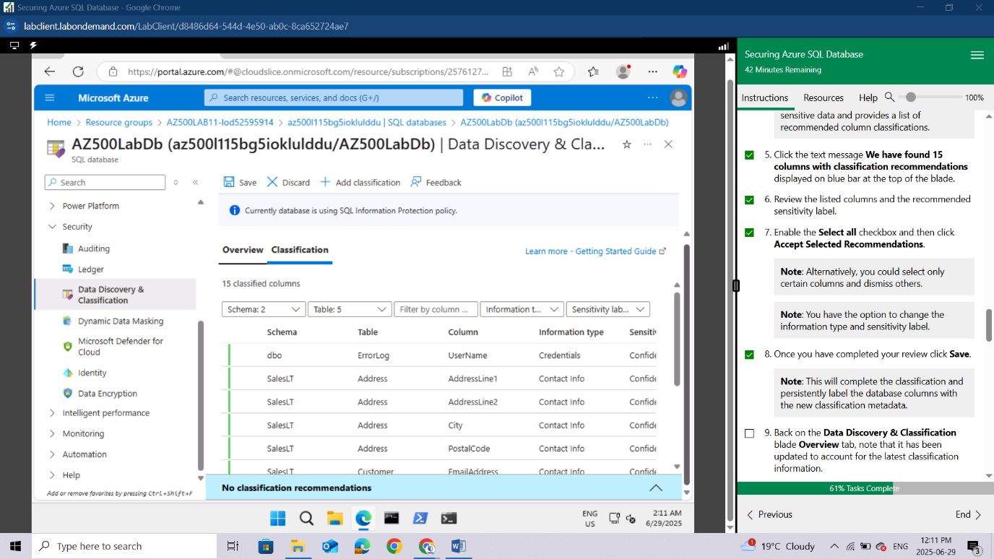
Back on the Data Discovery & Classification blade Overview tab, note that it has been updated to account for the latest classification information.
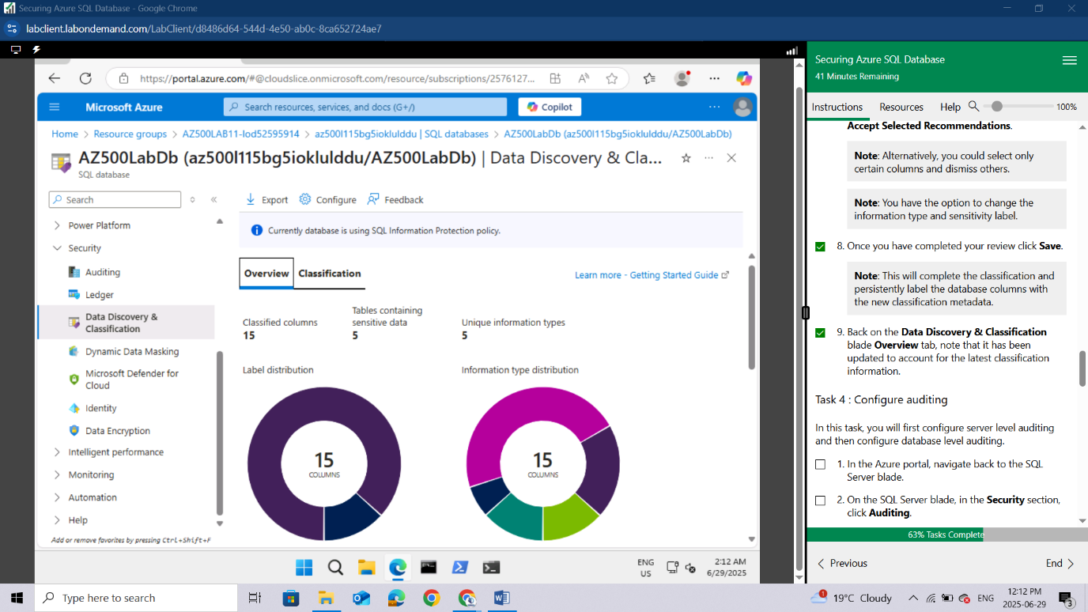

Task 4 : Configure auditing
In this task, you will first configure server level auditing and then configure database level auditing.
In the Azure portal, navigate back to the SQL Server blade.
On the SQL Server blade, in the Security section, click Auditing.
Note: This is server level auditing. The default auditing settings include all the queries and stored procedures executed against the database, as well as successful and failed logins.
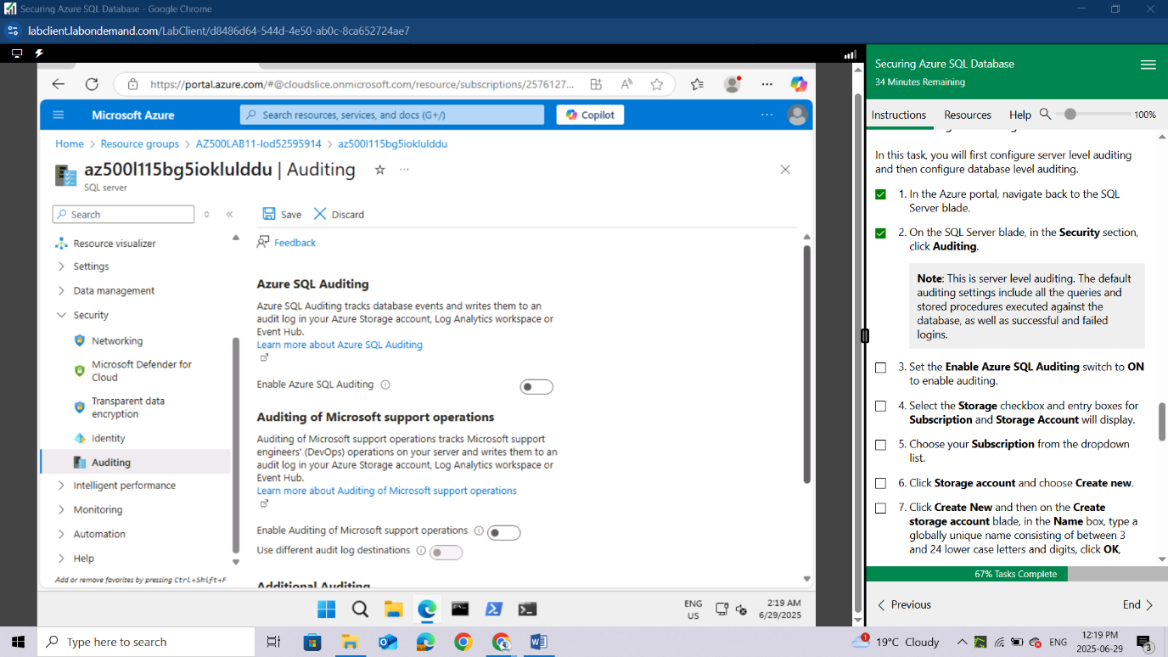

Set the Enable Azure SQL Auditing switch to ON to enable auditing. Select the Storage checkbox and entry boxes for Subscription and Storage Account will display. Choose your Subscription from the dropdown list.
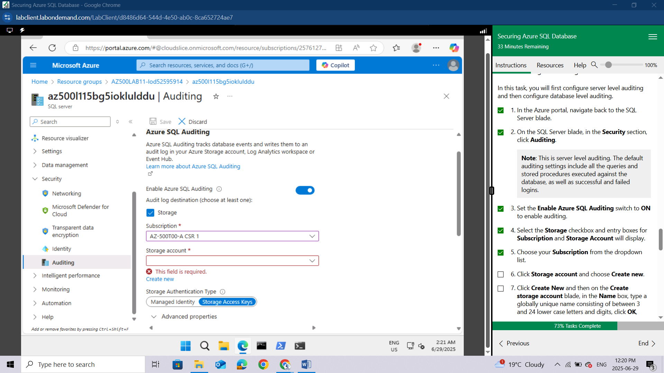
Click Storage account and choose Create new. Click Create New and then on the Create storage account blade, in the Name box, type a globally unique name consisting of between 3 and 24 lower case letters and digits, click OK,
Note: You may need to refresh the browser before the storage account becomes available.
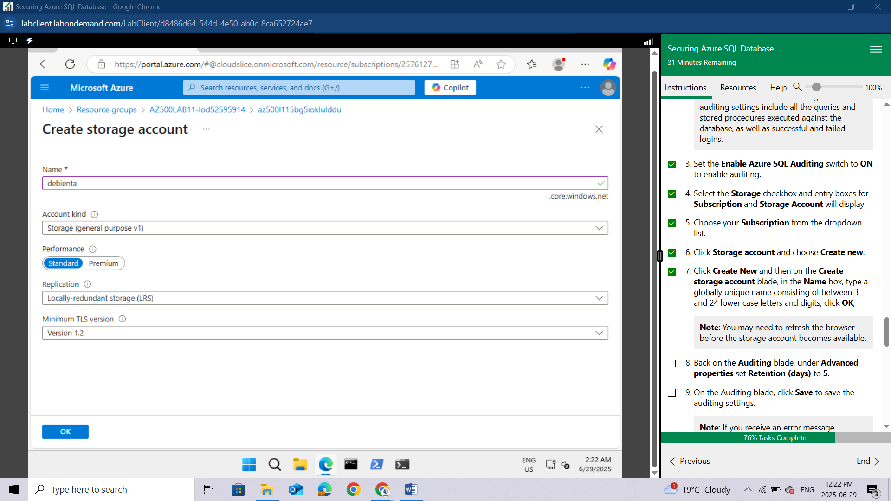

Back on the Auditing blade, under Advanced properties set Retention (days) to 5.
On the Auditing blade, click Save to save the auditing settings.
Note: If you receive an error message regarding invalid storage container path then the storage account may not have have been provisioned yet. Wait a few minutes, click Storage account, on the Choose storage account blade, select the newly created storage account and back on the Auditing blade, click Save.
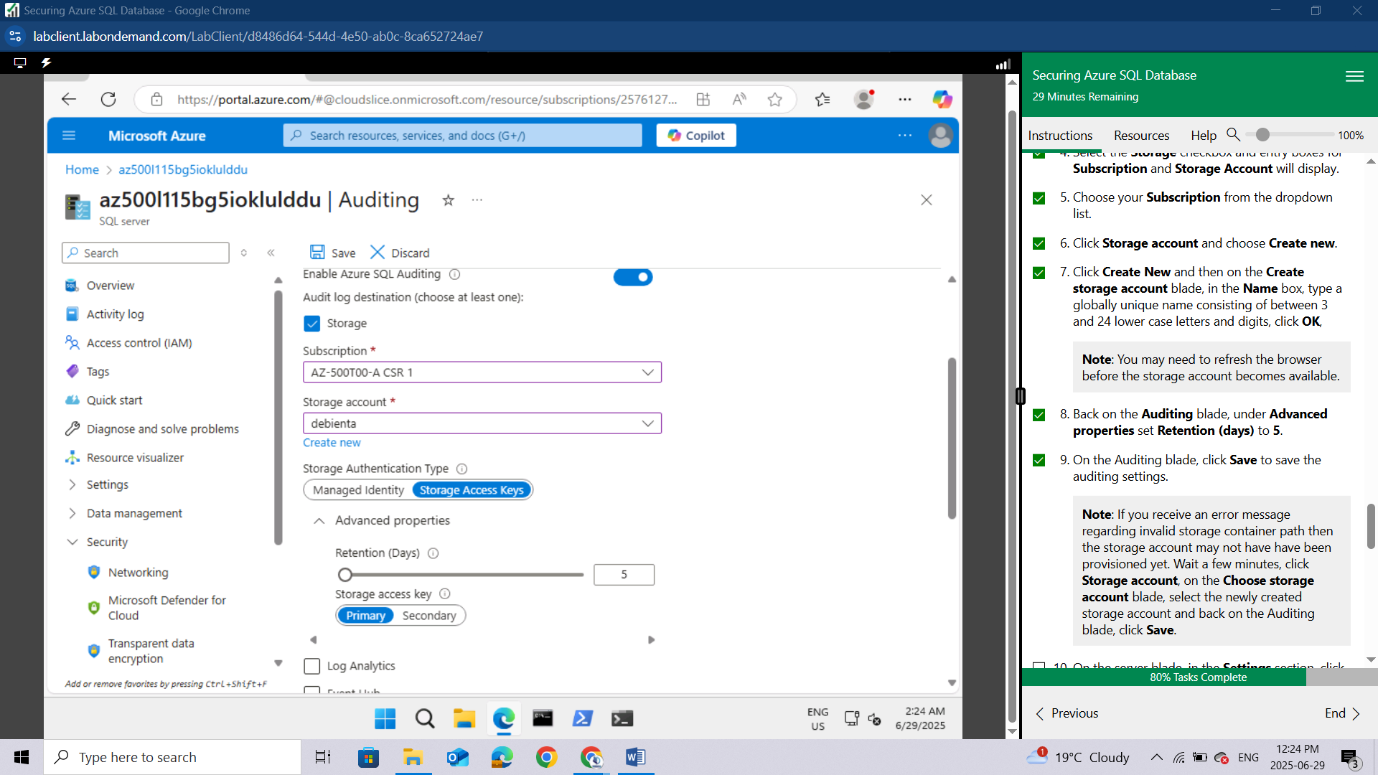
On the server blade, in the Settings section, click SQL Databases.
In the list of databases, select the AZ500LabDb entry.
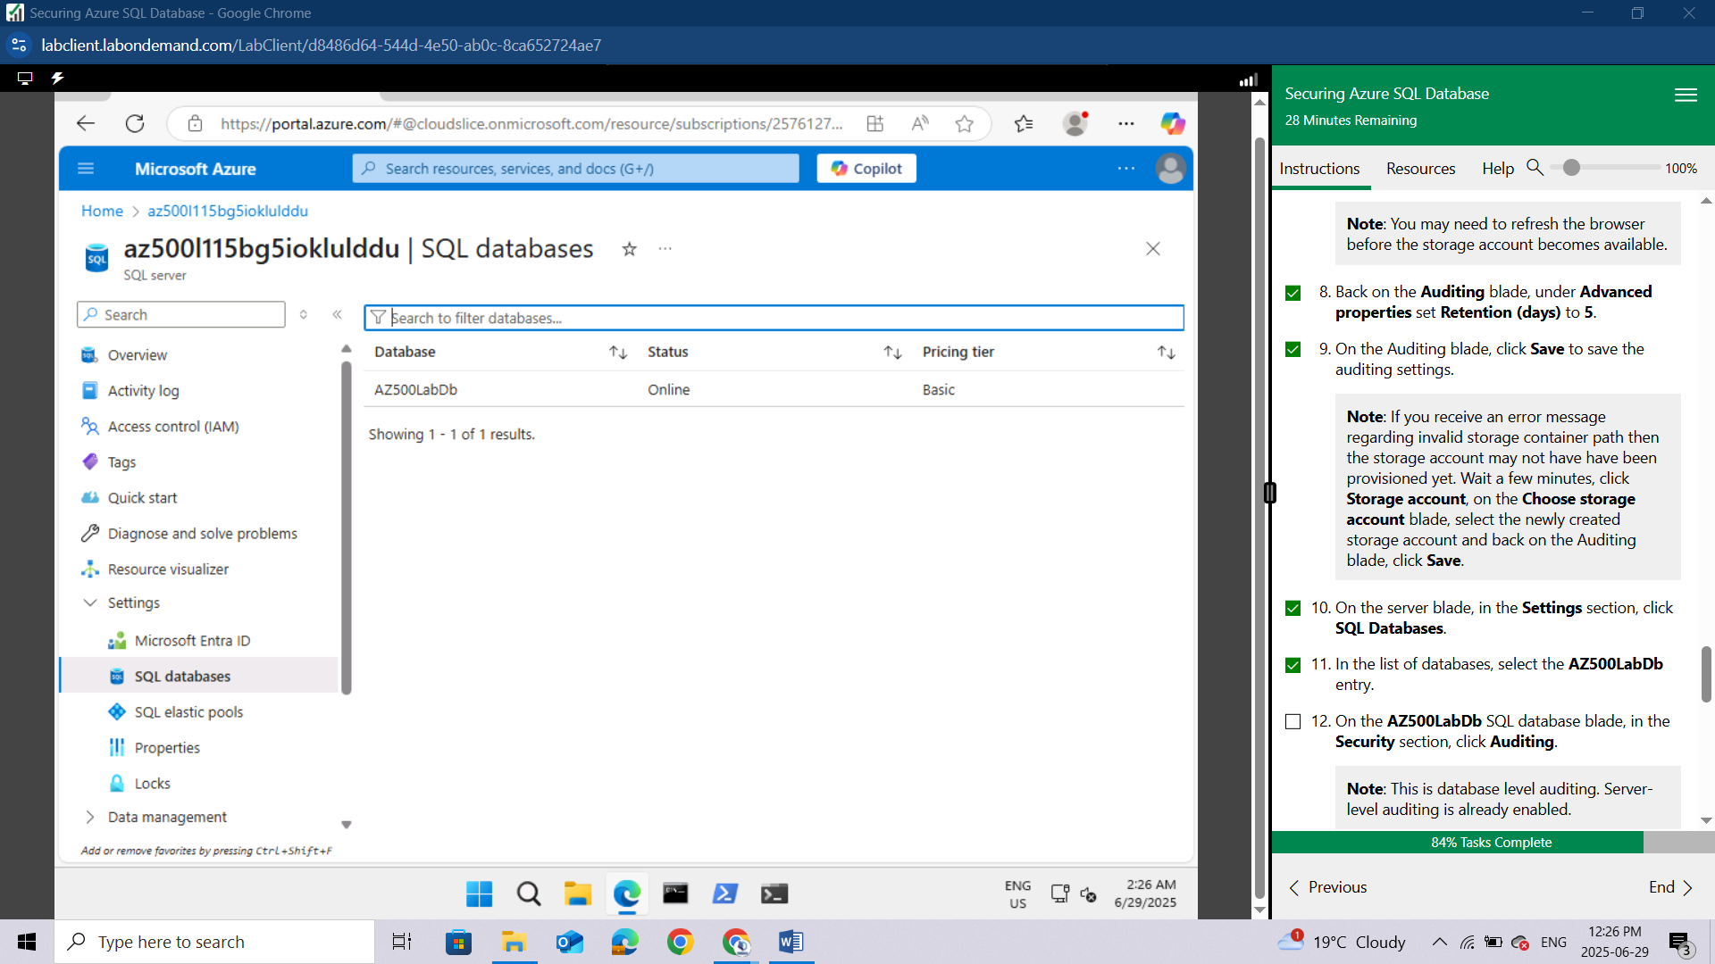
On the AZ500LabDb SQL database blade, in the Security section, click Auditing.
Note: This is database level auditing. Server-level auditing is already enabled.
Note: Audits can be written to an Azure storage account, to a Log Analytics workspace, or to the Event Hub. You can configure any combination of these options.
Note: If storage-based auditing is enabled on the server, it will always apply to the database, regardless of the database settings.
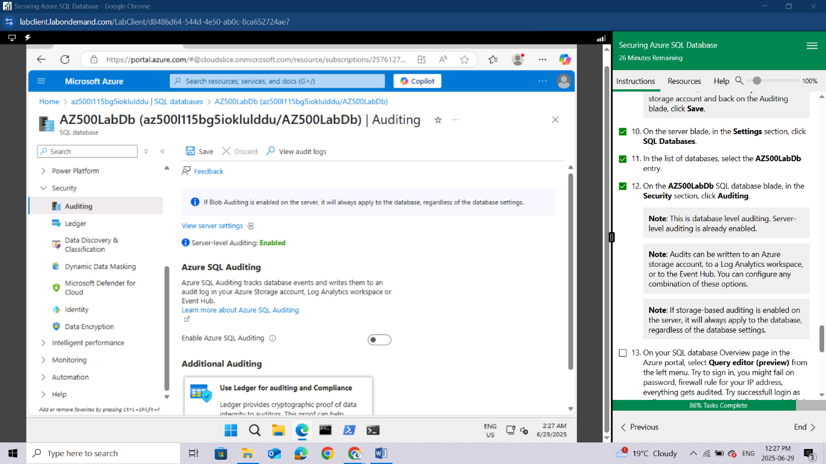
On your SQL database Overview page in the Azure portal, select Query editor (preview) from the left menu. Try to sign in, you might fail on password, firewall rule for your IP address, everything gets audited.
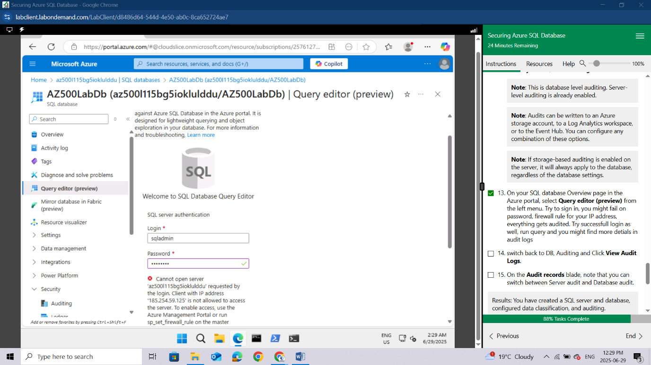
Try successfull login as well, run query and you might find more detials in audit logs.
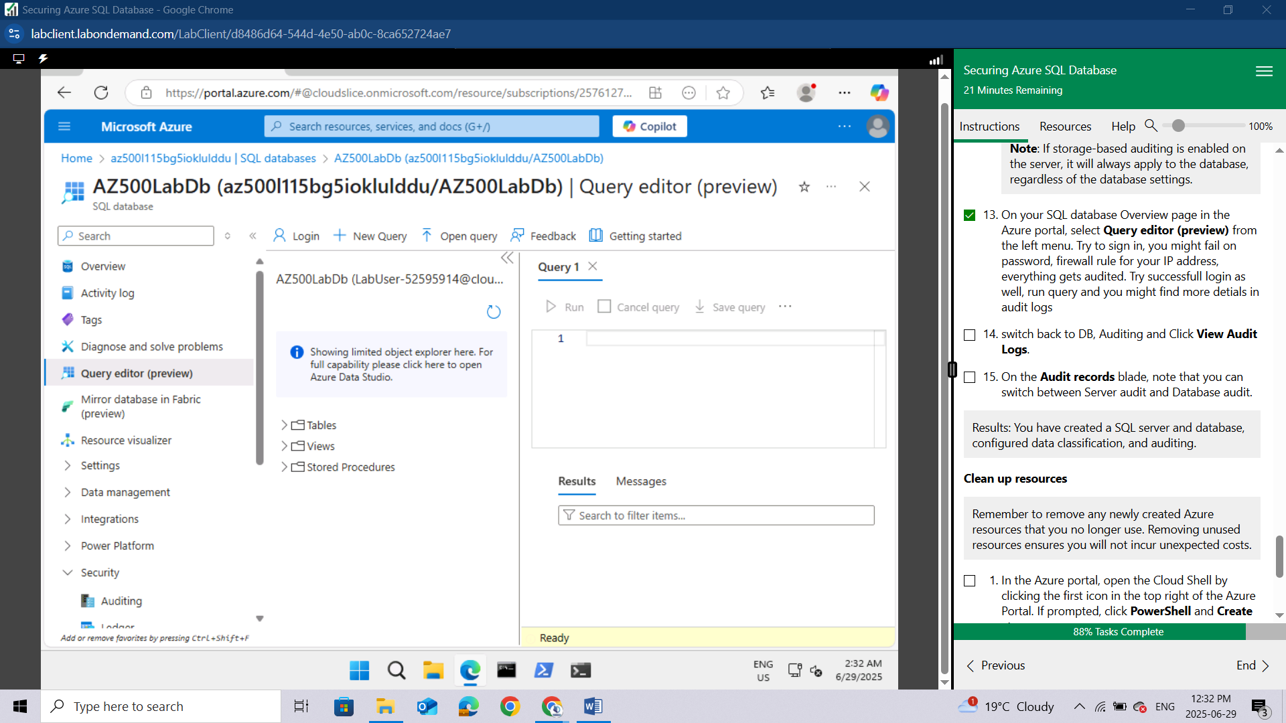
Switch back to DB, Auditing and Click View Audit Logs. On the Audit records blade, note that you can switch between Server audit and Database audit.
Results: You have created a SQL server and database, configured data classification, and auditing.
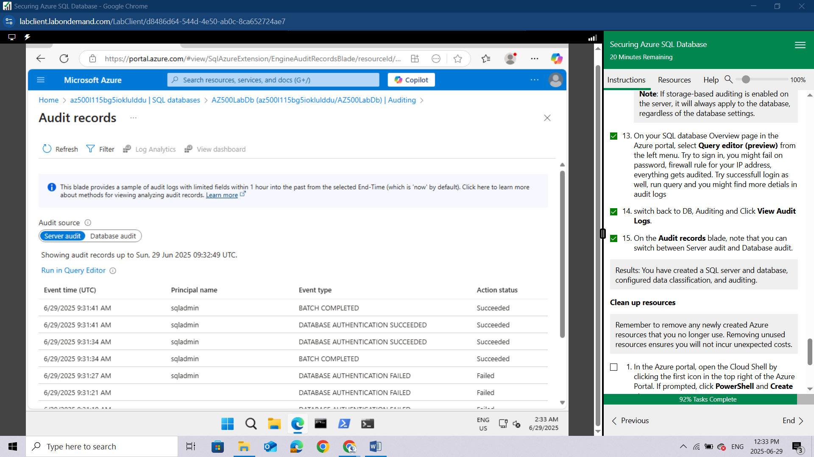

Clean up resources
Remember to remove any newly created Azure resources that you no longer use. Removing unused resources ensures you will not incur unexpected costs.
In the Azure portal, open the Cloud Shell by clicking the first icon in the top right of the Azure Portal. If prompted, click PowerShell and Create storage.
Ensure PowerShell is selected in the drop-down menu in the upper-left corner of the Cloud Shell pane.
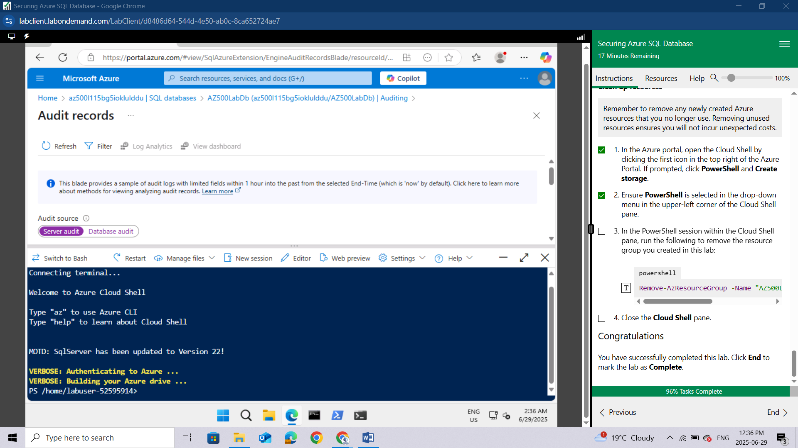
In the PowerShell session within the Cloud Shell pane, run the following to remove the resource group you created in this lab:
powershell
Remove-AzResourceGroup -Name "AZ500LAB11-lod52595914" -Force -AsJob
Close the Cloud Shell pane.
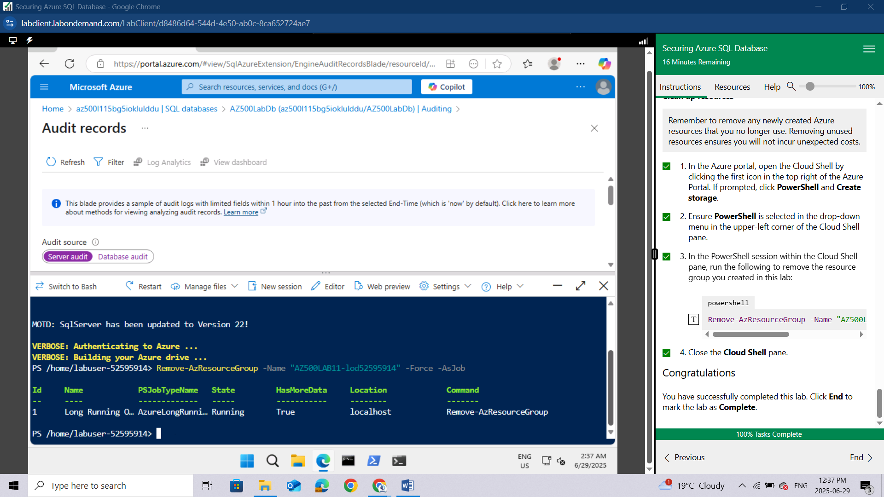
Congratulations! You have successfully completed this lab. Click End to mark the lab as Complete.

Conclusion
In this lab, I completed a series of tasks focused on securing an Azure SQL Database as part of the AZ500 Lab 05. First, I deployed an Azure SQL Database and ensured it was properly configured. Next, I enabled Advanced Data Protection, which provides security against potential threats like SQL injection and data exfiltration. I then moved on to Data Classification, where I discovered and labeled sensitive data within the database, categorizing it as Confidential to enhance visibility and compliance. Lastly, I configured Auditing to track and log database-level and server-level activities, allowing for effective monitoring and incident investigation. Through these tasks, I gained practical experience in applying critical security measures to protect data hosted in Azure SQL Databases.

