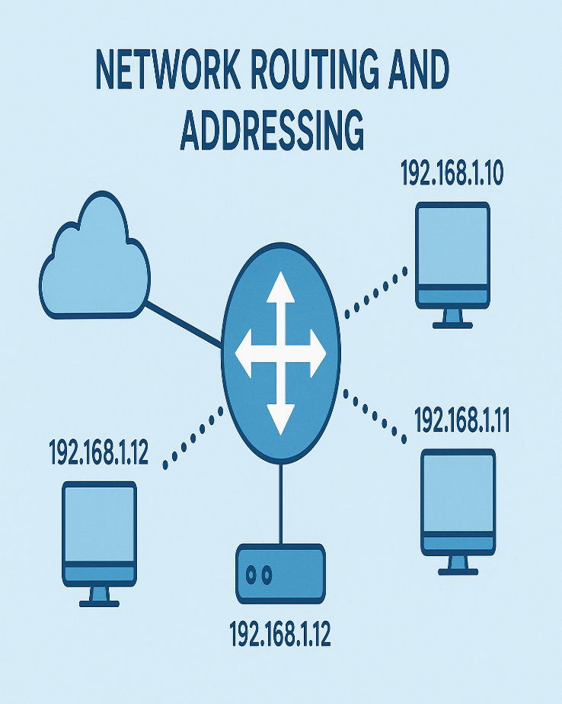  ROUTING AND ADDRESSING  Hands-on-Labs | Abstract  This module focuses on networking in Google Cloud, specifically on routing, addressing, and traffic management. It covers advanced DNS configuration using geolocation-based traffic steering to optimize user experience and direct traffic efficiently. Additionally, it explores enabling secure private connectivity to Google services through Private Google Access and configuring Cloud NAT to allow outbound internet access for resources without public IP addresses. These labs provide practical experience in designing scalable, secure, and geographically-aware network architectures in Google Cloud.  DEBORAH BINYANYA

Contents
CLOUD DNS - TRAFFIC STEERING USING GEOLOCATION POLICY 3
Overview 3
What you learn 3
Architecture 3
Setup and requirements 5
Activate Google Cloud Shell 7
Task 1. Enable APIs 9
Task 2. Configure the firewall 10
Task 3. Launch client VMs 11
Task 4. Launch Server VMs 12
Task 5. Setting up environment variables 13
Task 6. Create the private zone 14
Task 8. Testing 15
Use curl to access the web server 16
Testing from the client VM in us-east1 18
Testing from the client VM in Asia 18
Task 9. Delete lab resources 19
Review 20
Next steps / Learn more 21
End your lab 21
QUIZ 21
LAB 2: Implement Private Google Access and Cloud NAT 22
Overview 22
Setup and Requirements 22
Task 1. Create the VM instance 25
Create the VM instance with no public IP address 31
SSH to vm-internal to test the IAP tunnel 36
Task 2. Enable Private Google Access 39
Create a Cloud Storage bucket 39
Copy an image file into your bucket 42
Access the image from your VM instance 43
Enable Private Google Access 44
Task 3. Configure a Cloud NAT gateway 46
Try to update the VM instances 46
Configure a Cloud NAT gateway 47
Verify the Cloud NAT gateway 52
Task 4. Configure and view logs with Cloud NAT Logging 53
Enabling logging 53
NAT logging in Cloud Logging 55
Generating logs 56
Viewing Logs 57
Task 5. Review 58

CLOUD DNS - TRAFFIC STEERING USING GEOLOCATION POLICY

Overview
Cloud DNS routing policies enable users to configure DNS based traffic steering. A user can either create a Weighted Round Robin (WRR) routing policy or a Geolocation (GEO) routing policy. You can configure routing policies by creating special ResourceRecordSets with special routing policy values.
Use WRR to specify different weights per ResourceRecordSet for the resolution of domain names. Cloud DNS routing policies help ensure that traffic is distributed across multiple IP addresses by resolving DNS requests according to the configured weights.
​​In this lab, you will configure and test the Geolocation routing policy. Use GEO to specify source geolocations and to provide DNS answers corresponding to those geographies. The geolocation routing policy applies the nearest match for the source location when the traffic source location doesn't match any policy items exactly.

What you learn
You will learn how to:
- Launch client VMs, one in each region
- Launch server VMs, one in each region except asia-south1
- Create a private zone, for example.com
- Create a Geolocation routing policy using gcloud commands
- Test the configuration

Architecture
Use the default VPC network to create all the virtual machines (VM) and launch client VMs in 3 Google Cloud locations: one in the United States, another in Europe, and another in Asia. To demonstrate the Geolocation routing policy behavior, you will create the server VMs only in two of those location - in the United States and in Europe. The archirtecture will look similar to what is shown in the graphic. (Note that the actual regions and zones within the United States and Europe may differ from those shown in the graphic.)
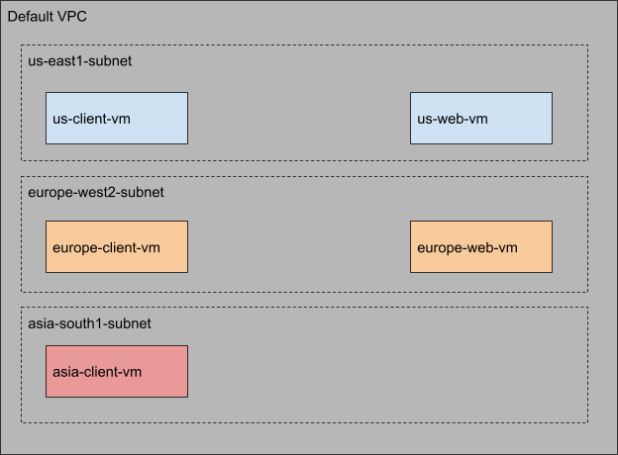
You will use Cloud DNS routing policies and create ResourceRecordSets for geo.example.com and configure the Geolocation policy to help ensure that a client request is routed to a server in the client's closest region.
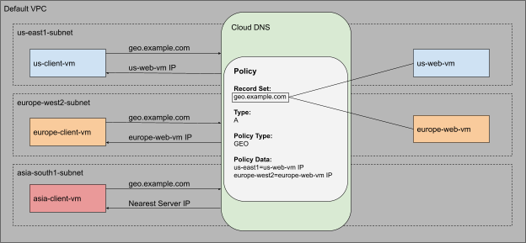

Setup and requirements
Before you click the Start Lab button
Note: Read these instructions.
Labs are timed and you cannot pause them. The timer, which starts when you click Start Lab, shows how long Google Cloud resources will be made available to you.
This Qwiklabs hands-on lab lets you do the lab activities yourself in a real cloud environment, not in a simulation or demo environment. It does so by giving you new, temporary credentials that you use to sign in and access Google Cloud for the duration of the lab.

What you need
To complete this lab, you need:
- Access to a standard internet browser (Chrome browser recommended).
- Time to complete the lab.
Note: If you already have your own personal Google Cloud account or project, do not use it for this lab.Note: If you are using a Pixelbook, open an Incognito window to run this lab.

How to start your lab and sign in to the Console
- Click the Start Lab button. If you need to pay for the lab, a pop-up opens for you to select your payment method. On the left is a panel populated with the temporary credentials that you must use for this lab.
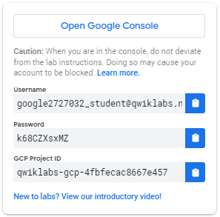
- Copy the username, and then click Open Google Console. The lab spins up resources, and then opens another tab that shows the Choose an account page.
Note: Open the tabs in separate windows, side-by-side.
- On the Choose an account page, click Use Another Account. The Sign in page opens.
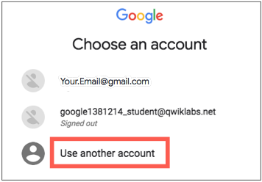
- Paste the username that you copied from the Connection Details panel. Then copy and paste the password.
Note: You must use the credentials from the Connection Details panel. Do not use your Google Cloud Skills Boost credentials. If you have your own Google Cloud account, do not use it for this lab (avoids incurring charges).
- Click through the subsequent pages:
- Accept the terms and conditions.
- Do not add recovery options or two-factor authentication (because this is a temporary account).
- Do not sign up for free trials.
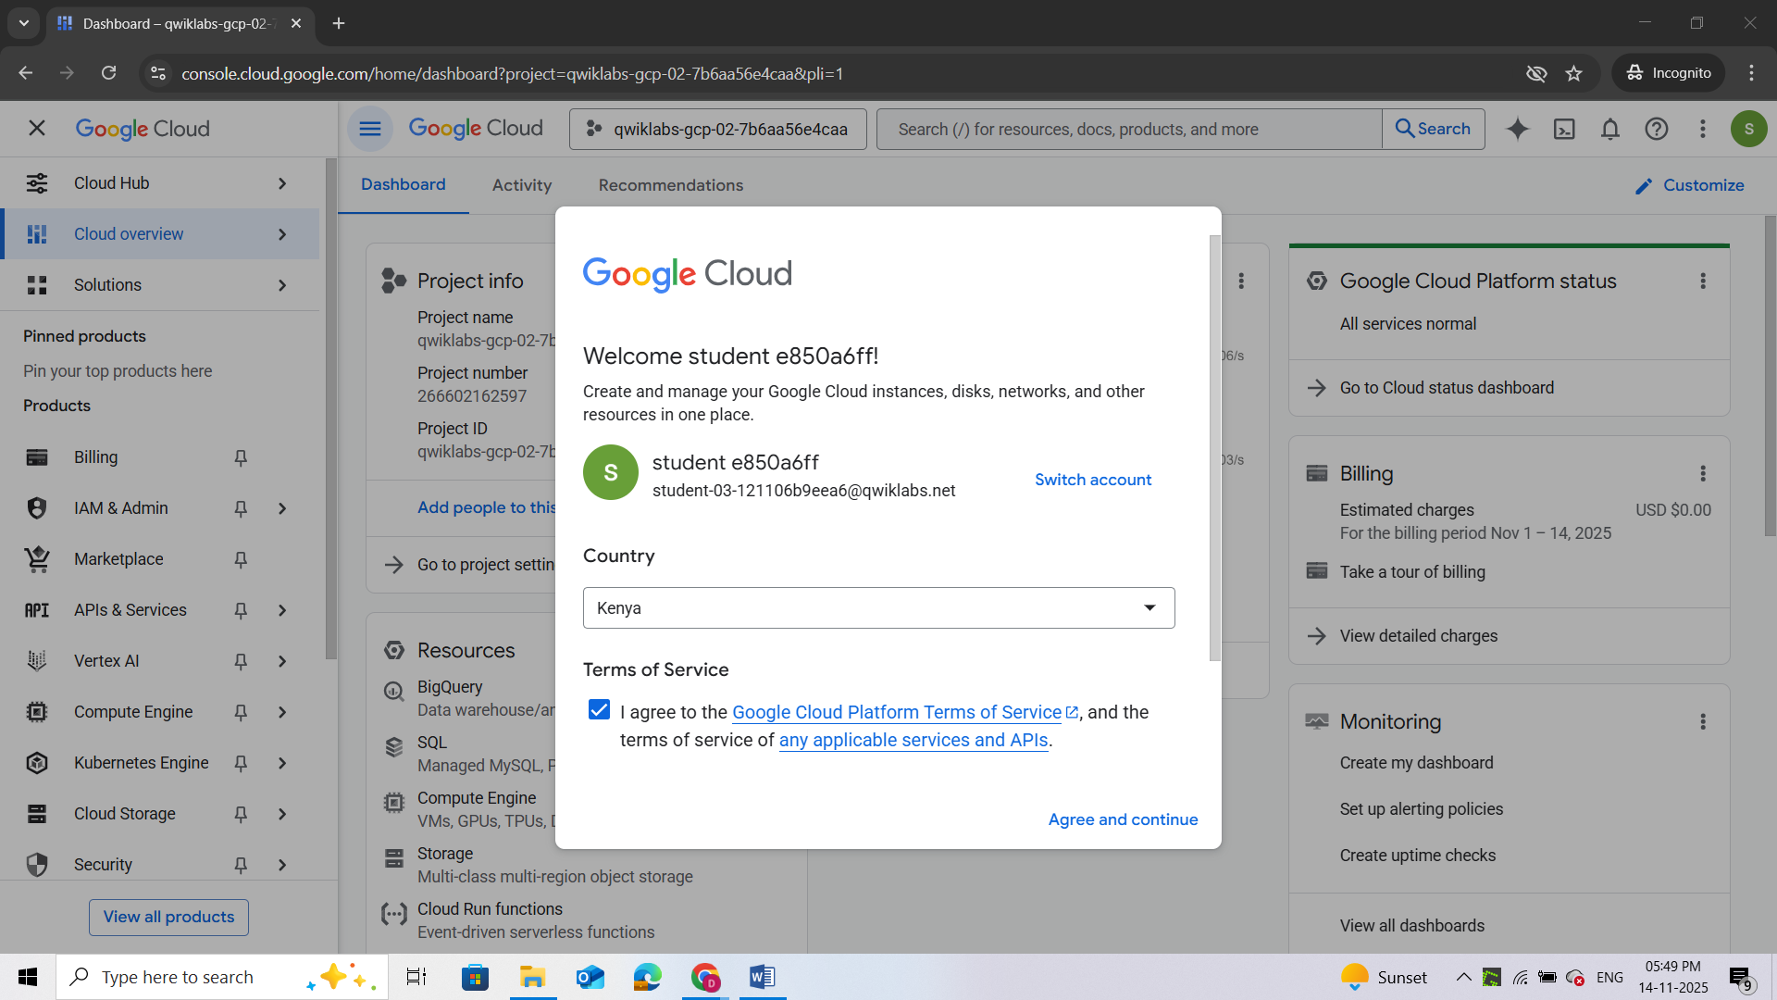

After a few moments, the Cloud console opens in this tab.
Note: You can view the menu with a list of Google Cloud Products and Services by clicking the Navigation menu at the top-left. 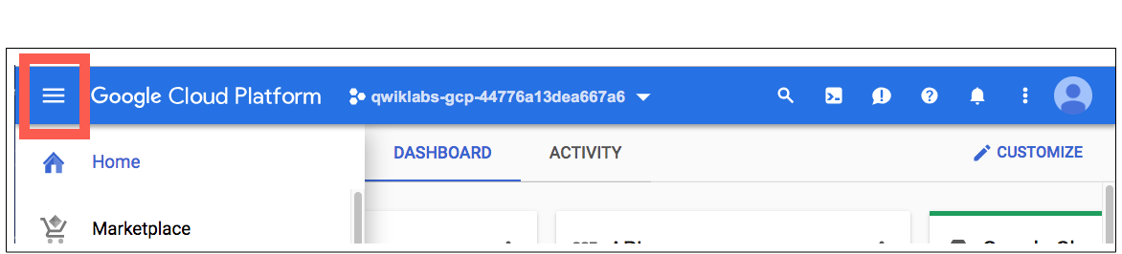

Activate Google Cloud Shell
Google Cloud Shell is a virtual machine that is loaded with development tools. It offers a persistent 5GB home directory and runs on the Google Cloud.
Google Cloud Shell provides command-line access to your Google Cloud resources.
- In Cloud console, on the top right toolbar, click the Open Cloud Shell button.
- Click Continue.
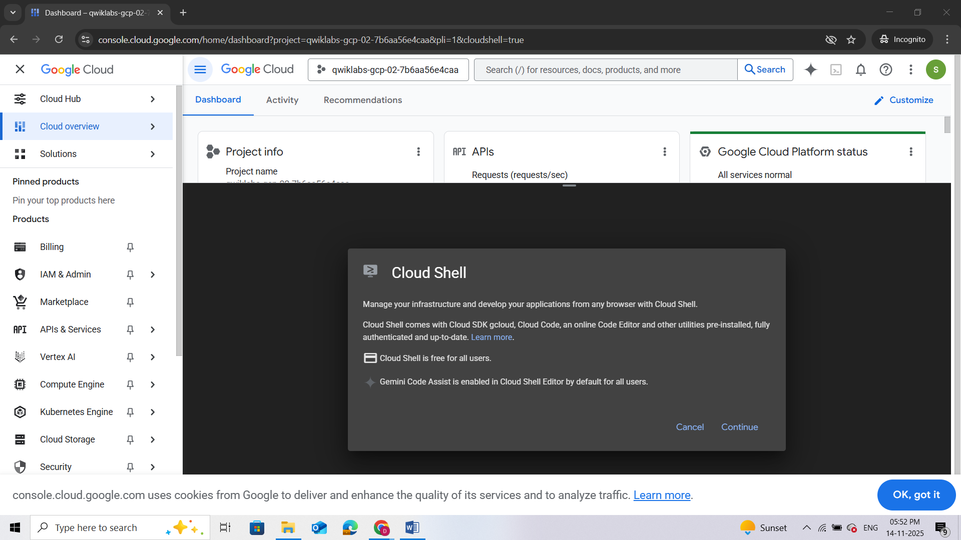
It takes a few moments to provision and connect to the environment. When you are connected, you are already authenticated, and the project is set to your PROJECT_ID. For example:
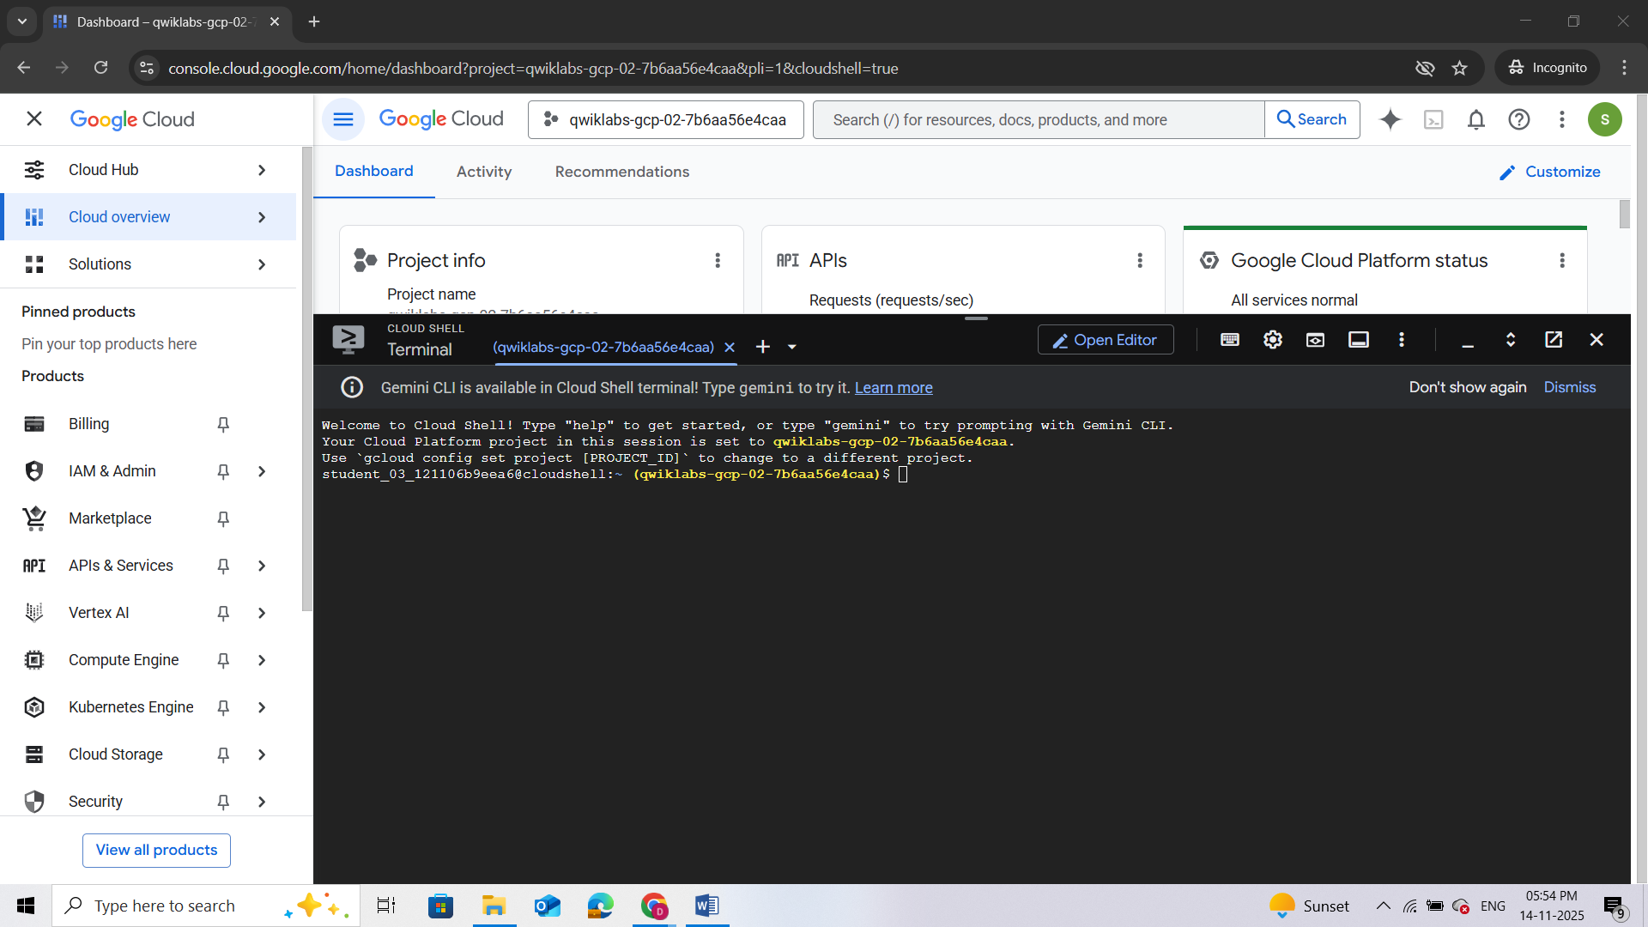
gcloud is the command-line tool for Google Cloud. It comes pre-installed on Cloud Shell and supports tab-completion.
- You can list the active account name with this command:
gcloud auth list
- You can list the project ID with this command:
gcloud config list project
Note: Full documentation of gcloud is available in the gcloud CLI overview guide .
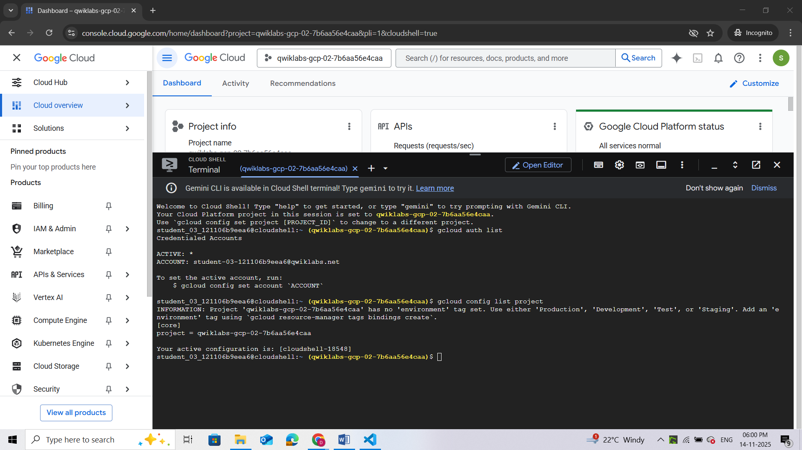

Task 1. Enable APIs
Ensure that the Compute and the Cloud DNS APIs are enabled. In this section, you will enable the APIs manually, using gcloud commands.
Enable Compute Engine API
- Run the gcloud services enable command to enable the Compute Engine API:
gcloud services enable compute.googleapis.com
This command can take a few minutes to complete.
Enable Cloud DNS API
- Run the gcloud services enable command to enable the Cloud DNS API:
gcloud services enable dns.googleapis.com
This command can take a few minutes to complete.
Verify that the APIs are enabled
- Run the gcloud services list command to list all the enabled APIs. We should see compute.googleapis.com and dns.googleapis.com in the listed output.
gcloud services list | grep -E 'compute|dns'
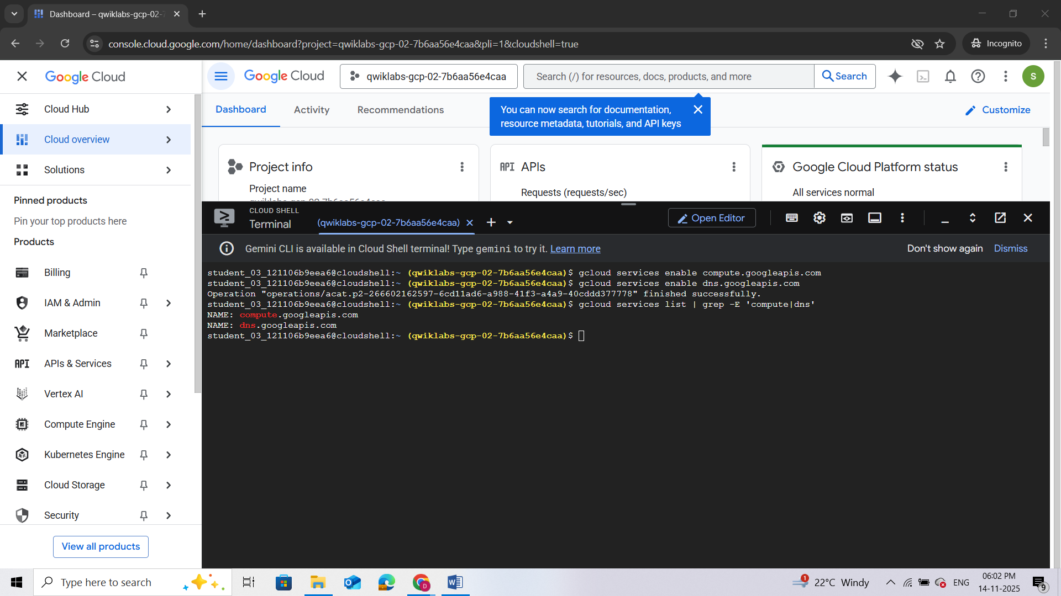

Task 2. Configure the firewall
Before you create the client VMs and the web servers, you need to create two firewall rules.
Note: The firewall-rules create command can take a few minutes to complete. Please wait for the "Creating firewall...done" message before proceeding to the next step.
- To be able to SSH into the client VMs, run the following to create a firewall rule to allow SSH traffic from Identity Aware Proxies (IAP):
gcloud compute firewall-rules create fw-default-iapproxy \
--direction=INGRESS \
--priority=1000 \
--network=default \
--action=ALLOW \
--rules=tcp:22,icmp \
--source-ranges=35.235.240.0/20
- To allow HTTP traffic on the web servers, each web server will have a "http-server" tag associated with it. You will use this tag to apply the firewall rule only to your web servers:
gcloud compute firewall-rules create allow-http-traffic --direction=INGRESS --priority=1000 --network=default --action=ALLOW --rules=tcp:80 --source-ranges=0.0.0.0/0 --target-tags=http-server
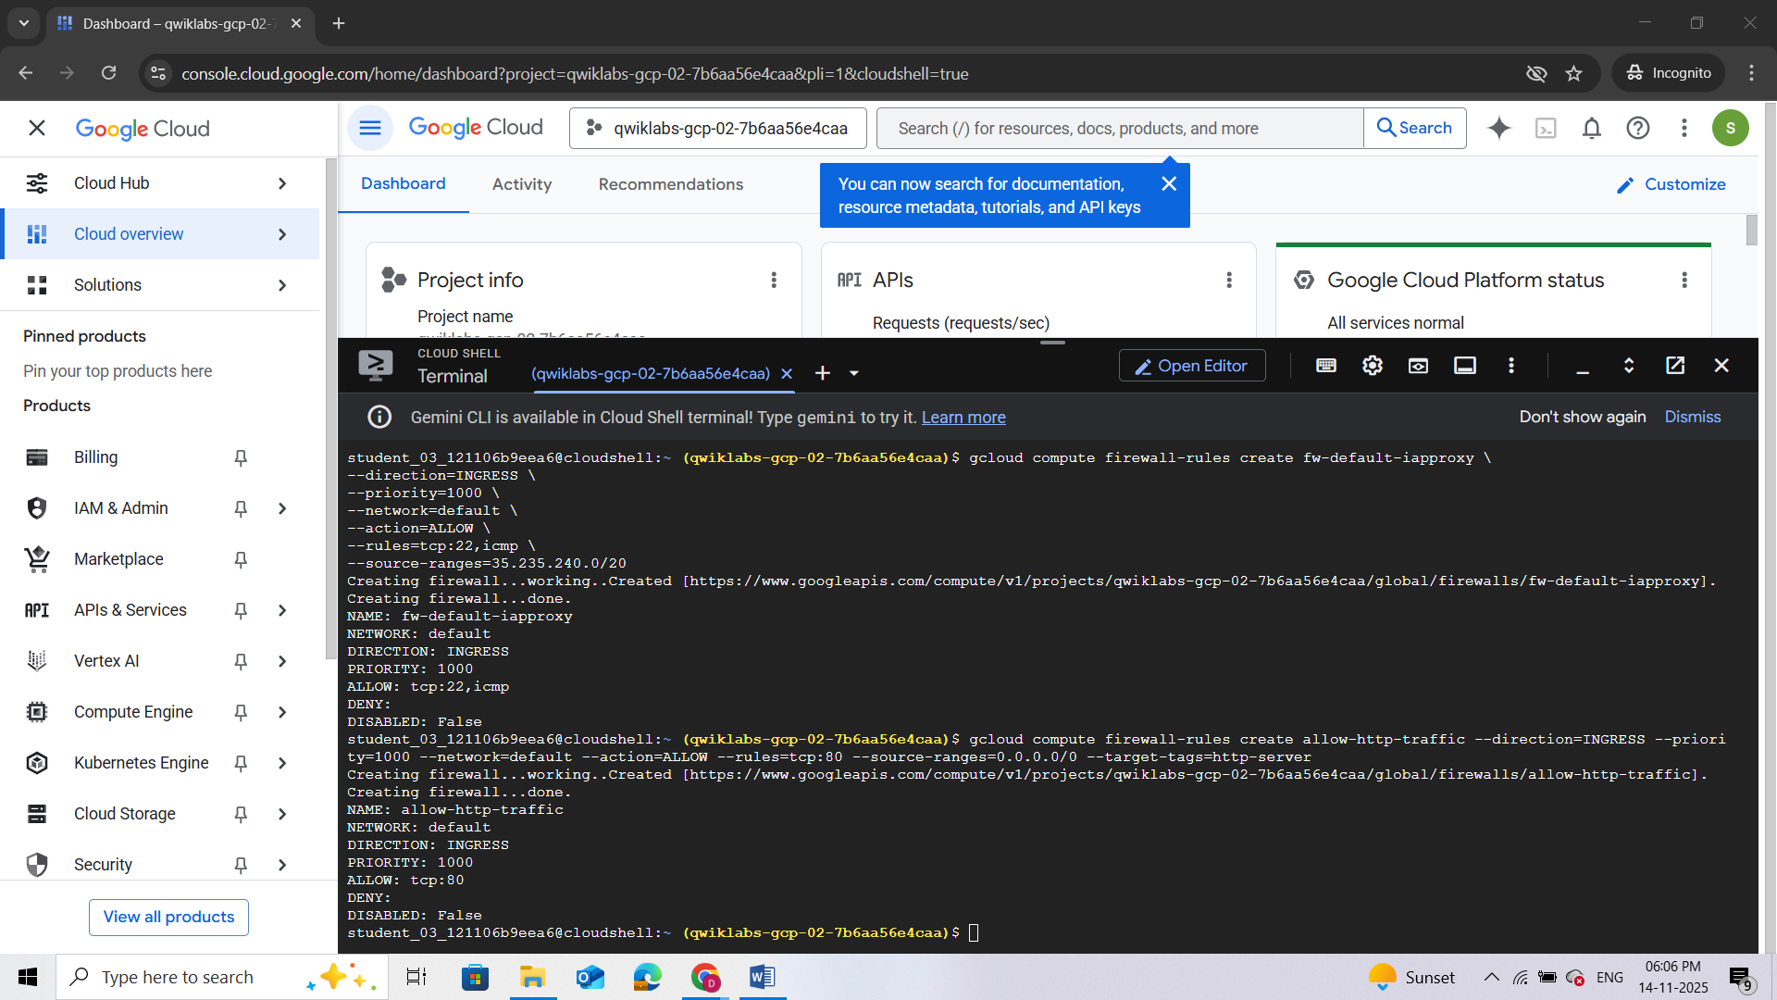

Task 3. Launch client VMs
Now that the APIs are enabled, and the firewall rules are in place, the next step is to set up the environment. In this section, you will create 3 client VMs, one in each region.
Launch a client in the United States
- Run the gcloud compute instances create command to create the client VMs:
gcloud compute instances create us-client-vm --machine-type=e2-micro --zone "Zone 1"
This command can take a few minutes to complete. Please wait for a "Created" message before moving to the next step. Note that you may see a different zone in gcloud than in the sample output shown below.
Launch a client in Europe
- Run the following to create the client VMs:
gcloud compute instances create europe-client-vm --machine-type=e2-micro --zone ""Zone 2""
Note that you may see a different zone in gcloud than in the sample output shown below.
Launch a client in Asia
- Run the following to create the client VMs:
gcloud compute instances create asia-client-vm --machine-type=e2-micro --zone ""Zone 3""
Note that you may see a different zone in gcloud than in the sample output shown below.
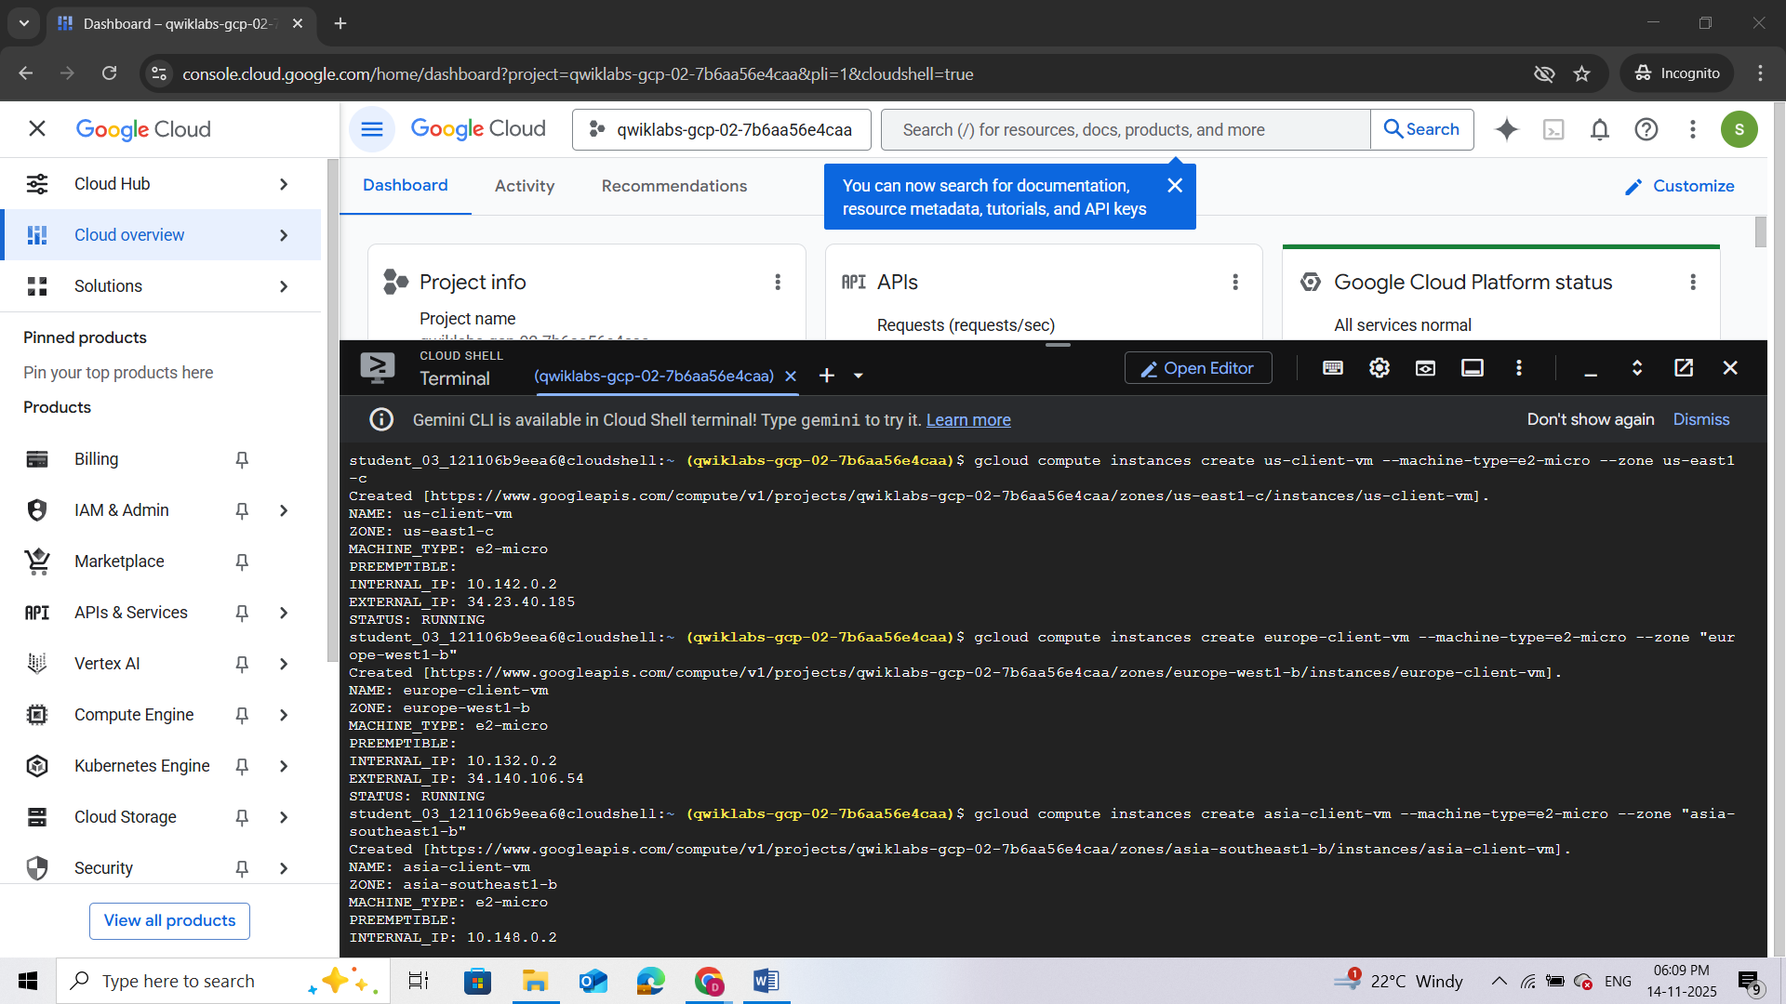

Task 4. Launch Server VMs
Now that the client VM's are up and running, the next step is to create the server VMs. You will use a startup script to configure and set up the web servers. As mentioned earlier, you will create the server VMs only in 2 regions: us-east1 and europe-west2.
- Run the gcloud compute instances create command to create the server VMs. The compute instance create command can take a few minutes to complete. Please wait for a "Created" message before moving to the next step.

Launch server in the United States
- Run the following command:
gcloud compute instances create us-web-vm \
--machine-type=e2-micro \
--zone="Zone 1" \
--network=default \
--subnet=default \
--tags=http-server \
--metadata=startup-script='#! /bin/bash
apt-get update
apt-get install apache2 -y
echo "Page served from: "Region 1"" | \
tee /var/www/html/index.html
systemctl restart apache2'
Note that you may see a different zone in gcloud than in the sample output shown below.
Launch server in Europe
- Run the following to command:
gcloud compute instances create europe-web-vm \
--machine-type=e2-micro \
--zone="Zone 2" \
--network=default \
--subnet=default \
--tags=http-server \
--metadata=startup-script='#! /bin/bash
apt-get update
apt-get install apache2 -y
echo "Page served from: "Zone 2"" | \
tee /var/www/html/index.html
systemctl restart apache2'
Note that you may see a different zone in gcloud than in the sample output shown below.
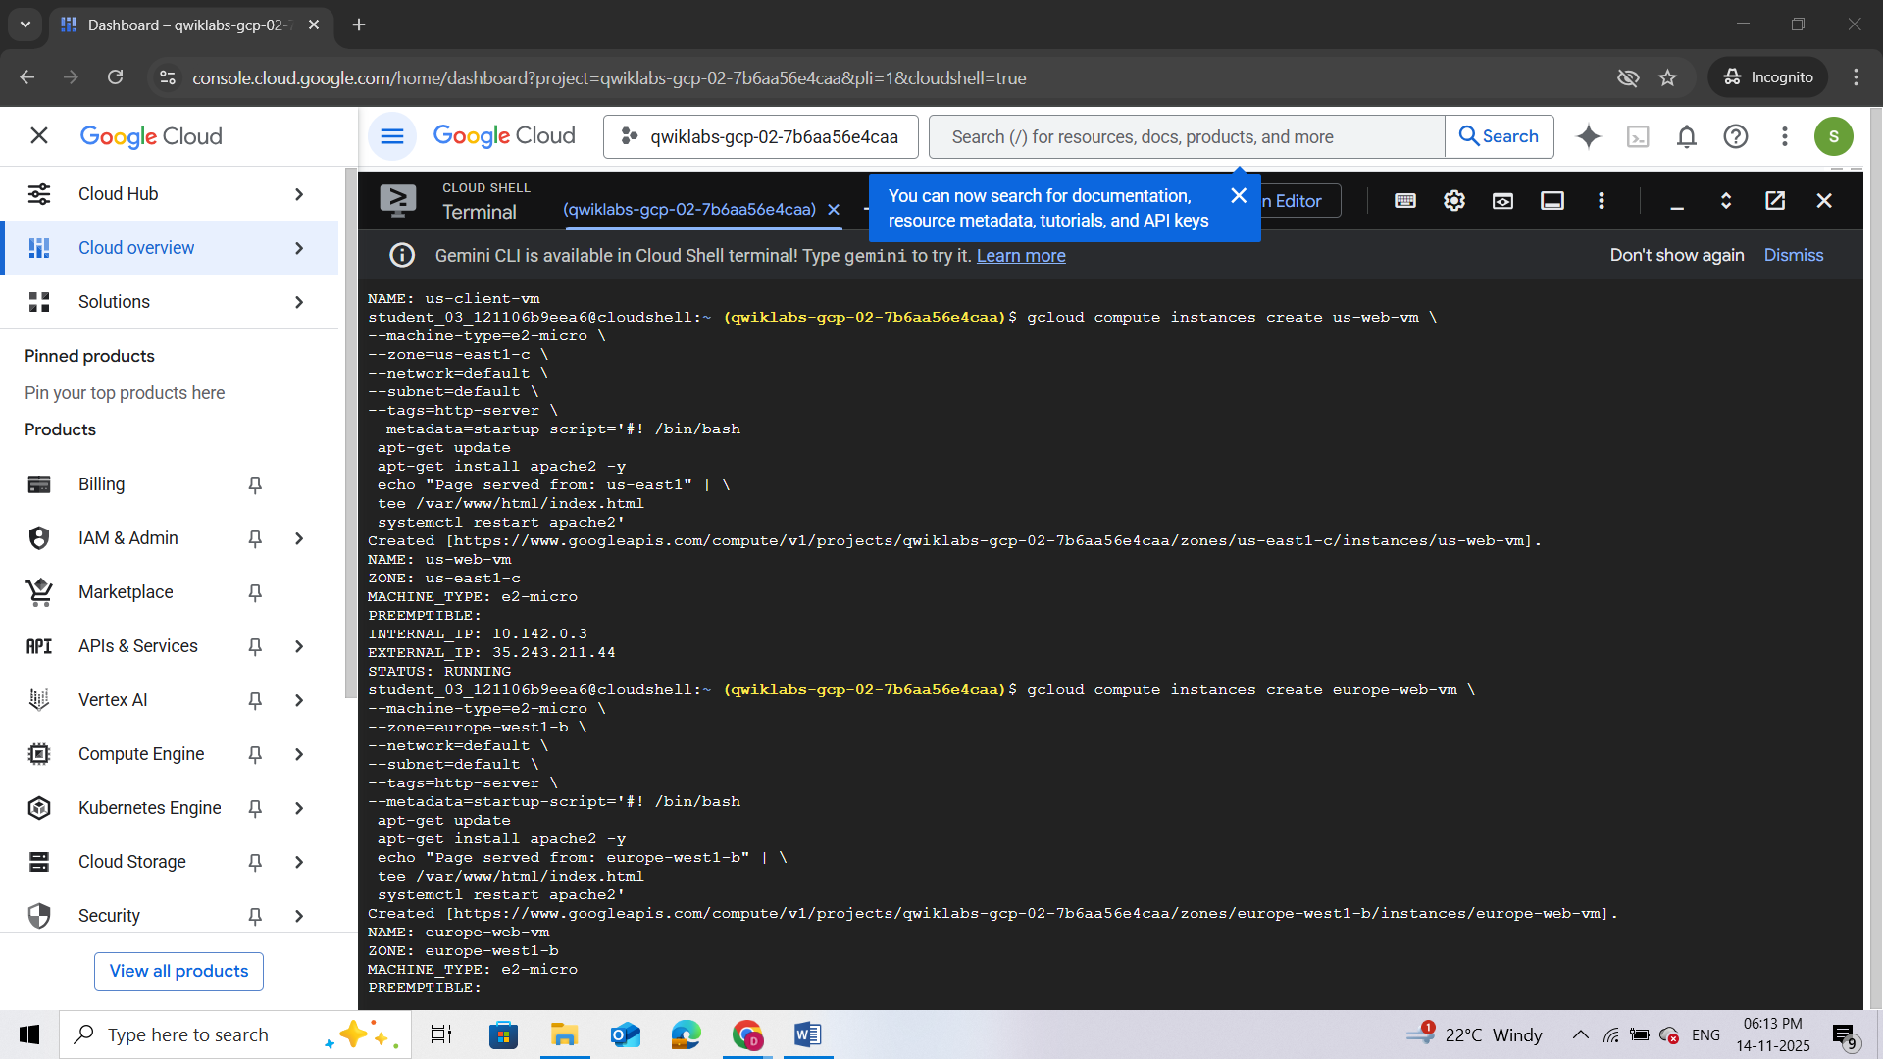

Task 5. Setting up environment variables
Before you configure Cloud DNS, note the Internal IP addresses of the web servers. You need these IPs to create the routing policy. In this section, you will use the gcloud compute instances describe command to save the internal IP addresses as environment variables.
- Command to save IP address for the VM in the United States
export US_WEB_IP=$(gcloud compute instances describe us-web-vm --zone="Zone 1" --format="value(networkInterfaces.networkIP)")
- Command to save the IP address for the VM in Europe:
export EUROPE_WEB_IP=$(gcloud compute instances describe europe-web-vm --zone="Zone 2" --format="value(networkInterfaces.networkIP)")
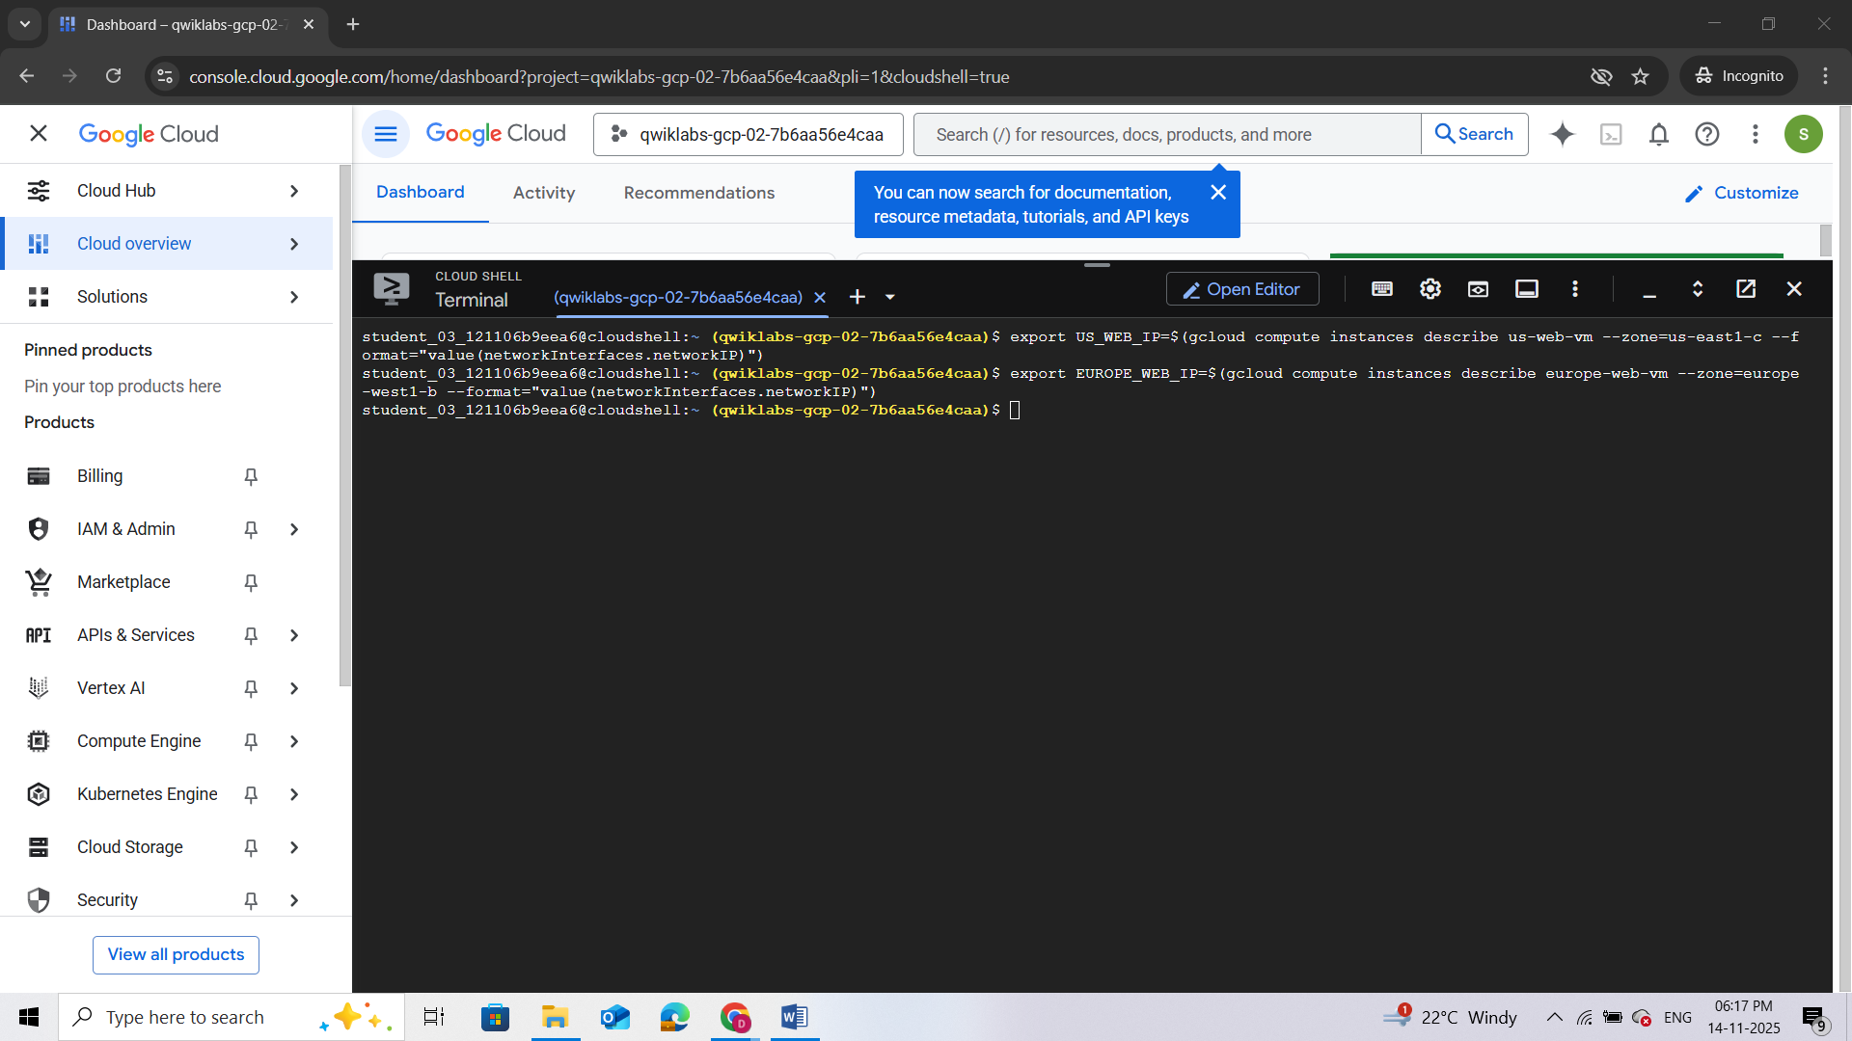

Task 6. Create the private zone
Now that your client and server VMs are running, it's time to configure the DNS settings. Before creating the A records for the web servers, you need to create the Cloud DNS Private Zone.
For this lab, use the example.com domain name for the Cloud DNS zone.
- Use the gcloud dns managed-zones create command to create the zone:
gcloud dns managed-zones create example --description=test --dns-name=example.com --networks=default --visibility=private
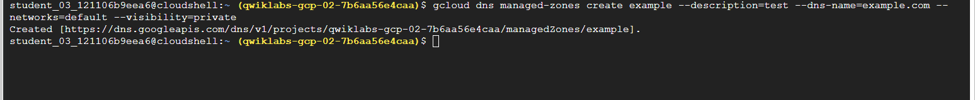Task 7. Create Cloud DNS Routing Policy
In this section, configure the Cloud DNS Geolocation Routing Policy. You will create a record set in the example.com zone that you created in the previous section.
Create
- Use the gcloud dns record-sets create command to create the geo.example.com recordset:
gcloud dns record-sets create geo.example.com \
--ttl=5 --type=A --zone=example \
--routing-policy-type=GEO \
--routing-policy-data=""Region 1"=$US_WEB_IP;"Region 2"=$EUROPE_WEB_IP"
You are creating an A record with a Time to Live (TTL) of 5 seconds. The policy type is GEO, and the routing_policy_data field accepts a semicolon-delimited list of the format ${region}:${rrdata},${rrdata}.
Verify
- Use the dns record-sets list command to verify that the geo.example.com DNS record is configured as expected:
gcloud dns record-sets list --zone=example
The output shows that an A record with a TTL of 5 is created for geo.example.com, and the data matches our server set up in each region.
Note that in gcloud, the DATA value under geo.example.com may include United States and Europe regions that differ from the sample output below.
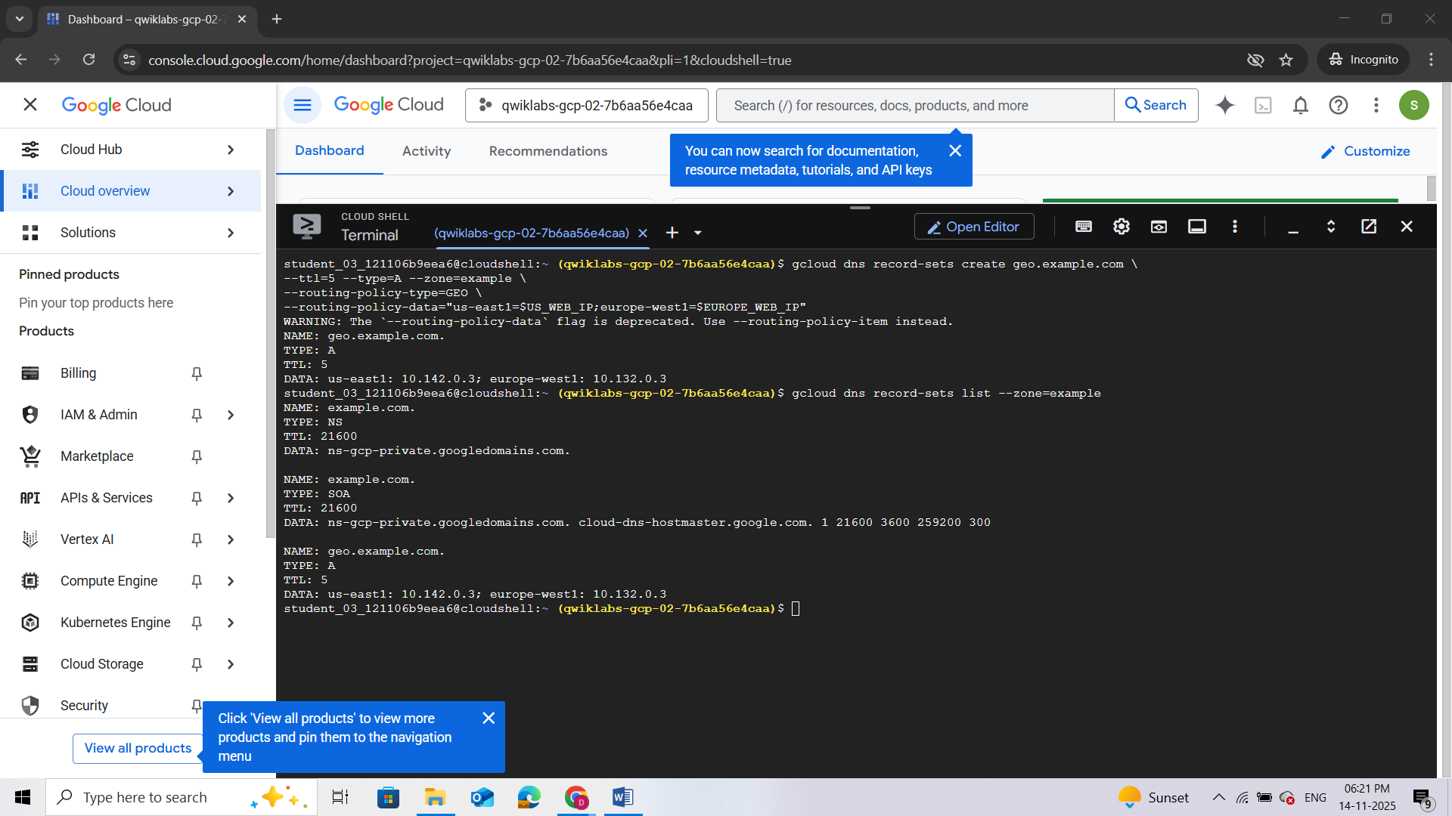

Task 8. Testing
It's time to test the configuration. In this section, you will SSH into all the client VMs. Since all of the web server VMs are behind the geo.example.com domain, you will use CURL command to access this endpoint.
Since you are using a Geolocation policy, the expected result is that:
- The client in the US should always get a response from the <Zone 1 region.
- The client in Europe should always get a response from the Zone 2 region.
Testing from the client VM in Europe
- Use the gcloud compute ssh command to log into the client VM:
gcloud compute ssh europe-client-vm --zone "Zone 2" --tunnel-through-iap
- Follow prompts to SSH into the machine. When asked to enter the passphrase, leave the field blank and press the Enter key twice.
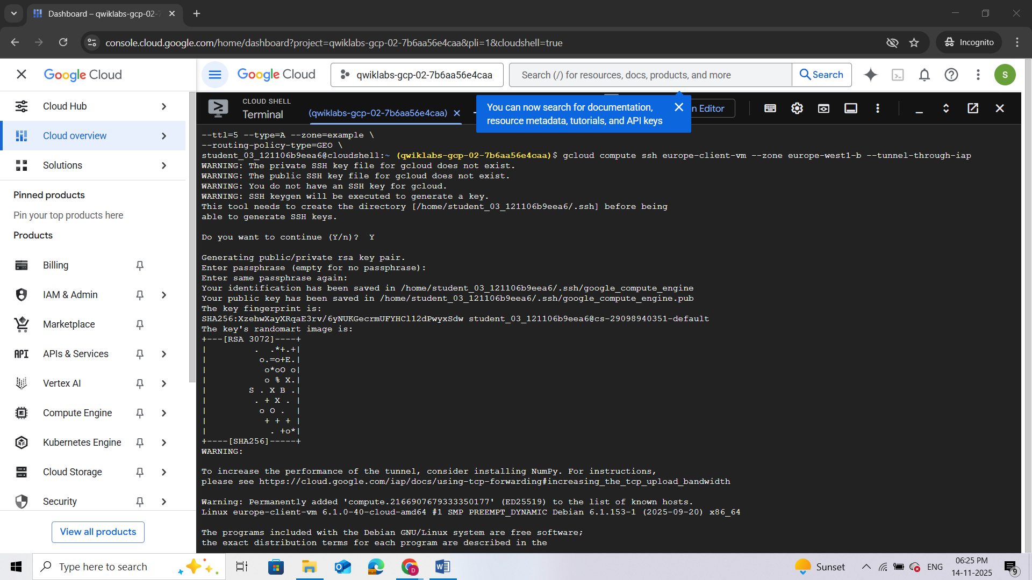
Once complete, the command line should change to "user_name@europe-client-vm:~$"

Use curl to access the web server
- Now that you are in the client VM, use the CURL command to access the geo.example.com endpoint. The loop is configured to run the command ten times with a sleep timer of 6 seconds:
for i in {1..10}; do echo $i; curl geo.example.com; sleep 6; done
Since the TTL on the DNS record is set to 5 seconds, a sleep timer of 6 seconds has been added. The sleep timer will make sure that you get an uncached DNS response for each cURL request. This command will take approximately one minute to complete.
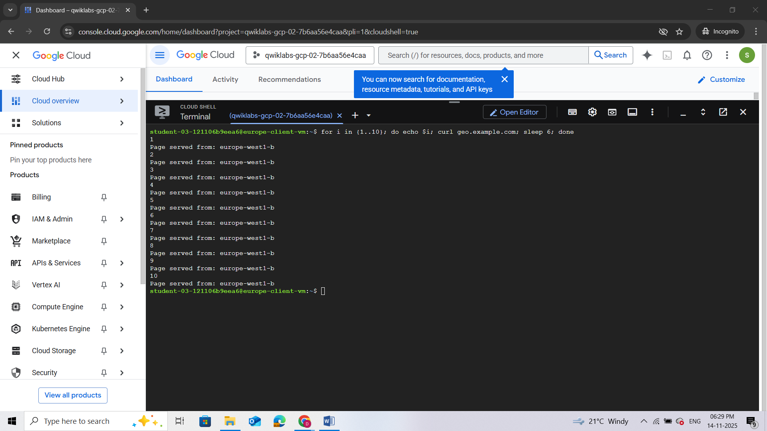
- Run this test multiple times and analyze the output to see which server is responding to the request. The client should always receive a response from a server in the client's region.
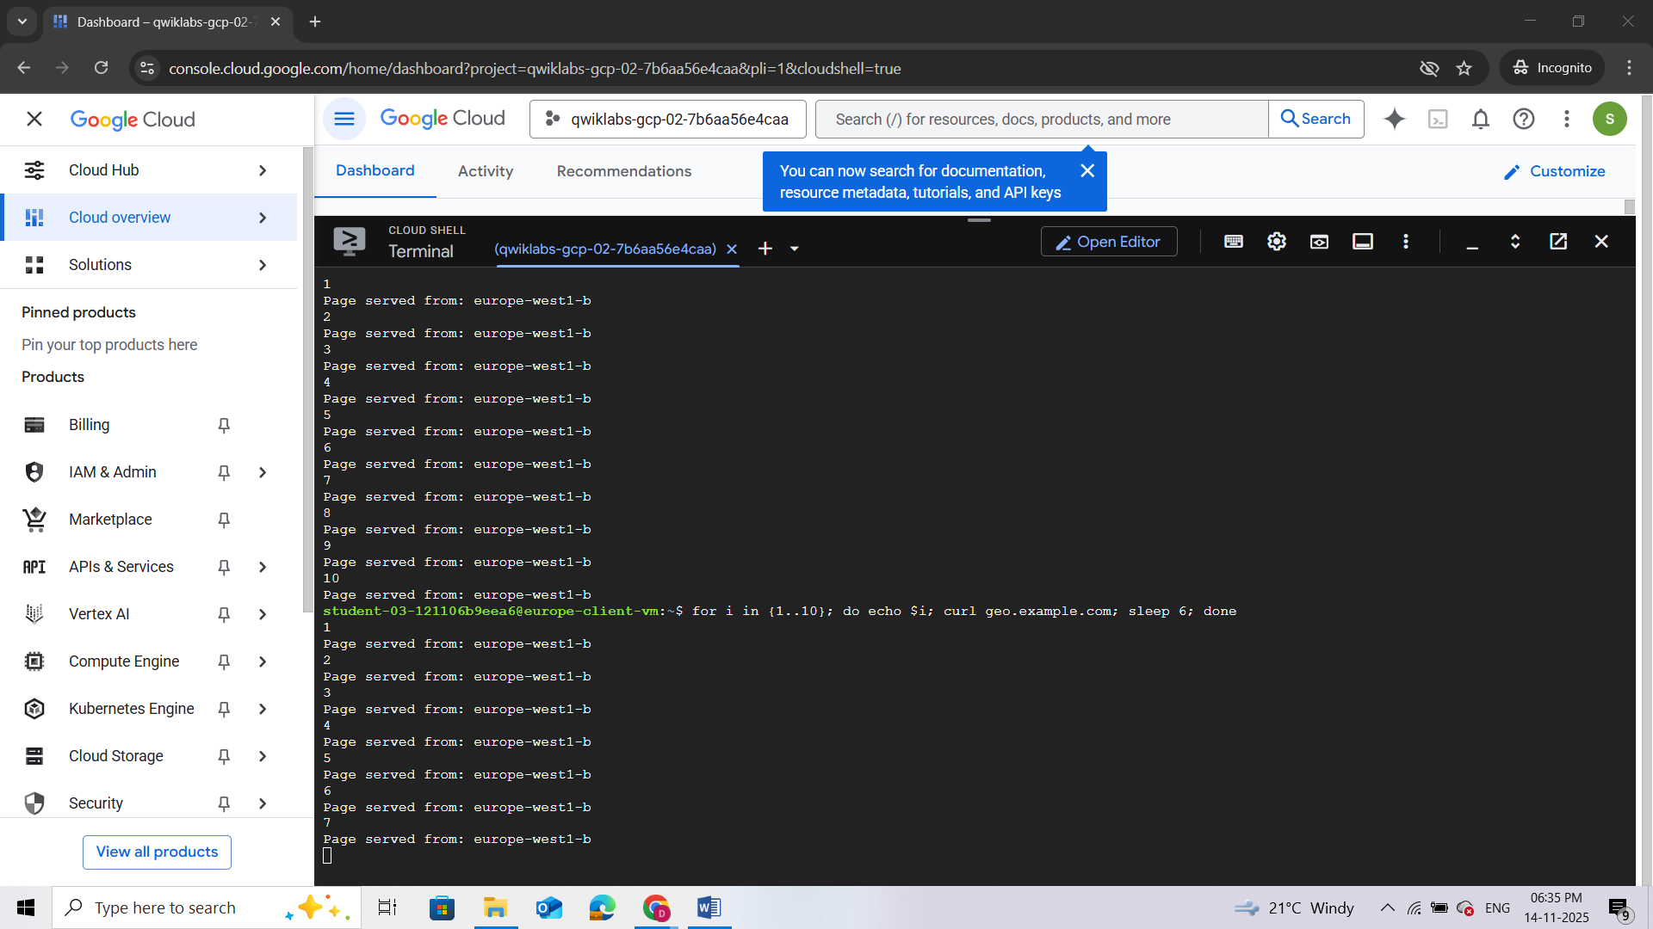
Getting back to Cloud Shell
- Once you have run the test multiple times, exit the client VM in Europe by typing "exit" in the VM's command prompt. This will bring you back to the Cloud Shell console.
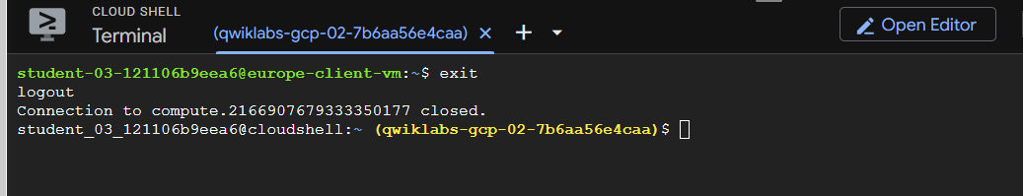

Testing from the client VM in us-east1
Now perform the same test from the client VM in the US.
- Use the gcloud command below to SSH into the us-client-vm:
gcloud compute ssh us-client-vm --zone "Zone 1" --tunnel-through-iap
- Use the curl command to access geo.example.com:
for i in {1..10}; do echo $i; curl geo.example.com; sleep 6; done
- Now analyze the output to see which server is responding to the request. The client should always receive a response from a server in the client's region. The expected output is "Page served from: <filled at lab start>".
- Once you have run the test multiple times, exit the client VM in the US by typing "exit" in the VM's command prompt.
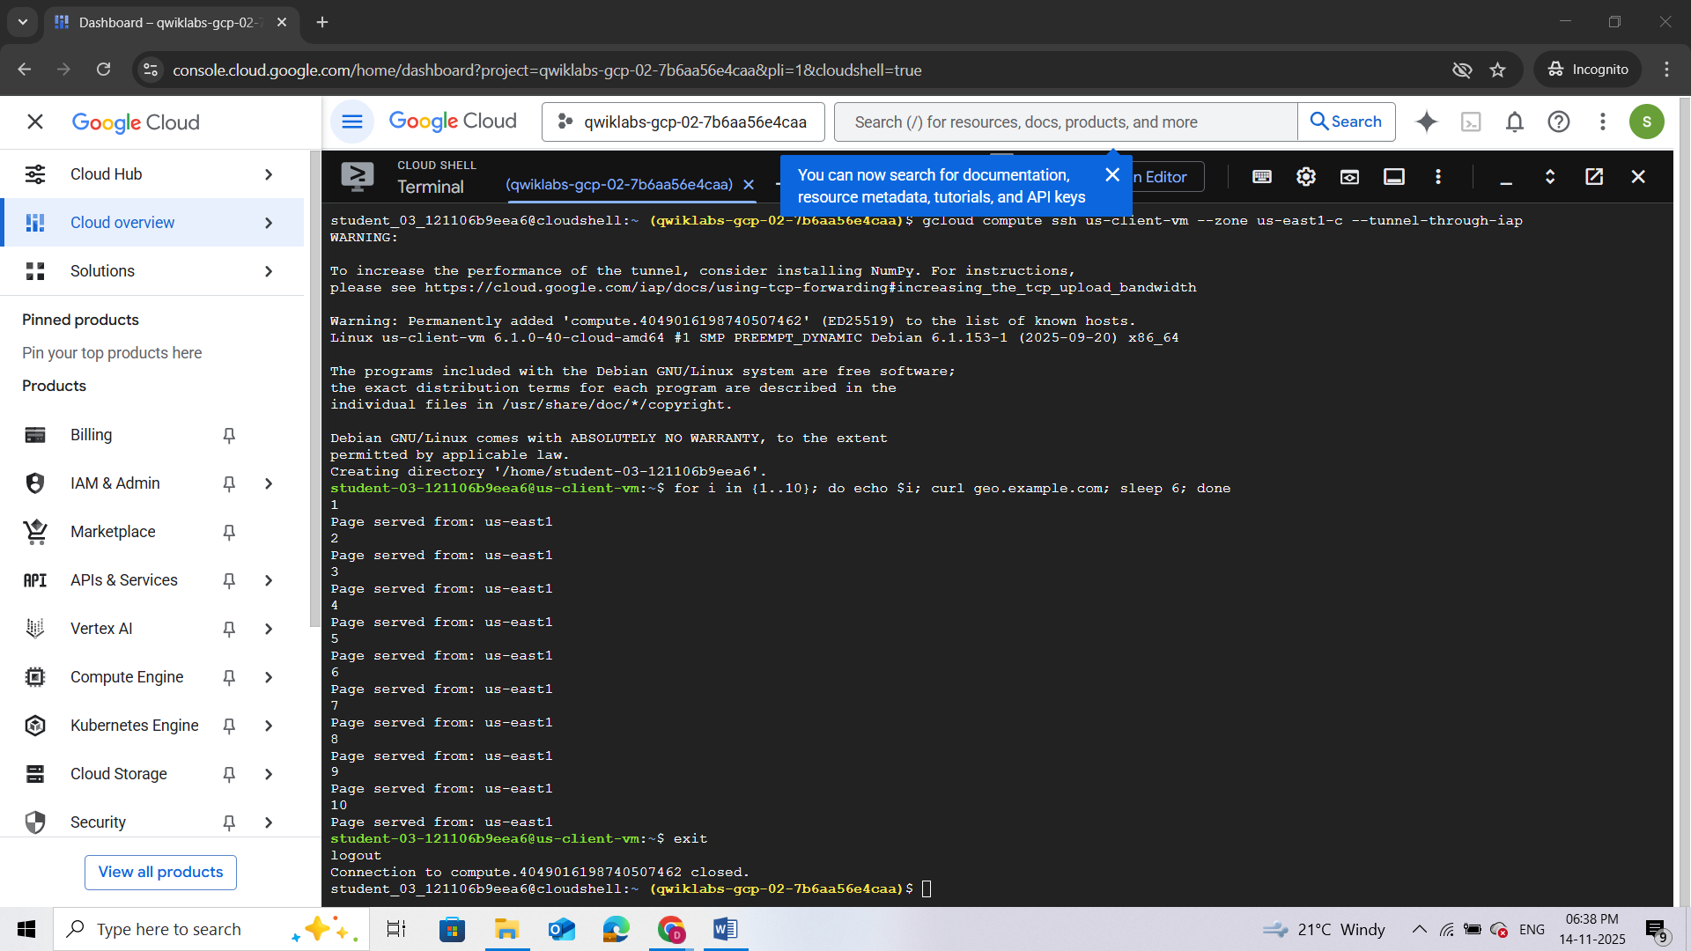

Testing from the client VM in Asia
So far you have tested the setup from the United States and Europe. You have servers running in both the regions and have matching record sets for both the regions in Cloud DNS routing policy. There is no matching policy item for the region within Asia (selected earlier) in the Cloud DNS routing policy.
The Geolocation policy will apply a "nearest" match for source location when the source of the traffic doesn't match any policy items exactly. This means that the Asia client should be directed to the nearest web server.
In this section, you will resolve the geo.example.com domain from the client VM in Asia and will analyze the response.
- SSH into the asia-client-vm. For <SELECTED-ZONE>, use the zone that you used to create the Asia client.
gcloud compute ssh asia-client-vm --zone <SELECTED-ZONE> --tunnel-through-iap
- Then access geo.example.com:
for i in {1..10}; do echo $i; curl geo.example.com; sleep 6; done
- Analyze the output to see which server is responding to the request. Since there is no policy item for any of the Asia regions, Cloud DNS will direct the client to the nearest server.
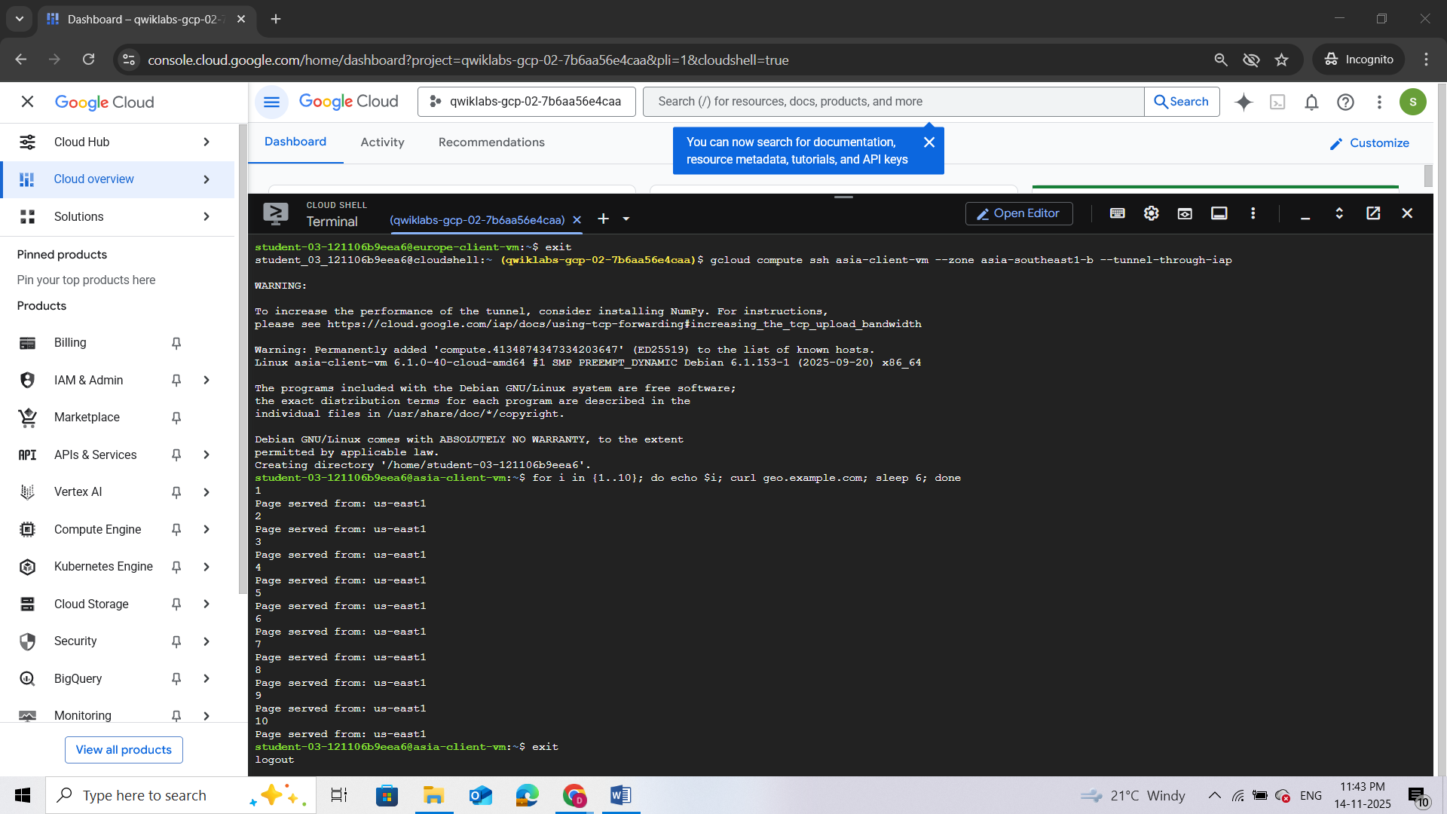
- Once you have run the test multiple times, exit the client VM in Asia by typing "exit" in the VM's command prompt.
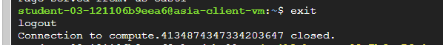

Task 9. Delete lab resources
Although all resources you used in this lab will be deleted when you finish, it is good practice to remove resources you no longer need to avoid unnecessary charges.
- The following gcloud commands will delete all the resources that were created in the lab. (Note that SELECTED-ZONE is the Asia zone that you wrote down earlier.)
#delete VMS
gcloud compute instances delete -q us-client-vm --zone "ZONE"

gcloud compute instances delete -q us-web-vm --zone "ZONE"

gcloud compute instances delete -q europe-client-vm --zone "Zone 2"

gcloud compute instances delete -q europe-web-vm --zone "Zone 2"

gcloud compute instances delete -q asia-client-vm --zone SELECTED-ZONE

#delete FW rules
gcloud compute firewall-rules delete -q allow-http-traffic

gcloud compute firewall-rules delete fw-default-iapproxy

#delete record set
gcloud dns record-sets delete geo.example.com --type=A --zone=example

#delete private zone
gcloud dns managed-zones delete example
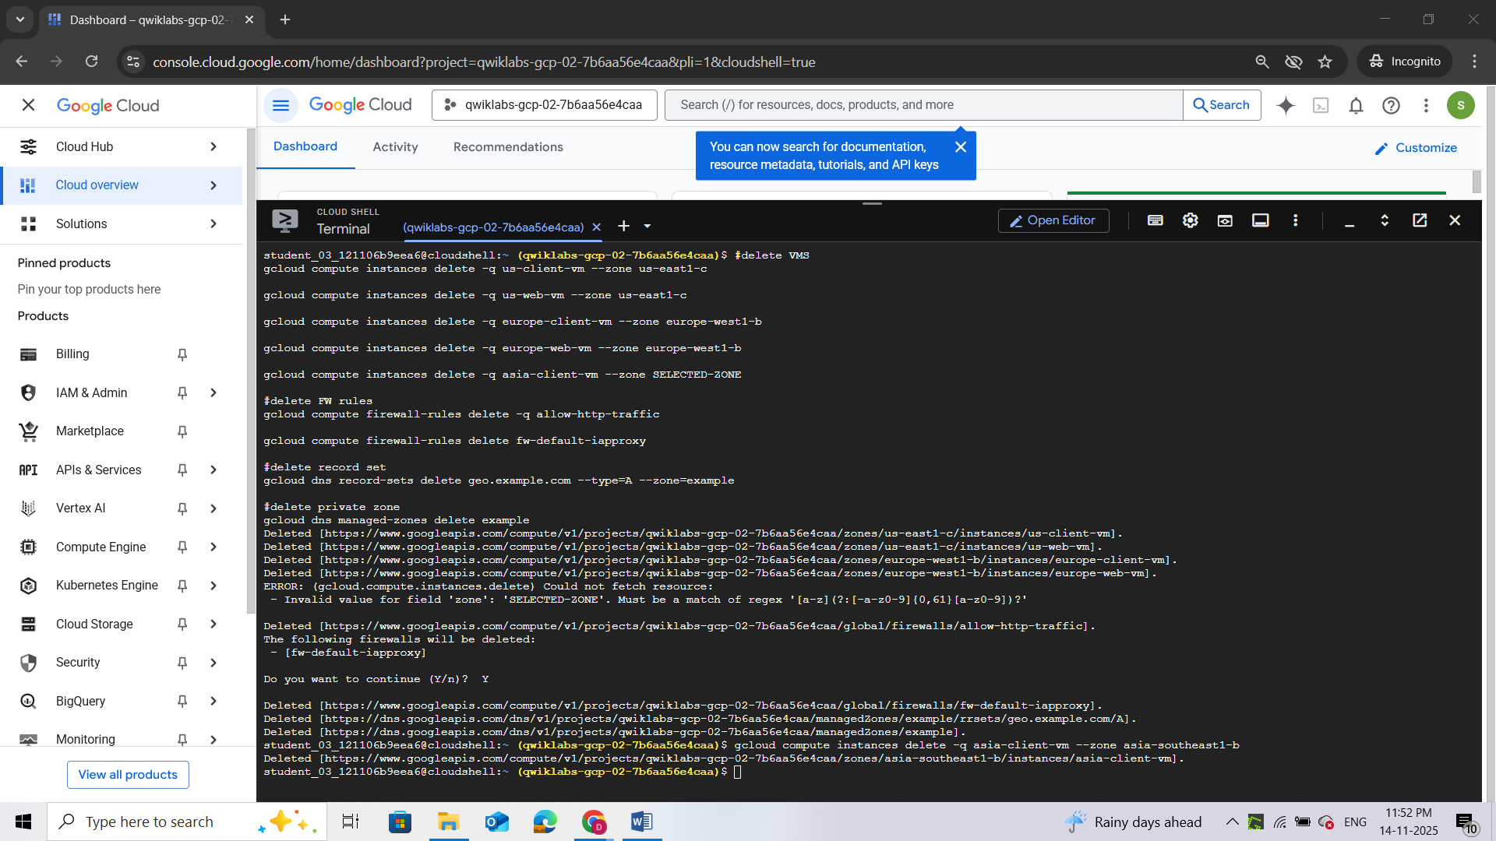

Review
In this lab, you configured and used Cloud DNS routing policies with Geolocation routing policy. You also verified the configuration and behavior of the Cloud DNS routing policy by observing the HTTP response when accessing the web servers.

Next steps / Learn more
You can read more about Cloud DNS routing policies.

End your lab
When you have completed your lab, click End Lab. Google Cloud Skills Boost removes the resources you’ve used and cleans the account for you.

QUIZ
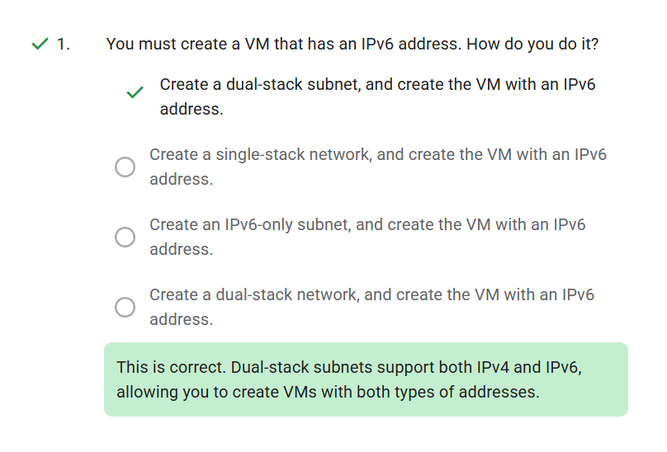
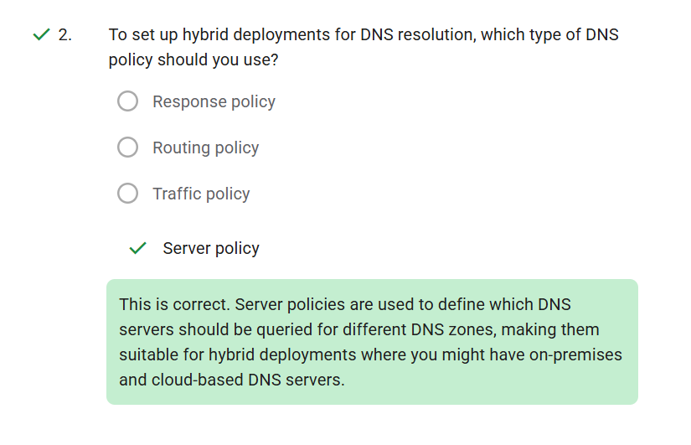

LAB 2: Implement Private Google Access and Cloud NAT

Overview
In this lab, you implement Private Google Access and Cloud NAT for a VM instance that doesn't have an external IP address. Then, you verify access to public IP addresses of Google APIs and services and other connections to the internet.
VM instances without external IP addresses are isolated from external networks. Using Cloud NAT, these instances can access the internet for updates and patches, and in some cases, for bootstrapping. As a managed service, Cloud NAT provides high availability without user management and intervention.
Objectives
In this lab, you learn how to perform the following tasks:
- Configure a VM instance that doesn't have an external IP address
- Connect to a VM instance using an Identity-Aware Proxy (IAP) tunnel
- Enable Private Google Access on a subnet
- Configure a Cloud NAT gateway
- Verify access to public IP addresses of Google APIs and services and other connections to the internet

Setup and Requirements
For each lab, you get a new Google Cloud project and set of resources for a fixed time at no cost.
- Click the Start Lab button. If you need to pay for the lab, a pop-up opens for you to select your payment method. On the left is the Lab Details panel with the following:
  - The Open Google Cloud console button
  - Time remaining
  - The temporary credentials that you must use for this lab
  - Other information, if needed, to step through this lab
- Click Open Google Cloud console (or right-click and select Open Link in Incognito Window if you are running the Chrome browser).
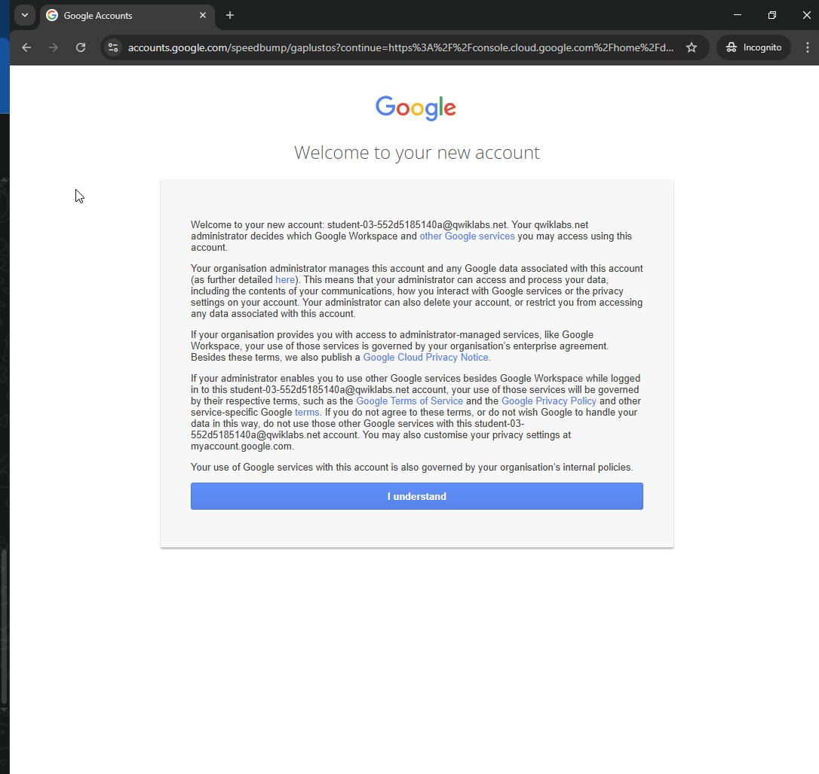
The lab spins up resources, and then opens another tab that shows the Sign in page.
- If necessary, copy the Username below and paste it into the Sign in dialog. You can also find the Username in the Lab Details panel.
- Click Next.
- Copy the Password below and paste it into the Welcome dialog. You can also find the Password in the Lab Details panel.
- Click Next.
- Click through the subsequent pages:
- Accept the terms and conditions.
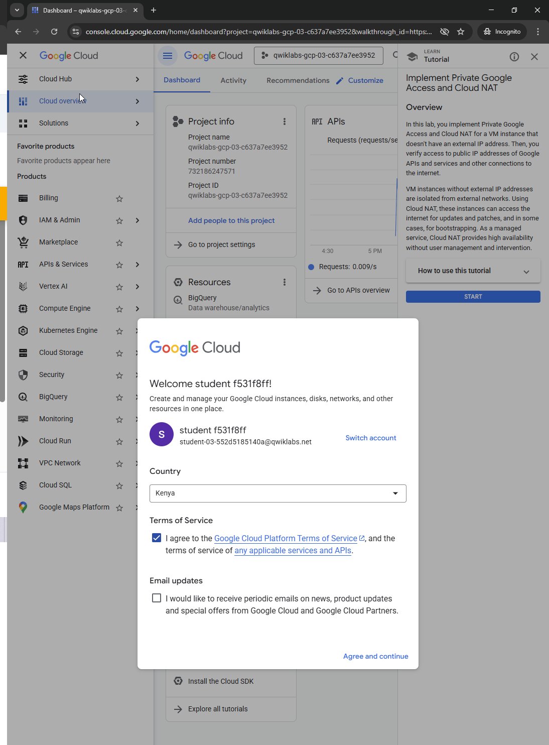
- Do not add recovery options or two-factor authentication (because this is a temporary account).
- Do not sign up for free trials.
After a few moments, the Google Cloud console opens in this tab.
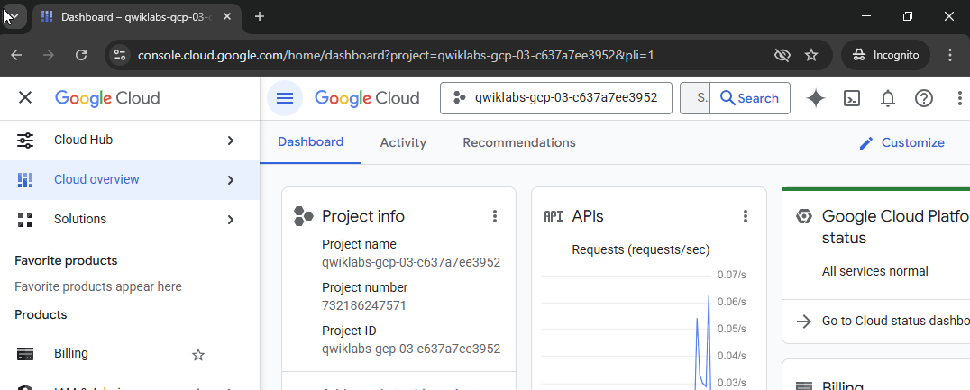

Task 1. Create the VM instance
Create a VPC network with some firewall rules and a VM instance that has no external IP address, and connect to the instance using an IAP tunnel.
Create a VPC network and firewall rules
First, create a VPC network for the VM instance and a firewall rule to allow SSH access.
- In the Google Cloud console, in the Navigation menu (), click VPC network > VPC networks.
- Click Create VPC Network.
- For Name, type privatenet.
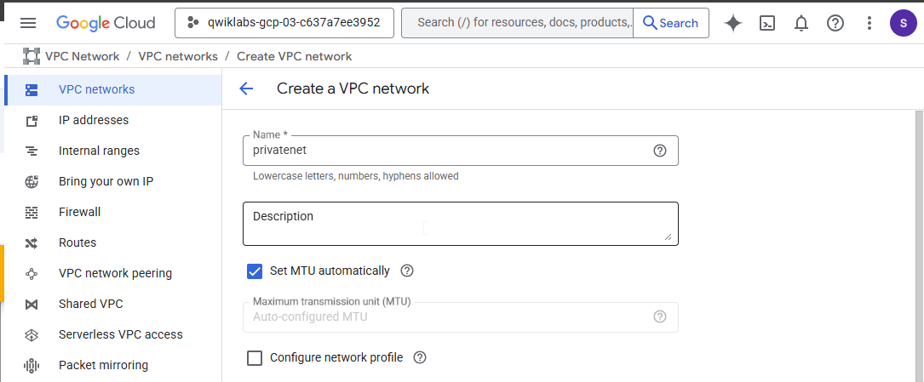

- For Subnet creation mode, click Custom.
- In New Subnet specify the following, and leave the remaining settings as their defaults:
Property | Value (type value or select option as specified)
Name | privatenet-us
Region | REGION
IPv4 range | 10.130.0.0/20
Note: Don't enable Private Google access yet!
- Click Done.
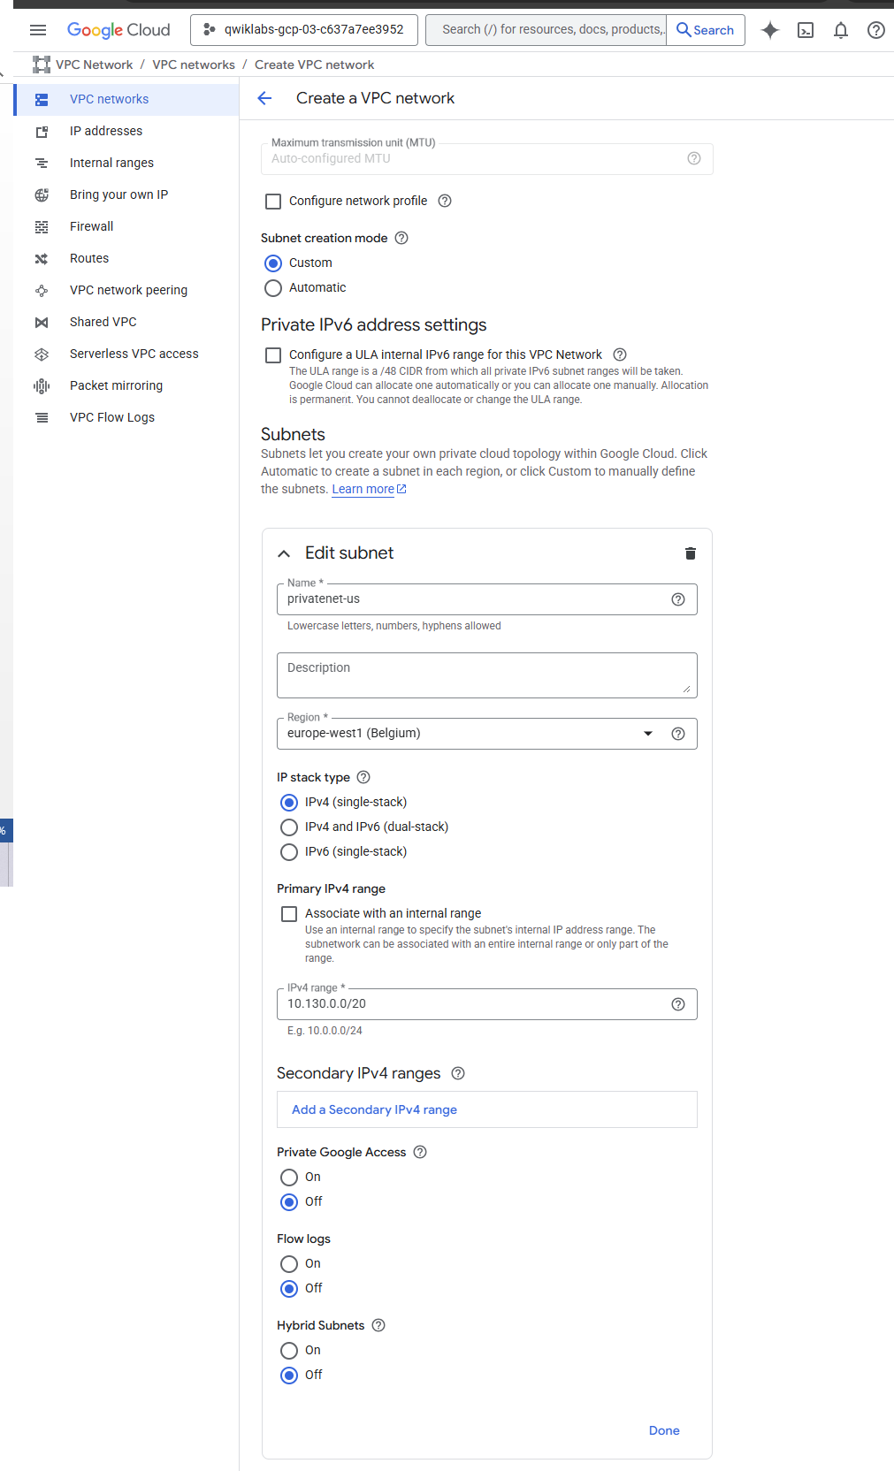
- Click Create and wait for the network to be created.
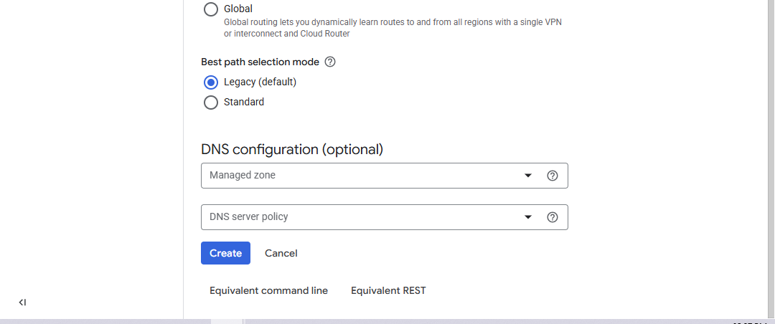
- In the left pane, click Firewall.
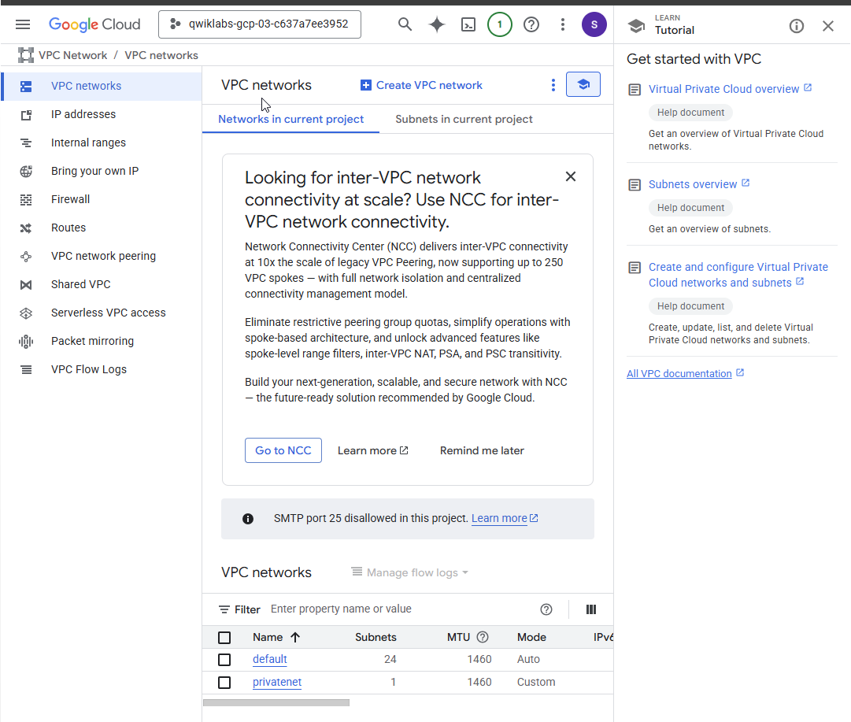
- Click Create Firewall Rule.
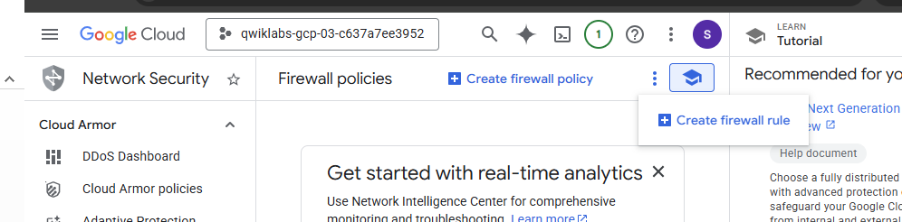

- Specify the following, and leave the remaining settings as their defaults:
Property | Value (type value or select option as specified)
Name | privatenet-allow-ssh
Network | privatenet
Targets | All instances in the network
Source filter | IPv4 ranges
Source IPv4 ranges | 35.235.240.0/20
Protocols and ports | Specified protocols and ports
- For tcp, click the checkbox and specify port 22.
- Click Create.
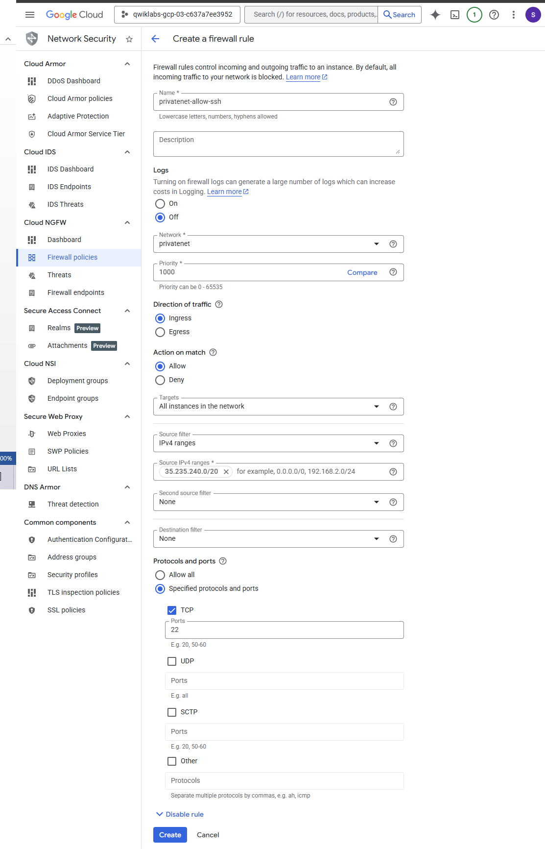
Note: In order to connect to your private instance using SSH, you need to open an appropriate port on the firewall. IAP connections come from a specific set of IP addresses (35.235.240.0/20). Therefore, you can limit the rule to this CIDR range.

Create the VM instance with no public IP address
- In the Google Cloud console, in the Navigation menu (), click Compute Engine > VM instances.
- Click Create Instance.
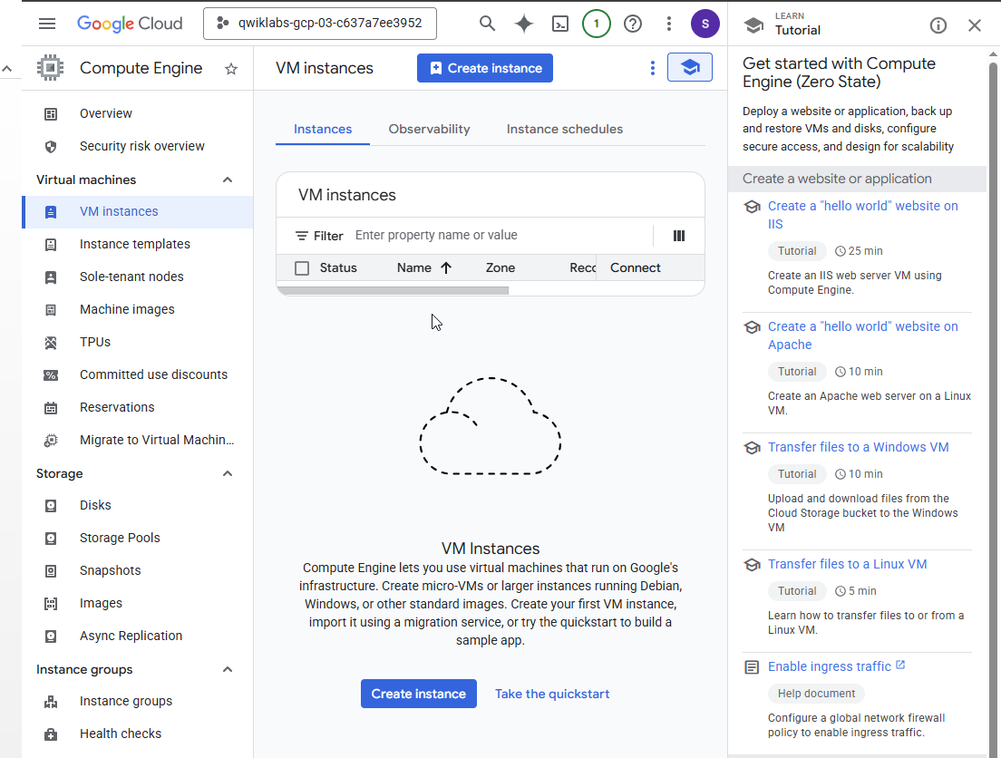

- On the Machine configuration page, specify the following, and leave the remaining settings as their defaults:
Property | Value (type value or select option as specified)
Name | vm-internal
Region | europe-west1
Zone | europe-west1-b
Series | E2
Machine type | e2-standard-2 (2vCPU, 1 core, 8 GB memory) 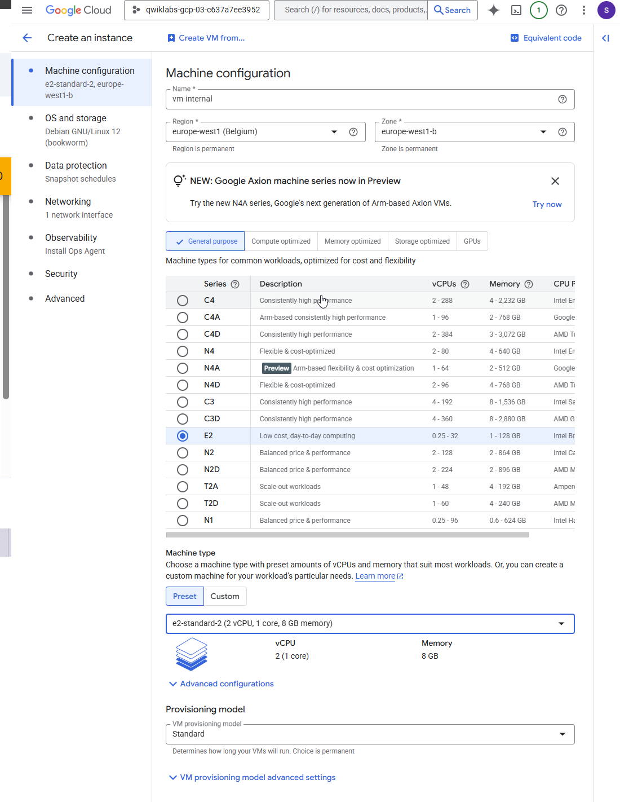

- Click OS and storage.
- If the Image shown is not Debian GNU/Linux 12 (bookworm), click Change and select Debian GNU/Linux 12 (bookworm), and then click Select.
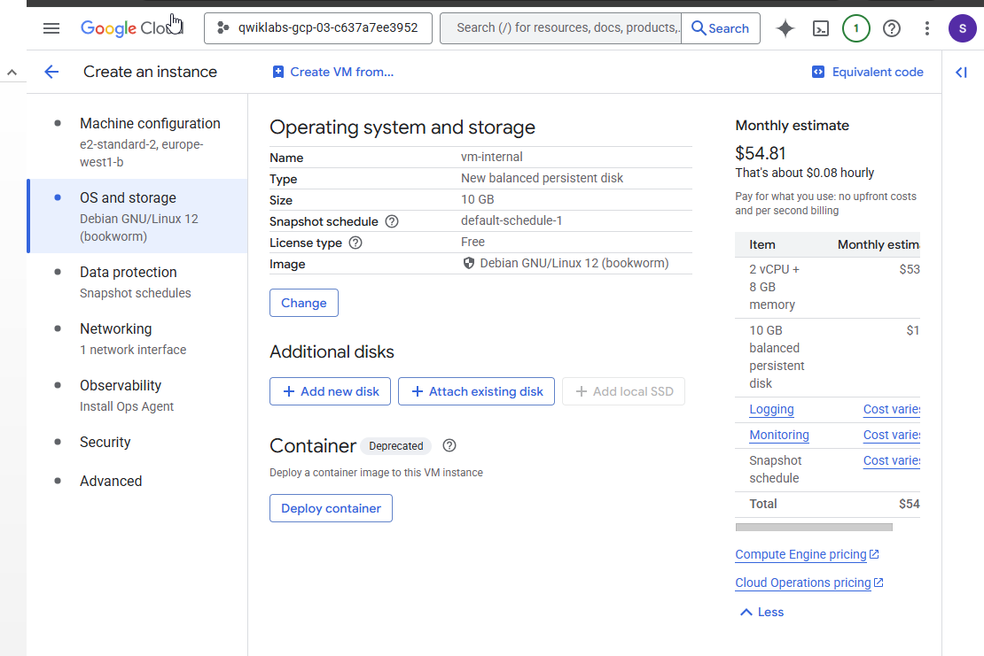
- Click Networking.
- In Network interfaces, edit the network interface by specifying the following:
Property | Value (type value or select option as specified)
Network | privatenet
Subnetwork | privatenet-us
External IPv4 address | None
Note: The default setting for a VM instance is to have an ephemeral external IP address. This behavior can be changed with a policy constraint at the organization or project level.
- Click Done.
- Click Create, and wait for the VM instance to be created.
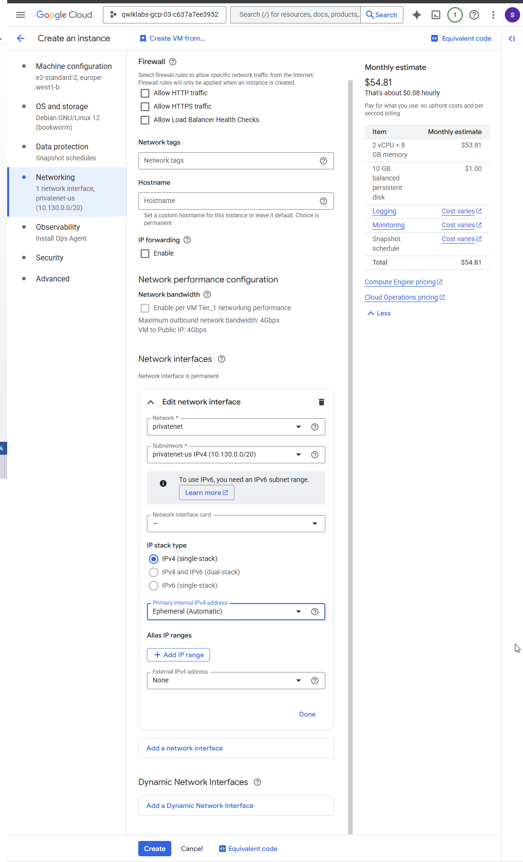
- On the VM instances page, verify that the External IP of vm-internal is None

SSH to vm-internal to test the IAP tunnel
- In the Cloud console, click Activate Cloud Shell ().
- If prompted, click Continue.
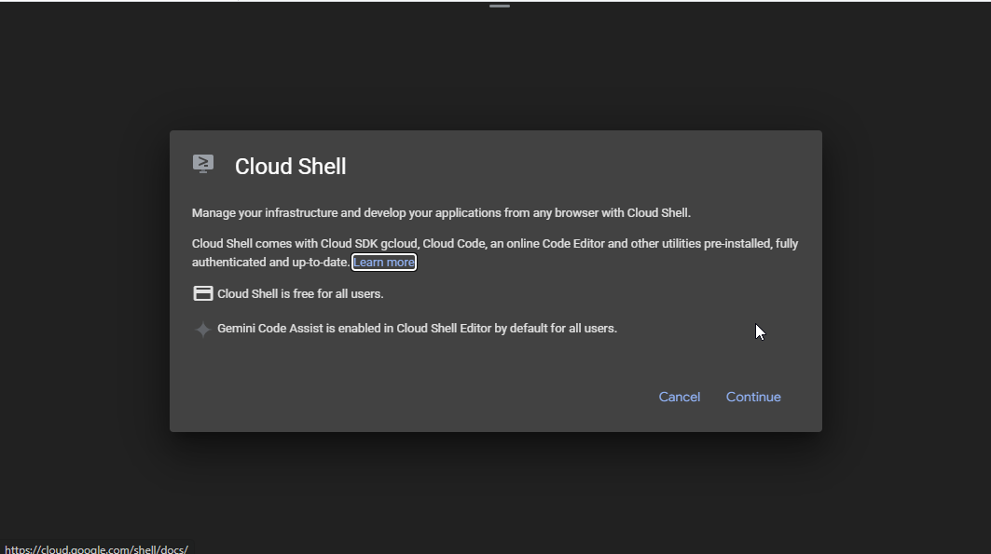
- If prompted to authorize, click Authorize.
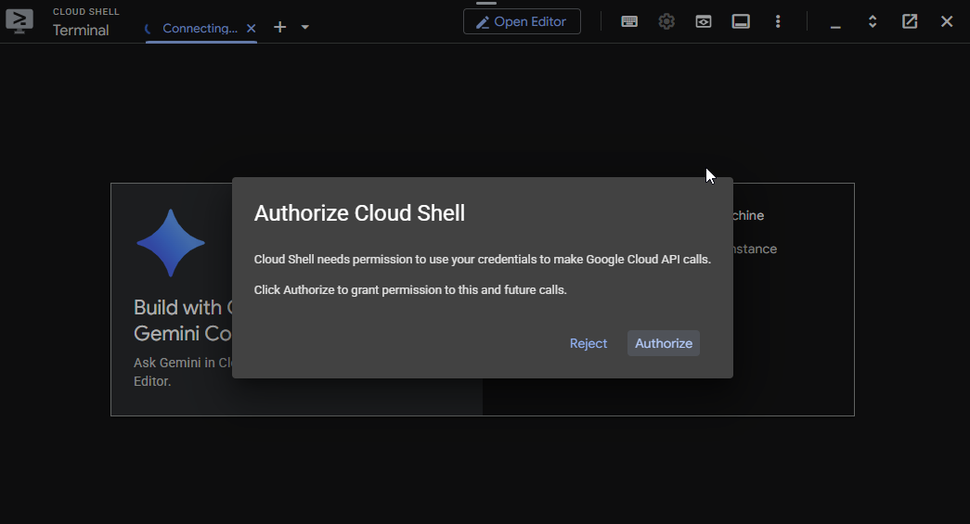
- Run the following command in Cloud Shell to setup auth without opening up a browser: gcloud auth login --no-launch-browser
If prompted [Y/n], press Y and then ENTER.
This will give you a link to open in your browser. 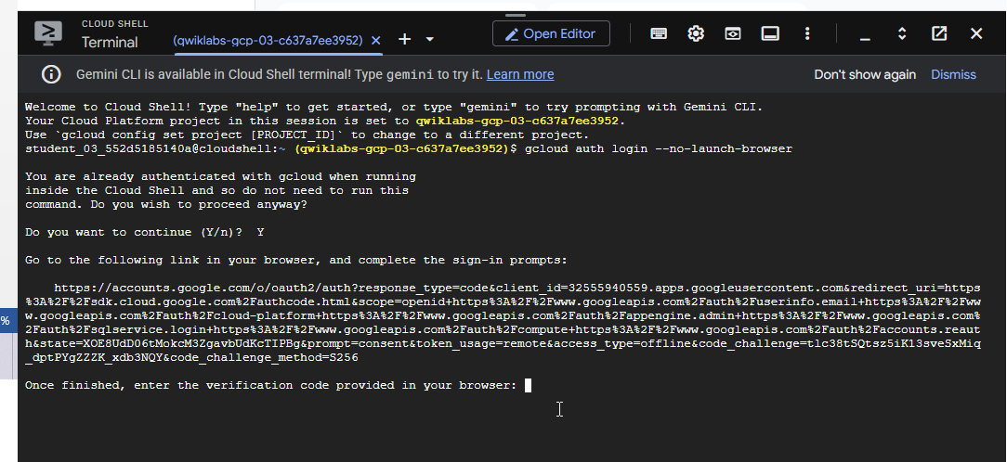Open the link in the same browser where you are logged in to the lab account. Once you login you will get a verification code to copy. Paste that code in the cloud shell.
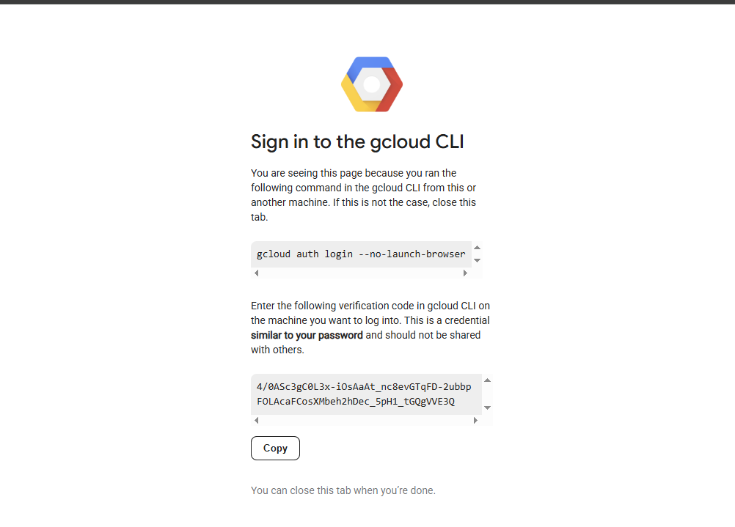
- To connect to vm-internal, run the following command:
- If prompted to continue, type Y.
- When prompted for a passphrase, press ENTER.
- When prompted for the same passphrase, press ENTER.
Did the command prompt change to @vm-internal?
True
False
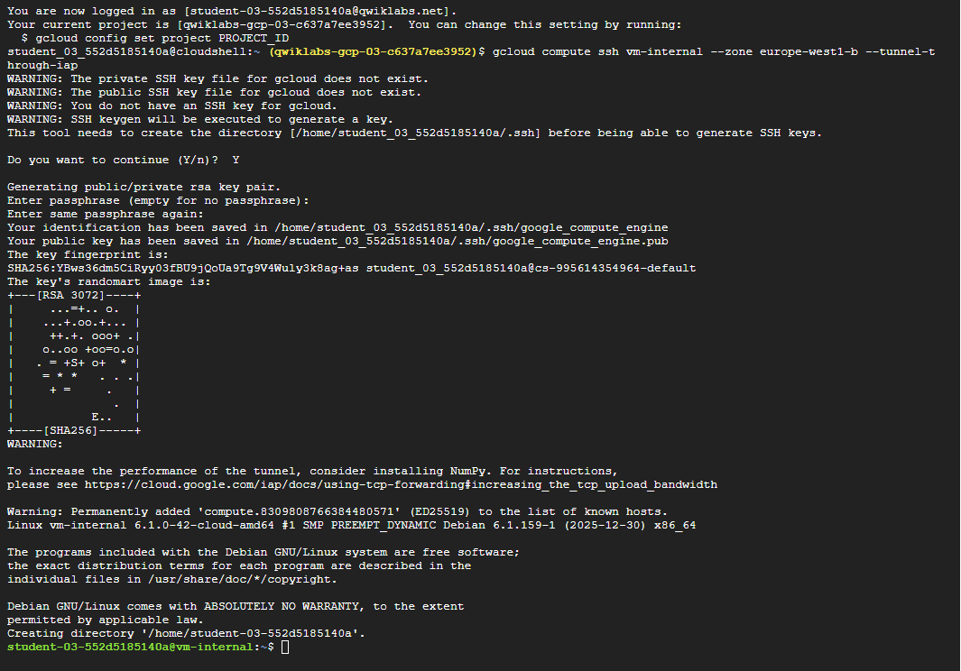
- To test the external connectivity of vm-internal, run the following command:
This should not work because vm-internal has no external IP address!
- Wait for the ping command to complete.
- To return to your Cloud Shell instance, run the following command:
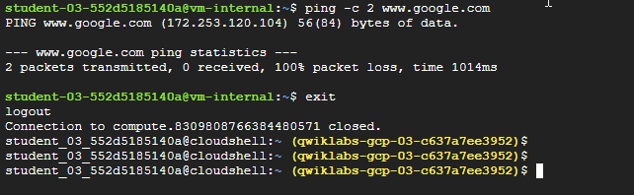
Note: When instances do not have external IP addresses, they can only be reached by other instances on the network via a managed VPN gateway or via a Cloud IAP tunnel. Cloud IAP enables context-aware access to VMs via SSH and RDP without bastion hosts.

Task 2. Enable Private Google Access
VM instances that have no external IP addresses can use Private Google Access to reach external IP addresses of Google APIs and services. By default, Private Google Access is disabled on a VPC network.

Create a Cloud Storage bucket
Create a Cloud Storage bucket to test access to Google APIs and services.
- In the Google Cloud console, in the Navigation menu (), click Cloud Storage > Buckets.
- Click +Create.
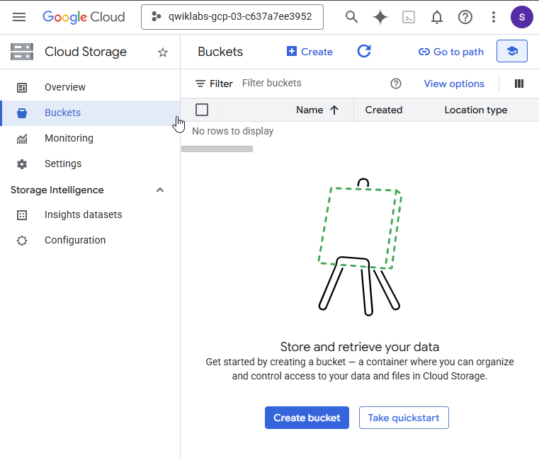
- Specify the following, and leave the remaining settings as their defaults:
Property | Value (type value or select option as specified)
Name | Enter a globally unique name
Location type | Multi-region
- Click Create.
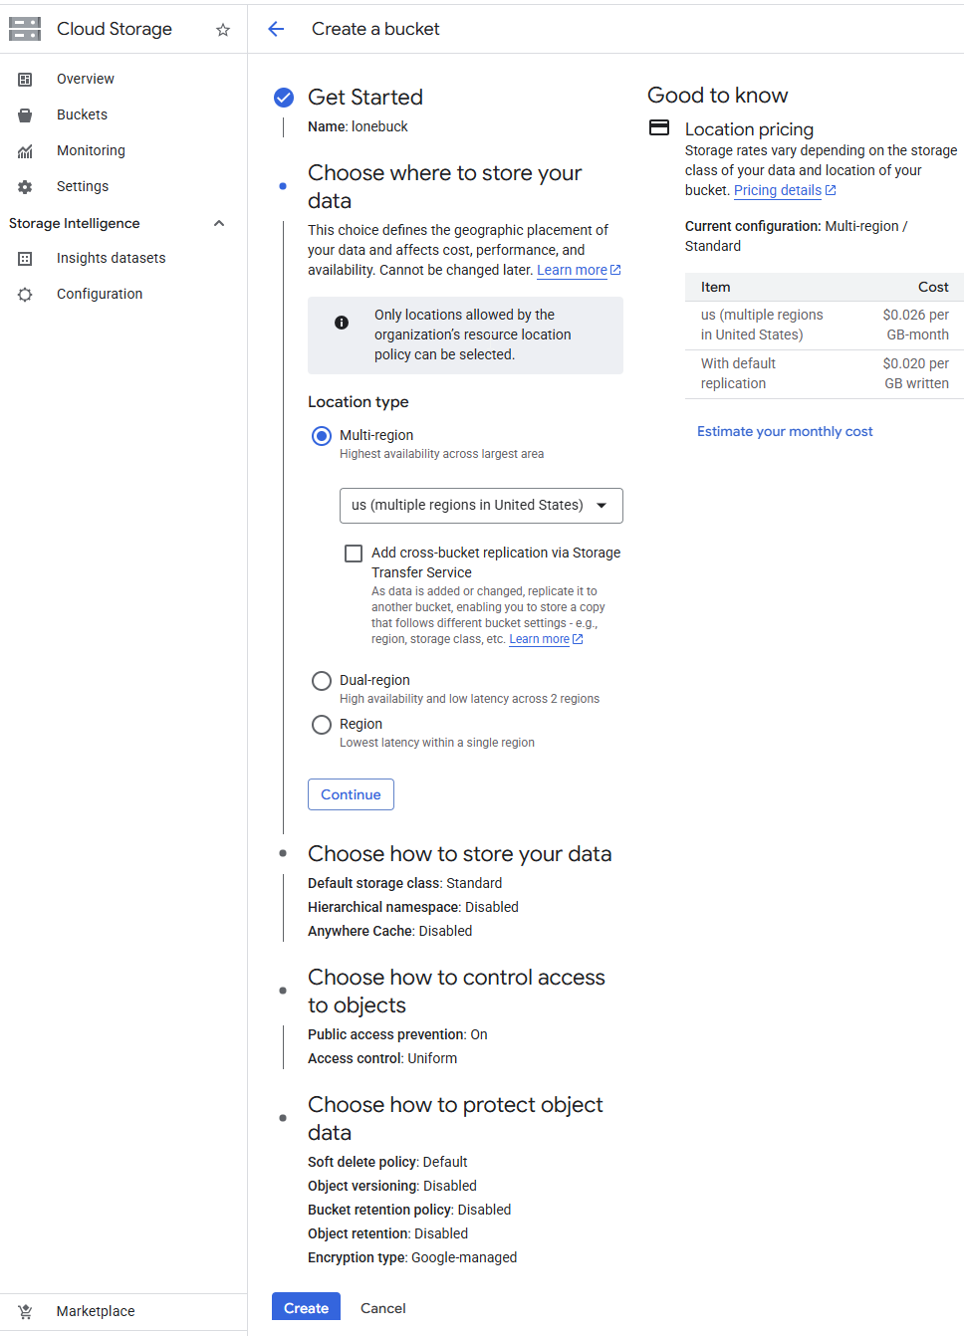

If prompted to enable public access prevention, ensure it is checked and cick Confirm. Note the name of your storage bucket.
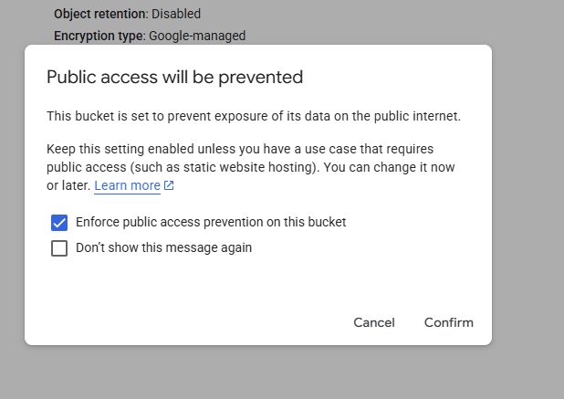
- Store the name of your bucket in an environment variable:
- Verify it with echo:
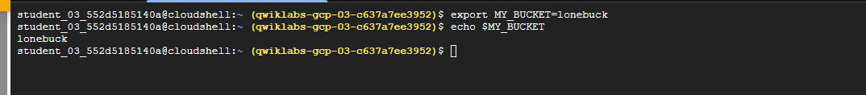

Copy an image file into your bucket
Copy an image from a public Cloud Storage bucket to your own bucket.
- In Cloud Shell, run the following command:
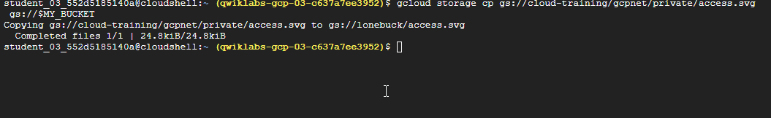
- In the Cloud console, click your bucket name to verify that the image was copied.
You can click on the name of the image in the Cloud console to view an example of how Private Google Access is implemented.
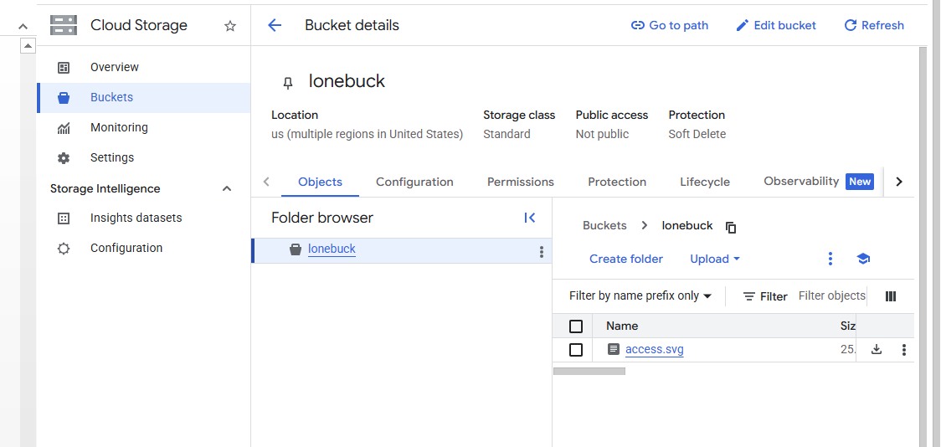

Access the image from your VM instance
Currently, which of your VM instances can access the image from your bucket?
Cloud Shell
vm-internal
- In Cloud Shell, to try to copy the image from your bucket, run the following command:
This should work because Cloud Shell has an external IP address!
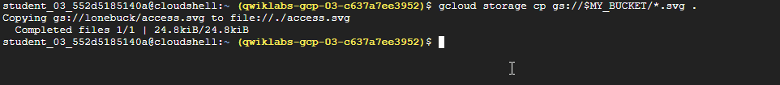
- To connect to vm-internal, run the following command:
- If prompted, type Y to continue.
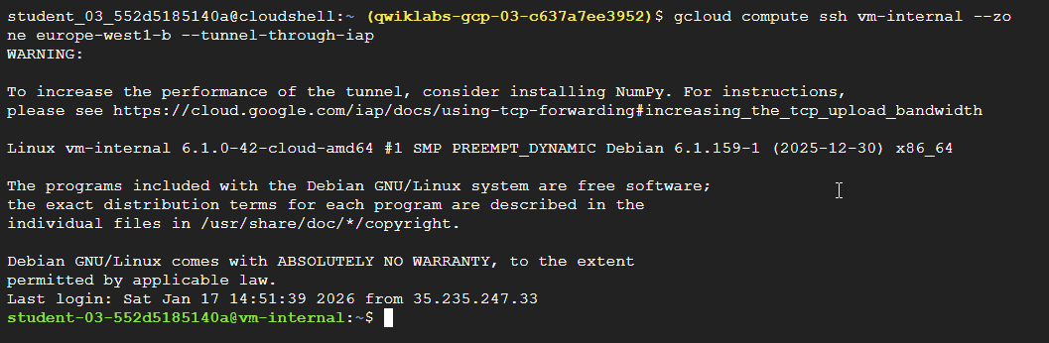
- Store the name of your bucket in an environment variable:
- Verify it with echo:
- Try to copy the image to vm-internal, run the following command:
This should not work: vm-internal can only send traffic within the VPC network because Private Google Access is disabled (by default).
- Press Ctrl+C to stop the request.
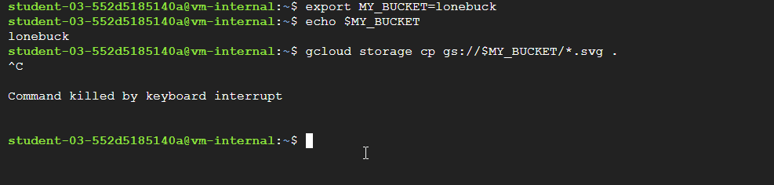

Enable Private Google Access
Private Google Access is enabled at the subnet level. When it is enabled, instances in the subnet that only have private IP addresses can send traffic to Google APIs and services through the default route (0.0.0.0/0) with a next hop to the default internet gateway.
- In the Cloud console, in the Navigation menu (), click VPC network > VPC networks.
- Click privatenet to open the network.
- Click Subnets, and then click privatenet-us.
- Click Edit.
- For Private Google access, select On.
- Click Save.
Note: Enabling Private Google Access is as simple as selecting On within the subnet!
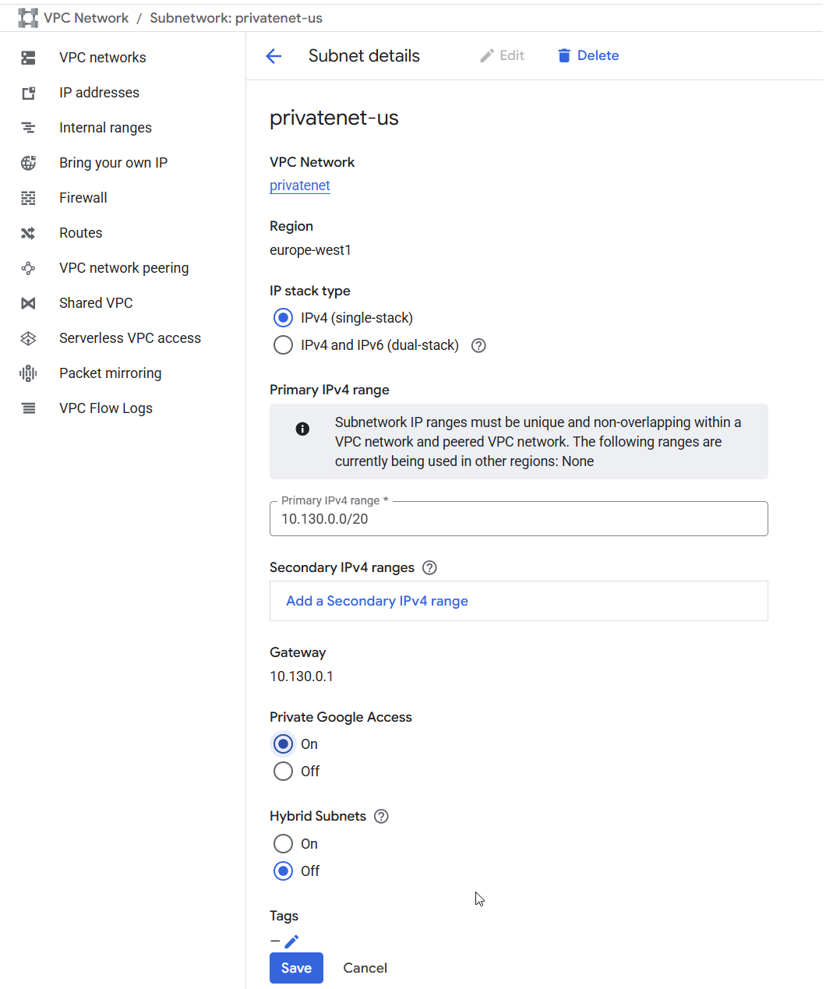

- Run the following command, in Cloud Shell for vm-internal, to try to copy the image to vm-internal.
This should work because vm-internal's subnet has Private Google Access enabled!
- To return to your Cloud Shell instance, run the following command:
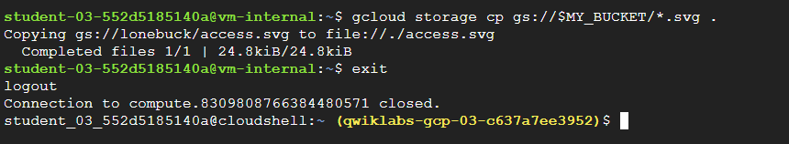

Task 3. Configure a Cloud NAT gateway
Although vm-internal can now access certain Google APIs and services without an external IP address, the instance cannot access the internet for updates and patches. Configure a Cloud NAT gateway, which allows vm-internal to reach the internet.

Try to update the VM instances
  - In Cloud Shell, to try to re-synchronize the package index, run the following:
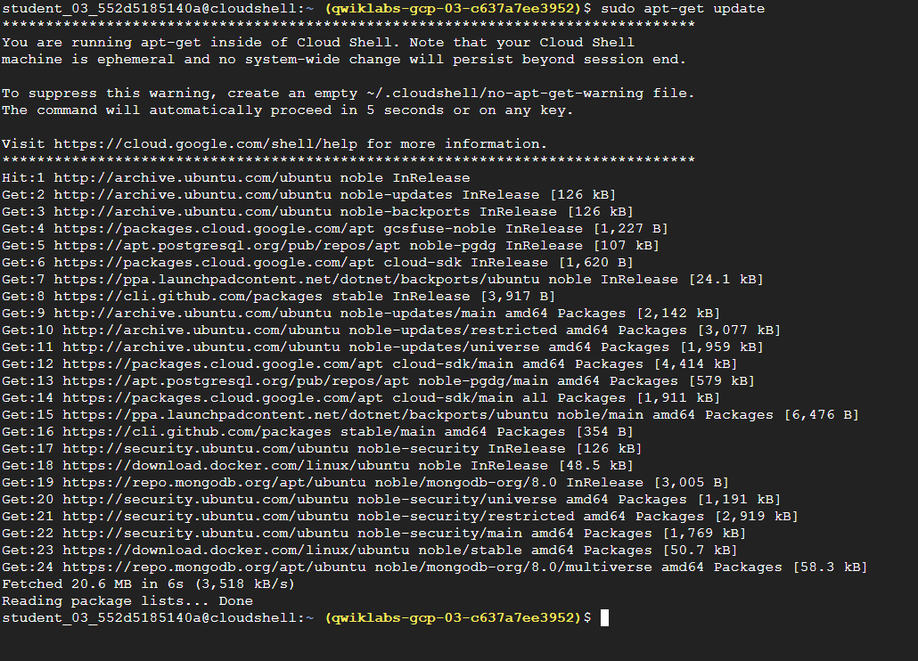
  - To connect to vm-internal, run the following command:
  - If prompted, type Y to continue.
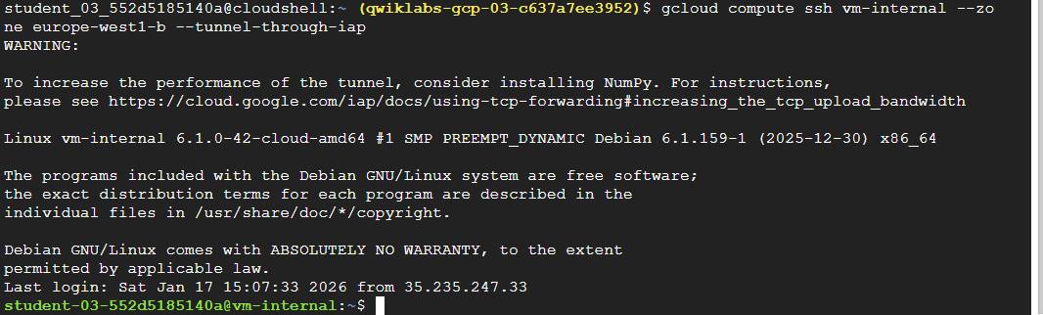
  - To try to re-synchronize the package index of vm-internal, run the following command:
This should only work for Google Cloud packages because vm-internal only has access to Google APIs and services!
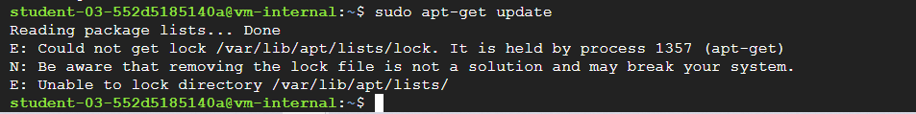

Configure a Cloud NAT gateway
Cloud NAT is a regional resource. You can configure it to allow traffic from all ranges of all subnets in a region, from specific subnets in the region only, or from specific primary and secondary CIDR ranges only.
- On the Google Cloud console title bar, type Network services in the Search field, then click Network services in the Products & Page section.
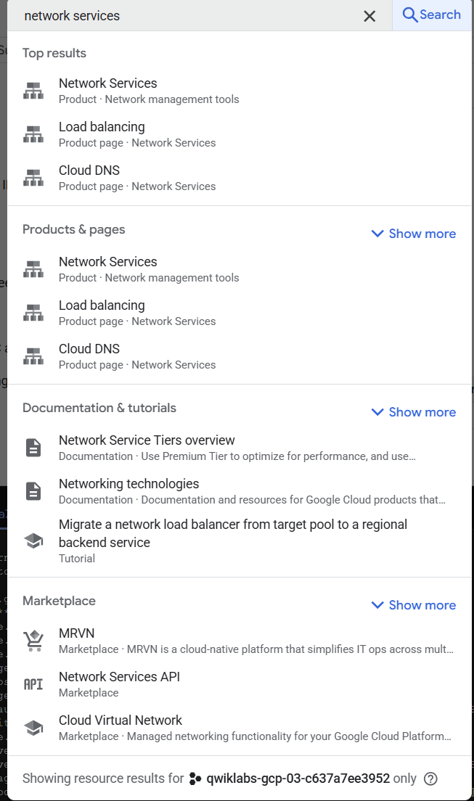
- On the Network service page, click Pin next to Network services.
- Click Cloud NAT.
- Click Get started to configure a NAT gateway.
- Specify the following:
Property | Value (type value or select option as specified)
Gateway name | nat-config
Network | privatenet
Region
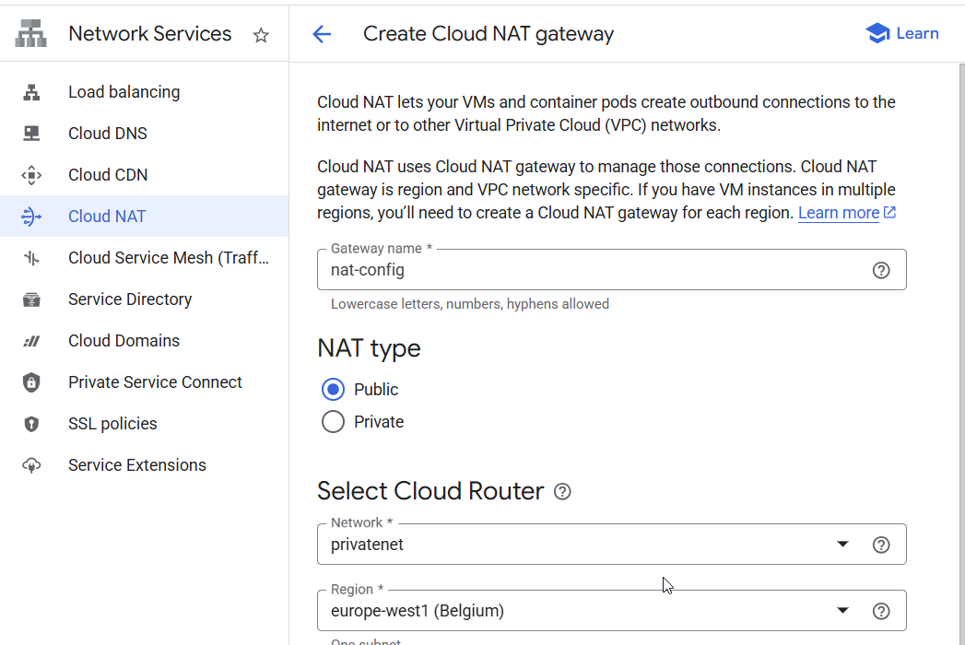
- For Cloud Router, select Create new router.
- For Name, type nat-router
- Click Create.
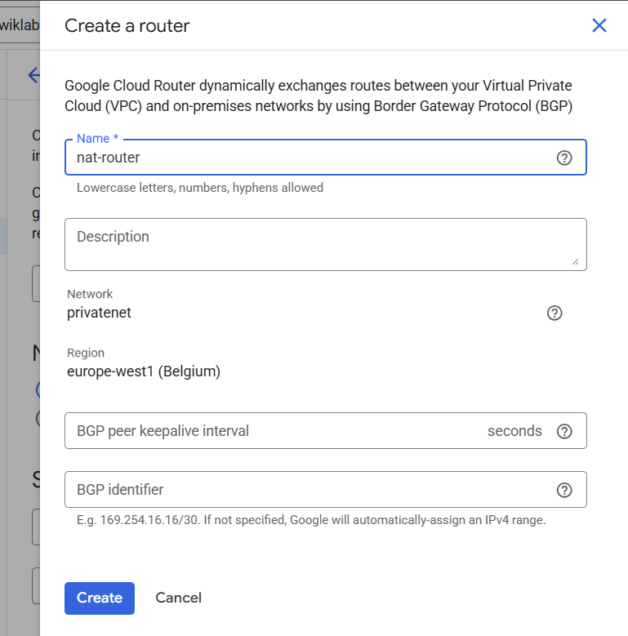
Note: The NAT mapping section allows you to choose the subnets to map to the NAT gateway. You can also manually assign static IP addresses that should be used when performing NAT. Do not change the NAT mapping configuration in this lab.
- Click Create.
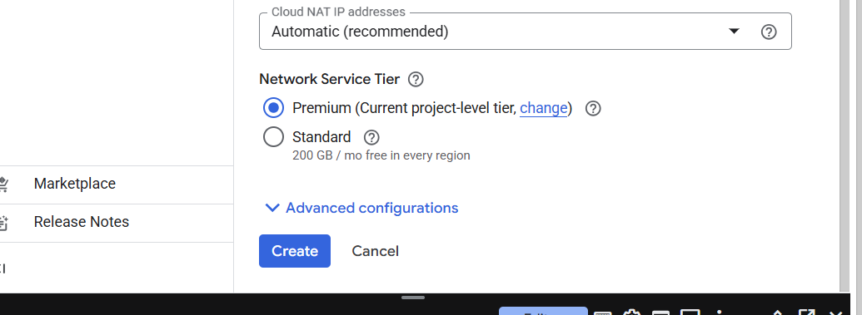
- Wait for the gateway's status to change to Running.
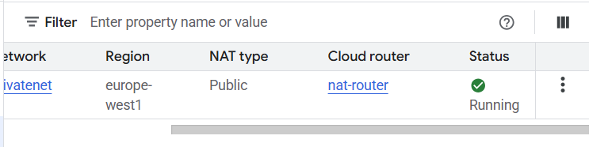

Verify the Cloud NAT gateway
It may take up to 3 minutes for the NAT configuration to propagate to the VM, so wait at least a minute before trying to access the internet again.
- In Cloud Shell for vm-internal, to try to re-synchronize the package index of vm-internal, run the following command:
This should work because vm-internal is using the NAT gateway!
- To return to your Cloud Shell instance, run the following command:
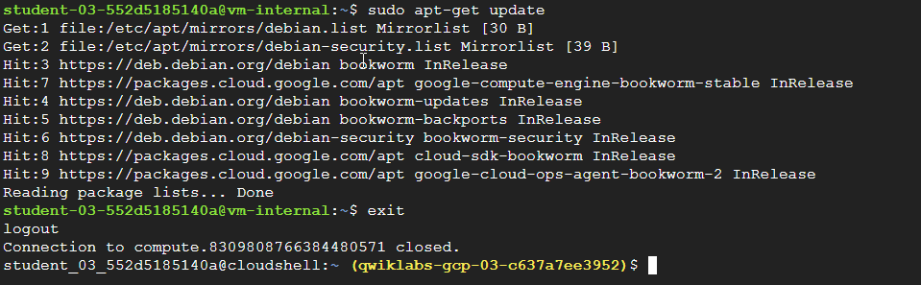
Note: The Cloud NAT gateway implements outbound NAT, but not inbound NAT. In other words, hosts outside of your VPC network can only respond to connections initiated by your instances; they cannot initiate their own, new connections to your instances via NAT.

Task 4. Configure and view logs with Cloud NAT Logging
Cloud NAT logging allows you to log NAT connections and errors. When Cloud NAT logging is enabled, one log entry can be generated for each of the following scenarios:
- When a network connection using NAT is created.
- When a packet is dropped because no port was available for NAT.
You can opt to log both kinds of events, or just one or the other. Created logs are sent to Cloud Logging.

Enabling logging
If logging is enabled, all collected logs are sent to Cloud Logging by default. You can filter these so that only certain logs are sent.
You can also specify these values when you create a NAT gateway or by editing one after it has been created. The following directions show how to enable logging for an existing NAT gateway.
- In the Google Cloud console, in the Navigation menu (), click Network services > Cloud NAT.
- Click on the nat-config gateway and then click Edit.
- Click the Advanced configurations dropdown to open that section.
- For Logging, select Translation and errors and then click Save.
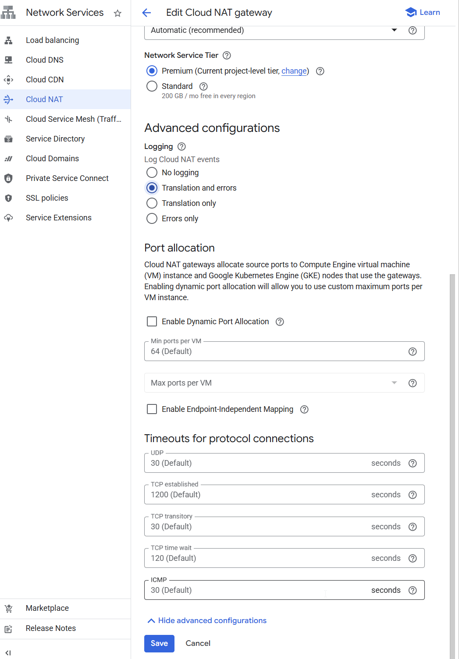

NAT logging in Cloud Logging
Now that you have set up Cloud NAT logging for the nat-config gateway, let's find out where we can view our logs.
- Click on nat-config to expose its details. Then click on the View in Logs Explorer.
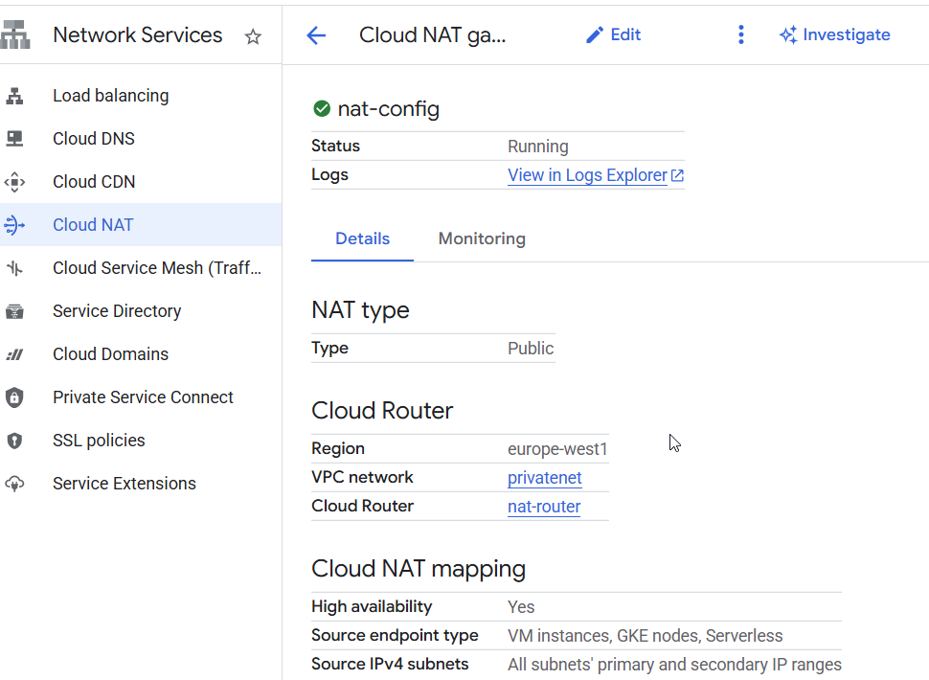
- This will open a new tab with Logs Explorer.
You will see that there aren't any logs yet—that's because we just enabled this feature for the gateway.
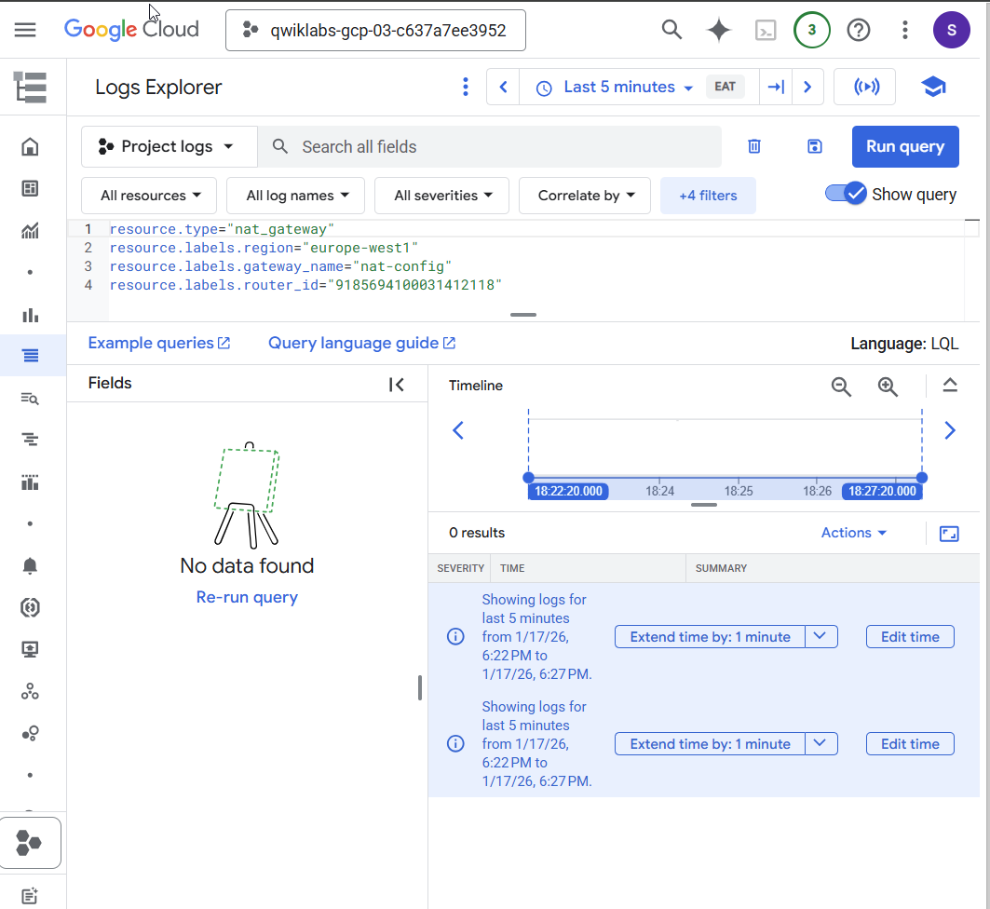
Note: Keep this tab open and return to your other Google Cloud console tab.

Generating logs
As a reminder, Cloud NAT logs are generated for the following sequences:
- When a network connection using NAT is created.
- When a packet is dropped because no port was available for NAT.
Let's connect the host to the internal VM again to see if any logs are generated.
- In Cloud Shell for vm-internal, to try to re-synchronize the package index of vm-internal, run the following command:
- If prompted, type Y to continue.
- Try to re-synchronize the package index of vm-internal by running the following:
- To return to your Cloud Shell instance, run the following command:
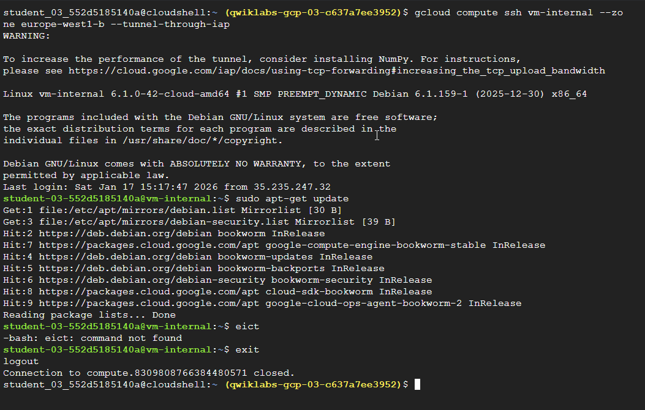
Let's see if opening up this connection revealed anything new in our logs.

Viewing Logs
- Return to your Logs Explorer tab, and in the navigation menu, click Logs Explorer.
You should see two new logs that were generated after connecting to the internal VM.
Note: You may need to wait for a few minutes. If you are still unable to see the logs, repeat step 1 to step 4, from the Generating logs section, and then refresh the logging page.
As we see, the logs give us details on the VPC network we connected to and the connection method we used. Feel free to expand different labels and details.
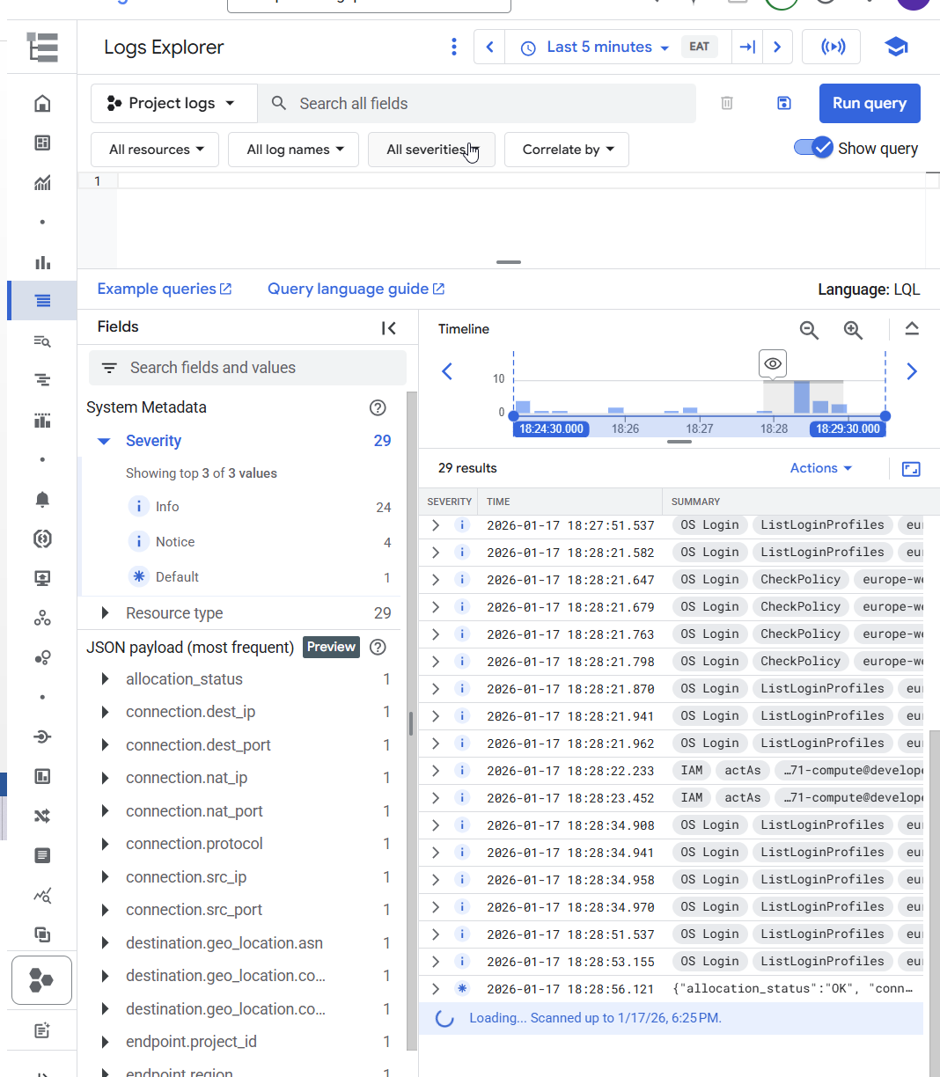

Task 5. Review
I created vm-internal, an instance with no external IP address, and connected to it securely using an IAP tunnel. Then I enabled Private Google Access, configured a NAT gateway, and verified that vm-internal can access Google APIs and services and other public IP addresses.
VM instances without external IP addresses are isolated from external networks. Using Cloud NAT, these instances can access the internet for updates and patches, and in some cases, for bootstrapping. As a managed service, Cloud NAT provides high availability without user management and intervention.
IAP uses your existing project roles and permissions when you connect to VM instances. By default, instance owners are the only users that have the IAP Secured Tunnel User role.

