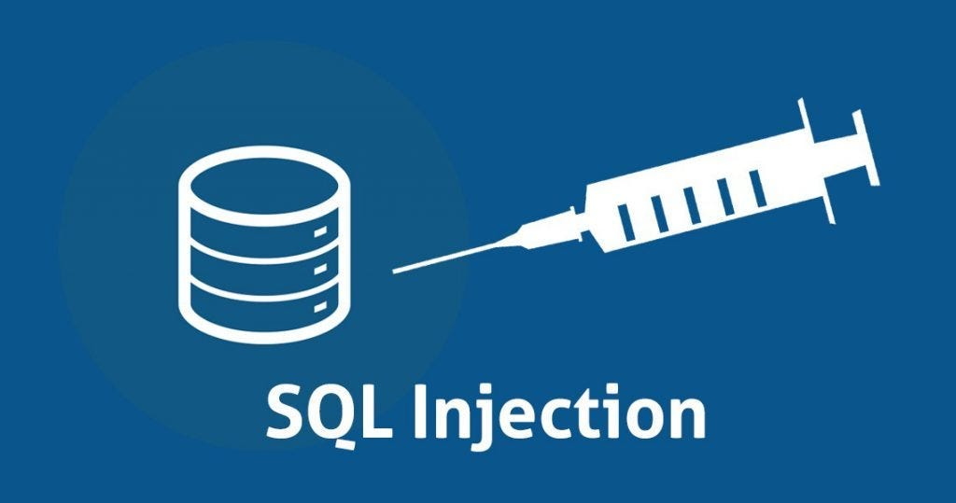
Lab - Injection Attacks

Objectives
Websites that are connected to backend databases can be vulnerable to SQL injection. In a SQL injection exploit, an attacker enters malicious queries that interact with the application database. In this lab, you will exploit a web site vulnerability with SQL injection and research SQL injection mitigation.
- Part 1: Exploit an SQL Injection Vulnerability on DVWA
- Part 2: Research SQL Injection Mitigation

Background / Scenario
SQL injection is a common attack used by hackers to exploit SQL database-driven web applications. This type of attack involves inserting malicious SQL code or statements into an input field or URL with the goal of reveling or manipulating the database contents, causing repudiation system issues, or spoofing identities.

Required Resources
- Kali VM customized for the Ethical Hacker course
- Internet access

Instructions

Part 1: Exploit an SQL Injection Vulnerability on DVWA
SQL injection is a code injection technique used to exploit security vulnerabilities in the database layer of an application. These vulnerabilities could allow an attacker to execute malicious SQL commands and compromise the security of the database.
In this part you will exploit a SQL vulnerability on the DVWA.

Step 1: Prepare DVWA for SQL Injection Exploit.
- Open your browser and navigate to the DVWA at http://10.6.6.13.
- Enter the credentials: admin / password.
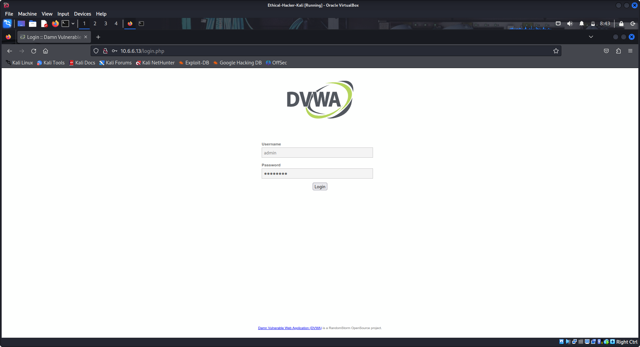
- Set DVWA to Low Security.
- Click DVWA Security in the left pane.
- Change the security level to Low and click Submit.
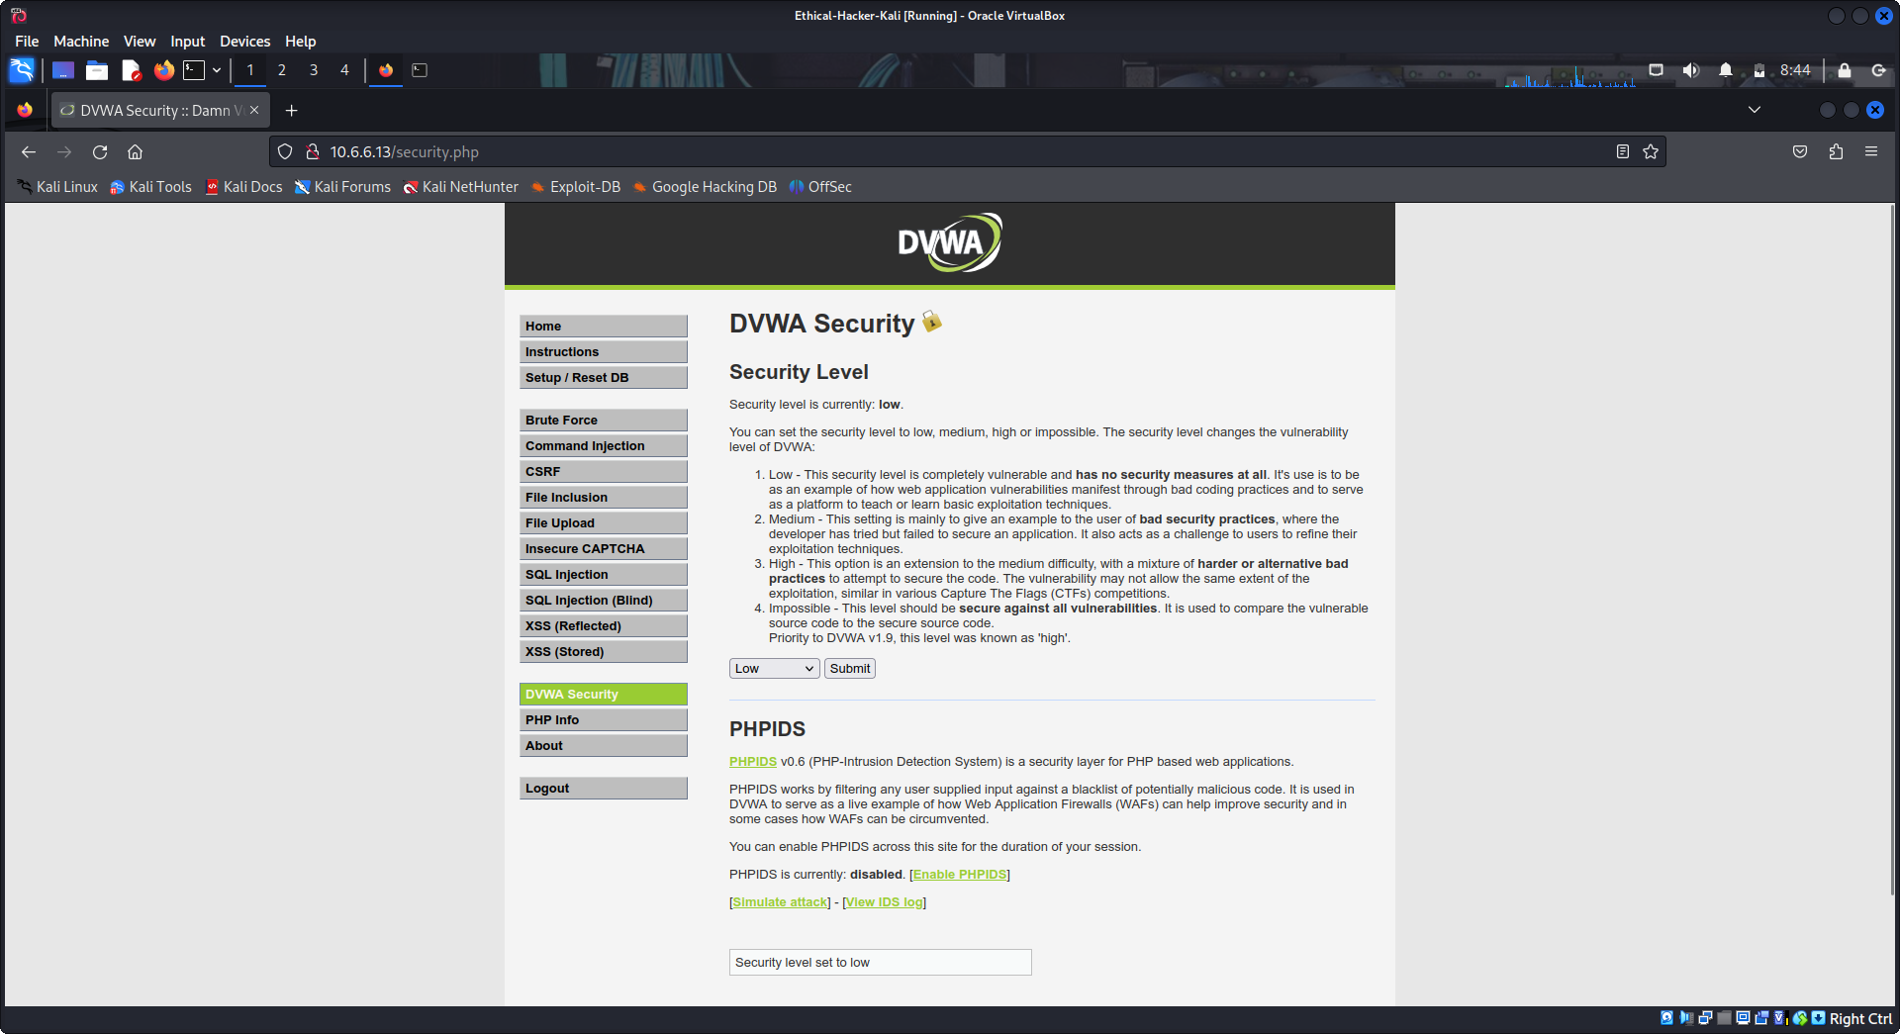

Step 2: Check DVWA to see if a SQL Injection Vulnerability is Present.
- Click SQL Injection in the left pane.
- In the User ID: field type ' OR 1=1 # and click Submit.
- You should receive the output shown below. The output confirms that there is a vulnerability present that permits execution of SQL statements that are entered directly into input fields.
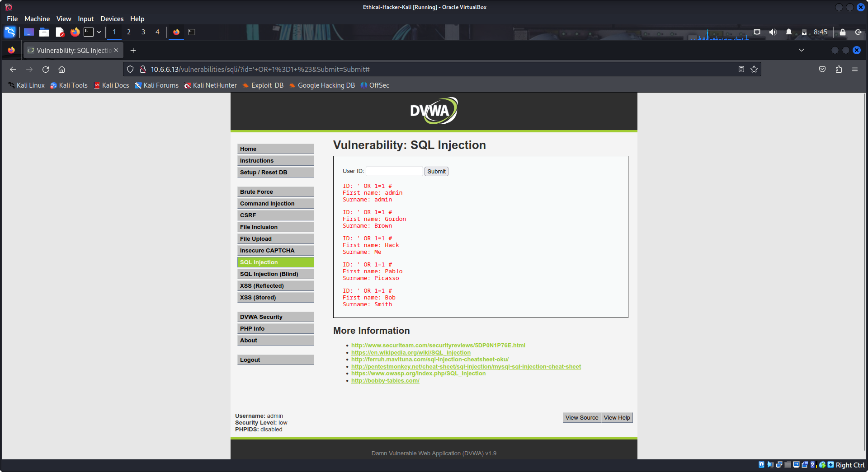
You have entered an “always true” expression that was executed by the database server. The result is that all entries in the ID field of the database were returned.

Step 3: Check for Number of Fields in the Query.
- In the User ID: field type 1' ORDER BY 1 # and click Submit.
You should receive the following output:
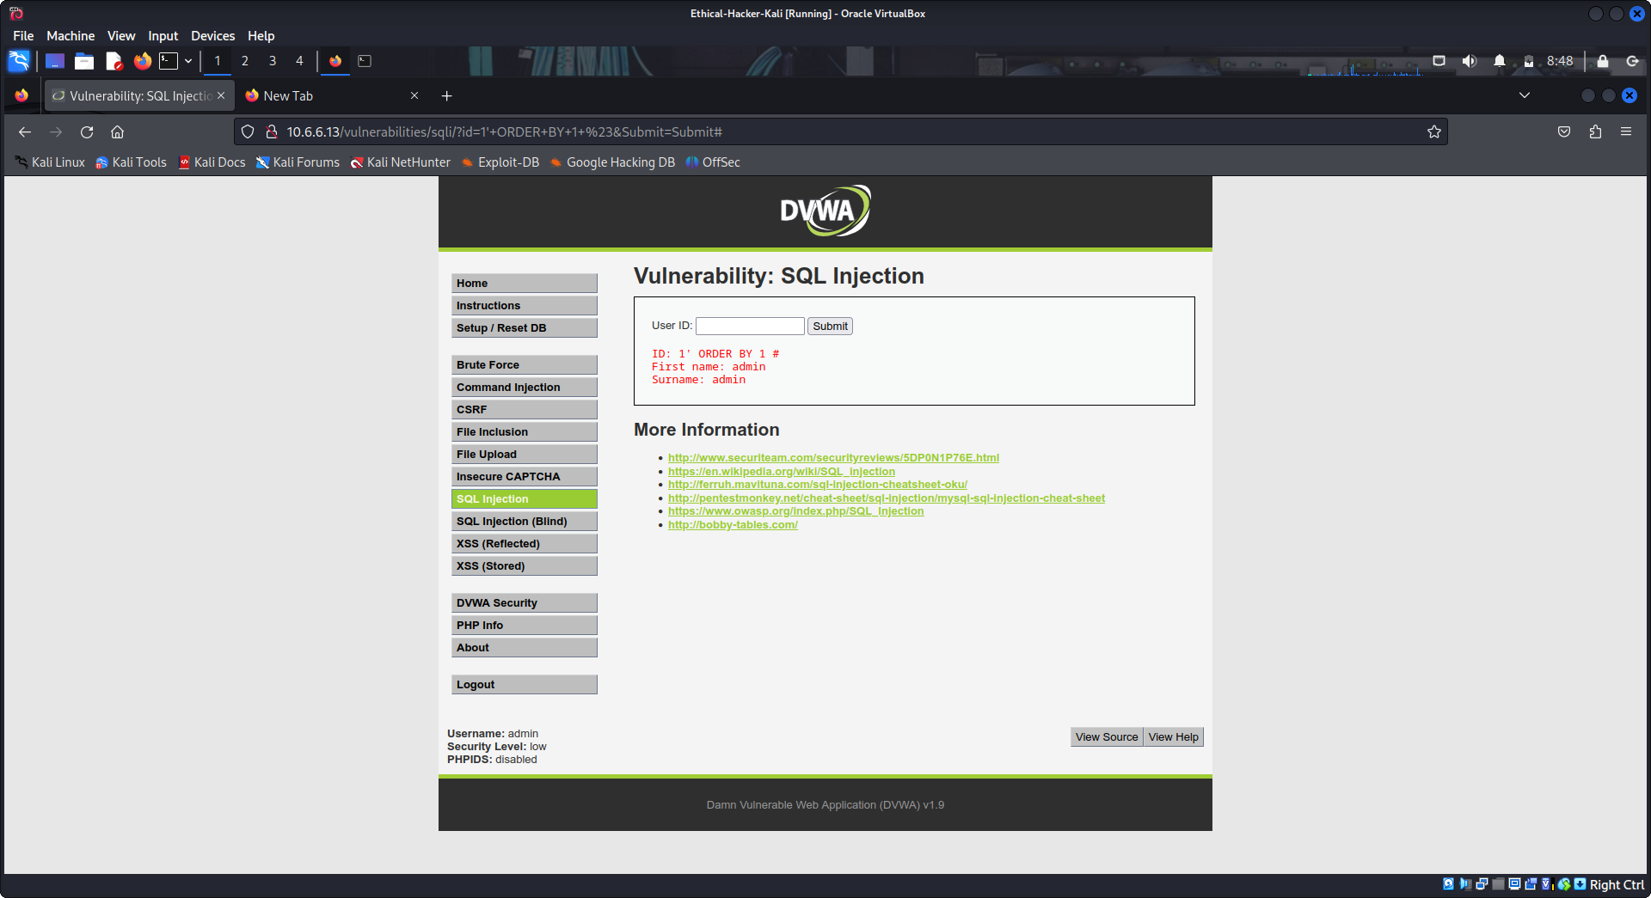
- In the User ID: field type 1' ORDER BY 2 # and click Submit.
You should receive the following output:
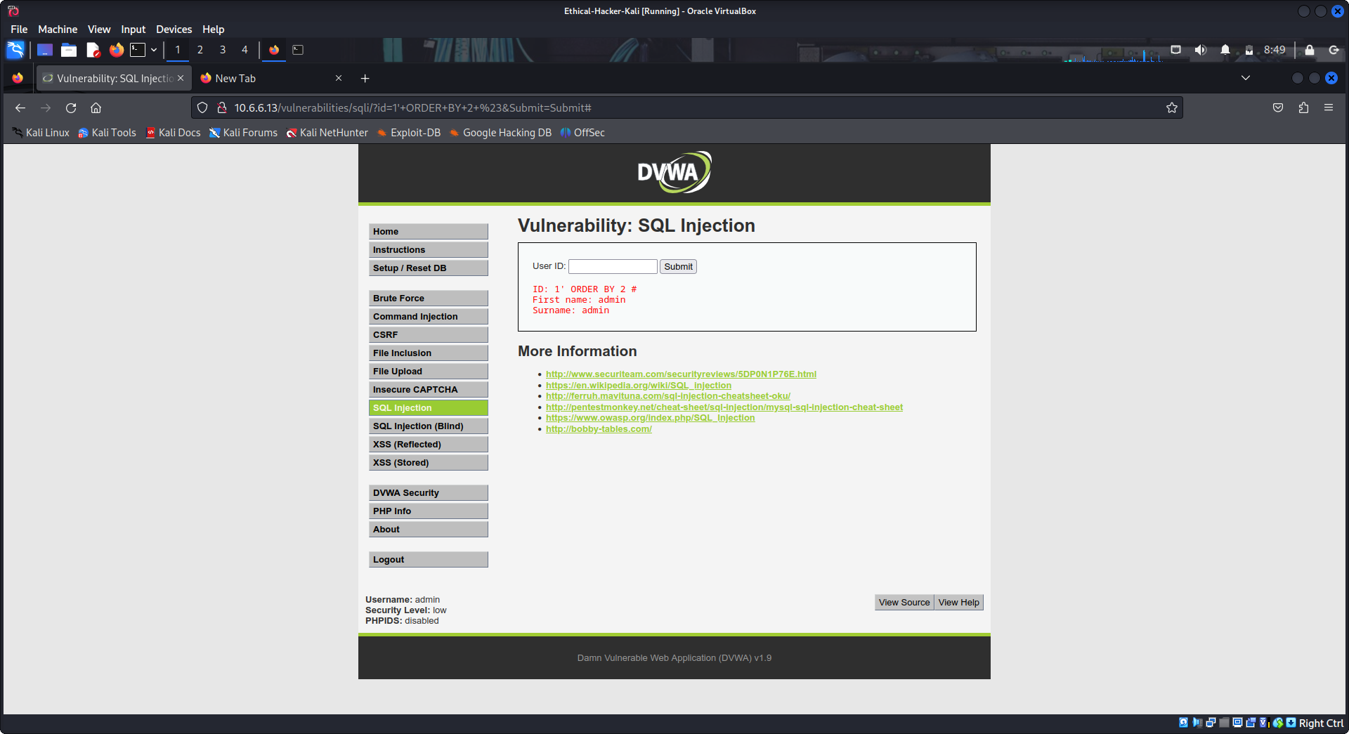
- In the User ID: field type 1' ORDER BY 3 # and click Submit.
This time you should receive the error Unknown column '3' in 'order clause'.
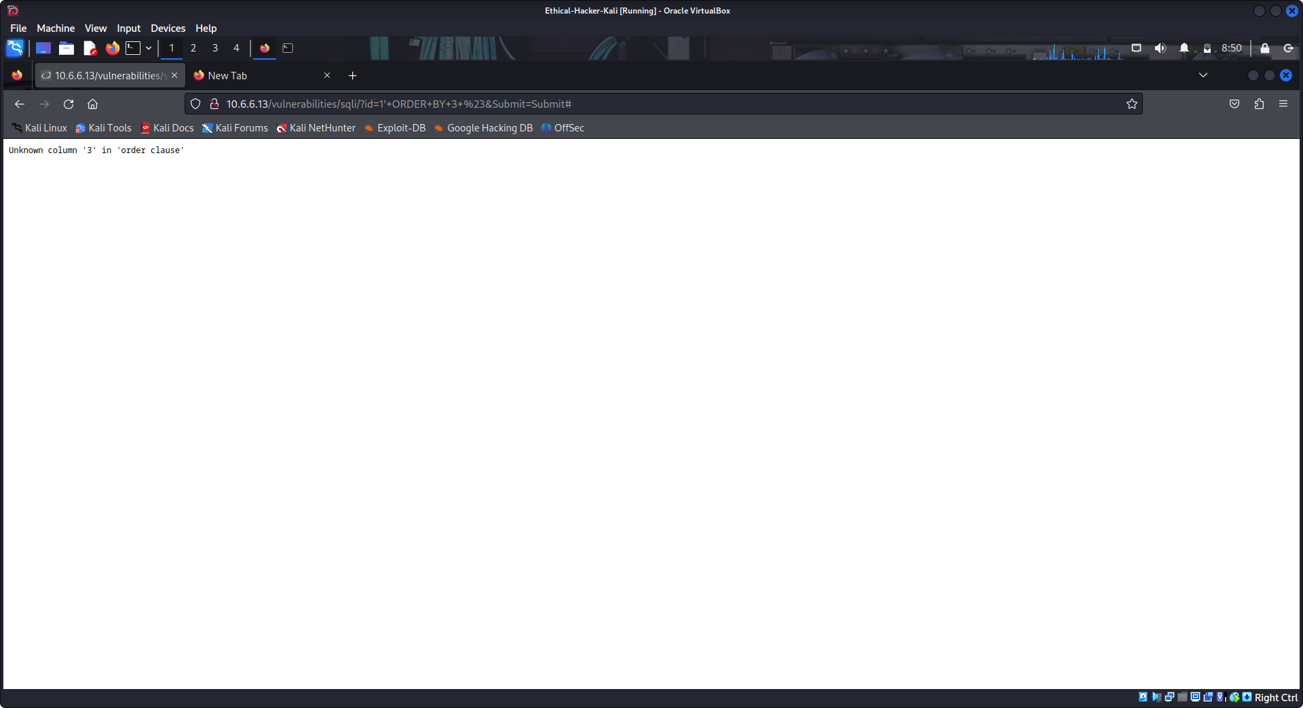
Because the third string returned an error, this tells us the query involves two fields. This is useful information to know as you continue your exploit.

Step 4: Check for version Database Management System (DBMS).
In the User ID: field type 1' OR 1=1 UNION SELECT 1, VERSION()# and click Submit.
At the end of the output, you should see a result similar to the following:
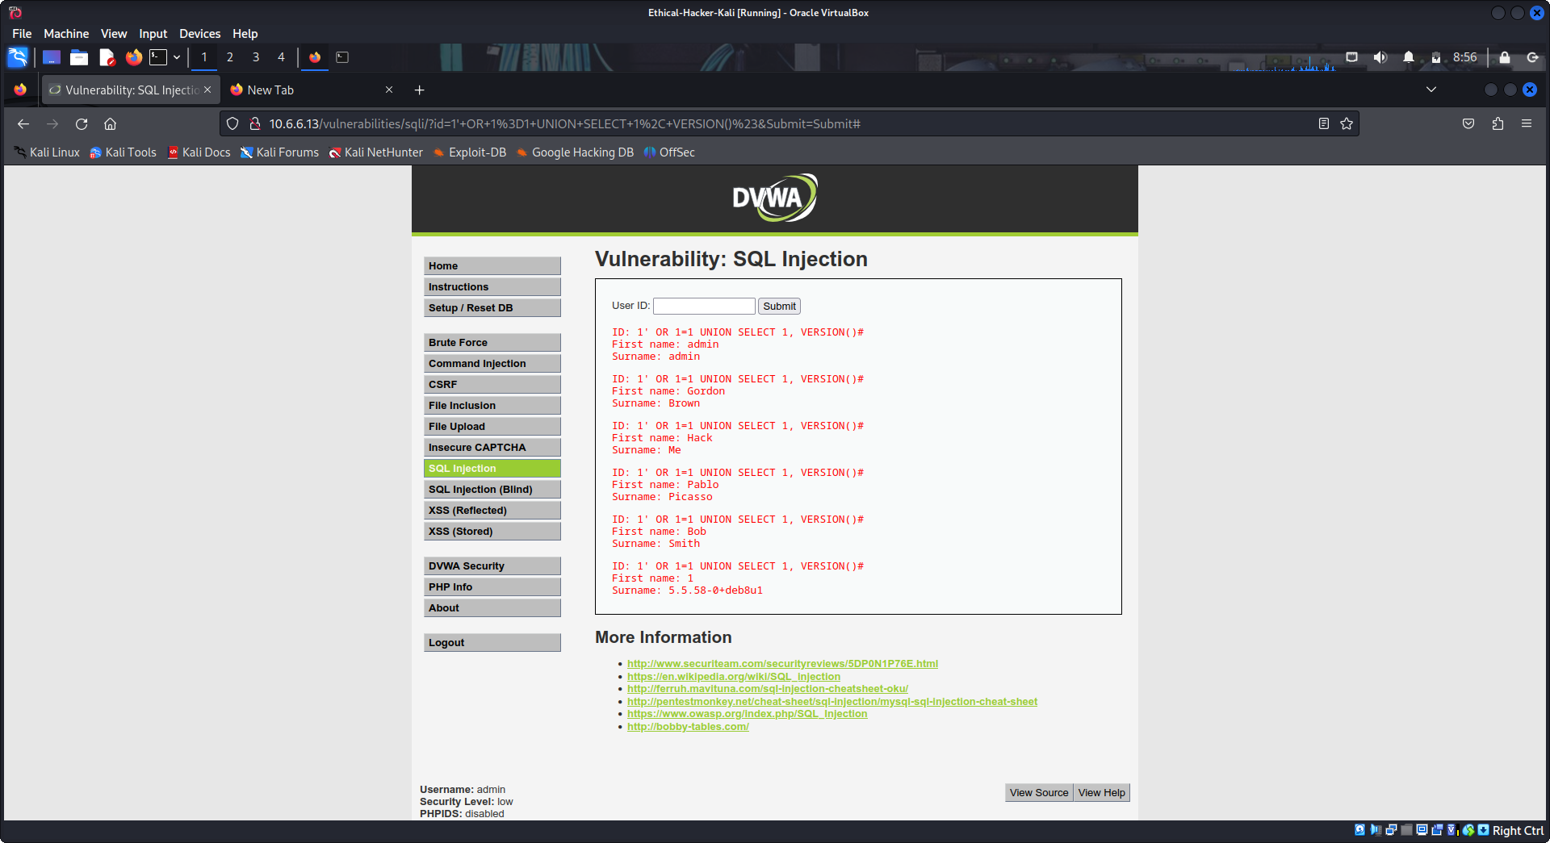
The output 5.5.58-0+deb8u1 indicates the DBMS is MySQL version 5.5.58 running on Debian.

Step 5: Determine the database name.
So far you have learned that the database is vulnerable, the query involves two fields, and the DDMS is MySQL 5.5.58.
Next, you will attempt obtain more schema information about the database.
In the User ID: field type 1' OR 1=1 UNION SELECT 1, DATABASE()# and click Submit.
At the end of the output, you should see the following result:
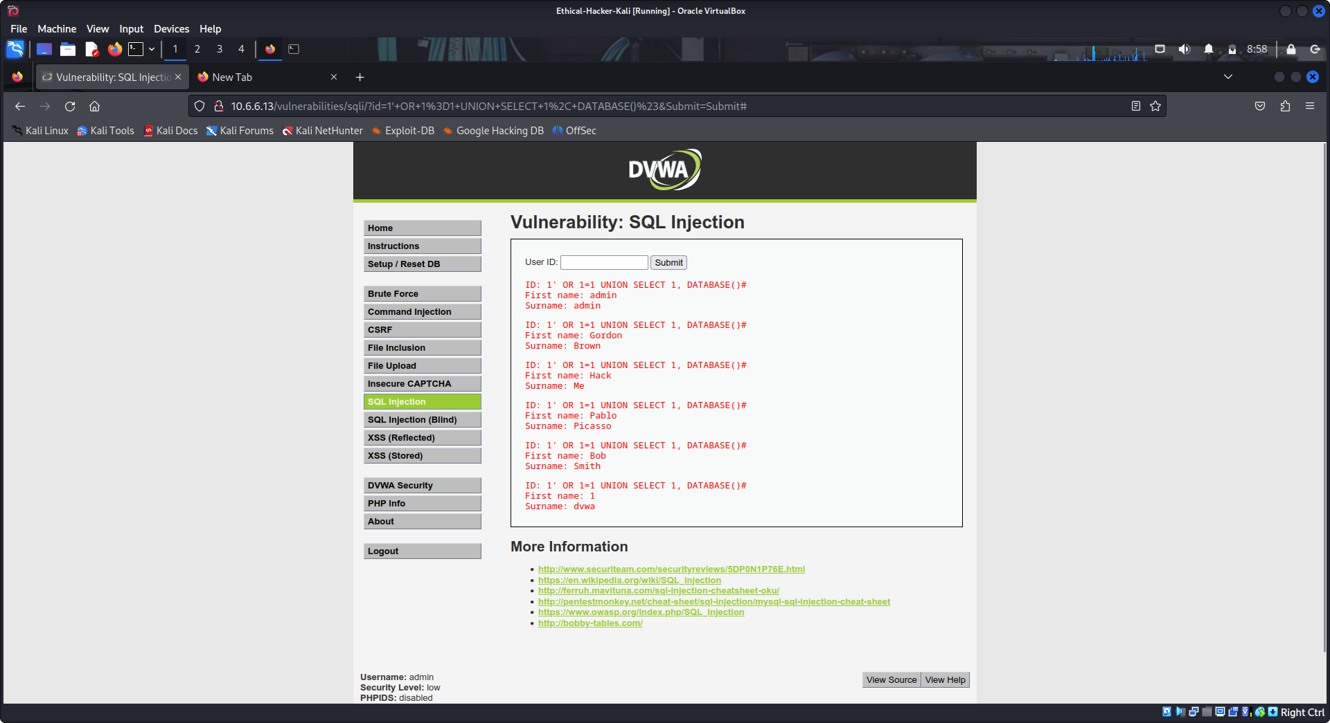
This means the name of the database is dvwa.

Step 6: Retrieve table Names from the dvwa database.
- In the User ID: field type:
1' OR 1=1 UNION SELECT 1,table_name FROM information_schema.tables WHERE table_type='base table' AND table_schema='dvwa'#
- Click Submit.
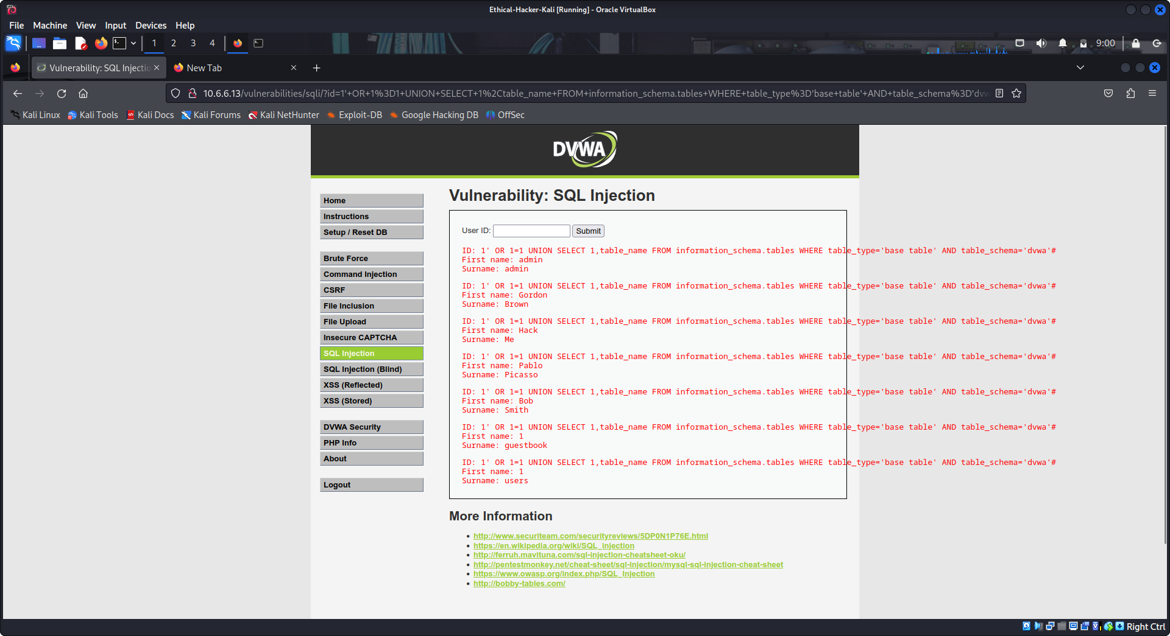
The output with First Name: 1 is the table information.
What are the two tables that were found? Guestbook and users
Which table do you think is the most interesting for a penetration test? Users table because it may include usernames and passwords.

Step 7: Retrieve column names from the users table.
You will now discover the field names in the users table. This will help you to find information that is useful for the pentest.
- In the User ID: field type:
1' OR 1=1 UNION SELECT 1,column_name FROM information_schema.columns WHERE table_name='users'#
- Click Submit.
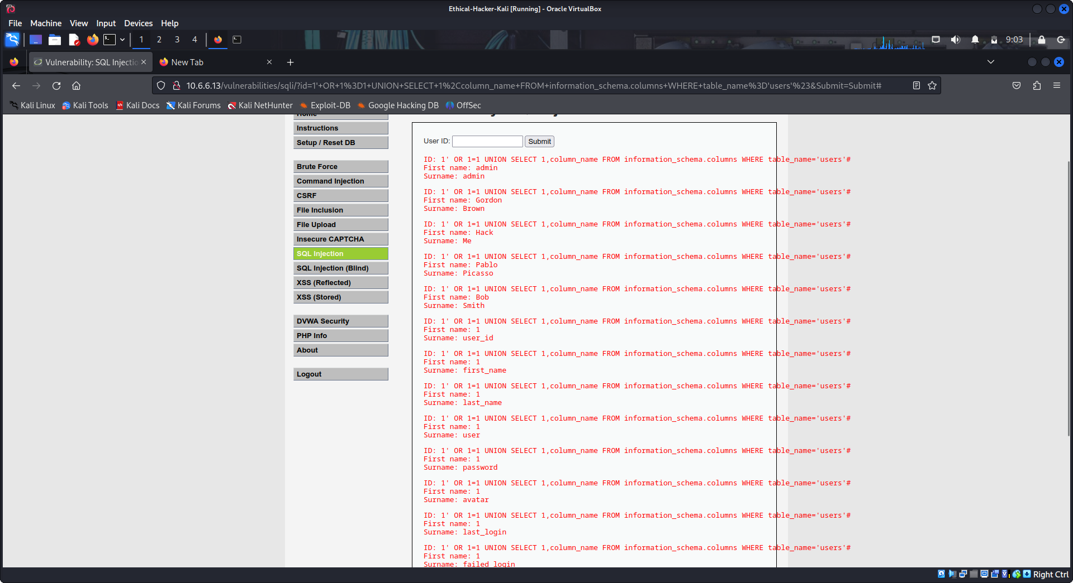
The list of column names displays after the listing of user accounts in the output. The information in which two columns is of interest to use in our penetration test? Explain.
The user column and the password column are of interest because they seem to contain information that can be used for unauthorized access.

Step 8: Retrieve the user credentials.
This query will retrieve the users and passwords.
- In the User ID: field type:
1' OR 1=1 UNION SELECT user, password FROM users #
- Click Submit.
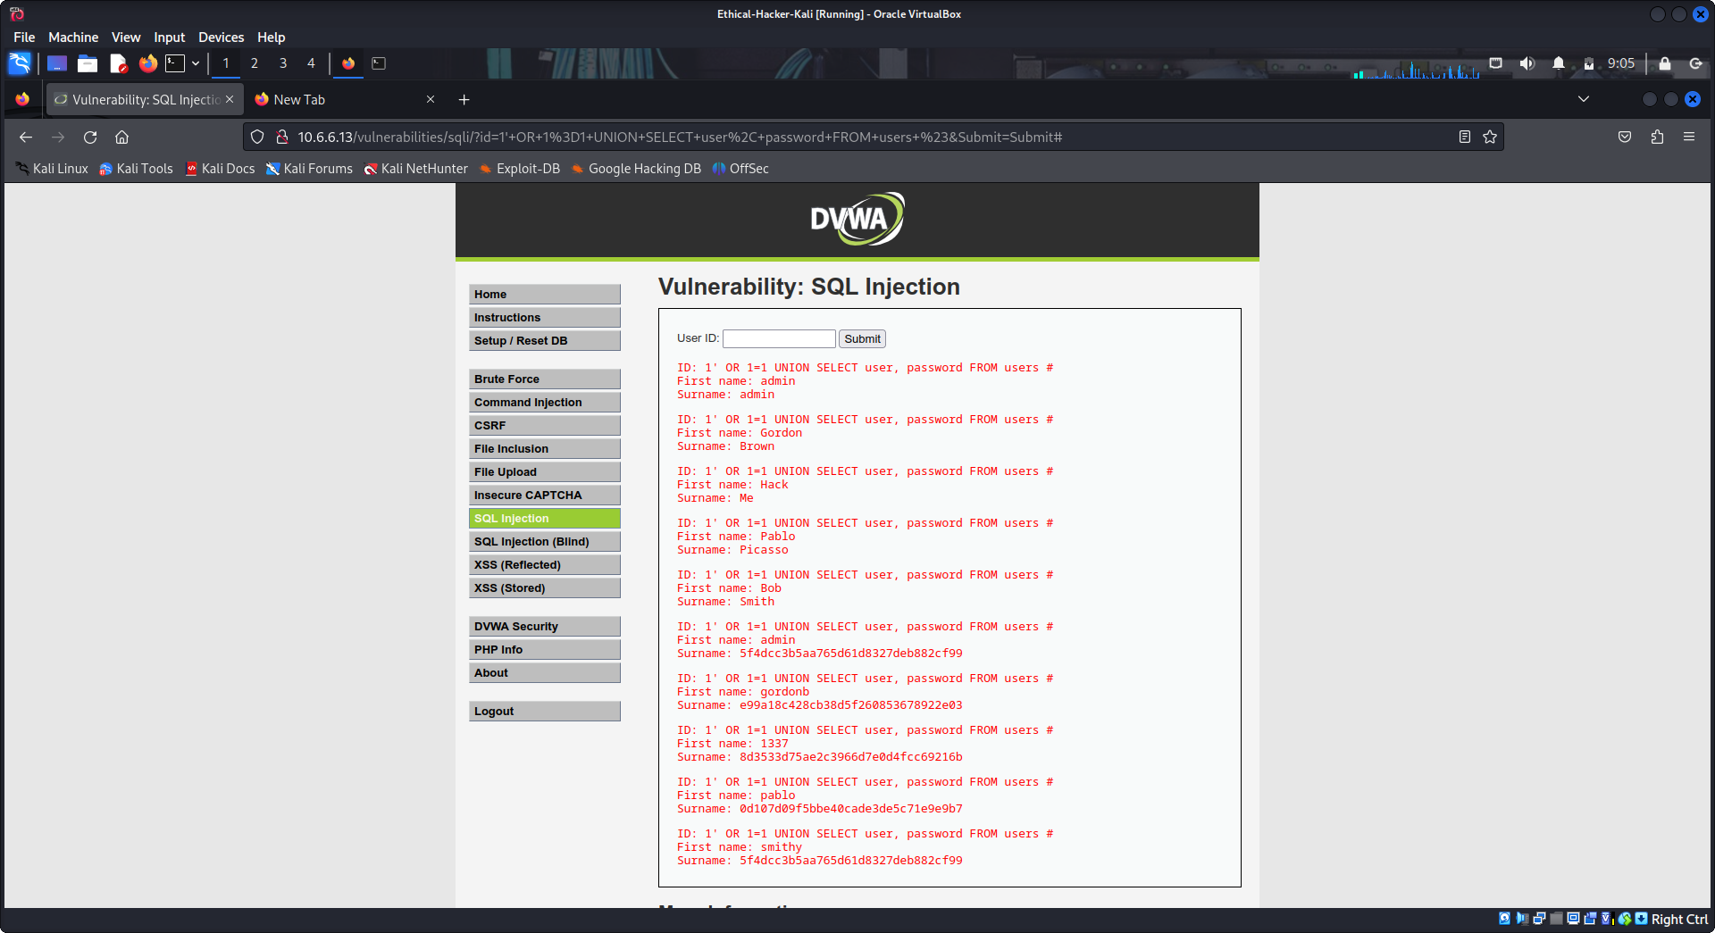
After the list of users, you should see several results with usernames and what appears to be password hashes.
Which account could be the most valuable in our pentest? Explain.
The admin account, it probably has the greatest rights and privileges on the system.
- Try crafting queries to display the contents of other fields in the table by varying the column names based on the names previously displayed.
What is the difference between the user_id and user fields? The user_id is a number, while the user field is the username.

Step 9: Hack the password hashes.
- Open another browser tab and navigate to https://crackstation.net.
CrackStation is a free online password hash cracker.
- Copy and paste the password hash from DVWA into CrackStation and click Crack Hashes.
What is the password of the admin account? password
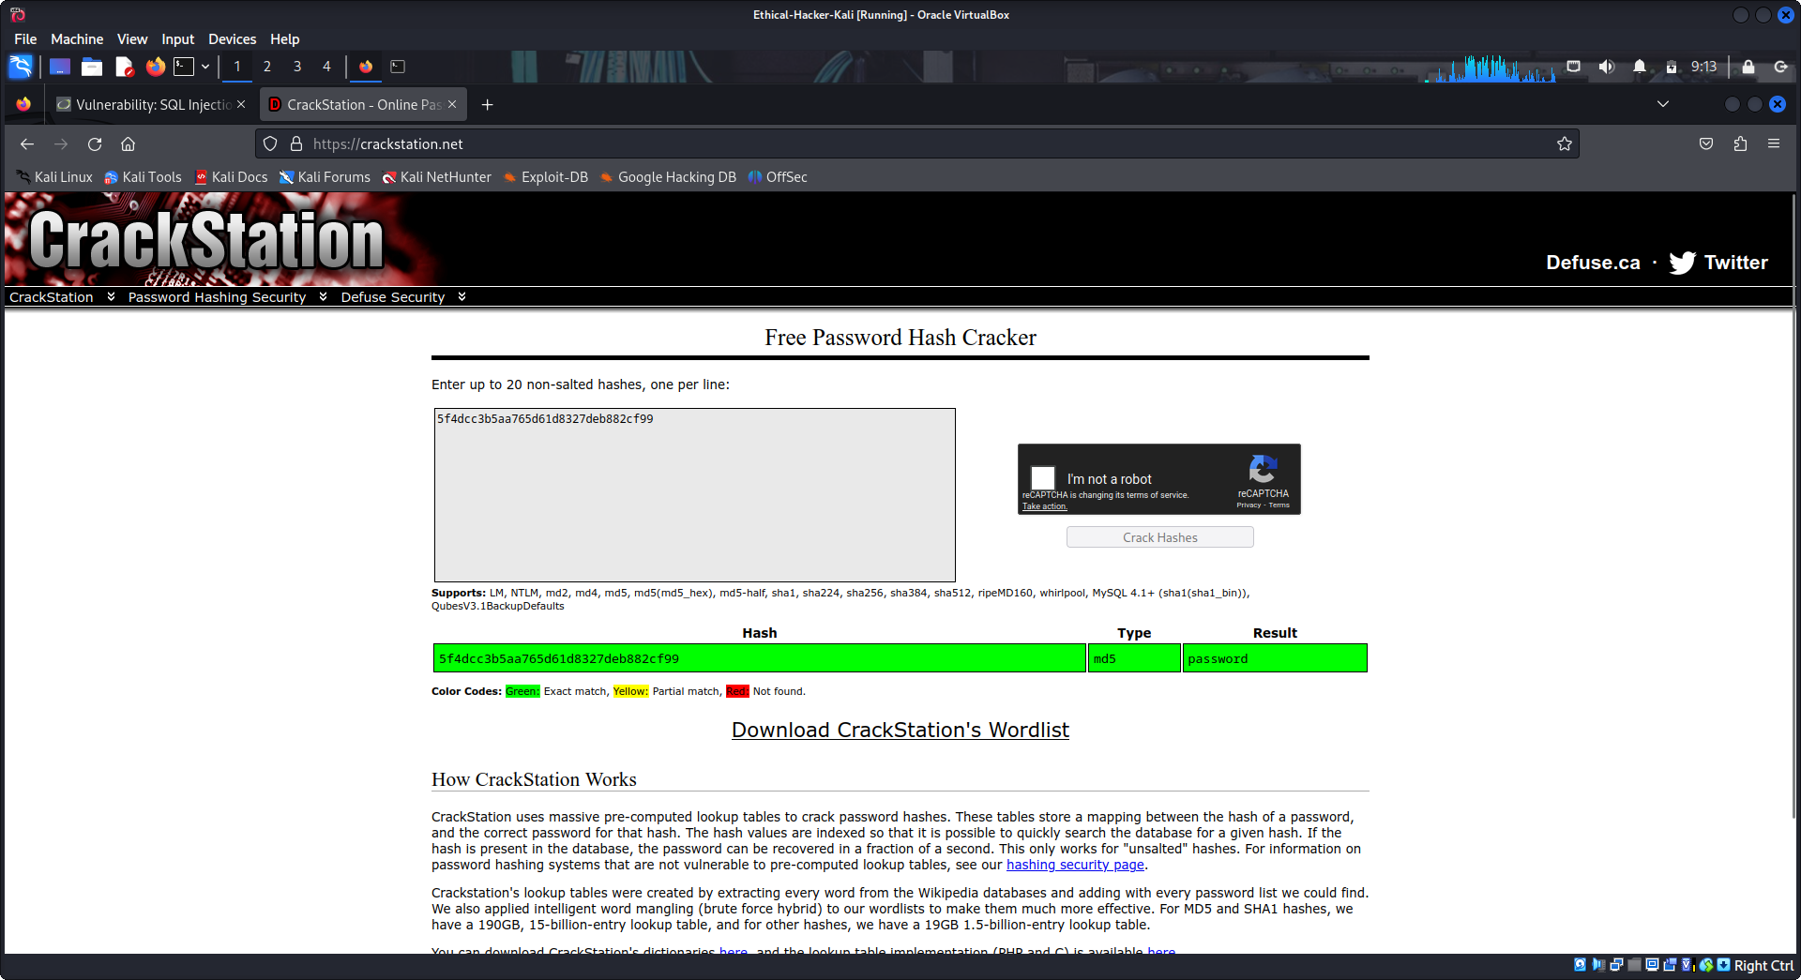
What is the password for the user pablo? letmein

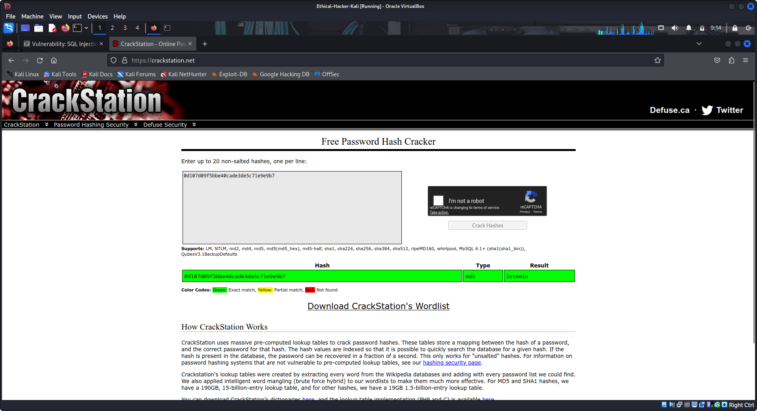
Part 2: Research SQL Injection Mitigation

Step 1: Conduct online research on SQL injection mitigation.
- Open a web browser and search SQL injection mitigation and SQL injection prevention.
- Take notes on your mitigation and prevention findings.

How to Prevent SQL Injections

Step 1: Train and maintain awareness: To keep your web application safe, everyone involved in building the web application must be aware of the risks associated with SQL Injections. You should provide suitable security training to all your developers, QA staff, DevOps, and SysAdmins. You can start by referring them to this page.

Step 2: Don’t trust any user input: Treat all user input as untrusted. Any user input that is used in an SQL query introduces a risk of an SQL Injection. Treat input from authenticated and/or internal users the same way that you treat public input.

Step 3: Use whitelists, not blacklists: Don’t filter user input based on blacklists. A clever attacker will almost always find a way to circumvent your blacklist. If possible, verify and filter user input using strict whitelists only.

Step 4: Adopt the latest technologies: Older web development technologies don’t have SQLi protection. Use the latest version of the development environment and language and the latest technologies associated with that environment/language. For example, in PHP use PDO instead of MySQLi.

Step 5: Employ verified mechanisms: Don’t try to build SQLi protection from scratch. Most modern development technologies can offer you mechanisms to protect against SQLi. Use such mechanisms instead of trying to reinvent the wheel. For example, use parameterized queries or stored procedures.

Step 6: Scan regularly (with Acunetix): SQL Injections may be introduced by your developers or through external libraries/modules/software. You should regularly scan your web applications using a web vulnerability scanner such as Acunetix. If you use Jenkins, you should install the Acunetix plugin to automatically scan every build.

