Module 3: Information Gathering and Vulnerability Scanning

3.1. Performing Passive Reconnaissance
3.1.1 Overview
Reconnaissance: is the initial step in a cyber attack. An attacker must first gather information about the target in order to be successful.
In Military, reconnnaissance is gathering of information about the enemy, such as information about the enemy’s location, capabilities, and movements.
In Penetration testing, reconnaissance engagement typically consists of scanning and enumeration.
3.1.2 Active Reconnaissance vs. Passive Reconnaissance
Active reconnaissance is a method of information gathering in which the tools used actually send out probes to the target network or systems in order to elicit responses that are then used to determine the posture of the network or system.
Passive reconnaissance is a method of information gathering in which the tools do not interact directly with the target device or network.
The passive reconnaissance technique that you use depends on the type of information that you wish to obtain.
One of the most important aspects of learning about penetration testing is developing a good methodology that will help you select the appropriate tools and technologies to use during the engagement.
Common active reconnaissance tools and methods include the following:
- Host enumeration
- Network enumeration
- User enumeration
- Group enumeration
- Network share enumeration
- Web page enumeration
- Application enumeration
- Service enumeration
- Packet crafting
Common passive reconnaissance tools and methods include the following:
- Domain enumeration
- Packet inspection
- Open-source intelligence (OSINT)
- Recon-ng
- Eavesdropping
3.1.5 DNS Lookups
Typically, an attacker would start with a small amount of information and gather more information while scanning, eventually moving on to performing different types of scans and gathering additional information.
For instance, the attacker targeting h4cker.org might start by using DNS lookups to determine the IP address or addresses used by h4cker.org and any other subdomains that might be in use.
Let’s say that those queries reveal that h4cker.org is using the IP addresses 185.199.108.153 for www.h4cker.org, 185.199.110.153 for mail.h4cker.org, and 185.199.110.153 for portal.h4cker.org. Example 3-1 shows an example of the DNSRecon tool in Kali Linux being used to query the DNS records for h4cker.org.
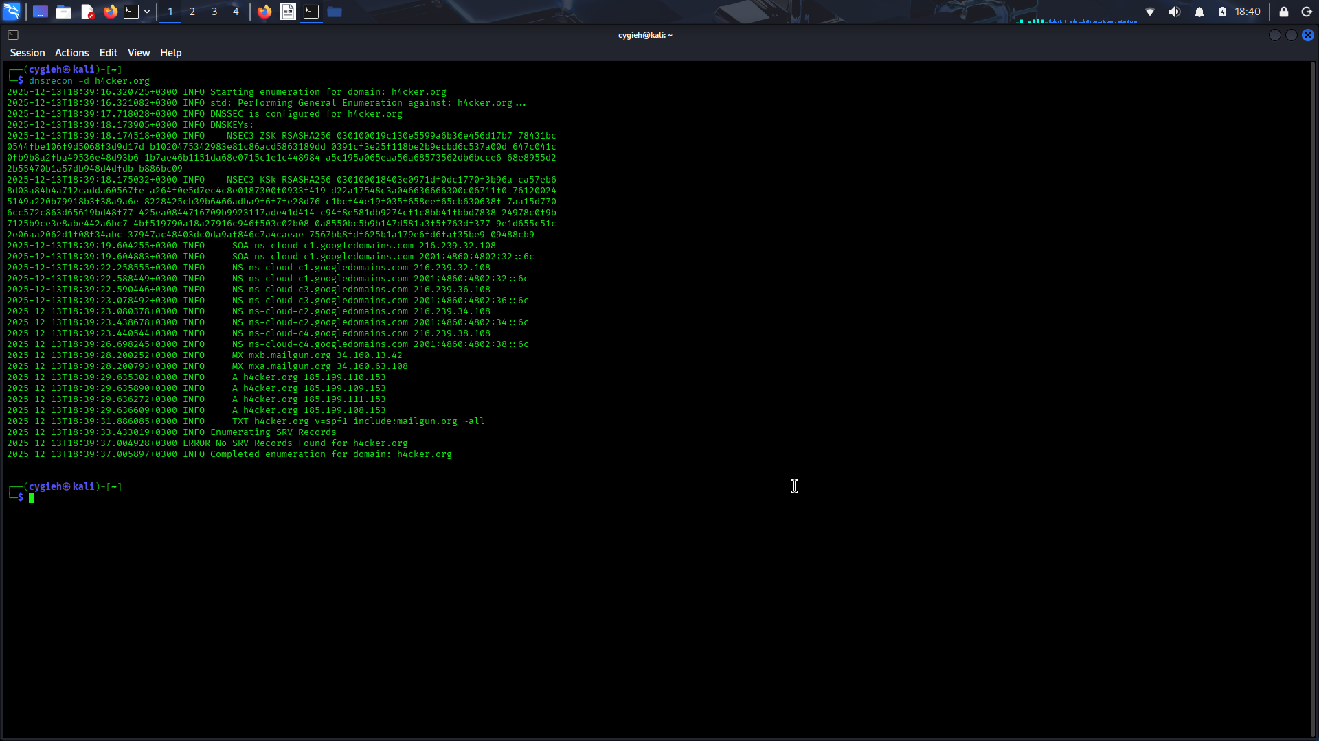
You can use other basic DNS tools, such as the nslookup, host, and dig Linux commands, to perform name resolution and obtain additional information about a domain. Example 3-2 shows how the Dig tool is used to show the DNS resolution details for h4cker.org.
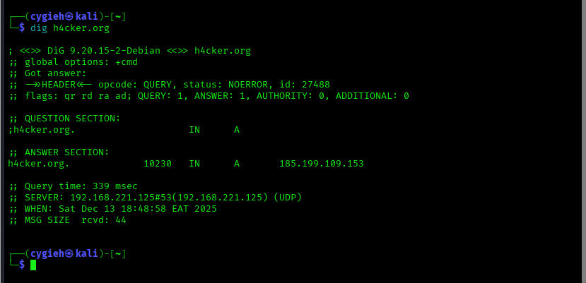
The highlighted lines show the IP addresses associated with h4cker.org. Similarly, you can use the dig < domain > mx command to obtain the email servers used by h4cker.org (mail exchanger [MX] record), as demonstrated in Example 3-3
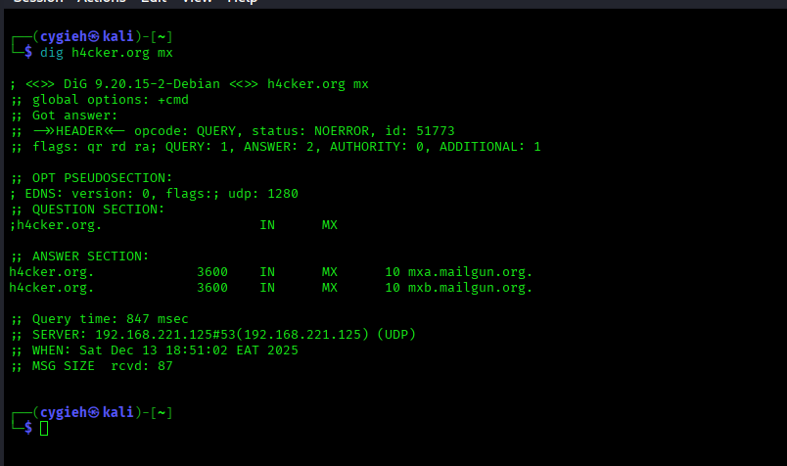
You can easily identify domain technical and administrative contacts by using the Whois tool. Many organizations keep their registration details private and instead use the domain registrar organization contacts. For instance, let’s look at the technical and administrative contacts of h4cker.org (shown in Example 3-4). Omar Santos owns the h4cker.org domain; however, the technical and administrative details are private. Only the abuse contact email and phone number from Google (the domain registrar) are displayed.
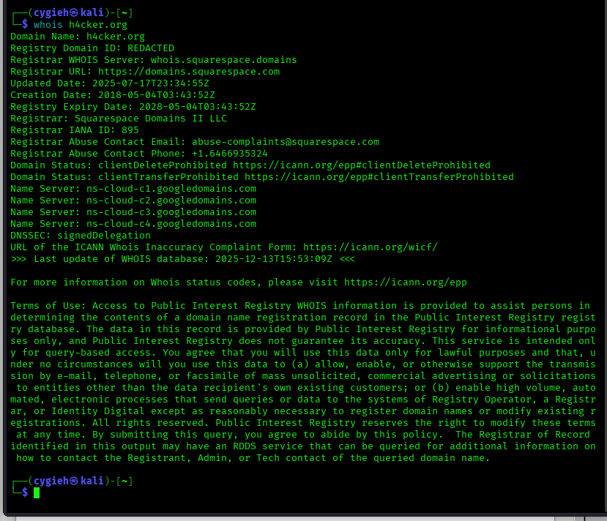
Now let’s look at the Whois details for tesla.com, shown in Example 3-5.
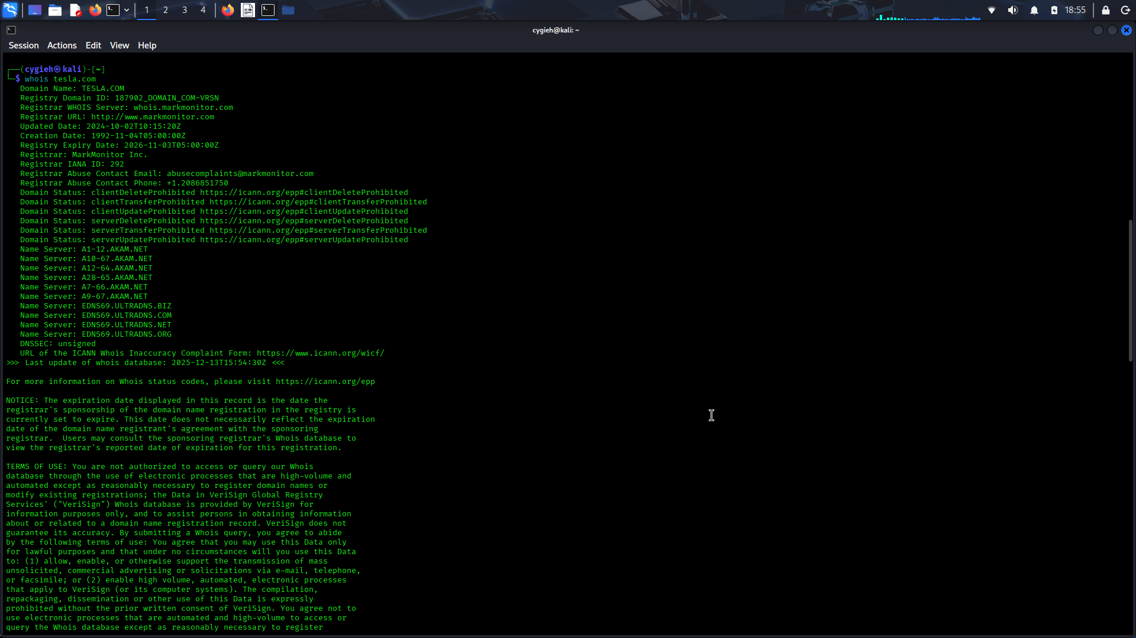
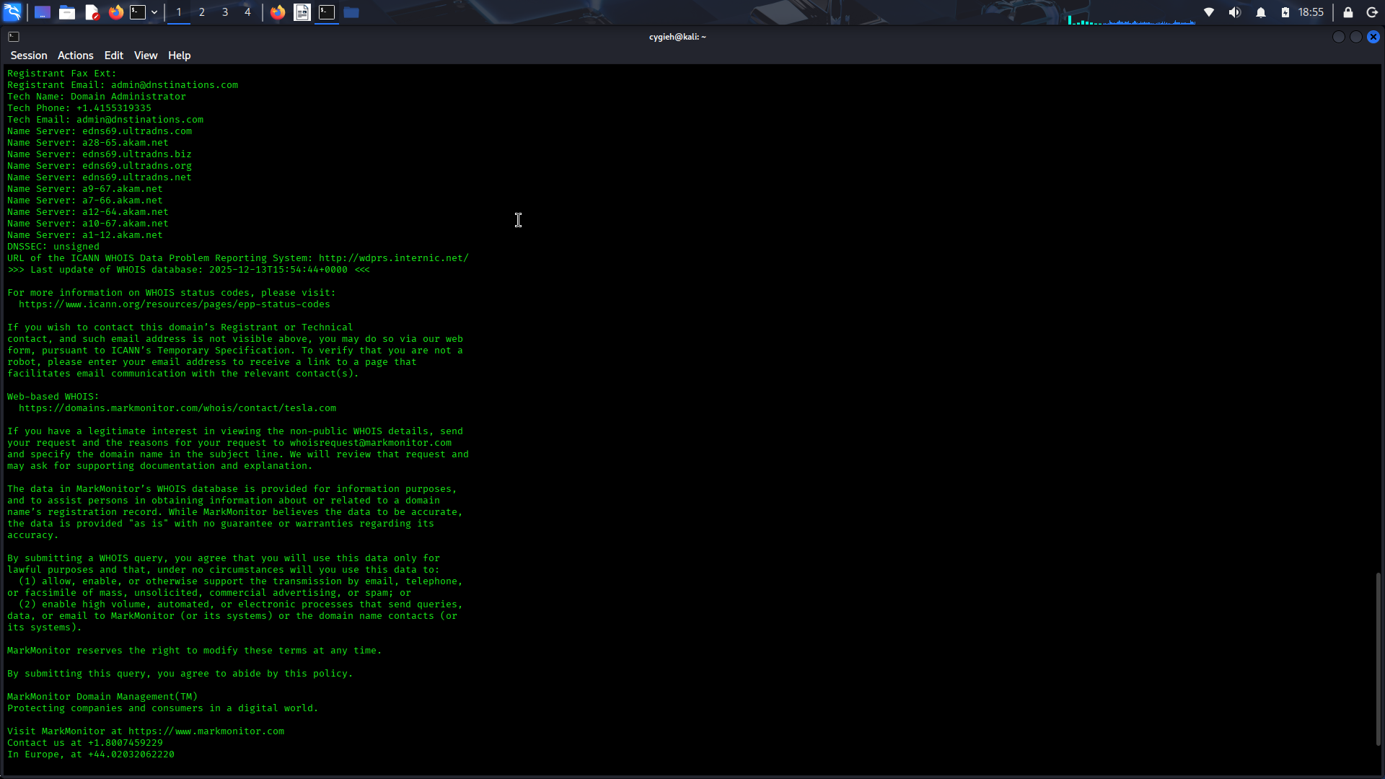
debientasolutions
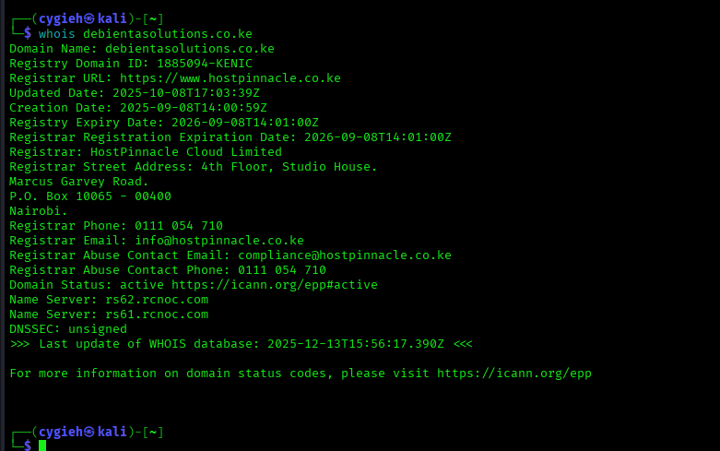
The highlighted lines in Example 3-5 show the technical and administrative contacts for the domain (which are also the ones for the domain registrar [MarkMonitor]). Example 3-6 shows another example; this example shows the technical and administrative email contacts for the domain cisco.com.
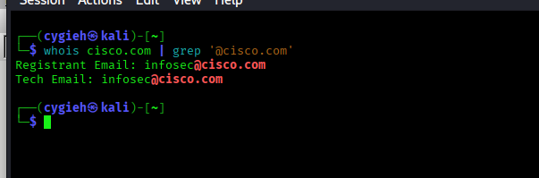
3.1.10 Cloud vs. Self-Hosted Applications and Related Subdomains
A company can own a domain and related subdomain, but its applications might be hosted in the cloud. For example, Netflix (at the time of writing) owns the domain netflix.com, which resolves to IPv4 addresses 3.230.129.93, 52.3.144.142, and 54.237.226.164 (as demonstrated in Example 3-7 with the Linux host command).
Example 3-7 - DNS Name Resolution for netflix.com
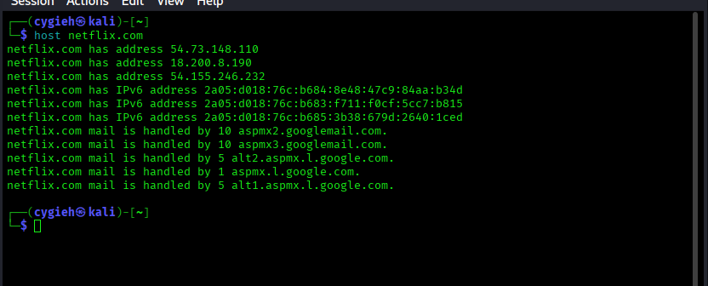
However, the IPv4 addresses are owned by Amazon Web Services (AWS), which hosts Netflix.com, as demonstrated in Example 3-8.
Example 3-8 - Example of the Ownership of IP Addresses and Applications Hosted in the Cloud
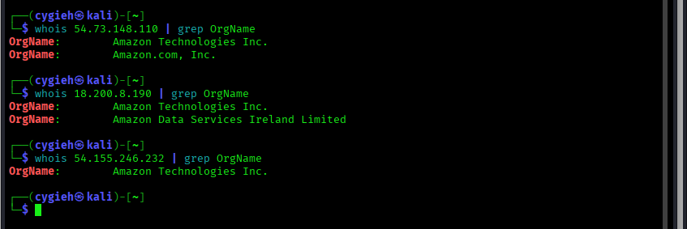
In Example 3-8, the whois command is used to retrieve the organization name (OrgName) of the owner for each of the IP addresses.

3.1.13 Cryptographic Flaws
During the reconnaissance phase, attackers often can inspect Secure Sockets Layer (SSL) certificates to obtain information about the organization, potential cryptographic flaws, and weak implementations.
Information inside digital certificates:
the certificate serial number,
the subject common name,
the uniform resource identifier (URI) of the server it was assigned to,
the organization name,
Online Certificate Status Protocol (OCSP) information,
the certificate revocation list (CRL)
URI
Certificate revocation is the act of invalidating a digital certificate.
Attackers can also leverage certificate transparency to reveal additional information and enumerate subdomains.
Certificate transparency was created to better detect the issuing of malicious certificates.
The goal of certificate transparency is for any organization or individual to be able to “transparently” verify the issuance of a digital certificate.
Certificate transparency allows certificate authorities (CAs) to provide details about all certificates that have been issued for a given domain and organization.
Attackers can also use this information to reveal what other subdomains and systems an organization may own.
Tools such as crt.sh enable you to obtain detailed certificate transparency information about any given domain.
3.1.15 Company Reputation and Security Posture
Security breaches can have a direct impact on a company’s reputation. Attackers can leverage information from past security breaches that an organization might have experienced. They may, for example, leverage the following data while trying to gather information about their victims:
- Password dumps
- File metadata
- Strategic search engine analysis/enumeration
- Website archiving/caching
- Public source code repositories
Password Dumps
Attackers can leverage password dumps from previous breaches. There are a number of ways that an attacker can get access to such password dumps, such as by using Pastebin, dark web websites, and even GitHub in some cases. Several different tools and websites make this task very easy. An example of a tool that allows you to find email addresses and passwords exposed in previous breaches is h8mail. You can install h8mail by using the pip3 install h8mail command, as demonstrated below
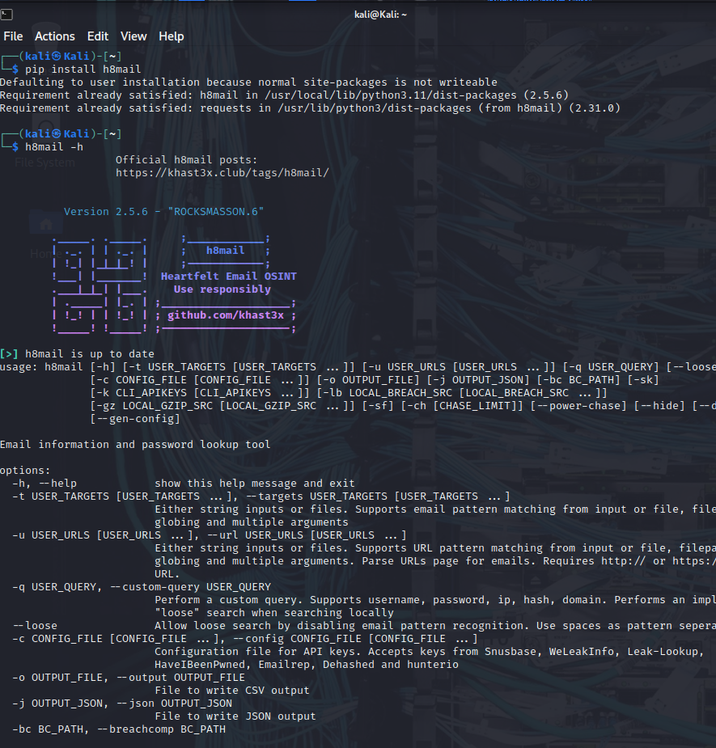
The following are additional tools that allow you to search for breach data dumps:
- WhatBreach: https://github.com/Ekultek/WhatBreach
- LeakLooker: https://github.com/woj-ciech/LeakLooker
- Buster: https://github.com/sham00n/buster
- Scavenger: https://github.com/rndinfosecguy/Scavenger
- PwnDB: https://github.com/davidtavarez/pwndb
Tools like h8mail and WhatBreach take advantage of breached data repositories of websites such as haveibeenpwned.com and snusbase.com. Historically, websites such as weleakinfo.com (seized by the FBI) have been used by criminals to dump information from past security breaches.
File Metadata
You can obtain a lot of information from metadata in files such as images, Microsoft Word documents, Excel files, PowerPoint files, and more.
For instance, Exchangeable Image File Format (Exif) is a specification that defines the formats for images, sound, and supplementary tags used by digital cameras, mobile phones, scanners, and other systems that process image and sound files.
Several tools can show Exif details. One of the most popular of them, ExifTool, is demonstrated below.
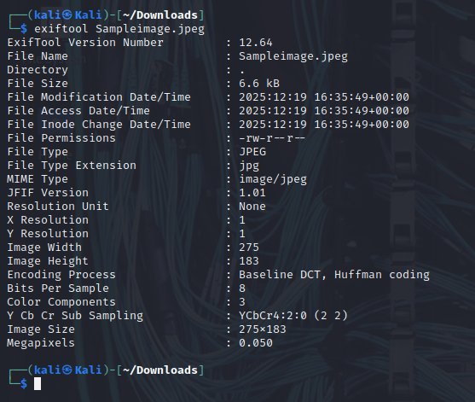
Strategic Search Engine Analysis/Enumeration
Most of us use search engines such as DuckDuckGo, Bing, and Google to locate information. What you might not know is that search engines, such as Google, can perform much more powerful searches than most people ever dream of. Google can translate documents, perform news searches, and do image searches.
In addition, hackers and attackers can use it to do something that has been termed Google hacking.
By using basic search techniques combined with advanced operators, both you and attackers can use Google as a powerful vulnerability search tool. The following are some advanced operators:
- Filetype: Directs Google to search only within the text of a particular type of file (for example, filetype:xls)
- Inurl: Directs Google to search only within the specified URL of a document (for example, inurl:search-text)
- Link: Directs Google to search within hyperlinks for a specific term (for example, link:www.domain.com)
- Intitle: Directs Google to search for a term within the title of a document (for example, intitle: “Index of /etc”)
By using these advanced operators in combination with key terms, both you and attackers can get Google to uncover many pieces of sensitive information that shouldn’t be revealed. These search strings are often called Google dorks.
To see how Google dorking works, enter the following phrase into Google:
intext:JSESSIONID OR intext:PHPSESSID inurl:access.log ext:log
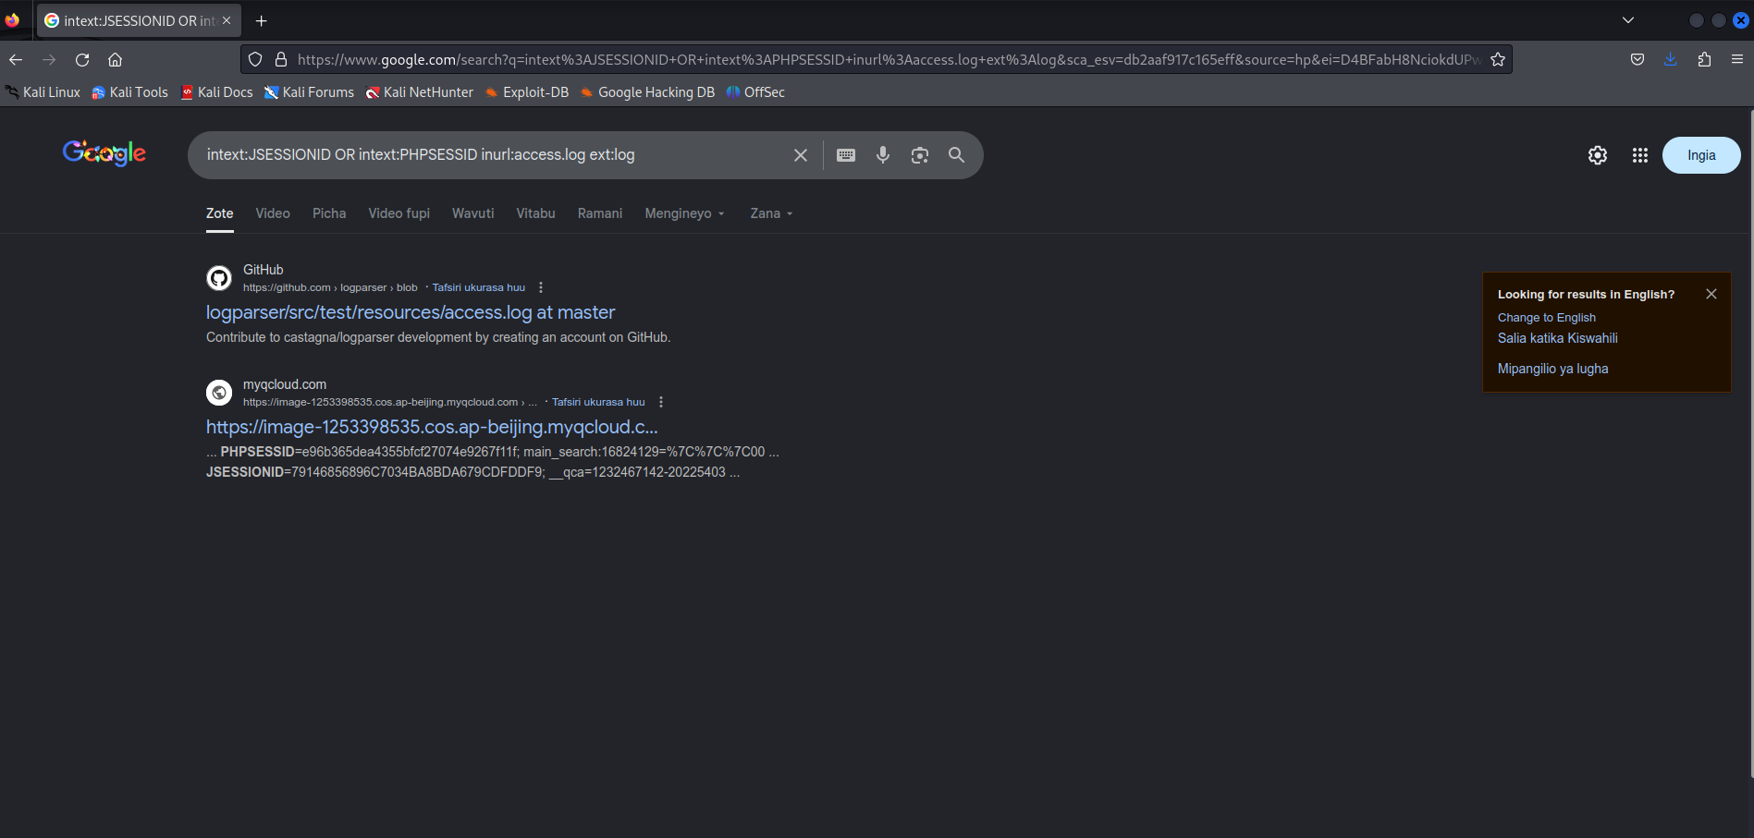
This query searches in a URL for the session IDs that could be used to potentially impersonate users. It's not unusual for this search to find more than 100 sites that store sensitive session IDs in logs that were publicly accessible. If these IDs have not timed out, they could be used to gain access to restricted resources.
You can use advanced operators to search for many types of data. The following is another example of a Google search string (or Google dork) that can reveal passwords of web applications:
"public $user =" | "public $password = " | "public $secret =" | "public $db =" ext:txt | ext:log -git
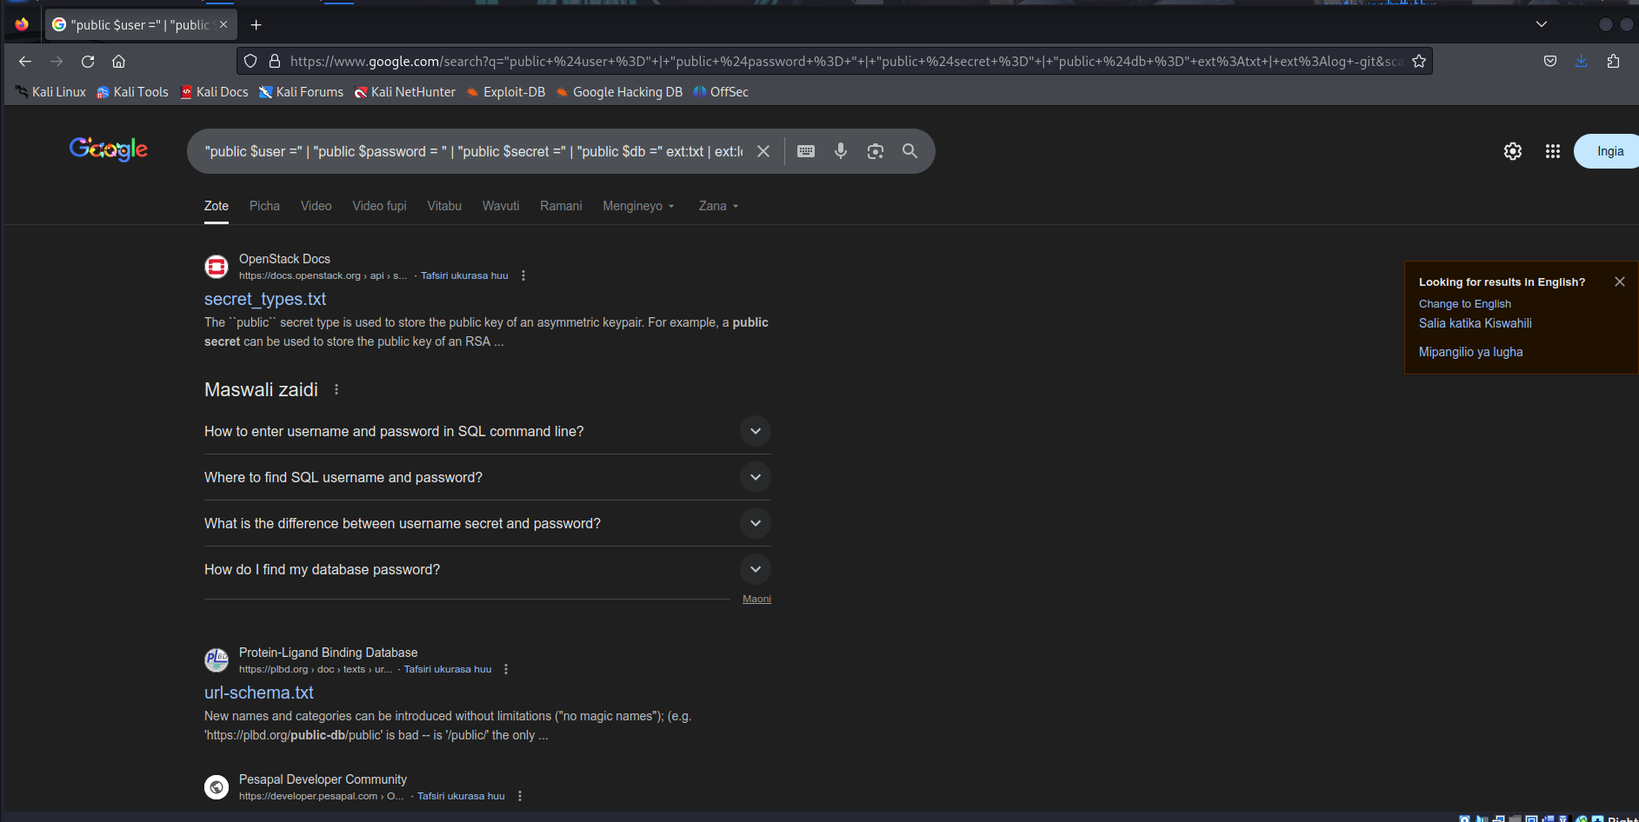
Now that we have discussed some basic Google search techniques, let’s look at advanced Google hacking. We recommend that you visit the Google Hacking Database (GHDB) repositories at https://www.exploit-db.com/google-hacking-database/. GHDB has the following search categories:
- Footholds
- Files containing usernames
- Sensitive directories
- Web server detection
- Vulnerable files
- Vulnerable servers
- Error messages
- Files containing juicy info
- Files containing passwords
- Sensitive online shopping info
- Network or vulnerability data
- Pages containing login portals
- Various online devices
- Advisories and vulnerabilities
GHDB is a community effort. Anyone can upload a new Google dork to perform these types of searches. Once you start playing with the dorks in GHDB, you will be surprised by the unbelievable things found through Google hacking. GHDB has made using Google dorks very easy, and there are other options as well. Later in this module, you will learn about additional tools that can be used to perform similar searches (such as Recon-ng).
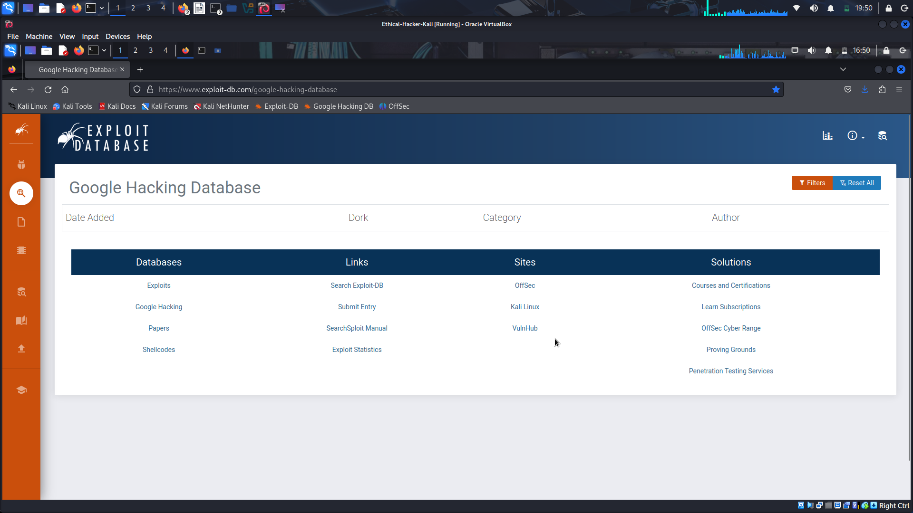
Website Archiving/Caching
Several organizations archive and cache website data on the Internet. One of the most popular repositories is the “Wayback Machine” of Internet Archive (https://archive.org/web).
The Wayback Machine allows you to go back in time on the Internet.
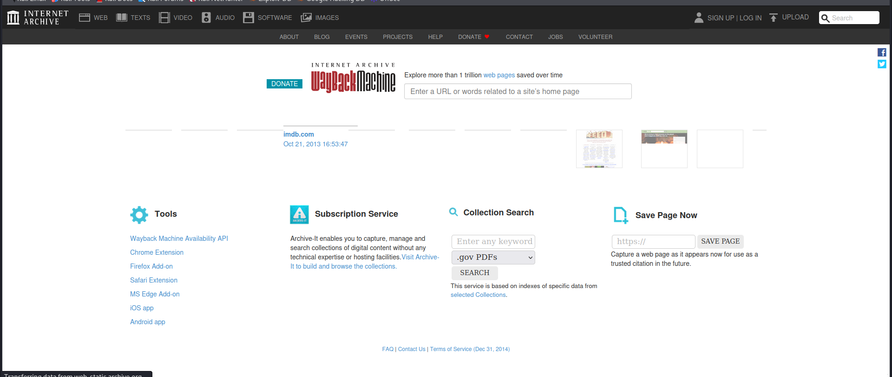
For example, the figure below shows what Cisco’s website looked like on November 3, 1999. You can access the archive of the site shown by copying the following link into your browser address bar: https://web.archive.org/web/19991103121048/http://www.cisco.com/.
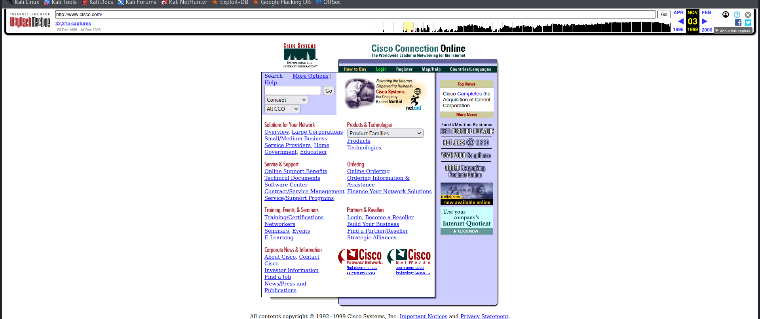
Public Source Code Repositories
An attacker can obtain extremely valuable information from public source code repositories such as GitHub and GitLab. Most of the applications and products we consume today use open-source software that is freely available in these public repositories. Attackers can find vulnerabilities in those software packages and use them to their advantage.
Similarly, as a penetration tester, you can obtain valuable information from these public repositories. Even if you do not immediately find security vulnerabilities in the code, these repositories can give you insights into the architecture and underlying code used in the organization’s applications and infrastructure.
3.1.20 Open-Source Intelligence (OSINT) Gathering
Open-source intelligence (OSINT) gathering is a method of gathering publicly available intelligence sources to collect and analyze information about a target. OSINT is “open source” because collecting the information does not require any type of covert methods. Typically, the information can be found on the Internet. The larger the online presence of the target, the more information that will be available. This type of collection can often start with a simple Google search, which can reveal a significant amount of information about a target. It will at least give you enough information to know what direction to go with your information-gathering process. Let's cover two tools that can be used for OSINT gathering: Recong-ng and Shodan.
Recon-ng
This module covers a number of individual sources and tools used for information gathering. These tools are all very effective for their specific uses;
It is a framework developed by Tim Tomes of Black Hills Information Security. This tool was developed in Python with Metasploit msfconsole in mind. If you have used the Metasploit console before, Recon-ng should be familiar and easy to understand.
Recon-ng is a modular framework, which makes it easy to develop and integrate new functionality. It is highly effective in social networking site enumeration because of its use of application programming interfaces (APIs) to gather information. It also includes a reporting feature that allows you to export data in different report formats. Because you will always need to provide some kind of deliverable in any testing you do, Recon-ng is especially valuable.
Select each of the following steps for an example of running Recon-ng in Kali Linux.
Step 1: Start Recon-ng
To start using Recon-ng, you simply run recon-ng from a new terminal window. Example 3-11 shows the command and the initial menu that Recon-ng starts with.
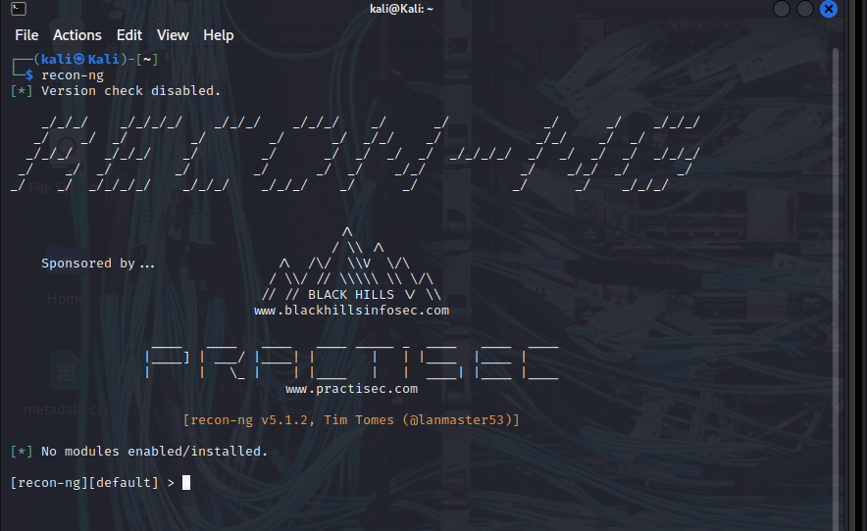
Step 2. View available commands
To get an idea of what commands are available in the Recon-ng command-line tool, you can simply type help and press Enter. Example 3-12 shows the output of the help command.
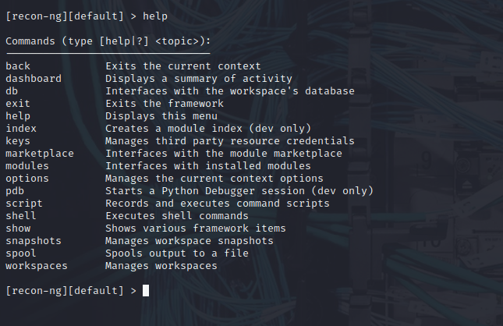
Step 3. Search for available modules.
Before you can start gathering information using the Recon-ng tool, you need to understand what modules are available. (You can see from the initial screen the current number of modules that are installed in Recon-ng.) Recon-ng comes with a “marketplace,” where you can search for available modules to be installed. You can use the marketplace search command to search for all the available modules in Recon-ng
Scroll the output to the right to see the D and K columns The letter D indicates that the module has dependencies. The letter K indicates that an API key is needed in order to use the resources used in a particular module. For example, the module with the path recon/companies-contacts/censys_email_address has dependencies and needs an API key in order to query the Censys database. (Censys is a very popular resource for querying OSINT data.)
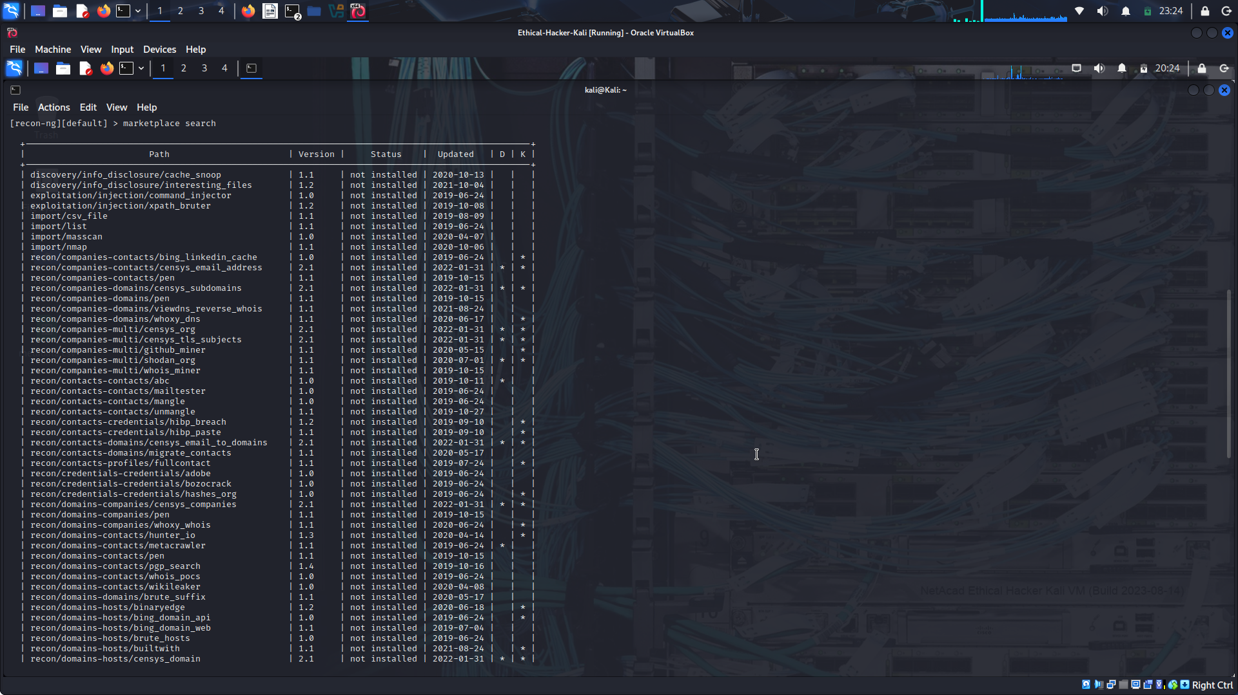
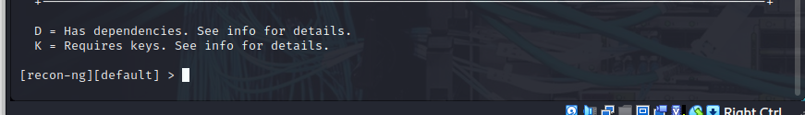
Step 4. Refresh the marketplace.
You can refresh the data about the available modules by using the marketplace refresh command
Step 5. Search the marketplace.
Let’s perform a quick search to find different subdomains of one of my domains (h4cker.org). We can use the module bing_domain_web to try to find any subdomains leveraging the Bing search engine. You can perform a keyword search for any modules by using the command marketplace search < keyword >
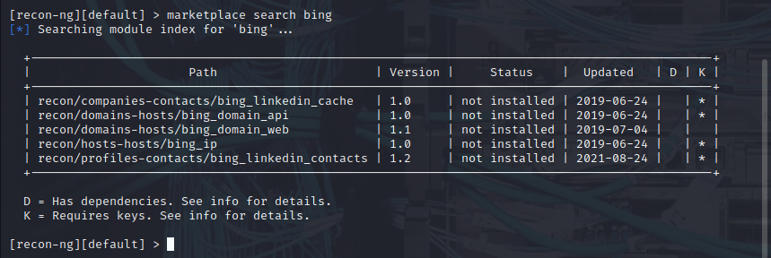
Step 6. Install a module.
Several results matched the bing keyword. However, the one that we are interested in is recon/domains-hosts/bing_domain_web. You can install the module by using the marketplace install command
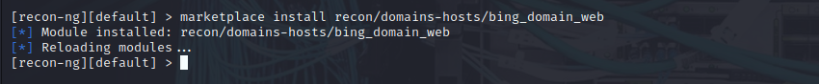
Step 7. Show installed modules.
You can use the modules search command to show all the modules that have been installed in Recon-ng.
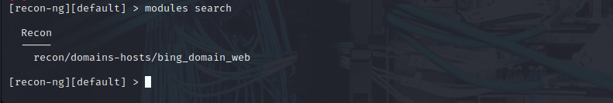
Step 8. Load a module.
To load the module that you would like to use, use the modules load command.
The bing_domain_web module is loaded. Notice that the prompt changed to include the name of the loaded module. After the module is loaded, you can display the module options by using the info command.
Step 9. Change the source.
You can change the source (the domain to be used to find its subdomains) by using the command options set SOURCE, as demonstrated in Example 3-19. After the source domain is set, you can type run to run the query. The highlighted lines show that four subdomains were found using the bing_domain_web module.
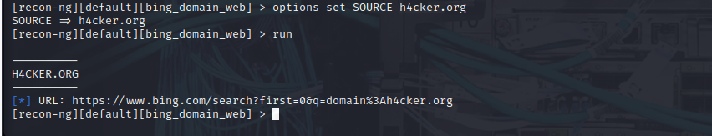
Recon-ng is incredibly powerful because it uses the APIs of various OSINT resources to gather information. Its modules can query sites such as Facebook, Indeed, Flickr, Instagram, Shodan, LinkedIn, and YouTube.
Shodan
Shodan is an organization that scans the Internet 24 hours a day, 365 days a year. The results of those scans are stored in a database that can be queried at shodan.io or by using an API. You can use Shodan to query for vulnerable hosts, Internet of Things (IoT) devices, and many other systems that should not be exposed or connected to the public Internet. Figure below shows different categories of systems found by Shodan scans, including industrial control systems (ICS), databases, network infrastructure devices, and video games.
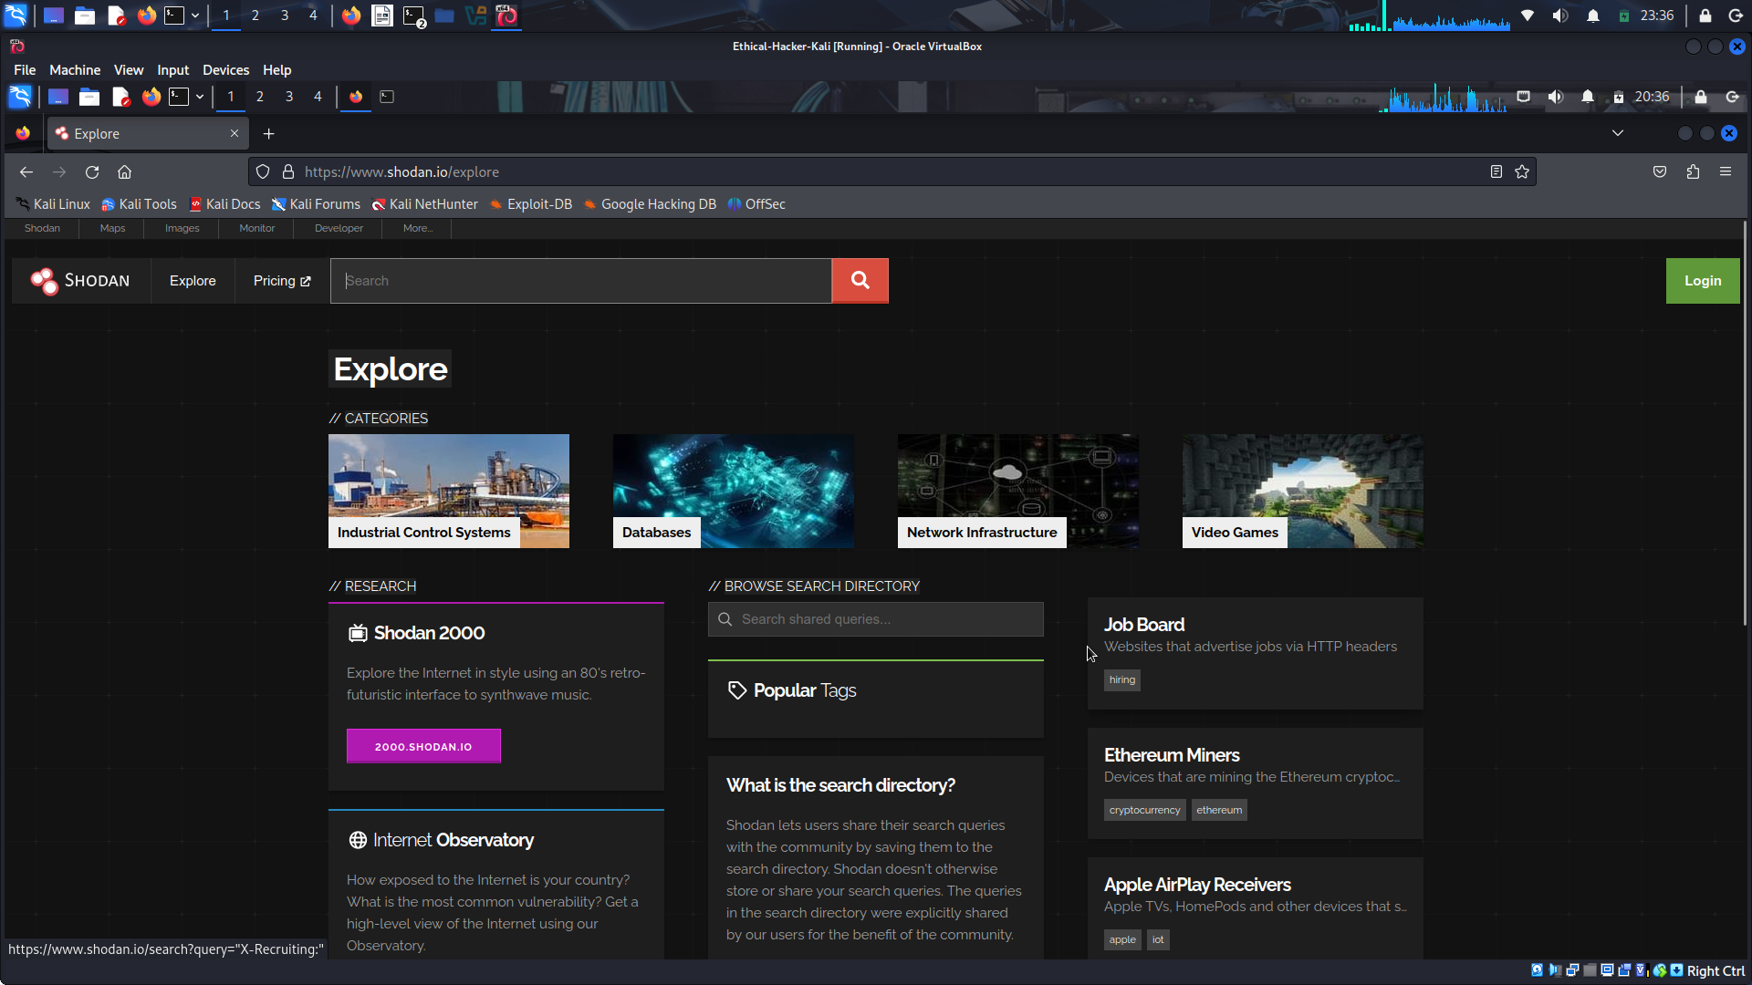
Figure below shows a query performed to find network infrastructure devices that are running a broken protocol called Cisco Smart Install. Attackers have leveraged this protocol for years to compromise different infrastructures. Cisco removed this protocol from its systems many years ago. However, many people are still using it in devices connected to the public Internet.
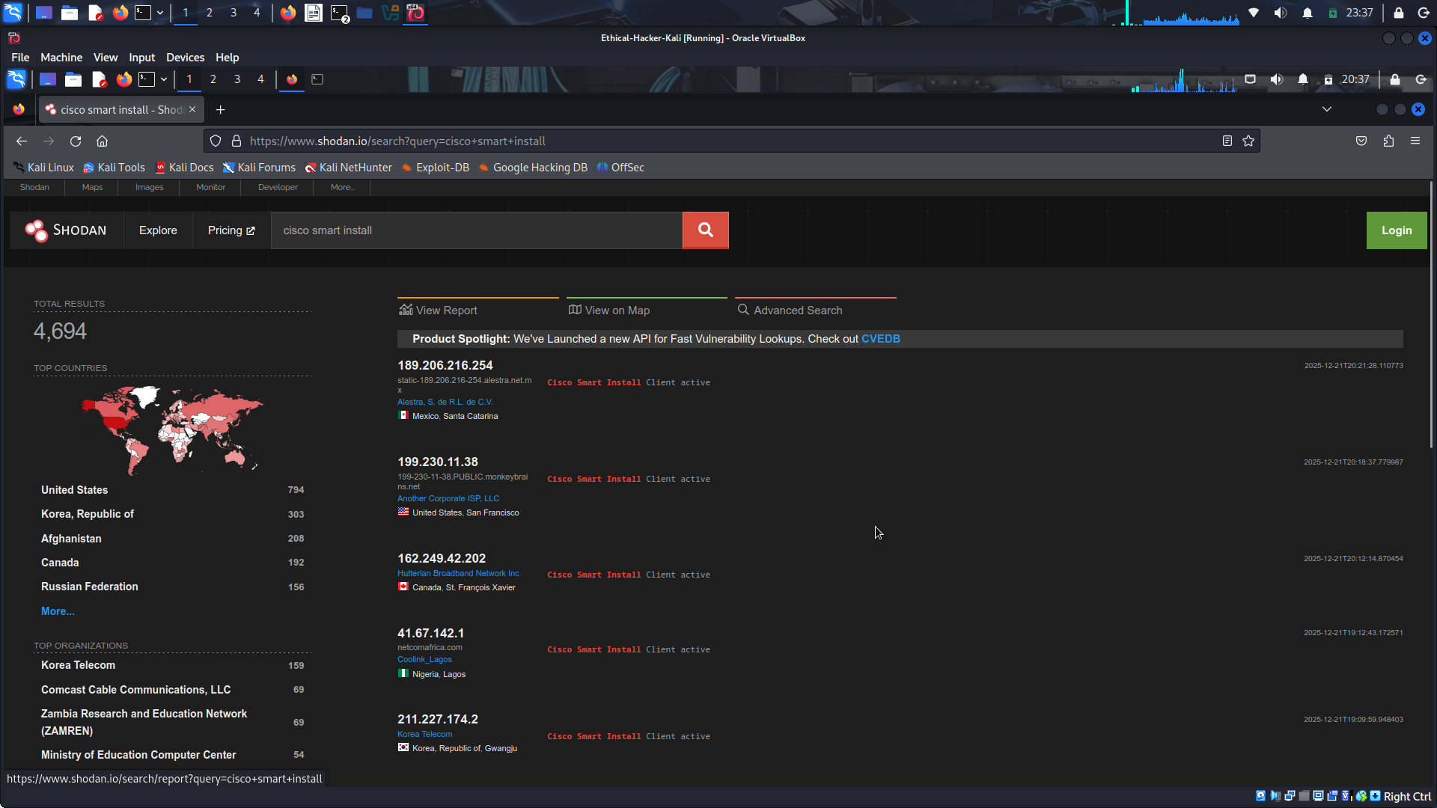
3.2. Performing Active Reconnaissance
As part of the PenTesting information gathering process, you will participate in active reconnaissance of the Pixel Paradise internal network. Here is what we know about the network so far.
The Pixel Paradise network includes the following:
- User endpoints: Desktops, laptops, mobile devices, and gaming consoles used by employees.
- Facilities-related endpoints: Surveillance cameras, an alarm system, climate control sensors and actuators, lighting control systems, and VoIP systems.
- Intermediary devices: Routers and switches that connect endpoints and other networks.
- Wireless Access Points: Devices that provide Wi-Fi access to employees.
- Firewalls: Devices that protect the network from external threats and unauthorized access.
- Servers: On-premises servers that provide file storage, database access, and other services such as email.
- Cloud Infrastructure: Amazon Web Services
Port Scans
A port scan is an active scan in which the scanning tool sends various types of probes to the target IP address and then examines the responses to determine whether the service is actually listening. For instance, with an Nmap SYN scan, the tool sends a TCP SYN packet to the TCP port it is probing. This process is also referred to as half-open scanning because it does not open a full TCP connection. If the response is a SYN/ACK, this would indicate that the port is actually in a listening state. If the response to the SYN packet is an RST (reset), this would indicate that the port is closed or is not in a listening state. If the SYN probe does not receive any response, Nmap marks it as filtered because it cannot determine if the port is open or closed. Table below defines the SYN scan responses when using Nmap.
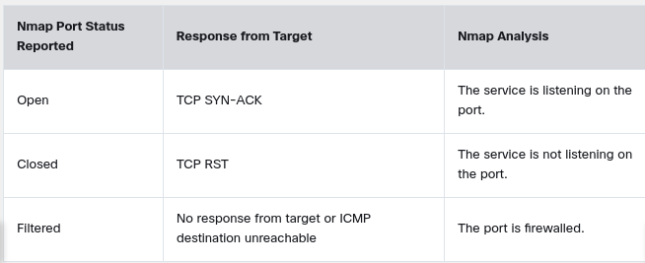
Example 1 illustrates how a SYN scan works
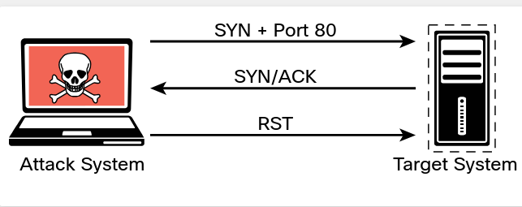
Example 2 shows the output of a SYN scan.
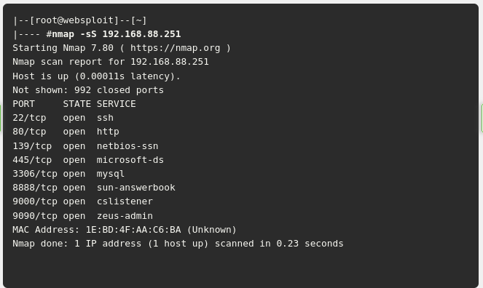
Example 2 shows how to run a TCP SYN scan using Nmap by specifying the -sS option against a host with the IP address 192.168.88.251. As you can see, this system has several ports open. In some situations, you will want to use the many different Nmap options in your scans to get the results you are looking for.
3.2.2 Nmap Scan Types
The following sections cover some of the most common Nmap scanning options used for specific scenarios, including the following:
- TCP Connect Scan (-sT)
- UDP Scan (-sU)
- TCP FIN Scan (-sF)
- Host Discovery Scan (-sn)
- Timing Options (-T 0-5)
TCP Connect Scan ( -sT )
A TCP connect scan actually makes use of the underlying operating system’s networking mechanism to establish a full TCP connection with the target device being scanned. Because it creates a full connection, it creates more traffic (and thus takes more time to run). This is the default scan type that is used if no scan type is specified with the nmap command. However, it should typically be used only when a SYN scan is not an option, such as when a user who is running the nmap command does not have raw packet privileges on the operating system because many of the Nmap scan types rely on writing raw packets. This section illustrates how a TCP connect scan works and provides an example of a scan from a Kali Linux system. Table below defines the TCP connect scan responses.
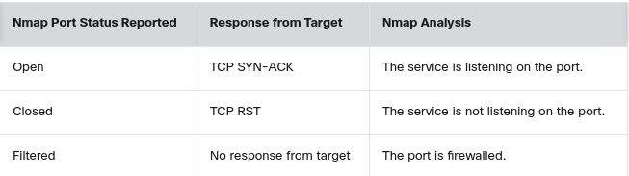
Illustration on how a TCP connect scan works.
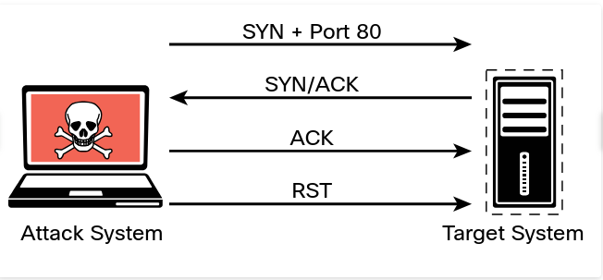
Output of a full TCP connection scan.
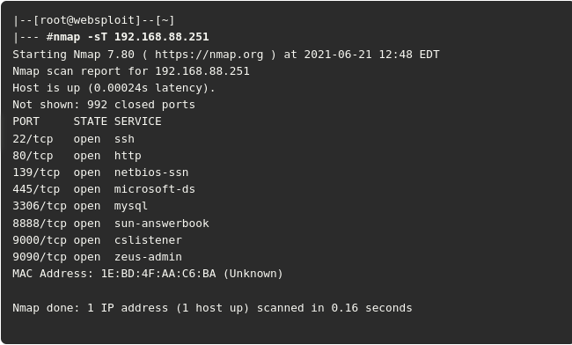
The output shows the results of an Nmap TCP connect scan. As you can see, the results indicate that a number of TCP ports are listening on the target device.
A full TCP connect scan requires the scanner to send an additional packet per scan, which increases the amount of noise on the network and may trigger alarms that a half-open scan wouldn’t trigger. Security tools and the underlying targeted system are more likely to log a full TCP connection, and intrusion detection systems (IDSs) are similarly more likely to trigger alarms on several TCP connections from the same host.
UDP Scan ( -sU )
The majority of the time, you will be scanning for TCP ports, as this is how you connect to most services running on target systems. However, you might encounter some instances in which you need to scan for UDP ports – for example, if you are trying to enumerate a DNS, SNMP, or DHCP server. These services all use UDP for communication between client and server. To scan UDP ports, Nmap sends a UDP packet to all ports specified in the command-line configuration. It waits to hear back from the target. If it receives an ICMP port unreachable message back from a target, that port is marked as closed. If it receives no response from the target UDP port, Nmap marks the port as open/filtered. Table below shows the UDP scan responses.
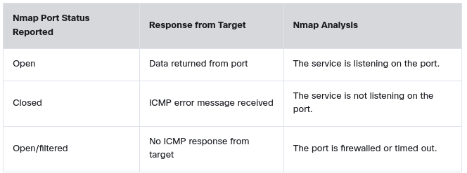
Illustration of how a UDP scan works.
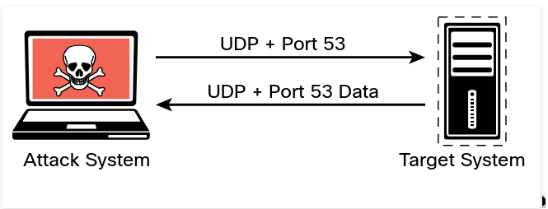
The output shows the results of an Nmap UDP scan on port 53 of the target 192.168.88.251. As you can see, the results indicate that this port is open.
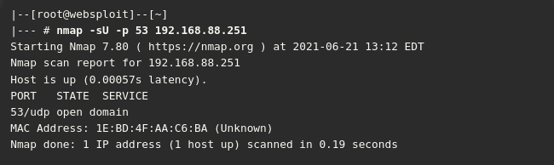
TCP FIN Scan ( -sF )
There are times when a SYN scan might be picked up by a network filter or firewall. In such a case, you need to employ a different type of packet in a port scan. With the TCP FIN scan, a FIN packet is sent to a target port. If the port is actually closed, the target system sends back an RST packet. If nothing is received from the target port, you can consider the port open because the normal behavior would be to ignore the FIN packet. Table below shows the TCP FIN scan responses.
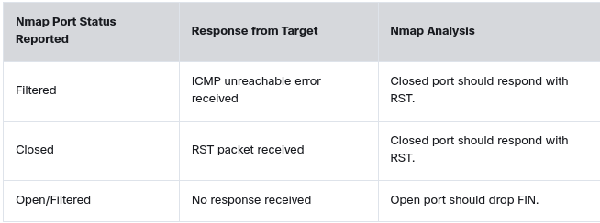
Illustration on how a TCP FIN scan works
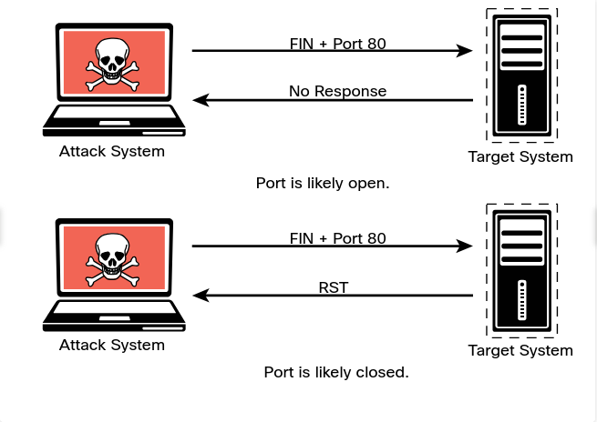
Output of a TCP FIN scan against port 80 of the target. The output shows the results of an Nmap TCP FIN scan, specifying port 80 on the target. The response from the target indicates that the port is open/filtered.
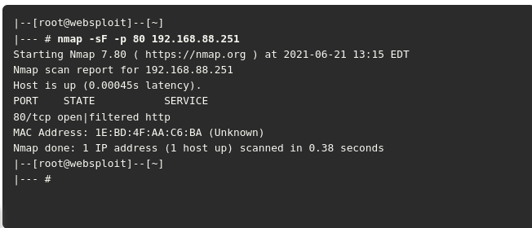
Host Discovery Scan ( -sn )
A host discovery scan is one of the most common types of scans used to enumerate hosts on a network because it can use different types of ICMP messages to determine whether a host is online and responding on a network.
Example of a ping scan of the 192.168.88.0/24 subnet. This is a very basic host discovery scan that can be performed to determine what devices on a network are live. Such a scan for host discovery of an entire subnet is sometimes referred to as a ping sweep.
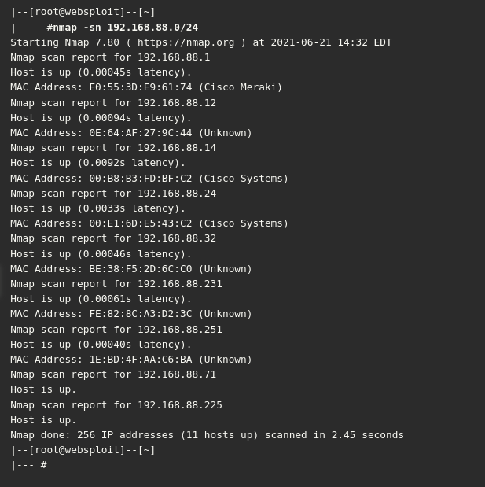
Timing Options ( -T 0-5 )
The Nmap scanner provides six timing templates that can be specified with the -T option and the template number (0 through 5) or name. Nmap timing templates enable you to dictate how aggressive a scan will be, while leaving Nmap to pick the exact timing values. These are the timing options:
- -T0 (Paranoid) : Very slow, used for IDS evasion
- -T1 (Sneaky) : Quite slow, used for IDS evasion
- -T2 (Polite) : Slows down to consume less bandwidth, runs about 10 times slower than the default
- -T3 (Normal) : Default, a dynamic timing model based on target responsiveness
- -T4 (Aggressive) : Assumes a fast and reliable network and may overwhelm targets
- -T5 (Insane) : Very aggressive; will likely overwhelm targets or miss open ports
3.2.4 Types of Enumeration
This section covers enumeration techniques that should be performed in the information-gathering phase of a penetration test. You will learn how and when these enumeration techniques should be used. This section also includes examples of performing these types of enumeration by using Nmap as well as a deep dive into packet crafting with Scapy.
- Host Enumeration
- User Enumeration
- Group Enumeration
- Network Share Enumeration
- Additional SMB Enumeration Examples
- Web Page Enumeration/Web Application Enumeration
- Service Enumeration
- Exploring Enumeration via Packet Crafting
Host Enumeration
The enumeration of hosts is one of the first tasks you need to perform in the information-gathering phase of a penetration test. Host enumeration is performed internally and externally.
When performed externally, you typically want to limit the IP addresses you are scanning to just the ones that are part of the scope of the test. This reduces the chance of inadvertently scanning an IP address that you are not authorized to test.
When performing an internal host enumeration, you typically scan the full subnet or subnets of IP addresses being used by the target. Host enumeration is usually performed using a tool such as Nmap or Masscan; however, vulnerability scanners also perform this task as part of their automated testing.
User Enumeration
Gathering a valid list of users is the first step in cracking a set of credentials. When you have the username, you can then begin brute-force attempts to get the account password. You perform user enumeration when you have gained access to the internal network. On a Windows network, you can do this by manipulating the Server Message Block (SMB) protocol, which uses TCP port 445.
SMB Message Illustration
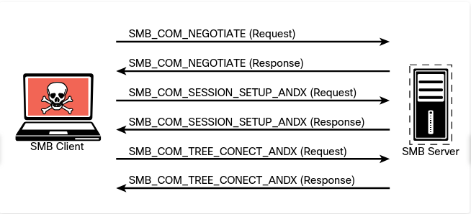
The information contained in the responses to these messages enables you to reveal information about the server:
- SMB_COM_NEGOTIATE: This message allows the client to tell the server what protocols, flags, and options it would like to use. The response from the server is also an SMB_COM_NEGOTIATE message. This response is relayed to the client about which protocols, flags, and options it prefers. This information can be configured on the server itself. A misconfiguration sometimes reveals information that you can use in penetration testing. For instance, the server might be configured to allow messages without signatures. You can determine if the server is using share- or user-level authentication mechanisms and whether the server allows plaintext passwords. The response from the server also provides additional information, such as the time and time zone the server is using. This is necessary information for many penetration testing tasks.
- SMB_COM_SESSION_SETUP_ANDX : After the client and server have negotiated the protocols, flags, and options they will use for communication, the authentication process begins. Authentication is the primary function of the SMB_COM_SESSION_SETUP_ANDX message. The information sent in this message includes the client username, password, and domain. If this information is not encrypted, it is easy to sniff it right off the network. Even if it is encrypted, if the mechanism being used is not sufficient, the information can be revealed using tools such as Lanman and NTLM in the case of Microsoft Windows implementations. The following example shows this message being used with the smb-enum-users.nse script: nmap --script smb-enum-users.nse <host>
It shows the results of the Nmap smb-enum-users script run against the target 192.168.88.251. As you can see, the results indicate that the script was able to enumerate the users who are configured on this Windows target. The highlighted line reveals the user who was enumerated by Nmap.
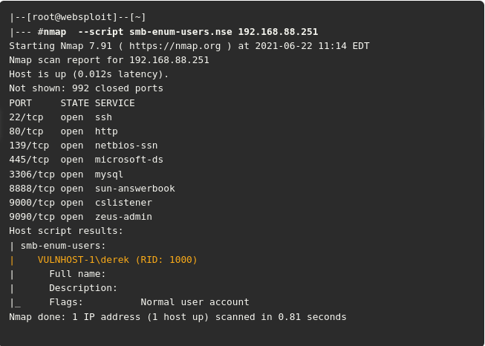
Group Enumeration
For a penetration tester, group enumeration is helpful in determining the authorization roles that are being used in the target environment. The Nmap NSE script for enumerating SMB groups is smb-enum-groups. This script attempts to pull a list of groups from a remote Windows machine. You can also reveal the list of users who are members of those groups. The syntax of the command is as follows: nmap --script smb-enum-groups.nse -p445 <host>
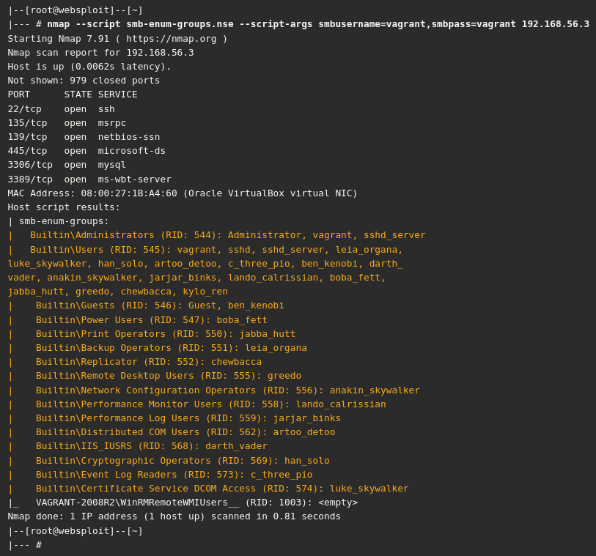
The highlighted output shows the enumerated groups and users in the target host. In Windows, the relative identifier (RID) is a variable-length number assigned to objects and becomes part of the object’s security identifier (SID) that uniquely identifies an account or a group within a domain.
Network Share Enumeration
Identifying systems on a network that are sharing files, folders, and printers is helpful in building out an attack surface of an internal network. The Nmap smb-enum-shares NSE script uses Microsoft Remote Procedure Call (MSRPC) for network share enumeration. The syntax of the Nmap smb-enum-shares.nse script is as follows: nmap --script smb-enum-shares.nse -p 445 <host>
Enumerating SMB Shares
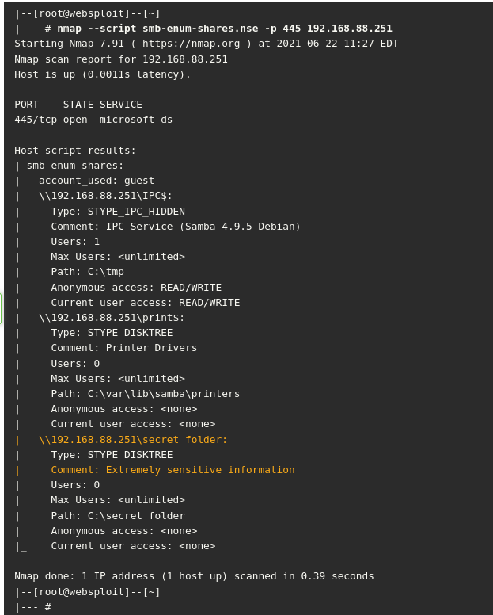
Additional SMB Enumeration Examples
The system used in earlier examples (with the IP address 192.168.88.251) is running Linux and Samba. However, it is not easy to determine that it is a Linux system from the results of previous scans. An easy way to perform additional enumeration and fingerprinting of the applications and operating system running on a host is by using the nmap -sC command. The - sC option runs the most common NSE scripts based on the ports found to be open on the target system.
Example below shows the output of the nmap -sC command launched against the Linux system at 192.168.88.251, which is running Samba.
Running the Nmap NSE Default Scripts
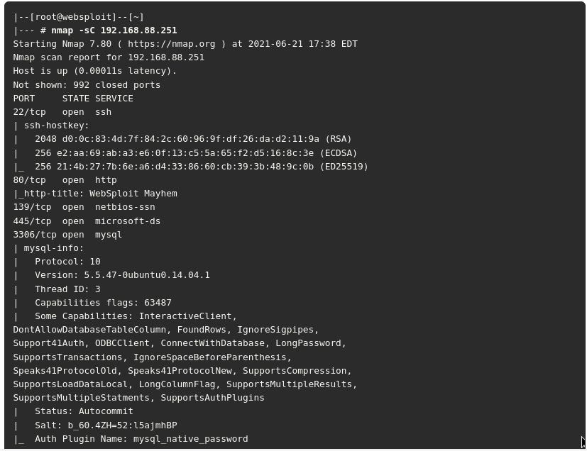
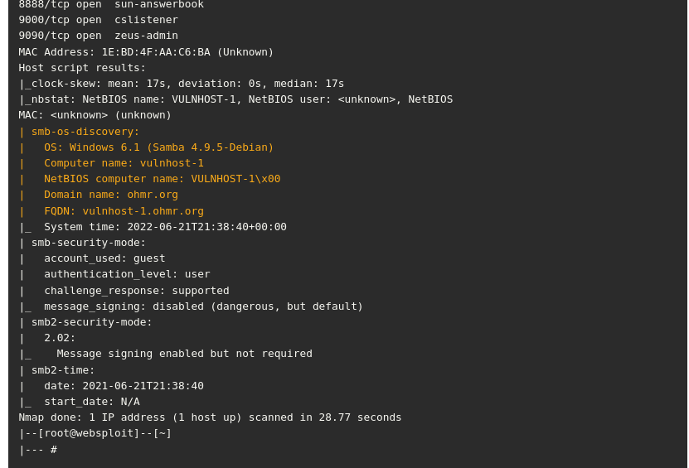
The highlighted lines above show details about the Samba version that is running on the system (Samba Version 4.9.5). You can also see that even though the OS is marked as Windows 6.1, the correct operating system is Debian.
Example below shows the output of the samba -V command at the target system (vulnhost-1), which confirms that the scanner was able to determine the correct Samba version.
Confirming Scan Results in the Target System
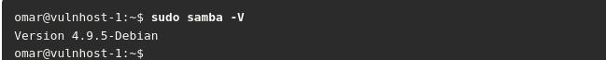
You can also use tools such as enum4linux to enumerate Samba shares, including user accounts, shares, and other configurations. Example below shows the output of the enum4linux tool after it is launched against the target system (192.168.88.251).
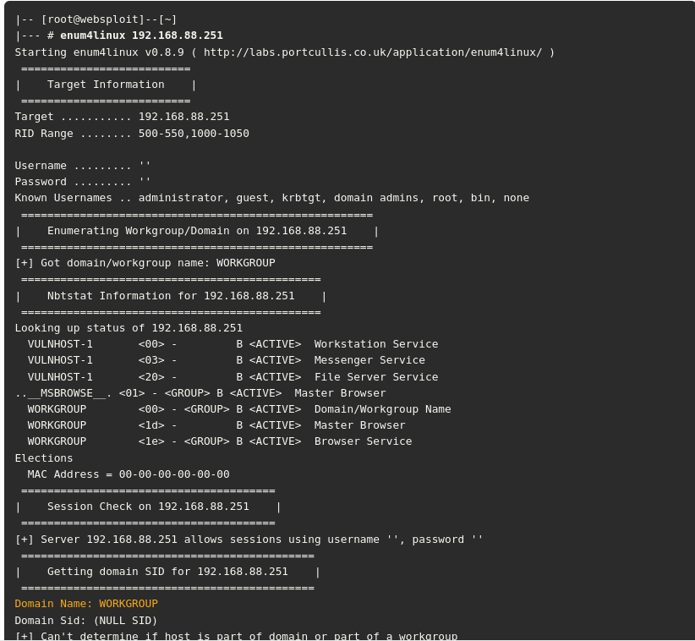
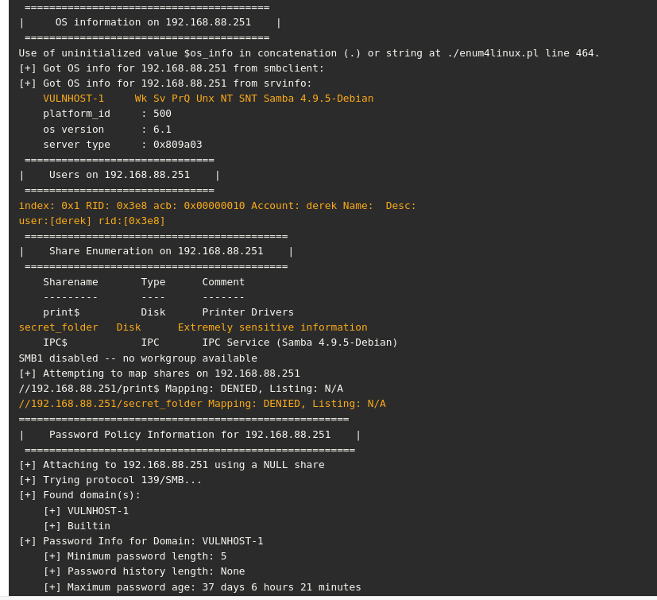
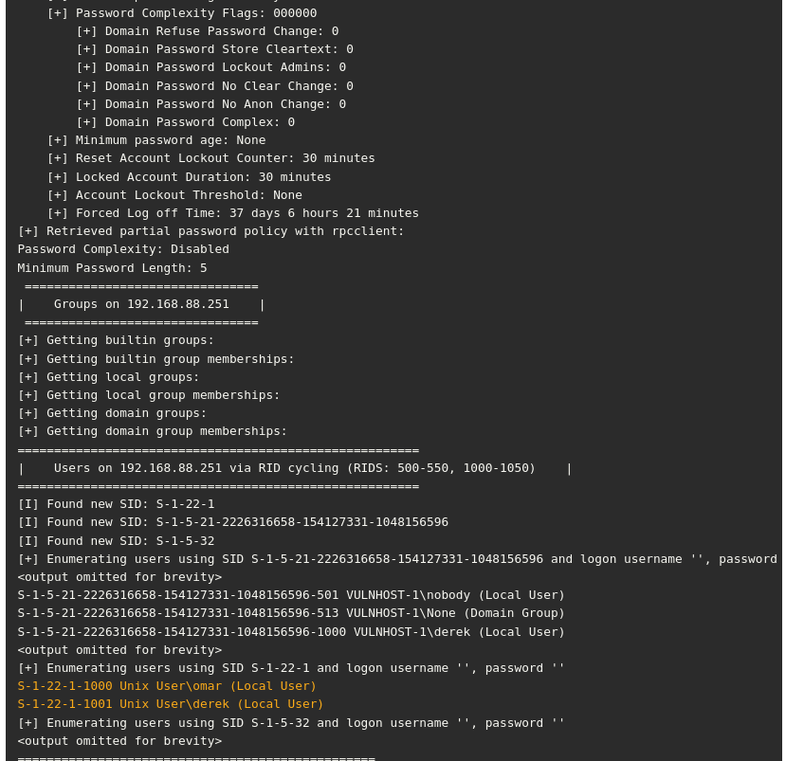
There is a Python-based enum4linux implementation called enum4linux-ng that can be downloaded from https://github.com/cddmp/enum4linux-ng.
Enumeration Using enum4linux-ng
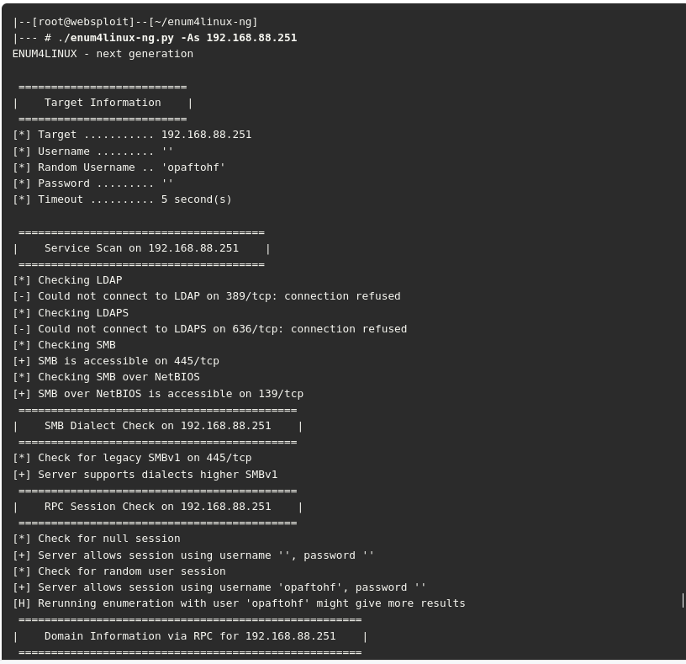
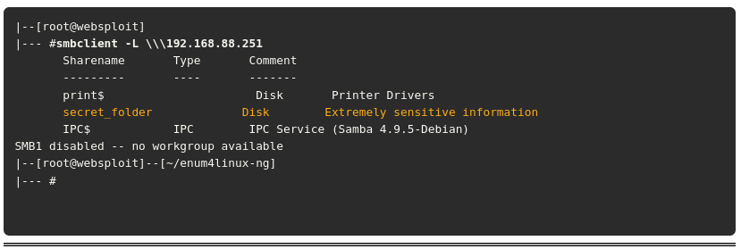
Enumeration Using smbclient
Web Page Enumeration/Web Application Enumeration
Once you have identified that a web server is running on a target host, the next step is to take a look at the web application and begin to map out the attack surface performing web page enumeration or often referred to as web application enumeration. You can map out the attack surface of a web application in a few different ways. The handy Nmap tool actually has an NSE script available for brute forcing the directory and file paths of web applications. Armed with a list of known files and directories used by common web applications, it probes the server for each of the items on the list. Based on the response from the server, it can determine whether those paths exist. This is handy for identifying things like the Apache or Tomcat default manager page that are commonly left on web servers and can be potential paths for exploitation. The syntax of the http-enum NSE script is as follows: nmap -sV --script=http-enum <target>
Sample Nmap http-enum Script Output
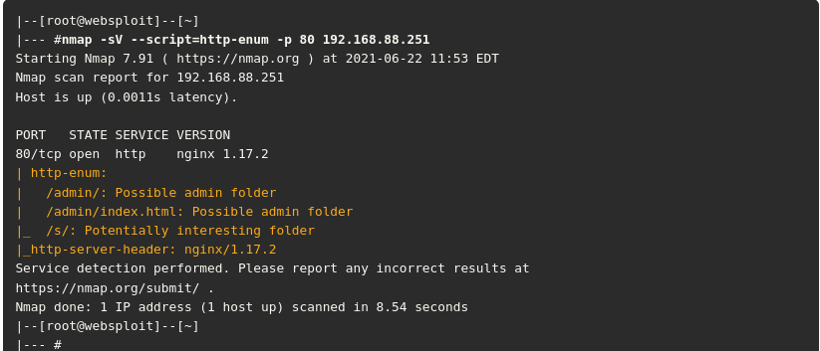
The highlighted output above shows several enumerated directories/folders and the version of the web server being used (Nginx 1.17.2). This is a good place to start in attacking a web application.
Another web server enumeration tool we should talk about is Nikto.
Nikto is an open-source web vulnerability scanner that has been around for many years. It’s not as robust as the commercial web vulnerability scanners; however, it is very handy for running a quick script to enumerate information about a web server and the applications it is hosting. Because of the speed at which Nikto works to scan a web server, it is very noisy. It provides a number of options for scanning, including the capability to authenticate to a web application that requires a username and password.
Sample Nikto Scan
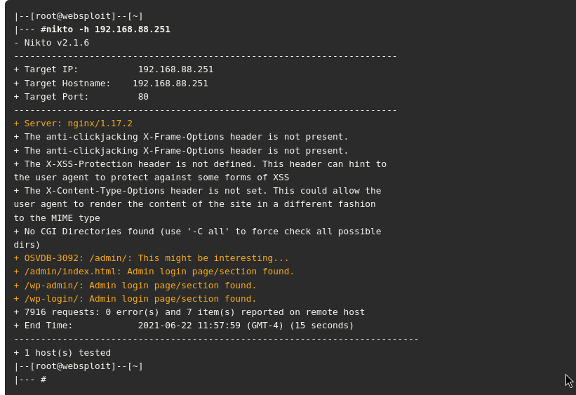
Service Enumeration
Service enumeration is the process of identifying the services running on a remote system, and it is a primary focus of what Nmap does as a port scanner. When you are connected to a system that is on a directly connected network segment, you can run some additional scripts to enumerate further. A port scan takes the perspective of a credentialed remote user. The Nmap smb-enum-processes NSE script enumerates services on a Windows system, and it does so by using credentials of a user who has access to read the status of services that are running. This is a handy tool for remotely querying a Windows system to determine the exact list of services running. The syntax of the command is as follows:
nmap --script smb-enum-processes.nse --script-args smbusername=<username>, smbpass=<password> -p445 <host>
Exploring Enumeration via Packet Crafting
When it comes to enumeration via packet crafting and generation, Scapy is one of pentesters' favorite tools and frameworks. Scapy is a very comprehensive Python-based framework or ecosystem for packet generation. This section looks at some of the simple ways you can use this tool to perform basic network reconnaissance.
Starting scapy from the Command Line
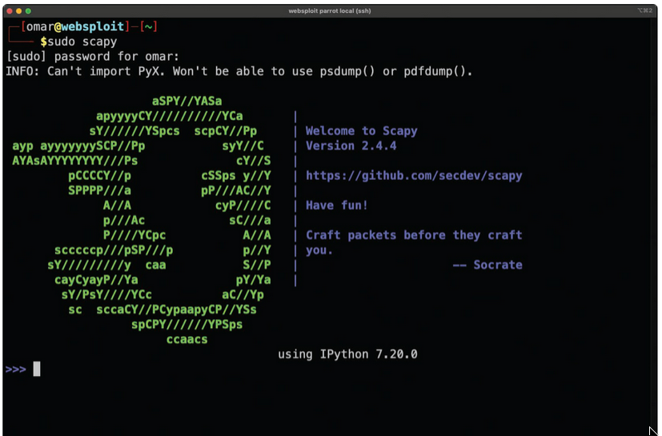
Example below shows how easy it is to begin crafting packets. In this example, a simple ICMP packet is crafted with malicious_payload as the payload being sent to the destination host 192.168.88.251.
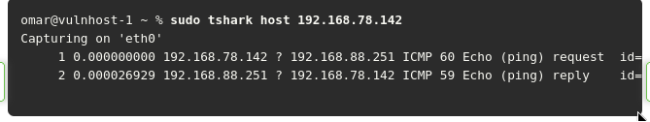
Scapy supports a large number of protocols. You can use the ls() function to list all available formats and protocols, as demonstrated below
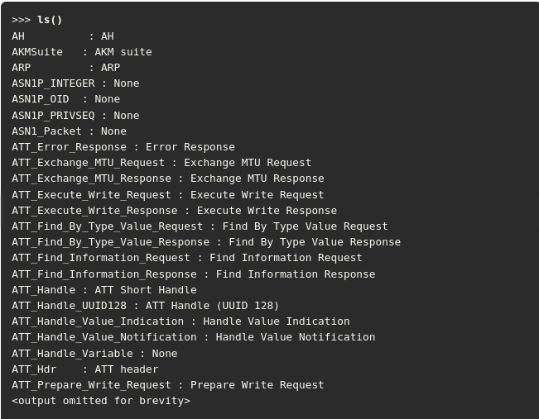
You can use the ls() function to display all the options and fields of a specific protocol or packet format supported by Scapy, as shown below. This example shows the available fields for the TCP protocol.
Listing the TCP Layer 4 Fields in Scapy
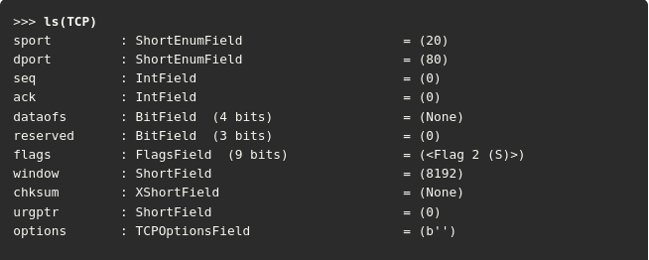
Listing the Available DNS Packet Fields in Scapy
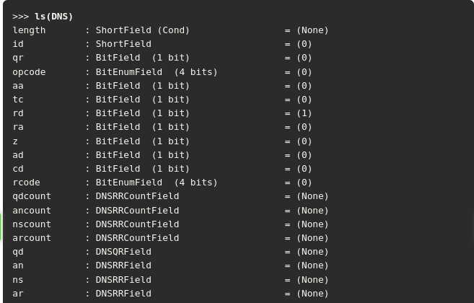
You can use the explore() function to navigate the Scapy layers and protocols. After you execute the explore() function, the screen in below is displayed.
Using the explore() Function in Scapy
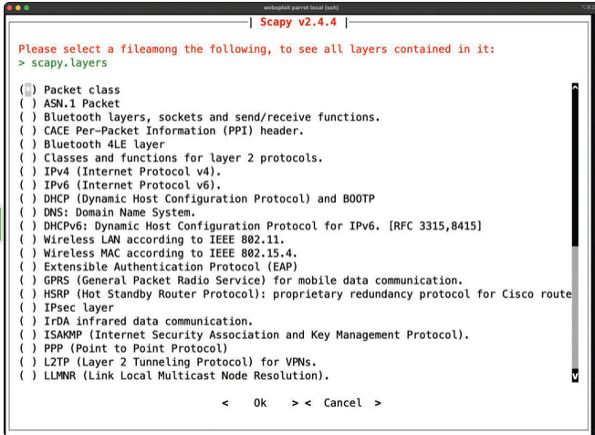
You can use the explore() function with any packet format or protocol. Example below shows the packets contained in scapy.layers.dns using the explore(“dns”) function.
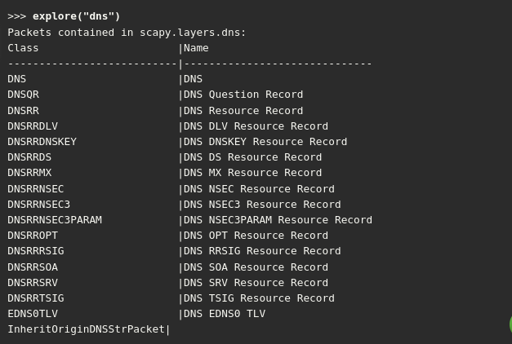
You can use Scapy as a scanner in many different ways.
Examples of Python scripts to perform network and system scanning using Scapy: https://github.com/The-Art-of-Hacking/h4cker/blob/master/python_ruby_and_bash
You can do a simple TCP SYN scan to any given port, as demonstrated below. In this example, a TCP port 445 SYN packet is sent to the host with the IP address 192.168.88.251. The output indicates that it received one answer, but it doesn’t specify what the actual answer (response) was.
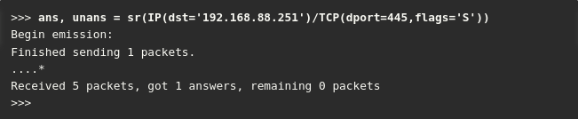
The Packet Capture of the TCP Packets on the Target Host
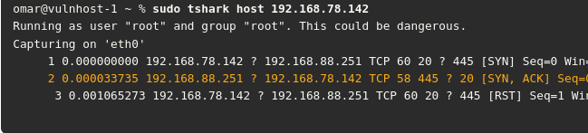
3.3. Understanding the Art of Performing Vulnerability Scans
Vulnerability scanners use a number of different methods to determine whether a service is vulnerable. The primary method is to identify the version of the software that is running on the open service and try to match it with an already known vulnerability. For instance, if a vulnerability scanner determines that a Linux server is running an outdated version of the Apache web server that is vulnerable to remote exploitation, it reports that vulnerability as a finding.
The main concern with automated vulnerability scanners is false positives; the output from a vulnerability scan may be useless if no validation is done on the findings. Turning over a report full of false positives to a developer or an administrator who is then responsible for fixing the issues can really cause conflicts. You don’t want someone chasing down findings in your report just to find out that they are false positives.
3.3.2 How a Typical Automated Vulnerability Scanner Works

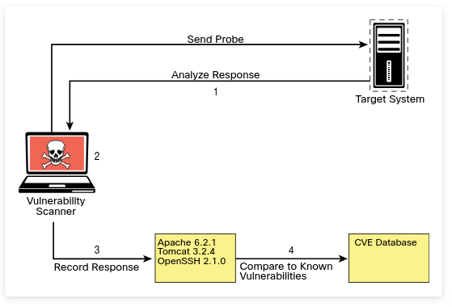
Step 1. In the discovery phase, the scanner uses a tool such as Nmap to perform host and port enumeration. Using the results of the host and port enumeration, the scanner begins to probe open ports for more information.
Step 2. When the scanner has enough information about the open port to determine what software and version are running on that port, it records that information in a database for further analysis. The scanner can use various methods to make this determination, including using banner information.
Step 3. The scanner tries to determine if the software that is listening on the target system is susceptible to any known vulnerabilities. It does this by correlating a database of known vulnerabilities against the information recorded in the database about the target services.
Step 4. The scanner produces a report on what it suspects could be vulnerable. Keep in mind that these results are often false positives and need to be validated. At the very least, this type of tool gives you an idea of where to look for vulnerabilities that might be exploitable.
3.3.4 Types of Vulnerability Scans
The type of vulnerability scan to use is usually driven by scan policy that is created in the automated vulnerability scanning tool. Each tool has many options available for scanning.
You can often just choose to do a full scan that will operate all scanning options, although you might not be able to use every option (for instance, if you are scanning a production environment or a device that is prone to crashing when scanning occurs). In such situations, you must be careful to select only the scan options that are less likely to cause issues. Let's take a closer look at the following typical scan types:
- Unauthenticated Scans
- Authenticated Scans
- Discovery Scans
- Full Scans
- Stealth Scans
- Compliance Scans
Unauthenticated Scans
By default, vulnerability scanners do not use credentials to scan a target. If you provide only the IP address of the target and click Scan, the tool will begin enumerating the host from the perspective of an unauthenticated remote attacker.
An unauthenticated scan shows only the network services that are exposed to the network. The scanner attempts to enumerate the ports open on the target host. If the service is not listening on the network segment that the scanner is connected to, or if it is firewalled, the scanner will report the port as closed and move on. However, this does not mean that there is not a vulnerability. Sometimes it is possible to access ports that are not exposed to the network via SSH port forwarding and other tricks. It is still important to run a credentialed (or authenticated) scan when possible.
NOTE Authenticated scans may provide a lower rate of false positives than unauthenticated scans.
Authenticated Scans
In some cases, it is best to run an authenticated scan against a target to get a full picture of the attack surface.
An authenticated scan requires you to provide the scanner with a set of credentials that have root-level access to the system. The scanner actually logs in to the target via SSH or some other mechanism. It then runs commands like netstat to gather information from inside the host. Many of the commands that the scanner runs require root-level access to be able to gather the correct information from the system.
Example below shows the netstat command run by a non-privileged user (omar);
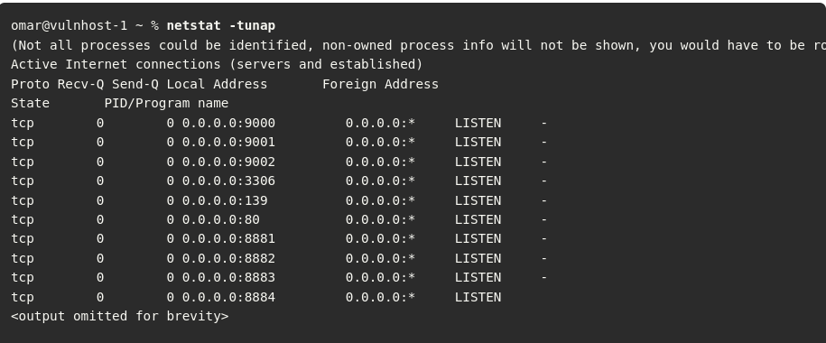
Example below shows the netstat command run by a root user. You can see that the output is different for the different user-level permissions. Specifically, notice that when running as the user omar, the PID/program name is not available, and when running as the user root, that information is displayed.
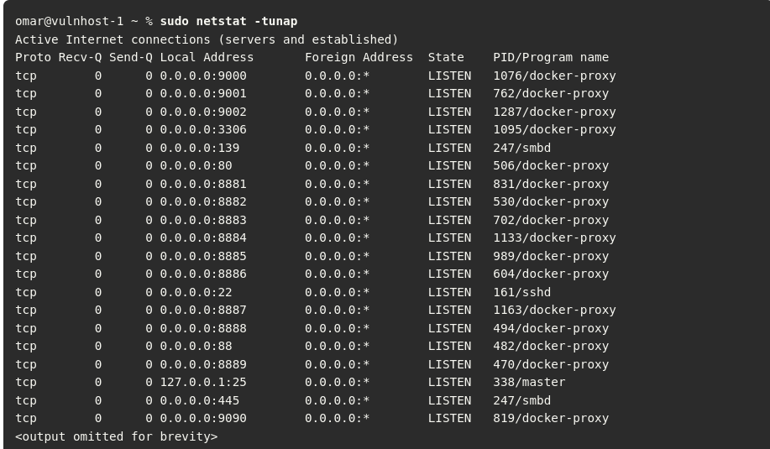
Discovery Scans
A discovery scan is primarily meant to identify the attack surface of a target. A port scan is a major part of what a discovery scan performs. A scanner may actually use a tool like Nmap to perform the port scan process. It then pulls the results of the port scan into its database to use that information for further discovery. For instance, the result of the port scan might come back showing that ports 80, 22, and 443 are open and listening. From there, the scanning tool probes those ports to identify exactly what service is running on each port. For example, say that it identifies that an Apache Tomcat 8.5.22 web server is running on ports 80 and 443. Knowing that a web server is running on the ports, the scanner can then perform further discovery tasks that are specific to web servers and applications. Now say that, at the same time, the scanner identifies that OpenSSH is listening on port 22. From there, the scanner can probe the SSH service to identify information about its configuration and capabilities, such as preferred and supported cryptographic algorithms. This type of information is useful for identifying vulnerabilities in later phases of testing.
Full Scans
A full scan typically involves enabling every scanning option in the scan policy. The options vary based on the scanner, but most vulnerability scanners have their categories of options defined similarly. For instance, they are typically organized by operating system, device manufacturer, device type, protocol, compliance, and type of attack, and the rest of the options might fall into a miscellaneous category. Example below shows a sample list of the plugin categories from the Nessus vulnerability scanner. As you can see from this list, there are a lot of plugins available for the scanner to run. It should also be obvious, based on the names of the plugin categories, that there will never be a single device that all of these plugins apply to. For instance, plugins for a macOS device would not be applicable to a Windows device. That is why you normally need to customize your plugin selection to reflect the environment that you are scanning. Doing so will reduce unnecessary traffic and speed up your scanning process.
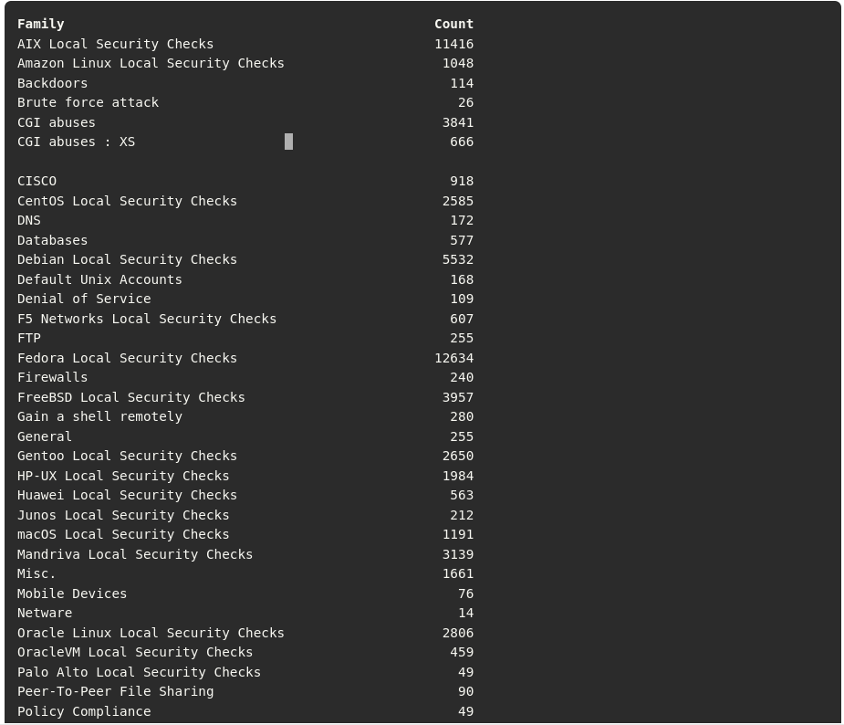
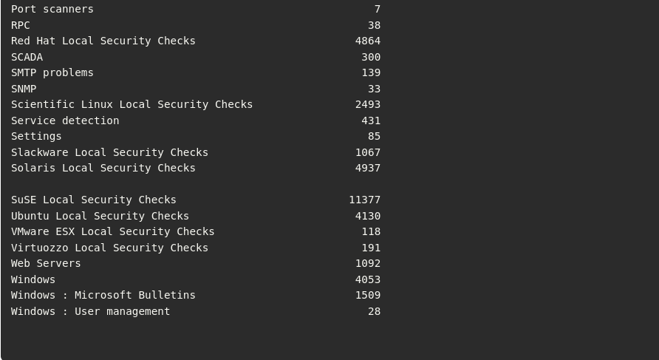
Stealth Scans
There are sometimes situations in which you must scan an environment that is in a production state. In such situations, there is typically a requirement for running a scan without alerting the defensive position of the environment; such a scan is called a stealth scan. In this case, you will want to implement a vulnerability scanner in a manner that makes the target less likely to detect the activity. Vulnerability scanners are pretty noisy; however, there are some options you can configure to make a scan quieter. For example, as discussed earlier in this module, there are different types of Nmap scans, and they can be detected by network intrusion prevention systems (IPSs) or host firewalls. You have learned that a SYN scan is a fairly stealthy type of scan to run. This same concept applies to vulnerability scanners because they all use some kind of port scanner to enumerate the target. These same options are available in the vulnerability scanner’s configuration. You can also disable any plugins/attacks that might be especially likely to generate noisy traffic, such as any that perform denial-of-service attacks, which would definitely arouse some concerns on the target network.
Passive Vulnerability Scanner Diagram
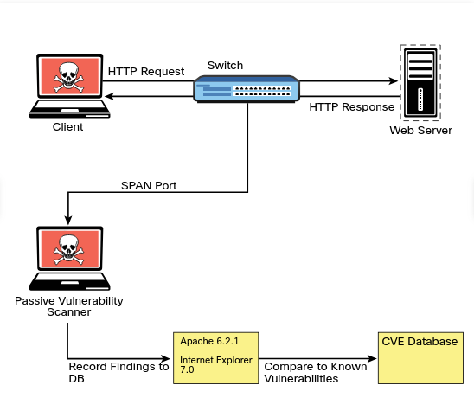
Aside from the modifications to a traditional vulnerability scanner just described, there is also the concept of a passive vulnerability scanner. A passive vulnerability scanner monitors and analyzes the network traffic. Based on the traffic it sees, it can determine what the topology of the network consists of and what service the hosts on the network are listening on. From the detailed information about the traffic at the packet layer, a passive vulnerability scanner can determine if any of those services or even clients have vulnerabilities. For instance, if a Windows client with an outdated version of Internet Explorer is connecting to an Apache web server that is also outdated, the scanner will identify the versions of the client and server from the monitored traffic. It can then compare those versions to its database of known vulnerabilities and report the findings based on only the passive monitoring it performed.
Compliance Scans
Compliance scans are network and application tests (scans) typically driven by the market or governance that the environment serves and regulatory compliance. An example of this would be the information security environment for a healthcare entity, which must adhere to the requirements sent forth by the Health Insurance Portability and Accountability Act (HIPAA). This is where a vulnerability scanner comes into play. It is possible to use a vulnerability scanner to address the specific requirements that a policy requires. Vulnerability scanners often have the capability to import a compliance policy file. This policy file can typically map to specific plugins/attacks that the scanner is able to perform. Once the policy is imported, the specific set of compliance checks can be run against a target system.
The challenge with compliance requirements is that there are many different types for different industries and government agencies, and they can all be interpreted in various ways. Some of the checks might be straightforward. If a requirement check is looking for a specific command to be run and that the output be a 1 instead of a 0, that is very simple for a vulnerability scanner to determine; however, many requirements leave more to be interpreted. This makes it very difficult for a tool like a vulnerability scanner to make a determination. Most vulnerability scanners also have the capability to create custom compliance policies. This is a valuable option for penetration testers, who typically want to fine-tune the scanner policy for each engagement.
Challenges to Consider When Running a Vulnerability Scan
1. Considering the best time to run a scan:
The timing of when to run a scan is typically of most concern when you are scanning a production network. If you are scanning a device in a lab environment, there is normally not much concern because a lab environment is not being used by critical applications.
There are a few reasons running a scan on a production network should be done carefully:
a) The network traffic that is being generated by a vulnerability scan can and will cause a lot of noise on the network. It can also cause significant congestion, especially when your scans are traversing multiple network hops.
b) Many of the options or plugins that are performed in a vulnerability scan can and will crash the target device as well as the network infrastructure. For this reason, you should be sure that when scanning on a production network, you are scanning at times that will have the least possible impact on end users and servers. Most of the time, scanning in the early hours of the day, when no one is using a network for critical purposes, is best.
2. Determining What Protocols are In Use:
One of the first things you need to know about a network or target device before you begin running vulnerability scans is what protocols are being used. If a target device is using both TCP and UDP protocols for services that are running, and you only run a vulnerability scan against TCP ports, then you are going to miss any vulnerabilities that might be found on the UDP services.
3. Network Topology
The network topology should always be considered when it comes to vulnerability scanning.
Scanning across a WAN connection is never recommended because it would significantly impact any of the devices along the path. The rule of thumb when determining where in the network topology to run a vulnerability scan is that it should always be performed as close to the target as possible. For example, if you are scanning a Windows server that is sitting inside your screened subnet (formerly known as the demilitarized zone, or DMZ), the best location for your vulnerability scanner is adjacent to the server on the screened subnet. By placing it there, you can eliminate any concerns about impacting devices that your scanner traffic is traversing.
Any device that you traverse could also affect the results of your scanner. This is mostly a concern when traversing a firewall device; in addition, other network infrastructure devices could possibly impact the results as well.
4. Bandwidth Limitations
Any time you flood a network with a bunch of traffic, it is going to cause an issue with the amount of bandwidth that is available. As a penetration testing professional, you need to be cognizant of how you are affecting the bandwidth of the networks or systems you are scanning. Specifically, depending on the amount of bandwidth you have between the scanner and the target, you might need to adjust your scanner settings to accommodate lower-bandwidth situations. If you are scanning across a VPN or WAN link that most likely has limited bandwidth, you will want to adjust your scanning options so that you are not causing bandwidth consumption issues. The settings that need to be adjusted are typically those related to flooding and denial-of-service (DoS) type attacks.
5. Query Throttling
To work around the issue of bandwidth limitations and vulnerability scanning, slowing down the traffic created by your scanner can often help. This is often referred to as query throttling, and it can typically be achieved by modifying the options of the scanning policy.
One way to do this is to reduce the number of attack threads that are being sent to the target at the same time. There isn’t a specific rule of thumb for the number of threads. It really depends on the robustness of the target. Some targets are more fragile than others. Another way to accomplish this is to reduce the scope of the plugins/attacks that the scanner is checking for. If you know that the target device is a Linux server, you can disable the attacks for other operating systems, such as Windows. Even though the attacks won’t work against the Linux server, it still needs to receive and respond to the traffic. This additional traffic can cause a bottleneck in processing and network traffic consumption. Limiting the number of requests that the target would need to respond to would reduce the risk of causing issues such as crashing on the target and result in a more successful scan.
6. Fragile Systems/ Nontraditional Assets
When using a vulnerability scanner against your internal network, you must take into consideration the devices on the network that might not be able to stand up to the traffic that is hurled at them by a vulnerability scanner. For these systems, you might need to either adjust the scanning options to reduce the risk of crashing the devices or completely exempt the specific devices from being scanned. Unfortunately, by exempting the specific devices, you reduce the overall security of the environment.
Printers are often considered “fragile systems.” Historically, they have been devices that have not been able to withstand vulnerability scanning attempts. With the surge in IoT devices, today there are many more devices that may be considered fragile, and you need to consider them when planning for vulnerability scanning. The typical way to address fragile devices is to exempt them from a scan; however, these devices can pose a risk to the environment and do need to be scanned. To address this issue, you can “throttle” the scan frequency as well as the options used in the scan policy to reduce the likelihood of crashing the device.
3.4. Understanding How to Analyze Vulnerability Scan Results
Reconnaissance is important for understanding our client's assets and attack surface.
Vulnerability scans offer an automated way of linking scan information to details of vulnerabilities that exist for the scan results. With this information, it is possible to craft exploits that can lead to serious consequences such as data breaches and service disruptions.
3.4.4 How to Deal with a Vulnerability
After you identify a vulnerability, you need to verify it. There are many ways to determine if a vulnerability scanner’s findings are valid. The ultimate validation is exploitation.
To determine if a vulnerability is exploitable, you need to first identify an exploit for a vulnerability.
As a general rule, if a vulnerability has a matching module in Metasploit, it should almost always be considered high severity.
To determine the priority, you need to answer a few questions:
- What is the severity of the vulnerability?
- How many systems does the vulnerability apply to?
- How was the vulnerability detected?
- Was the vulnerability found with an automated scanner or manually?
- What is the value of the device on which the vulnerability was found?
- Is this device critical to your business or infrastructure?
- What is the attack vector, and does it apply to your environment?
- Is there a possible workaround or mitigation available?
Answering these questions can help you determine the priority you should assign to the vulnerabilities found.
Standard protocol would have you start with the highest-severity vulnerabilities that have the greatest likelihood of being exploited. If these vulnerabilities are actually valid, they might already be compromised.
2. You should address any vulnerabilities that are on critical systems, regardless of the severity level. It is possible that there might be an exploit chain available to an attacker that would allow a lower-severity vulnerability to become critical. You need to protect critical systems first.
3. Next, you might want to prioritize based on how many systems are affected by the finding. If a large number of systems are affected, then this would raise the priority because many exploits on this vulnerability would have a higher impact on your environment. These are suggested guidelines, but when it comes to prioritization of vulnerability management and mitigation, it really depends on the specific environment.

