Lab - Explore the Social Engineer Toolkit (SET)

Objectives
Many exploits begin with a social engineering attack that is designed to obtain credentials or plant malware to create entry points into the target network. One of the tools used to perform these social engineering attacks is the Social Engineer Toolkit (SET), developed by David Kennedy.
- Launching SET and exploring the toolkit
- Cloning a website to obtain user credentials
- Capturing and viewing user credentials

Background / Scenario
In this activity, you will clone a website and obtain user credentials. This activity is performed under carefully controlled conditions within a virtual environment. SET tools should only be used for penetration testing in situations where you have written permission to perform social engineering exploits.
In an actual penetration test, this procedure could be used to reveal problems with user security training and the need take measures to educate users about various types of phishing attacks.

Required Resources
- Kali VM customized for Ethical Hacker course
- Internet access

Instructions

Part 1: Launching SET and Exploring the Toolkit

Step 1: Load the SET application.
- Start Kali Linux using the username kali and the password kali. Open a terminal session from the menu bar at the top of the screen.
- SET must be run as root. Use the sudo -i command to obtain persistent root access. At the prompt, enter the command setoolkit to load the SET menu system. The Social Engineering Toolkit can also be run from the Applications >Social Engineering Tools >social engineering toolkit (root) choice on the Kali menu.
If this is the first time that you have run SET, the license terms and conditions are displayed, and an agreement is required. Read the terms carefully. After reading the disclaimer, enter y to accept the terms of service.
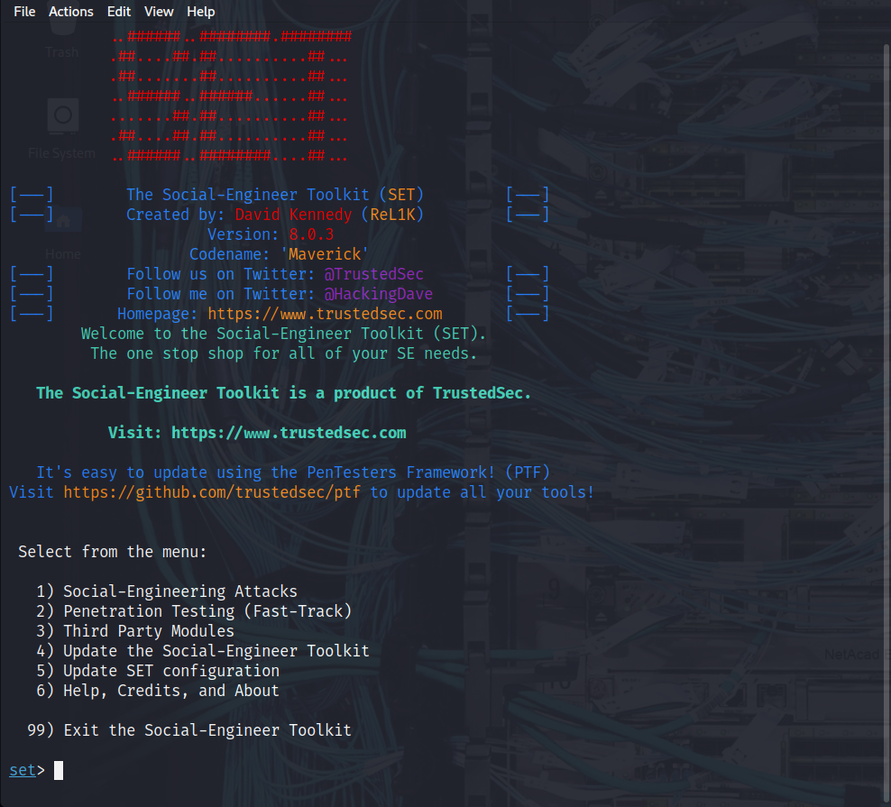

Step 2: Examine the Available Social-Engineering Attacks.
- At the SET prompt, enter 1 and press Enter to access the Social-Engineering Attacks submenu.

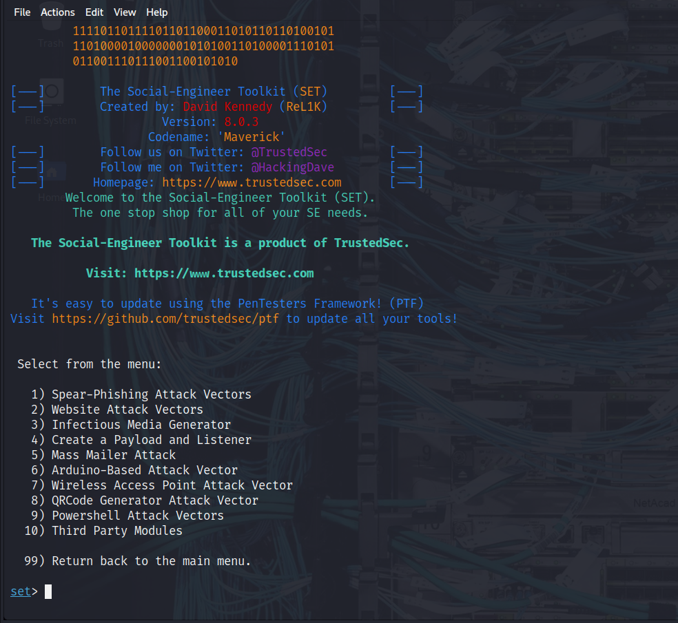
Select each option to see a brief description of each exploit and what the tool does for each.
Note: Some options may not have a choice. In that case, use CTRL-C or enter 99 to return to the main menu.
Option 1
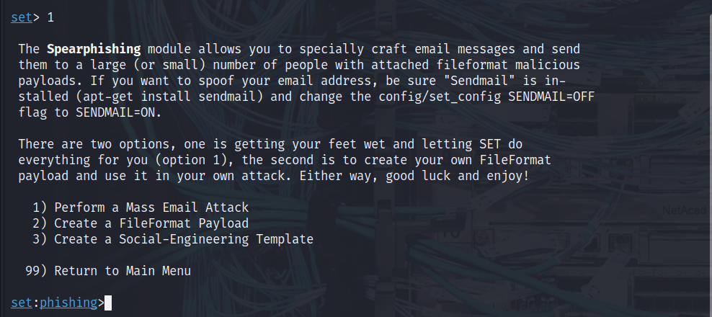
Option 2
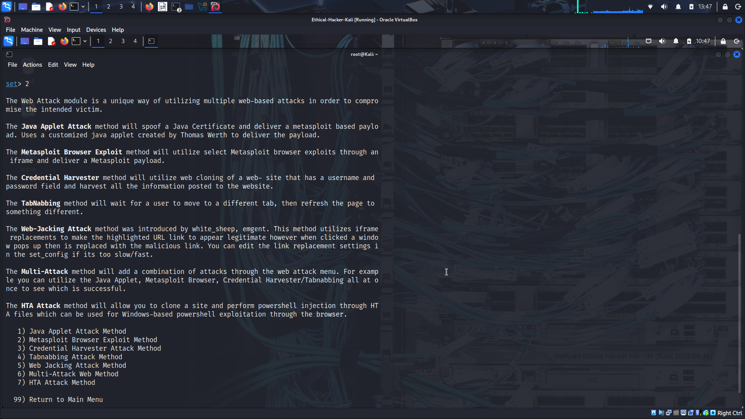
Option 3
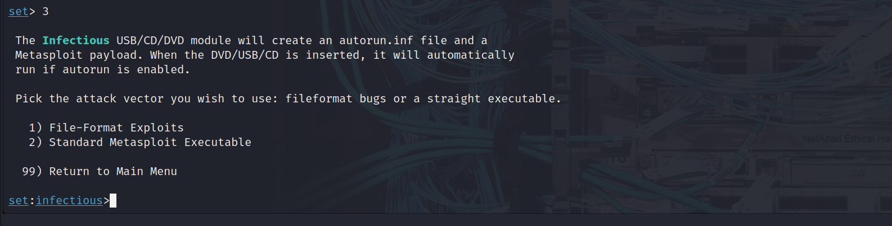
Option 4
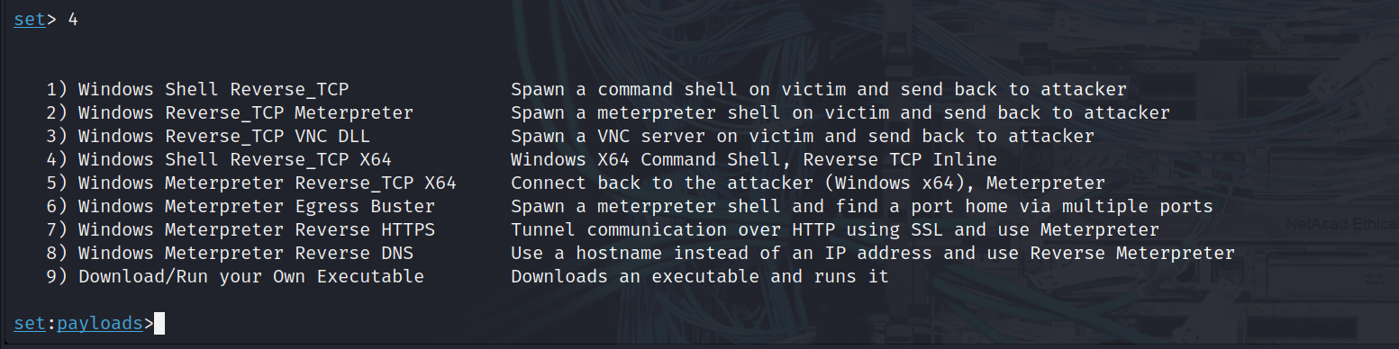
Option 5
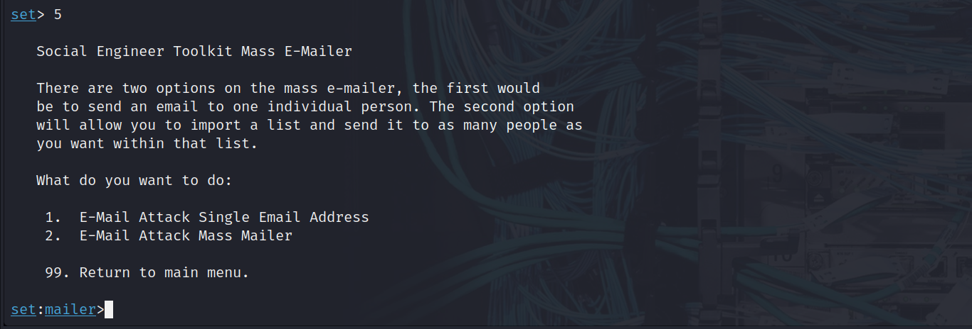
Option 6
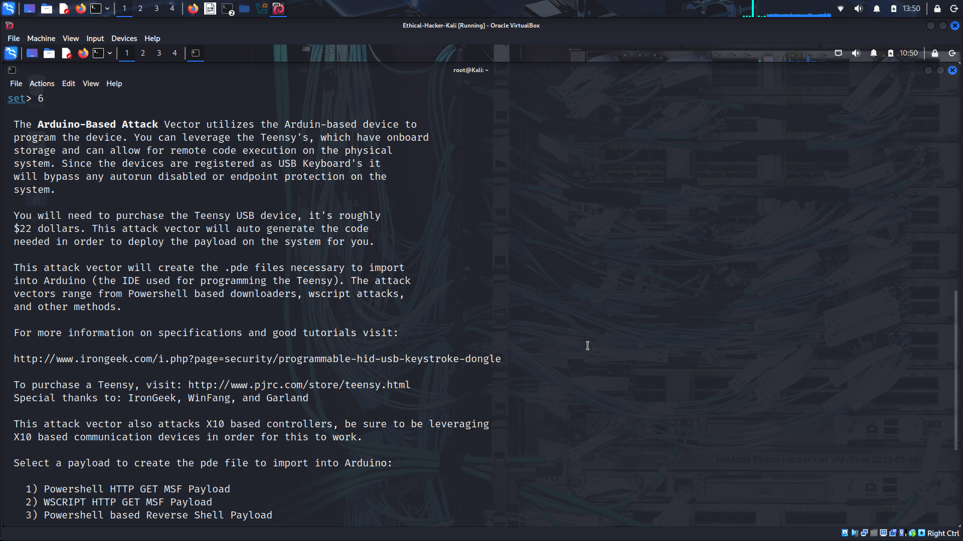
Option 8
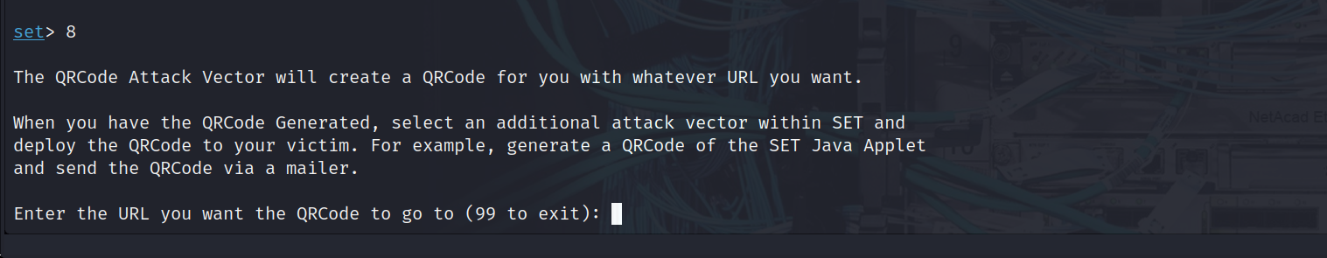
Option 9
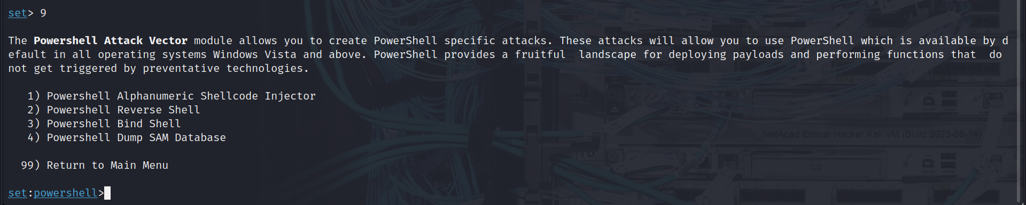
Option 10
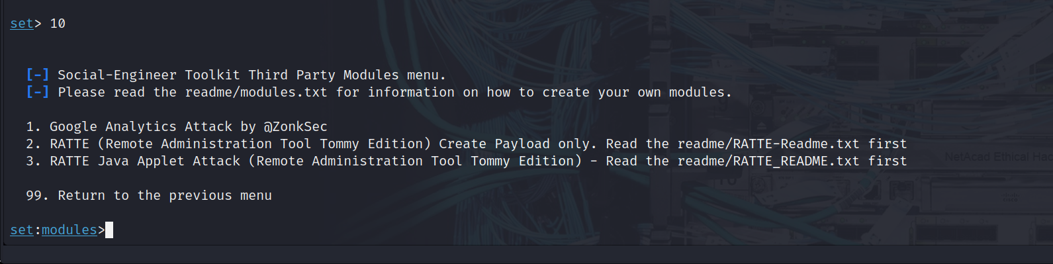
Which option creates a DVD or USB thumb drive that will autorun malicious software when inserted into the target device? 3 Infectious Media Generator
How could this functionality be used in a penetration test? The penetration tester could create and distribute some sort of benign malware on USB drives. The drives could be dropped in the parking lot and other open areas of the client facility. If the malware had a “phone home” functionality, the number of instances in which the USB drives were inserted into corporate computers could be quantified and reported.

