

Cloning a Website to Obtain User Credentials
In this part of the lab, you will create a perfect copy of the login page for a website. The fake login page will gather all credentials submitted to it and then redirect the user to the real website.

Step 1: Investigate Web Attack Vectors in SET.
- From the Social-Engineering Attacks submenu, choose 2) Website Attack Vectors to begin the web site cloning exploit.
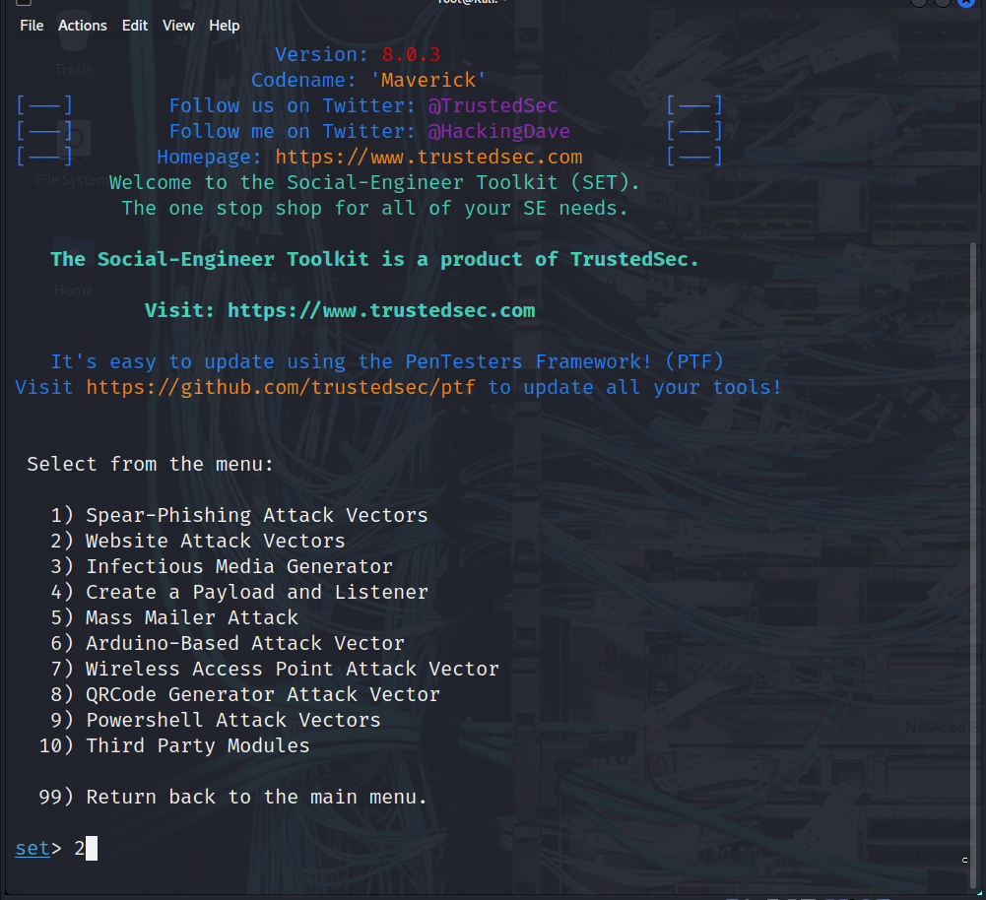
- Review the brief attack description of each type of attack.
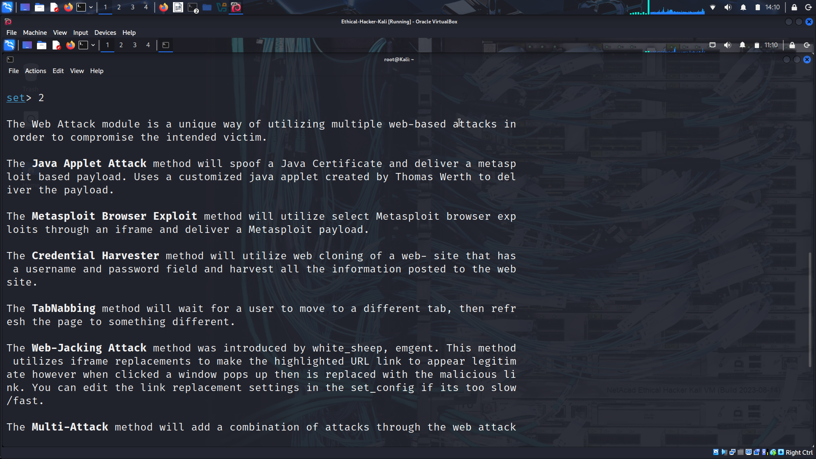
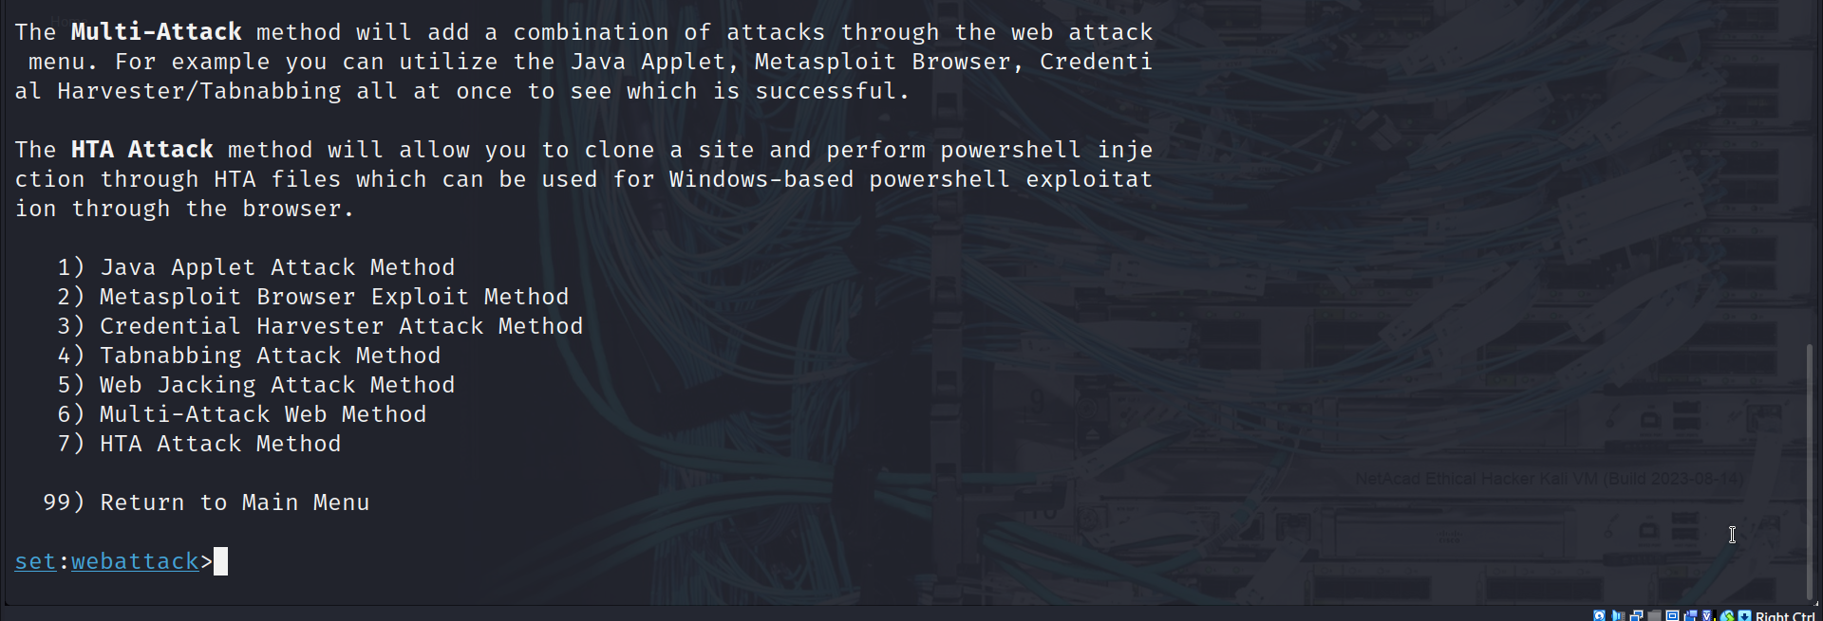
Which type of attack will you choose to create a cloned website to obtain login credentials for users on the target network? 3:Credential Harvester Attack Method
Select 3) Credential Harvester Attack Method from the menu. A description of the ways to configure this exploit is displayed. Which method enables you to use a custom website for the exploit that you create? 3: Custom Import

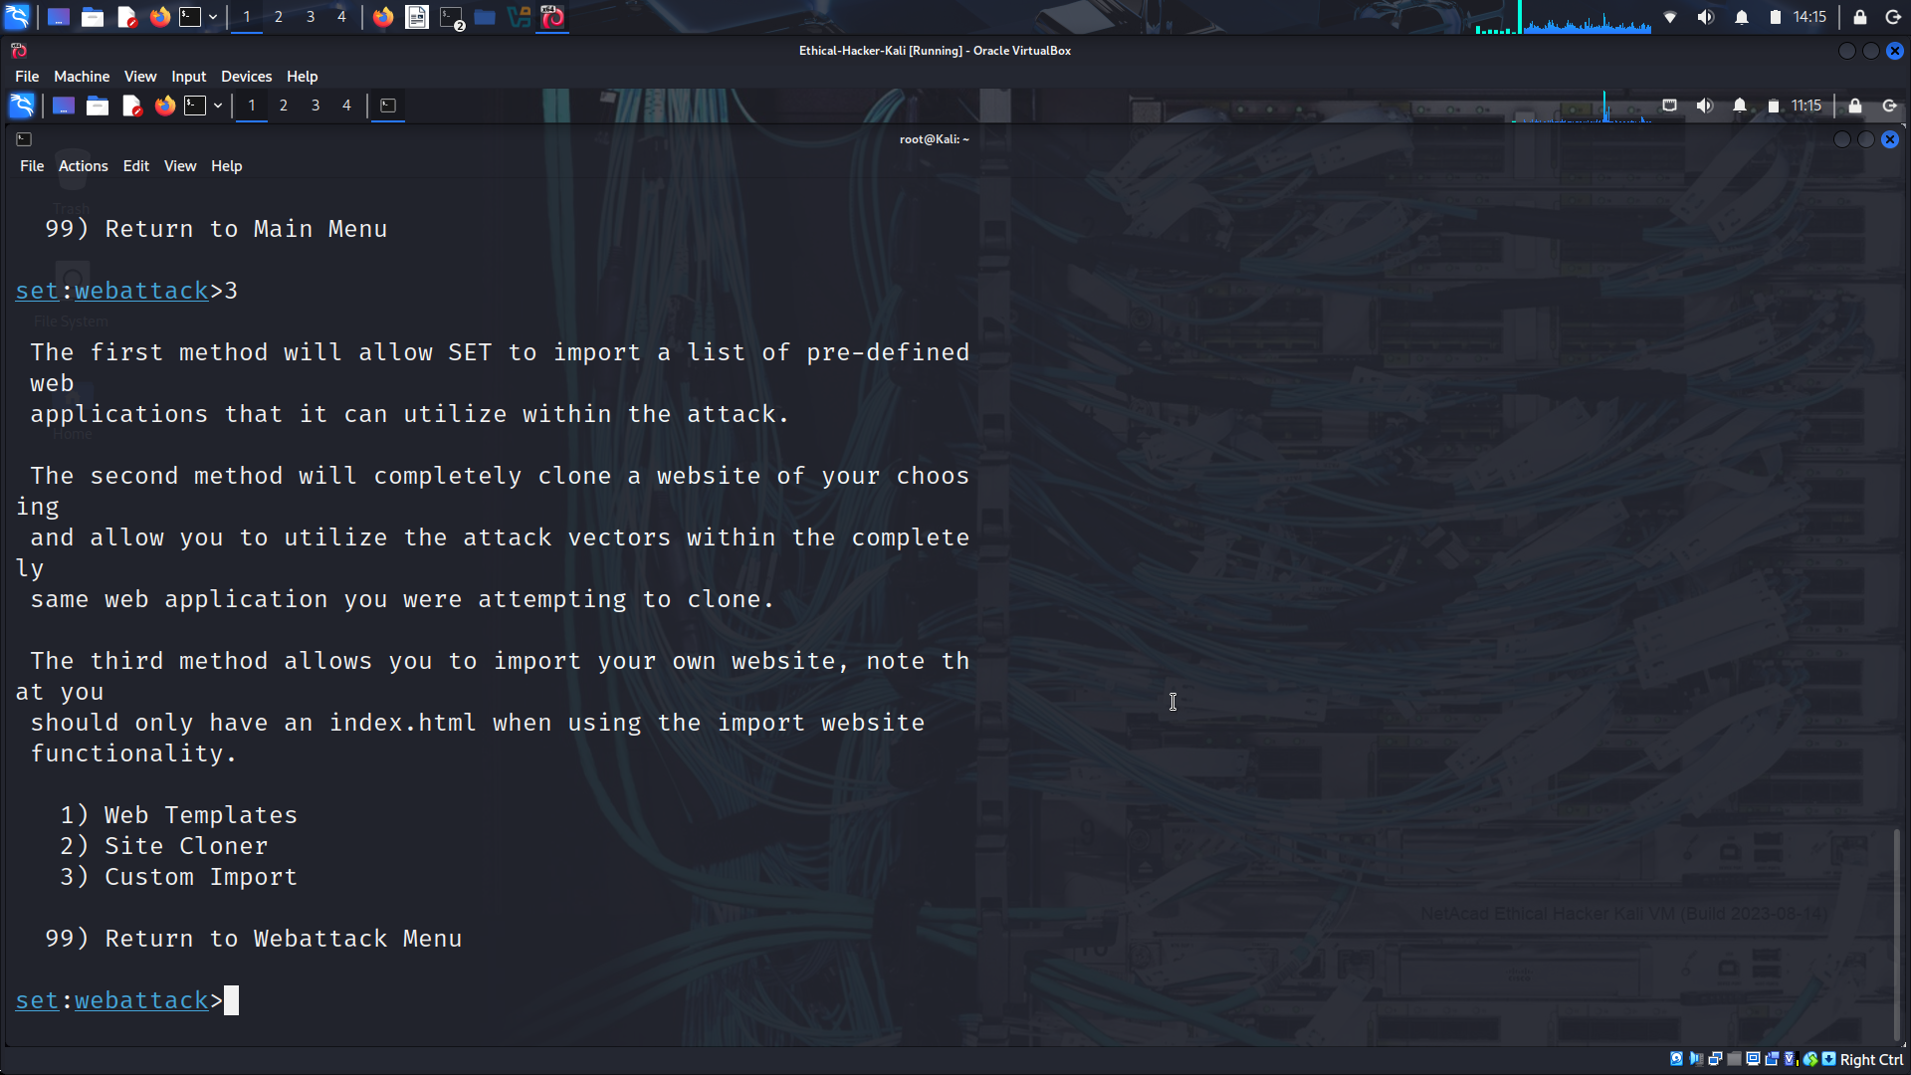
Step 2: Clone the DVWA.vm Login Screen.

In this step, you will create a cloned website that duplicates the DVWA.vm login website. The SET application creates a website hosted on your Kali Linux computer. When the target users enter their credentials in the cloned website, the credentials and the users will be redirected to the real website without being aware of the exploit. This is similar to an on-path attack.

In this lab, we are using the internal website hosted on the DVWA.vm virtual machine. To see what the website looks like, open the Kali Firefox browser, and enter the URL http://DVWA.vm/ The login screen will appear. If the URL is not found, enter http://10.6.6.13/ to access the web server using its IP address.

What is the URL of the login screen? http://dvwa.vm/login.php
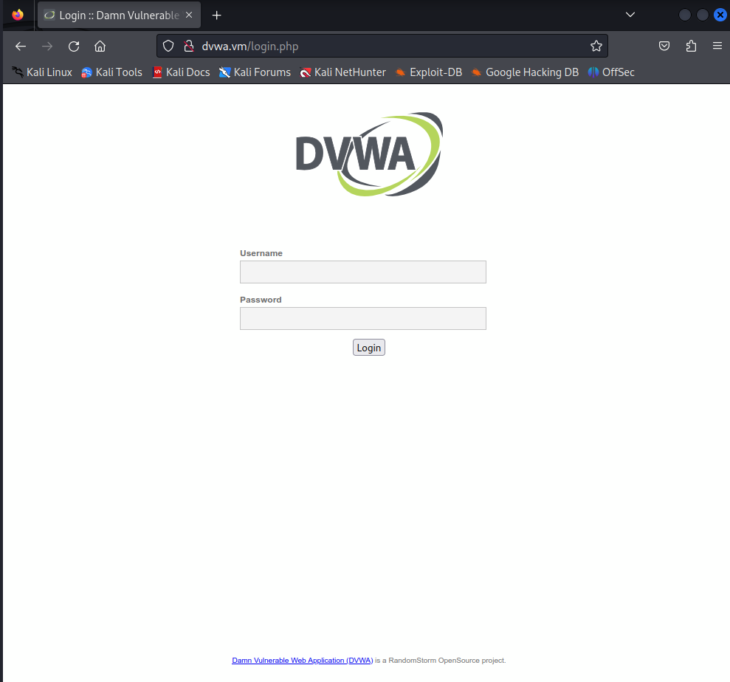
Return to the terminal session. Select 2) Site Cloner from the Credential Harvester Attack Method menu. Information describing which IP address is needed to host the fake website and to receive the POST data is displayed.

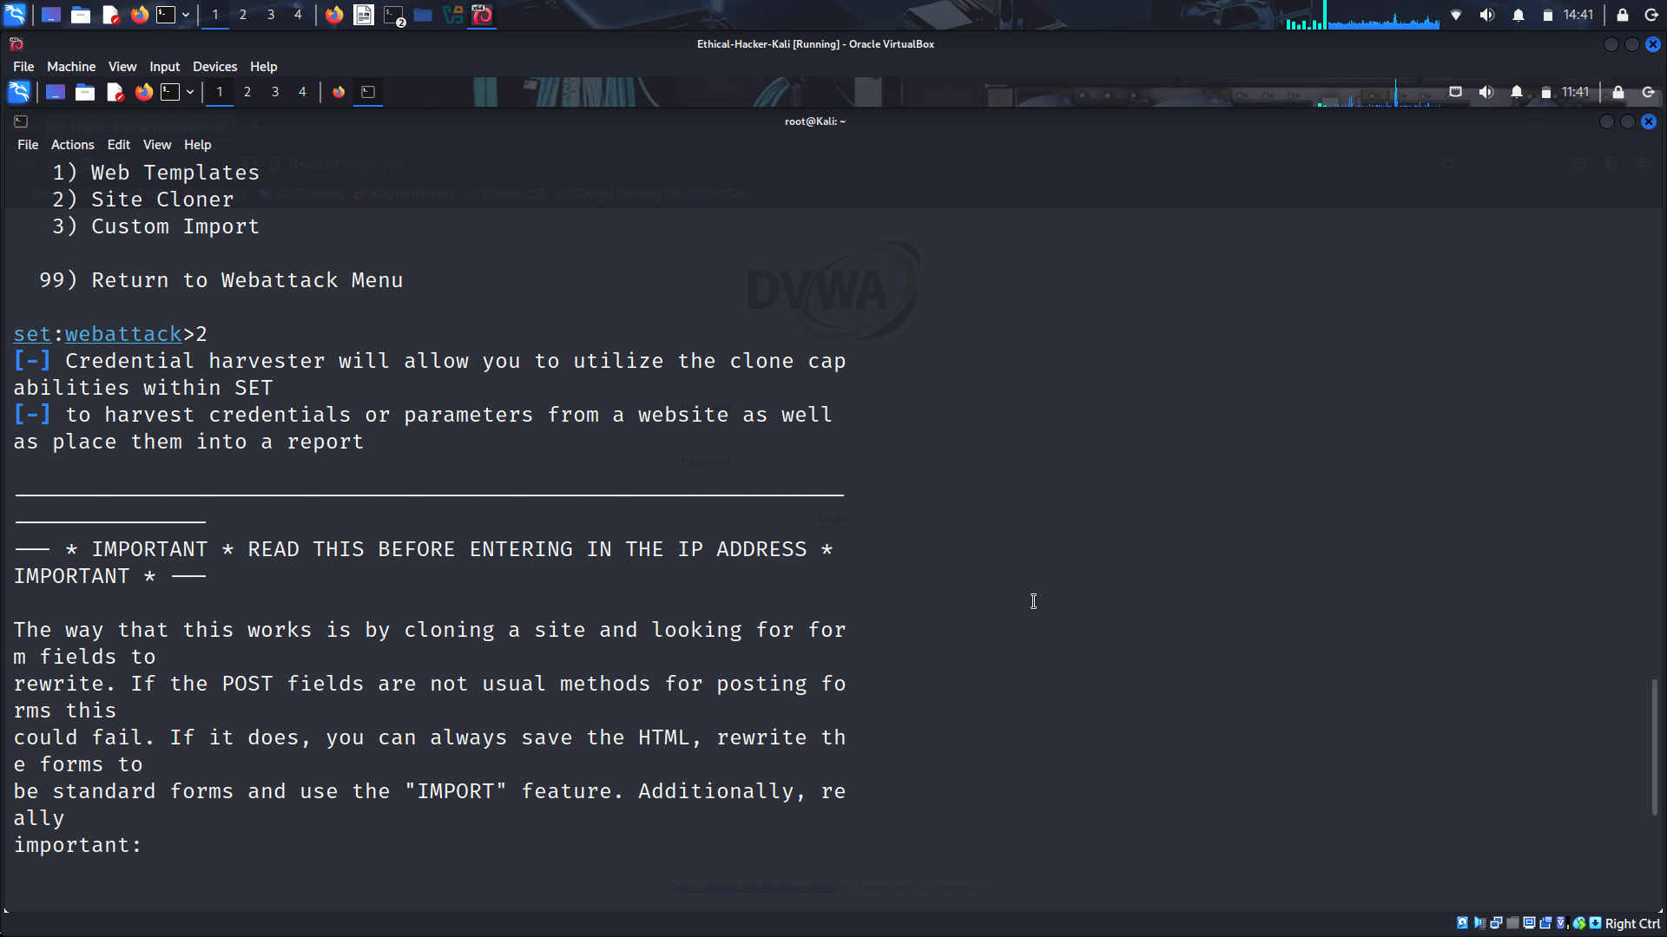
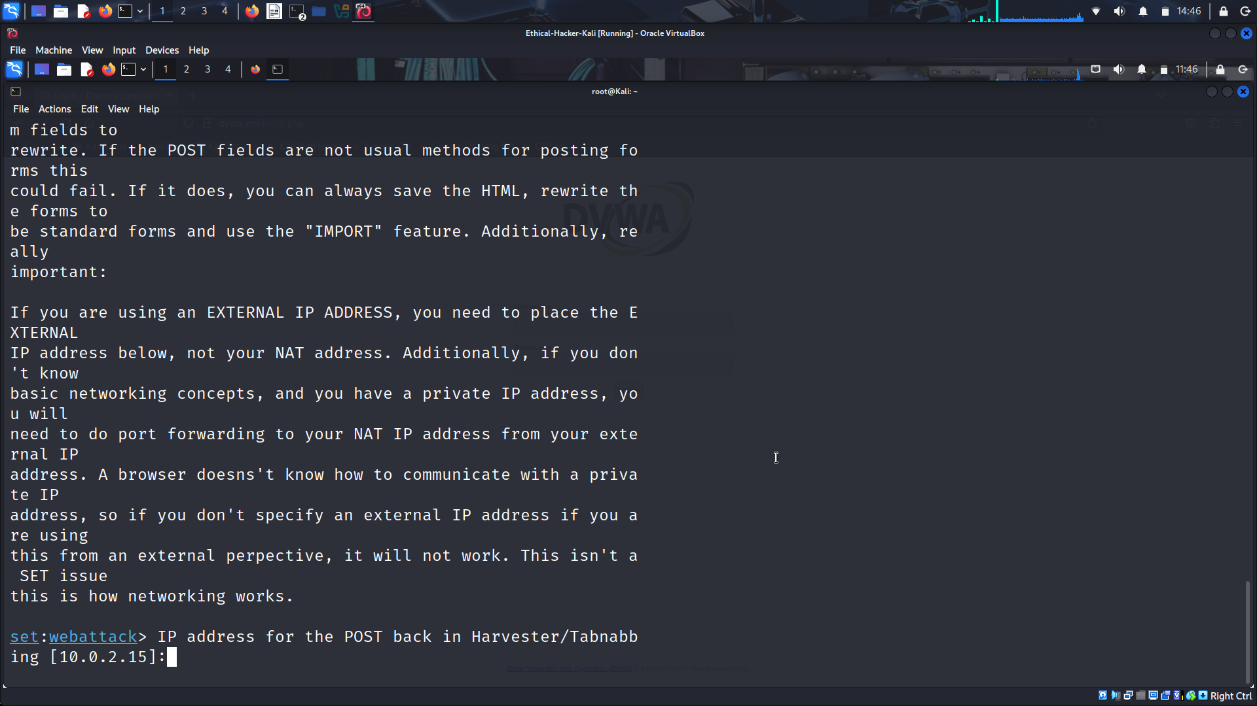
Enter the web attacker IP address at the prompt. This is the IP address of the virtual Kali internal interface on the 10.6.6.0/24 network. In an actual exploit, this would be the external (internet facing) address of the attack computer.
At the prompt, enter the IP address 10.6.6.1.
Next, enter the URL of the website that you want to clone. This is the URL of the DVWA website, http://DVWA.vm.
When the website is cloned, the following message appears on the terminal.
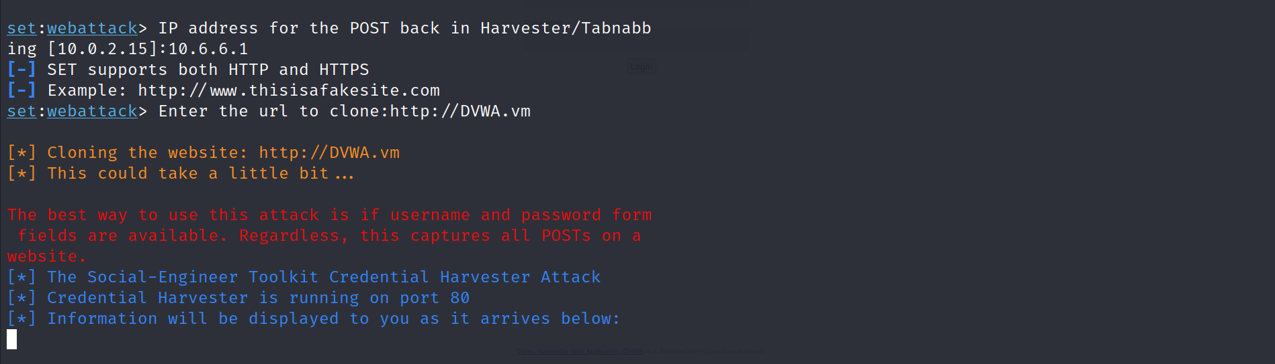
Note: No prompt will be returned to you. This is because a listener is now active on port 80 on the Kali computer and all port 80 traffic will be redirected to this screen. Do not close the terminal window. Continue to Part 3.

Part 3: Capturing and Viewing User Credentials

Step 1: Create the Social Engineering Exploit.
In a “real-life” exploit, at this point, a phishing exploit containing a link or QR code that sends the user to the fake website is created and sent. In this lab, an html document is created to direct the user to the fake webpage. This document simulates a distributed phishing URL. It could be distributed as a file attachment in phishing emails.
Open the Kali Linux Mousepad text editor using the Applications > Favorites > Text Editor choice from the menu. Enter the HTML code shown into the Mousepad document.
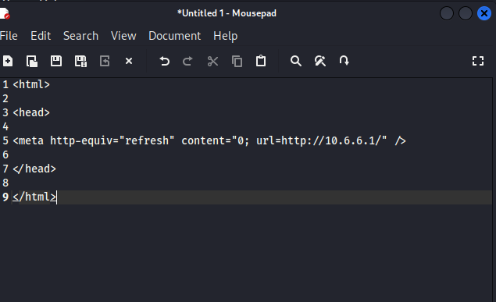
Select File > Save from the Mousepad menu. Name the document Great_link.html and save it in the /home/kali/Desktop Folder. The icon appears on the Kali desktop.
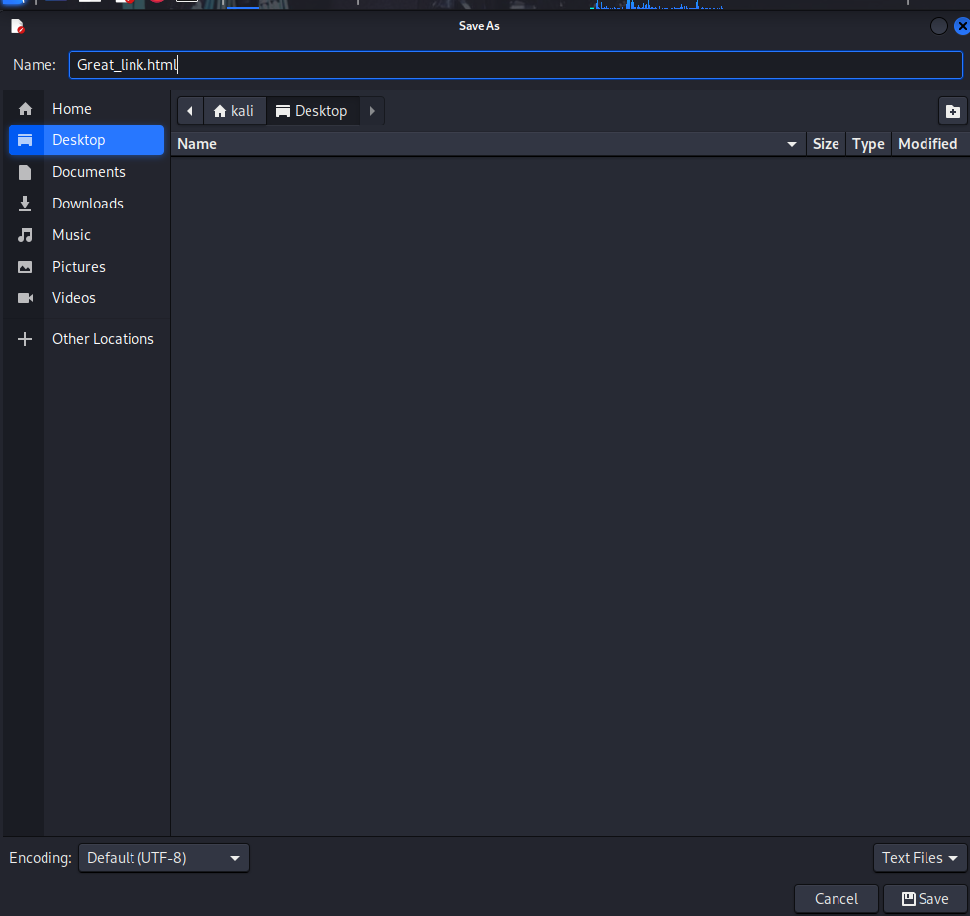
Close the Mousepad application.

Step 2: Capture User Credentials.
The purpose of the cloned website is to present a web page that looks identical to the one that the user is expecting. A good hacker would create a fake URL that would be very similar to the actual URL, so that unless the user inspects the URL very closely, it would go unnoticed.
- Double-click the desktop icon for the Great_link.html page. The DVWA login page that you viewed in Part 2, Step 2a should appear in a browser window.
What URL appears on the browser now? http://10.6.6.1/ Is it the same as the URL you recorded in Part 2, Step 2a? NO
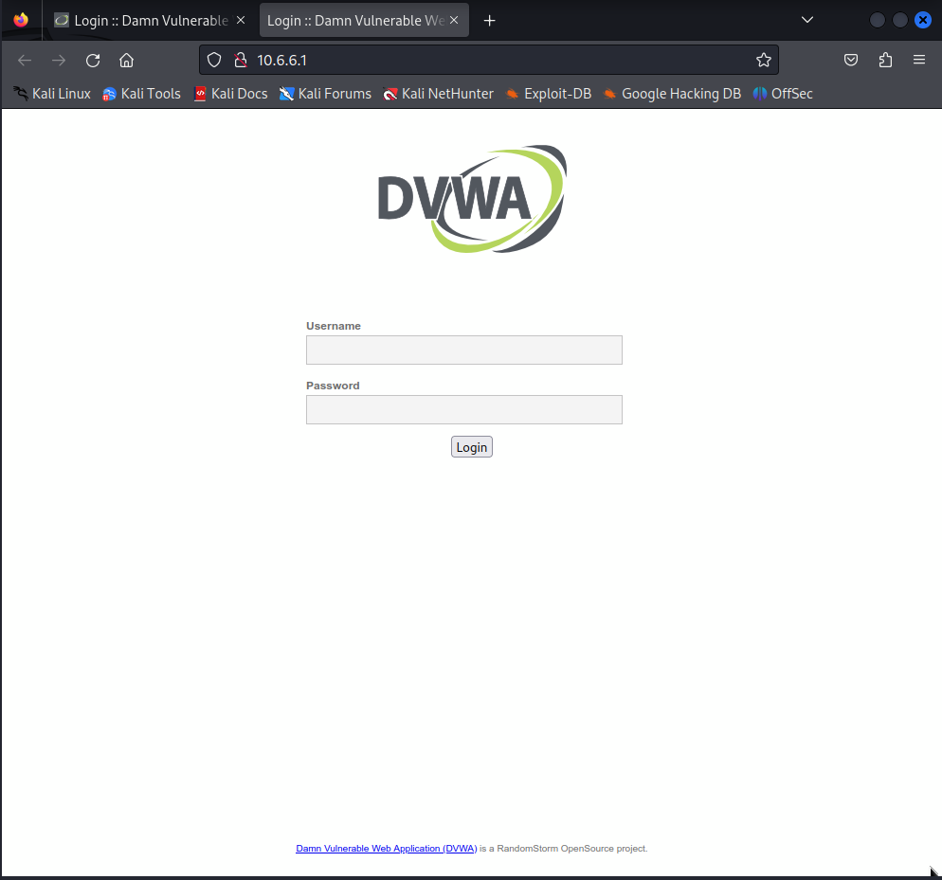
Enter some information in the Username and Password fields and click Login to send the form.
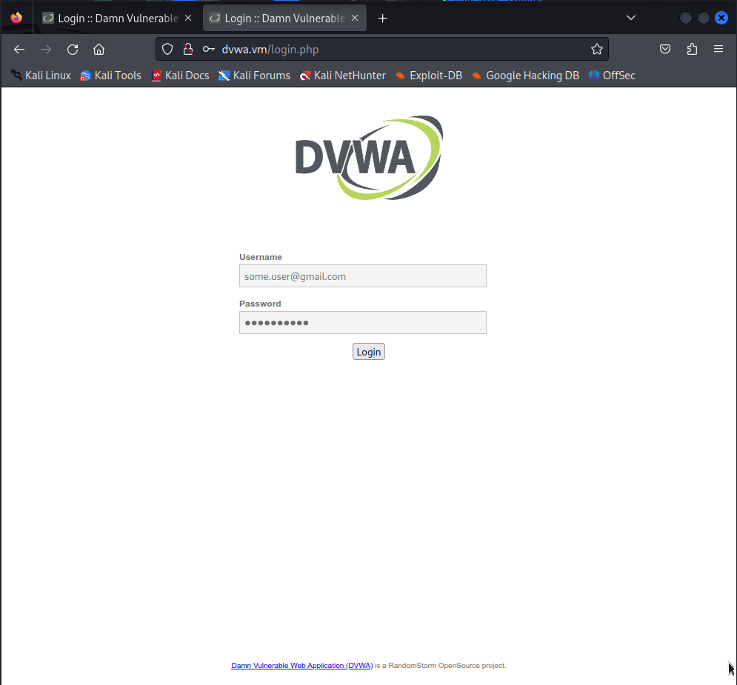
What is the URL after you entered the information and clicked the Login button? http://dvwa.vm/login.php Is it the same as the URL you recorded in Part 2, Step 2a? Yes
What happened? After the login attempt, the cloned web page redirected the browser to the real web site. However, the user has real credentials have been provided to the hacker’s clone of the original website.

Step 3: View the Captured Information.
- Return to the terminal session that is running the SET application. Output from the login attempt should appear, similar to what is shown:
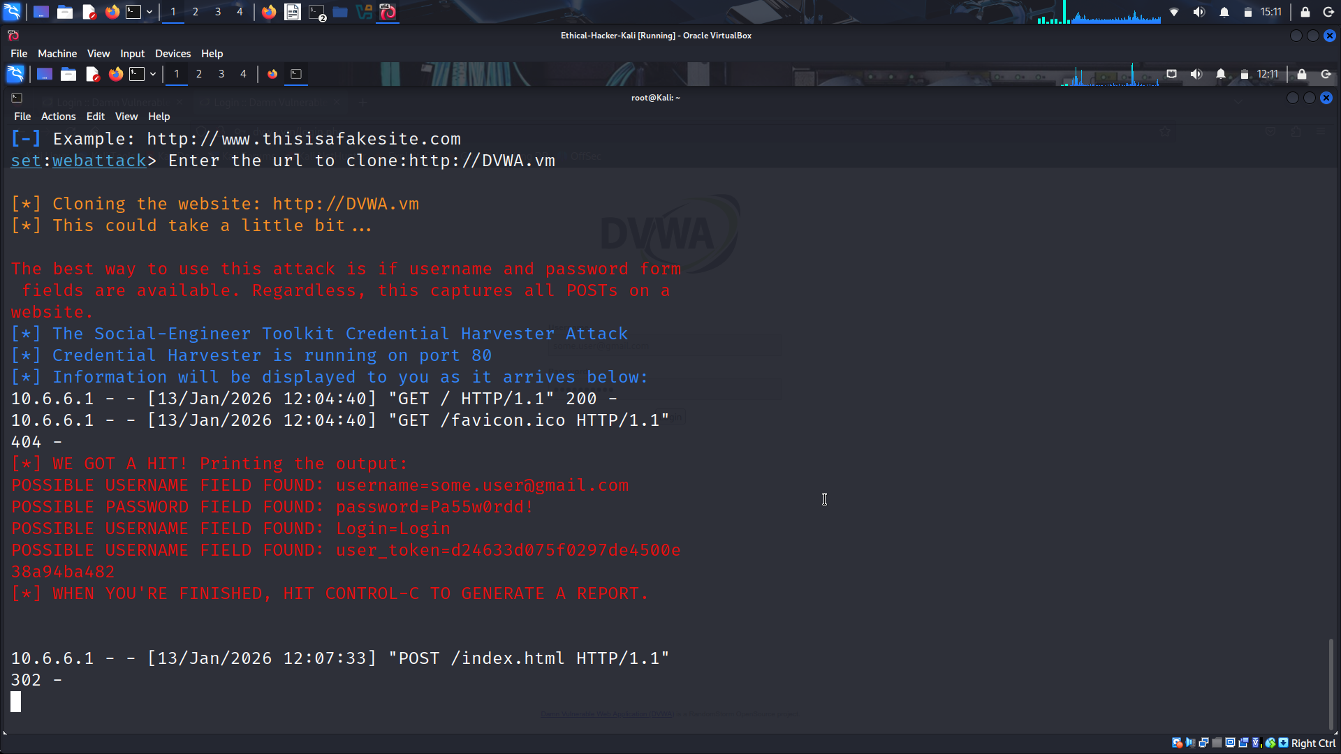
To save the report in XML format to use in other penetration testing applications, enter CTRL-C. The report file name and path are returned. Select the path and filename and right-click to copy the selection. The filenames that are created contain the date and time the file was created in this format:
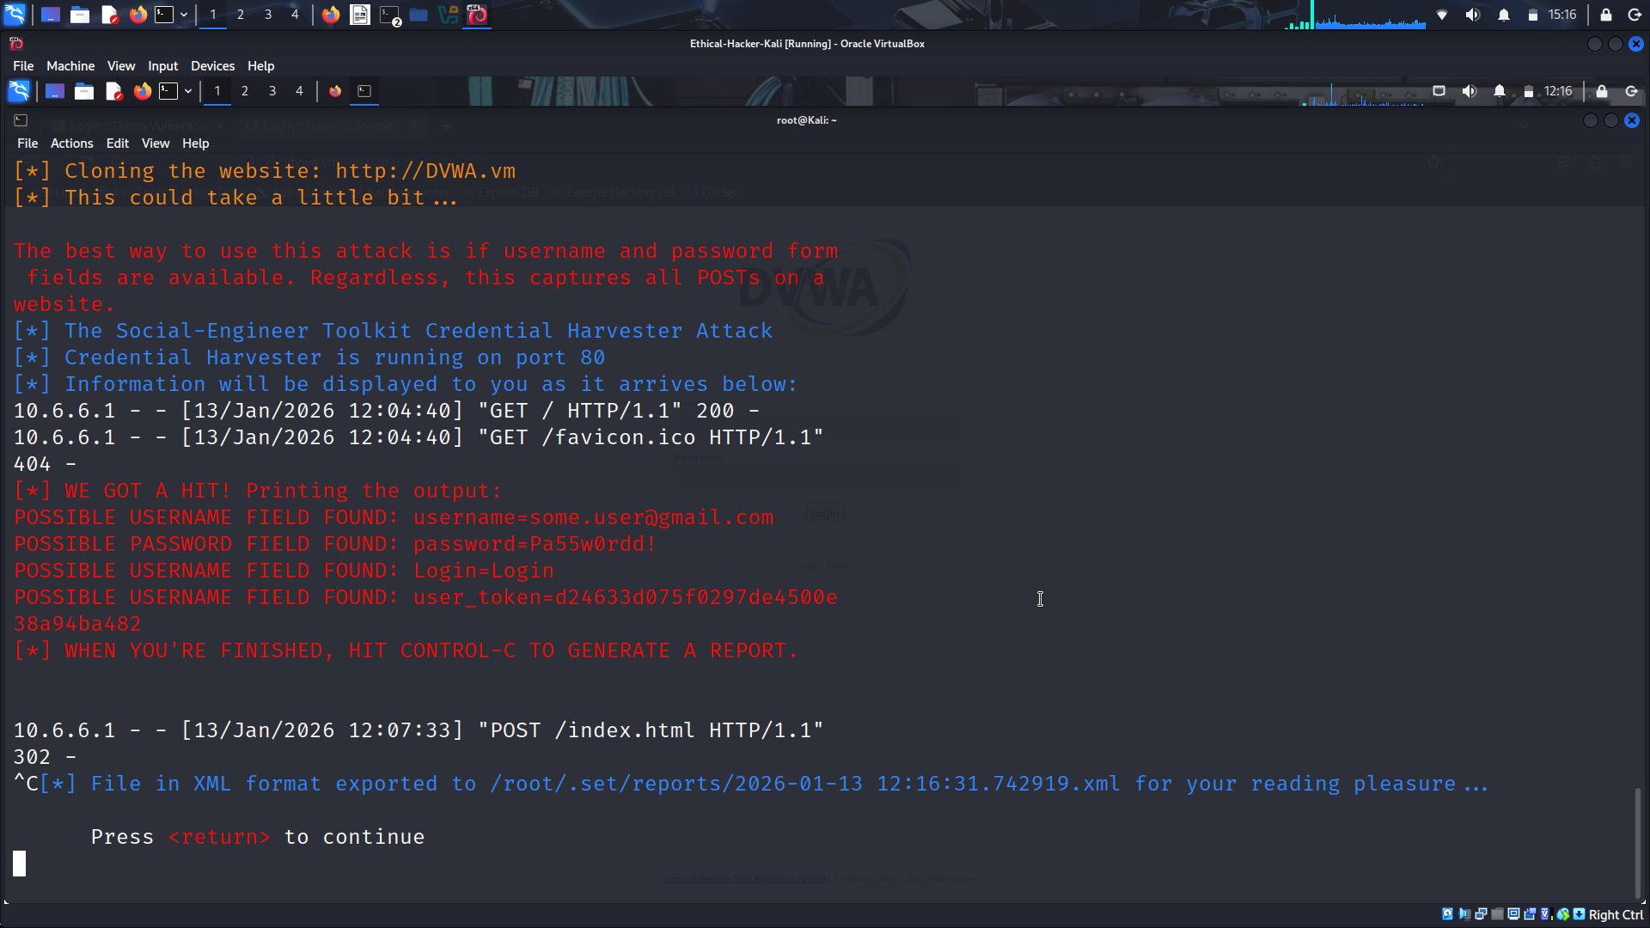
Continue to enter 99 and press enter until you have exited setoolkit.
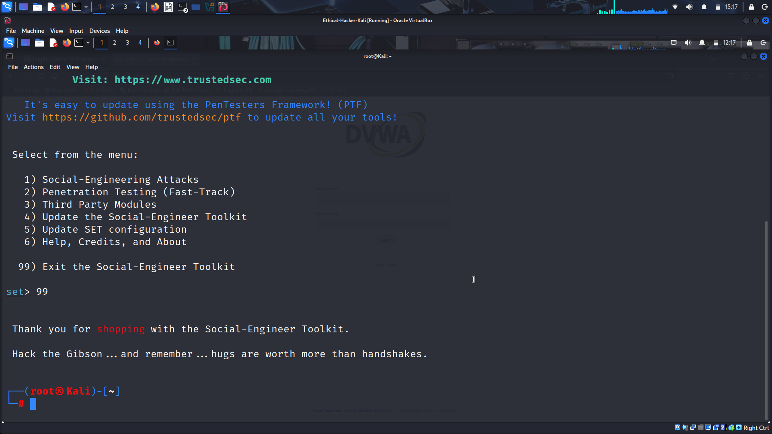
To view the content of the XML file, you need to place the filename in double-quotes (“) because it contains spaces and special characters. Use the cat command to see the information that is saved. The file path shown is the default path for the lab VM when this lab was created.
cat /root/.set/reports/"2026-01-13 12:16:31.742919.xml"
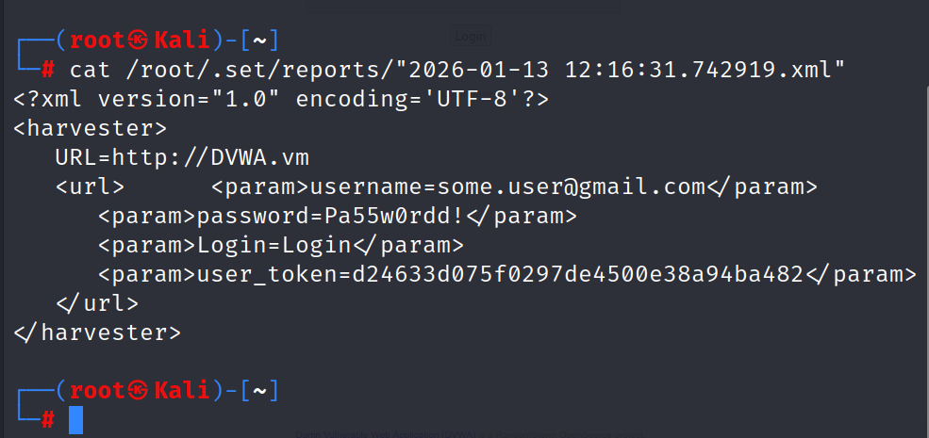
What information did the cloned web page gather? Username, password, user_token
What could a penetration tester do with this information? Go to the real website and login in as a legitimate user. How could an ethical hacker use this procedure in a test? It could be used with a phishing email. For example, the tester could send emails to various employees asking them to login to a fake URL that looks like the real one. The URL links to the very familiar login page that was cloned from the real site. From there, credentials could be harvested for multiple users. The results of this test could then be reported to the customer with the mitigation recommendation of additional user training to prevent similar actual attacks.

