Cisco Final Capstone Project- Ethical Hacker
Objectives
For this Final Capstone Activity, you will conduct a complete penetration test starting with reconnaissance and then launching exploits against vulnerabilities that you have discovered. Finally, you will propose remediation for the exploits.
This assessment is in the form of a cybersecurity capture the flag exercise. You will use your ethical hacking skills to locate files that contain flag values. You will then report the flag values that you found as part of the assessment.
In this simulation of an ethical hacking engagement, you will use tools to exploit vulnerabilities that you discover in order to reach a goal. This can entail a trial-and-error approach that requires persistence and may include a degree of struggle. For your own skill development, working through this struggle can be productive. If you are completely stuck, ask your instructor for assistance.
NOTE: We will be using Kali VM customized for the Ethical Hacker course
- Challenge 1 – Use SQL injection to find a flag file.
- Challenge 2 – Use web server vulnerabilities to investigate directories and find a flag file.
- Challenge 3 – Exploit open Samba shares to access a flag file.
- Challenge 4 – Analyze a Wireshark capture file to find the location of a file containing flag information.
Background / Scenario
You have been hired to conduct a penetration test for a customer. At the conclusion of the test, the customer has requested a complete report that includes any vulnerabilities discovered, successful exploits, and remediation steps to protect vulnerable systems. You have access to hosts on the 10.5.5.0/24 and 192.168.0.0/24 networks.
BrainStorm
Challenge 1: SQL Injection
In this part, you must discover user account information on a server and crack the password of Bob Smith's account. You will then locate the file that contains the Challenge 1 code and use Bob Smith's account credentials to open the file at 192.168.0.10 to view its contents.
Goal
Discover user account info on the server: reconnaissance and findings to get injection points
Injection points can either be in:
- login forms
- search bars
- URL parameters(e.g. ?id=1, ?user=bob)
- HTTP headers( user agent, referer, cookie)
Possible tools:
- browser- manually test fields with ‘ or “ to trigger sql errors
- burpsuite: intercept and modify HTTP requests
- sqlmap: automated SQL injection discovery and exploitation
Crack Bob’s password
- have the password hash (likely MD5, SHA1, bcrypt):
Possible tools:
- hashcat- GPU- accelerated cracking
- John the Ripper:
Access the file at 192.168.0.10 using Bob’s credentials

Key Tips
- Always note error messages: they reveal DB type (MySQL, MSSQL, SQLite)
- Try both GET and POST injection points
- Check for second-order injection (stored, not just reflected)
- If the password is plaintext in the DB... lucky you!
- The file might be a .txt, .pdf, or protected archive: check what protocol is being used to serve it
SOLUTION&Questions

Step 1: Preliminary setup
- Open a browser and go to the website at 10.5.5.12(DVWA website).
Note: If you have problems reaching the website, remove the https:// prefix from the IP address in the browser address field.
- Login with the credentials admin / password.
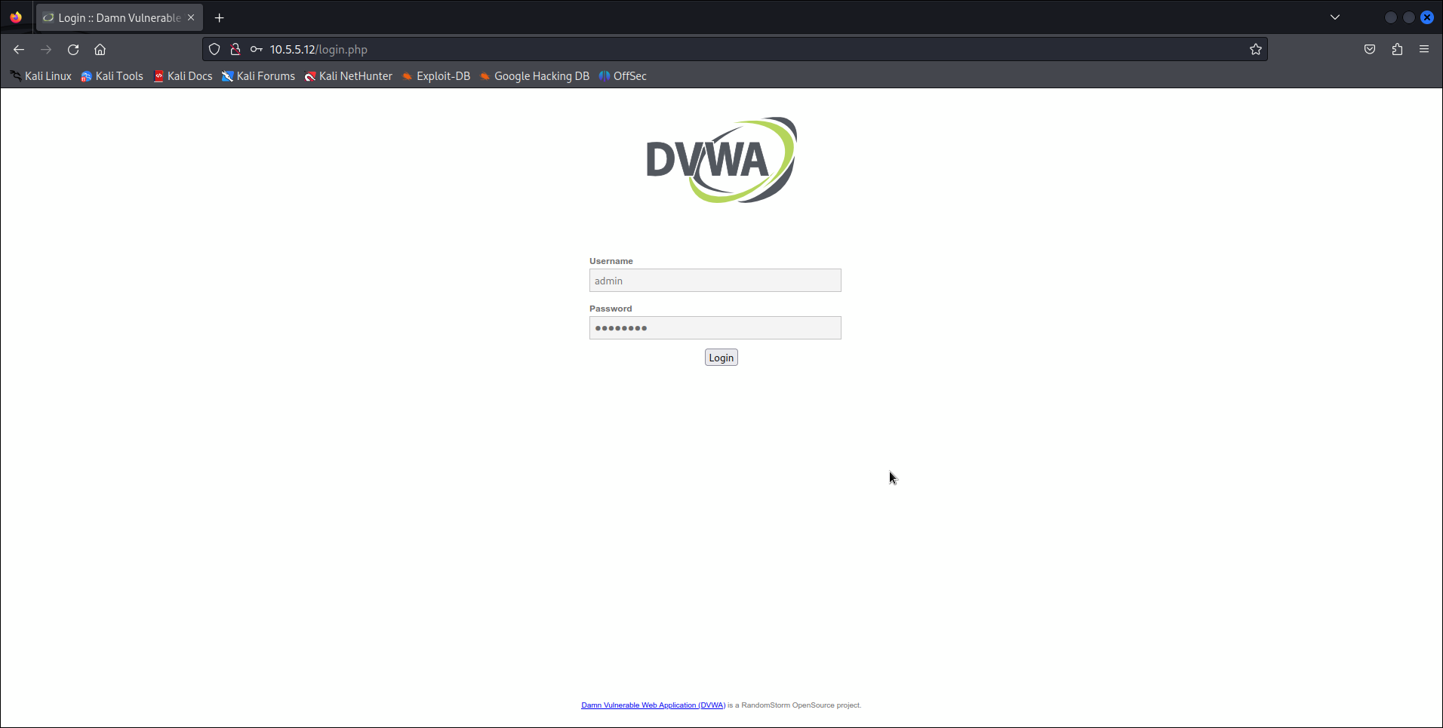
- Set the DVWA security level to low and click Submit.

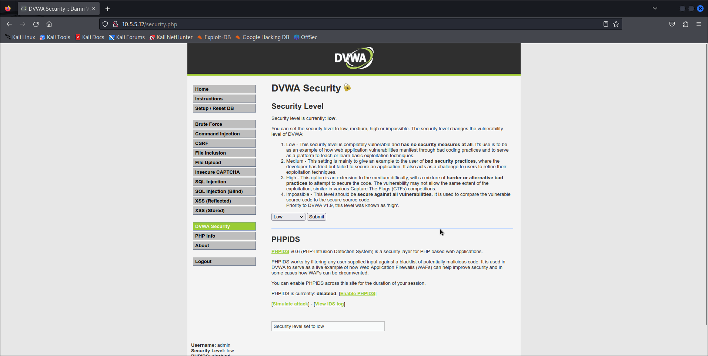
Step 2: Retrieve the user credentials for the Bob Smith's account.
- Identify the table that contains usernames and passwords.
- Locate a vulnerable input form that will allow you to inject SQL commands.
- Retrieve the username and the password hash for Bob Smith's account.
Initial testing used the payload 1' OR '1'='1 to confirm the site executes injected SQL. The payload terminates the surrounding string, adds an always-true condition, and comments out the remainder of the query.
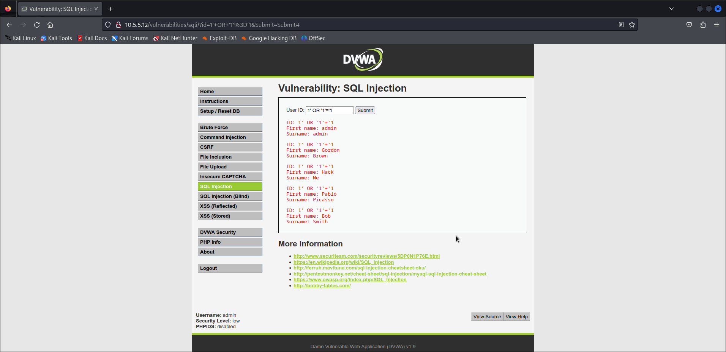
The response confirms SQL injection is possible: the application processed an always-true expression and returned database results.
2. Use ORDER BY probes to detect the number of returned columns. For example: (1' ORDER BY 1 # ) and 1' ORDER BY 3 #. The error Unknown column '3' in 'order clause' shows the query uses two columns, which informs subsequent UNION payloads.
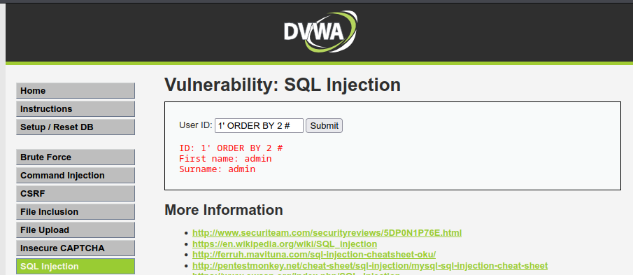


Use UNION-based payloads to enumerate database properties. Example:
Command | What it does | Output
1' OR '1'='1 | confirm the site executes injected SQL. | application processed an always-true expression and returned database results.
1' ORDER BY 2 # | probes to detect the number of returned columns | Return the DB results
' UNION SELECT database(),NULL# | Get current database name | Returns the DB in our case: dvwa
' UNION SELECT table_name,NULL FROM information_schema.tables WHERE table_schema='dvwa'# | List all tables in dvwa | Returns users, guestbook
' UNION SELECT user,password FROM users# | Dump all usernames and password hashes | Returns usernames and hashed passwords

Command: ' UNION SELECT user,password FROM users# → Dump all usernames & password including Bob’s username and hashed password

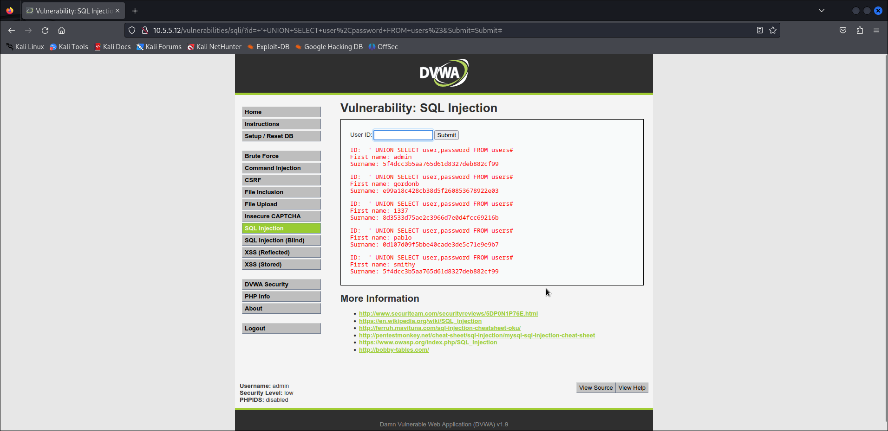
Step 3: Crack Bob Smith's account password.
Use any password hash cracking tool desired to crack Bob Smith’s password
What is the password of Bob Smith's account? Password
I recovered the plaintext password from the MD5 hash using two approaches: an online hash lookup and an offline cracking tool.
Part 1: Crackstation( online hash lookup)
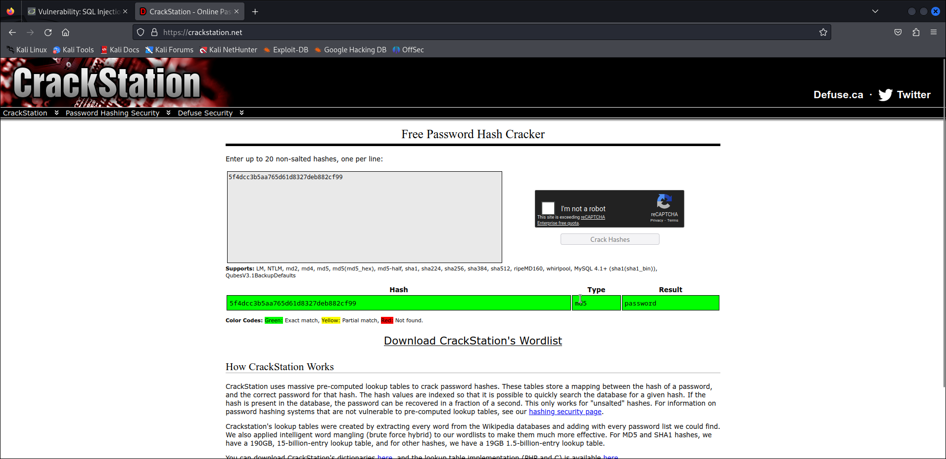
Part 2 — John the Ripper ( offline cracking tool)
Paste the hash password in a .txt file and use john to crack it as shown below.

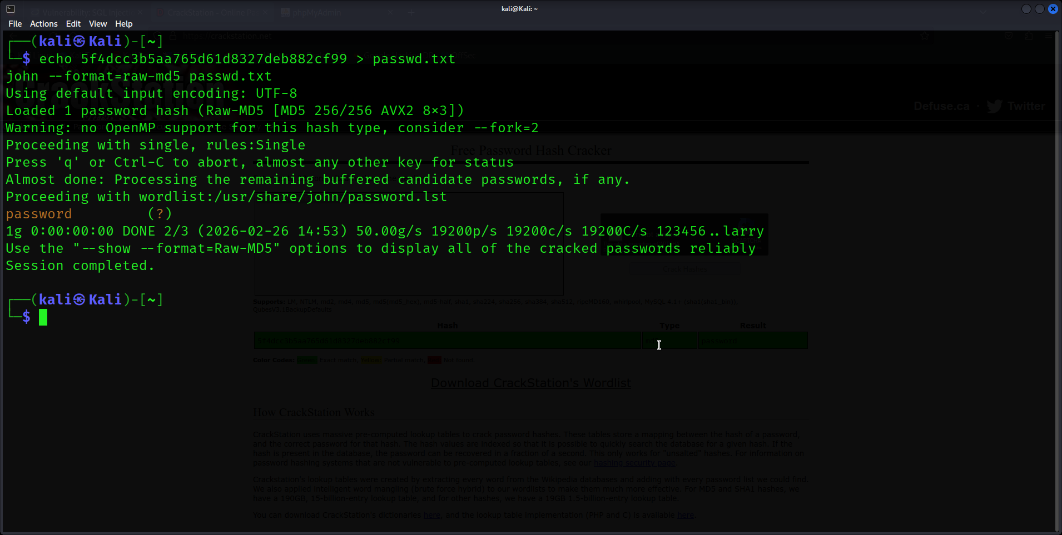
Step 4: Locate and open the file with Challenge 1 code.
- Log into 192.168.0.10 as Bob Smith.
- Locate and open the flag file in the user's home directory.
Ping to confirm communication:
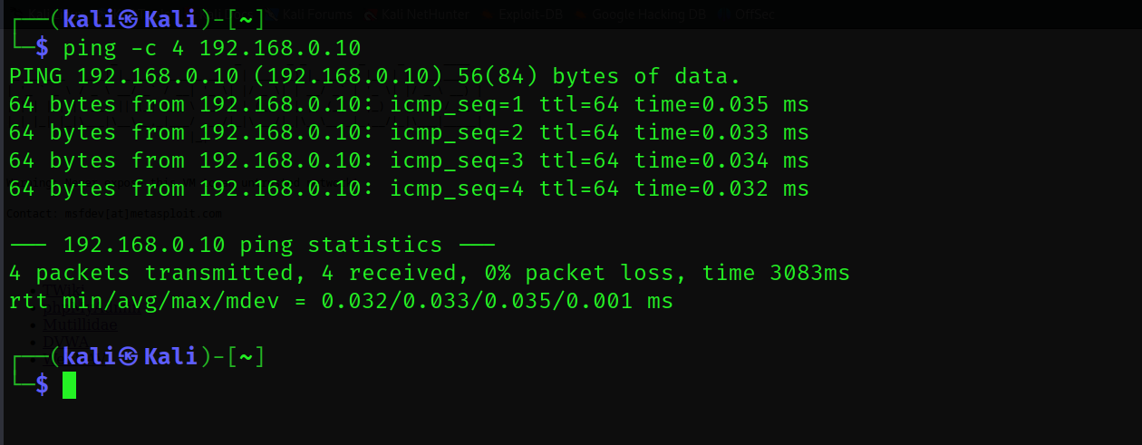
Scan using nmap to confirm open ports and their services
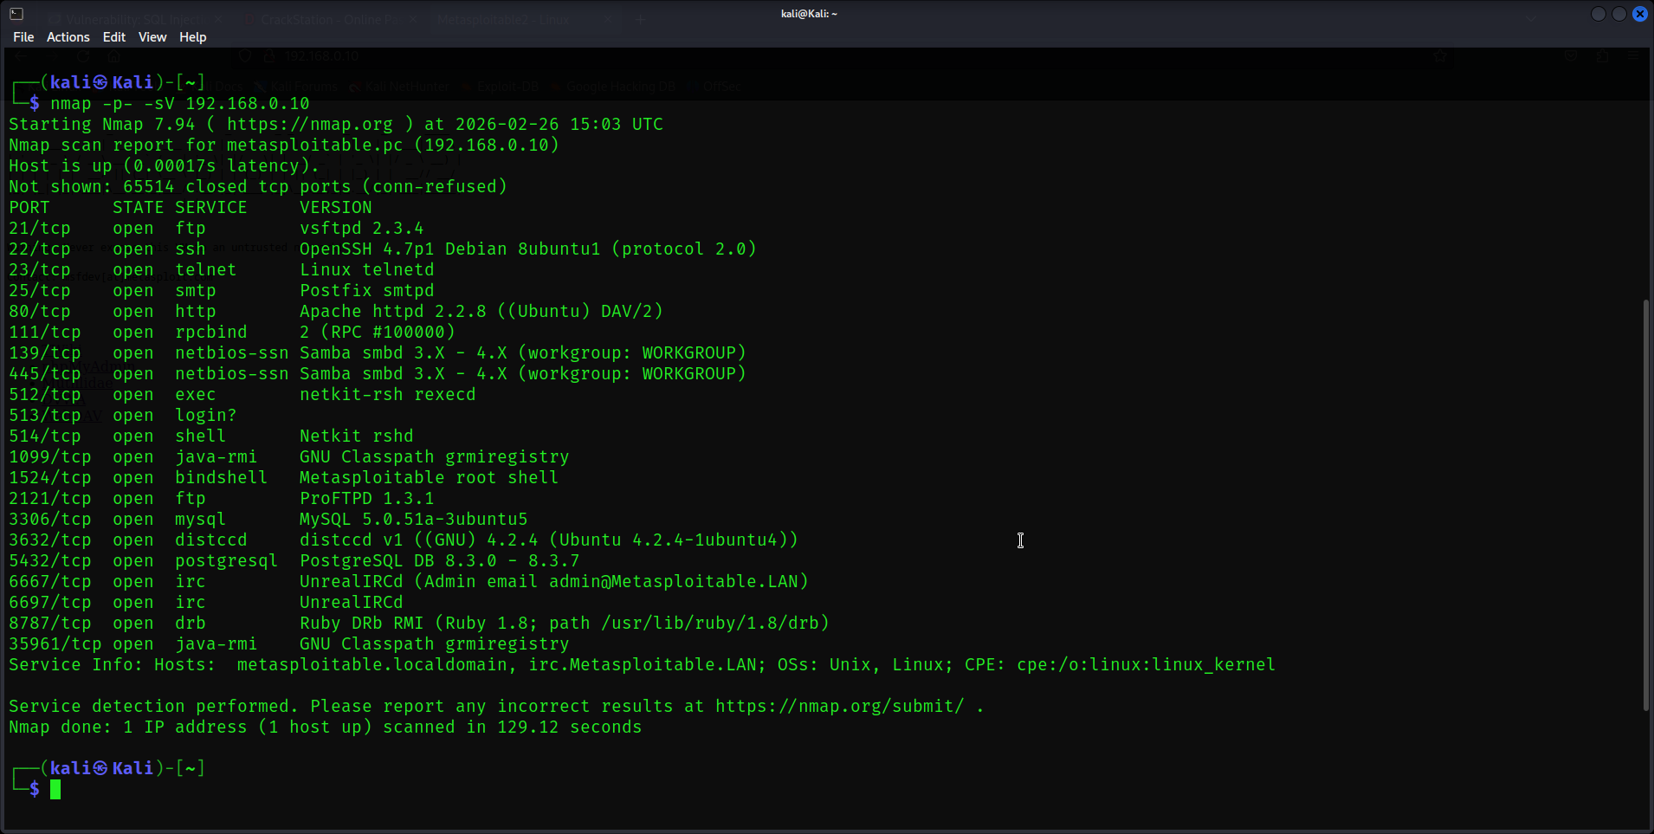
We can use ssh to login
We retrieved our username and password early
username: smithy
password: password
ssh smithy@192.168.0.10 -p 22
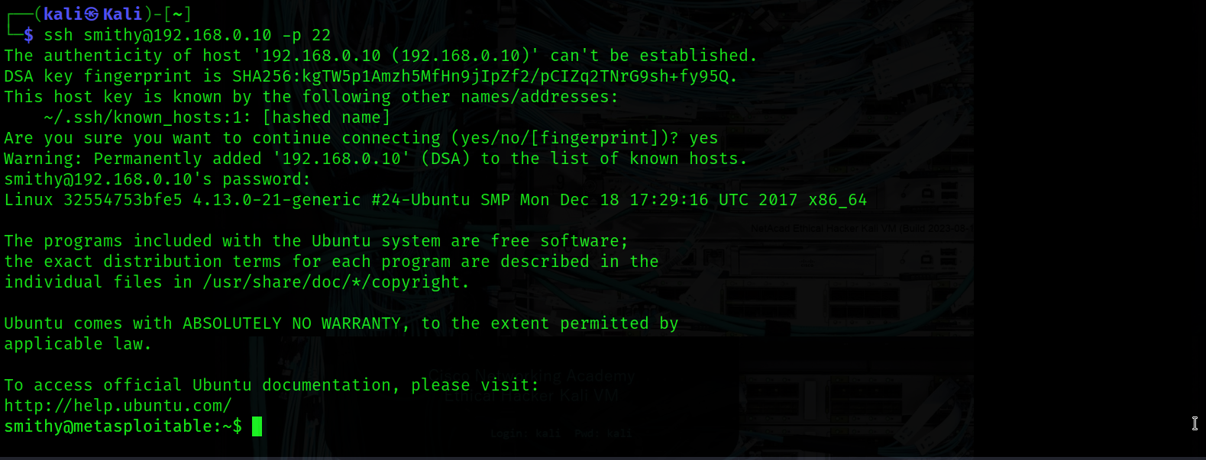
We have successfully logged in and we can confirm it is a metasploitable
We have successfully identified the file and got the code
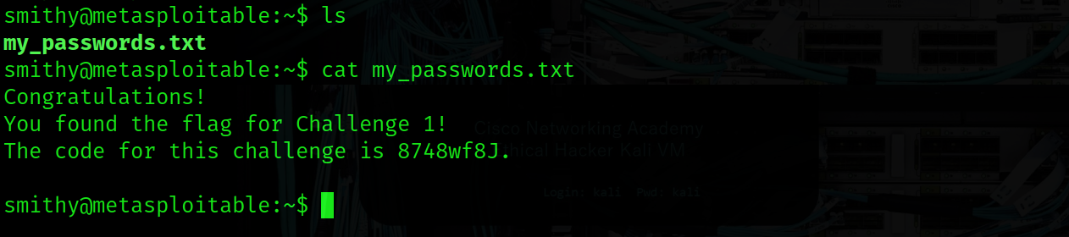
What is the name of the file with the code? my_passwords.txt
What is the message contained in the file? Enter the code that you find in the file: 8748wf8J.

Step 5: Research and propose SQL attack remediation.
What are five remediation methods for preventing SQL injection exploits?
- Parameterized Queries (Prepared Statements): The most effective defense. Instead of concatenating user input into SQL strings, use placeholders that the database treats strictly as data, never as executable code.
- Stored Procedures: Encapsulate SQL logic in pre-compiled database procedures. When implemented correctly (without dynamic SQL inside them), they separate code from data and prevent injection by design.
- Input Validation & Allowlisting: Validate all user-supplied input against strict rules — expected data type, length, format, and character set. Prefer allowlisting (only permit known-good values) over denylisting (blocking known-bad characters), since attackers continuously find new bypass techniques.
- Least Privilege (Database Account Hardening): Ensure the database account used by your application has only the minimum permissions necessary (e.g., SELECT only if writes aren't needed; no access to system tables or admin functions). This limits the blast radius if an injection does occur an attacker can't drop tables or read sensitive system data.
- Web Application Firewall (WAF): Deploy a WAF to detect and block common SQL injection patterns in HTTP traffic before they reach your application. While not a substitute for secure coding practices, a WAF provides an important additional layer, especially for legacy systems that are harder to recode. Rules can be tuned to your specific application profile.

Challenge 2: Web Server Vulnerabilities
In this part, you must find vulnerabilities on an HTTP server. Misconfiguration of a web server can allow for the listing of files contained in directories on the server. You can use any of the tools you learned in earlier labs to perform reconnaissance to find the vulnerable directories.
In this challenge, you will locate the flag file in a vulnerable directory on a web server.
Goal
Find directory listing vulnerabilities on HTTP server and locate the flag file in a vulnerable directory on a web server.

Step 1: Preliminary setup
If not already, log into the server at 10.5.5.12 with the admin / password credentials.
Set the application security level to low.
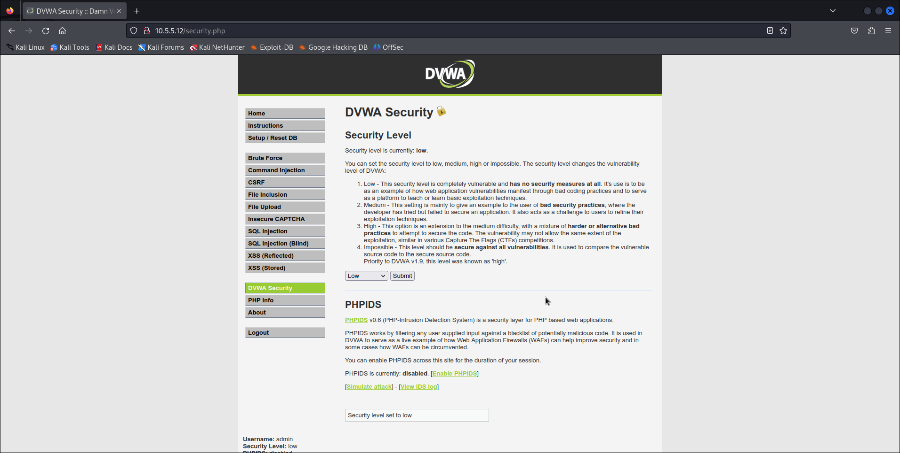
Step 2: determine which directories are viewable using a web browser and URL manipulation.
Perform reconnaissance on the server to find directories where indexing was found.
Run Nikto: Nikto will specifically report "Directory indexing found" for vulnerable directories
Run Dirb simultaneously: It will discover hidden or unlinked files and directories on a web server
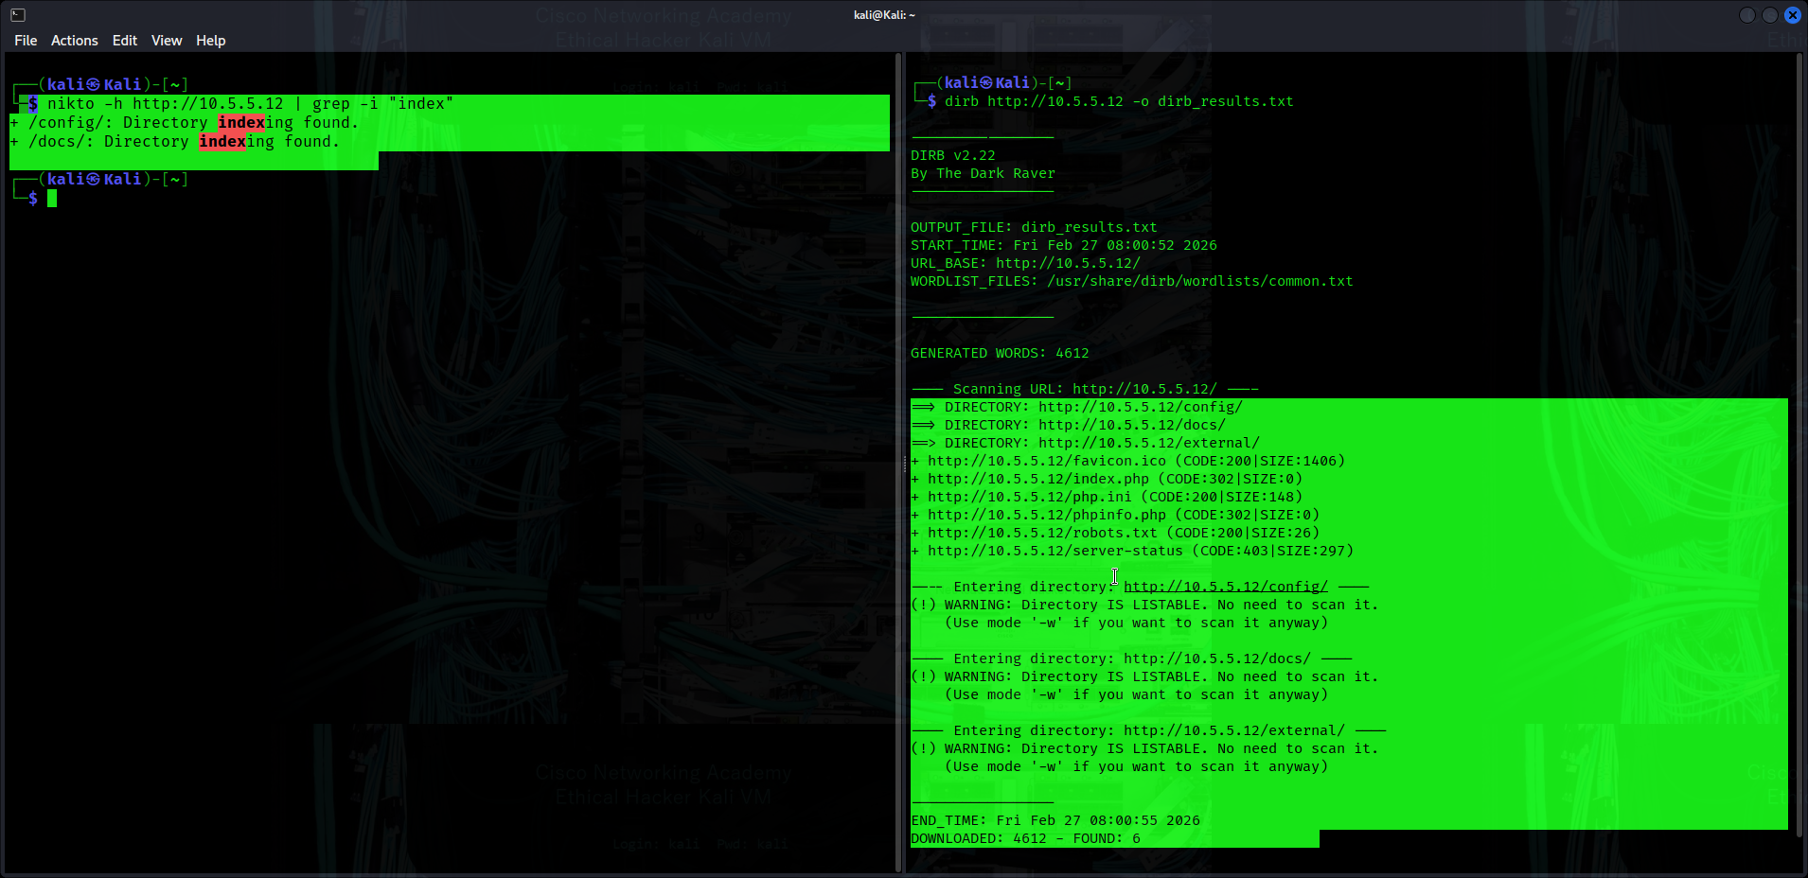
Common discoveries included /docs and /config directories often containing documentation or configuration artifacts.

Open the directories in the web browser to see the existing files
/docs contains:
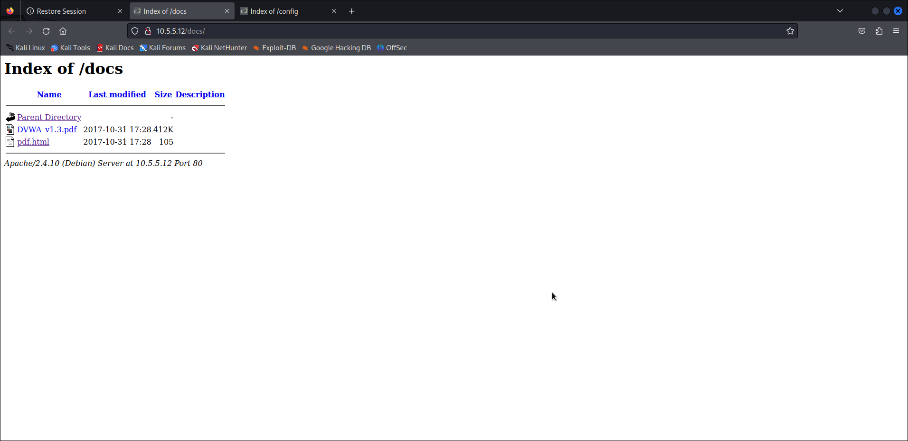
The /config contains
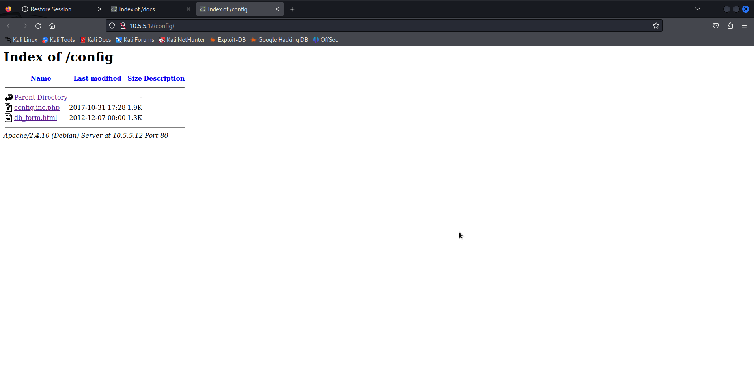
Navigate through all the files in the directories to find the flag location:
The flag was contained in the: http://10.5.5.12/config/db_form.html
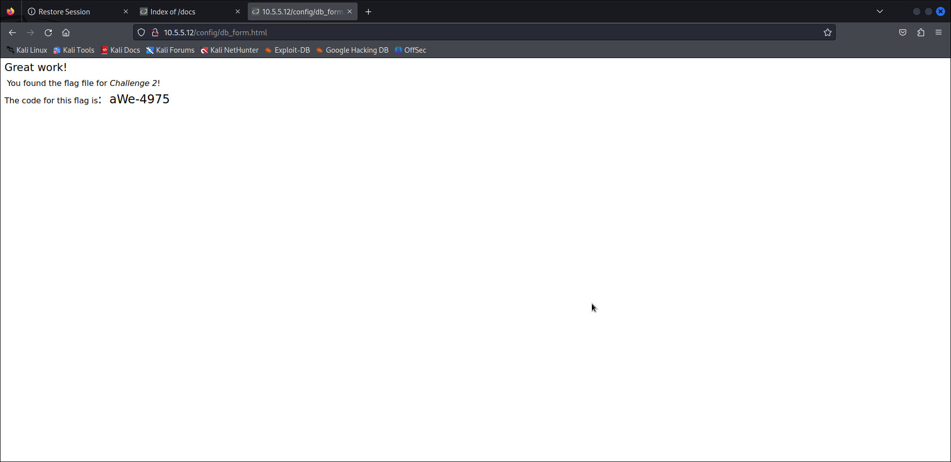
In which two subdirectories can you look for the file? /docs and /config
What is the filename with the Challenge 2 code? db_form.html
Which subdirectory held the file? Config
What is the message contained in the flag file? Enter the code that you find in the file. aWe-4975

Step 4: Research and propose directory listing exploit remediation.
What are two remediation methods for preventing directory listing exploits?
- Disable Directory Listing/Browsing: Modify the web server configuration file (e.g., .htaccess for Apache or web.config for IIS) to turn off the indexing feature, which prevents the server from generating a listing of files.
- Add Default Index Files: Place a blank index.html, index.php, or similar file into all directories within the web root. If a user requests a directory, the server will serve this file instead of listing its contents.
- Move Sensitive Data Outside Web Root: Ensure sensitive, non-public files are stored outside the public web root directory, making them unreachable by browsing.
- Configure Access Controls: Use Access Control Lists (ACLs) to restrict access to specific directories and files.

Challenge 3: Exploit open SMB Server Shares
Total points: 25
In this part, you want to discover if there are any unsecured shared directories located on an SMB server in the 10.5.5.0/24 network.
Target Network: 10.5.5.0/24
Protocol: SMB (Server Message Block)
Goal: Find unsecured/open shared directories and locate the flag file
Key Questions to Think About:
Which hosts are existing?
Which shares are open anonymously?
Which shares require credentials?
Where is the flag likely hidden?

Step 1: Scan for potential targets running SMB.
Run a service discovery scan with Nmap: nmap -sV 10.5.5.0/24
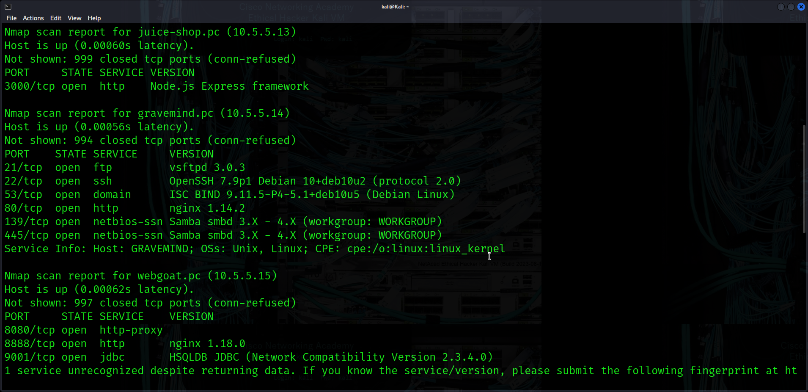
The scan reveals open ports including ports 139 and 445 indicating SMB file-sharing services.

Step 2: Determine which SMB directories are shared and can be accessed by anonymous users.
Use enum4linux and smbclient to list shares and test anonymous access. For target: 10.5.5.14 that we found with Open SMB ports.
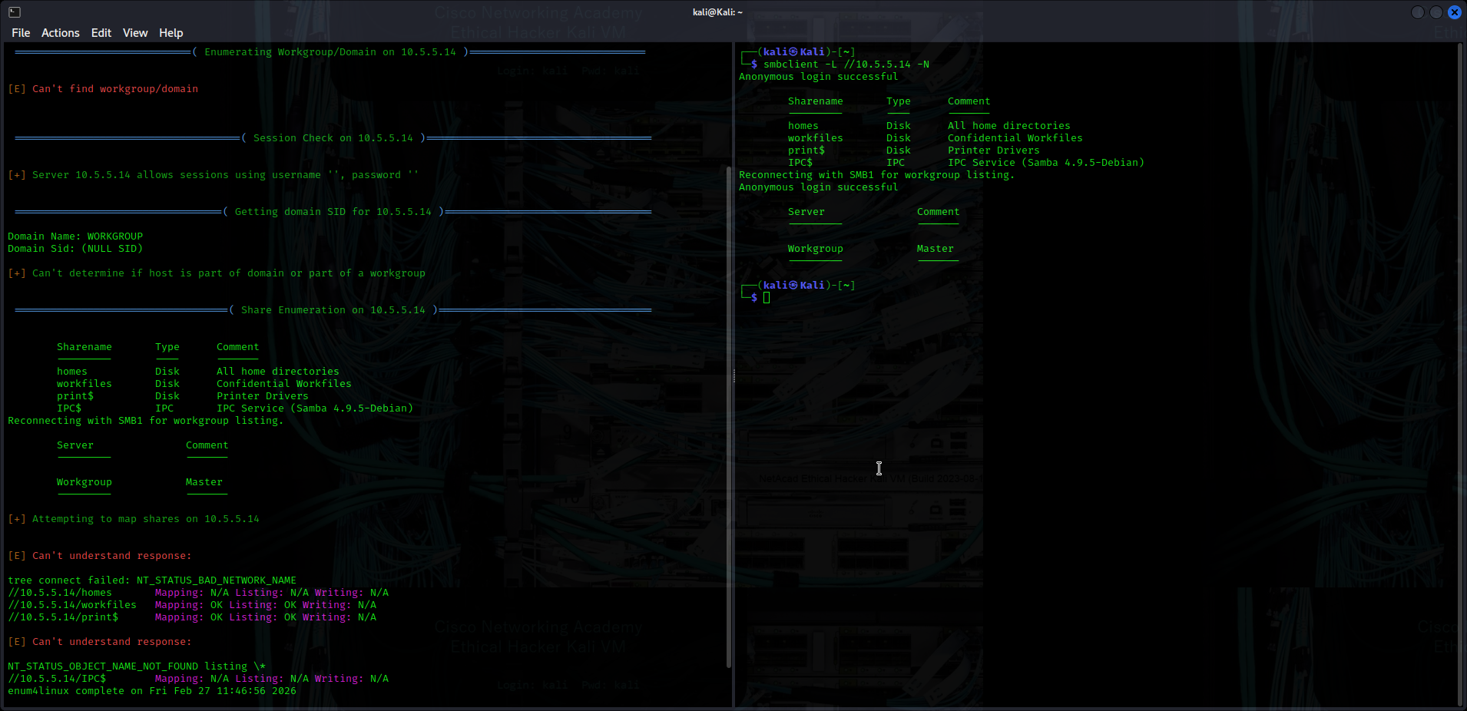
Step 3: Investigate each shared directory to find the file.
Connect to the share with smbclient //<target IP>/<share> -N and navigate using ls, cd, and get.
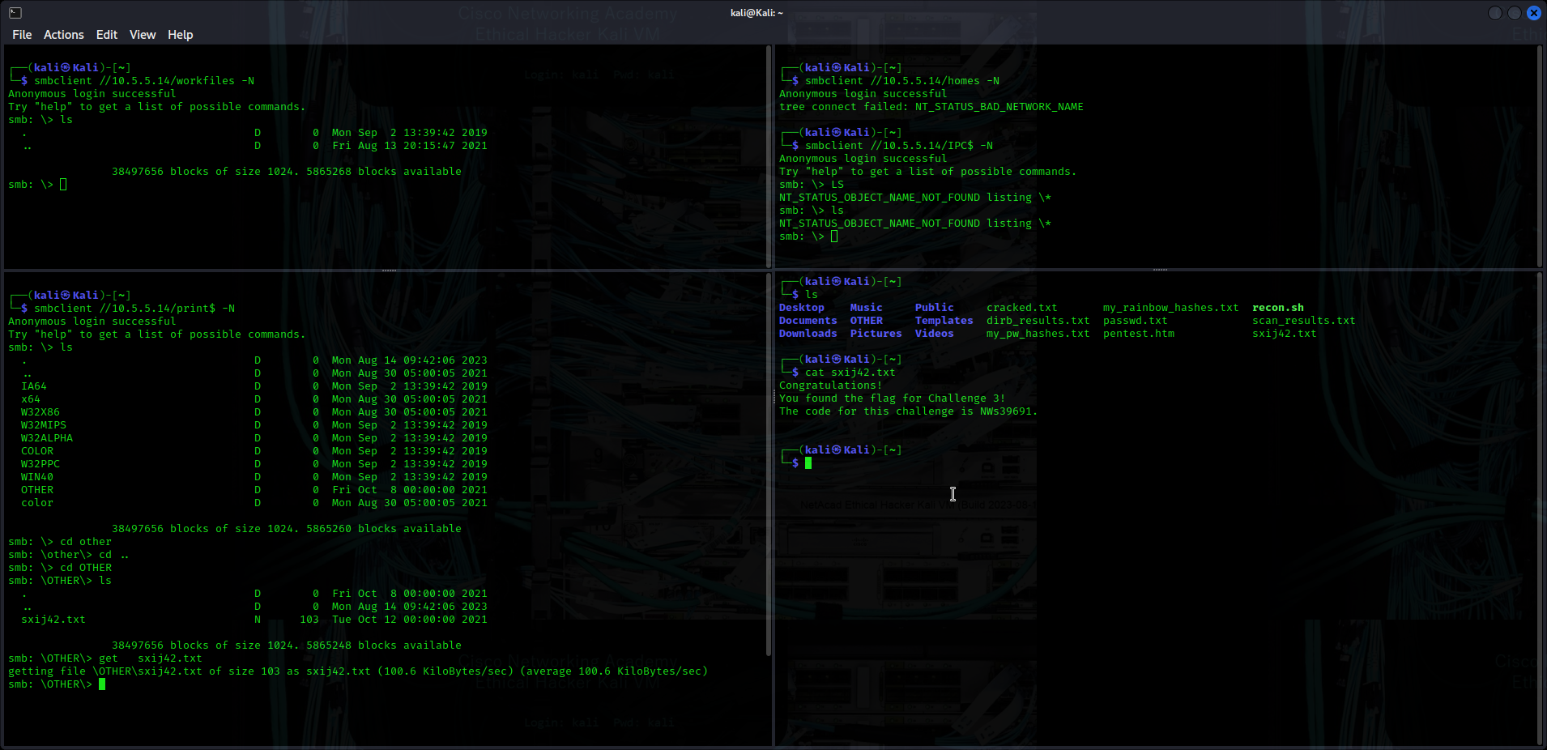
We were able to locate the flag in the print$ shared folder and extracted the .txt file to read it’s contents as shown above.
In which share is the file found? print$
What is the name of the file with Challenge 3 code? sxij42.txt
Enter the code for Challenge 3 below: NWs39691

Step 4: Research and propose SMB attack remediation.
- Disable Anonymous/Guest Access and Implement Proper Authentication: Restrict SMB shares from allowing null sessions or anonymous guest access.
- Firewall — Block SMB Ports — Block ports 139 and 445 using UFW or iptables to prevent unauthorized external SMB connections

Challenge 4: Analyze a PCAP File to Find Information.
Total Points: 25
As part of your reconnaissance effort, your team captured traffic using Wireshark. The capture file, SA.pcap, is located in the Downloads subdirectory within the kali user home directory.
Information
File: SA.pcap
Location: /home/kali/Downloads/SA.pcap
Tools: wireshark
Goal: analyze captured traffic to solve the challenge
Key Questions to Think About:
What protocols are in the capture?
Are there any credentials in plaintext?
Are there any suspicious packets?
What conversations took place?

Step 1: Find and analyze the SA.pcap file.
Analyze the content of the PCAP file to determine the IP address of the target computer and the URL location of the file with the Challenge 4 code.
Confirm the file exists
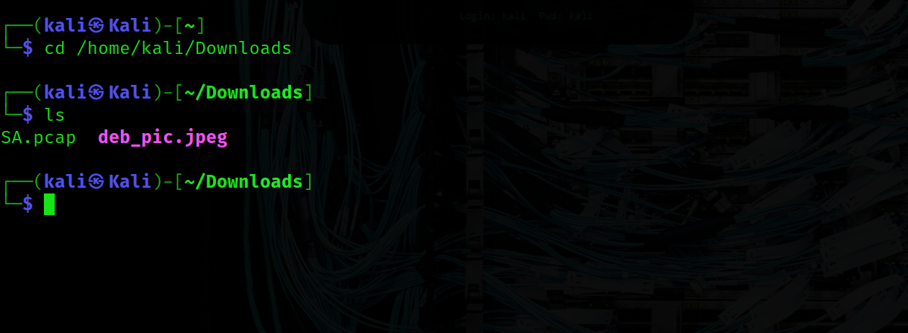
Open in wireshark: wireshark SA.pcap
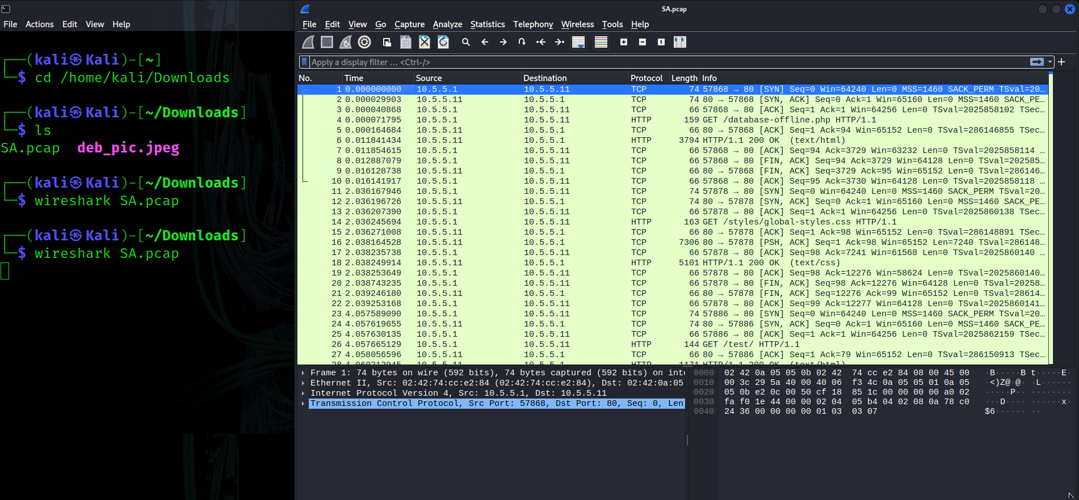
Inspect HTTP requests or follow TCP streams to identify URLs and file paths transmitted in plain text.
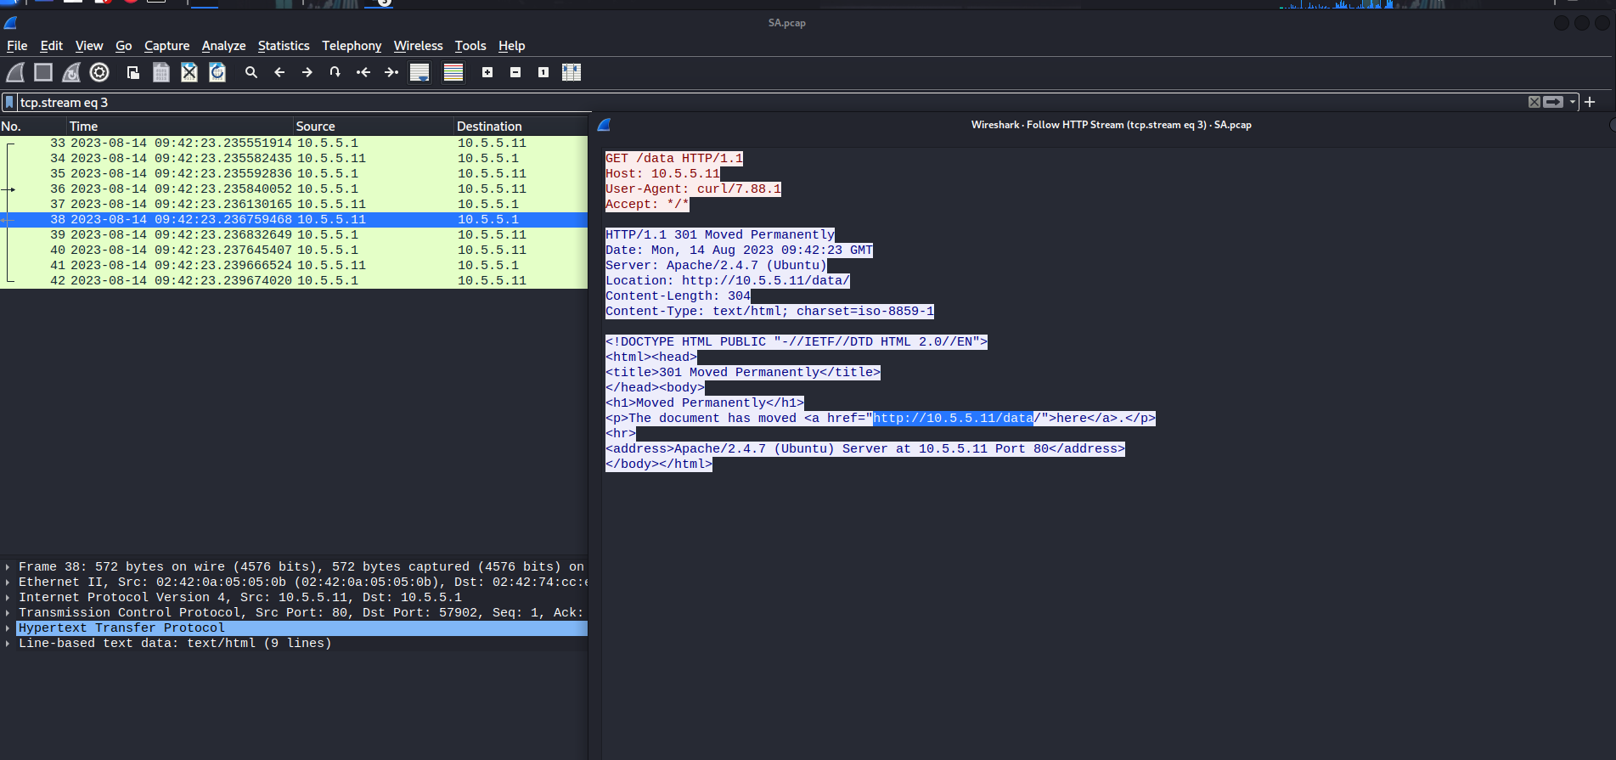
Step 3: Use a browser to access the recovered path.
Path: http://10.5.5.11/data
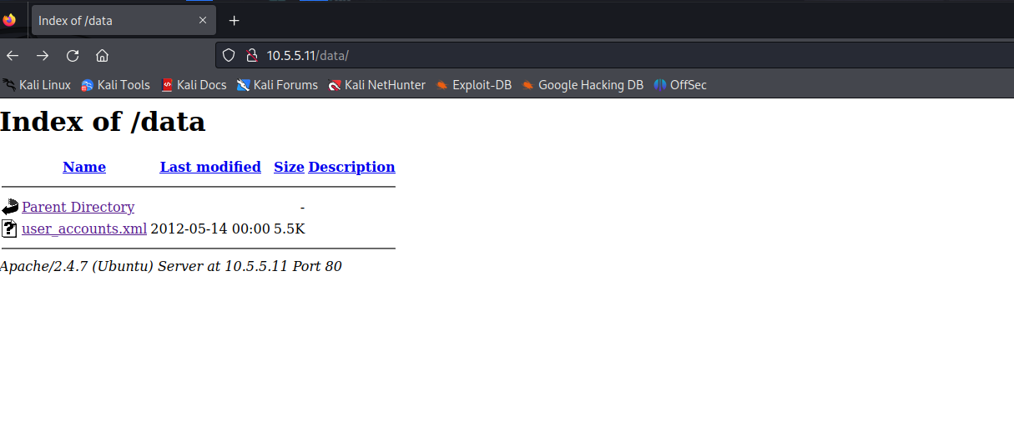
The directory listing contained user_accounts.xml, which held the required information.
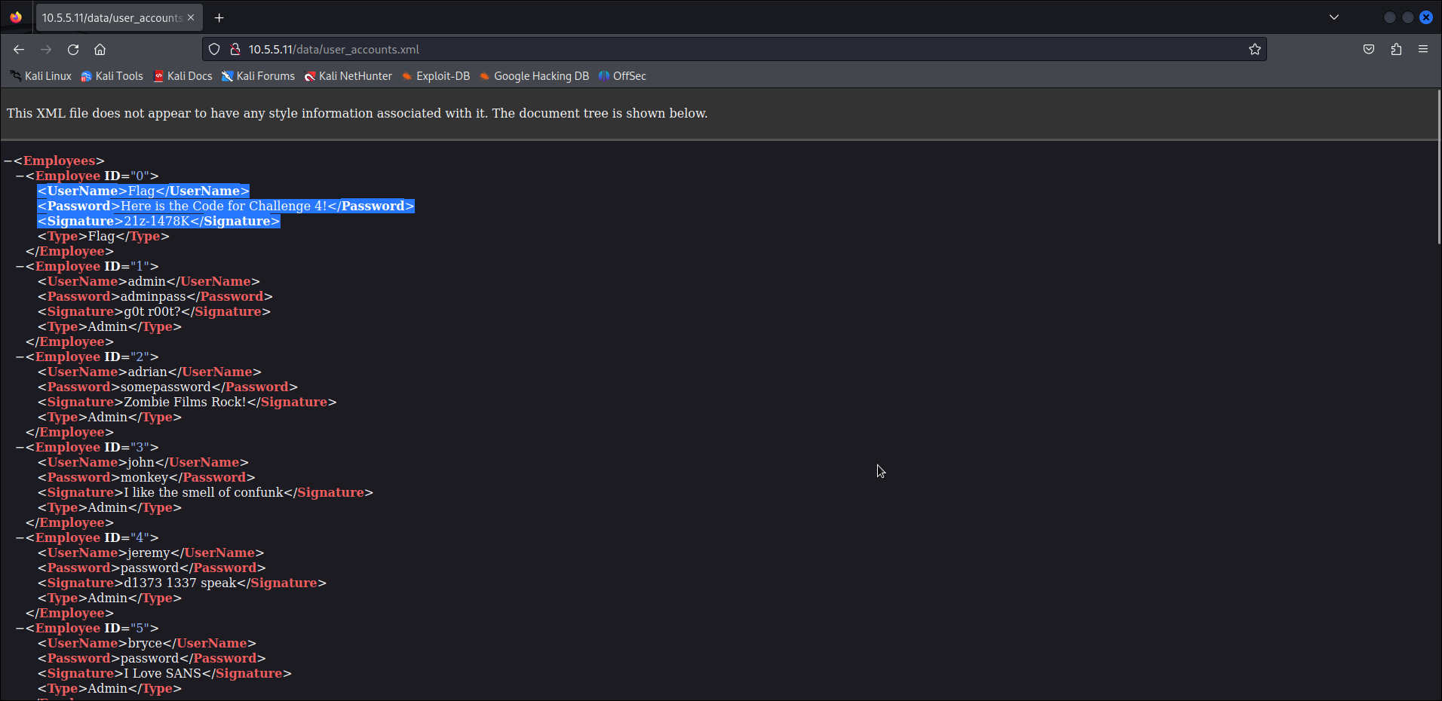
What is the IP address of the target computer? 10.5.5.11
What directories on the target are revealed in the PCAP? Data
What is the URL of the file? http://10.5.5.11/data/user_accounts.xml
What is the content of the file? Employees info: ID, usernames, passwords signatures and types
What is the code for Challenge 4? 21z-1478K

Step 3: Research and propose remediation that would prevent file content from being transmitted in clear text.

Implement Transport Layer Security (TLS): TLS uses a combination of asymmetric and symmetric cryptography to create a secure "tunnel." Before any data is sent, the client and server perform a "handshake" to verify identities and exchange session keys.
- End-to-End File-Level Encryption: The sender encrypts the file locally using a strong algorithm before it is ever uploaded or transmitted. The recipient must possess the corresponding decryption key to view the content.

