Lab - Recommend Remediation Based on Findings

Objectives
In this lab, you will complete the following objectives:
- Identify and prioritize vulnerabilities found on the DVWA server.
- Research and recommend mitigation strategies.

Background / Scenario
Your pentesting team scanned the server at 10.6.6.13 with Nikto and determined that vulnerabilities exist on the server. It is your responsibility to further investigate the findings and determine which mitigation recommendations need to be included in the pentest report.

Required Resources
- Kali VM customized for the Ethical Hacker course
- Internet access

Instructions

Part 1: Identify and Prioritize Vulnerabilities Found on the DVWA Server

Step 1: Scan a vulnerable host with Nikto and create a report.
Run a quick scan of the DVWA server using Nikto and output the results to an HTM file. A number of vulnerabilities were discovered.
nikto -h 10.6.6.13 -o pentest.htm
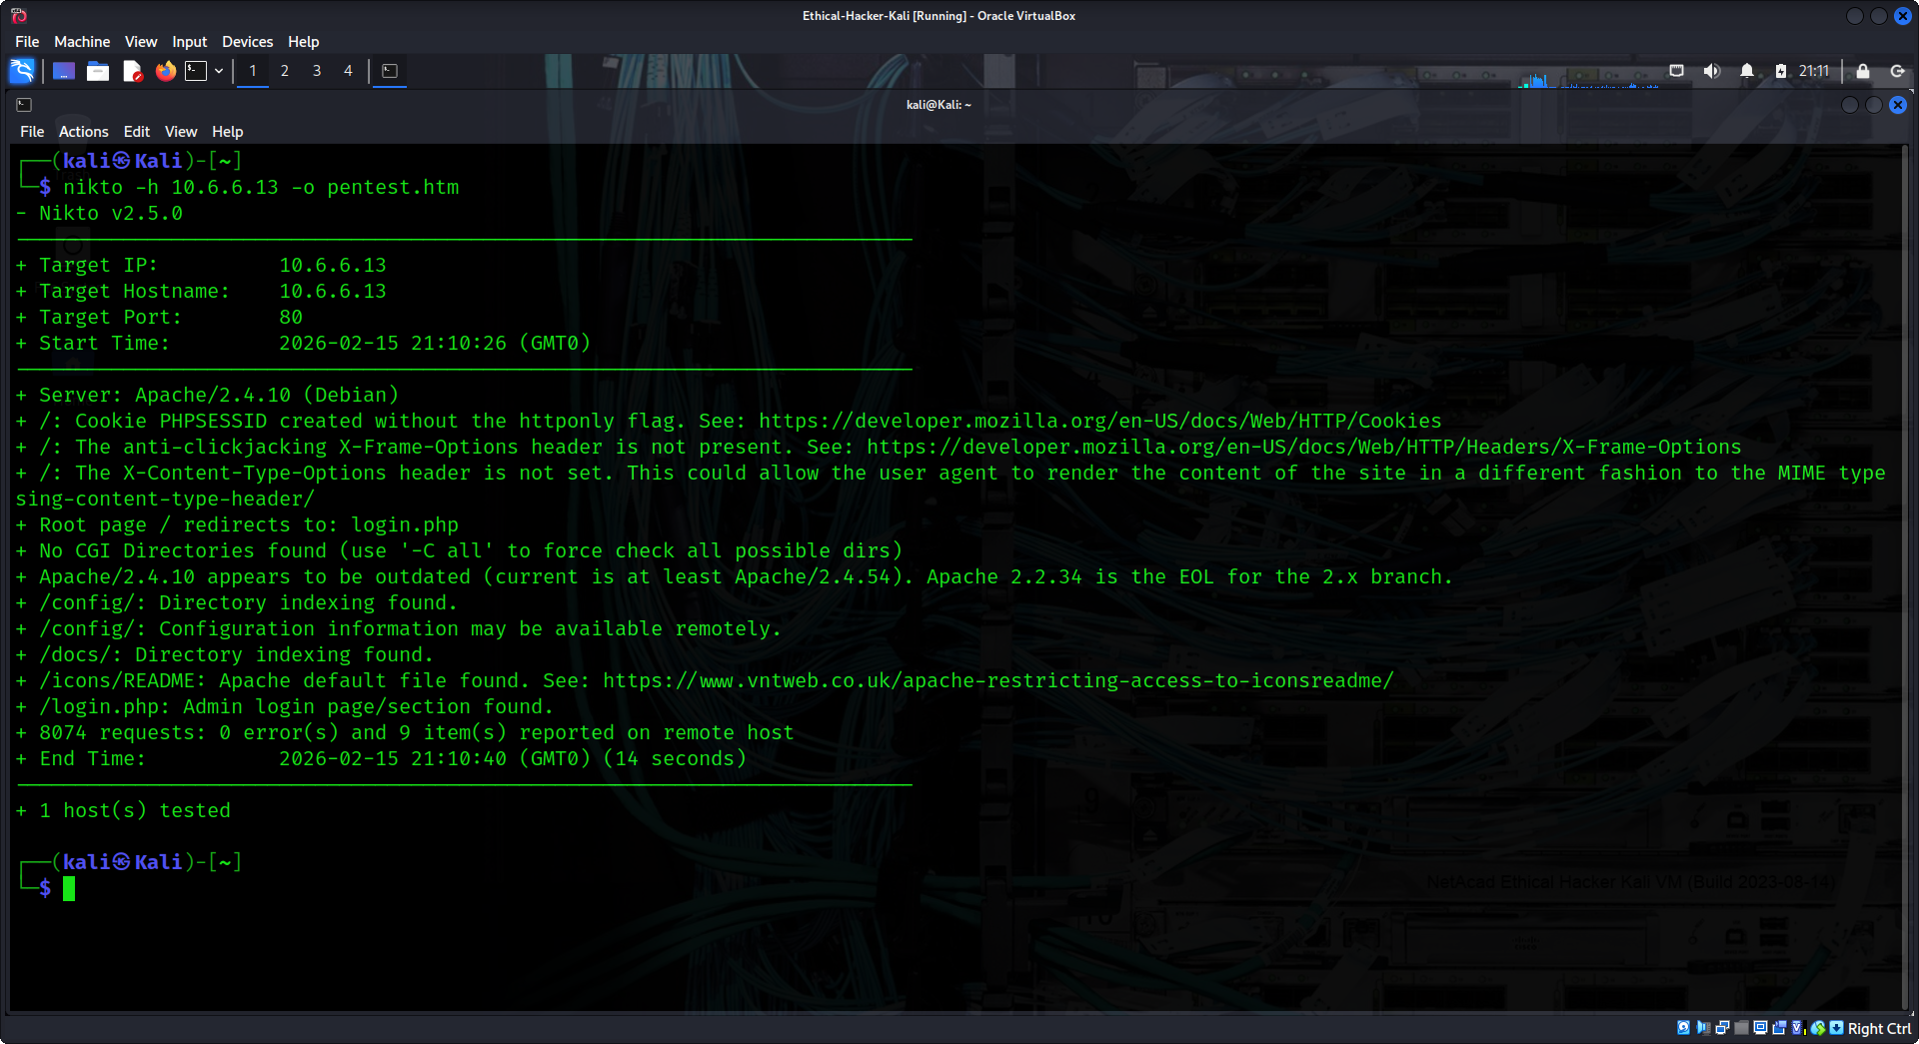
You can use this report to investigate vulnerabilities that were found on the target.

Step 2: Perform a detail scan using GVM to further investigate the vulnerabilities on the server.
- Start the GVM Dashboard to scan the DVWA server.
- When the Firefox browser opens, login with the username admin and the password of kali.
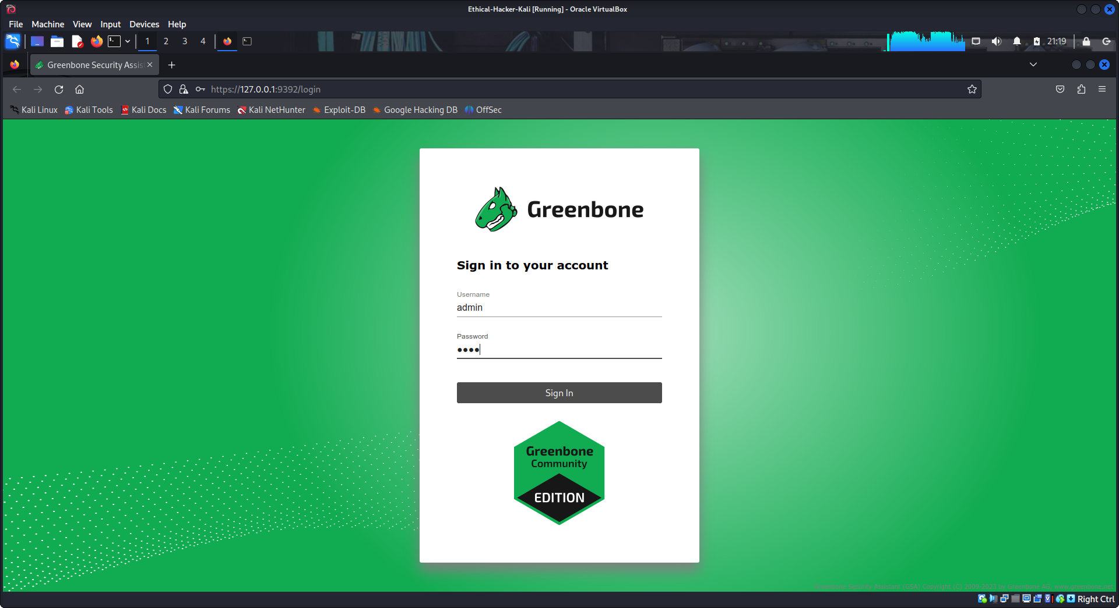
- Start a new task using the Task Wizard by clicking Scans from the menu bar and then selecting the Task Wizard from the magic wand icon on the top left of the scan window.
Enter the IP address 10.6.6.13 in the IP address or hostname field. Click Start Scan.
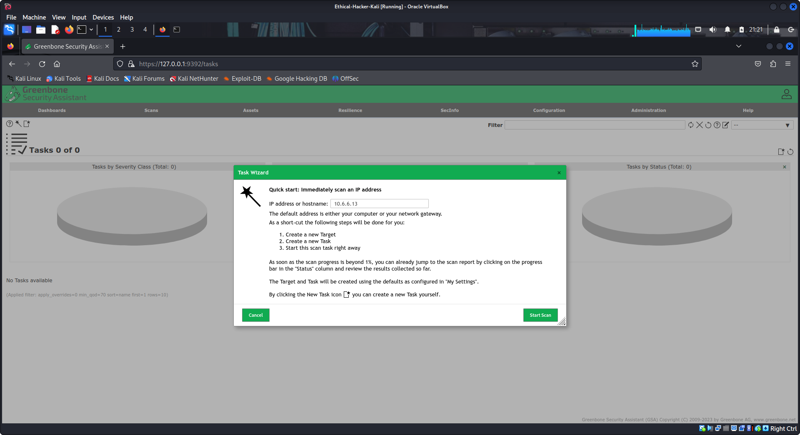
The scan may take a few minutes, the status bar next to the scan name indicates the percent completed.
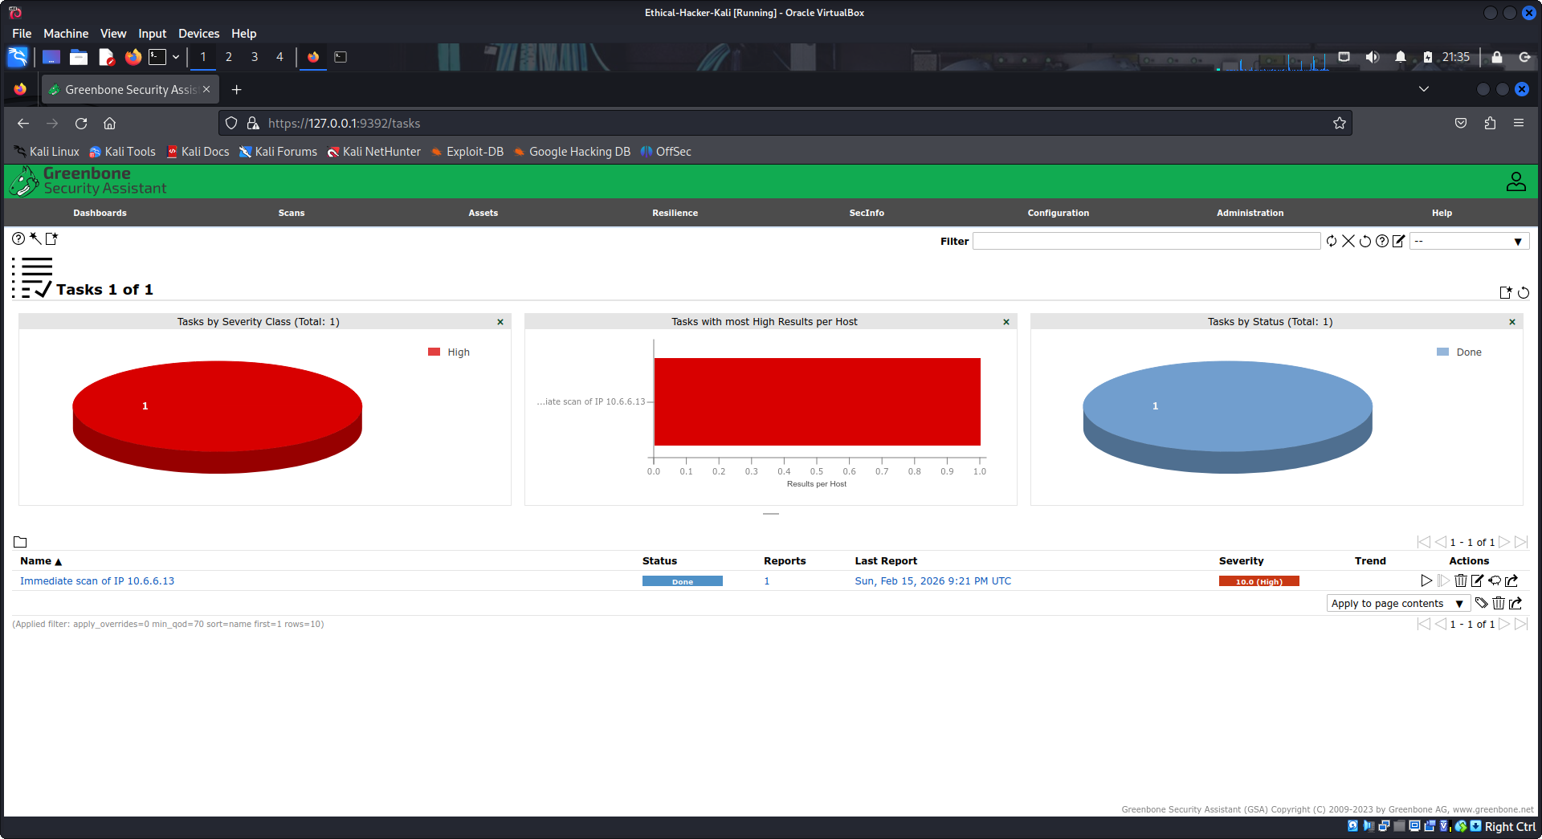
Step 3: Research the risks associated with each vulnerability.
- When the GVM scan completes, go to the Scans menu and select Reports. You should see the report for your last scan listed there.
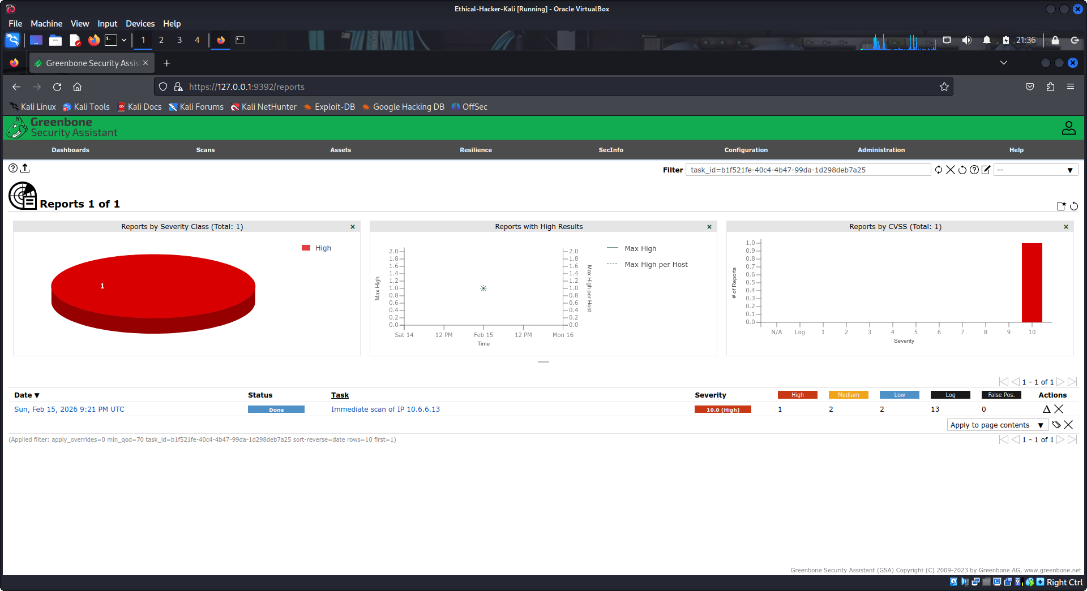
- Click the date and time entry for the task to view the report. Click the Results tab to view the results of your scan.
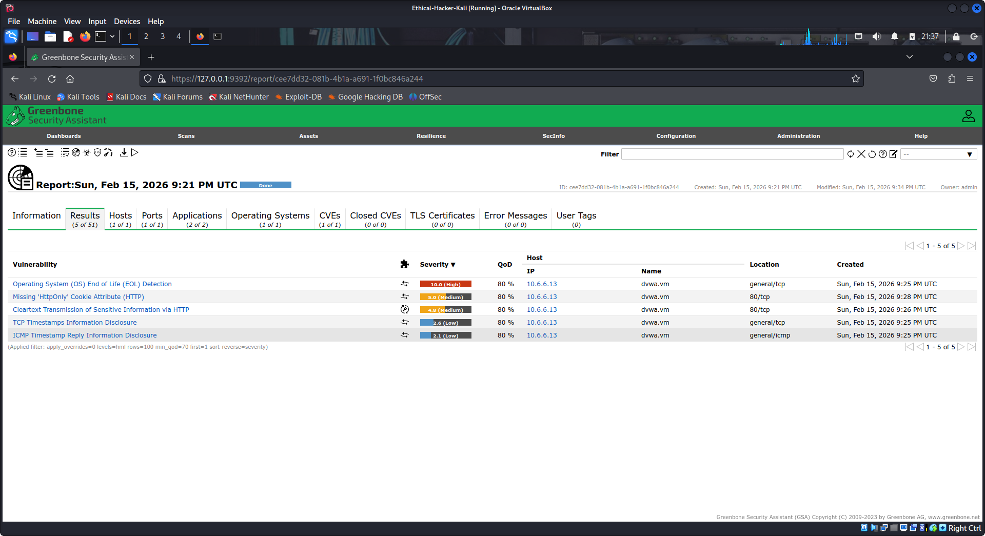
- Click each vulnerability that was found to display the detailed information about the risks associated with the vulnerability.
- Open the Nikto pentest.htm scan report file that was created in Step 1.
- Use internet resources to further research the vulnerabilities that were discovered using Nikto and GVM. Fill in the table with the information that you found. Based on your research, assign a priority to mitigation efforts.
- Priority 1 vulnerabilities should be fixed immediately.
- Priority 2 vulnerabilities should be fixed but are less likely or more difficult to exploit.
- Priority 3 vulnerabilities are low risk and unlikely to be exploited.
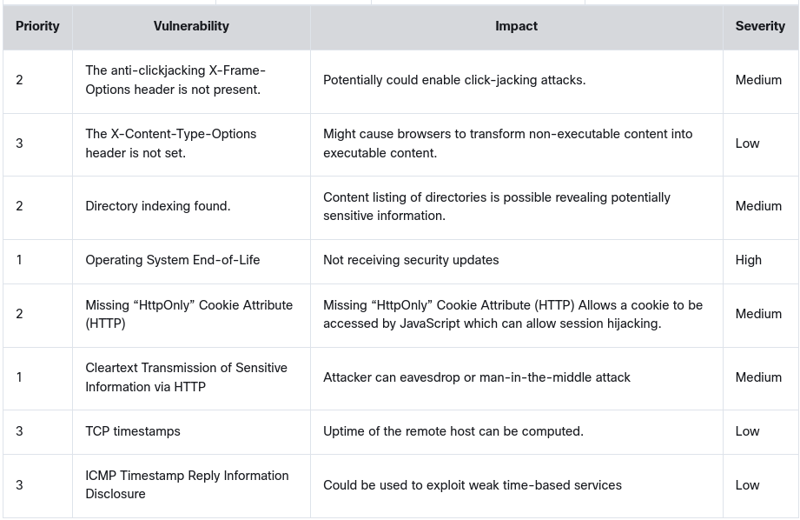
Part 2: Research and Recommend Mitigation Strategies
At the end of a penetration testing project, a report or series of reports are created to inform the stakeholders of the test results. One of the main components of the report is the suggested fixes to mitigate, or work-around, the identified vulnerabilities. In this part, you will research each of the critical vulnerabilities and identify the necessary remediation.
For each of the listed vulnerabilities, describe a suggested fix or mitigation strategy.
What is your suggested fix for the Operating System End-of-Life vulnerability? Update to the current supported version of the operating system and plan a means of keeping the OS up to date in the future.
What is your suggested fix for the Directory indexing found vulnerability? Add a blank index page in each web-accessible directory or disable the feature in the web server configuration file.
What is your suggested fix for the Cleartext Transmission of Sensitive Information via HTTP vulnerability? Use encryption protocols such as SSL/TLS or HTTPS to ensure data is encrypted in transit.
What is your suggested fix for the Missing “HttpOnly” Cookie Attribute (HTTP) vulnerability? Tag cookies with the HttpOnly flag which tells the browser that this particular cookie should only be accessed by the server.
What is your suggested fix for the anti-clickjacking X-Frame-Options header is not present vulnerability? Send the proper X-Frame-Options in HTTP response headers that instruct the browser to not allow framing from other domains. Employ defensive code in the UI to ensure that the current frame is the most top level window.
Why is it important to use multiple methods to find vulnerabilities and misconfigurations in web servers? Because not all vulnerability scanners use the same methodologies to uncover vulnerabilities. To get the most complete view of the device, it can be necessary to use multiple scanning tools.

