Cloud, Mobile, and IoT Security
7.1. Researching Attack Vectors and Performing Attacks on Cloud Technologies
Advantages of using a cloud-based service:
- Distributed storage
- Scalability
- Resource pooling
- Access from any location
- Measured service
- Automated management
Characteristics of cloud computing:
- On-demand self-service
- Broad network access
- Resource pooling
- Rapid elasticity
- Measured service
Cloud deployment models:
- Public cloud: Open for public use
- Private cloud: Used just by the client organization on premises or at a dedicated area in a cloud provider
- Community cloud: Shared between several organizations
- Hybrid cloud: Composed of two or more clouds (including on-prem services)
Cloud computing can be broken into the following three basic models:
IaaS is a cloud solution in which you rent infrastructure. You purchase virtual power to execute your software as needed. This is much like running a virtual server on your own equipment, except that you run a virtual server on a virtual disk. IaaS is similar to a utility company model in that you pay for what you use.
PaaS provides everything except applications. Services provided by this model include all phases of the systems development life cycle (SDLC) and can use application programming interfaces (APIs), website portals, or gateway software. These solutions tend to be proprietary, which can cause problems if the customer moves away from the provider’s platform.
SaaS is designed to provide a complete packaged solution. The software is rented out to the user. The service is usually provided through some type of front end or web portal. While the end user is free to use the service from anywhere, the company pays a per-use fee.
Attacks against cloud technologies :
- Credential harvesting
- Privilege escalation
- Account takeover
- Metadata service attacks
- Attacks against misconfigured cloud assets
- Resource exhaustion and denial-of-service (DoS) attacks
- Cloud malware injection attacks
- Side-channel attacks
- Direct-to-origin attacks
7.1.3 Credential Harvesting
Credential harvesting/ password harvesting is the act of gathering and stealing valid usernames, passwords, tokens, PINs, and any other types of credentials through infrastructure breaches.
One of the most common ways that attackers perform credential harvesting is by using phishing and spear phishing emails with links that could redirect a user to a bogus site.
This is why it is so important to use multifactor authentication. However, in some cases, attackers could bypass multifactor authentication by redirecting the user to a malicious site and stealing a session cookie from the user’s browser.
Credential Harvesting Attack Using Social Engineering and Spear Phishing Emails
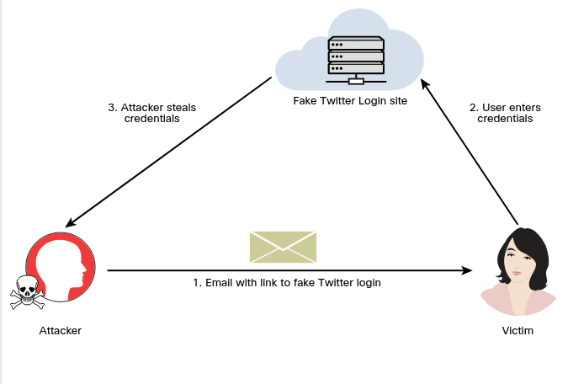
Perform a social engineering attack and instantiate a fake website (in this case, a fake Twitter login site) to perform a credential harvesting attack.
Launch SET by entering the setoolkit command in the root user: sudo setoolkit
Select 1) Social-Engineering Attacks from the main menu
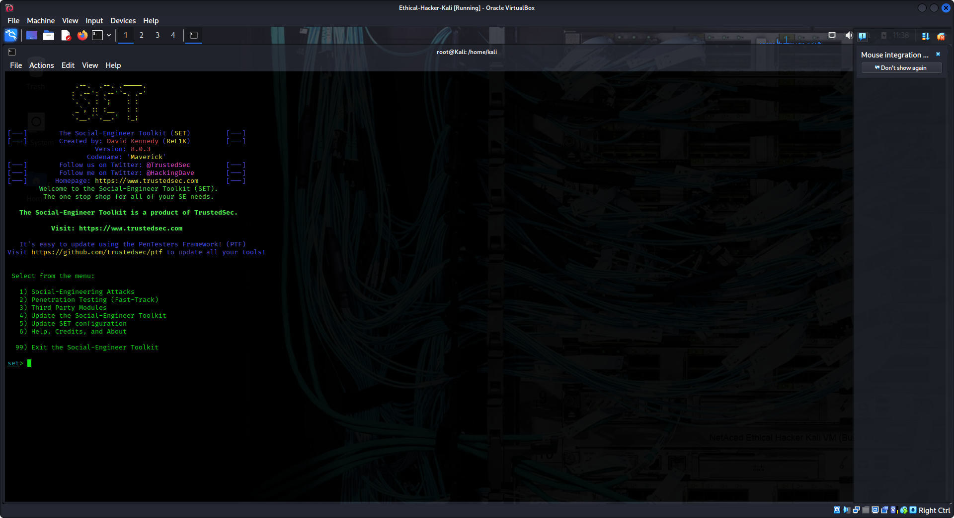
select 2) Website Attack Vectors.
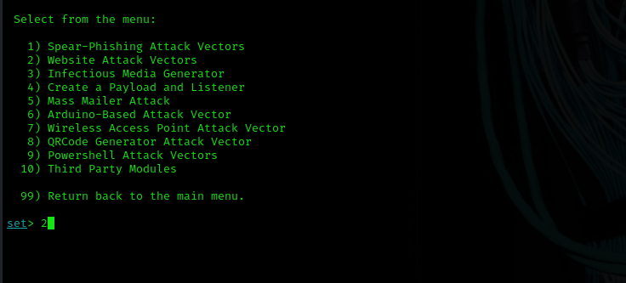
select 3) Credential Harvester Attack Method.
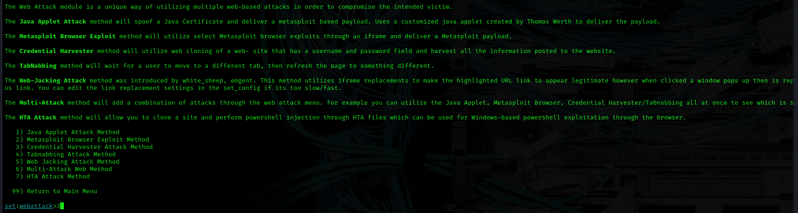
select 1) Web Templates to use a predefined web template (Twitter).
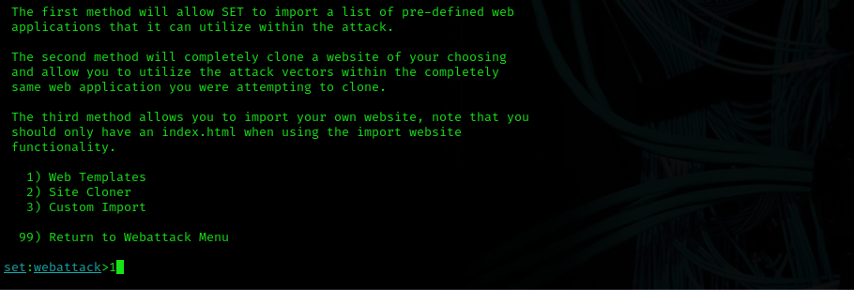
Enter the IP address of the host that you would like to use to harvest the user credentials (in this case, 10.0.2.15). In this example, SET has recognized the attacking system’s IP address. If this occurs for you, you can just press Enter to select the attacking system’s IP address.
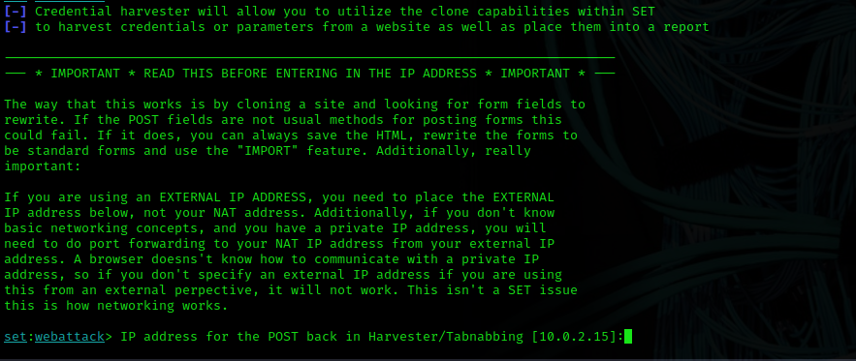
Select 3. Twitter
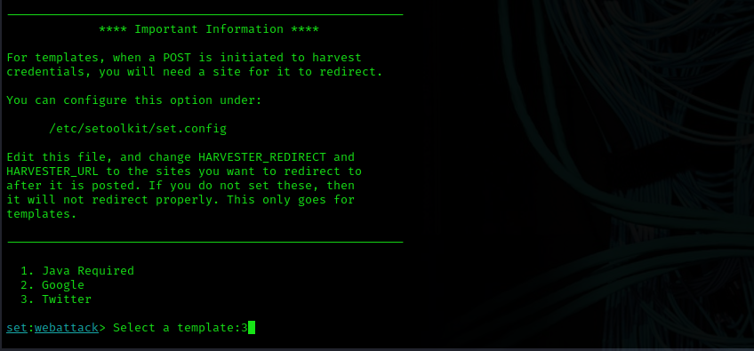
You can then redirect users to this fake Twitter site by sending a spear phishing email or taking advantage of web vulnerabilities such as cross-site scripting (XSS) and cross-site request forgery (CSRF).
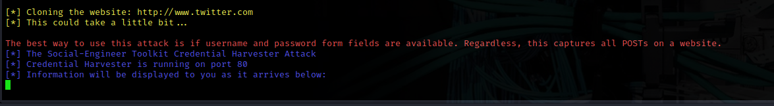
Figure below shows the fake Twitter login page, where the user enters their credentials.
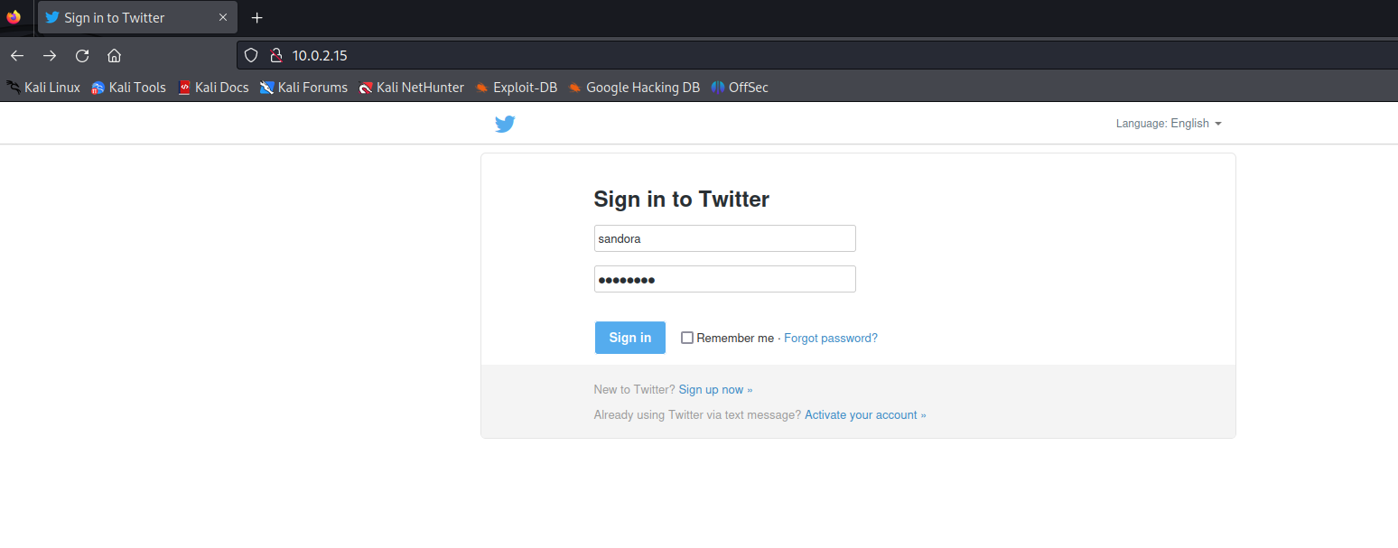
Example below shows how the attacking system harvests the user credentials. The username entered is sandora, and the password is sunny123. You can also see the session token.
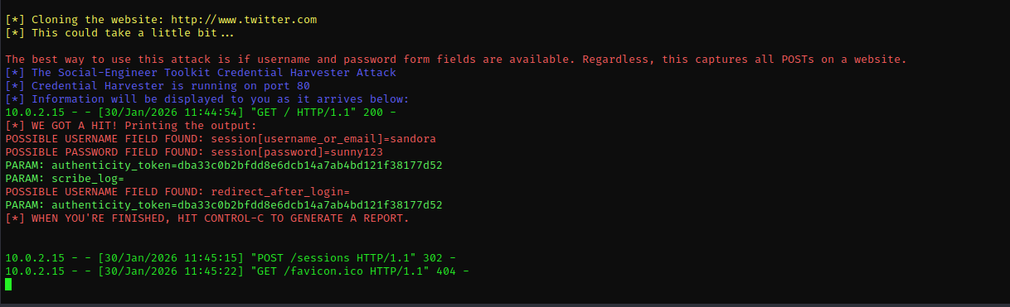
Attackers have been known to harvest cloud service provider credentials once they get into their victims’ systems. Different threat actors have extended their credential harvesting capabilities to target multiple cloud and non-cloud services in victims’ internal networks and systems after the exploitation of other vulnerabilities.
7.1.5 Privilege Escalation
Privilege escalation is the act of exploiting a bug or design flaw in a software or firmware application to gain access to resources that normally would have been protected from an application or a user.
This results in a user gaining additional privileges beyond what the application developer originally intended.
Types of privilege escalation:
Vertical Priviledge Escalation: This type of privilege escalation, also called privilege elevation, occurs when a lower-privileged user accesses functions reserved for higher-privileged users.
To protect against this situation, you should update the network device firmware. In the case of an operating system, it should again be updated. The use of some type of access control system; for example, User Account Control (UAC)–is also advisable.
Horizontal Priviledge Escalation: This type of privilege escalation occurs when a normal user accesses functions or content reserved for other normal users. This can be done through hacking or by a person walking over to someone else’s computer and simply reading their email. Always have your users lock their computer (or log off) when they are not physically at their desk.
7.1.6 Account Takeover
In an account takeover, the threat actor gains access to a user or application account and uses it to then gain access to more accounts and information. There are different ways that an account takeover can happen in the cloud. The impact that an account takeover has in the cloud can also be a bit different from the impact of an on-premises attack.
Some of the biggest differences are the organization’s ability to detect a cloud account takeover, find out what was impacted, and determine how to remediate and recover.
Ways to detect account takeover attacks:
Login location: The location of the user can clue you into a takeover. For instance, you may not do business in certain geographic locations and countries. You can prevent a user from logging in from IP addresses that reside in those locations. Keep in mind, however, that an attacker can easily use a VPN to bypass this restriction.
Failed login attempts: It is now fairly easy to detect and block failed login attempts from a user or an attacker.
Lateral phishing attempts: These are phishing emails that originate from an account that has already been compromised by the attacker.
Malicious Oauth, SAML or OpenID Connect connections: An attacker could create a fake application that could require read, write, and send permissions for email SaaS offerings such as Office 365 and Gmail. Once the application is granted permission by the user to “connect” and authenticate to these services, the attacker could manipulate it.
Abnormal file sharing and downloading: You might suspect an account takeover attack if you notice that a particular user is suddenly sharing or downloading a large number of files.
7.1.8 Attacks Against Misconfigured Cloud Assets
IAM Implementations: IAM solutions are used to administer user and application authentication and authorization. Key IAM features include SSO, multifactor authentication, and user provisioning and life cycle management. If an attacker is able to manipulate a cloud-based IAM solution in an IaaS or PaaS environment, it could be catastrophic for the cloud consumer.
Federation misconfigurations: Federated authentication or federated identity is a method of associating a user’s identity across different identity management systems.
Object storage: Insecure permission configurations for cloud object storage services, such as Amazon’s AWS S3 buckets, are often the cause of data breaches.
Containerization technologies: Attacks against container-based deployments (such as Docker, Rocket, LXC, and containerd) have led to massive data breaches.
For instance, you can passively obtain information from Shodan (shodan.io) or run active recon scans to find cloud deployments widely exposing the Docker daemon or Kubernetes elements to the Internet. Often attackers use stolen credentials or known vulnerabilities to compromise cloud-based applications. Similarly, attackers use methods such as typosquatting to create malicious containers and post them in Docker Hub. This attack, which can be considered a supply chain attack, can be very effective. You could, for example, download the base image for NGINX or Apache HTTPd from Docker Hub, and that Docker image might include a backdoor that the attacker can use to manipulate your applications and underlying systems.
Typosquatting is a technique that leverages human error when typing URLs in a web browser or accessing other resources.
7.1.9 Resource Exhaustion and DoS Attacks
One of the benefits of leveraging cloud services is the distributed and resilient architecture that most leading cloud providers offer. This architecture helps minimize the impact of a DoS or distributed denial-of-service (DDoS) attack compared to what it would be if you were hosting your application on premises in your data center.
On the other hand, in recent years, the volume of bits per second (bps), packets per second (pps), and HTTP(s) requests per second (rps) have increased significantly.
Often attackers use botnets of numerous compromised laptops and desktop systems and compromise mobile, IoT, and cloud-based systems to launch these attacks.
The Figure below illustrates the key metrics used to identify volumetric DDoS attacks.
DDoS Attack Metrics
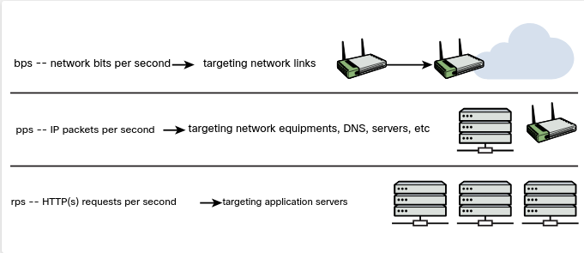
Attackers can launch more strategic DoS attacks against applications hosted in the cloud that could lead to resource exhaustion.
For example, they can leverage a single-packet DoS vulnerability in network equipment used in cloud environments, or they can leverage tools to generate crafted packets to cause an application to crash. For instance, you can search in Exploit Database (exploit-db.com) for exploits that can be used to leverage “denial of service” vulnerabilities, where an attacker could just send a few packets and crash an application or the whole operating system.
Using the searchsploit to Search for Exploits
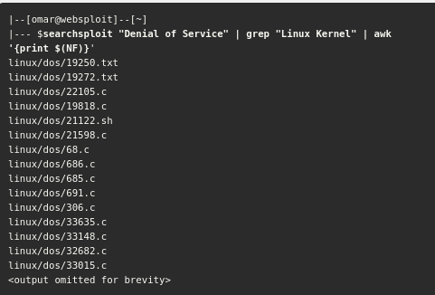
Another example of a DoS attack that can affect cloud environments is the direct-to-origin (D2O) attack. In a D2O attack, threat actors are able to reveal the origin network or IP address behind a content delivery network (CDN) or large proxy placed in front of web services in a cloud provider. A D2O attack could allow attackers to bypass different anti-DDoS mitigations.
A CDN is a geographically distributed network of proxies in data centers around the world that offers high availability and performance benefits by distributing web services to end users around the world.
7.1.10 Cloud Malware Injection Attacks
In a cloud malware injection attack, the attacker creates a malicious application and injects it into a SaaS, PaaS, or IaaS environment. Once the malware injection is completed, the malware is executed as one of the valid instances running in the cloud infrastructure. Subsequently, the attacker can leverage this foothold to launch additional attacks, such as covert channels, backdoors, eavesdropping, data manipulation, and data theft.
7.1.11 Side-Channel Attacks
Side-channel attacks are often based on information gained from the implementation of the underlying computer system or cloud environment instead of a specific weakness in the implemented technology or algorithm. For instance, different elements – such as computing timing information, power consumption, electromagnetic leaks, and even sound – can provide detailed information that can help an attacker compromise a system. The attacker aims to gather information from or influence an application or a system by measuring or exploiting indirect effects of the system or its hardware. Most side-channel attacks are used to exfiltrate credentials, cryptographic keys, and other sensitive information by measuring coincidental hardware emissions.
Side-channel attacks can be used against VMs and in cloud computing environments where a compromised system controlled by the attacker and target share the same physical hardware.
Examples of vulnerabilities that could lead to side-channel attacks: the Spectre and Meltdown vulnerabilities affecting Intel, AMD, and ARM processors. Cloud providers that use Intel CPUs in their virtualized solutions could be affected by these vulnerabilities if they do not apply the appropriate patches.
7.1.13 Tools and Software Development Kits (SDKs)
Software development kits (SDKs) and cloud development kits (CDKs) can provide great insights about cloud-hosted applications, as well as the underlying infrastructure.
An SDK is a collection of tools and resources to help with the creation of applications (on premises or in the cloud). SDKs often include compilers, debuggers, and other software frameworks.
CDKs, help software developers and cloud consumers deploy applications in the cloud and use the resources that the cloud provider offers. For example, the AWS Cloud Development Kit (AWS CDK) is an open-source software development framework that cloud consumers and AWS customers use to define cloud application resources using familiar programming languages.
7.2. Explaining Common Attacks and Vulnerabilities Against Specialized Systems
7.2.2 Attacking Mobile Devices
Common mobile device attacks:
Reverse Engineering: The process of analyzing the compiled mobile app to extract information about its source code could be used to understand the underlying architecture of a mobile application and potentially manipulate the mobile device. Attackers use reverse engineering techniques to compromise the mobile device operating system (for example, Android, Apple iOS) and root or jailbreak mobile devices.
Sandbox Analysis: iOS and Android apps are isolated from each other via sandbox environments. Sandboxes in mobile devices are a mandatory access control mechanism describing the resources that a mobile app can and can’t access. Android and iOS provide different interprocess communication (IPC) options for mobile applications to communicate with the underlying operating system. An attacker could perform detailed analysis of the sandbox implementation in a mobile device to potentially bypass the access control mechanisms implemented by Google (Android) or Apple (iOS), as well as mobile app developers.
Spamming Unsolicited messages are a problem with email and with text messages and other mobile messaging applications as well. In such an attack, a user may be presented with links that could redirect to malicious sites to steal sensitive information or install malware.
Prevalent vulnerabilities affecting mobile devices:
Insecure storage: save as little sensitive data as possible in a mobile device’s permanent local storage. Android and iOS provide secure storage APIs that allow mobile app developers to use the cryptographic hardware available on the mobile platform. If these resources are used correctly, sensitive data and files can be secured via hardware-based strong encryption.
Passcode Vulnerabilities and biometric intergrations: Android and iOS provide different methods for integrating local authentication into mobile applications. Vulnerabilities in these integrations could lead to sensitive data exposure and full compromise of the mobile device. Attacks such as the objection biometric bypass attack can be used to bypass local authentication in iOS and Android devices.
Certificate pinning: Attackers use certificate pinning to associate a mobile app with a particular digital certificate of a server. The purpose is to avoid accepting any certificate signed by a trusted certificate authority (CA). The idea is to force the mobile app to store the server certificate or public key and subsequently establish connections only to the trusted/known server. The goal of certificate pinning is to reduce the attack surface by removing the trust in external CAs. There have been many incidents in which CAs have been compromised or tricked into issuing certificates to impostors. Attackers have tried to bypass certificate pinning by jailbreaking mobile devices and using utilities such as SSL Kill Switch 2 or Burp Suite Mobile Assistant app or by using binary patching and replacing the digital certificate.
Using unkwonwn vulnerable components: Attackers may leverage known vulnerabilities against the underlying mobile operating system, or dependency vulnerabilities. Attackers may leverage known vulnerabilities against the underlying mobile operating system, or dependency vulnerabilities
Execution of activities using root and over-reach of permissions: Application developers must practice the least privilege concept. That is, they should not allow mobile applications to run as root and should give them only the access they need to perform their tasks.
Business logic vulnerabilities: An attacker can use legitimate transactions and flows of an application in a way that results in a negative behavior or outcome. Most common business logic problems are different from the typical security vulnerabilities in applications (such as XSS, CSRF, and SQL injection). A challenge with business logic flaws is that they can’t typically be found by using scanners or any other similar tools.
Tools most commonly used to perform security research and test the security posture of mobile devices:
Burp Suite: can be used to test mobile applications and determine how they communicate with web services and APIs.
Drozer: ThisAndroid testing platform and framework provides access to numerous exploits that can be used to attack Android platforms.
Needle: This open-source framework is used to test the security of iOS applications.
MobSF(Mobile Security Framework): is an automated mobile application and malware analysis framework.
Postman: Postman is used to test and develop APIs.
Ettercap:This tool is used to perform on-path attacks.
Frida: is a dynamic instrumentation toolkit for security researchers and reverse engineers.
Objection: This runtime mobile platform and app exploration toolkit uses Frida behind the scenes. You can use Objection to bypass certificate pinning, dump keychains, perform memory analysis, and launch other mobile attacks.
Android SDK: You can use Android SDK tools to analyze and obtain detailed information about the Android environment.
ApkX: This tool enables you to decompile Android application package (APK) files.
APK Studio: You can use this tool to reverse engineer Android applications.
7.2.5 Attacking Internet of Things (IoT) Devices
IoT is an incredibly broad term that can be applied across personal devices, industrial control systems (ICS), transportation, and many other businesses and industries.
Designing and securing IoT systems and ICS, involves a lot of complexity.
Managing and orchestrating IoT systems introduces additional complexity due to disparate hardware and software, the use of legacy technologies, and, often, multiple vendors and integrators.
IoT platforms must integrate a wide range of IoT edge devices with varying device constraints and must be integrated to back-end business applications. In addition, no single solution on the market today can be deployed across all IoT scenarios.
A secure IoT platform should provide the complete end-to-end infrastructure to build an IoT solution, including the software, management, and security to effectively collect, transform, transport, and deliver data to provide business value.
7.2.6 Analyzing IoT Protocols
Analyzing IoT protocols is important for tasks such as reconnaissance as well as exploitation.
On the other hand, in the IoT world, you will frequently encounter custom, proprietary, or new network protocols.
Some of the most common network protocols for IoT implementations include the following:
- Wi-Fi
- Bluetooth and Bluetooth Low Energy (BLE)
- Zigbee
- Z-Wave
- LoraWAN
- Insteon
- Modbus
- Siemens S7comm (S7 Communication)
Bluetooth Low Energy (BLE) is used by IoT home devices, medical, industrial, and government equipment. You can analyze protocols such as BLE by using specialized antennas and equipment such as the Ubertooth One.
BLE involves a three-phase process to establish a connection:
Phase 1. Pairing feature exchange
Phase 2. Short-term key generation
Phase 3. Transport-specific key distribution
BLE implements a number of cryptographic functions. It supports AES for encryption and key distribution exchange to share different keys among the BLE-enabled devices. However, many devices that support BLE do not even implement the BLE-layer encryption. In addition, mobile apps cannot control the pairing, which is done at the operating system level.
Attackers can scan BLE devices or listen to BLE advertisements and leverage these misconfigurations. Then they can advertise clone/ fake BLE devices and perform on-path attacks.
In some cases, IoT proprietary or custom protocols can be challenging. Even if you can capture network traffic, packet analyzers like Wireshark often can’t identify what you’ve found. Sometimes, you need to write new tools to communicate with IoT devices.
7.2.8 IoT Security Special Considerations
Fragile Environment: Many IoT devices have limited compute resources. Because of this lack of resources, some security features, including encryption, may not even be supported in IoT devices.
Availability Concerns: DoS attacks against IoT systems are a major concern.
Data Corruption: IoT protocols are often susceptible to input validation vulnerabilities, as well as data corruption issues.
Data Exfiltration: IoT devices could be manipulated by an attacker and used for sensitive data exfiltration.
7.2.9 Common IoT Vulnerabilities
Insecure defaults: Default credentials and insecure default configurations are often concerns with IoT devices. For instance, if you do a search in Shodan.io for IoT devices, you will find hundreds of IoT devices with default credentials and insecure configurations exposed on the Internet.
Plaintext communication and data leakage: many IoT devices fail to implement encrypted communications, and an attacker could easily steal sensitive information. The leakage of sensitive information is always a concern with IoT devices.
Hard-coded configurations: Often IoT vendors sell their products with hard-coded insecure configurations or credentials.
Outdated firmware/ hardware and the use of insecure or outdated components: Many organizations continue to run outdated software and hardware in their IoT devices. In some cases, some of these devices are never updated! In some cases, these devices are never updated, and if you update them, you will have to send a crew to physically perform a software or hardware upgrade. IoT devices often lack a secure update mechanism.
7.2.11 Data Storage System Vulnerabilities
IoT architectures extend from IoT endpoint devices (things) to intermediary “fog” networks and cloud computing. Gateways and edge nodes are devices such as switches, routers, and computing platforms that act as intermediaries (“the fog layer”) between the endpoints and the higher layers of the IoT system.
IoT Architecture Layers
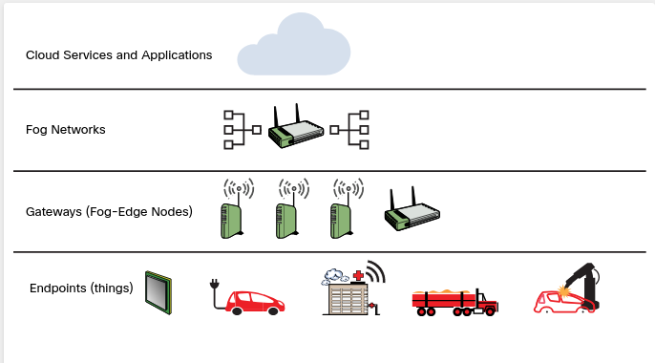
Misconfigurations in IoT on-premises and cloud-based solutions can lead to data theft.
Misconfigurations of IoT devices and cloud-based solutions.
Default/blank username&password: Hardcoded or default credentials are often left in place by administrators and in some cases by software developers, exposing devices or the cloud environment to different attacks.
Network Exposure: Many IoT, ICS, and SCADA systems should never be exposed to the Internet.
Lack of user input sanitization: Input validation vulnerabilities in protocols such as modbus, s7 communication, DNP3 and Zigbee could lead to DoS and code execution.
Underlying S/W vulnerabilities and injection vulnerabilities:
Error messages and debug handling:Many IoT systems include details in error messages and debugging output that can allow an attacker to obtain sensitive information from the system and underlying network.
7.2.12 Management Interface Vulnerabilities
The Intelligent Platform Management Interface (IPMI) is a collection of compute interface specifications designed to offer management and monitoring capabilities independently of the host system’s CPU, firmware, and operating system.
System administrators can use IPMI to enable out-of-band management of computer systems and to monitor their operation.
Many IoT devices have supported IPMI to allow administrators to remotely connect and manage such systems.
An IPMI subsystem includes a main controller, called a baseboard management controller (BMC), and other management controllers, called satellite controllers.
The satellite controllers within the same physical device connect to the BMC via the system interface called Intelligent Platform Management Bus/Bridge (IPMB).
The BMC, which has direct access to the system’s motherboard and other hardware, may be leveraged to compromise the system. If you compromise the BMC, it will provide you with the ability to monitor, reboot, and even potentially install implants or any other software in the system. Access to the BMC is basically the same as physical access to the underlying system.
7.2.14 Exploiting Virtual Machines
A VM is supposed to be a completely isolated system. One VM should not have access to resources and data from another VM unless that is strictly allowed and configured.
VM Example
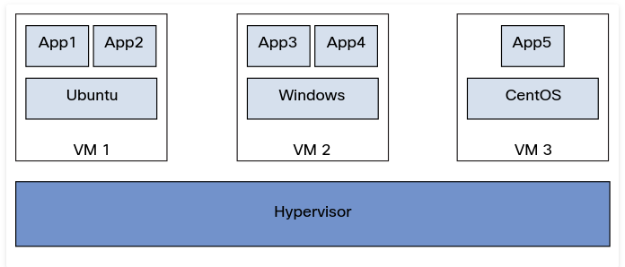
The hypervisor is the entity that controls and manages the VMs. There are two types of hypervisors:
- Type 1 hypervisors (native or bare-metal hypervisors) run directly on the physical system. Examples of Type 1 hypervisors include VMware ESXi, Proxmox Virtual Environment, Xen, and Microsoft Hyper-V.
- Type 2, or hosted hypervisors run on top of other operating systems. Examples of type 2 hypervisors include VirtualBox and VMware Player or Workstation.
These virtual systems have been susceptible to many vulnerabilities, including the following:
- VM escape vulnerabilities: These vulnerabilities allow an attacker to “escape” the VM and obtain access to other virtual machines on the system or access to the hypervisor. In Figure below, an attacker finds a VM escape vulnerability in the underlying hypervisor and uses that vulnerability to access data from another VM.
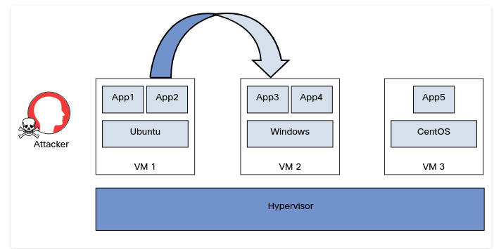
Hypervisor vulnerabilities such as hyperjacking:
Hyperjacking is a vulnerability that could allow an attacker to control the hypervisor.
Hyperjacking attacks often require the installation of a malicious or fake hypervisor that can manage the entire virtual environment. The compromised or fake hypervisor operates in a stealth mode, avoiding detection.
Hyperjacking attacks can be launched by injecting a rogue hypervisor beneath the original hypervisor or by directly obtaining control of the original hypervisor. You can also launch a hyperjacking attack by running a rogue hypervisor on top of an existing hypervisor.
VM repository vulnerabilities: Attackers can leverage these vulnerabilities to compromise many systems and applications. There are many public and private VM repositories that users can leverage to deploy VMs, including different operating systems, development tools, databases, and other solutions. Examples include the VMware Marketplace and AWS Marketplace.
Attackers have found ways to upload fake or impersonated VMs with malicious software and backdoors. These ready-to-use VMs are deployed by many organizations, allowing the attacker to manipulate the user’s systems, applications, and data.
7.2.15 Vulnerabilities Related to Containerized Workloads
The Evolution of Computing
Computing has evolved from traditional physical (bare-metal) servers to VMs, containers, and serverless architectures.
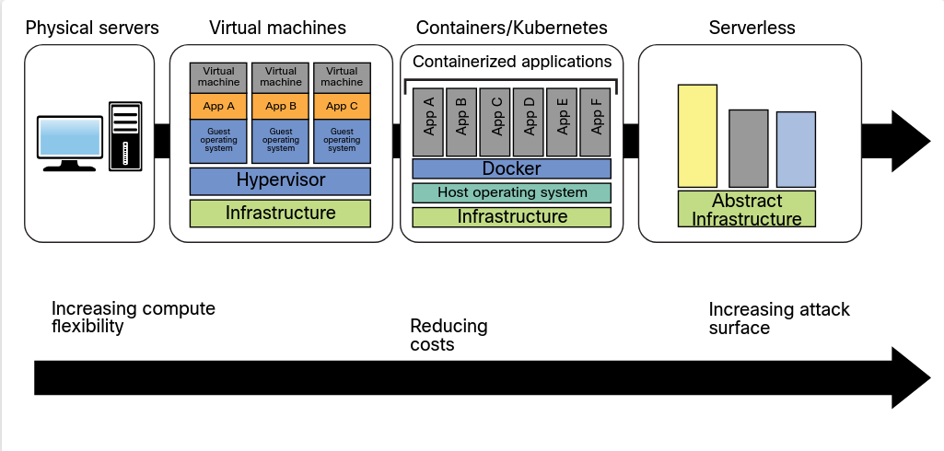
Vulnerabilities in applications and in open-source software running in containers such as Docker, Rocket, and containered are often overlooked by developers and IT staff.
Attackers may take advantage of these vulnerabilities to compromise applications and data. A variety of security layers apply to containerized workloads:
- The container image
- Software inside the container
- The host operating system
- Interaction between containers and the host operating system
- Security in runtime environment and orchestration platforms such as Kubernetes
Securing Container Images
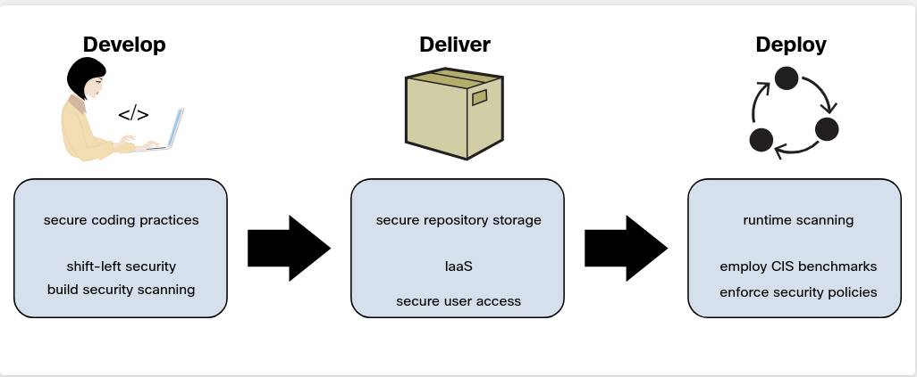
Key security best practices that organizations should use to create a secure container image.
Often software developers run containers with root privileges. These containers are one vulnerability away from full compromise.
The CIS Benchmarks for Docker and Kubernetes provide detailed guidance on how to secure Docker containers and Kubernetes deployments.
Tools that allow you to scan Docker images for vulnerabilities and assess Kubernetes deployments:
Anchore’s Grype: Grype is an open-source container vulnerability scanner.
Scanning Container Images with Grype: grype santosomar/mayhem
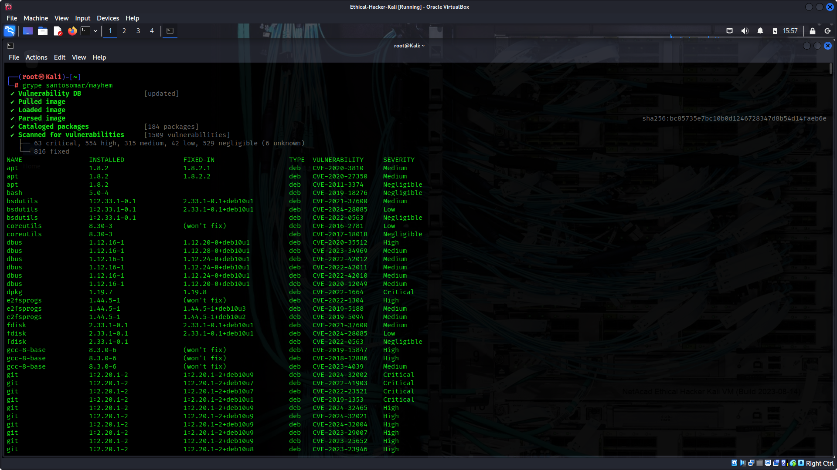
Clair: Clair is another open-source container vulnerability scanner.
Dagda: This set of open-source static analysis tools can help detect vulnerabilities, Trojans, backdoors, and malware in Docker images and containers. It uses the ClamAV antivirus engine to detect malware and vulnerabilities.
Kube-bench: This open-source tool performs a security assessment of Kubernetes clusters based on the CIS Kubernetes Benchmark.
Kube-hunter: This open-source tool is designed to check the security posture of Kubernetes clusters.
Falco: Threat detection engine for Kubernetes
Another strategy that threat actors have used for years is to insert malicious code into Docker images on Docker Hub (This has been a very effective “supply chain” attack.

